CREATING A DISABILITY
ACTION PLAN
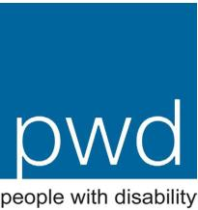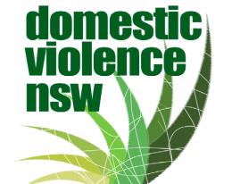
People with Disability Australia (PWDA)
PO Box 666
Strawberry Hills NSW 2012
Ph: (02) 9370 3100
Fax: (02) 9318 1372
Email: pwd@pwd.org.au
Website: www.pwd.org.au
Domestic Violence NSW (DVNSW)
PO Box 3311
Redfern NSW 2016
Ph: (02) 9698 9777
Fax: (02) 9698 9771
Email: admin@dvnsw.org.au
Website: www.dvnsw.org.au
The information in these documents was prepared by Meredith Lea, as part of
a collaboration between People with Disability Australia and Domestic Violence
NSW.
As information gets updated, new versions of this document will be available on
both websites
(C) PWDA and DVNSW 2015
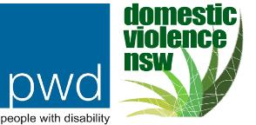
CREATING A DISABILITY ACTION PLAN
As outlined in the Disability Discrimination Act 1992 (DDA), Disability Action Plans (DAPs) help to
eliminate disability related discrimination. Writing a Disability Action Plan will help to highlight any
discriminatory policies, procedures, attitudes and other barriers that may exist in your service.
In creating a DAP, it is vital to consult women with disability, making sure that their voices and
opinions are heard and included in any new plans, policies and practices.^{i} Consultation should
include people with different impairments, including mental illness, to increase the chances of
uncovering all barriers that need to be addressed. Likewise, collaborating with disability advocacy
organisations or employing people with disability to assist in audit processes, would help to
ensure that your DAP is as broad and inclusive as possible.^{ii} Your DAP should schedule ongoing
consultation with people with disability.
If existing policies and practices are not inclusive, a DAP can help you begin to improve your
commitment to inclusivity for all. Writing a DAP can help you come up with strategies as to how to
iii
address and overcome the barriers to access that it uncovers. All members of your service should
be made aware of the DAP, as well as the steps they will each need to take to help implement the
plan.
Ultimately, DAPs are most effective when they outline a timeframe within which changes are to
occur, and when staff are allocated responsibility for certain alterations. Implementing realistic
timeframes, allocating adequate resources, and performing regular audits will help keep the
changes towards inclusivity on track, clearly monitoring whether various aspects of the plan have
been completed, or whether they are still in progress. Such processes of continual evaluation and
review are important elements, helping to ensure that the DAP has been implemented efﬁciently
and appropriately.
In addition to regular audits, it is important to get into the habit of checking the physical
accessibility of your service if and when things get moved around or changed.^{iv} Even relatively
minor changes to the layout of the physical environment could create a barrier for women with
disability. In turn, however, this means that changes to increase accessibility can also be quite
minor. Indeed, there are many quick and manageable steps that can be taken which will help
make your service more accessible for women with disability.
More detailed information concerning Disability Action Plans can be found at
https://www.humanrights.gov.au/our-work/disability-rights/standards/action-plans/developing-
effective-action-plan and
http://www.ncoss.org.au/resources/DNF/forum/141203-NSWDNF-Disability-Inclusion-Action-
Plan-Project.pdf.
Additionally, the Australian Human Rights Commission has compiled a ‘Register of
Disability Discrimination Act Action Plans’, which is available at
https://www.humanrights.gov.au/our-work/disability-rights/standards/action-plans/register-
disability-discrimination-act-action.
Your service can submit your DAP to this register, which could provide much needed information
or ideas for the DAPs of other domestic and family violence services. Collaboration is key in
ensuring that women with disability have access to a whole range of domestic and family violence
services.
1
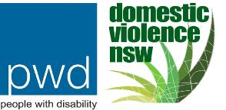
AUDIT THE SERVICE
Physical Accessibility Guidelines
Physical access is often seen to relate only to wheelchair access. This is problematic, as physical
access must address the needs of women with a whole range of impairments, including physical,
visual, hearing, cognitive and/or mental illness.
The following questions are a good starting point to help you consider what changes your service
may need to make to ensure physical accessibility.
1. Physical Accessibility Outside The Service
Yes
Yes
No
No
1.1 Is there a wide, clear path towards the building?
1.2 Are there accessible parking spots for people with disability
near the main entrance of the building?
1.3 Do pamphlets and informational materials map out the
closest, safest and most accessible form of public transport
to your service?
Yes

Yes
No

No
1.4 Is there a grassed area outside for toileting service dogs?
2. Physical Accessibility Inside The Service
2.1 Are ﬂoor surfaces hard and non-slip?
Yes
Yes
Yes
No
No
No
2.2 Are corridors wide, clear, free from clutter and obstacles?
2.3 If there are obstacles, such as poles, are they easily located
by the use of a cane?
2.4 Are there warning or directional Tactile Ground Surface
Indicators (TGSI) near potential hazards?
Yes
No
2.5 Is furniture placed in sensible and consistent positions?
2.6 Is furniture located well out of the way of walkways?
2.7 Is furniture clean and intact?
Yes
Yes
Yes
Yes
No
No
No
No
2.8 Are pathways and doorways wide enough for a wheelchair
user to navigate?
2.9 Is there sufﬁcient room for a wheelchair to turn around in
Yes
No
every area of the service?
2
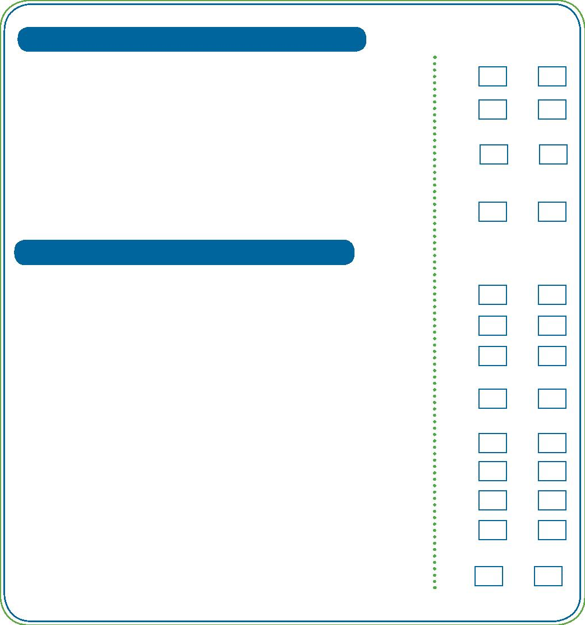
AUDIT THE SERVICE
2. Physical Accessibility Inside The Service
2.10 Where there are handrails, are they painted a different
colour from the wall on which they are located?
Yes
Yes
Yes
No
No
No
2.11 Are light switches, elevator buttons, doorknobs, power
points and telephones located at appropriate heights?
2.12 Do elevator buttons have braille or tactile markings on
them?
Yes
Yes
No
No
2.13 Is there an audio system in the elevator itself?
2.14 Do telephones have large numbers and an audible touch
tone?
2.15 Are there signs (in large print or braille) identifying
accessible bathrooms?
Yes
Yes
No
No
2.16 Are sinks, bench tops and cooktops at an appropriate
height to allow a person who is sitting, or is of short stature,
to use them comfortably?
2.17 Are soaps, hand driers or towels located at an accessible
height?
Yes
No
2.18 Are there handrails in the bathrooms?
2.19 Is there a step into the shower?
2.20 Is the shower head hand held?
Yes
Yes
Yes
Yes
Yes
No
No
No
No
No
2.21 Are shower seats available if required?
2.22 Are kitchen utensils and appliances kept at an accessible
level?
2.23 Are the insides of cupboards white to increase brightness
and make it easier to ﬁnd things?
Yes
Yes
Yes
No
No
No
2.24 Are contrasting colours used to identify obstacles or
hazards?
2.25 Is there sufﬁcient lighting in all rooms?
3
AUDIT THE SERVICE
2. Physical Accessibility Inside Th Service
2.26 Are lights installed in such a way that minimises glare?
2.27 Are lights installed in such a way that minimises shadows?
Yes

Yes

Yes
No

No

No
2.28 Do your smoke alarms take hearing impairment into
consideration? For instance, is the alarm tone converted
into ﬂashing lights or a vibration?
2.29 Do you have a signalling mechanism that converts sound
from alarm clocks and door bells into ﬂashing lights?
Yes

Yes
No

No
2.30 Is your emergency evacuation plan available in alternate
formats, such as braille, Easy English or audio recording?
Consider getting someone to review your emergency
evacuation plan and provide feedback as to how to make it
better for people with various impairments.
2.31 Do you have assistive listening devices? Is there a hearing
loop?
Yes

Yes
No

No
2.32 Are the women in the service informed about how their
actions inﬂuence women with disability? For instance,
ensuring that things are put back in their place after use
can make life easier (and safer) for women with vision
impairment.
Additionally, any future changes to the physical layout of the service should emphasise universal
design and keep in mind the diverse range of people who may one day use the service.
^{v}
Ensure
that any changes abide by the National Construction Code (NCC) and the Disability (Access to
Premises – Buildings) Standards 2010, as well as the standards outlined by Liveable Housing
Australia.
For more detailed information about accessible environments, see Vision Australia:
https://www.visionaustralia.org/business-and-professionals/creating-an-accessible-environment/
accessible-design-for-homes and
https://www.visionaustralia.org/business-and-professionals/creating-an-accessible-environment/
accessible-design-for-public-buildings.
4
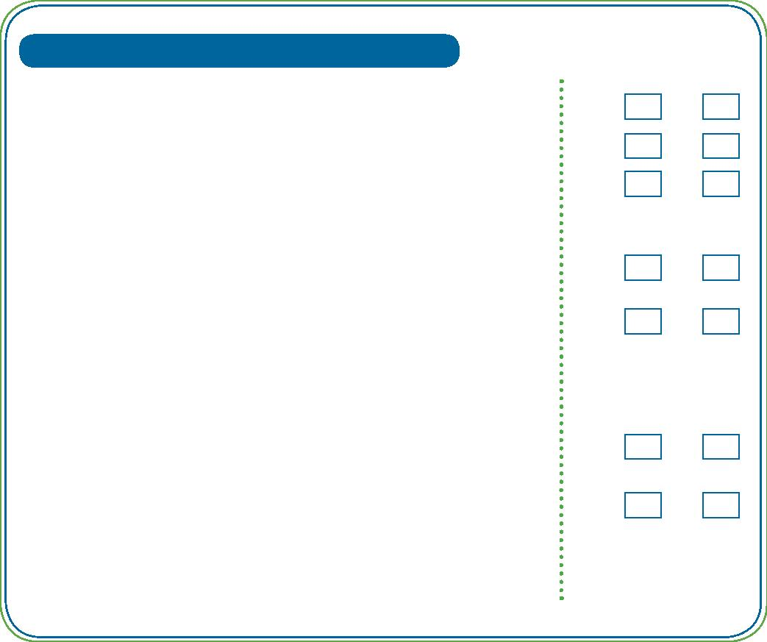
AUDIT THE SERVICE
Information Accessibility Guidelines
Information provided about and within your service should be accessible for women with disability.
By considering the following questions, it is possible to make information more accessible for
women with disability, as well as women from culturally and linguistically diverse backgrounds, and
women with low literacy.
1. Accessibility of Print Information
1.1 Are your informative materials available in large print and
braille formats?
Yes

Yes

Yes
No

No

No
1.2 Do you have Easy English alternatives for all informative
materials?
1.3 Do your written documents conform to the guidelines
provided by Vision Australia?(see links at the end of this
page).
1.4 Are you distributing print materials in safe, public locations
where people with disability are likely to access them?
Yes

Yes
No

No
1.5 Are you publicising the accessibility of your service?
Consider providing this information in presentations,
publications or brochures in a range of locations.
2. Accessibility of Electronic Information
2.1 Does your informative material include pictures of women
with various impairments?
Yes

Yes
No

No
2.2 Does your website meet the Web Content Accessibility
Guidelines (WCAG) outlined by the World Wide Web
Consortium (W3C)?
2.3 Is your electronic information accessible? Note: Microsoft
Word documents are more accessible than PDFs.
Yes
No
2.4 Does your website provide audio recordings of information?
Yes

Yes
No

No
2.5 Does your crisis or telephone line have a TTY and people
trained to use this technology?
5
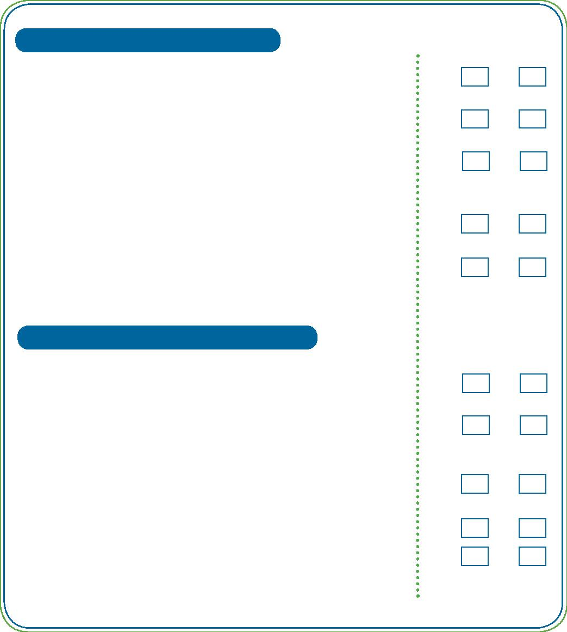
AUDIT THE SERVICE
3. Accessibility of Information at the Service
3.1 Are service entry forms available in alternate formats?
Yes

Yes
No

No
3.2 Is assistance available for those who require help ﬁlling out
the necessary forms?
3.3 Is information about the service, rules and regulations
available in alternate formats, such as braille, Easy English,
large print or audio recording?
Yes

Yes
No

No
3.4 Is the induction able to be broken down into smaller
segments to accommodate women with learning or
intellectual disability?
3.5 Do you have assistive communication devices available for
women with disability to use while in your service?
Yes

Yes
No

No
3.6 Do you have TTY and other assisted listening devices at
your service?
3.7 Do televisions have closed-captioning text and staff capable
of using this function?
Yes

Yes
No

No
3.8 Do your staff know how to access interpreters?
For more information about accessible and alternate print materials, see
http://www.visionaustralia.org/business-and-professionals/print-accessibility-services/inclusive-
communication-strategies and
http://www.visionaustralia.org/business-and-professionals/print-accessibility-services/alternate-
format-production.
For information about W3C and web accessibility, see
http://www.w3.org/WAI/.
For more information about how to ensure your printed material is in Easy English, please contact
NSW Council on Intellectual Disability or Intellectual Disability Rights Service for referral to a
consultant.
6
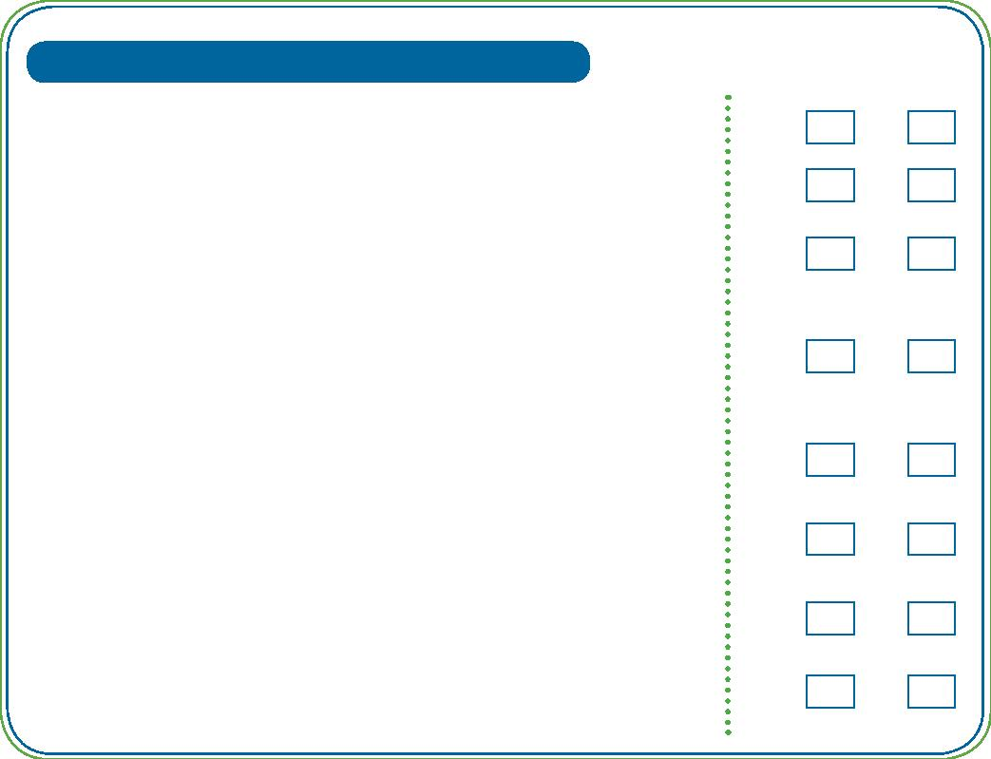
AUDIT THE SERVICE
Attitudinal Accessibility Guidelines
No single or overarching change will make your service accessible for all. However, attitudinal
changes are incredibly signiﬁcant in making services more accessible. As such, the following
questions may help identify whether the staff at your service are demonstrating inappropriate
attitudes, and thus embedding exclusionary practices.
1. Attitudinal Accessibility of the Service
1.1 Have staff members been informed about myths and
stereotypes about disability, and how these can negatively
impact their interactions with people with disability?
Yes
No
1.2 Have staff members been informed about how their
language can impact people with disability? Encourage
them to read PWDA’s Guide to Reporting Disability.
Yes

Yes

Yes
No

No

No
1.3 Are staff members aware of the many complex issues faced
by women with disability who have experienced domestic
and family violence?
1.4 Do staff members make assumptions about women with
disability? Do they use a different tone of voice, or patronise
these individuals?
1.5 Do staff members react indignantly when a woman with
disability comments on an access problem she is having?
Yes

Yes

Yes
No

No

No
1.6 Do staff members interact well with other services which
may be supporting a woman with disability?
1.7 Do staff members modify their interactions with women with
disability to respond to their needs? For instance, do they
slow down, use simpler language, and take more time as
required?
Yes

Yes
No

No
1.8 Do staff members respond to disclosure of violence with
disbelief, or doubt that it occurred?
1.9 Do staff members take the voices and opinions of women
with disability seriously?
7
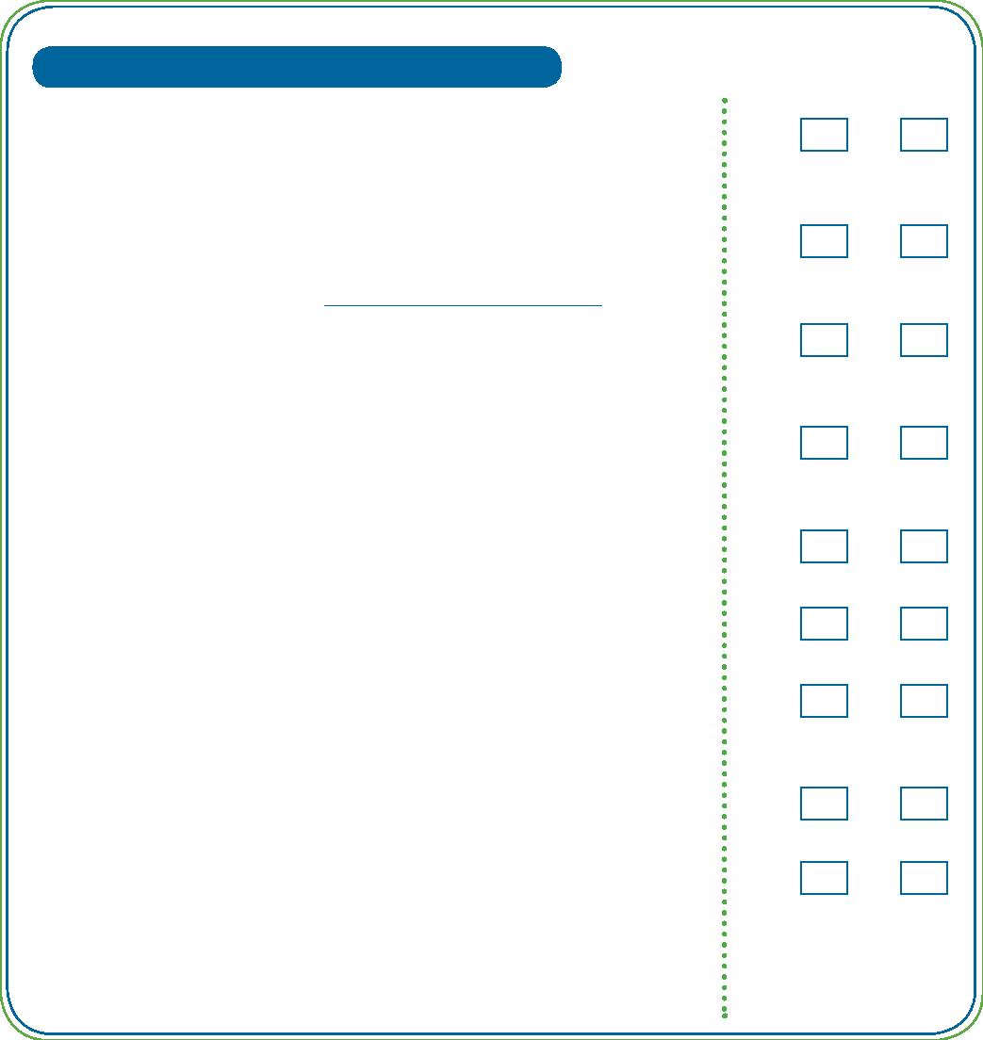
AUDIT THE SERVICE
1. Attitudinal Accessibility of the Service
1.10 Are staff members required to participate in disability
awareness training?
Yes
No
1.11 Are all staff members and volunteers trained to work with
women with disability?
Yes

Yes
No

No
1.12 Are staff members encouraged to develop further skills to
work with women with disability?
1.13 Are staff members conﬁdent communicating with and
understanding women with a range of different impairments,
including mental illness and/or a history of trauma?
Yes
No
1.14 Are staff members engaged in making your service more
accessible?
Yes

Yes
No

No
1.15 Are staff members encouraged to engage in the service’s
Disability Action Plan?
1.16 Are staff members encouraged to contribute to best practice
standards for interacting with women with disability?
Yes

Yes

Yes
No

No

No
1.17 Are staff trained to use assistive technology and disability
equipment?
1.18 Are women with disability represented in the service’s staff?
If not, how can attitudes and stereotypes be addressed to
allow for equal employment opportunities?
8
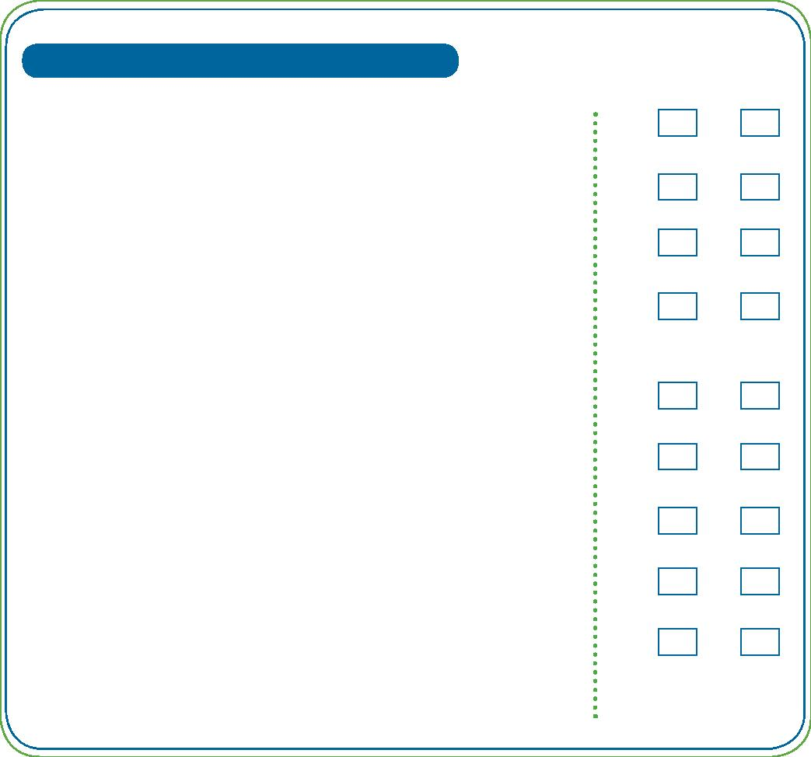
AUDIT THE SERVICE
Procedural Accessibility Guidelines
The needs of women with disability should be included within procedures and policies to ensure
that they are not discriminated against further after gaining access to your service. Revise policies
and consider how they can be changed so they don’t (intentionally or unintentionally) exclude
women with disability. The following questions should be considered when auditing the policies,
procedures and practices of your service.
1. Procedural Accessibility of the Service
1.1 Are policies based upon inclusive deﬁnitions? For instance,
does your service acknowledge that domestic and family
violence can be perpetrated by paid and unpaid carers or
support staff in a range of settings?
Yes

Yes
No

No
1.2 Are women with disability asked about their accessibility
needs upon arriving at your service? Are these needs met
as quickly as possible?
1.3 Do policies allow carers to accompany women with disability
into your service?
Yes

Yes

Yes

Yes

Yes
No

No

No

No

No
1.4 Do policies allow service dogs to accompany women with
disability into your service?
1.5 Do policies outline the protocol for accessing interpreters or
assistive communication devices?
1.6 Do policies and practices ensure that women with disability
are as independent as they desire within your service?
1.7 Do procedures outline that induction must be performed
conversationally? Would it be possible to provide rules and
regulations in writing or audio recordings instead?
1.8 If the physical environment or layout of the service is
changed at all, are there policies in place to ensure that
people with vision impairment are made aware of these
changes?
Yes

Yes
No

No
1.9 Are there procedures or policies in place that outline your
service’s minimum requirements for accessible information?
9
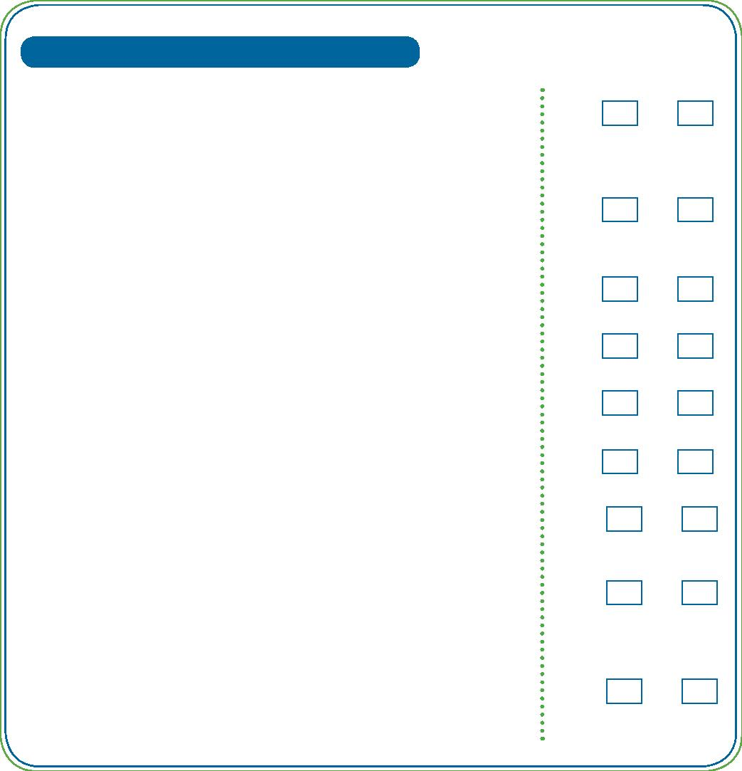
AUDIT THE SERVICE
1. Procedural Accessibility of the Service
1.10 Do programs discriminate against women with disability in
terms of setting unrealistic timeframes or goals?
Yes

Yes
No

No
1.11 Can procedures be easily and consistently altered to make
your service more accessible? For instance, changing how
questions are asked or how information is provided.
1.12 Does your service have formal policies and procedures
concerning disability, or do staff members rely on
Yes
No
informal policies such as making their own personal
accommodations when dealing with women with disability?
1.13 Do recruitment policies discriminate against women with
disability?
Yes

Yes
No

No
1.14 Can recruitment policies and practices be changed to
move towards equal employment and inclusivity?
1.15 Could your service employ a disability-speciﬁc case
manager to assist women with disability?
Yes
No
10
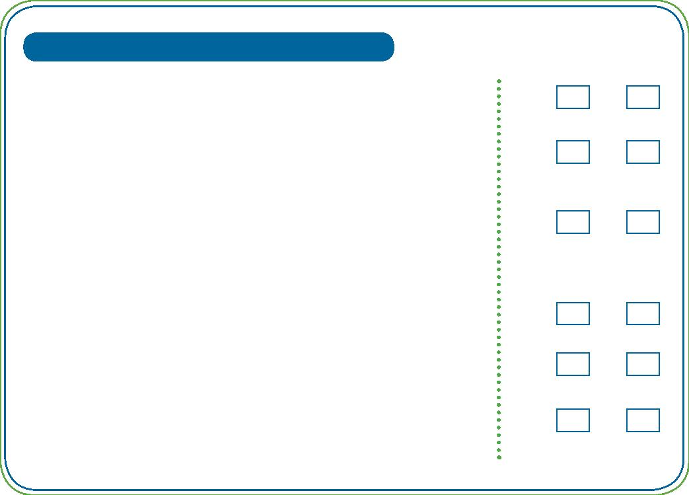
We would like to acknowledge Carolyn Frohmader for all her previous work in this area which has substantially
informed our work here. See also Frohmader, C. 2007. ‘More than just a ramp: a guide for women’s refuges to
develop disability discrimination act action plans’, Women With Disabilities Australia,
http://wwda.org.au/wp-content/uploads/2013/12/More_Than_Just_A_Ramp.pdf.
A lot of the following resources have been drawn from the Stop the Violence Resource Compendium on domestic and
family violence, available at http://www.stvp.org.au/RC-Domestic-and-Family-Violence.html.
The Stop the Violence Resource Compendium also provides more general resources concerning violence against
women with disability. It is available at http://www.stvp.org.au/Resource-Compendium.html.
The questions used in this document have been adapted from
Frohmader, 2007; Hague et.al., 2007; Hoog, 2004; Vision Australia, 2014; WCHM et.al., 2009.
Endnotes:
^{i} Hague, G., Thiara, R., Magowan, P. and Mullender, A. 2007. ‘Making the links: Disabled women and domestic
violence. Final Report’, Women’s Aid. <http://www.womensaid.org.uk/core/core_picker/download.asp?id=1763>
WDVCS (Women’s Domestic Violence Crisis Service), 2012. ‘WDVCS Disability
Action Plan 2013-2016’ Women’s Domestic Violence Crisis Service. <https://www.
google.com.au/url?sa=t&rct=j&q=&esrc=s&source=web&cd=4&cad=rja&uact=8&ved=
0CDUQFjAD&url=https%3A%2F%2Fwww.humanrights.gov.au%2Fsites%2Fdefault%2Fﬁles%2FW
DVCS%2520Disability%2520Action%2520Plan%25202013-2016.docx&ei=MmhZVP-
FBIKdmwWCp4GICA&usg=AFQjCNETtLbF-v82WffYExvlyGSKIRe7mg&sig2=-
ogoYunfP8O9xUI2MWilOA&bvm=bv.78677474,d.dGY>
^{ii} WCHM, DVCS, WWDACT and WESNET, 2009. ‘Women with Disabilities Accessing Crisis Services’. <http://www.
pwd.org.au/documents/pubs/SBWWD.pdf>
^{iii} Frohmader, C. 2007. ‘More than just a ramp: a guide for women’s refuges to develop disability discrimination act
action plans’, Women With Disabilities Australia. <http://wwda.org.au/wp- content/uploads/2013/12/More_Than_
Just_A_Ramp.pdf>
^{iv} Hoog, C. 2004. ‘Increasing Agency Accessibility for People with Disabilities: Domestic Violence Agency Self-
Assessment Guide’, Abused Deaf Women’s Advocacy Services for the Washington State Coalition Against Domestic
Violence <http://www.stvp.org.au/documents/Compendium/Domestic%20and%20Family%20Violence/hoog1. pdf>
^{v} Healey, L., Howe, K., Humphreys, C., Jennings, C. and Julian, F. 2008. ‘Building the Evidence: A report on the status
of policy and practice in responding to violence against women with disabilities in Victoria’, Women’s Health Victoria
and Victorian Women with Disabilities Network. <http://www.wdv.org.au/documents/BTE%20Final%20Report.pdf>
Vision Australia, 2014a. ‘Creating an accessible environment: Accessible design for homes’, Vision
Australia. <https://www.visionaustralia.org/business-and-professionals/creating-an-accessible- environment/
accessible-design-for-homes>
Vision Australia, 2014b. ‘Creating an accessible environment: Accessible design for public buildings’, Vision
Australia. <https://www.visionaustralia.org/business-and-professionals/creating-an- accessible-environment/
accessible-design-for-public-buildings>
11

