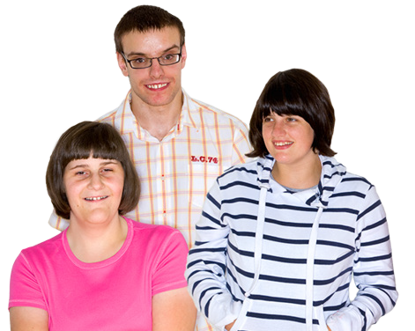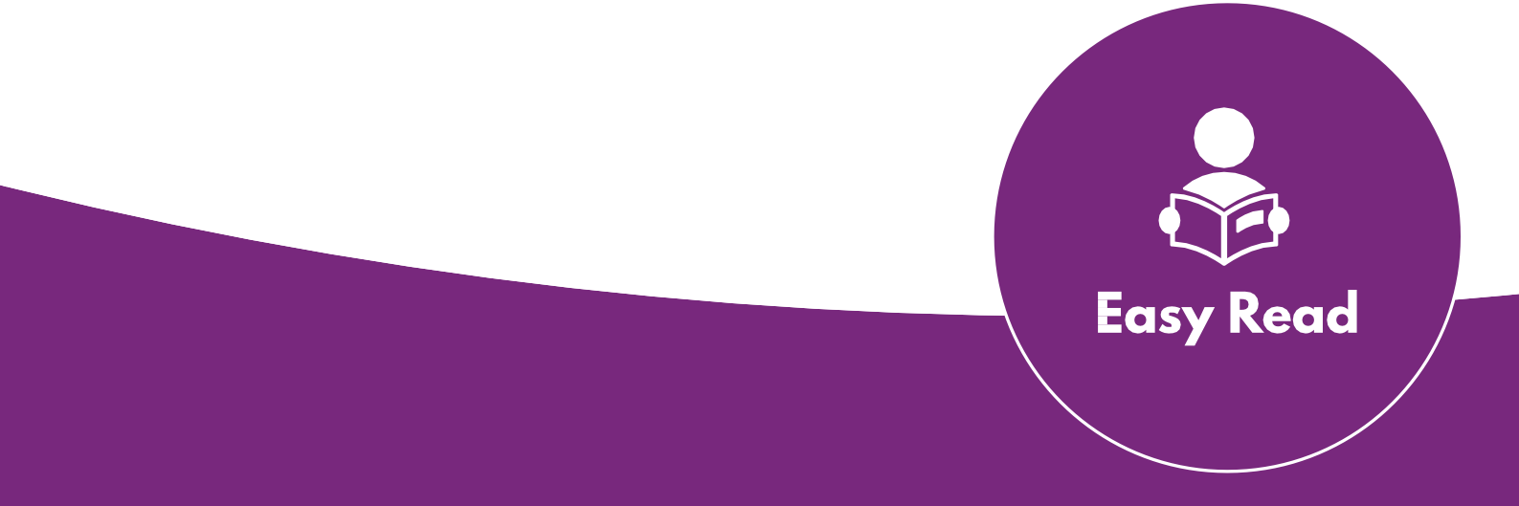Creating Access
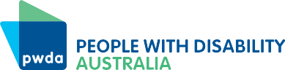

Speaking up for social change

www.pwd.org.au www.youthaction.org.au

Speak up

You have the right to speak up.

You can speak up and make change on big issues.

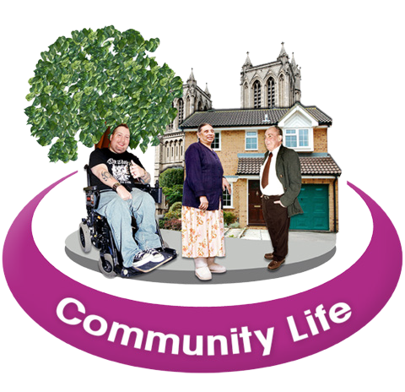It could be a big issue that affects you, other young people or everyone in the community.

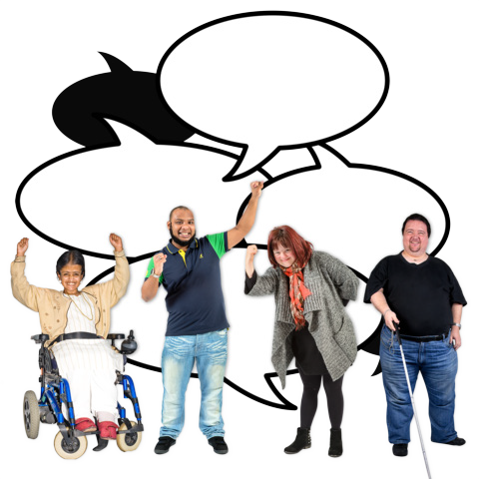You can speak up about things like
Jobs
NDIS
My rights

- Disability rights and awareness

- The National Disability Insurance Scheme (NDIS)
- Education and employment

- The environment

Get ready to speak up

Think about how you want to speak up about the issue.

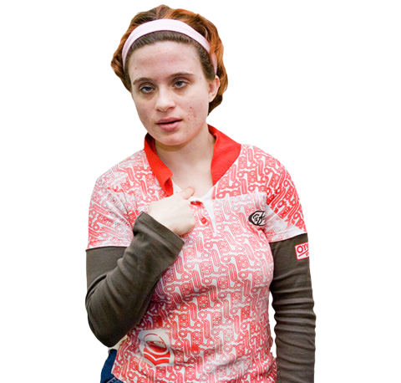Think about how you want to speak up about the issue.

Know what your rights are.

Find out who makes decisions on the issue.

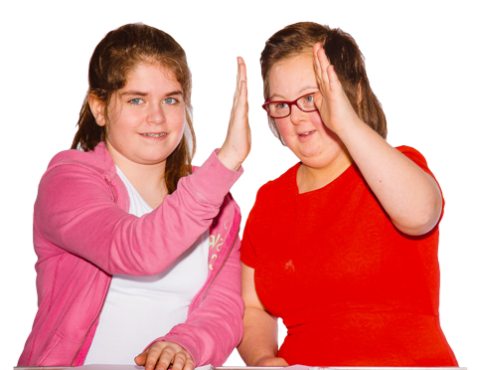Team up with other people speaking up to support each other.

Practice speaking up with other people.

Make a plan

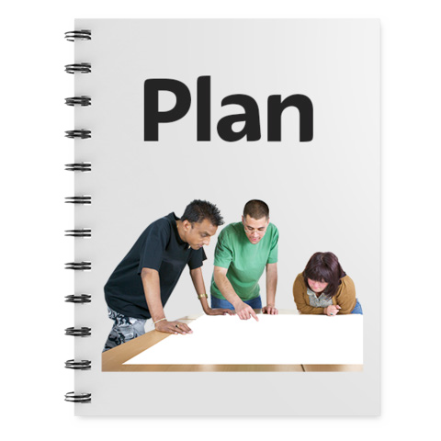It is important to be prepared when you are speaking up.

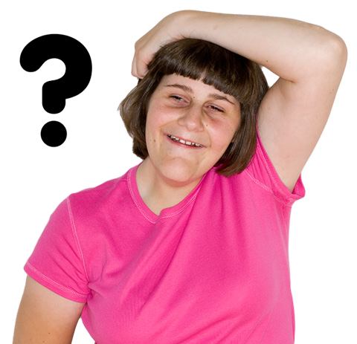These 5 questions will help you make a plan.

- What do you need to do?

- How will you do it?

- Will it cost money and how will you pay for it?

- Who do you need to talk to?

- Who can support you?

What to do if nothing changes

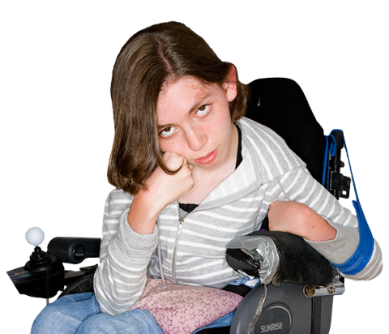Keep going because making change takes time!

Try a different way to speak up.

Work with advocacy or human rights organisations.

More information on speaking up for social change

Look at our other factsheets for more information

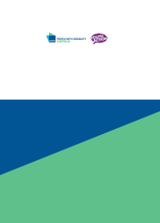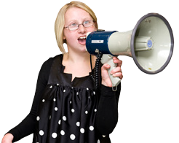Speaking up for yourself

Creating Access

Speaking up for yourself

www.pwd.org.au

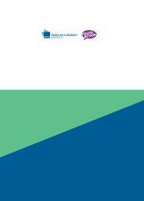What is advocacy?

Creating Access

What is Advocacy?

www.pwd.org.au www.youthaction.org.au

Contact PWDA for more information

Phone (02) 9370 3100

Email pwd@pwd.org.au

Contact Youth Action for more information

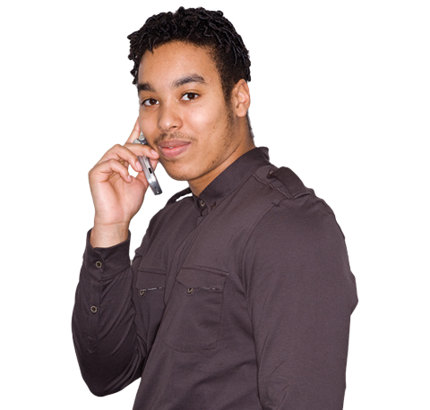Phone (02) 8354 3700

Email info@youthaction.org.au

Creating Access
6

The information in this document was prepared as part of the Creating Access project.

It is between People with Disability Australia (PWDA) and Youth Action.

This work is copyright. Apart from any use as permitted under the Copyright Act 1968, no part may be reproduced without written permission from People with Disability Australia (PWDA) and Youth Action.

© 2019 People with Disability Australia (PWDA) and Youth Action.

