Women with Disability and Domestic and
Family Violence:
A Guide for Policy
and Practice

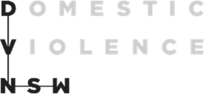

People with Disability Australia (PWDA) PO Box 666
Strawberry Hills NSW 2012 Ph: (02) 9370 3100
Email: pwd@pwd.org.au Website: www.pwd.org.au

Domestic Violence NSW (DVNSW) PO Box 3311
Redfern NSW 2016
Ph: (02) 9698 9777
Email: admin@dvnsw.org.au Website: www.dvnsw.org.au

The information in these documents was prepared as part of a collaboration between People with Disability Australia and Domestic Violence NSW.

© PWDA and DVNSW 2021

Part 1: Women with disability are at high risk of experiencing domestic and family violence
Women with disability experience significantly higher levels of all forms of violence, including domestic and family violence (DFV) (Frawley et al 2015, pp5-6). According to a recent Australian Bureau of Statistics (ABS) disability and violence report, women with disability are almost twice as likely as women without disability to have experienced physical or sexual violence by a cohabiting partner over a 12-month period (2.5 per cent compared with 1.3 per cent) (ABS 2021). The likelihood of emotional abuse by a cohabiting partner is also significantly increased (6.3 per cent compared with 4.1 per cent) (ABS 2021).
An intellectual or psychological disability puts women further at risk. A woman with an intellectual or psychological disability is almost three times more likely than a woman with a physical disability to experience physical or sexual violence by a cohabiting partner (ABS 2021). She is more than twice as likely to experience emotional abuse by a cohabiting partner (ABS 2021).
While women with disability experience all the same forms of DFV that other women experience, they are at risk of additional forms of DFV, including forced sterilisation, seclusion and restrictive practices. Their need for disability supports also means they experience DFV in a range of institutional and service settings, such as in residential institutions and aged care facilities (Frohmader et al 2015, p12).
It is widely accepted that violence against women with disability is significantly under-reported. Although three in four (74 per cent) women with disability experienced anxiety or fear for their personal safety, following their most recent incident of physical assault by a man, fewer than one in three (29 per cent) reported the incident to police (ABS 2021).
What’s more, the data used in the ABS disability and violence report excludes residential care and institutional facilities, such as group homes. It also excludes participants who need third party assistance with communication.

Understanding disability
In this guide, we use the term disability within the context of the internationally recognised social model of disability (Kayess & Sands 2020, pp6-10). Born out of the civil rights movement of the 1960s and 70s, the social model focuses on the person, not their impairment. It describes disability as an interaction between people with impairments and the barriers created by society to their full and effective participation on an equal footing with others. The social model of disability is outlined in the UN Convention on the Rights of Persons with Disabilities (CRPD).
Under the social model of disability, equality of access is a shared responsibility. Physical, attitudinal and communication barriers reduce the opportunities afforded to people with impairments, resulting in exclusion and/or discrimination. These barriers may also exist in DFV services. Ratified by Australia in 2008, the CRPD outlines the obligations your service has to people with disability. These include ensuring access to physical locations, information, employment, adequate standards of living, support services and assistive technologies.

Language used in this guide
The terms ‘people with disability’ and ‘women with disability’ are used throughout this manual. However, some people prefer other language, such as ‘disabled woman’ or ‘woman with a disability’.

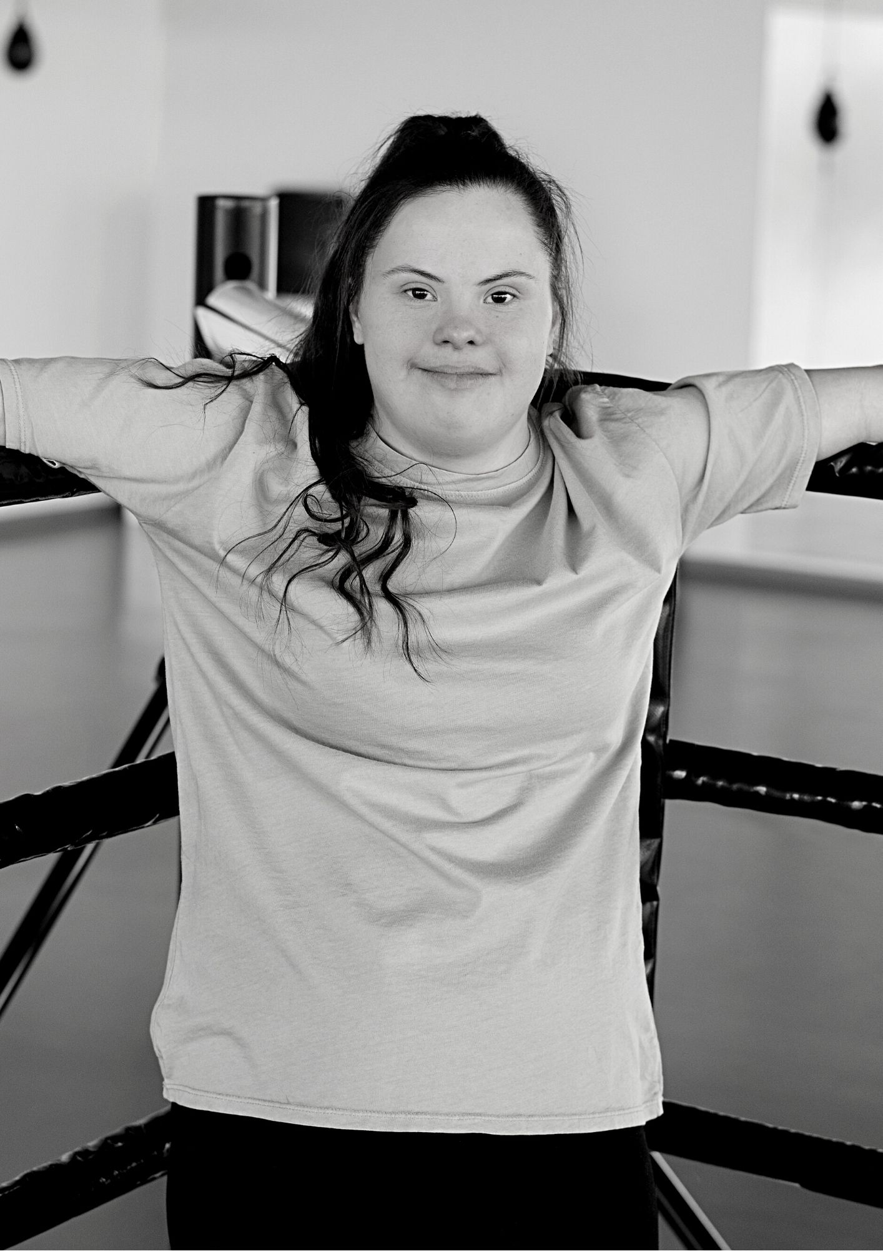

Part 2: The Intersection of Disability, Gender and DFV
Gender is not the only factor that affects a woman’s experience of DFV. Disability, class, age, geographical location, Aboriginal and Torres Strait Islander identity, culturally and linguistically diverse (CALD) background, sexuality, and/or gender diversity also intersect to affect how DFV is experienced. ‘Intersectionality’ is a theoretical term that is now widely used to describe how these different factors interact to shape a person’s experience.
‘Intersectionality’ recognises that women with disability experience unique forms of DFV not experienced by women without disability, due to the way gender and disability-based discrimination intersect (Frohmader & Sands 2015, pp16-18). It also recognises that women with disability experience DFV in a broader range of settings and encounter barriers that are not experienced by women without disability (Frohmader et al 2015, p12; Mitra-Kahn et al 2016, pp26-27).

Unique Types of DFV Experienced by Women with Disability
DFV commonly includes physical, emotional, sexual and financial abuse. However, women with disability experience forms of abuse, in each of these categories, which are not experienced by women without disability. Some of the unique forms of DFV perpetrated against women with disability include:
- Physical abuse, such as the withholding of food, water, medication or support services, the use of chemical or physical restraints, and the destruction or withholding of disability-related equipment (Healey 2013, p38).
- Sexual violence, such as inappropriate touching during care giving, sexual activity being demanded or expected in return for care, taking advantage of a physical impairment to force sexual activity, and control of reproductive processes (Healey 2013, pp39-40).
- Emotional abuse, such as denial of disability, threats to withdraw care or services, threats to institutionalise, violation of privacy, neglect, abandonment and deprivation (Healey 2013, p39).
- Economic abuse, such as theft of disability-related payments, abuse of Powers of Attorney and refusal to pay for essential medication or disability-related equipment (Healey 2013, p39).
- Coercive control that results from existing hierarchies between people with disability and people without disability, such as people with disability being led to believe that the abusive behaviours occur in all relationships (Healey 2013, p44; Maher et al 2018, pp36-40).

Women with disability experience DFV in a variety of contexts. Settings include large residential institutions, group homes, respite centres, boarding houses, private homes, and on the street.
Perpetrators include intimate, cohabiting partners, family members, formal or paid carers, informal or unpaid carers, staff in residential institutions, other residents in residential institutions, and disability support workers (Healey 2013, pp40-41).
The Crimes (Domestic and Personal Violence) Act 2007 (NSW) reflects the intersectional experience of violence for women with disability. This is an excellent legislative model for services and refuges.

Barriers to Assistance for Women with Disability
Survivors may face challenges accessing DFV services because community need often outstrips resources (Equity Economics 2021). For women with disability, this is compounded by accessibility issues. The number of DFV services accessible to people with disability is poorly documented in Australia. However, a 2011 UK study found that 76 per cent of the DFV services surveyed did not comply with the UK Disability Discrimination Act (Frawley et al 2015, p13).
Other barriers women with disability face in accessing DFV services include:
- They may be socially and/or physically isolated (Dowse et al, 2013, p54).
- They may have difficulty accessing spaces where they can safely disclose DFV (Dowse et al, 2013, p46).
- They may not recognise their experiences as DFV. Community education may not be available or appropriate to them (Healey 2013, p44; Dowse, pp46, 55).
- Information may be actively denied to them by the perpetrator, or it may not be available in accessible formats (such as Easy Read, Auslan and braille) (Healey 2013, p47).

Providing women with disability with accessible information about DFV may increase their ability or willingness to leave abusive situations.
Women with disability are frequently not believed upon disclosing their experiences of DFV (Healey 2013, p43), which may make them less likely to disclose. It can also normalise their experiences of violence and oppression (Maher et al 2018, pp36-40).
People may respond inappropriately to disclosure of DFV by women with disability. This is often the result of discrimination caused by social myths and stereotypes. Some people hold the misconception that people with disability do not have sexual feelings or are incapable of sustaining relationships. Others believe people with disability to be ‘hypersexual’ or lacking the ability to control themselves. Such myths shift the blame from the perpetrator to the person being abused (Healey 2013, p43).
There is also a perception that women with disability are a burden to those supporting them. This discriminatory idea of carer sacrifice means authorities can fail to recognise the abuse of women with disability by formal and informal supporters.
Women with disability may be reluctant to report DFV due to a fear of losing custody of their children. This fear is not unjustified; women with disability do disproportionately have children removed from their care (Pearce, 2012; Maher et al 2018, p69).
Without accessible crisis accommodation, women with disability may not leave a violent situation due to a fear of losing support services or other care provisions.
Women with disability may not have access to alternative supports, even if their current support worker or informal carer is abusing them. This results in unequal power relationships that can lead to exploitation, neglect and abuse (Maher et al 2018, pp43-47).
Women with disability may be afraid that accessing DFV services will result in them being institutionalised. This is a reasonable fear. Accessible housing is limited. They may not have financial resources to support their independence and may face discrimination when applying for rental properties (Healey 2013, pp19-21). Forty-five per cent of Australians with disability live in poverty. Mitra-Kahn et al, Oct 2020, p5).

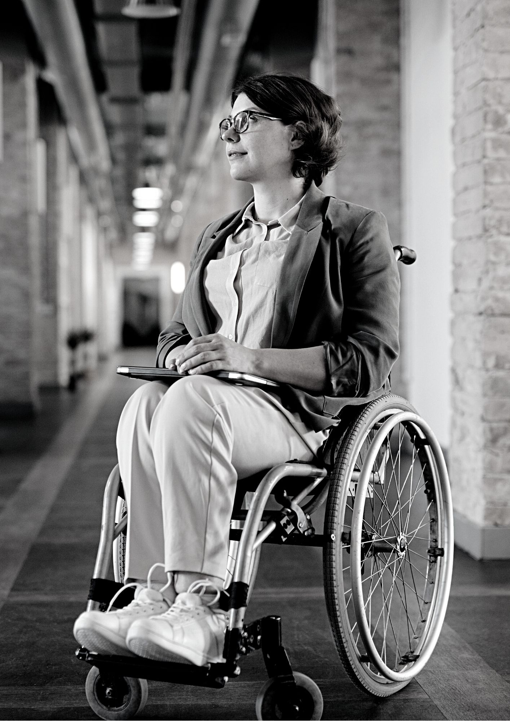

Part 3: Access to DFV Services for Women with Disability
Accessibility isn’t just about physical modifications, such as wheelchair ramps, or providing Auslan interpreters.
It also includes:
- how services think about disability (attitudinal factors),
- how information about services is made available (communication factors), and
- going beyond the minimum access requirements set out in the Commonwealth Disability Discrimination Act (1992) (Frawley et al 2017, p3).

An accessible service is ‘approachable, acceptable, affordable and available’ (Levesque et al 2013). Women with disability need to know such services exist and they must feel comfortable accessing them.

Inclusive Policies
Women with disability may be excluded from services if the service does not recognise the particular kinds of DFV women with disability experience (Frohmader et al 2015, pp15,17). To be inclusive of women with disability, a service’s policies should address these forms of DFV and the ways in which gender and disability discrimination intersect. Cross-sector collaboration – between DFV and disability specialists – is vital in this process (Frawley et al 2017, p4).
Women with disabilities should also be actively included, in the planning and strategic stages of service development, because they are the experts on their own lives (Frawley et al 2017, p2).

Targeted accommodation, programs and supports
DFV services are not experts in disability and meeting some women’s access needs can be challenging (Frawley et al 2017, p3). For example, some women’s disabilities are not ‘officially’ recognised by disability services or government organisations (Frawley et al 2017, p3). The experiences of women with psychosocial disability – that is, a disability arising from a mental health issue – can be particularly complex. These women may not identify as having mental illness and may consequently be seen as ‘difficult’ service users. To meet the needs of women with disability, DFV services need to provide programs and supports that are tailored to their needs.
Whether or not they have a disability, women who have experienced trauma demonstrate a range of coping strategies, including emotional outbursts, anger, sadness, confusion, withdrawal, increased sensitivity, isolation, or other seemingly erratic behaviours. These are normal responses to trauma (including the trauma of experiencing DFV) and should be responded to appropriately. Ensuring staff safety by excluding these women is inadequate.
To develop appropriate and targeted supports, your service should:
- Train your staff to support women with disability and/or trauma. This includes vicarious trauma training.
- Develop partnerships with appropriate disability and/or mental health organisations, at an organisational level, to assist these women.

Addressing Barriers to Access for Women with Disability
Under the Commonwealth Disability Discrimination Act 1992, it is unlawful to discriminate against people on the basis of their disability, or perceived disability. Changes must be made to ensure that women with disability are not (intentionally or unintentionally) discriminated against.
This means your service has an obligation to develop inclusive policies, procedures and practices, to review them regularly, and to implement the necessary changes to ensure women with disability are not (intentionally or unintentionally) discriminated against.
Below are some barriers your service should address.

Barrier 1: Inaccessible Information and Communication
Information provided by services is not always accessible, nor communicated effectively, to women with disability. As a result, women with disability may be unaware of the services available to them. Inaccessible information and inappropriate communication techniques can also cause problems within refuges, because women are unaware of the rules, regulations and expectations.

Recommendations to address barrier 1:
Highlight the work you have done around access and inclusion so women with disability know your service is ‘approachable and acceptable’.
Inform local disability organisations about the work you have done around access and inclusion so they can confidently refer women with disability to your service.
Your website should have an accessible design and should comply with the Web Content Accessibility Guidelines (WCAG).
Distribute brochures in places that are frequented by women with disability, such as disability services, advocacy organisations, doctor’s offices, supermarkets, community centres, and accessible bathrooms.
Information should be available in braille, large print, Easy Read, audio and electronically. Some of these formats are also useful to women from culturally and linguistically diverse (CALD) backgrounds and to women with low literacy.
During intake, assess a woman’s accessibility and communication needs. For example, women with intellectual disability may have difficulty remembering large amounts of information. Be clear and concise. Think about breaking the intake session into stages.
Provide information in writing (including in braille, large print and Easy Read), so women have a hard copy to refer back to. Recorded versions of the information could also assist with comprehension and retention.
Auslan and other interpreters should be made available (the woman should choose her own interpreter). Keep in mind that cultural/linguistic communities are often quite small and confidentiality is a complex matter.

Barrier 2: Physical Inaccessibility
Physical access doesn’t just apply to wheelchair users. Women with vision impairment, sensory sensitivity and/or psychosocial disability also face significant barriers.

Recommendations to address barrier 2:
Perform an access audit. Consult women with different disabilities to get a first-hand account of the accessibility of your service, and how it can be improved.
Minor changes include minimising clutter, providing adequate storage, eliminating trip or slip hazards, ensuring adequate lighting and installing handrails.
Women with vision impairment often rely on memory to navigate buildings. Simple designs, clear walkways and set places for furniture will help.
Ensure other women are mindful of the impact they can have on the physical accessibility of your service. For example, care should be taken to place items back in cupboards, and doors should be left consistently close or consistently open. Loud noise should be kept to certain areas, and minimised where possible.
Let women with disability know that this information has been communicated to the other women who are using the service.
It may take time for women with disability to adjust to the new environment. Support them to gain confidence and independence.

Barrier 3: Organisational Attitudes and Experience
The attitudes of staff, managers and governance bodies can be a significant barrier to women with disability. Myths and stereotypes are often deeply entrenched.

Recommendations to address barrier 3:
Hire people with disability, or disability-specific training since they will address discrimination from within.
Include women with disability in your governance body. Make inclusiveness part of your organisation’s strategic plan.
Ensure disability awareness training is part of your induction process.
Disability awareness training should be provided by disability services or by women with disability. People With Disability Australia (PWDA) offers training packages.
Ensure all staff are involved in the creation of an Inclusion Action Plan (IAP). Allocate specific tasks or responsibility for a particular aspect of the plan.
Make asking about a reasonable adjustment plan for individual staff members part of their supervision agenda, whether a staff member identifies as having a disability or not.
Make staff aware of the ways in which language can reinforce negative stereotypes and exclude people with disability. For more information, see PWA’s inclusive Language Guide.

Barrier 4: Perceived Discrimination
Women with disability often perceive DFV services to be unsafe, unapproachable and inaccessible (Healey 2013, p 47). They fear these services will discriminate against them on the basis of their disability. This fear may prevent them from accessing DFV services and increase their risk of homelessness.

Recommendations to address barrier 4:
To demonstrate your anti-discrimination policies, ensure women with disability are represented among your staff. There is little evidence, to date, of women with disabilities being involved in services beyond their role of client (Frawley et al 2017, p5).

Your IAP should implement equal employment measures. This also applies to governance bodies. Advertise jobs in accessible locations and use your networks to ensure women with disability have an equal chance to apply. Women with disability should be included in any promotional pathways that exist within your service.
Consider employing a specialist disability worker. This will improve the experience of women with disability who engage with your service.

Looking Forward
Creating an accessible, approachable service will be a dynamic process. Ensure guidelines are being consistently implemented through your organisation’s strategic plan. (You might want to include an annual audit.) Host regular workshops with women with disability, disability advocacy organisations, and disability services. Regular feedback from women with disability will help to keep track of progress.
Keep in mind that you are not the only service making these changes. Share IAPs with similar organisations to develop a community of practice around accessibility. Liaise with your local disability services, especially advocacy organisations, to increase cross-sector collaboration.

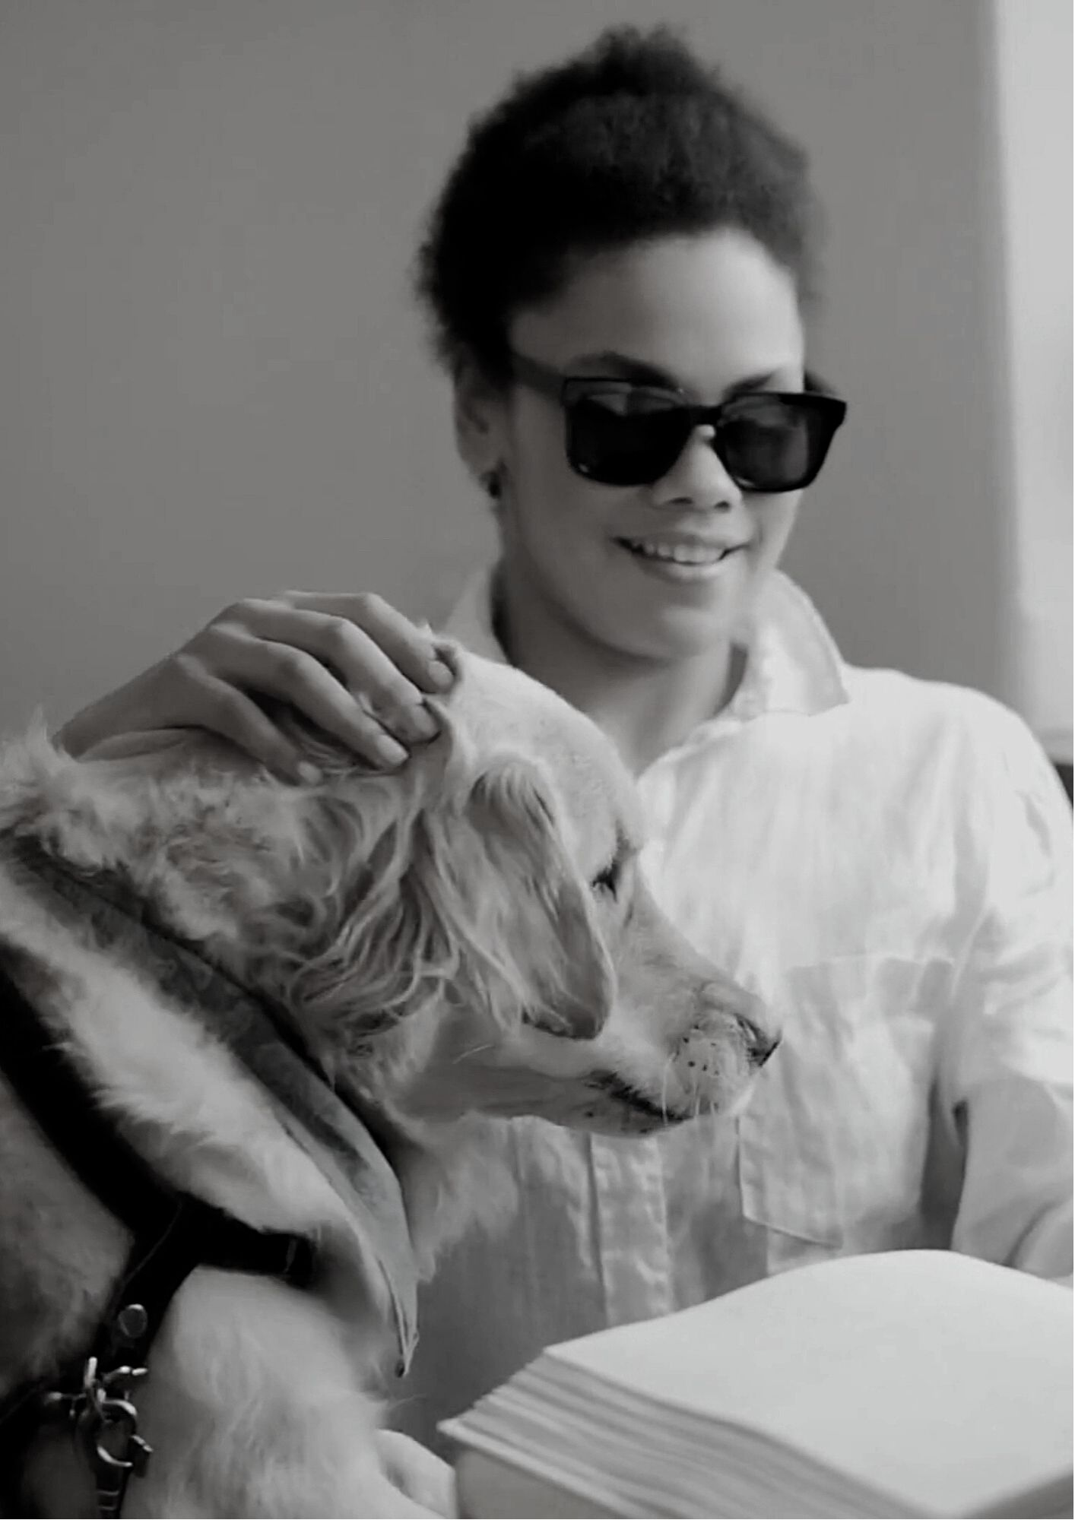

NSW Disability Advocacy Organisations
- First Persons Disability Network
fpdn.org.au
- Synapse
biansw.org.au
- Central Coast Disability Network
ccdn.com.au
- Disability Advocacy NSW (DA)
da.org.au
- Illawarra Advocacy
illawarraadvocacy.org.au
- Intellectual Disability Rights Service (IDRS)
idrs.org.au
- Multicultural Disability Advocacy Association (MDAA)
mdaa.org.au
- Council for Intellectual Disability
cid.org.au
- Penrith Disabilities Resource Centre
pdrc.org.au
- People With Disability Australia (PWDA)
pwd.org.au
- Physical Disability Council of NSW (PDCN)
pdcnsw.org.au
- Self Advocacy Sydney Inc
sasinc.com.au
- Side By Side Advocacy Inc
sidebysideadvocacy.org.au

Endnotes
Australian Bureau of Statistics. (2021). ‘Disability and Violence – in Focus: Crime and Justice Statistics, Australian Bureau of Statistics’. Retrieved May 31, 2021 from https://www.abs.gov.au/statistics/people/crime-and-justice/focus-crime-and-justice-statistics/april-2021.
Dowse, L., Soldatic, K., Didi, A., Frohmader, C. and van Toorn, G. (2013). ‘Stop the Violence: Addressing Violence Against Women and Girls with Disabilities in Australia’. Background Paper. Hovard. Women with Disabilities Australia. Retrieved on June 25 2021 from https://wwda.org.au/publication/stop-the-violence-addressing-violence-against-women-and-girls-with-disabilities-in-australia-background-paper/.
Equity Economics (2021), The Social Sector in NSW: Capitalising on the Potential for Growth, A Report Prepared for the New South Wales Council of Social Service, Sydney. Retrieved on June 30 from http://www.equityeconomics.com.au/socialsectorinnsw.
Frawley, P., Dyson, S., Robinson S., Dixon, J. (2015) ‘What does it take? Developing informed and effective tertiary responses to violence and abuse of women and girls with disabilities in Australia’, State of Knowledge Paper. ANROWS. Retrieved on June 8 from https://www.anrows.org.au/publication/whatever-it-takes-access-for-women-with-disabilities-to-domestic-and-family-violence-services-final-report/.
Frawley, P., Dyson, S., Robinson S. (2017) ‘Whatever it takes: Access for women with disabilities to domestic and family violence services: Key findings and future directions.’ ANROWS. Retrieved on June 10 from https://www.anrows.org.au/publication/whatever-it-takes-access-for-women-with-disabilities-to-domestic-and-family-violence-services-final-report/.

Frohmader C., Dowse L., Didi A., (2015) ‘Preventing violence against women and girls with disabilities: Integrating a human rights perspective’, Women With Disabilities Australia. Retrieved on June 15 from https://wwda.org.au/wp-content/uploads/2015/04/Think-Piece_WWD.pdf.
Frohmader, C., and Sands, T. (2015). ‘Australian Cross Disability Alliance submission to the Senate inquiry into violence, abuse and neglect against people with disability in institutional and residential settings.’ Sydney, NSW: Australian Cross Disability Alliance. Retrieved June 7, 2021 from https://dpoa.org.au/acda-submission-senate-inquiry-violence-abuse-neglect-people-disability-institutional-residential-settings/.
Healey, L. (2013). ‘Voices Against Violence Paper Two: Current Issues in Understanding and Responding to Violence against Women with Disabilities,’ Women with Disabilities Victoria, Office of the Public Advocate and Domestic Violence Resource Centre Victoria. Retrieved June 9 from https://www.wdv.org.au/our-work/building-the-knowledge/voices-against-violence/.
Kayess, R., and Sands, T. (2020). ‘Convention on the Rights of Persons with Disabilities: Shining a light on Social Transformation’, UNSW Social Policy Research Centre. Retrieved June 7, 2021 from UNSW website https://www.arts.unsw.edu.au/sprc/our-projects/convention-rights-persons-disabilities.
Levesque, JF., Harris, M.F., Russell, G. (2013) ‘Patient-centred access to health care: conceptualising access at the interface of health systems and populations’, International Journal for Equity in Health 12, 18. Retrieved on June 11 2021 from https://equityhealthj.biomedcentral.com/articles/10.1186/1475-9276-12-18.

Maher, J. M., Spivakovsky, C., McCulloch, J., McGowan, J., Beavis, K., Lea, M., Sands, T. (2018). ‘Women, disability and violence: Barriers to accessing justice: Final report’, ANROWS. Retrieved June 3 2021 from https://www.anrows.org.au/publication/women-disability-and-violence-barriers-to-accessing-justice-final-report/.
Mitra-Kahn T., Frohmader, C. (October, 2020). ‘Answers to questions on notice.’, House Standing Committee on Social Policy and Legal Affairs inquiry into family, domestic and sexual violence, Women with Disabilities Australia (WWDA).
Mitra-Kahn, T., Newbigin, C., & Hardefeldt, S. (2016). ‘Invisible women, invisible violence: Understanding and improving data on the experiences of domestic and family violence and sexual assault for diverse groups of women: State of Knowledge Paper’, ANROWS Landscapes, DD01/2016. Retrieved on June 15 from https://www.anrows.org.au/publication/invisible-women-invisible-violence-understanding-and-improving-data-on-the-experiences-of-domestic-and-family-violence-and-sexual-assault-for-diverse-groups-of-women-state-of-knowledge-paper/.
Pearce, C. (2012). ‘Disability no bar to good parenting.’ SMH. Retrieved on June 10 from https://www.smh.com.au/politics/federal/disability-no-bar-to-good-parenting-20121214-2bf75.html.

