

30 October 2018

People with Disability Australia Ltd PO Box 666

Strawberry Hills NSW 2012

DECLARATION OF RESULTS – People with Disability Australia Ltd Board Election 2018 - Directors

I am writing to you in my capacity as the duly appointed Returning Officer for the People with Disability Australia Ltd Board Election 2018.

In accordance with the rules of People with Disability Australia Ltd, I declare the following results for the FIVE (5) contested positions as Director.

Ref: 790-Director-Declaration-FINAL.docx

Page 1 of 2

POSITIONS: FIVE (5) POSITIONS AS DIRECTOR

COUNT METHOD APPLIED: MULTIPLE PREFERENTIAL

CANDIDATES

VOTES

STATUS

David Abello

Excluded

Jaci Armstrong

121

Elected

Karen Burgess

119

Elected

Paige Burton

131

Elected

David Clark

Excluded

Jorden Gunton

Excluded

Shakira Hussein

Excluded

Stuart Mawbey

Excluded

Jason McCurry

Excluded

Jarad McLoughlin

Excluded

Wayne Nevinson

Excluded

BALLOT COUNT

Postal Ballot Paper Declarations received

12

Informal Ballot Paper Declarations

0

Total Formal Ballot Paper Declarations

12

Postal Ballot Papers

12

Informal Postal Ballot Papers

2

Total Formal Postal Ballot Papers

10

Total Formal Online Ballots

210

Total Formal Ballots for count

220

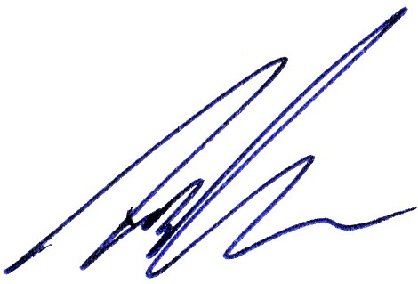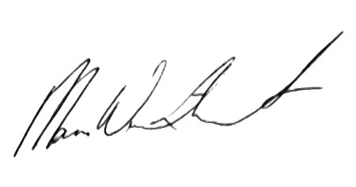

…………………………

I therefore declare the following person(s) have/has been elected to the FIVE (5) position(s) as Director (in order of votes received):

-

-

-

-

-

Hannah Solomons Kristy Trajcevski Paige Burton

Jaci Armstrong Karen Burgess

The count method and result has been audited by CorpVote Pty Ltd.

Yours sincerely,

Signed: ……………………………….

Date: 30/10/2018

Timothy Jones as Returning Officer.

Signed:

Date: 30/10/2018

…….

Mara Winthorst as Election Administrator.

Commercial in Confidence

Ref: 790-Director-Declaration-FINAL.docx

Page 2 of 2

Terence O’Hanlon

Excluded

Alex Pankau

Excluded

Suresh Rajan

Excluded

Trudy Ryall

Excluded

Hannah Solomons

136

Elected

Kristy Trajcevski

134

Elected

Steven Yates

Excluded

\* Elected as President so therefore excluded