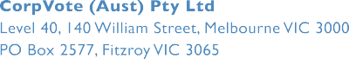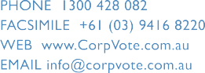

30 October 2018

People with Disability Australia Ltd PO Box 666

Strawberry Hills NSW 2012

DECLARATION OF RESULTS – People with Disability Australia Ltd Board Election 2018 – President.

I am writing to you in my capacity as the duly appointed Returning Officer for the People with Disability Australia Ltd Board Election 2018.

In accordance with the rules of the People with Disability Australia Ltd, I declare the following result for the ONE (1) contested position as President.

I therefore declare the following person has been elected to the ONE (1) position as President:

-

David Abello

The count method and result has been audited by CorpVote Pty Ltd.

Ref: 790-President-Declaration-FINAL.docx

Page 1 of 2

POSITIONS: ONE (1) POSITION AS PRESIDENT

COUNT METHOD APPLIED: OPTIONAL PREFERENTIAL

CANDIDATES

VOTES

STATUS

David Abello

Absolute Majority

Elected

Kevin Boyce

Excluded

Andrew Hewber

Excluded

Suresh Rajan

Excluded

BALLOT COUNT

Postal Ballot Paper Declarations received

12

Informal Ballot Paper Declarations

0

Total Formal Ballot Paper Declarations

12

Postal Ballot Papers

12

Informal Postal Ballot Papers

1

Total Formal Postal Ballot Papers

11

Total Formal Online Ballots

210

Total Formal Ballots for count

221

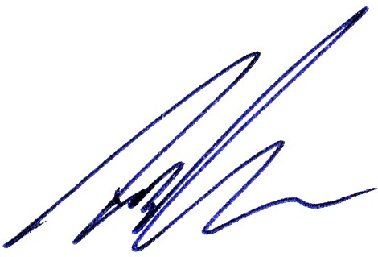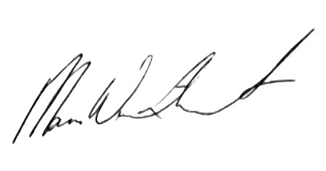

…………………………

Yours sincerely,

Signed: ……………………………….

Date: 30/10/2018

Timothy Jones as Returning Officer.

Signed:

Date: 30/10/2018

…….

Mara Winthorst as Election Administrator.

Commercial in Confidence

Ref: 790-President-Declaration-FINAL.docx

Page 2 of 2