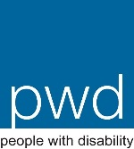
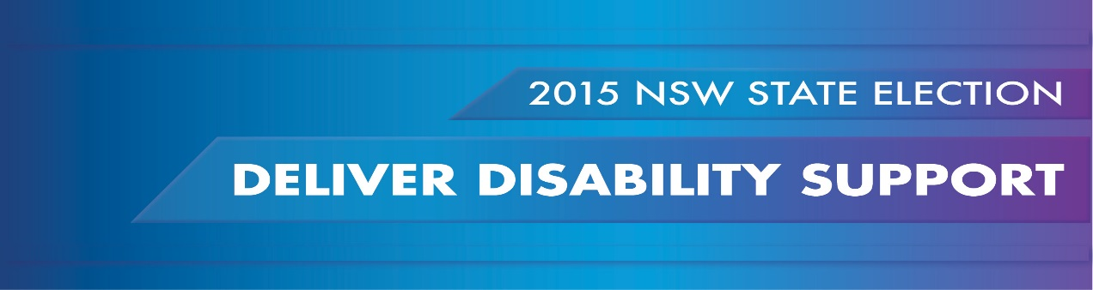
PWDA calls on candidates to ensure that during the NDIS transition and beyond, all people with disability receive the person-centred disability support services they require in a diverse, competitive and sustainable market that delivers choice and control for consumers.
THE SITUATION NOW
By 2018-19 approximately 10% of people with disability in NSW (140,000 people) will receive funding under the NDIS to organise and pay for their disability support requirements. However, many thousands of people with disability will not meet the eligibility requirements but will still have disability support needs. Their requirements may include support to attend medical appointments and participate in recreational activities, help with everyday tasks such as shopping, cooking, cleaning and personal care, or use of free community transport. With NSW funding for disability services being entirely diverted to support the NDIS roll out, people with disability are concerned that access to these essential services will be lost.
EnableNSW is the NSW service provider responsible for ensuring that people with disability have access to essential aids, equipment and assistive technology. Funding for EnableNSW has not kept pace with demand, meaning people with disability are not receiving these essential supports. People with disability in NSW not eligible for NDIS funding will rely on EnableNSW to provide or sell them equipment that meets their needs, but it is unclear how they will be able to access or pay for these supports.
Following the NDIS (NSW Enabling) Act 2013, disability services in NSW are being transferred to and provided by the non-government sector. However, there is a growing risk that transfer of these state assets to large for-profit providers may undermine the emergence of a diverse, competitive and sustainable market for disability supports, and consequently limit the choice and control of consumers. The sale of Home Care as a single entity to a for-profit, for example, risks creating a monopoly service provider motivated by profit rather than person centred service delivery.
With disability support provision shifting to a market driven model, there is a real risk that some people with disability will not have their needs met, and they will be left without essential supports. The early withdrawal of government service provision risks leaving many people with disability not eligible for the NDIS with little or no person centred disability supports. Non-government providers may refuse services to people they regard as ‘too difficult’, too costly, or where they do not have sufficiently skilled staff to meet their needs.

WHAT IS NEEDED
Commitment to ensuring that people with disability will not lose or receive reduced disability support services as a result of the transition to the NDIS. This includes a commitment that Home and Community Care (HACC) and EnableNSW services will continue to be funded for those who fall outside of the NDIS eligibility criteria.

Encouragement and stimulation of the growth of a healthy and diverse market for disability support services in NSW that promotes innovation and maximises choice for people with disability. This responsibility to contribute to the development and regulation of this emerging market should form part of the NSW Disability Inclusion Plan, and should be considered during negotiations for the sale of all NSW assets as part of the NDIS transition.

Commitment not to prematurely withdraw government services before the full roll out of the NDIS without guaranteeing equivalent supports; and guaranteeing the provision of disability support where there is market failure. People with disability must be able to rely on quality, person centred government support where their needs are not met by the market.

Increased growth in funding for the Aids and Equipment program under EnableNSW; and a shift in the culture of EnableNSW to become a person-centred service provider offering personalised budgets that can be amalgamated with other disability support funding to maximise choice and control for people with disability.

Phil Berry, NSW/NDIS Cross-Agency Coordinator, NSW Community Housing Federation Housing and Disability Forum, August 26, 2014

