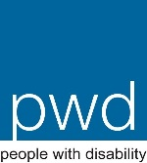
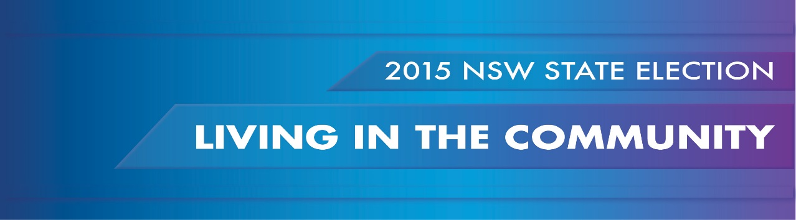
PWDA calls on candidates to commit to addressing the systemic barriers which exclude people with disability in NSW from living in the community and participating fully in economic, social and cultural life.
THE SITUATION NOW
People with disability are disproportionately affected by the lack of accessible and affordable housing in NSW. More than 1/3 of social housing tenants in NSW are people with disability. With demand far outstripping supply many people with disability on low incomes are compelled to rent privately in a market where they face discrimination and a shortage of accessible properties. Affordable housing is often poorly located outside metropolitan areas, with limited accessible public transport, local services and employment opportunities.
Despite bipartisan commitment to the closure of large residential institutions for people with disability in NSW, alternative accommodation options are limited due to a lack of appropriate housing in the community. New models such as group homes, cluster housing and supported accommodation facilities remain institutional in nature and do not provide genuine community living options for people with disability. Binding disability support services with accommodation compels people with disability to live in these facilities, which limits choice and control.
People with psychosocial disability remain in acute hospital settings rather than transitioning back to the community because of the lack of housing and support services available to meet their needs in the community.
People with disability face inaccessible communities and public services. Footpaths are poorly designed, essential services such as doctors and dentists are located within inaccessible premises, and accessible toilets are not available in public venues. Information on public services is often inadequate, unreliable and not provided in accessible and alternate formats.
Adequate provision of accessible and affordable public and community transport remains a significant barrier for people with disability in NSW. Buses are inaccessible, train stations don’t always have lifts, and mobility parking spaces are unavailable. People with disability living in remote, rural and regional NSW are increasingly isolated and can’t access essential services due to the lack of regular and reliable public and community transport.
The social and economic consequences of the additional cost of transport for people with disability isn’t recognised. The Taxi Transport Subsidy Scheme (TTSS) subsidises the cost of using private taxis where public transport isn’t accessible. However, despite continually rising taxi fares the subsidy hasn’t increased since 1999, it only pays up to half the fare and is capped at $30 per trip.

WHAT IS NEEDED
- Full and timely implementation of the findings of the 2014 Report of the NSW Legislative Council Select Committee on Social, Public and Affordable Housing. In particular, the recommendation that a strategy be developed to improve access to social public and affordable housing for vulnerable groups, including people with disability; and that the needs of people with disability be prioritised in the social housing reforms of the Department of Family and Community Services (FACS).
- Bipartisan commitment to achieve the 2020 targets agreed to in the National Dialogue on Universal Housing Design. The National Disability Strategy (NDS) identifies achieving universal design in new and existing housing stock as a priority for future action across all levels of Government. Minimum access requirements should be introduced in NSW for all new and extensively modified housing as a priority.
- All candidates and political parties need to publicly declare their commitment to the closure of large institutional living arrangements for people with disability in NSW. As funding for disability services is transferred to the NGO sector as part of the NDIS transition, the development of alternative housing and support options must not result in further segregated and institutional accommodation models. People who currently reside in institutions, including group homes, must be able to access independent advocacy and support to assist in decisions about where and with whom they want to live in the community. This should be identified as a priority within the NSW Disability Inclusion Plan.
- As large institutions are closed and the land sold, all profits should be quarantined for the provision of accessible and affordable housing for people with disability in the community.
- Engagement with the Social Issues Committee of the Local Government and Shires Association of NSW to develop mutually agreed guidelines for disability inclusion action planning. This should include allocated budget for public infrastructure upgrades across NSW.
- Embedding of universal access design principles in all NSW infrastructure initiatives.
- An immediate increase to the TTSS subsidy from 50% to 75% of the total fare. The TTSS should also be indexed to the rising cost of fares and the capped rate increased.
- The NSW Government to accelerate progress towards compliance with the National Access to Public Transport Standards. This should be a cornerstone of the NSW Disability Inclusion Plan to be achieved within the agreed national timeframes through dedicated resourcing and cross government coordination.

The report can be found here http://www.parliament.nsw.gov.au/prod/parlment/committee.nsf/0/12B4DA4578015782CA257D4D00120FFE

