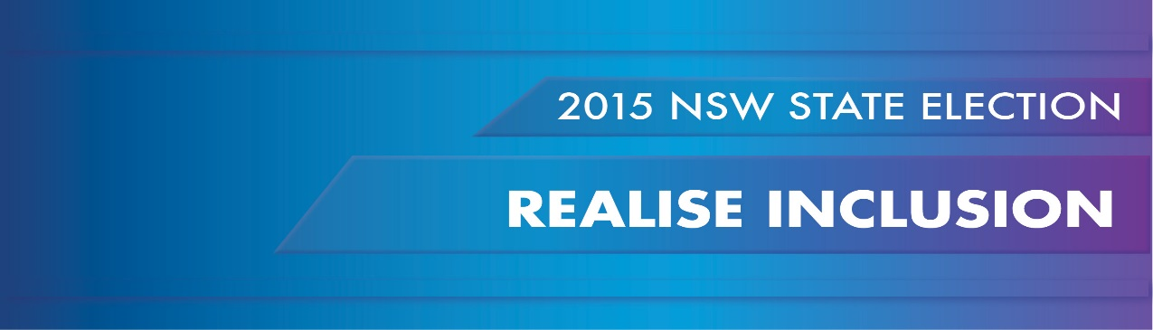
PWDA calls on candidates to prioritise genuine inclusion of people with disability in NSW, through a commitment towards significant resourcing and cross-Government leadership dedicated to the full and timely implementation of the National Disability Strategy in NSW.
THE SITUATION NOW
The next 3 years will be a critical time for the 1.3 million people with disability living in NSW.
The National Disability Insurance Scheme (NDIS) promises to transform the lives of thousands of people with disability in NSW by giving them the choice and control to direct their own supports and services.
However, the vast majority of people with disability in NSW (approximately 85-90%) will not meet the NDIS eligibility criteria for a support package, and the future of the disability services upon which they depend is uncertain.
NSW disability service funding is being transferred to the Commonwealth. Consequently, the services and funding streams provided by the Department of Aging, Disability and Home Care (ADHC) are being wound down, the assets of ADHC are transferring to the non-government sector, and a number of services and supports will likely be provided by ‘for profit’ organisations. In the emerging and unregulated open market for disability supports, it is essential that the needs of all people with disability including those with the most complex requirements are met; that consumers are protected from exploitation, especially the vulnerable and marginalised; that the profit motive does not quash quality, diversity or innovation; and that the new environment serves to enhance rather than threaten the realisation of rights for people with disability.
Disability reform must not focus solely on the NDIS and the market to deliver specialist disability supports. All people with disability in NSW need improved access to mainstream supports and services; an increase in the supply of accessible and affordable housing and public transport; more inclusive education, training and job opportunities; access to participate in community life; and the freedom to live their lives free from violence, abuse and neglect.
Mechanisms to support NSW to achieve this progress and implement the UN Convention on the Rights of Persons with Disabilities (CRPD) already exist in the form of the NSW Disability Inclusion Act (2014), the National Disability Strategy NSW Implementation Plan (2012-2014), the development of the NSW Inclusion Plan and related multi-level, cross-government Action Plans. However, the success of these initiatives requires whole of government coordination and adequate resourcing.
Non-government mechanisms - representative organisations of people with disability, and independent advocacy and independent information services - also remain fundamental to safeguarding people with disability. These services identify system risks and gaps, resolve complex situations across multiple agencies and provide a voice for people with disability to make laws, policies and programs relevant and responsive. Yet, the future and funding of these functions is uncertain.
We are at a critical juncture: realising disability inclusion is the responsibility of all of us – government, non-government, the community and people with disability. We need strong, visionary leadership from Government to inspire and deliver the changes that will make NSW a better place for people with disability wherever they are, whatever they need, every day.
WHAT IS NEEDED
Development of a NSW Human Rights Act. This should incorporate international human rights obligations, including those under the UN Convention on the Rights of Persons with Disabilities (CRPD) and be developed in consultation with the NSW community.
Creation of a ministerial position responsible for Disability Inclusion. This role would lead and oversight disability reform and innovation; act as a disability focal point across government to steer disability inclusion across all levels; champion the rights of people with disability; and take a leadership role at the Council of Australian Governments (COAG) to develop and implement State/Commonwealth initiatives.
Establishment of a dedicated Office for Disability Inclusion. This office should be maintained over the long term to coordinate the resourcing, implementation, monitoring and evaluation of disability policy, strategies and initiatives across Government both during the NDIS transition and into the future. This Office would be responsible to the ministerial position for Disability Inclusion.
The NSW Disability Inclusion Plan, and its monitoring and evaluation framework must directly respond to the six outcome areas of the COAG agreed National Disability Strategy 2010-2020. This will ensure that NSW initiatives reflect the COAG agreed priority areas of reform.
All government agencies need to provide adequate and dedicated resources to their Disability Inclusion Action Plans in order to achieve the full and timely implementation of the NSW Disability Inclusion Plan. Plans must build on existing policies and initiatives; be responsive to changing community needs; outline budget measures; have clear accountability and monitoring frameworks linked to senior staff responsibility and oversight; have effective and accessible feedback and complaints mechanisms, and be informed by people with disability themselves and their representative organisations.
Recurrent funding for representative organisations of people with disability and independent advocacy and independent information services; and growth funding into the future. These functions will not be funded by the NDIS. However, NDIS participants as well as those who are not NDIS eligible will need increasing support to navigate and adapt to the new service environment; government will still require consultation mechanisms to develop and implement effective policy; and independent voices will be needed to ensure that the market for disability supports grows in a way which promotes human rights.

ABS Disability, Ageing and Carers, Australia: New South Wales, 2012 - http://www.abs.gov.au/AUSSTATS/abs@.nsf/DetailsPage/4430.02012?OpenDocument

