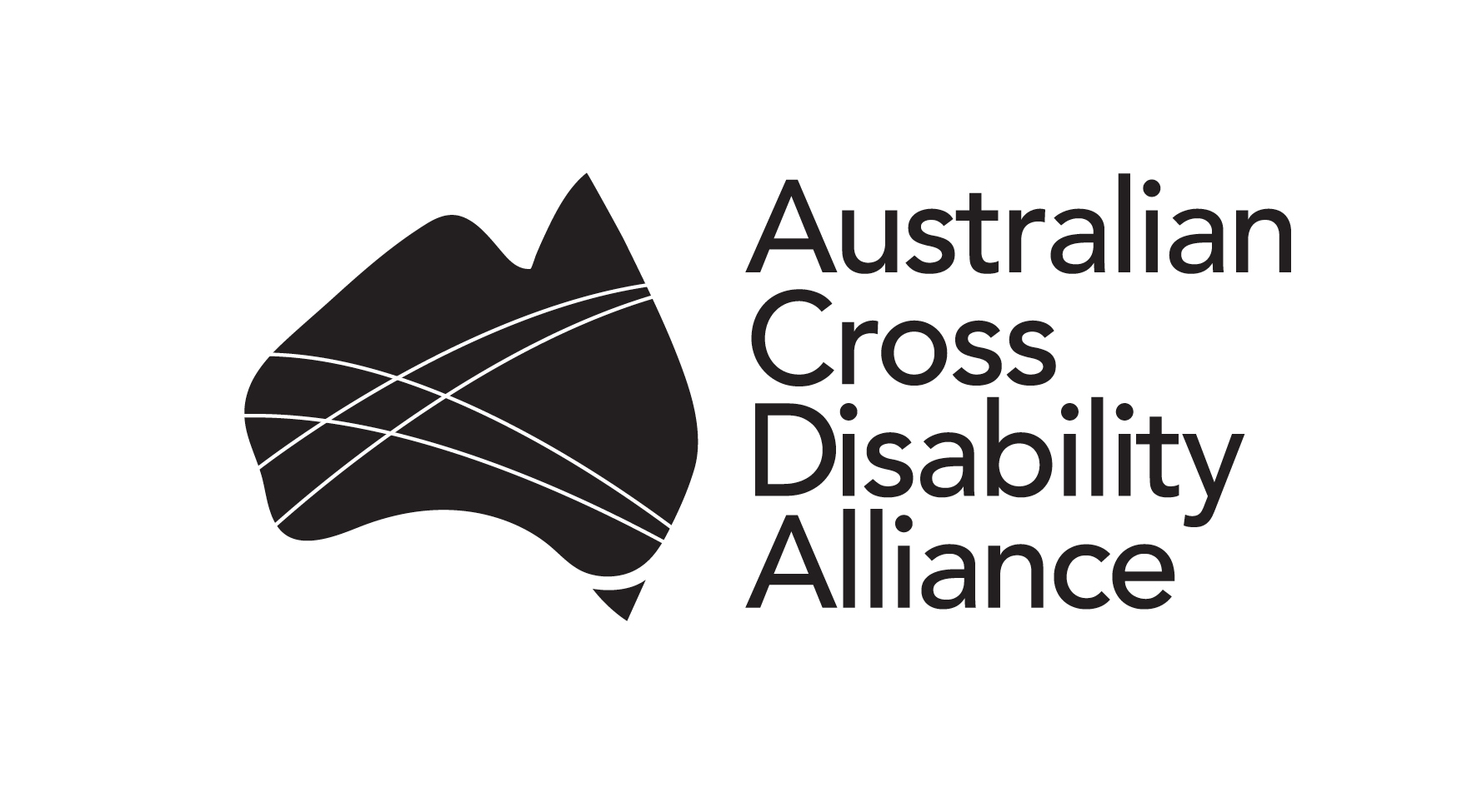
Australian Cross Disability Alliance
PO Box 407
Lenah Valley TASMANIA 7000
E: contact@crossdisabilityalliance.org.au
W: http://crossdisabilityalliance.org.au

Friday 1st April, 2016

Response to Victorian Creating Child Safe Institutions Consultation Paper

The Australian Cross-Disability Alliance (ACDA) thanks the Victorian Government for the opportunity to provide this submission in response to the Victorian Child Safe Institutions Consultation Paper (Consultation Paper).

The ACDA is a coalition of Disabled Peoples Organisations (DPOs), which are organisations made up and led by people with disability. The key purpose of the ACDA is to promote, protect and advance the human rights and freedoms of people with disability in Australia by working collaboratively on areas of shared interests, purposes and strategic priorities and opportunities. The ACDA has been funded by the Australian Government to be the recognised coordinating point between Government/s and other stakeholders, for consultation and engagement with people with disability in Australia.

The ACDA has a specific focus and expertise in the area of violence, abuse and neglect of people with disability, including the specific age, gender, and cultural dimensions of such violence. For the purposes of this submission, we have drawn on our analysis of the impact of the reportable conduct scheme conducted by the NSW Ombudsman, known as the 3A powers. This scheme is referenced throughout the Consultation Paper as the model for the proposed Victorian Reportable Conduct Scheme. Due to time constraints, this submission will focus on the section of the Consultation Paper regarding the Reportable Conduct Scheme.

Overarching comments
In 2014, Australia was horrified to hear that children with disability in a Victorian school had allegedly been locked in a darkened room, and subject to physical ‘restraint’ such a being sat on by teachers. Many of the questions raised following this situation related to oversight: how was it possible that this treatment had become a routine without anyone being notified?. This was not the only instance of inappropriate restrictive practices against children with disability in educational settings reported in the past few years, but it remains emblematic of some of the serious forms of violence that an oversight scheme like a reportable conduct scheme ought to address.

Children with disability have a human right to be protected from all forms of violence (Article 19, Convention on the Rights of the Child and Article 16, Convention on the Rights of Persons with Disabilities). Yet children with disability experience a prevalence of maltreatment 3.4 times higher than other children.

The findings and reports of the NSW Ombudsman regarding the heightened risk for children with disability demonstrates some of the key issues. Recent reports demonstrate that children with disability are substantially overrepresented in substantiated reports to the Reportable Conduct Scheme in NSW. Also alarming is that ‘despite the fact that 29% of notifications which we close involves a child with disability or additional needs, they represent only 6% of all open matters that involve a criminal charge.’

However, there are numerous forms of violence against children with disability which are excluded from the NSW scheme because they happen in institutions that are excluded from the scheme, or because the definition of reportable conduct explicitly or implicitly excludes these forms of violence. Unfortunately, it is far from clear that the locking of children in cages, in cupboards or in rooms is understood to be reportable under the NSW Reportable Conduct Scheme.

The ACDA recommends that the Victorian Reportable Conduct Scheme ensure that children with disability and their experiences of violence are fully included in this scheme by:
- Including disability-specific settings (including those designed primarily for adults)
- Amending the definition of reportable conduct to ensure that all forms of violence against children with disability cannot be excluded
- Ensuring that Claim or Kind Determinations cannot be made to dilute the oversight mechanism
- Understanding a key responsibility of oversight is development of the sector in order to reduce violence against children with disability.
Specific comments
Reach of the scheme
Organisations should be included insofar as they provide services to children, rather than on the basis of how they are funded. Organisations which are designed for adults but are used by children must also be included. Additionally, it must also include all institutions that children with disability are more likely than other children to make use of: respite, day centres, special schools, psychiatric facilities, residential facilities (including those which primarily or only provide services to adults), therapeutic camps, and so on.

Institutions and organisations designed for children with disability have a history of being far more ‘closed’ in how they function than other institutions. There is strictly limited community oversight, and this can mean that behaviours and the treatment of children with disability within these settings does not live up to community standards. Indeed, in some circumstances, behaviour towards or treatment of children with disability can become neglectful or even violent, perhaps without staff noticing. Thus it is particularly important that these settings are included.

Defining ‘Reportable Conduct’

Given that the Consultation paper utilises a definition that aligns with the NSW Reportable Conduct Scheme, it is important to understand how the NSW Scheme functions to exclude some forms of violence against children with disability from oversight.

The first exception to the definition in the NSW Scheme is: 'conduct that is reasonable for the purposes of the discipline, management or care of children, having regard to the age, maturity, health or other characteristics of the children and to any relevant codes of conduct or professional standards.' Unfortunately, disability is frequently interpreted as one of these 'other characteristics of the children'.

Additionally, many settings understand violence against children with disability as ‘reasonable’ in line with this definition even when they fail to implement strategies that support a child to manage the complex demands of being in a service provision setting with others. Violence may become construed as ‘reasonable’ as a response to behaviour that is avoidable with proper supports. In many cases, the setting has been provided with detail about such strategies by parents or other professionals.

This is often the background to an instance of violence against a child. A child with autism, for example, might become overstimulated and react violently, with a teacher then responding violently in turn. The use of what is euphemistically called 'physical restraint' often involves behaviour that would count as physical violence if a child without disability were subject to it. However, because this conduct is interpreted as ‘reasonable for the purposes of discipline, management or care of children,’ it may not be reported. Indeed, in
NSW, such behaviours in schools are routinely considered reasonable and in line with professional conduct and thus not reported to the Ombudsman. This situation, however, would have been entirely manageable in a non-violent way, had the child received proper forms of support.

The NSW Scheme effectively allows certain organisations to assess whether or not a particular form of conduct is ‘reportable’. This can undermine the oversight function granted to the Ombudsman in these circumstances. For example in NSW, decisions about whether certain behaviour is reportable conduct is made by the Employee Performance and Conduct Directorate within the Department of Education and Training. As a result, the Department of Education's perspective on whether or not a particular behaviour is reasonable for the care of other children may preclude particular instances of violence against children with disability from even reaching the Ombudsman. In other words, the exception in the legislation tends to collude with potential reporters' failures to recognise violence against children with disability as violence.

Class or Kind Determinations
Under the NSW Scheme, a ‘Class or Kind Determination’ was made with schools which has provided guidance regarding reportable conduct and agreed that some forms of conduct need not be reported to the Ombudsman. This Determination has been identified as key to enabling schools to comply with the Reportable Conduct Scheme by reducing the ‘onerous’ demands it makes on schools. It has been presented as essential to the successful compliance of schools with the Scheme.

The ‘Class or Kind Determination’ made with schools, however, has also provided greater specificity about and narrowing of the definition of reportable conduct:
The amendments also make it clear that employees, particularly teachers, can take reasonable action to exercise effective classroom management and discipline. This includes actions such as reasonably restraining a student for the safety of that student or others, comforting a distressed student or raising their voices to restore order with a group of students.

This clearly may exclude some of the forms of violence a child with disability may experience in school.

In addition to the exception described above, the Class or Kind Determination excludes from ‘reportable conduct’:
‘using reasonable force to:
- Disarm a child seeking to harm themself or another; or
- Separate children in the act of fighting; or
- Move a child away from a place where the person may be harmed; or
- Restrain a child from causing intentional damage to property.’

The exclusion of these forms of conduct from being reported can collude with the ongoing failure to understand that these form of ‘reasonable force’ can constitute violence against children with disability.

The creation of this scheme is the perfect opportunity to address issues in professional practice which may not be criminal but may result in other forms of harm, especially if these strategies are ongoing. These problems substantially affect children with disability. The scheme must be designed to protect against breaches of human rights, such as the solitary confinement evidenced in the ‘child in the cage’ incident.

Developing responses to children with disability
For children with disability to be safe, institutional settings must have good understandings of disability, of the heightened risk of violence that children with disability are at, and how to respond to both. This, however, is rare in most service settings. A Reportable Conduct scheme should be designed to maximise sector development in relation to disability. This means that the scheme must intervene in, and not inadvertently support misperceptions about disability or double-standards regarding acceptable conduct towards children with disability. The scheme should improve policy and practice with respect to children with disability, ensuring that children with disability are provided with the support they need, and not subject to violence. For this reason, the proposed scheme would be well-served to operate with a broader understanding (even if similar formal definition) of ‘reportable conduct’ than informs the NSW Scheme.

In NSW, the Scheme operates in service settings that often do not have positive records of recognising and responding appropriately to disability. There is, in general, a poor understanding of disability and impairment in our society. In many cases, a disability or a support need will not be recognised or fulfilled without a formal diagnosis of impairment. A child with disability may instead be understood as recalcitrant, as refusing to comply, or as having 'challenging behaviour'. Alternately, where a diagnosis has been made, it may be used to ‘explain away’ distress, leading to the dismissal of the cues that reportable conduct may have occurred.
A child with disability was at an out of school hours (OOSH) centre held in a building on school grounds. When her mother arrived to pick her up, she was told that her daughter had ‘had a temper tantrum’ and refused to move. This sounded very unlike her child, and on investigation, the mother found that actually her daughter couldn’t move her legs. When she was taken to the hospital, it was found that her hip was broken.
The mother was then investigated by Child Protection due to an unexplained injury. Eventually, with much advocacy from the mother and the child’s advocates, a Department of Education and Training interview with the centre staff found that there were compliance issues on the part of the OOSH centre specifically in documenting and reporting the incident. Eventually, the OOSH centre was compelled to undertake an investigation, and found no wrongdoing. The NSW Ombudsman’s investigations similarly found that there was no available evidence of wrongdoing on the Centre’s part. Essentially, as no one documented this incident, there was no trail to follow. And the characterisation of the child as ‘having a temper tantrum’ when it is likely that she was in severe pain exemplifies the way that disability can be used to dismiss signs of reportable conduct.

Other important outcomes for children with disability
Perhaps one of the most important benefits of the NSW Reportable Conduct Scheme has been to provide some data about violence and other inappropriate behaviours against children with disability. This data is extremely rare, especially given that crimes data does not disaggregate by disability.

Additionally, the data from the Reportable Conduct Scheme in NSW has demonstrated that – even with the issues outlined above with respect to exceptions, Determinations and the limited reach – children with disability experience a very disproportionate rate of violence. It also demonstrates that violence against children with disability only very rarely results in criminal charges. The formulation of the Victorian Reportable Conduct Scheme should draw on these learnings, and seek to develop a mechanism that will ensure that children with disability are provided with the same protections as other children. It should be designed to ensure capture of those experiences of violence which are often excluded by other services such as the police.

We would be pleased to provide further assistance with the development of the Victorian Reportable Conduct Scheme if required. Please contact Dr Jessica Cadwallader, Advocacy Projects Manager, Violence Prevention on jessc@pwd.org.au or (03) 9267 3717.

Yours sincerely

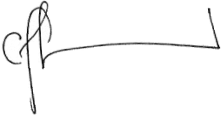  Carolyn Frohmader  Executive Director  Women With Disabilities Australia (WWDA) | 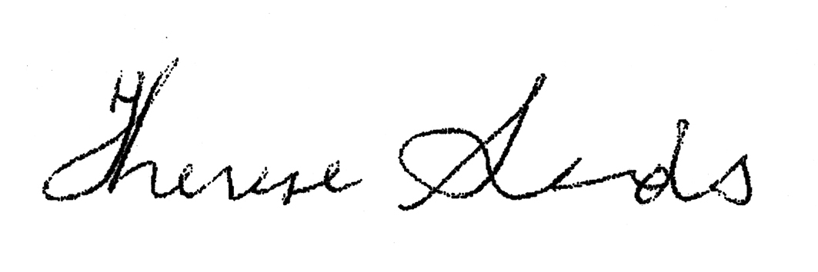  Co-Chief Executive Officer  People with Disability Australia (PWDA) | 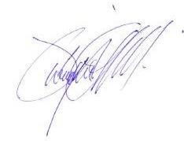  Dwayne Cranfield  Chief Executive Officer  National Ethnic Disability Alliance (NEDA) | 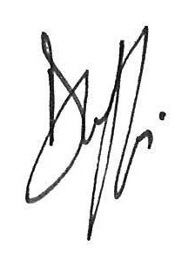  Damian Griffis  Chief Executive Officer  First People’s Disability Network Australia (FPDN)

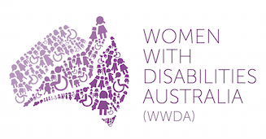 | 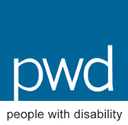

ACDA comprises First People’s Disability Network (FPDN), National Ethnic Disability Alliance (NEDA), People with Disability Australia (PWDA) and Women With Disabilities Australia (WWDA).
Elissa Doherty, ‘School locked autistic children in dark room, parents claim’ 18 May 2014, The Herald Sun available at: http://www.heraldsun.com.au/news/victoria/school-locked-autistic-children-in-dark-room-parents-claim/story-fni0fit3-1226921952506
Sally Robinson (2012), ‘Enabling and protecting: Proactive approaches to addressing the abuse and neglect of children and young people with disability,’ Children with Disability Australia.
NSW Ombudsman, ‘Data – disability’ at the NSW Reportable Conduct Forum 2016. https://www.ombo.nsw.gov.au/__data/assets/pdf_file/0017/31760/Data-disability.pdf
NSW Department of Education and Training (2004), ‘Responding to Allegations against Employees in the Area of Child Protection’ available at http://www.dec.nsw.gov.au/detresources/pd04_08_alleg_childprot_Mk2_GSPuJAJdZT.pdf
Class or Kind Determination by the NSW Ombudsman under section 25CA of the Ombudsman Act 1974 concerning the Association of Independent Schools of NSW Limited and its member schools (2012) available at https://www.aisnsw.edu.au/Services/ChildProtection/Documents/Class%20or%20Kind%20Determination%20(2012).pdf

