Cuts to Transport Support Opposed by National Disability Groups
Joint Statement by the Disability and Community Sector

CALL FOR SENATE TO BLOCK THE MOBILITY ALLOWANCE BILL
We are a diverse partnership of representative organisations of people with disability, disability advocacy organisations, disability services and disability peak bodies that have come together to call on Federal Senators to block the Mobility Allowance Bill that is currently before the Senate. If passed, this Bill will:

- Reduce transport support for people with disability;
- Increase social isolation and reduce the ability for people with disability to contribute to the community;
- Create further barriers to economic participation for people with disability, at a time when there are increasing obligations upon them to find and keep work;
- Exacerbate the already considerable costs involved for people with disability entering or re-entering the workforce. These additional costs can outweigh the economic benefits of having a job, and be a disincentive to looking for work.

The Social Services Legislation Amendment (Transition Mobility Allowance to the National Disability Insurance Scheme) Bill 2016 will restrict access to essential transport funding to only those eligible for the National Disability Insurance Scheme (NDIS). There are approximately two million people with disability of working age, but only 460,000 will be transiting to the NDIS, This means that this Bill will impact many thousands of people with disability who will not have access to the NDIS, including people over the age of 65. The Bill has been to the Senate Community Affairs Committee, where people with disability gave extensive evidence about the problems with the legislation, which was ignored by the Government.

People with disability face significant barriers to accessing transport, which can limit their ability to work, participate in education or other community and economic activities. The current Mobility Allowance is already inadequate to cover the full cost of transport for many people. This Bill will make things much harder, with very little savings for the Government.

The Mobility Allowance goes some way to address the additional expense of higher transport costs for people with disability unable to access public transport and who are forced to rely on taxis or private vehicle to get to work. Any cuts to the Mobility Allowance will impact the capacity of many people to seek and retain employment and volunteering opportunities. This is exactly the opposite of what the NDIS is trying to achieve! The Mobility Allowance needs to be maintained as an income support for those people with disability who cannot participate in the NDIS.

Collectively, our organisations are deeply concerned that the Federal Government proposal to cut Mobility Allowance to those unable to access the NDIS sets a precedent, cutting essential supports that should be available for all people with disability across Australia.

We are calling on Senators to vote NO to the Bill to make sure all people with disability can continue to access the transport they need for full community and economic participation.

This Joint Statement is supported by:
- Australian Blindness Forum
- Blind Citizens Australia
- Capricorn Citizen Advocacy
- Children and Youth with Disability Australia
- Council for Intellectual Disability NSW
- Disability Advocacy Network Australia
- Disabled People’s Organisations Australia
- First Peoples Disability Network of Australia
- Guide Dogs Australia
- Guide Dogs Victoria
- Independent Advocacy Townsville
- Macular Disease Foundation Australia
- Melbourne East Disability Advocacy
- National Ethnic Disability Alliance
- National Social Security Rights Network
- NSW Council of Social Service
- ParaQuad NSW
- Physical Disability Council of NSW
- People with Disability Australia
- People with Disabilities Western Australia
- Queensland Advocacy Inc.
- Retina Australia
- Royal Australian and New Zealand College of Ophthalmologists
- Spinal Cord Injuries Australia
- The Royal Society for the Blind
- VisAbility
- Vision Australia
- Vision 2020 Australia
- Women with Disabilities Australia
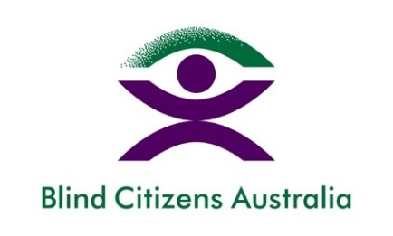
Australian Blindness Forum |  | Blind Citizens Australia (BCA)
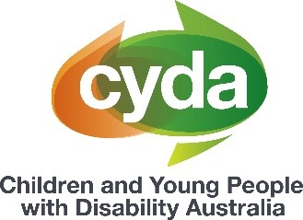
Capricorn Citizen Advocacy |  | Children and Youth with Disability Australia

Council for Intellectual Disability NSW |  | Disability Advocacy Network Australia (DANA)

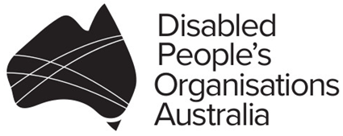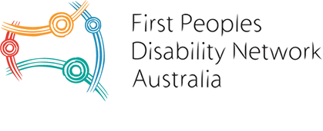
Disabled People’s Organisations Australia |  | First People Disability Network
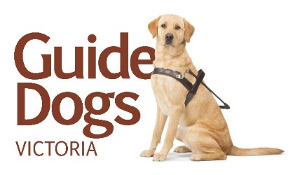
Guide Dogs Australia |  | Guide Dogs Victoria

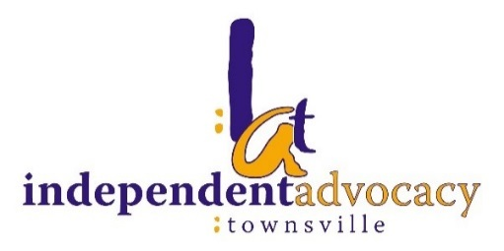
Independent Advocacy Townsville |  | Macular Disease Foundation Australia
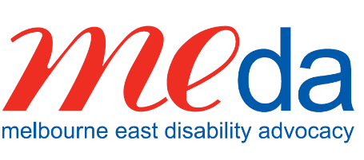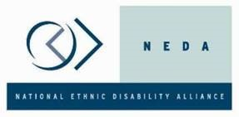
Melbourne East Disability Advocacy (MEDA) |  | National Ethnic Disability Alliance (NEDA)
National Social Security Rights Network |  | NSW Council of Social Service
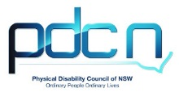
ParaQuad NSW | Physical Disability Council of NSW
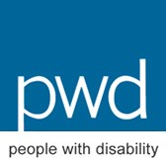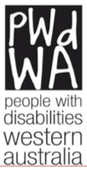
People with Disability Australia |  | People with Disabilities Western Australia
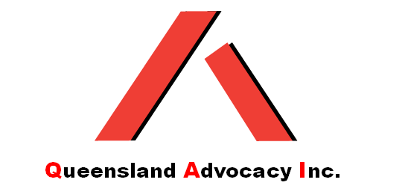
Queensland Advocacy Inc. |  | Retina Australia
Royal Australian and New Zealand College of Ophthalmologists |  | Spinal Cord Injuries Australia
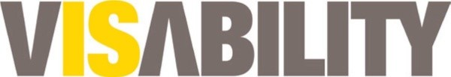
The Royal Society for the Blind |  | VisAbility

Vision Australia |  | Vision 2020 Australia
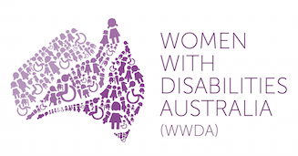
Women with Disabilities Australia

