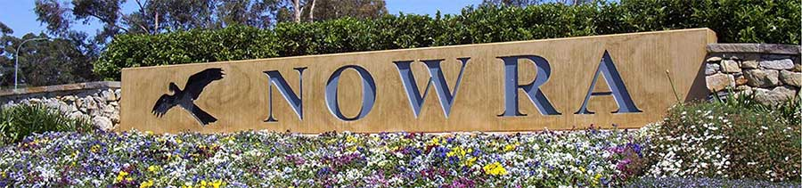 | Do you live in Nowra?
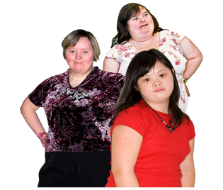 | Are you a woman with a learning disability?
 | Do you want to learn about relationships?
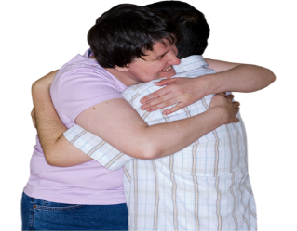 | Do you want to learn about sex and relationships?
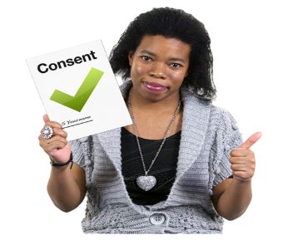 | Do you want to learn more about your body and what is ok?
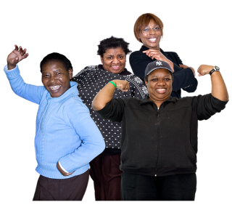 | Do you want to meet and make friends with other women?
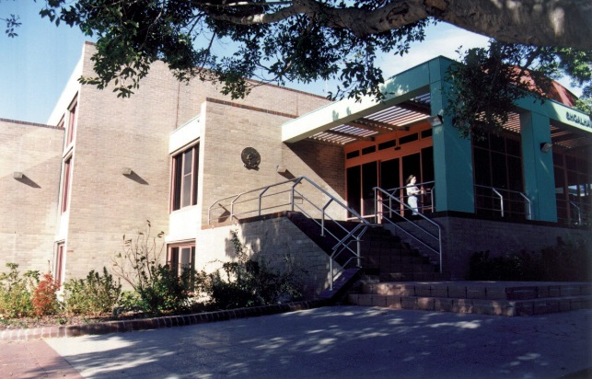 | We will meet at Nowra Library on Thursday’s

Call Polly on 9370 3100 or on 0434 692 845 if you want to come to the lessons.

Polly is here to help.

