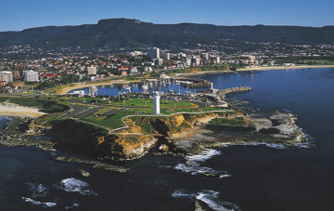 | Do you live in the Illawarra?
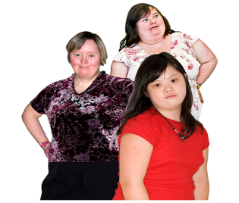 | Are you a woman with a learning disability?
 | Do you want to learn about relationships?
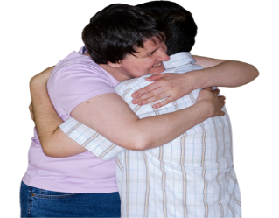 | Do you want to learn about sex and relationships?
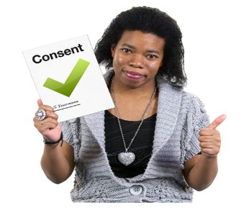 | Do you want to learn more about your body and what is ok?
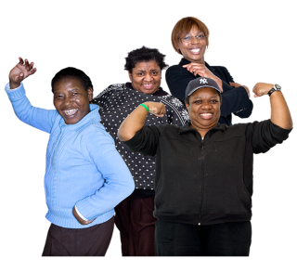 | Do you want to meet and make friends with other women?
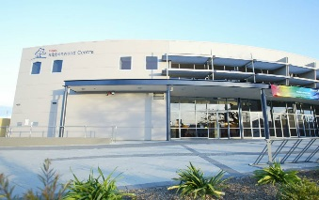 | We will meet at Dapto Ribbonwood Centre on Wednesdays

Call Polly on 9370 3100 or on 0434 692 845 if you want to come to the lessons.

Polly is here to help.

