People with disability have a right to be included and heard in NSW. We have rights to representation, advocacy, and support. We have the right to decide our futures. Yet our rights are under threat, and decisions are still being made for us. The NSW Government can change this.

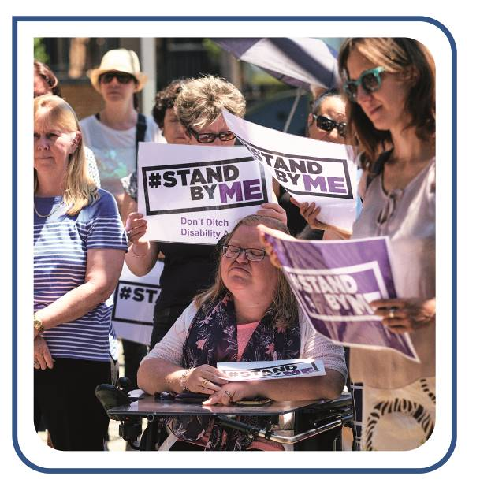
What people with disability are facing now
There are nearly 1.4 million people with disability living in NSW. At full implementation, the National Disability Insurance Scheme (NDIS) is estimated to provide support to 140,000 people with disability in NSW. While the NDIS seeks to transform the lives of thousands of people with disability by giving them the choice and control to direct their own supports, the reality is that only 10% of people with disability in NSW will be eligible for an NDIS package. The NSW Government has responsibility for all people with disability living in NSW, including the 90% of us who are not part of the NDIS.
With the closure of the NSW Department of Family and Community Services, Ageing, Disability and Home Care and the transfer of funding to the NDIS, many of us, ‘the other 90%’, are facing difficulties accessing the services and supports we need. Mainstream supports and services, such as health, education and transport, are not always inclusive and accessible to us and private support services are costly for those of us on low incomes. Many of us find we are going without the services and supports we need.
Representative organisations of people with disability, along with independent advocacy and information services also have a vital role to play for people with disability in NSW. They help us have our voices heard both for the individual issues we are facing on a day-to-day basis as well as contributing our experiences and solutions to the NSW policies and programs that affect our lives. However, the future of advocacy and representative organisations is uncertain as NSW Government funding commitments are not guaranteed beyond 2020, with some services set to lose funding in 2019.
There is a long way to go before we have a truly inclusive and accessible community, and some of the ways that the NSW Government is currently committed to this include:
- The United Nations Convention on the Rights of Persons with Disabilities (CRPD)
- Coalition of Australian Governments’ (COAG) National Disability Agreement (NDA)
- COAG’s National Disability Strategy (NDS)
- NSW Disability Inclusion Act 2014
- NSW Disability Inclusion Plan, and
- Oversight of all NSW Government Department, Agency and Local Council Disability Inclusion Action Plans.
NSW Government leadership is required to meet these commitments.

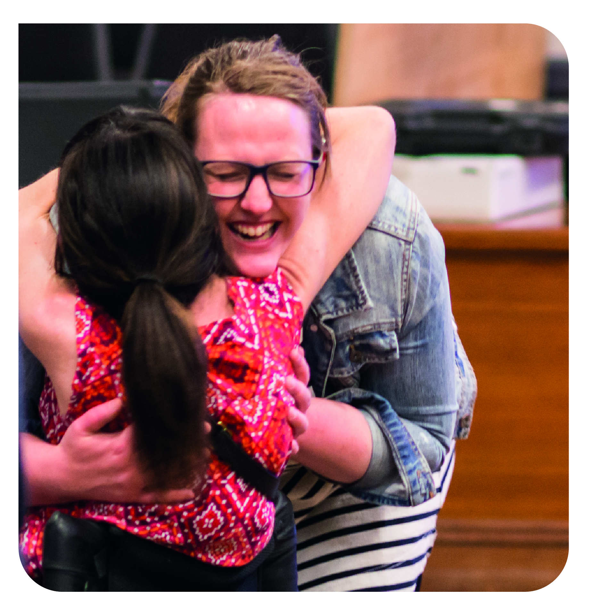
What the NSW Government can do to make a difference
Establish a Minister for Disability Inclusion. The NSW Government has obligations and responsibilities to invest in services and infrastructure that deliver positive change for people with disability and realise the goal of disability inclusion. It is time for the NSW Government to establish a Minister for Disability Inclusion to lead this change. A Minister for Disability Inclusion should be responsible for:
- implementing the NSW Disability Inclusion Plan across government
- overseeing and co-ordinating funding arrangements for delivery on Disability Inclusion Action Plans within NSW Government departments, agencies and local government
- co-ordinating and reporting on progress under legislation, COAG agreements and state-wide disability strategies and plans
- leading inter-jurisdictional negotiations in relation to improvements to the NDIS, NDA and NDS
- funding and resourcing representative peak organisations of people with disability, independent advocacy and independent information services
- overseeing the inclusiveness and accessibility of major government projects (for example, public transport upgrades).

Invest in ongoing funding for representative organisations of people with disability, independent advocacy and independent information services, so that our voices are heard. The Government must recognise the value of an inclusive NSW by committing to ongoing funding for representation, independent disability advocacy, and independent information services in NSW, as advocated by the NSW Disability Advocacy Alliance’s Stand By Me campaign.
Establish a NSW Government provider of last resort. The NSW Government must re-establish necessary disability support roles as a provider of last resort. A provider of last resort will enable people to access supports where there may be limited numbers of service providers, such as in rural, regional or remote communities, or where supports are urgently needed due to a change in person’s circumstances or in a crisis situation.
Establish an Office of the Public Advocate. Following the NSW Law Reform Commission’s Review of the Guardianship Act 1987 (NSW), the NSW Government must implement changes to the Guardianship Act to deliver on supported decision-making and establish the Office of the Public Advocate, independent of the Office of the Public Guardian. A standalone Public Advocate would play a key role in driving supported decision-making processes as well as having powers to investigate cases of potential abuse, neglect and exploitation.
Close the gaps on access to early intervention support for children. The early years represent a vital time in a child’s growth and development. Access to early intervention services can make a significant difference for children with disability or children who may be experiencing developmental delays. Despite the introduction of the Early Childhood Early Intervention Approach under the NDIS, too many children and their families are missing out on vital services at the time when they need them most. The NSW Government must develop an integrated state-wide early intervention program to ensure that all children from birth and into their early school years receive the services and supports they need.
Develop a NSW Human Rights Act. Other states and territories, such as Queensland, Victoria and the ACT, have created human rights legislation. It is time for NSW to do the same. This should incorporate meeting international human rights obligations, including those under the CRPD, and be developed in consultation with the NSW community.
For more information please contact:
Romola Hollywood, Director Policy and Advocacy
0431 998 273 romolah@pwd.org.au

According to Australian Bureau of Statistics Disability, Ageing and Carers, Australia: Summary of Findings, 2015, 1.3724 million people with disability are living in NSW. Australian Bureau of Statistics. Disability, Ageing and Carers, Australia: Summary of Findings, 2015, Data Cube: New South Wales, 2018. http://www.abs.gov.au/AUSSTATS/abs@.nsf/DetailsPage/4430.02015?OpenDocument#Data Released 12/01/2017
NSW Government. About the NDIS in New South Wales, https://ndis.nsw.gov.au/about-ndis-nsw/
PWDA. Realising the State of Inclusion: The role of the NSW Government for people with disability, 2018, 25, https://www.parliament.nsw.gov.au/lcdocs/submissions/61696/0329%20People%20with%20Disability%20Australia.pdf
Ibid., 25.
New South Wales Law Reform Commission. Review of the Guardianship Act 1987, May 2018, Report 145, 206, https://www.lawreform.justice.nsw.gov.au/Documents/Currentprojects/Guardianship/Report/Report%20145.pdf
Ibid.
Joint Standing Committee on the National Disability Insurance Scheme. Provision of services under the NDIS Early Childhood Early Intervention Approach, xiii–xv, https://www.aph.gov.au/Parliamentary_Business/Committees/Joint/National_Disability_Insurance_Scheme/EarlyChildhood/Report

