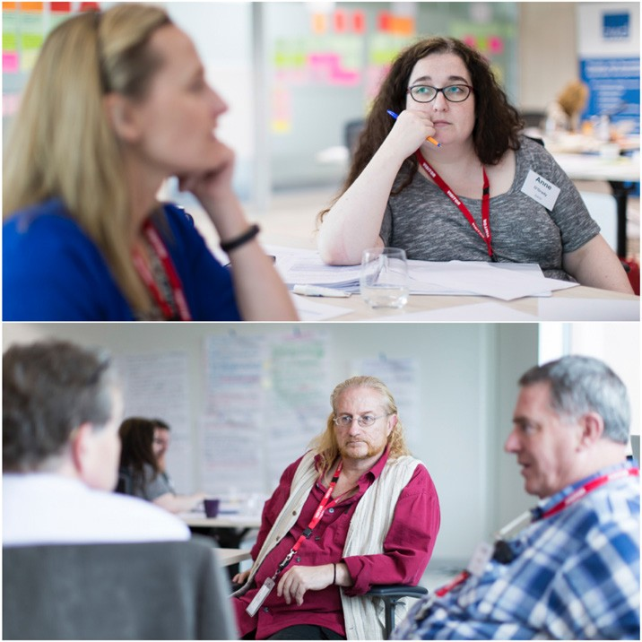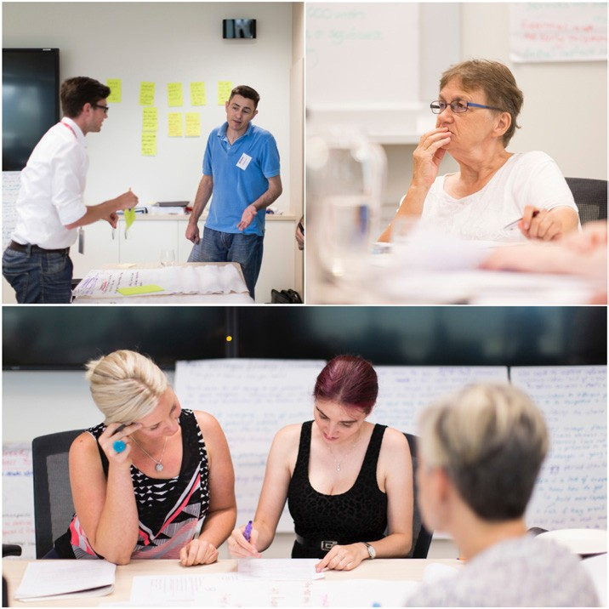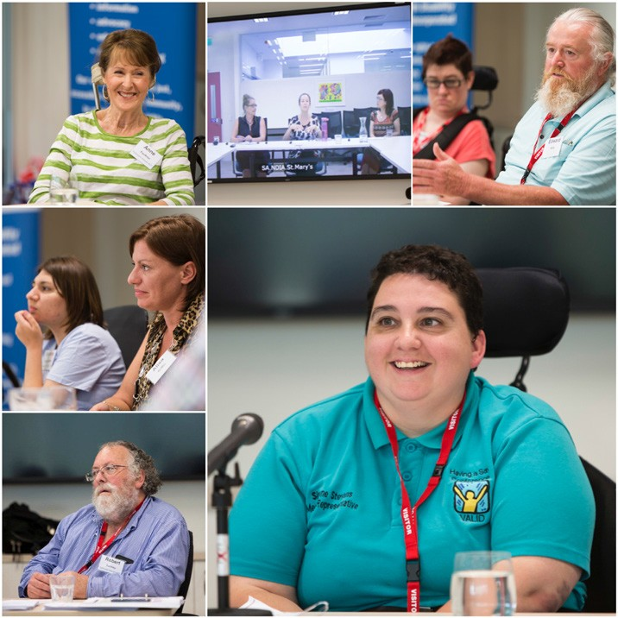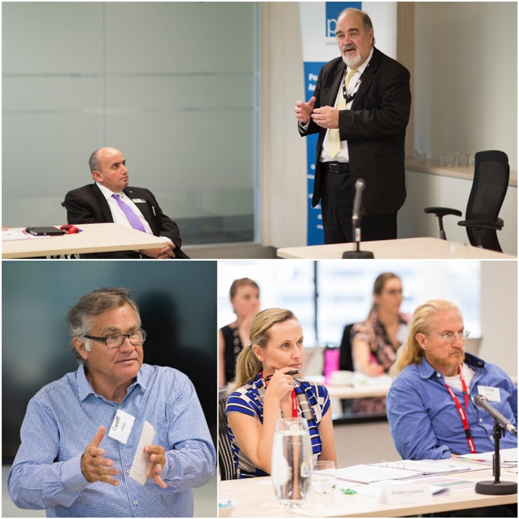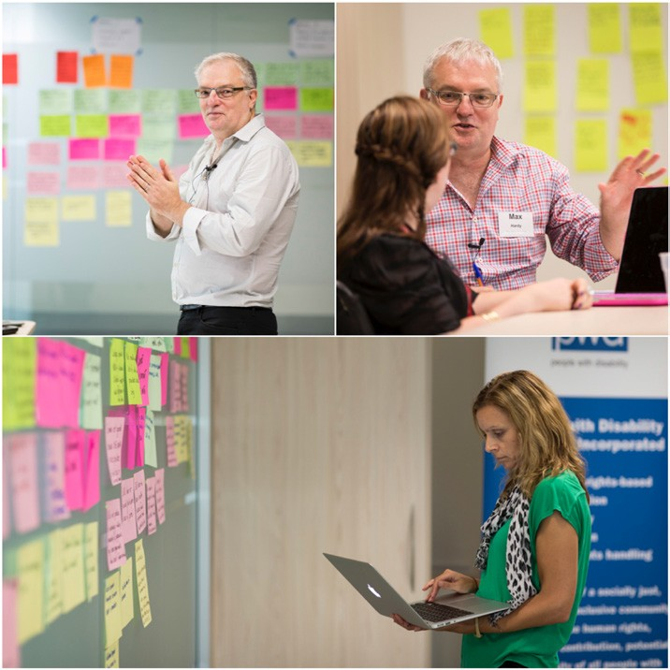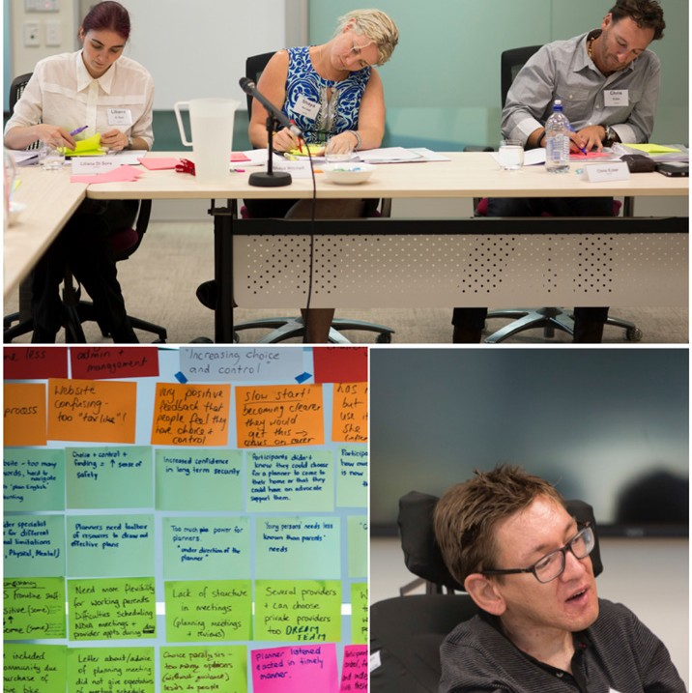National Disability Insurance Scheme Citizens’ Jury Scorecard
for the
National Disability Insurance Agency
and
People with Disability Australia

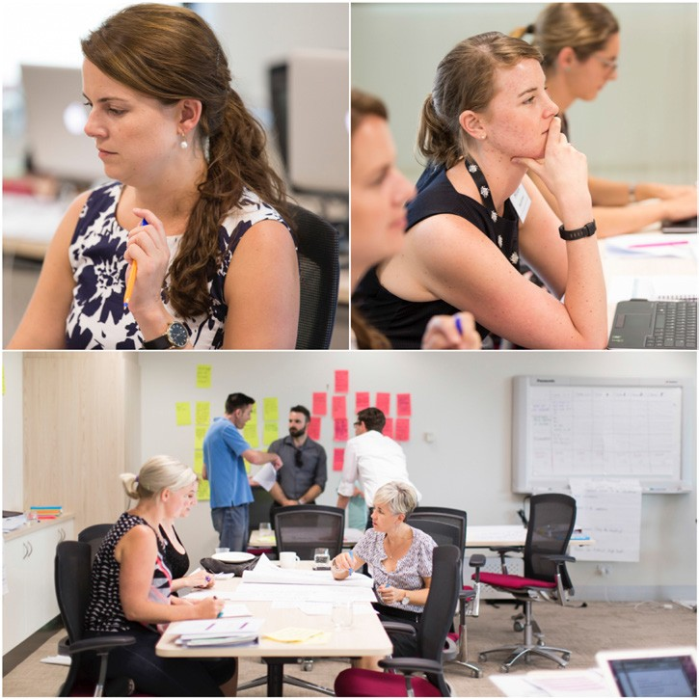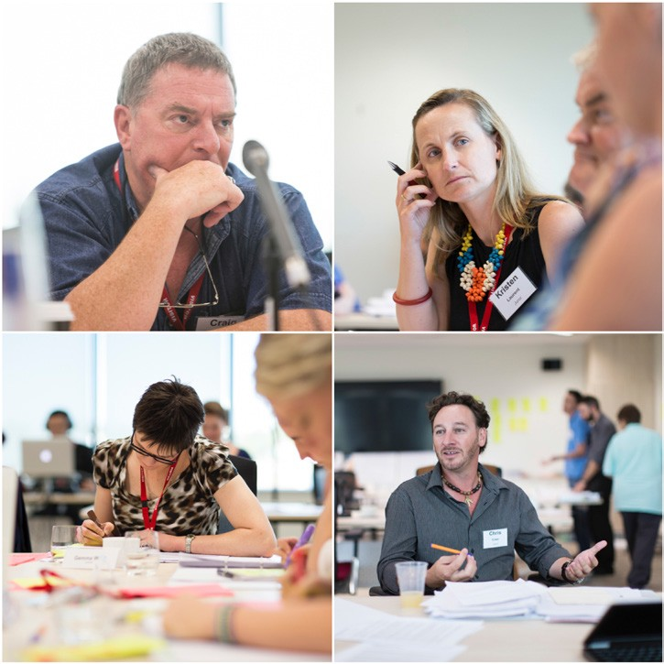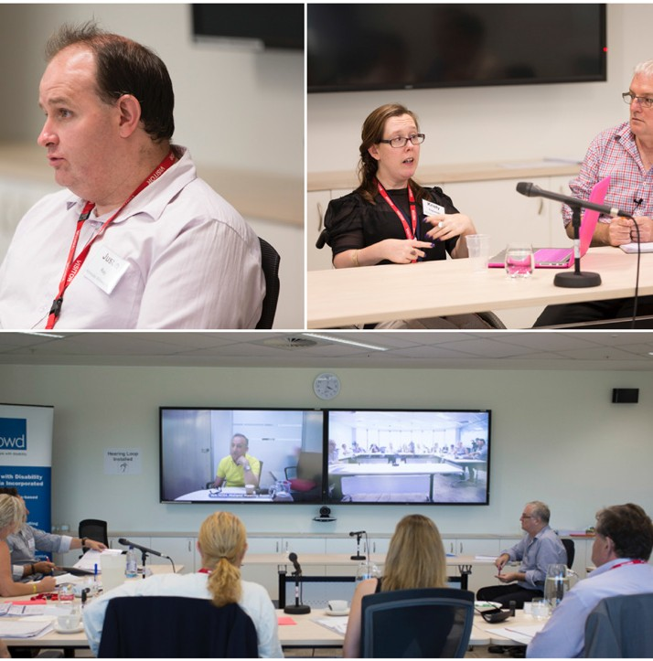

Published by: People with Disability Australia Inc,
Tower 1, Lvl 10, 1 Lawson Square, Redfern NSW 2016 Australia. May 2015.

Contact us:
Phone: 02 9370 3100
Toll Free: 1800 422 015
Fax: 02 9318 1372
TTY: 02 9318 2138
TTY Toll Free: 1800 422 016
Email: pwd@pwd.org.au Website: www.pwd.org.au

Disclaimer: The information outlined from Section 5 - Citizens' Jury Scorecard represents the views of the twelve jurors of the National Disability Insurance Scheme (NDIS) Citizens' Jury.

©People with Disability Australia (PWDA) Incorporated 2015. This publication is copyright. No part of it may be reproduced by any process without permission from PWDA, or in accordance with the Copyright Act 1968. On request PWDA may give permission for this material to be reproduced, provided it is for a purpose consistent with the project aims and PWDA is acknowledged as the source.

Accessible formats: This document is available for downloading from our website at www.pwd.org.au in PDF and Word. Please contact PWDA is you require other accessible formats.

ISBN: 978-0-9807364-4-1

Photography Credit to Claudio Raschella for photographic images used throughout this report.

Title Page: Top Image - Jurors, Liliana Di Sora, Shaya Mitchell, Chris Ecker. Right: Juror Postit note summaries. Left: Participant witness Tom Dow.

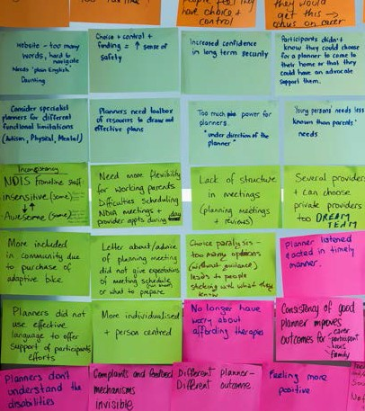

National Disability Insurance Scheme
Citizens’ Jury Scorecard
for the
National Disability Insurance Agency
and
People with Disability Australia

17th - 20th February 2015

Table of Contents

Project Overview ...................................................................................................................................... 5

1. Project introduction.................................................................................................................. 5

2. The jury and their role .............................................................................................................. 6

3. Project background.................................................................................................................. 8

3.1. Project aims .............................................................................................................................. 8

3.2. How the project was conducted............................................................................................... 8

4. Project model and its components........................................................................................... 9

4.1. Jury process .............................................................................................................................. 9

4.2. Juror and participant witness recruitment ............................................................................... 9

4.3. The participant witness ............................................................................................................ 10

4.4. Advocate witness...................................................................................................................... 11

4.5. Additional evidence and testimony .......................................................................................... 12

4.6. Documentary record................................................................................................................. 13

Citizens’ Jury Scorecard ............................................................................................................................ 15

5. Executive summary.................................................................................................................. 15

6. Comments about the jury process and selection of witnesses ................................................ 17 7. Overarching NDIS successes ..................................................................................................... 19
7.1. Inclusivity.................................................................................................................................. 19

7.2. Choice and control.................................................................................................................... 19

7.3. Sense of security....................................................................................................................... 20

7.4. Improved options through funding with a long-term vision .................................................... 20

- Successes, issues and concerns related to the Productivity Commission’s themes ................. 21

  - Themes 1 & 2 ‘Putting people at the centre and increasing choice and control’ ..................... 22 8.1.1. Successes.................................................................................................................................. 22 8.1.2. Recommendations.................................................................................................................... 23

  - Themes 3 & 4 ‘Improving portability and reducing fragmentation’ 28
    - Successes 28
    - Recommendations 29
  - Theme 5 ‘Uniform understanding of the scheme’ 32
    - Successes 32
    - Recommendations 32
  - Theme 6 ‘Addressing unmet needs’ 40
    - Successes 40
    - Recommendations 41
  - Theme 7 ‘Community support, linkages and referrals’ 45
    - Successes 45
    - Recommendations 45
  - Theme 8 ‘Meeting the goals of greater economic and social inclusion for people
with disability’ 48
    - Successes: 48
    - Recommendations 49
Appendix 1 - Glossary of project terms 52
Appendix 2 - Acknowledgements 54

Project Overview

Project introduction

The National Disability Insurance Scheme (NDIS) Citizens’ Jury Scorecard Project was an innovative project led by People with Disability Australia (PWDA) in collaboration with Max Hardy Consulting, with the support of the National Disability Insurance Agency (NDIA) between September 2014 and May 2015.
The NDIS Scorecard Project’s objective was to provide the Australian community with the first user led evaluation of the NDIS. Its intention was to use a citizens’ jury and a process known as deliberative democracy to involve both Australian citizens who have helped fund the NDIS and those who have direct knowledge of it as participants, to evaluate the progress of the staged rollout of the NDIS through six of its trial sites.
The citizens’ jury process is recognised globally as an effective engagement mechanism, which not only involves experts with key knowledge and experience but also the wider community in a
participatory process of deliberation and feedback. In this way, the citizens’ jury provides an honest and balanced scorecard based on direct evidence to the Australian community about how their taxes are being used and the development of important policy reform.
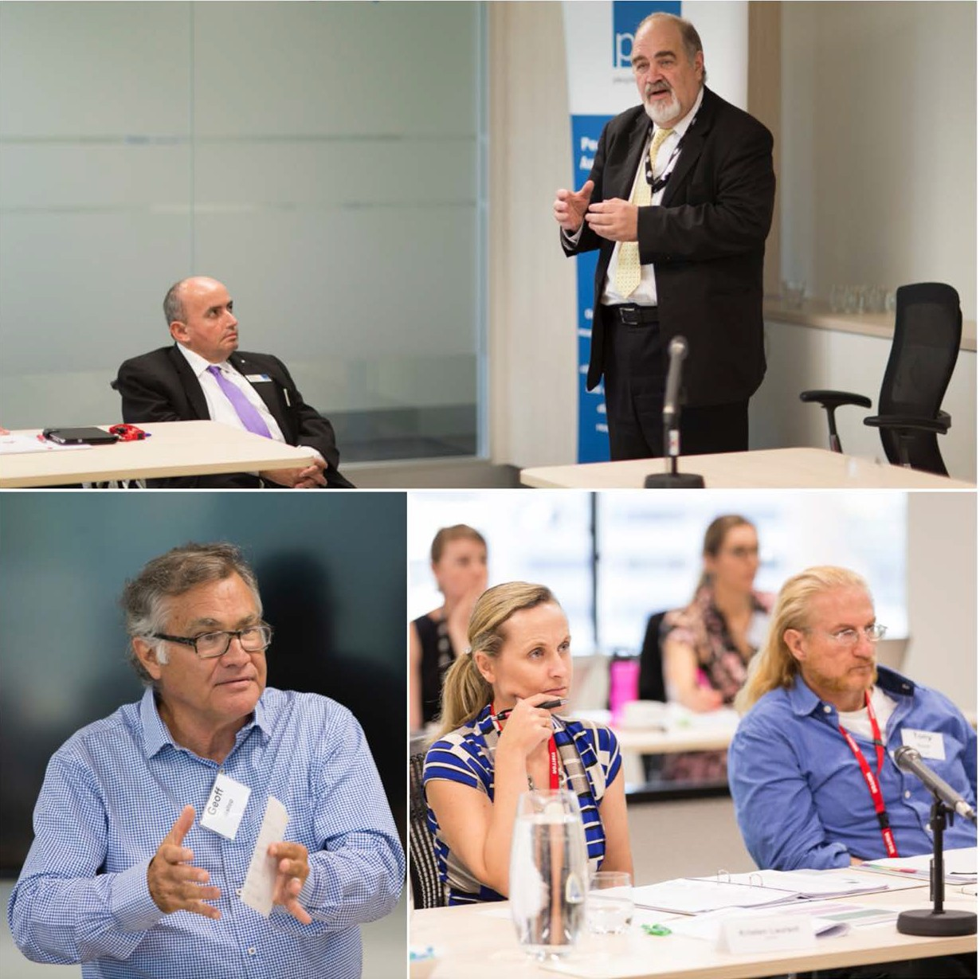This citizens’ jury scorecard presents the findings of the jury including a series of recommendations aimed at enhancing the future roll out of the NDIS. It has been compiled by the 12 member jury, with the assistance of the citizens’ jury facilitators Max Hardy Consulting following a three and a half day ‘trial’ held in Sydney from
17 February – 20 February 2015.
Following a commitment from the Chief Executive Officer of the NDIA this report will be passed on to the Australian Prime Minister, every Chief Minister and Premier, each member of Parliament in every jurisdiction hosting a NDIA trial site, as well as the Joint Standing Committee on the NDIS, and the NDIA Board, with the intention of influencing an improved rollout of the NDIS.

The scorecard adds a valuable segment of evidence to the body of work coming from consultants,
NDIA’s reports and the report from the Joint Standing Committee on the NDIS.

Top image - David Bowen, Chief Executive Officer, NDIA and Craig Wallace, President, PWDA. Right: Professor Geoff Gallop opens event. Left: Jurors – Kristen Laurent and Tony Guyot.

The jury and their role

Members of the citizens’ jury:

Liliana Di Sora Chris Ecker Aidan Greenrod

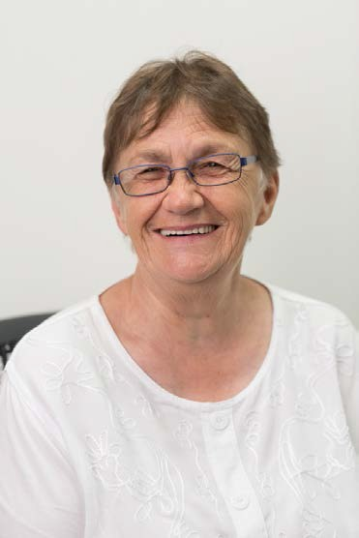

Tony Guyot Craig Hughes Lorraine Hughes

Kristen Laurent Shaya Mitchell Anne O’Grady

Michael Steeth Darcy Treloar Gemma West

Twelve Australians, including people with disability, were randomly selected to serve as non-specialist jurors on this unique citizens’ jury. Representing a microcosm of the Australian public, they were charged with the role of determining to what extent the NDIS is ‘on track’ to achieve its stated vision and aspirations to:

- establish a new way of providing community linkages and individualised support for people with permanent and significant disability, their families and carers;
- improve the quality of life of people with disability, their families and carers; and

- increase their economic and social participation with improved care and support services.

Hearing evidence directly from participants of the NDIS, the citizens’ jury assessed the evidence presented to them over three and a half days and considered a number of key questions against a number of thematic areas including:
- Putting people with disability at the centre;

- Increasing choice and control;

- Improving portability;

- Reducing fragmentation;

- Uniform application of the scheme;

- Addressing unmet need;

- Providing information and support; and

- Meeting the goals of greater economic and social inclusion for people with disability.

‘The Charge’ or key assessment questions for the citizens’ jury were as follows:

- a) In what thematic areas is solid progress being made?

b) What can the Australian community specifically celebrate?

- To what extent are people with disability experiencing a different kind of support with more choice and control, since the implementation of the NDIS?
- What thematic areas require more attention or intervention?

- Given progress to date, what areas of focus would this recommend in the short and medium terms for governments, the NDIA and the Australian community in order to maximise success for the full rollout of the NDIS?

Project background

Project aims
The aim of this project was to ensure that the voice of people with disability informed the ongoing implementation and cultural change needed for the reform of the Australian disability service system via the NDIS.
It was also designed to mirror the person-centred nature of the NDIS. Much like the stories at
the heart of the Productivity Commission report that informed the creation of the NDIS, personal accounts and direct experience were at the centre of this project and in turn reflected through the citizens’ jury scorecard.
Such personal stories were intended to provide the scorecard with a vivid and deeply qualitative flavour whilst acting as a reminder to the Australian people of their choices in investing in the NDIS, what that investment is reaping and where it needs to improve.

How the project was conducted
A Project Steering Group (PSG) was established to advise the project. The PSG was chaired by the PWDA President and consisted of representatives of PWDA, NDIA and Max Hardy Consulting including:

Craig Wallace PWDA President

Max Hardy
Max Hardy Consulting
Matthew Bowden Co-Chief Executive Officer, PWDA

Danielle Annells Max Hardy Consulting
Sonya Price-Kelly NDIS Scorecard Project Manager,
PWDA

Alexandra Madsen Director, Governance Section, NDIA
Pete Darby Information and Project Liaison Officer, PWDA

Hilda McGrillen Governance Division, NDIA

Specialist support was provided by:

- newDemocracy Foundation with regard to the independent and randomly selected recruitment of jurors and participant witnesses;
- Sara Irvine, SAZCOM with media coordination; and

- Lara Damiani, Think Films for the filming and production of the citizens’ jury film.

Project model and its components

Jury process
The citizens’ jury process has proven that it is a sound process for delivering a judgment, verdict, or scorecard, with regard to a wide range of programs and initiatives.
Jurors are provided with insights, stories, evidence and data from a variety of sources. They have the opportunity to scrutinise that information, and then to deliberate together to form a view. Led by Max Hardy Consulting, the jury undertook this process on numerous occasions, balancing equal time for information provision and deliberation.
Using a combination of group deliberation processes to form consensus, and processes which reviewed and rated the evidence against the key assessment questions, the jury were guided
to look for consistencies and inconsistencies before drawing conclusions and making a series of recommendations.

Juror and participant witness recruitment
The newDemocracy Foundation, an independent research organisation was contracted to undertake a random selection process to recruit the jury members as well as participant witnesses who would present evidence directly to the jury of their experience as an NDIS participant.
NewDemocracy used a large open source database to recruit the jurors, jurors with and without disability were recruited from the one source. No jurors were recruited from disability services or advocacy groups likely to have a predisposed opinion about the NDIS.
Participant witnesses were randomly selected from NDIS databases and included participants who had previously given consent for their details to be used if and when the NDIA undertook activities relating to its learning feedback loop for the continued development of the NDIS.
This random selection process aimed to ensure representation of the diversity of the community, including gender balance, cultural diversity, Indigenous status and age, as well as a diversity of experiences of disability.
The following NDIS trial sites were used for the recruitment of participant witnesses:

- Tasmania for young people aged 15-24;
- South Australia for children aged 5 and under;

- the Barwon area of Victoria;

  - the Hunter Region in New South Wales;

  - the Australian Capital Territory; and

  - the Perth Hills area of Western Australia, each for people up to age 65.

The participant witness
Fifteen participant witnesses were recruited from across the above mentioned trial sites, including:

      - one from WA;

      - two from Tasmania;

      - three from South Australia;

      - three from NSW;

      - three from Victoria; and

      - three from the ACT.

Thirteen gave direct evidence to the citizens’ jury either in person or via video link up. Two participant witnesses withdrew from the process at late notice. Five participant witnesses were represented by their parents due to their age and/or by choice. A number of participant witnesses were accompanied and supported by a parent or support person to give their evidence.
Extra time was provided for testimony from witnesses with barriers to communication; witnesses with physical barriers were able give testimony via video link. Strong efforts were made by
the project to ensure that all barriers to participation were diminished. The inclusion of these participant witnesses ensured that the process captured people who are outside of the usual circle of informants on the NDIS.
No participant witnesses were able to be recruited from the Northern Territory - Barkley Region NDIS Trial site. Numerous attempts were made by both newDemocracy to recruit participant witnesses as well as by PWDA to recruit an advocate witness for engagement with this project, however due to the low numbers of people with disability signed up to the NDIS in this trial site, limited contact options for such NDIS participants, large travel distances across the Barkley region necessary to undertake face to face consultation interviews and the withdrawal of a person identified as a potential advocate witness, the project was unable to secure the involvement of this trial site. It was determined that an alternative consultative method should be considered in the future to evaluate the effectiveness of the NDIS role out in the Barkley Region.

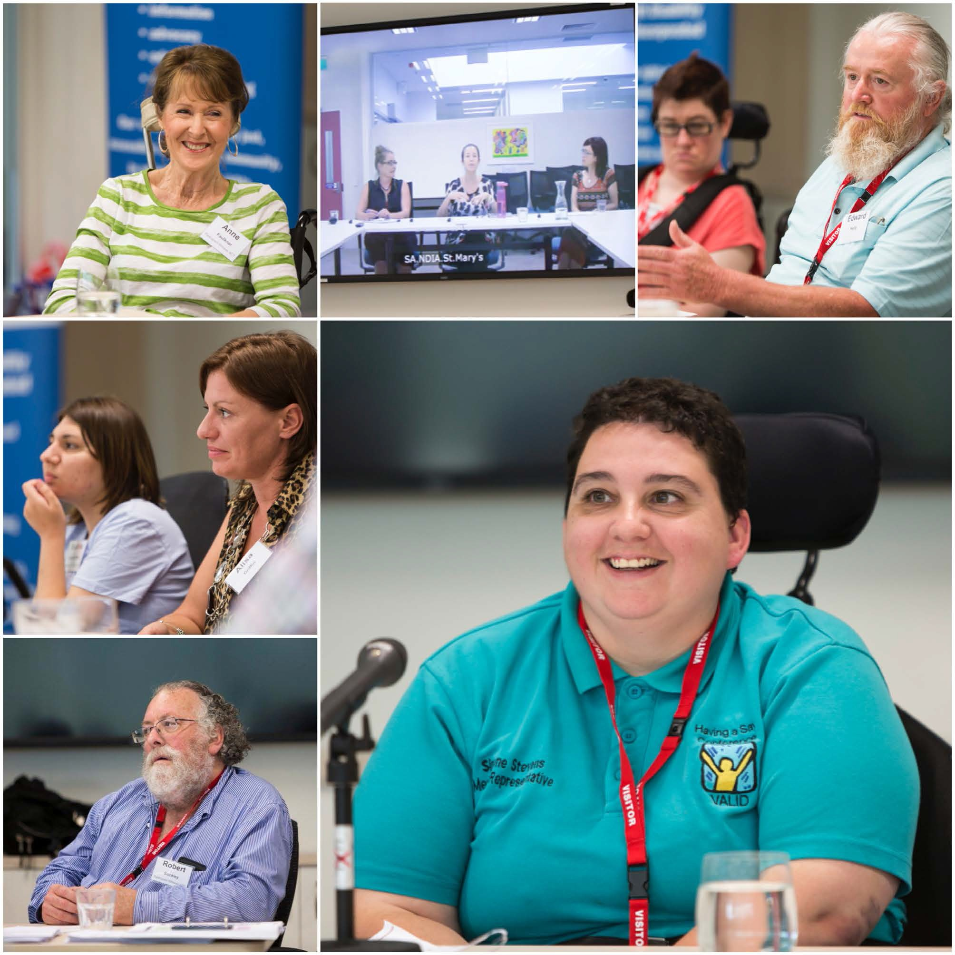
Participant witnesses: Top right: Anne Faulkner. Top middle (L-R): Cindy Zbierski, Michaela Banks and Taryn Waters via video link up from South Australia. Top left: Jacinta Kelly supported by her Dad, Edward Kelly. Middle Right: Brihana Grant-Griffin, supported by Mum, Alisa Griffin. Bottom right: Bob Buckley representing son Kieran. Right: Focus Group Representative – Simone Stevens.

Advocate witness
Six advocate witnesses were recruited by PWDA each representing one of the six NDIS trial sites. Each advocate witness was a person with disability, selected on the basis of being networked within the nominated NDIS trial site, good at consultation and able to bring a greater range of evidence before the jury.
The role of the advocate witness was to gather feedback and information from a further group of people with disability who use the NDIS. Using an interview format via face to face meetings, email or phone interview formats and a set of questions based on the key assessment questions being considered by the jury, the advocate witnesses interviewed a further 45 people with disability and/ or their carers who were current participants of the NDIS.

The feedback and information gathered in these interviews was compiled by each advocate witness and presented as evidence of the NDIS in practice to the citizens’ jury.
The advocate witnesses included:
      - Angelo Cianciosi for the Perth Hills area of Western Australia;
      - Crockett Cooke for the Barwon region in Victoria;
      - Justin Ray for the ACT;
      - Kerry Telford for South Australia;
      - Kristy Trajcevski for the Hunter Region in NSW; and
      - Jane Wardlaw for Tasmania.

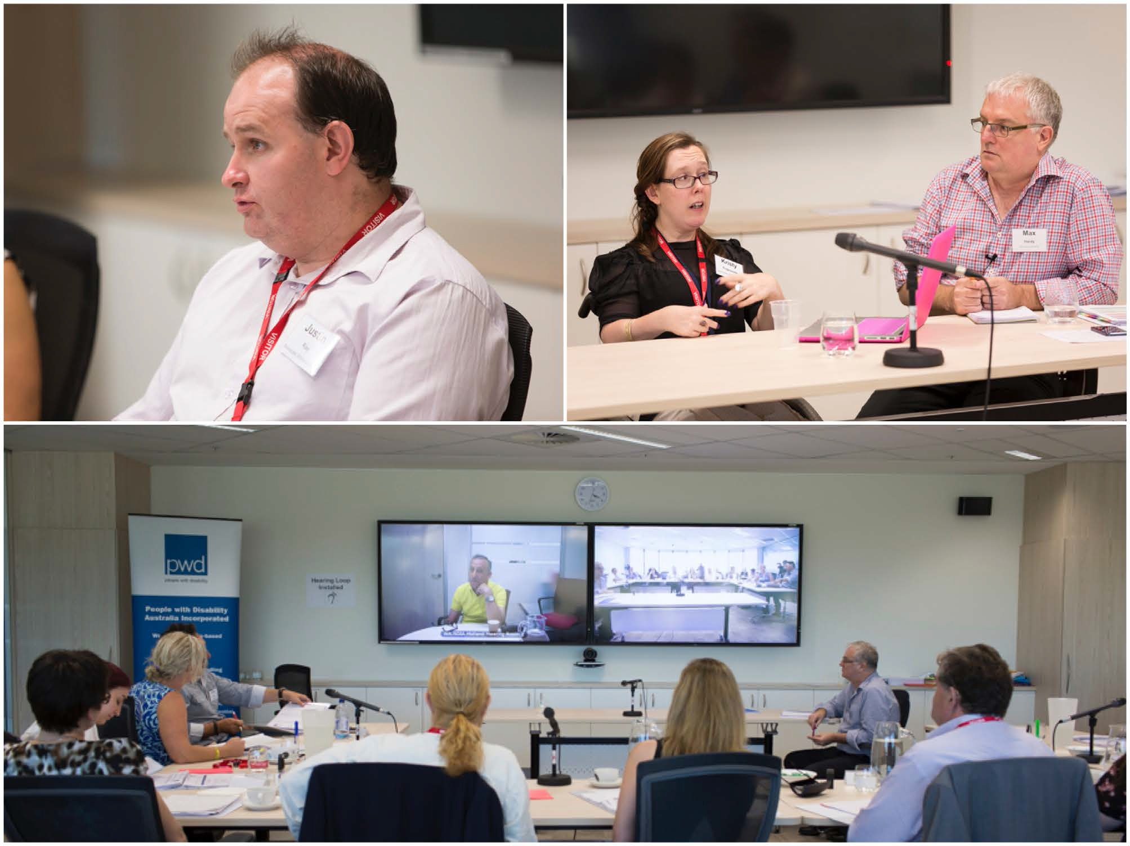
Advocate witnesses: Top Left: Justin Ray - ACT. Top Right: Kristy Trajcevski – Hunter, NSW. Bottom: Angelo Cianciosi - Perth Hills, WA.

Additional evidence and testimony
Two further methods were used by the project to broaden its consultation base and allow for maximum input by interested parties and included three focus group forums for people with intellectual disability and a social media forum.
The advocate witnesses from Tasmania, Hunter/NSW and Barwon/Victoria each recorded feedback from focus groups held with people with intellectual disability who were users of the NDIS

incorporating this feedback into their evidence provided to the jury. A representative member from the Barwon focus group was also invited to give direct evidence to the jury.
On the 19th of November 2014, PWDA also hosted a social media forum via Facebook and Twitter. The same standardized questions used by the advocate witnesses in their interviews with NDIS participants were posted onto PWDA’s Facebook page and Twitter feed over a period of 4 hours. Over this time some 78 people, located across Australia, provided feedback on their views and experience of the NDIS. Additional responses were also received via Twitter or by phone, if the person did not have access to Facebook. This feedback was then compiled into a report which was presented to the jury.
The final component of evidence considered by the jury was that provided by the NDIA itself. Critical to the process was the ability of the jury to test evidence, to pose questions and hear direct responses provided by high level officers of the NDIA itself.

Documentary record
A final component of the project was the creation of a vital documentary that will ‘tell the story’ of the process of the citizens’ jury and visually explain the jury’s deliberations and its findings.
Filmed and produced by an experienced small filmmaking consultancy – Think Films, the result not only provides a transparent record of the process and outcomes but also acts as a key means to providing an accessible scorecard format for people with disability through the integration of Auslan and captioning descriptions. Access to the citizens’ jury film, can be sought via PWDA’s website or by contacting PWDA directly.

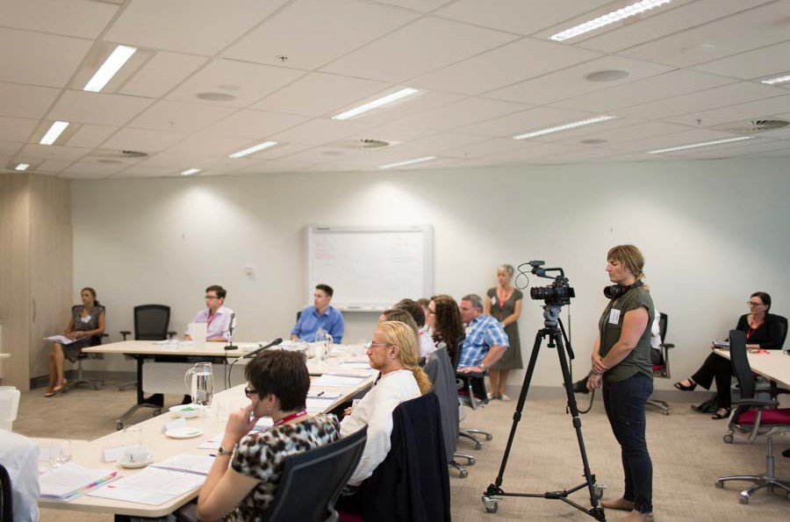
Lara Damiani of Think Films filming the Citizens' Jury.

Top left: Juror Craig Hughes, Top right: Juror Kristen Laurent, Middle left: Juror Gemma West, Middle right: Juror Chris Ecker,
Bottom: NOIA Project Staff observing the Citizens' Jury process.
14 NDIS Citizens' Jury Scorecard

Citizens’ Jury Scorecard

Executive summary

The NDIS citizens’ jury was formed over a 3.5 day ‘trial’ in February 2015, and with expert and advocate witness testimonies was tasked with determining to what extent the NDIS is ‘on track’ to achieve its stated aspirations and the kinds of transformational change described in the Productivity Commission’s 2011 Disability Care and Support Inquiry Report1.
The jury was asked to develop a scorecard to measure this. Due to the wide range of witness testimonies and variation in the experiences of participants and implementation time lapsed at the trial sites in each state and territory of Australia, the jury decided that a numerical-style scorecard would not be adequate and probably be misleading in describing the NDIA’s achievement of goals to date. To this end, the jury have reported the successes of the trial sites and recommendations to be implemented prior to the national roll out of the scheme, against the eight themes described by the Productivity Commission.
The jury was unanimous in affirming the intent, ethos and rationale for the NDIS. Unquestionably the NDIS is already enabling quality of life outcomes for some people with disability that would otherwise be unattainable. The jury believes the NDIA has learned many lessons from the early stages, where implementation was rapid, and are hopeful the issues that have been identified and recommendations that follow will help to strengthen the NDIS as it moves to full implementation and continues to make a significant difference in the lives of people with disability, their carers, families and the broader Australian community.
Several successes were identified by the jury as having been achieved by the NDIS. These fit
under the themes of: inclusivity; choice and control; an enhanced sense of security; and improved options for participants through use of a long-term funding vision.
However, the NDIS has not been without challenges. The rapid timeframe from passing of legislation through to the NDIA’s inception, then roll out of trial sites has understandably caused teething problems. Recommendations to address some of these challenges are detailed against each of the eight themes, detailed in the Productivity Commission’s Inquiry Report into Disability Care and Support.
Part of the NDIS remit was to enable participants to lead an “ordinary life”, that is a life that they would normally have had the chance to lead had it not been for their disability. A recurring theme throughout the ‘trial’ was the importance of NDIS planners in enabling participants to achieve the said ‘ordinary life’ under the themes, through assisting them to develop and review their plan, and in the local area coordinators for helping to achieve the plan’s goals.

1 http://www.pc.gov.au/inquiries/completed/disability-support/report

The importance of the planner’s role cannot be underestimated when determining whether the NDIS will be successful in the long term. As such, the NDIS needs to nurture, resource and
support its planners especially, but also other frontline staff. Having the right skill sets and personal qualities in these roles will be fundamental to the success of the scheme both for participants and the strategic and effective use of the Australian community’s resources through the Medicare levy.
Besides planners, another key outcome of the recommendations are supporting the change of
the service provision model from one where service providers held the power under the pre-NDIS “block funding” model, to the participants being provided funds to pay and choose their service providers directly, and the complexities brought about by this change.
The NDIA should not underestimate the importance of seeking robust and routine feedback about its performance from participants to ensure it is on the right track, and unfortunately, although the NDIS has actively gathered feedback, the results from surveys using their current method did not reflect the testimonies heard by the jury.
The rapid growth of the scheme as the NDIS rolls out nationally will be arguably the most challenging task for the NDIA. Evaluating trial site outcomes, developing a best-practice model and rolling it out in the current scheduled period; whilst sourcing adequate qualified and experienced frontline staff, both from a high-turnover industry and with the necessary aforementioned qualities, will be unprecedented in Australia. The estimated staff employed under the NDIS after national rollout will be 95 000 FTE.
However, the NDIS is fortunate to have bipartisan support, being passed by an unanimous vote of the Parliament in 2013. With this backing and the commitment by the NDIA to “learn, build and repeat” in its operations, the NDIS has the potential to become a world-class disability insurance scheme.

Juror – Anne O’Grady makes notes during the Citizens’ Jury.

Comments about the jury process and selection of witnesses

The jury recognises that there was an element of self-selection involved with participants that were willing to give evidence. Although random selection was used through the New Democracy Foundation, most of the participants appeared to be very assertive, and therefore perhaps not reflective of the broader range of participants. The jury believes that it should be noted that evidence provided may not be sufficiently balanced for that reason – that those who accepted the opportunity were likely to be more confident, and perhaps either very satisfied, or very dissatisfied, with their experience of the NDIS thus far.
The jury recognised that participant witnesses had an obvious reason to share their story, whereas advocate witnesses had a range of other reasons, such as advocating for the needs of particular groups.
The jury identified that the vast majority of witnesses were Caucasian, and cannot be certain that evidence was provided from a sufficiently representative source, as the demographic of likely participants of the NDIS is not yet known, due to a lack of accurate Australian data on the number of people with disability.
The evidence heard represented every Australian state and territory except two: Northern Territory (as outlined above) and Queensland. Queensland’s state government has elected not to take part
in the NDIS trial phase, but commence with the national rollout, and therefore does not have a trial site like the other states and territories, so no participants existed to provide a testimony.
For each trial site represented, evidence was provided from 0-3 participant witnesses, as well as advocate witnesses, who each interviewed 4-10 participants, giving evidence on their behalf. As each pilot site is run differently, the jury recognised that these sample sizes were small.
In terms of representation of various impairments, the jury did not hear from anyone who lives in a boarding house or from an institution like Stockton in New South Wales, which is the home for hundreds of people with intellectual disability, amongst other impairments. However, it is
important to note that despite the jury not hearing from any witnesses from Stockton, that several attempts were made by the advocate witness, Kristy Trajcevski, a qualified lawyer, to interview at least three Stockton residents. These attempts seemed to be blocked by staff at Stockton, based on the following:
- Letters were sent by Ms Trajcevski well in advance, notifying participants about the process, inviting them to take part and that they would be contacted, to which no response was received.
- Ms Trajcevski then:

  - Attempted to contact the participants over the phone via Stockton’s main switchboard, to which the receptionist offered to answer questions on the participants’ behalf, stating that they couldn’t answer the questions because the participants had intellectual disability and would not be able to speak;

    - Ms Trajcevski told the receptionist that she had sent a letter to them, so they should be aware that she would attempt to call, to which she was told that the participants had never received said letters and that maybe they were directed to their parents’ houses. When told the participants only had one address, Stockton, the receptionist could not explain this;
    - When the receptionist couldn’t answer Ms Trajcevski’s questions, Ms Trajcevski was transferred to the ward, where she received a similar message from the nurses about the participants’ lack of capability to discuss the matter due to their
impairments. Assuring the nurses that she would try to discuss it with them anyway, they would still not allow her to speak to the participants.
Ms Trajcevski has a speech impairment, and told the jury that because she thought that her impairment may be causing a problem in either the Stockton staff understanding her generally or questioning her capability to speak to participants, she asked a representative with no speech impairment, to call on her behalf and ask the questions of the participants for her. This
representative was met with the same problem, and had the same experience of being blocked by staff and not being able to speak to the participants at all. As such, Ms Trajcevski concluded that her speech impairment had nothing to do with her inability to access NDIS participants at Stockton to ask their views on the NDIS.
The jury concluded from this that the staff at Stockton did not want the participant residents to speak with the advocate witness about the NDIS. This raises several issues about the transition of power from the current service providers to the NDIS participants, based on the change from the block funding model to the NDIS participant funding controlled model. These issues are discussed in the recommendations.
It is also concerning that people with disability living in shared accommodation may not have
the same voice as others in the community if they need to raise any issues. Putting people at the centre of control, as a tenet of the NDIS, will go some way to addressing this issue.
While the jury managed to develop a comprehensive set of responses to the questions asked, through completing the report in their own time outside the face-to-face sessions, they believed that greater deliberation time would have been beneficial. All jurors had access to the report throughout the out-of-session completion process and had the opportunity to comment, contribute and review the report at any time before submission. As such, the jury do not believe that the somewhat inadequate deliberation time was detrimental in any way to the quality of their final report.

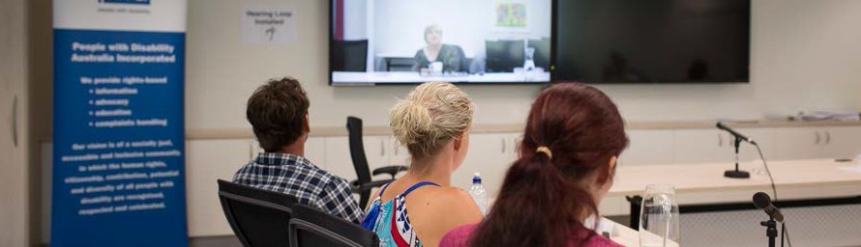
Jurors listen to Advocate witness Kerry Telford via video link form SA.

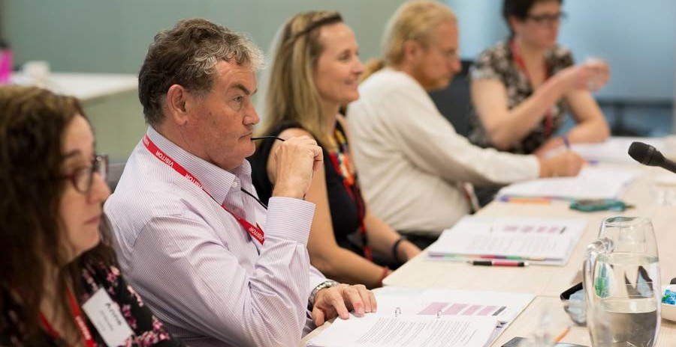

Overarching NDIS successes
Jurors hearing evidence during Citizens’ Jury

Through the evidence presented, the jury identified a number of successes that the Australian community and NDIA can celebrate. These are outlined below:

Inclusivity
It is evident that many of the participants we heard from are feeling more included in their communities, and are participating more actively as a result of the NDIS. We heard evidence that participants are feeling more connected to their communities, and engaging in a wider range
of activities. One participant, a woman with several impairments, including vision impairment, reported that she is now planning to move out of her parents’ home to live independently
in a shared house, with people of her choice, something that would have been impossible to contemplate previously.

Choice and control
Many of the participants reported a great deal of satisfaction about having greater choice with activities they wanted to pursue, being able to change service providers, or access services from a range of providers simultaneously. For some this meant that they feel, for the first time, that they are making choices about their lives, as opposed to just accepting what service providers or services were offered, which was the norm under the block funding model.
Participants also expressed a mixture of relief, pleasure, and enthusiasm about being able to finally set their own goals and aspirations, and how they can work toward them. Another woman with vision impairment appreciates the flexibility of choosing her own service providers and the
ability to change whenever she feels the need to. She reported that she had experienced a positive change in the level of service now being provided compared to the block funded model. Many participants are feeling they now have real control of their lives.

Sense of security
A recurring theme was the expression that participants are feeling more secure and relaxed about being supported into the future, and that the NDIS can adapt to their changing needs over time.
A woman diagnosed with polio decades ago, reported that she feels the NDIS will provide for her needs as they change, and feels secure about the future. This long-term stability enables goal setting and growth, as opposed to a ‘getting by day-to-day’ attitude. It also provides a great sense of relief for these participants.

Improved options through funding with a long-term vision
Many of the participants the jury heard from expressed a great deal of satisfaction about being able to purchase equipment to improve their mobility, and being able to perform more tasks independently. Innovative options available to planners enable more scope for this in the NDIS than under traditional models. For example, parents of a child with an acquired brain injury were able to use NDIS funding to purchase a modified three-wheeled bike that enabled him to become involved in play and assist in his social development as he was included with other children in their street.
Other innovative options have enabled at least one participant to achieve greater independence and become employed in a field of her choice. A young woman, who has cerebral palsy and learning difficulties, loves dolls and with the help of her mother and post-school options government funding, has begun setting up a micro-business. The NDIS has contributed with the purchase of a push-button sewing machine because she is unable to use a standard machine. She has already started making dolls and is looking forward to selling them at markets. This innovative solution with a long-term vision for her has enabled her to create a future that may not have been otherwise possible.
Overall, the jury recognised and strongly supported the ‘heart’ of the NDIS, which is aiming to achieve a more inclusive society, where everyone can participate in their communities in valued ways.

Successes, issues and concerns related to the Productivity Commission’s themes

The report layout has been designed to address the eight themes described in the Productivity Commission’s Inquiry Report.
It is important to note that within all themes, there may be a juxtaposition of successes
and recommendations. This is intended, and largely due to the wide variation of participant experiences within the NDIS trial sites, in most states from which evidence was provided.
Each theme is divided into two parts:

- A list of successes – areas where the jury felt that the NDIS was addressing the intent of the themes, as presented by the witnesses.
- A table of recommendations that the jury believes the NDIS should implement to address the Productivity Commission’s report and build on the success they have already achieved. These have been determined by compiling the witness testimonies and addressing the complications that the jury believes is hindering or will hinder people with disability from achieving ‘an ordinary life’.
Against each recommendation is a suggested timeframe for implementation. The jury believes these timeframes will enable the NDIS to achieve a successful national rollout, and were determined according to what the jury considered to be priority need and their estimated reasonable time to review and implement each.
The needs of participants, balanced with ensuring sound use of the Australian community’s resources, were considered throughout the process of forming recommendations.

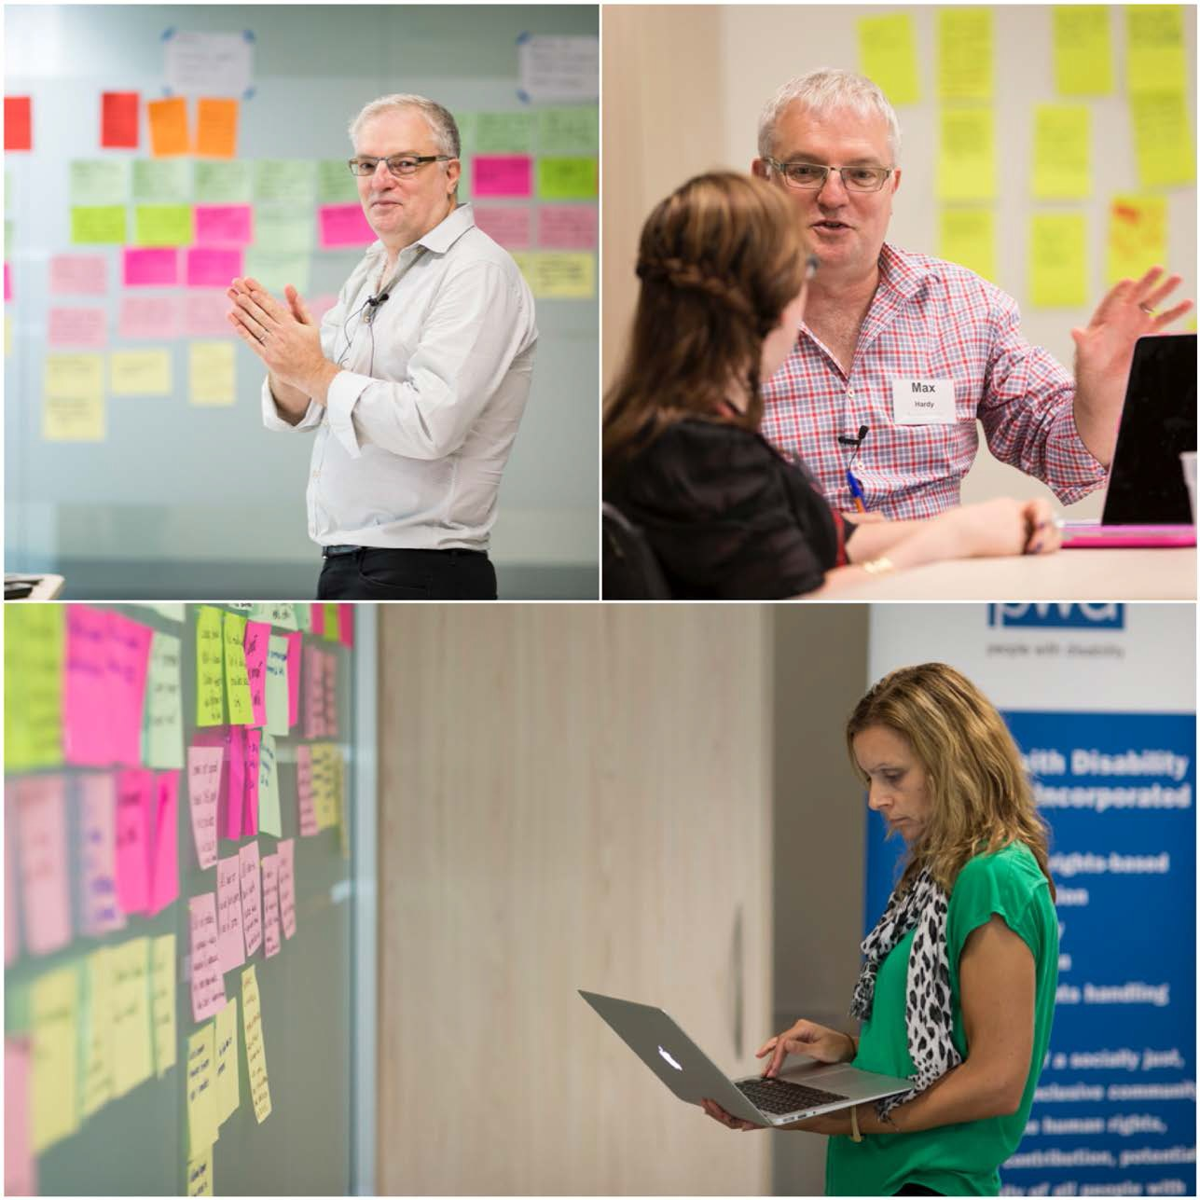
Max Hardy and Danielle Annells facilitating the citizens’ jury process.

Themes 1 & 2
‘Putting people at the centre and increasing choice and control’

Successes
- Many of the participants feel that they are at the centre of the scheme – it is a participant-focused process.
- The goal-oriented nature of plans enables and encourages participants to grow not just exist.
- There are examples of holistic planning which seems to be an improvement upon traditional block funding models.
- Some participants now have greater independence (e.g. motorised wheel chairs after waiting several years for this under the block funding model.)
- There are examples of innovative solutions (e.g. psychological treatment for a carer; and specialised tools to enable greater support in starting and growing their own business).
- Self-determination is being promoted through the NDIS.
- Many witnesses who gave evidence experienced increased self-esteem.
- Participants felt secure about the assurance of ongoing funding.
- Participants are increasing their involvement and participation in the community.
- Planners, especially in the Australian Capital Territory (ACT), responded quickly to participant requests to adjust/change plans.

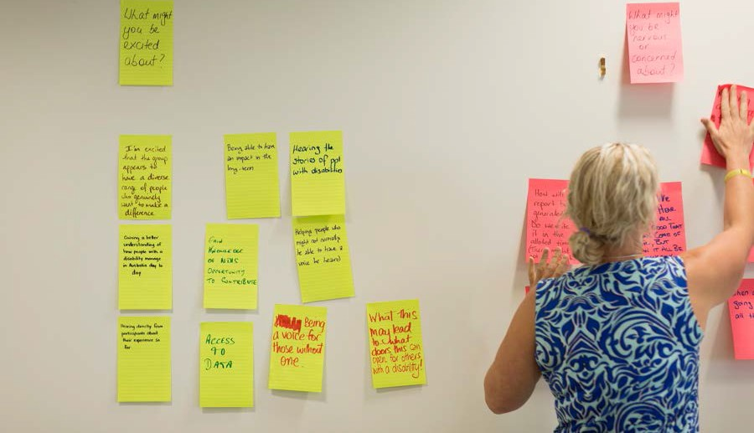
Juror, Shaya Mitchell posting notes during a deliberation session.

Recommendations

ISSUE | SITUATION | COMPLICATION | RECOMMENDATIONS
Planning | The initial planning | Participants are not given | Pre-meeting:
meetings. | meeting between the NDIS and participants is essential to building ongoing relationships  and ensuring sound use of NDIS resources. | adequate information regarding expectations and preparation required for the initial contact.  This leads to negative experiences for the participant/carer and wasted resources for the NDIS in having to reallocate planners due  to negative experiences, and run subsequent, sometimes unnecessary meetings because participants did not know what they needed to prepare. Even well educated, proactive, parent carers expressed  that meetings could have been more efficiently run had they been provided upfront information. | Provide correspondence to participants to enable them to proactively manage their time and feel more in control, including:  - Clear expectations of what is required from them (e.g. what to bring to meetings), such as any quotes for mobility equipment and list of required services.  - To consider their short-long goals prior to arrival.  - A run sheet of the meeting agenda and what to expect.  - A template and examples of a completed plan.  - Names of their allocated planner and local area coordinator.  - Enable greater flexibility for meetings, and ensure participants’ awareness of this, including:  - option of holding the meeting at the participant’s home or place other than the NDIS Office;  - a time of day to suit them, including after hours to suit working people such as carer parents; and  - be flexible in the length of time, including enabling sectioning of planning meetings into parts over several sessions if required.  Urgency of Recommendation Implementation  Immediate.

ISSUE | SITUATION | COMPLICATION | RECOMMENDATIONS
 |  | Participants and carers were not furnished, nor could not readily find any information about the complaints or feedback process without making direct enquiries when they had a problem. Less assertive participants and participants with certain  impairments are much less likely to seek out methods to provide feedback than others, and are therefore disadvantaged. | At meeting:  Furnish participants with:  - A simple process map of what happens next including timelines.  - Information on feedback mechanisms available to them, including the complaints process.  - If applicable, ensuring that planners are all sensitive to the role parents play as carers, to be discussed at the beginning of the planning process.  Urgency of Recommendation Implementation  Immediate.
 |  | Planners did not appear | With regards to planner tools, NDIS
 |  | to have adequate tools | to:
 |  | to assist them to draw | 1. Review processes, protocols,
 |  | out participants’ goals, | procedures and templates so
 |  | develop innovative | Planners have the tools they need.
 |  | solutions to their problems | 2. Develop and roll out improved
 |  | or work outside the | tools to solve complex problems,
 |  | traditional bounds of | draw information out from
 |  | disability assistance. | participants to help them set goals  and be innovative in solutions.  Urgency of Recommendation Implementation  Immediate.

ISSUE | SITUATION | COMPLICATION | RECOMMENDATIONS
Planner skill | Planners, local area | High variability in attitudes | Training:
sets and | coordinators (LACs) | and skills of frontline | 1. Ensure all frontline staff; are
training. | and frontline staff (e.g. | staff (including planners | suitably skilled to deal with
 | administrators) are | and LACs) resulting in | people with disability, their carers
 | paramount in ensuring | participants receiving | and families, can build positive
 | participants receive support to put them in control and in dispelling myths about the NDIS. | great variability in service and outcomes. Some participants had wonderful experiences, others had very poor experiences.  This appears to be both | relationships with families, and  that their manner reflects this. For example, training to a prescribed minimum level of Certificate in Disability and personal qualities.  2. Must achieve greater consistency of LACs and planners (i.e. that
 |  | a hiring and a training | outcomes for participants should
 |  | issue. For example, | not depend on who their LAC or
 |  | the training length and | planner is).
 |  | probationary period is | 3. Language used and attitude -
 |  | much shorter than other | should be positive, supportive and
 |  | Federal departments like | uplifting.
 |  | Centrelink. | 4. Greater focus on participant
 |  |  | needs and innovative methods to
 |  | A strong theme arose | meet them.
 |  | that participants believed planners had heavy caseloads, had targets | 5. Better training on problem  solving to find innovative methods to build participant capability.
 |  | to reduce plan costs and increase participant throughput. The NDIA | Urgency of Recommendation Implementation  Immediate.
 |  | stated in their response
 |  | to the jury that planners | Skill sets:
 |  | were not incentivised or | 1. Match participants to planners
 |  | measured on throughput, | for suitability, and provide
 |  | nor had they been given | flexibility for participants to
 |  | direction to minimise | choose and change their planner
 |  | costs of plans to the NDIS. | based on skills and experience
 |  | Participants did not feel | with different impairments (e.g.
 |  | that the Productivity | Autism experienced planner with
 |  | Commission’s statement regarding nobody being disadvantaged under the NDIS when compared to | participant with Autism Spectrum  Disorder).  2. A planner skill set matrix would need to be maintained by NDIS.
 |  | previous funding models was heeded. | Urgency of Recommendation Implementation
 |  |  | Immediate.

ISSUE | SITUATION | COMPLICATION | RECOMMENDATIONS
 |  | A lack of trust in the system left over from the pre-NDIS block-  funding model still exists in participants and their  carers. For example, carers of child participants felt that if they relayed to a planner that their child was making physical improvements, then they might have their services cut at the next review, even if these were still genuinely required. | Provide tools to help frontline staff address the lack of trust in the system from some participants, which creates barriers to achieving optimum planning outcomes.  Urgency of Recommendation Implementation  Immediate.
General planning | NDIA needs to instil faith in the NDIS amongst the disabled community and Australian tax payer. | Wide variability in experiences of witnesses that had their planners changed. Many did not know they had been allocated a new planner. | Participants are assigned a single planner when possible, to provide the participant more stability and uniformity during the planning process. Introduce a process for changes in planners and LACs  to ensure a smooth transition between planners for participants. Witnesses expressed that the current disability sector case manager transition process works well.  Urgency of Recommendation Implementation  Implement during trial phase.
 |  | Jury were not aware of | Investigate and implement a
 |  | whether a quality control | framework such as ISO for quality
 |  | system is in place, but | control and customer service.
 |  | evidence presented
 |  | suggested that there is | Urgency of Recommendation
 |  | not, or if there is a system, | Implementation
 |  | it is not working optimally. | Prior to national rollout.

ISSUE | SITUATION | COMPLICATION | RECOMMENDATIONS
 | Measurement (Key Performance Indicators (KPIs)) drives behaviour.  Ensure planners and LACs are being  measured on the ‘right’ things. | Strong belief amongst participants that Planners are measured on the quantity not quality of plans produced. | Planner incentives (if applicable) and performance measurement: Ensuring planners and LAC KPIs are focused on participant outcomes and not just throughput.  Urgency of Recommendation Implementation  Implement during trial phase.
National  and regional consistency | Trial sites have been set up to test optimal execution processes, but national rollout must be designed to enable participant movement between regions or states with a smooth transition. | Past performances in state-based government systems (e.g. schooling) has shown a lack of consistency between states and poor handover processes, which disadvantages people moving interstate. A participant may be disadvantaged if a defined hand over  process between planners regionally and interstate is not developed. | Ensure uniformity for itinerant participants (moving interstate)  – with a consistent process and national metrics.  Urgency of Recommendation Implementation  Prior to national rollout.

Juror Adian Greenrod reads his evidence book.

Themes 3 & 4 ‘Improving portability and reducing fragmentation’

Successes
- Service providers are now more accountable.
- Dreams of services for the individual are now possible.
- Participants are empowered to change providers.
- Early interventions are possible and there is evidence it is increasing the number of positive outcomes.
- Waiting lists are being reduced.
- ‘One plan, one person’ reduces fragmentation.
- The ACT trial was working well for the witnesses (but we acknowledge it is early days). This needs to be balanced with participant satisfaction surveys of other ACT
participants, as the jury heard that there were other participants in the ACT community that had not had a good experience.

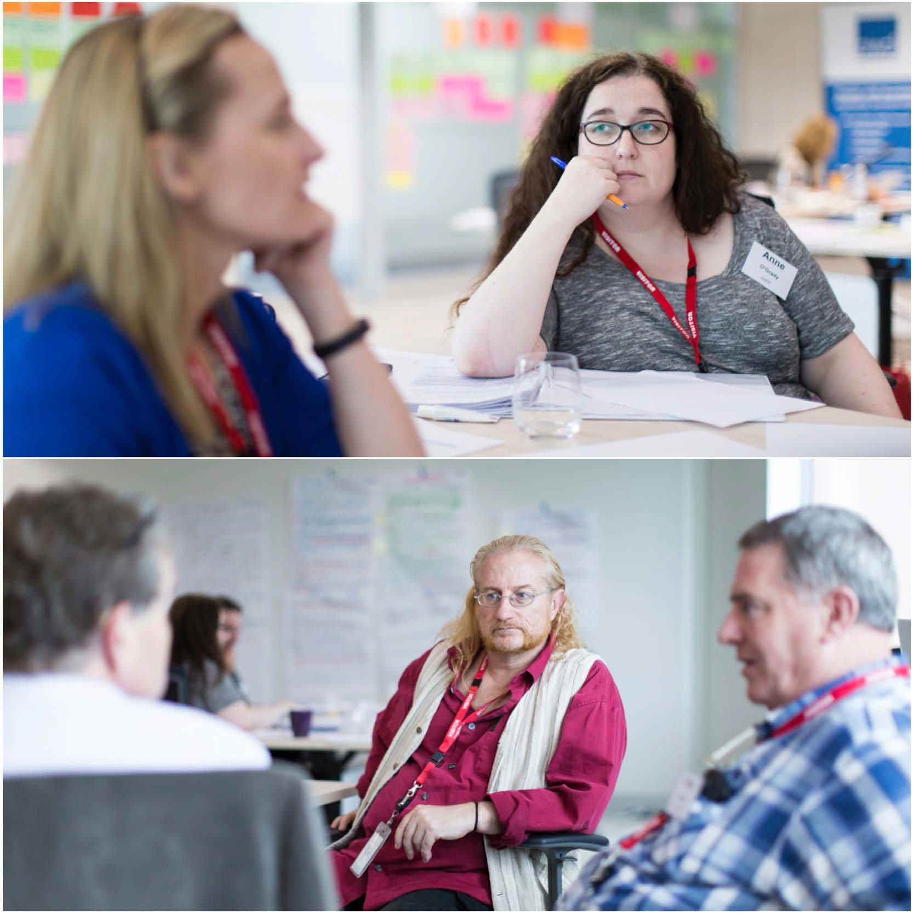
Top: Juror Anne O’Grady. Bottom Juror Tony Guyot.

Recommendations

ISSUE | SITUATION | COMPLICATION | RECOMMENDATIONS
Disability | The change from a | The NDIA needs to be aware | The NDIA work with federal and
service | block-funding model | that in some trial sites and | state governments to ensure
provider | where governments | jurisdictions, such as in the | that any NDIS roll out provides
market. | fund disability services providers directly, to the NDIS participant controlled service has raised some issues  of attaining optimum outcomes from a free market.  The jury fully supports the NDIS model of participants being empowered to select and directly pay their service providers through funding being made available to them rather than the previous model of funding  service providers. | Australian Capital Territory, the government, who  was the main provider of services, withdrew services immediately when the NDIS was launched.  This has caused a gap in service offerings as a free market has not had time, nor been supported to develop, resulting in participants having little or no access to services. Per the new model, participants should have the option to change providers, which is difficult if there are few or no providers in their area, or the nearest provider  is in a different region or state. | adequate time and resources to enable a transition of disability services into a free market, that will facilitate the participant controlled funding model.  Urgency of Recommendation Implementation  High. Immediate for trial site locations such as the ACT  where this is occurring. Must be addressed prior to the national rollout.
Assisting | Enabling portability of | Due to participants’ previous | Grassroots assistance:
participants | disability services is key | experiences (many for a | 1. Provide tools to frontline staff
to change | in putting participants | lifetime), of block funding | and develop content to assist
providers. | at the centre of control, and is a hallmark of the NDIS. | models, many are having difficulty in navigating their new entitlement to change providers.  Participants with intellectual disability or aphasia or speech type impediment are more  at risk. The NDIS need to be aware of and develop policies to minimise provider abuse of power, when participants elect to change providers. | participants and their carers  to understand and assert their rights, and the responsibilities of service providers and the NDIA.  - Develop a simpler process for changing providers and  increasing participant awareness of their freedom to choose.  - Providing advocates for individuals if required.  - Explore non-threatening methods to measure the satisfaction of participants with intellectual and other disabilities regarding service providers.  Urgency of Recommendation Implement during trial phase.

ISSUE | SITUATION | COMPLICATION | RECOMMENDATIONS
 |  | The jury was not made | Ensuring service provider
 |  | aware of any processes in | accountability:
 |  | place to assist or educate | 1. Develop NDIS policies: no
 |  | current providers to move | tolerance of service provider
 |  | from the block funded | exploitation of participants.
 |  | model to the free market | 2. Develop process for complaints
 |  | model. Some providers are | about service providers, accessible
 |  | struggling with the power | for participants, carers, families,
 |  | shift of funding from | and public to escalate acts of
 |  | themselves to participants. | unconscionable behaviour.
 |  | This allows for | 3. Develop educational material
 |  | opportunistic exploitation | regarding the change in the funding
 |  | of participants. | model and their responsibilities under the NDIS funding model, including anti-competitive behaviour. Distribute to service providers.  Urgency of Recommendation Implementation prior to national rollout.
 |  | New providers have had difficulty registering for the NDIS (i.e. Participants wish to select a provider but cannot pay them  for services) due to the service codes not being accessible/published on the registration section of the website. | Publish service codes on NDIS website to enable faster provider registration.  Urgency of Recommendation Implementation  Immediate.
Reducing | The NDIS employs | In many trial sites, | Further investigation is required
fragmen- | two different roles - | participants did not have | into whether the planner and LAC
tation of | planners and local area | an understanding of the | role should be combined, as in the
services | coordinators (LACs) at each trial site (except the ACT - where the role is combined). The planner’s role is to  assist participants in the generation and reviews of their NDIS plan; | role of the planner and LAC. In some cases, several had never even met the LAC.  It is not clear to date and from the testimonies heard by the jury, whether the positive experiences  of the ACT witnesses were due to a combined | ACT trial site.  Urgency of Recommendation Implementation  Prior to national rollout.

ISSUE | SITUATION | COMPLICATION | RECOMMENDATIONS
 | the LAC’s role is to assist the participant in coordinating the activities that are  on their plan at a grassroots level. | planner/LAC role or because the incumbents had deeper experience and more aligned skill sets prior to joining the NDIS. This needs further investigation before  the planner/LAC role is combined. | The NDIS must ensure participants are aware of the responsibilities of each of the roles, and the contact details for each role. This could  be added as an item to the initial planning meeting.  They need to be made aware that an LAC exists to assist them.  Urgency of Recommendation Implementation  Immediate.

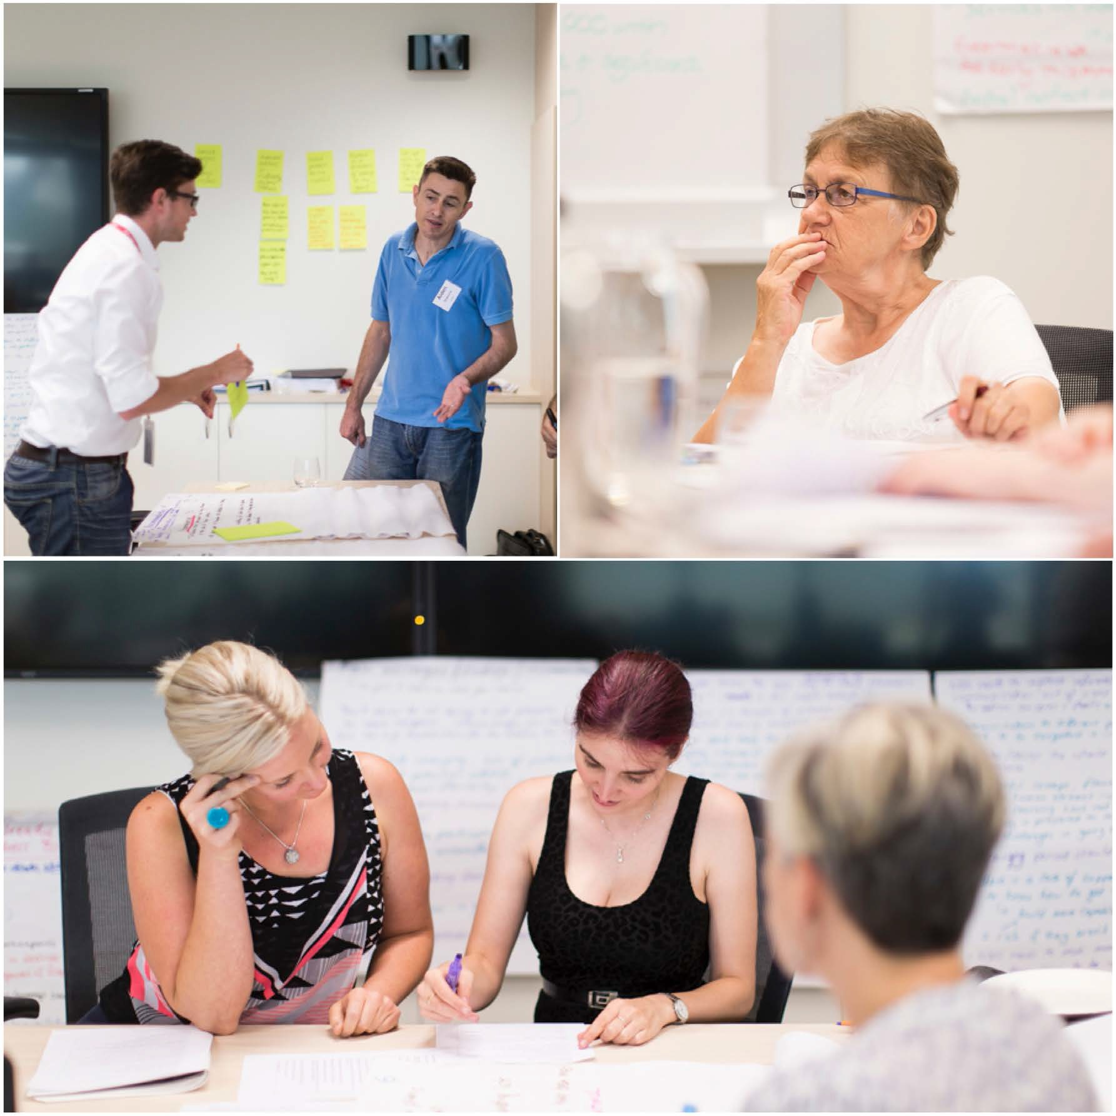
Top Left: Jurors Darcy Treloar, Aidan Greenrod. Top right: Juror Lorraine Hughes listens to evidence. Bottom: Jurors Shaya Mitchell and Liliana Di Sora work together during deliberations.

Theme 5 ‘Uniform understanding of the scheme’

S.es
      - Services funded through the NDIS are enriching lives across all trial sites.
      - South Australian (SA) trial site service providers, focusing on children with disability, appeared to be applying the scheme very consistently.
      - Participants were consistently having positive experiences in the ACT.
      - The NDIA is working toward a consistent approach, while still retaining flexibility in the way services are provided.

Recommendations

ISSUE | SITUATION | COMPLICATION | RECOMMENDATIONS
Rapid | The NDIS trial sites | The NDIS trial sites have | The NDIS must ensure the
growth of | have needed to expand | needed to expand rapidly | recruitment of staff is implemented
the scheme | rapidly in some areas (e.g. SA) to address growing demand for services. This will be compounded when the national rollout occurs. | in some areas (e.g. SA) to address growing demand for services. This will be compounded when the national rollout occurs. | with adequate lead time to not detrimentally affect the national roll out through a lack of human resources.  - Training must be consistent Australia wide.  - In order to attract skilled people from other industries to fill the expanding number of positions, the remuneration of planners and LACs should be reviewed.  - Review the planner and LAC role requirement to enable flexible work practices and part-time  or casual employees. This may address the skilled staff shortage and improve flexibility of offerings to participants (e.g. offering after hours planning meetings).  Urgency of Recommendation Implementation  Prior to national rollout.

ISSUE | SITUATION | COMPLICATION | RECOMMENDATIONS
Consistency | Consistency in service | The jury acknowledges | Review the entire methodology of
of service | delivery, both in NDIS | the difficulties in achieving | the current NDIS to create a system
delivery and | operated facilities and | equal service provision in | for national rollout that is based on
communica- | those indirectly funded | all areas, especially due to | the customers’ (i.e. participants’)
tions | through the NDIS, is important in ensuring a fair and equitable system for participants, no matter where they  reside or their disability. The communications that support this must accurately reflect  NDIS services and be consistent scheme wide. | the range of impairments and geography.  However the NDIA need to ensure the scheme  is developed using a “customer experience” methodology. The evidence suggests that currently it has been designed with the service provider’s (i.e. NDIS) needs at the forefront, with  a supplier to customer methodology. | needs and develops its processes backwards from there. It will then enable it to be recognised as a world-class system.  Several issues that must be addressed, which are examples of how the current offering does not align to a customer service  methodology and was not designed with the customer in mind are included below and in subsequent recommendations:  - Provide greater flexibility and  a defined process for participants that do not fall into standard categories upon NDIS registration (i.e. the eligibility process demands that participants must complete  a standard “tick-a-box” form - participants do not always fit into categories), including;  - For participants with undiagnosed impairments to register for the NDIS (not all conditions can be categorised  into current, medically prescribed conditions):  - For participants that do not yet know if their condition is permanent or temporary (e.g. in the case of an accident).  Urgency of Recommendation Implementation  Immediate review required. Processes and customer facing service delivery should be in place.

ISSUE | SITUATION | COMPLICATION | RECOMMENDATIONS
 |  | The jury heard that some witnesses had asked for information in certain formats or via alternative, albeit standard, delivery methods and the NDIS was not able to accommodate this. This disadvantaged participants either due  to their disability or their place of residence (regional). | Improve the flexibility of the  format of delivery of information to participants:  - Enable delivery of plans and other correspondence via post or email at participants choosing (e.g. regional applicants should  not have to drive home from a city appointment to access registration forms delivered by post, as no other format was available).  - Ensure delivery formats  are available that take various impairments into account (e.g. reading device compatible for vision impaired, large print, plain English etc.).  Urgency of Recommendation Implementation  Immediate review required. Processes and customer facing service delivery should be in place prior to national rollout.
 |  | Regional participants | The NDIS should benchmark
 |  | are at risk of being | regional services against
 |  | disadvantaged due to | metropolitan services and support
 |  | lack of service provision | where possible, disability services
 |  | due to the sheer nature | in regional areas. It must remain
 |  | of lower populations and | consistent in its own intrastate and
 |  | geographical distance. | interstate service delivery.  Urgency of Recommendation Implementation  Prior to national rollout.
 | The individualised | Without appropriate | 1. Ensure appropriate
 | funding model creates | communications | communication strategies are
 | the opportunity for | and transparent | developed and the frontline staff
 | participants with | processes (including | are adequately trained in delivering
 | similar impairments to | complaints process) | a consistent message that plans are
 | compare their plans and | there is opportunity | individualised and the NDIS is fair
 | self-determine that the | for participants, their | and equitable. Ensure that reality
 | scheme is inequitable. | supporters and the general | reflects these communications.
 | NB. The jury supports | public to deem that the
 | the individualised | NDIS is inequitable.
 | funding model.

ISSUE | SITUATION | COMPLICATION | RECOMMENDATIONS
- Ensure that individual cases are monitored that may be seen by participants as not adhering to the Productivity Commission’s estimate of “no one being worse off under the NDIS”. These cases may need individual attention if required.

- Include in NDIS communications strategy, a definition of “worse off”,
i.e. not all participants stating they are worse off actually will be, needs to be balanced with NDIS outcome of “an ordinary life”.

4. Reassure participants that they will not be penalised financially for achieving goals on their plan.

Urgency of Recommendation Implementation
Implement during trial phase.
 | The NDIS website is a | The NDIS website was a | The NDIA has recognised that
 | key communications | recurring pain point for | the website is a problem and is
 | tool and often the | participants. Described as | currently addressing this, however,
 | first point of contact | a “tax office-like” website | there a several areas that the jury
 | with the NDIS for | by one participant, and | feels the NDIA need to review and
 | participants, so must | difficult to navigate by | improve:
 | be consistent in its | many others. | 1. Reduce complexity and
 | approach and designed |  | wordiness.
 | with the useability for | Given the impairments | 2. Enable user to select plain
 | its customers in mind. | of participants (including intellectual), the website needs to be redesigned and communications within it aimed at the end user. | English and pictogram versions, as  well as other enablers required by various impairment types.  - Remove names and address information for forms enabling basic requirements checking.  - Provide tablet capability.  - Generally design the website with the user in mind.
Urgency of Recommendation Implementation
Prior to national rollout.

ISSUE | SITUATION | COMPLICATION | RECOMMENDATIONS
Quality assurance | The sustainable use of resources is essential for the NDIS to provide support to disabled people and value for  the Australian tax payer.  The NDIS must be able to robustly measure its performance and act to improve it based on feedback. | The jury was not made aware of any quality assurance system operating within the NDIS, nor any plans to  implement such a system.  The lack of consistency between performance of planners and LACs could be due to what the jury perceived as inadequate performance reviews and management. | 1. Review quality assurance systems and implement a system that focuses on customer facing metrics and sustainable use of resources.  - All NDIS staff should have  KPIs aligned to customer service  excellence and quality.  - Conduct proactive, routine reviews of processes for improvement, based on customer feedback.  Urgency of Recommendation Implementation  Prior to national rollout.  Currently planners’ performance reviews are based solely on  peer-assessment. Although this is an important component of performance management and improvement, the NDIA should  also ensure planners and LACs are also measured using the following components:  1. Measured based on customer feedback (e.g. no. of complaints against planner/LAC, getting plans right first time (taking into account multi-stage planning meetings), building capability in participants, support of participants, participant- judged improvements directly resultant of NDIS that have enabled them to lead an ordinary life).  - Demonstration of capability building in participants over time (3-5 years).  - Response time.  Urgency of Recommendation Implementation  Immediate review required. Processes should be in place prior to national rollout.

ISSUE | SITUATION | COMPLICATION | RECOMMENDATIONS
 |  | The results from the current survey  methodology used by the NDIA do not align with testimonies the jury  heard from all jurisdictions represented. The NDIA Annual Report states that customer surveys have yielded a satisfaction  rating of +1.66 on a 5 point hedonic scale of “Very Dissatisfied” at -2 to “Very Satisfied” at +2. The wide variation of participant experiences presented by witnesses by no means reflected a satisfaction score of +1.66.  The jury heard that the survey yielding the +1.66 result was determined using one survey question (i.e. Are you satisfied with the NDIS?) and achieved an approximately 90% response rate. The jury notes that a 90% response rate would be deemed an extremely high response rate for any survey. The jury heard the survey was sent out to participants every 4 weeks to 1 month. | In order to accurately determine participants’ satisfaction levels, the NDIA should engage an  independent expert to conduct the surveys on an ongoing basis.  The independent expert should ensure best practice survey methodology is implemented.  Urgency of Recommendation Implementation  Immediate.

ISSUE | SITUATION | COMPLICATION | RECOMMENDATIONS
 |  | One of the witnesses coined the term “gratefulness syndrome”, defined as a high level of satisfaction from a participant who has suddenly been provided with what they deem is a high level of support/funding when they have fought for their whole lives to get support and were provided with little under  the previous block funding scheme. This was described as being akin to winning the lottery for some participants.  The jury determined that there is potential that participants experiencing “gratefulness syndrome” are attesting that they are very satisfied with the NDIS  simply due to a previous lack of funding.  There is a major problem with this in that the NDIS is being rated by respondents who are benchmarking their satisfaction against an old system rather than against  a modern system, which could be inflating satisfaction results in the survey.  Further the jury heard from several witnesses greatly concerned about having their funding cut. There is potential for this issue to be skewing survey results, as participants may be afraid to respond with their true feelings in the fear that a negative response may be linked to them. | To complement the survey, establish a ‘participant experience panel’ made up of participants  of NDIS, staff influencing and people responsible for the NDIS experience, to enable timely and routine feedback. (For reference, RMIT University - Melbourne has a Student Experience Advisory Panel in place2).  Urgency of Recommendation Implementation  Prior to national rollout.
2 www.rmit.edu.au - Staff/Workplace essentials/Student Experience Advisory Committee

Theme 6 ‘Addressing unmet needs’

Successes
• There is greater flexibility to modify/review plans when requested by participants.
• Many participants are no longer on waiting lists for disability services (versus the state and territory disability services registers of the block funded model).
• Most witnesses feel that previously unmet needs have been met.
• Standards and priorities are becoming national.
• The NDIS is meeting some participant needs by providing more:
      - Carer hours/support

      - Mainstream activities

      - Independence from parents; and

      - Long term planning.
• The NDIS is successfully focusing on individual needs where possible, which is leading to better outcomes (e.g. physiotherapy arranged during child care – South Australia. It is important to note that the jury were not made aware of whether this occurred because the time of day for service delivery suited the physiotherapist or it was requested by the parents. However, the jury acknowledges that this type of offering takes the pressure
off families with children with a disability and recommends this is supported where possible).
• There is greater security of knowing that long term needs will be met.

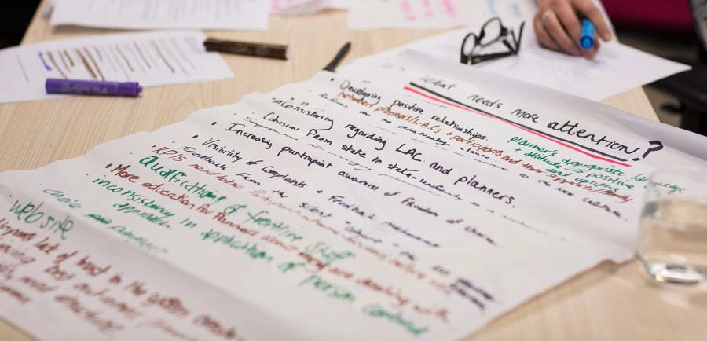
What needs attention butchers paper notes.

Recommendations

ISSUE | SITUATION | COMPLICATION | RECOMMENDATIONS
Participant | In order for the NDIS to | In some cases, especially | 1. The NDIS works with disability
satisfaction | help participants build | when a participant is a | advocate groups to determine the
with their | capability, the NDIS | child, has an intellectual | optimum method for determining a
plans. | must enable them to be in control of their plans.  Participants who  are not assertive, or have certain types of impairment are at increased risk of not being allowed to be in control. | disability, or aphasia or speech impediment, they are at increased risk of not having their needs met despite the best intentions of the NDIS.  This may occur when their needs are expressed on their behalf, which may  be more aligned with the carer's or family's needs or disappointingly, a service provider's needs.  This may result in the participant having unmet needs. | disabled person's needs, taking into account that these may be different from the needs presented by their carer or family.  - Use the information from the above to develop training material for frontline staff, including sensitivity in delivery.  - Routinely benchmark "at-risk disability groups" against other groups to determine if this issue is occurring covertly.  - Facilitate access to self advocacy/ peer support, education and training to support participants  in making informed choices (this should be considered as valid expenditure of NDIS funds).  Urgency of Recommendation Implementation  Immediate review required, implement prior to national rollout.

Jury's butchers paper notes

ISSUE | SITUATION | COMPLICATION | RECOMMENDATIONS
 |  | The jury heard cases of | 1. Planners must be trained
 |  | plans being submitted | and more aware of these cases,
 |  | before the participant was | and offer flexible planning
 |  | comfortable with the plan, | meeting arrangements to ensure
 |  | especially in cases of non- | participants feel they have had
 |  | assertive participants, e.g. | adequate time to develop their
 |  | people with intellectual | plans.
 |  | disability, or aphasia or | 2. Participants should be advised
 |  | speech impairment. | upfront (in pre-planning material) and offered the option to continue their planning meeting with a new planner if they feel that there is not a good match, without retribution. The NDIS must implement a process for this to occur.  The recommendation under Theme 1 & 2 regarding pre- planning correspondence and recommendations regarding visibility of the complaints process should also assist with this issue.  Urgency of Recommendation Implementation  Immediate.
Self- | The individualised | Participants are unlikely | NDIS to ensure planners require
management | funding model | to be used to and perhaps | appropriate training on this issue.
of funding. | enables three models of participant funds management that can be offered by planners (i.e. self-managed, partly self-managed and NDIA-managed). | comfortable with this level of control at first.  NB. The jury agreed that the individualised funding model was satisfactory. | In the case of no participant preference, or an ability to decide, planners to guide participants  to funding model best suited to participant at that time. Set  goals with participant to increase capability to self-manage plans if possible.  Urgency of Recommendation Implementation  Immediate review required, implement prior to national rollout.

ISSUE | SITUATION | COMPLICATION | RECOMMENDATIONS
Creating a | For health and well | Participants are less likely to | Planners should be provided
long-term | being, social inclusion | be assertive about their needs | training to enable and coach
focus | and independence reasons, plans should be developed with a long-term focus. | and have thought about their goals as a part of a disability funding scheme, due to the lack of funding flexibility  and focus on these areas in the block funding model.  Therefore in the early stages of the NDIS, the planner  will need to facilitate more discussion on these topics. | participants to develop a long term focus on their plans, including:  - Helping participants to gain a broader knowledge of the types of services and products available (i.e. they don’t know what they don’t know, and can’t choose what they are unaware of).  - Developing planning meeting frameworks that go beyond a short term focus, so that they combine future aspirations with NDIS support, and support for capability building such as funding personal goals using participant's own funds.  - Planners should be resourced and trained to encourage participants to think outside standard, current service offerings so that a wider and more creative range of services are available and to ensure needs can be met.  Urgency of Recommendation Implementation  Implement during trial phase.
Sustainable | Planners have a large | The NDIS must be sustainable | Planners must receive adequate
and proper | responsibility in | to represent value to the | training on, and have KPIs relating
use of NDIS | balancing sustainable | Australian community and | to ensuring needs are met within
resources | use of NDIS resources with participants' potentially unmet needs and them acquiring enough funding through the NDIS to lead "an ordinary life". | government and enable  participants to lead "an ordinary life".  Whilst the jury heard no evidence of participants receiving funding greater than the NDIS principles entitles them to, with a greater focus on meeting unmet needs and the increased participants joining the NDIS post-roll out, it is imperative that a balance is achieved. | budget, whilst efficiently using the funds available to each participant.  Urgency of Recommendation Implementation  Prior to national rollout.

ISSUE | SITUATION | COMPLICATION | RECOMMENDATIONS
 | Participants | There is risk that carers and | The NDIS develops a two-pronged
 | receive funding | parents of participants with | process to identify and act upon
 | from the NDIS | a disability might misdirect | misuse of its funds.
 | as a direct debit | funding for service providers | 1. Develop and use software to
 | to their bank | from the participants, resulting | reconcile funding provided to
 | accounts under | in the participants not receiving | participants with claims by service
 | the individualised | the services and misuse of NDIS | providers, to identify internally if
 | funding scheme, | funds. | there is a problem, and investigate
 | from which |  | accordingly.
 | they pay service | The jury requested information | 2. Develop a process and internal
 | providers directly. | from the NDIA regarding whether there was an escalation process  in place for reporting of this. The NDIA advised the jury that to enable choice and control, it approaches this issue on a risk basis – and that it has levers it could use under the NDIS Act if  necessary. The NDIA also stated that one way they would notice misuse was because the service providers would not have been paid. At this time, there was no early intervention or reporting process in place.  NB. The jury supports the individualised funding model. | workflow tool for the general public to anonymously report misuse of NDIS funds via the NDIS website, or other contact methods. Family members and those close to participants are likely to have early warnings of these activities occurring.  Urgency of Recommendation Implementation  Immediate review required, implement prior to national rollout.

Juror finalising note taking with Project Staff on final day.

Theme 7 ‘Community support, linkages and referrals’

Successes
- Mainstream support and social inclusion is beneficial to everyone; participant, family and community.
- Introducing competition between service providers through participant-controlled funding is changing service provider culture, improving outcomes and accountability
– evidence from a blind participant stated “it’s sorting out the men from the boys” amongst service providers.
- When LACs are involved, outcomes for participants are in most cases better.
- In places where linkages are effective, referral of people in to NDIS is smoother and outcomes are better (e.g. General Practitioners and Women’s & Children’s Hospital in SA).
- Participants reported reduced isolation.

Recommendations

ISSUE | SITUATION | COMPLICATION | RECOMMENDATIONS
Participant | Participants identified | There needs to be | 1. Have a database as a collection
support | it can be difficult to find | improved access to | point of providers, supports,
to identify | suitable providers. | information through the | contacts, etc. and use the database
suitable |  | participant and provider | to make service providers more
providers. |  | portals so participants can easily access lists of providers in the relevant service areas. | accessible and visible via the NDIS website.  2. Ensure LACs are adequately trained to support participants in choosing providers.  Urgency of Recommendation Implementation  Immediate review required, implement prior to national rollout.

ISSUE | SITUATION | COMPLICATION | RECOMMENDATIONS
Local area | The plans for most | The jury acknowledges the | 1. The roles and responsibilities
coordinators | participants appeared | NDIA has chosen to adopt | of LACs, including the participant
(LACs). | to emphasise funded supports with existing disability providers, greater emphasis could be placed on mainstream services. | different models for LACs and planners in different trial sites in order to evaluate the most effective model and inform national implementation. However, some participants were  not clear on the role of the LAC and others had never heard of an LAC. The jury heard that one of the roles of the LAC  is to train participants in the use of the NDIS portal but this is not happening consistently. | pathway to a LAC, needs to be clarified and promoted to participants.  - The profile of LACs should be increased across the country.  - The NDIA must ensure participants are offered training in the use of the NDIS portal for managing plans.  Urgency of Recommendation Implementation  Immediate review required, implement prior to national rollout.
Fostering | The pathway to | The jury believes greater | 1. Develop a communications plan
effective | the NDIS for some | emphasis needs to be | (who, what, when, where, how)
linkages and | participants was | placed on disseminating | and information pack to distribute
referrals. | assisted by the knowledge of workers in the heath and community sectors (GPs, hospitals, specialists, child care workers). However  it was clear that this was not the case for all participants and  a contributing factor appeared to be the lack of a universal language. | information about the  NDIS and eligibility criteria to frontline workers in mainstream services  such as health and early childcare education and care. | to referral points (e.g. GP, child care centre). Include processes, templates and common language.  2. The NDIS should implement a national awareness campaign for the Australian community.  Urgency of Recommendation Implementation  Immediate review required, implement prior to national rollout.  - Prior to national rollout.

ISSUE | SITUATION | COMPLICATION | RECOMMENDATIONS
Mishandling | The jury heard that | This created additional | Design the workflow of initial
of participant | on two occasions | stress and anxiety for | application to capture all records in a
paperwork. | participant application | participants at what is | timely fashion to stop loss and allow
 | paperwork had been | already a challenging | centralised allocation. All paperwork
 | lost and the onus had | time. | should be scanned into an internal
 | been placed on the |  | database in a timely fashion as soon
 | participants to provide  this information again. |  | as it is received from participants. The Victorian Department of Human
 |  |  | Services has an existing process that
 |  |  | could be replicated.
 |  |  | Urgency of Recommendation
 |  |  | Implementation
 |  |  | Immediate review required,
 |  |  | implement prior to national rollout.
Availability of | The plans for most | There may be a need | 1. Identify mainstream services and
mainstream | participants appeared | to assist mainstream | provide support for organisations
services. | to emphasise funded | service providers to | to adapt services to include people
 | supports with existing | overcome safety fears | with disability.
 | disability providers, | and insurance issues. It | 2. Educate mainstream entities on
 | with little evidence | was noted that LACs play | disability awareness and how NDIS
 | of participants  being connected to mainstream services. | a vital role in connecting  participants to other forms of community support. It is therefore important to ensure | can work with them to improve or create inclusion opportunities for people with disability.  3. Ensure organisations are informed
 |  | greater clarity for LACs | of their legal responsibility to not
 |  | on delineation between | discriminate.
 |  | mainstream health
 |  | services/organisations | Urgency of Recommendation
 |  | and when to refer to | Implementation
 |  | disability services. | Prior to national rollout.
Accessibility | All NDIS participants | It is apparent that | 1. Convene another citizens’ jury to
of service | need service providers | some traditional | examine how providers are working
providers. | and the block funding model has made some providers complacent and perhaps no longer competitive in an open market. | service providers don’t want to change their culture which results in reduced service quality and outcomes for participants. | with participants and the NDIA.  2. Develop disability services so that a viable market exists for participants to ensure coverage and choice.  Urgency of Recommendation Implementation  Prior to national rollout.

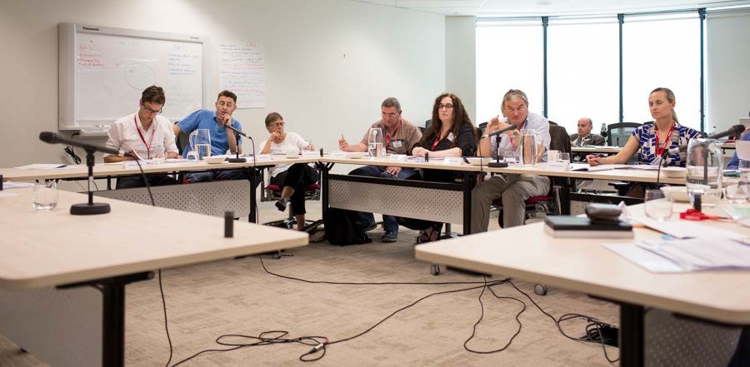
Jurors convene for final day of Citizens' Jury

Theme 8 ‘Meeting the goals of greater economic and social inclusion for people with disability’

Successes
- Creative innovations are life changing for participants, their families and their communities e.g. three-wheel bike; sewing machine for young person to commence her own business. The NDIS enables participants to take the initiative to explore and pursue innovative career paths and alternative income streams (like business start-up grants).
- The NDIS is currently enabling some participants to do what people without disability do – enjoy mainstream services.
- Some participants are living more independently, transitioning to mainstream study and employment.
- Enormous, positive life changes for participants and their families.
- Additional support given allows parents to maintain full-time work.
- Allows families to maintain relationships with other members of family due to additional care and respite provided.
- Participants have reconnected with the community.
- Having choice of housemate when moving on to independent living.
- The NDIS is providing the means for participants to choose mainstream social activities such as bowling, gym, dancing and swimming, with friends of their choice.

Recommendations

ISSUE | SITUATION | COMPLICATION | RECOMMENDATIONS
Innovation | Planners have an | The previous block funding | Implement the following
and long- | immense deal of power | model did not encourage | mechanisms into planner training:
term goals | and responsibility when | anyone to think outside | 1. Develop a creative toolbox to
used in | it comes to assisting | the box when it came | encourage innovation by planners,
developing | participants with | to developing goals and | integrated into planner training,
plans. | developing their plans. | allocating funding for participants. The short term focus due the block funding has left many participants and any planners coming from the previous model without the experience to think innovatively and 'blue-sky' to solve their problems and imagine a positive future. Planners need to  be provided with tools and participants need to be encouraged and enabled to imaginatively use their resources to improve their lives, not simply maintain them. | also for ongoing use e.g. types of questions to ask participants to open up possibilities, for greater inclusion.  - Encouraging and training planners/LACs to be more innovative when making plans with participants.  - Navigating the divide between “cutting edge” treatments and evidence-based treatments.  - Encouraging planners to be proactive to break down barriers to increase inclusion and participation in the longer term.  - Actively supporting the social inclusion of all participants in mainstream activities.  - Train planners to explicitly avoid, identify and overcome barriers.  - Provide planners with the tools they need to navigate the influence of parents/carers who limit goal setting.  - Train planners to consider mainstream options not just disability supports.  - Trains planners to drawing out and/or set goals for alternative.

ISSUE | SITUATION | COMPLICATION | RECOMMENDATIONS
 |  | The NDIS funding must enable participants to choose service providers and services that may be cutting edge or new, in order to foster innovative thinking, but this must be balanced with evidence based  treatments and opportunistic (with dishonourable intentions) service providers. | The NDIS:  - Develops policies and communications to advise participants what treatment and services are eligible for funding to manage their expectations.  - Develop a policy to exclude opportunistic service providers that may not be credible, including the ability for the NDIS to remove that provider from their provider list if it is deemed appropriate.  - Ensuring that therapies relating to long term benefits (e.g. independent mobility) are not defunded without considering the long term effects of defunding. An independent assessment panel may be required to refer such decisions to.  Urgency of Recommendation Implementation  Prior to national rollout.

Juror Shaya Mitchel makes notes

ISSUE | SITUATION | COMPLICATION | RECOMMENDATIONS
Integration | Everyone in society | Unfortunately sometimes | 1. The NDIS run an Australia wide
of | benefits from inclusion | participants may not | marketing campaign about the
participants | in the community and | feel they are ready to | benefits of inclusivity in society for
into | everyone should have | participate in mainstream | people with disability, including;
mainstream | access to and feel | services generally or may | - advantages of the use of
services | included if they chose | have been precluded | mainstream services; targeted at the
and the | to participate in the | from participating in | community.
community. | community and use  mainstream services. | the past, invoking a  negative perception when attempting this again. Further,  mainstream society can be | - advantages of employment and diversity in workforces, and  economic activity; targeted at the community.
 |  | unaccepting of diversity in the community. This is a wider social issue, however the NDIS can make some inroads into assisting participants to  become more involved in mainstream society and using mainstream services, if participants so choose. | - attitudes of mainstream service  providers (e.g. employment agencies) in assisting people with disability; targeted at the community and service providers - both not-for- profit service and private and public health providers.  - attitudes of employers; targeted at employers and employees.  - The NDIS develop information resources to assist mainstream services and employers in helping to include participants in their activities and raise disability awareness.  - The NDIS supports and/or develops programs to enable life skill development so participants have increased chance of improved life outcomes and increased chance of positive economic outcomes  of participants in the general community/nation.  The NDIS ensure that its activities, processes and policies are sensitive to and address the needs of participants who:  - are indigenous;  - are from culturally and linguistically diverse (CALD) background;  - are transient, including homeless.
Urgency of Recommendation Implementation
Prior to national rollout.

Appendix 1 - Glossary of project terms

Advocate witness: A person with disability employed by the project to undertake interviews with participant witnesses and present a complied evidence report, based on the interview feedback, to the citizens’ jury.
Block funding: Block funding is any non-individualised funds that purchase goods or services directly from a service provider, where the funds are held and controlled by the Service Provider.
Citizens’ Jury: A citizens' jury provides the opportunity for citizens to learn about a complex issue, deliberate together and develop well-informed, common- ground recommendations or solutions to difficult public issues. The citizens' jury process also allows decision-makers and the public to discover what
people really think once they have heard from a balanced range of witnesses and taken a close look at a topic.
In a citizens' jury project, a randomly selected and demographically balanced panel of citizens meets for three to five days to carefully examine an issue of public significance. The jury of citizens serves as a
microcosm of the public. Jurors are paid a stipend for their time. They hear from a variety of expert witnesses and are able to deliberate together on the issue. On the final day of their moderated hearings, the members of the citizens’ jury produce recommendations for decision-makers and
the public. Decision-makers commit to respond to the jury's report and recommendations publicly.

Deliberative Democracy:
Deliberative democracy is a field of political inquiry that is concerned with improving collective decision-making. It emphasizes the right, opportunity, and capacity of anyone who is subject to a collective decision to participate (or have their representatives participate) in deliberations about that decision.

Expert/Participant witness:
A person with disability who is a current user of the NDIS in a trial site who was randomly selected to tell their story to the NDIS citizens’ jury.

Local Area Coordination (LAC):
Is a role under the NDIS which is intended to help people with disability, to be linked up in their community and to assist to coordinate the supports they receive through the NDIS as well as those they receive outside
the NDIS.

Medicare levy: From 1 July 2014, the Australian government increased the Medicare levy rate from 1.5 to 2% of taxable income. The money raised from the increase will be placed into a DisabilityCare Australia Fund for 10 years, which will only be drawn upon to fund the additional costs of delivering the NDIS.
NDIS Planner: A planner is a person employed under the NDIS whose role is to assist an NDIS participant to undertake planning and assessment processes to determine the types of services and supports the person needs to achieve their goals.

Person-centred approaches:
Is a process of working with a person with disability to identify and achieve things that they want, drawing on the supports and resources that are available around each individual. The person is at the centre of all decisions regarding their need for, and access to, services and supports.
Plan: NDIS participants can choose how to manage the funding for the supports, this is documented in their individual NDIS plan.
Portability: Portability is ability to transfer of funds for disability services between states and territories should a person move.
Scorecard: The result of the project, in the form of this final report which reports on the determinations of the NDIS citizens’ jury.
Trial Site: The NDIS commenced in July 2013. For the first three years, it is being introduced at trial sites at selected locations. On 1 July 2013, the NDIS began in Tasmania for young people aged 15-24, in South Australia for children aged six and under (on 1 July 2014), and in the Barwon area of Victoria
and the Hunter area in New South Wales for people up to age 65. From 1 July 2014 the NDIS commenced across the ACT, the Barkly region of Northern Territory, and in the Perth Hills area of Western Australia.
Full roll-out of the scheme in New South Wales, Victoria, Queensland, South Australia, Tasmania, the ACT and the Northern Territory will commence progressively from July 2016.

Appendix 2 - Acknowledgements

The jury would like to thank the following organisations and people for providing us with this opportunity and supporting us through the process:

Max Hardy Consulting
Max Hardy Danielle Annells

The National Disability Insurance Agency
David Bowen Alex Madsen Hilda McGrillen

The newDemocracy Foundation
Nivek Thompson

People with Disability Australia
Craig Wallace Matthew Bowden Sonya Price-Kelly Pete Darby

Think Films
Lara Damiani Claudio Raschella Sasha Zastavnikovic
And all of the advocate witnesses and participant witnesses who gave their time and personal stories willingly, to provide us with an understanding of being a participant in the NDIS.

Participant witnesses
Edwina Barker, supported by husband, Arthur Barker Cindy Zbierski, on behalf of son Max
Taryn Waters, on behalf of son Rufus Michaela Banks, on behalf of son Harry

Anne Molloy, on behalf of son Dylan

Sarah Downey, supported by Mum, Anne Marie Downey Tom Dow, supported by Rylan Finch
Linda Blaik Garry Hill
Jacinta Kelly, supported by Dad, Edward Kelly Anne Faulkner
Bob Buckley, representing son Kieran

Briahna Grant-Griffin, supported by Mum, Alisa Griffin

Focus Group Representative
Simone Stevens, supported by Ally Blackney
Advocate witnesses Angelo Cianciosi Crockett Cooke
Justin Ray Kerry Telford
Kristy Trajcevski Jane Wardlaw

National Disability Insurance Scheme Citizens’ Jury Scorecard

The National Disability Insurance Scheme (NDIS) Citizens’ Jury Scorecard Project was an innovative project led by People with Disability Australia (PWDA) in collaboration with Max Hardy Consulting, with the support of the National Disability Insurance Agency (NDIA) between September 2014 and May 2015.
The NDIS Scorecard Project’s objective was to provide the Australian community with the first user led evaluation of the NDIS. Its intention was to use a citizens’ jury and a process known as deliberative democracy to involve both Australian citizens who have helped fund the NDIS and those who have direct knowledge of it as participants, to evaluate the progress of the staged rollout of the NDIS through six of its trial sites.
The citizens’ jury process is recognised globally as an effective engagement mechanism, which not only involves experts with key knowledge and experience but also the wider community in a participatory process of deliberation and feedback. In this way, the citizens’ jury provides an
honest and balanced scorecard based on direct evidence to the Australian community about how their taxes are being used and the development of important policy reform.

people with disability

