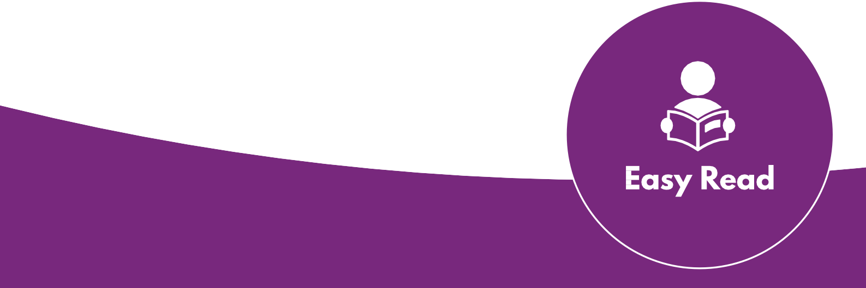Creating Access

Speaking up for yourself

www.pwd.org.au www.youthaction.org.au

- 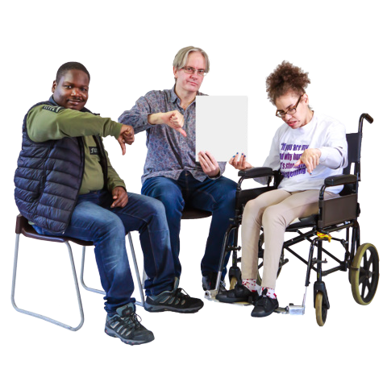A service does not support you the way you want.

- An organisation does not give you the opportunity to have your say.

- 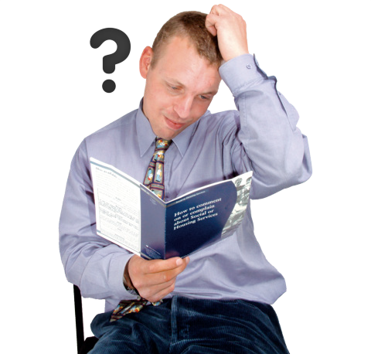Information is hard to read or a website is hard to use.

Think about

- What is the problem you want fixed?

- What do you want to change?

- What support do you need?

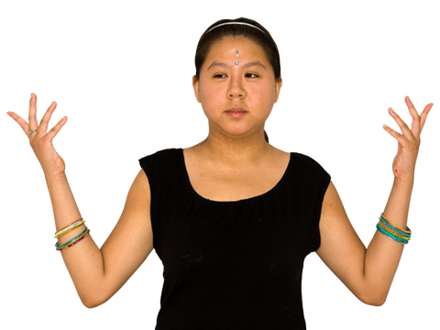What is the best way to raise the issue? Over the phone, by email or in person?

Ask someone you trust what they think.

Think about what you are good at.

If you are good at public speaking you might want to meet with the person.

If you are not good at public speaking you might want to send an email.

Ask for help from your family, friends or an advocate if you need it.

Practice

Write down what you want to say. Be clear and say how you feel.
Practice what you are going to say with someone you trust like a friend or support person.

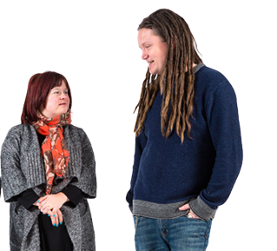If your issue is with a person you can try and talk to them.

Talking to them might fix the problem.

Contact the organisation

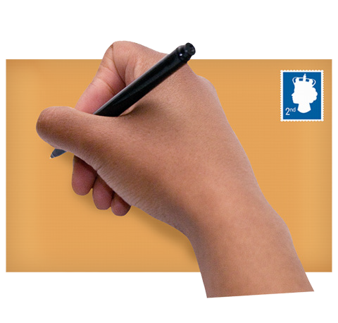If your issue is with an organisation or service you can call them or write to them.

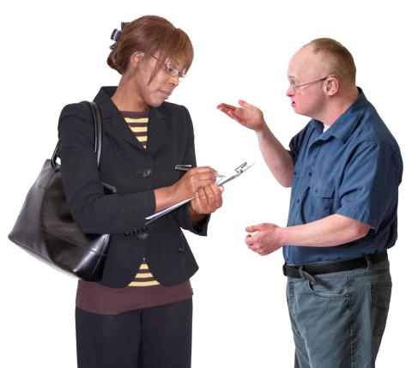You can give feedback to the service.

Feedback means saying what you like or do not like.

Feedback can help make things better.

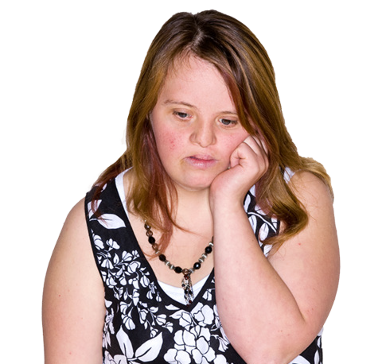A complaint means telling someone that you are not happy about something.

Ask to see their complaints policy it will tell you how they manage issues.

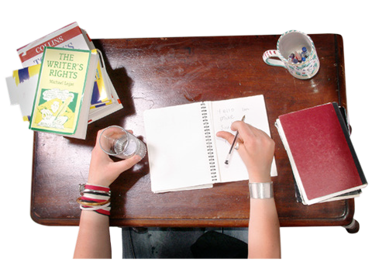Write down

- Who you spoke to

- The date

- Important things you talked about

Make a complaint to the boss.

Contact an advocacy service to help you like People with Disability Australia.

Learn more about speaking up.

There are organisations that train people to speak up.

Look at our other factsheets for more information

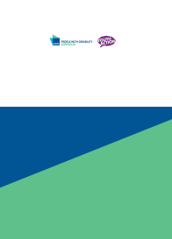Speaking up for social change

Creating Access

Speaking up for social change

www.pwd.org.au www.youthaction.org.au

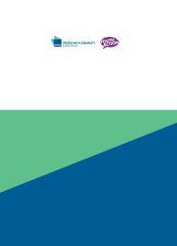What is advocacy?

Creating Access

What is Advocacy?

www.pwd.org.au www.youthaction.org.au

Phone (02) 9370 3100

Email pwd@pwd.org.au

Contact Youth Action for more information

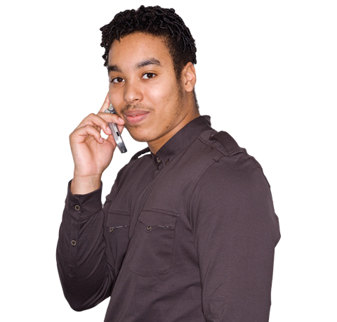Phone (02) 8354 3700

Email info@youthaction.org.au

Creating Access
9

The information in this document was prepared as part of the Creating Access project.

It is between People with Disability Australia (PWDA) and Youth Action.

This work is copyright. Apart from any use as permitted under the Copyright Act 1968, no part may be reproduced without written permission from People with Disability Australia (PWDA) and Youth Action.

© 2019 People with Disability Australia (PWDA) and Youth Action.

