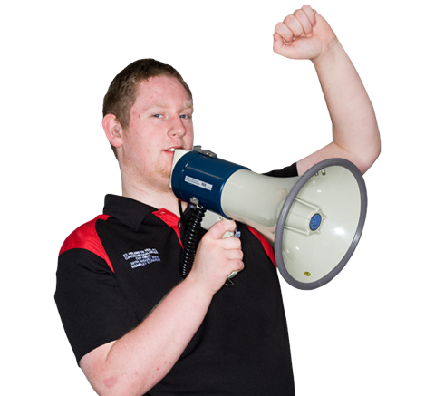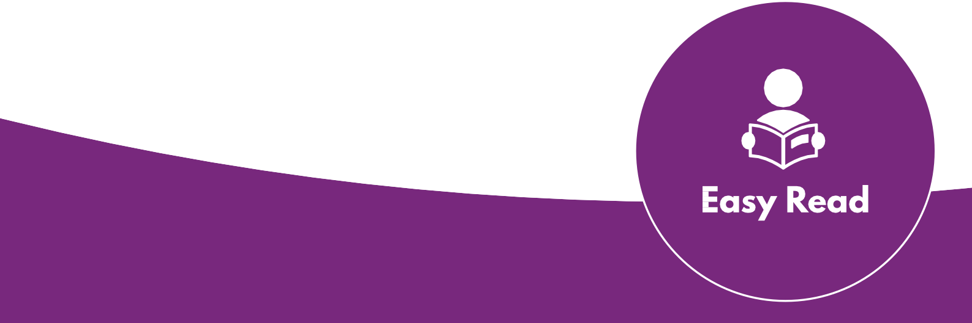Creating Access

What is Advocacy?

www.pwd.org.au www.youthaction.org.au

Your rights

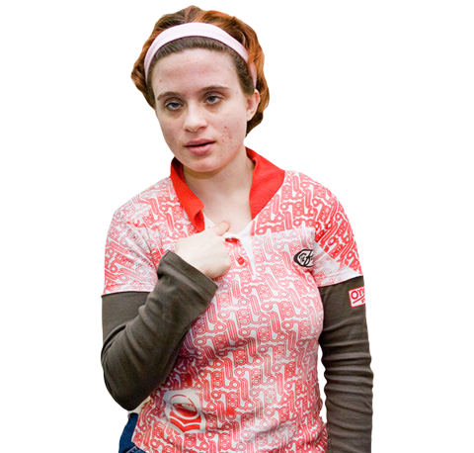Human rights are the rights and freedom we all have.

They are what we need to have a good life.

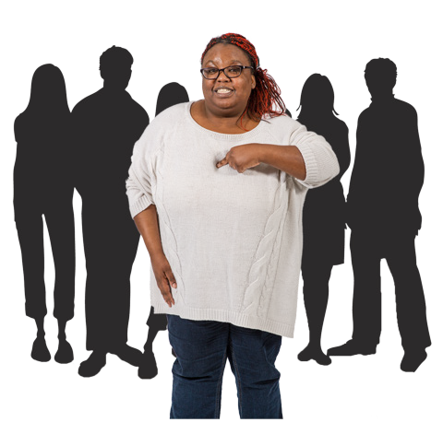People with disability have the same rights as people without disability.

Every person should be treated equal.

Advocacy

Advocacy is about making change by speaking up.

This can be speaking up for

- Your own rights

- Someone else

- An issue in the community

Doing advocacy

Know the issue.

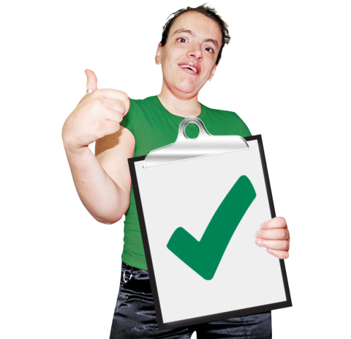Know the change you want.

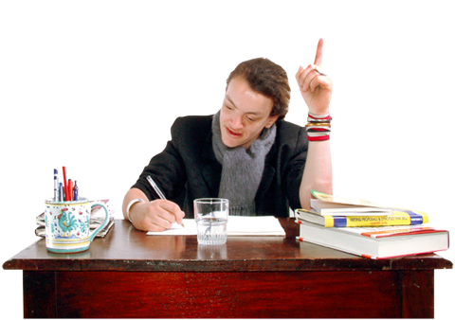Learn skills.

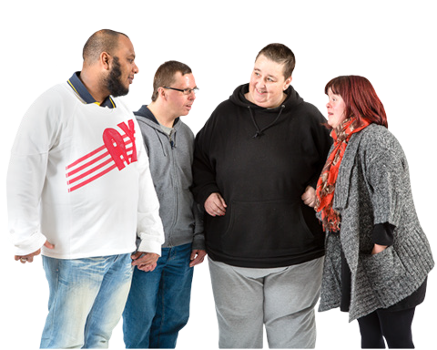Talk to others.

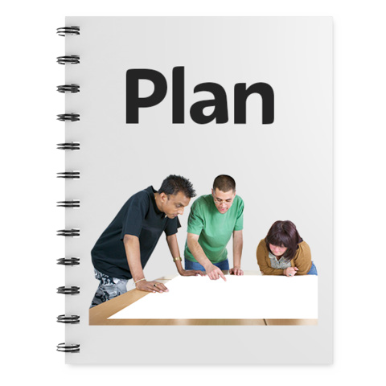Make a plan about how you want to speak up.

Doing advocacy with others

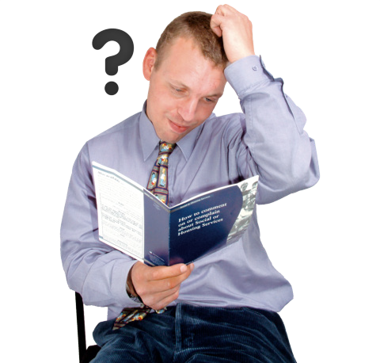Speaking up and doing advocacy on your own can be hard.

There are ways you can do it with other people.

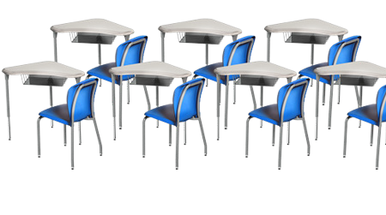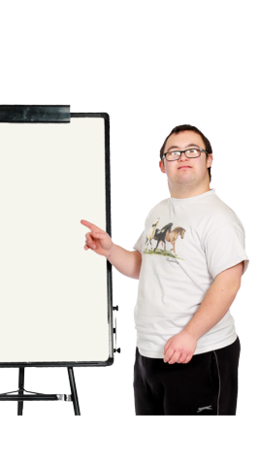You can join a leadership group at your school.

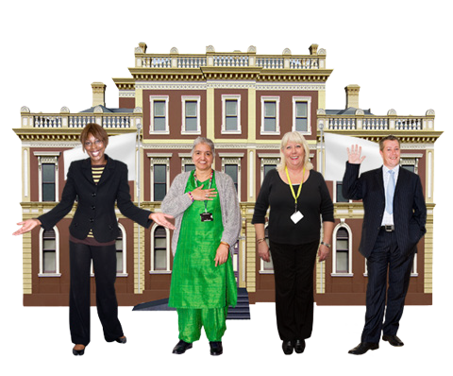Talk to your local council or youth centre and ask if there is a group you can be part of.

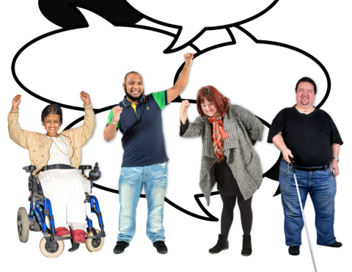Connect with an advocacy group

- Follow them on social media

- Become a member

- Sign up for their newsletter

Who can support you

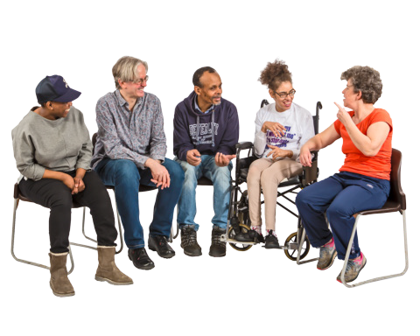If you want to speak up you can get support from
- Friends or family

- Teachers

- A support worker

- An advocacy organisation

More information on advocacy

Look at our other factsheets for more information

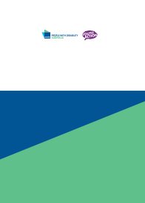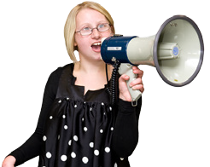Speaking up for yourself

Creating Access

Speaking up for yourself

www.pwd.org.au

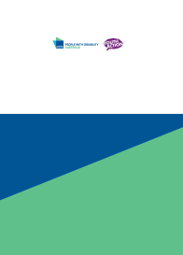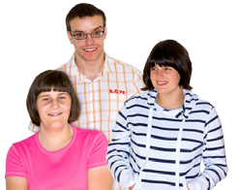Speaking up for social change

Creating Access

Speaking up for social change

www.pwd.org.au www.youthaction.org.au

Contact PWDA for more information

Phone (02) 9370 3100

Email pwd@pwd.org.au

Contact Youth Action for more information

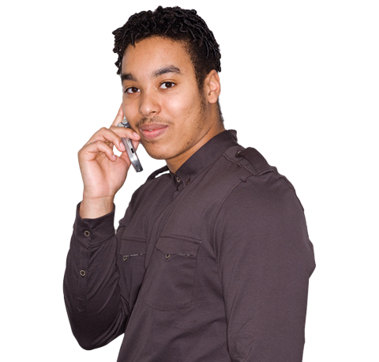Phone (02) 8354 3700

Email info@youthaction.org.au

Creating Access
6

The information in this document was prepared as part of the Creating Access project.

It is between People with Disability Australia (PWDA) and Youth Action.

This work is copyright. Apart from any use as permitted under the Copyright Act 1968, no part may be reproduced without written permission from People with Disability Australia (PWDA) and Youth Action.

© 2019 People with Disability Australia (PWDA) and Youth Action.

