Inquiry into Newstart and alternative mechanisms for determining income support

Submission to the Senate Standing Committee on Community Affairs Inquiry into the adequacy of Newstart and alternative mechanisms to determine the level of income support payments in Australia
SEPTEMBER 2019

About PWDA
People with Disability Australia (PWDA) is a leading disability rights, advocacy and representative organisation of and for all people with disability. We are the only national, cross-disability organisation, and we represent the interests of the 1 in 5 Australians with a disability. We are a non-profit, non-government organisation.

PWDA’s membership is made up of people with disability and organisations primarily constituted by people with disability. PWDA also has a large associate membership of other individuals and organisations committed to the disability rights movement.

We have a vision of a socially just, accessible and inclusive community, in which the human rights, belonging, contribution, potential and diversity of all people with disability are recognised, respected and celebrated with pride. PWDA was founded in 1981, the International Year of Disabled Persons, to provide people with disability with a voice of our own.

PWDA is a NSW and national peak organisation and founding member of Disabled People’s Organisations Australia (DPO Australia) along with Women With Disabilities Australia, First Peoples Disability Network Australia, and National Ethnic Disability Alliance. Disabled Peoples Organisations (DPOs) are organisations that are led by, and constituted of, people with disability.

The key purpose of DPO Australia is to promote, protect and advance the human rights and freedoms of people with disability In Australia by working collaboratively on areas of shared interests, purposes, strategic priorities and opportunities.

Postal address:
PO Box 666
Strawberry Hills NSW 2012
Street address:
Level 8
418A Elizabeth St
Surry Hills NSW 2010
Phone: 02 9370 3100
Fax: 02 9318 1372
Toll Free: 1800 422 015
NRS: 1800 555 677
TTY: 02 9318 2138
TTY Toll Free: 1800 422 016
TIS: 13 14 50
Email: pwd@pwd.org.au
ACN: 621 720 143

Contents
About PWDA 2
Introduction 4
Summary of recommendations 6
Response to Terms of Reference 8
- Item A- Consideration of what constitutes an acceptable standard of living 8
- Item B- The labour market, unemployment and underemployment in Australia, including the structural causes of long term reliance on Newstart 10
- Item D- The appropriateness of current arrangements for supporting those experiencing insecure employment, inconsistent employment and precarious hours in the workforce 13
- Item E – The current approach to setting income support payments in Australia 14
- Item F – The impact of the current approach to setting income support on people with disability 17
- Item H – The adequacy of income support payments in Australia and whether they allow people to maintain an acceptable standard of living in line with community expectations and fulfil job search activities (where relevant) and secure employment and training 18
- Item N – The relevant merits of alternative investments in health, education, housing and other programs to improve outcomes 19
- Item R – Other related matters 19
Appendix A – Shadow Report Survey 21

Introduction
Research shows that people with disability face significant barriers to accessing employment. People with disability rely on income support payments to meet basic living costs as well as disability-related costs.

PWDA has significant concerns about the level of income support for both Newstart and related payments such as the Disability Support Pension (DSP) due to the following structural reasons:

- We face barriers to employment

As part of our work with DPO Australia, we recently conducted a survey of nearly 900 people with disability for the Civil Society Shadow Report to the United Nations Committee on the Rights of Persons with Disabilities (Appendix A). Our survey found that 60% of respondents do not have the same employment opportunities as non-disabled Australians.

Our survey also found that we constantly face discrimination. 76.5% of us have felt discrimination or feel like we have been treated unfairly, and 51% of us do not feel anti-discrimination laws help us when we have been treated badly. These findings go some way to explain the barriers we face in access to mainstream employment.

Of those of us who are employed, 1 in 3 of us do not think our employer makes adjustments for our disability. This impacts our ability to maintain a job or forces us to make decisions around the type of job we can have despite our actual capabilities and strengths.

- We face barriers to accessing mainstream education and training

A large percentage of people with disability surveyed also feel like we do not have the same education opportunities as non-disabled Australians, with 41% of those surveyed feeling this way. Poorer education outcomes represents another barrier we face to meaningful employment.

For these reasons, amongst others, we may find we have to rely on income support payments. Regrettably, income support payments are not simply a safety net while we transition to another job.

Sometimes due to multiple barriers to employment, we are forced to rely on these payments for the long term as our main source of income.

- We have higher living costs

The Shadow Report survey also found 61% of us believe our income, even if we are employed, is not enough to support our basic needs for housing, food and transport. For those of us relying solely on income support payments, that feeling of insecurity is greatly exacerbated.

In addition, people with disability incur higher costs of living than those without disability. This is because disability is expensive. We have higher medical expenses, and need to spend more on transportation, and to live in housing that is modified to suit our individual circumstances. We also have disability support costs that we need to meet, unlike those without disability.

When we are not funded by the National Disability Insurance Scheme (NDIS) then these cost pressures are worse. As a result, the financial insecurity we experience limits our choices to live in the community, preventing the full realisation our social, political and economic rights.

Considering the above, and noting the Terms of Reference for this Inquiry, we will comment on the following matters:

- consideration of what constitutes an acceptable standard of living in Australia

- the labour market, unemployment and under-employment in Australia, including the structural causes of long-term unemployment and long-term reliance on Newstart

- the appropriateness of current arrangements for supporting those experiencing insecure employment, inconsistent employment and precarious hours in the workforce

- the current approach to setting income support payments in Australia

- the impact of the current approach to setting income support payments on people with disability, people from culturally and linguistically diverse backgrounds, and people living in regional and remote areas

- the adequacy of income support payments in Australia and whether they allow people to maintain an acceptable standard of living in line with community expectations and fulfil job search activities (where relevant) and secure employment and training

- the relative merits of alternative investments in health, education, housing and other programs to improve outcomes

- any other related matters.

Summary of recommendations
Recommendation 1 – Establish a Senate inquiry into the adequacy of the income support system for people with disability. The Terms of Reference for the inquiry should be designed with people with disability, and should include a review of the current approach and definitions within the impairment tables, debt recovery processes, and ways in which people with disability can be supported to gain entry into open employment, without being punished through the withdrawal of payments.
Recommendation 2 – Create a National Jobs Plan to address the multiple and systemic barriers people with disability face in finding and keeping a job. This Plan must:
- implement recommendations from the 2016 Willing to Work Inquiry into Employment Discrimination Against Older Australians and Australians with Disability
- commit to no more people with disability entering ADEs, no new ADEs being established, and a plan to close all ADEs and end segregated employment within the next decade
- set specific targets, performance indicators and timeframes for increasing the workforce participation for people with disability across all sectors
- address intersectional barriers that make it harder for many of us to find and keep work, such as gender and cultural discrimination and rural and remoteness
- strengthen the transition of young people with disability from the school education system into tertiary education and into open/mainstream employment
- integrate with the social security system to support those of us with episodic disability who may move in and out of employment
- have a monitoring and evaluation framework, with key milestones, and specified dates for public reporting on progress.
Recommendation 3 – Establish and fund a national, multi-sector Disability Employment Coalition to:
- drive development and track implementation of the National Jobs Plan
- exchange ideas and showcase good practice in inclusive employment
- drive strategies to remove the multiple barriers to employment for people with disability
- provide high-level advice to the Commonwealth Government.
Recommendation 4 – Ensure membership of the Disability Employment Coalition include:
- Disabled People’s Organisations (DPOs)
- disability, employer and industry peaks
- best-practice disability employment services
- cross-agency representatives from local, state and Commonwealth government representatives from the NDIA
Recommendation 5 – End the automated debt collection process for people with disability and design a new process that considers the following:
- the time and support needed to understand the information provided about these debts and compliance measures
- the availability of information in different and accessible formats
- the ability of people with disability to provide evidence for inaccurate debts
- the availability of advocacy to support people with disability engage with the Centrelink system
- the adequacy of steps for people with disability before a debt is referred to a debt collection agency.
- the impact of outsourcing debt collection will have on people with disability
Recommendation 6 – Maximum rates of Newstart be raised by an absolute minimum of $75 per week.

Recommendation 7 – Newstart be indexed (for both singles and couples) twice per year to movements in a standard Australian Bureau of Statistics measure of wage levels before tax, as well as movements in the CPI.

Recommendation 8 – End the ongoing eligibility restrictions for the DSP to ensure a more adequate standard of living for people with disability.

Recommendation 9 – The Government respond to the recommendations outlined in the Jobactive: failing those it is intended to serve Report to the Senate Standing Committees on Education and Employment’s Inquiry into the appropriateness and effectiveness of the objectives, design, implementation and evaluation of jobactive.

Recommendation 10 – The Government investigate an appropriate rent assistance increase and increase rent assistance accordingly.

Response to Terms of Reference

Item A- Consideration of what constitutes an acceptable standard of living

Article 11 of the International Covenant on Economic, Social and Cultural Rights (ICESCR) establishes a clear right to an adequate standard of living. Article 28 of the Convention of the Rights of Persons with Disabilities (CRPD) also provides for an adequate standard of living for people with disability and their families “…including adequate food, clothing and housing”.

Research by the Australian Council of Social Service (ACOSS) shows that 13.2% of the general population live below the poverty line. People with a disability experience a greater level of poverty, with Australia remaining last out of the 27 Organisation for Economic Co-operation and Development (OECD) countries when it comes to relative poverty risk for people with a disability.

This means that 45% of people with disability in Australia live near or are below the poverty line.

Many people with disability do not currently enjoy an acceptable standard of living in Australia. At a bare minimum we expect an acceptable standard of living would mean that:

- we can meet our basic living costs
- we can meet disability support costs.

However, as our recent Shadow Report survey showed, 61% of us believe our income, even if we are employed, is not enough to support these very basic needs. Recent statistics from the Australian Institute of Health and Welfare (AIHW) support this, with income more likely to come from the income support system than employment.

This suggests our reliance on income support is caused by structural barriers. For people with a disability, Newstart and other related payments are not transitory payments. In fact, income support is often the primary source of income.

A recent online survey of our members for this submission supports this conclusion. We found 35% of our members remain on Newstart for one to three years, 24% remained for three to five years, and another 24% remained on Newstart for over five years. This means, a significant majority (79%) of our members who participated in the survey remain on Newstart between 1-5 years.

Therefore, assessment of what constitutes an acceptable standard of living for people with disability needs to also consider the structural barriers preventing us from working, particularly education, health and housing barriers.

Drawing on further data from the AIHW, we are falling behind in the following ways:

- Education

- only 32% of us have completed year 12, compared to 62% of us without disability
- only 15% of us obtain a bachelor’s degree, compared to 31% of us without disability
- we are more likely to leave school before 16 than those without a disability (19% vs 11%)
- more of us are attending special schools due to inaccessibility than a decade ago (14% in 2015 vs 10.7% in 2003)
- 1 in 5 of us studying have experienced discrimination, and the largest source of discrimination are our teachers (29%).

- Health

- we are six times more likely to self-assess our health as poor or fair
- of those with severe or profound disability, we are 12 times more likely to experience a very high level of psychological distress
- 1 in 5 of us delay or do not see a primary health physician because of costs
- our health risks are higher across all risks than those without disability.

- Housing

- 8.1% of people accessing Specialist Homelessness Services have a disability and 34% have a severe or profound disability.
- of those seeking homelessness services, 42% seek them for basic accommodation
- we are 4 times more likely to live in social housing than those without disability
- 2 in 5 social housing households (42%) have at least one person with disability.

These statistics show the standard of living for people with a disability clearly needs to be improved. Structural and systemic barriers prevent us from achieving the same standard of living as everyone else on even the most basic indicators such as health, housing, education and employment.

Until these structural barriers are removed, we will be reliant on the safety net that income support provides. Because of the entrenched structural barriers to employment of people of disability in Australia, we recommend the following:

Recommendation 1 – Establish a Senate inquiry into the adequacy of the income support system for people with disability. The Terms of Reference for the inquiry should be designed with people with disability, and should include a review of the current approach and definitions within the impairment tables, debt recovery processes, and ways in which people with disability can be supported to gain entry into open employment, without being punished through the withdrawal of payments.

Item B- The labour market, unemployment and underemployment in Australia, including the structural causes of long term reliance on Newstart

The employment rates for people with disability are unacceptably low. Only 48% of people with disability of working age are employed, compared to 79% of our non-disabled peers. This gap has not changed in decades. When compared with other OECD countries, Australia ranks 21 out of 29 in employment participation rates for people with disability.

Since 2010, the Commonwealth Government has introduced measures to force many of us off social security payments and into jobs. However, this approach hasn’t worked. It has failed to address the systemic barriers we face in gaining access to open employment.

We need a whole-of-government and whole-of-community approach to enable employers to create meaningful, flexible and inclusive employment, make workplaces more accessible, remove discrimination and build positive employer and community attitudes.

- The Commonwealth Government needs to be a model employer

This needs to start with the Commonwealth Government becoming a model employer. Despite efforts through the As One: Making it Happen – APS Disability Employment Strategy 2016-2019, the percentage of employees with disability has only increased by 0.3% in nearly ten years (from 3.4% in 2009 to 3.7% in 2018).

The APS also has difficulty retaining diverse talent. The ability to retain employees with a disability in the APS diminishes the higher the APS level. The 2018 Employee Census reveals the APS can do more to keep people with disability employed.

Of employees in APS level 1-4, 11% have an ongoing disability, with this percentage decreasing to 8% in APS level 5-6. Of those employees in Executive Levels 1-2, 7% have an ongoing disability, and this then drops to 5% of Senior Executive Service employees.

- Employment outcomes for NDIS participants need to improved

The National Disability Insurance Agency (NDIA) needs to also improve the employment outcomes of NDIS participants. The longitudinal trend in employment outcomes for NDIS participants were last reported in the 2018 Second Quarterly Report to the Council of Australian Governments (COAG) Disability Reform Council (DRC). It was noted:

Since baseline measures were recorded in 2016-17 Q1 and Q2, overall participant employment rates have remained static. While some participants have been successful in gaining employment over this period, others have left their positions. Of those who had a job when they entered the NDIS, 81% had a job two years later, 11% were seeking another job two years later, and the remaining 8% were not seeking another job. Of those who were looking for a job when they entered the NDIS, 14% had a job two years later.

The NDIS is designed to support us to pursue our social and economic goals. Therefore the NDIS has a pivotal role to play in enabling us to find and keep a job we want.

The NDIA should focus on strengthening employment goal setting in NDIS planning and reviews, with a focus on providing a supported career pathway for participants. This should take a long-term, life-time approach putting in place the support we need to transition through our school, training and employment journey.

The static longitudinal employment outcomes reported in the 2018 Q2 Quarterly Report further highlights the structural barriers to employment are deeply entrenched.

- Addressing the challenges with the Disability Employment Services (DES) system

Currently DES support approximately 160,000 jobseekers with disability. This represents only a small proportion of us seeking employment. However, for those of us who do use DES, the system is not working: only 10% of DES participants secure employment.

We need DES to strengthen their focus on pathways and outcomes for young people with disability who are leaving school and moving to vocational and tertiary education and employment. Without this, we will not address the long-term and entrenched structural barriers to employment for people with disability.

We want higher expectations for school leavers with disability and a stronger focus on career planning, not just for NDIS participants, but for all young people with disability.

Despite the reforms to DES over the last 12 months, we still don’t have a system that meets our needs. Independent advocacy and information is required to support us to make informed decisions around our choice of DES providers and assist us to navigate the system.

Ending the segregation of people with disability in Australian Disability Enterprises (ADEs)

ADEs are a form of segregated employment where employees are paid as little as a $1 an hour. Less than 1% of the 20,000 people with disability who currently work in an ADE get the opportunity and support to move into open employment. This has to change.

We need measures that include clear pathways and timeframes to transition all ADE workers into open employment, or where workers are older, plans should look at progressive retirement.

To address the above labour market issues, we recommend the following:

Recommendation 2 – Create a National Jobs Plan to address the multiple and systemic barriers people with disability face in finding and keeping a job. This Plan must:
- implement recommendations from the 2016 Willing to Work Inquiry into Employment Discrimination Against Older Australians and Australians with Disability
- commit to no more people with disability entering ADEs, no new ADEs being established, and a plan to close all ADEs and end segregated employment within the next decade
- set specific targets, performance indicators and timeframes for increasing the workforce participation for people with disability across all sectors
- address intersectional barriers that make it harder for many of us to find and keep work, such as gender and cultural discrimination and rural and remoteness
- strengthen the transition of young people with disability from the school education system into tertiary education and into open/mainstream employment
- integrate with the social security system to support those of us with episodic disability who may move in and out of employment
- have a monitoring and evaluation framework, with key milestones, and specified dates for public reporting on progress.
Recommendation 3 – Establish and fund a national, multi-sector Disability Employment Coalition to:
- drive development and track implementation of the National Jobs Plan
- exchange ideas and showcase good practice in inclusive employment
- drive strategies to remove the multiple barriers to employment for people with disability
- provide high-level advice to the Commonwealth Government.
Recommendation 4 – Ensure membership of the Disability Employment Coalition include:
- Disabled People’s Organisations (DPOs)
- disability, employer and industry peaks
- best-practice disability employment services
- cross-agency representatives from local, state and Commonwealth government representatives from the NDIA

Item D- The appropriateness of current arrangements for supporting those experiencing insecure employment, inconsistent employment and precarious hours in the workforce

The current arrangements to supporting people with disability experiencing insecure employment, inconsistent employment and precarious hours are not appropriate.

The arrangements, in particular the reporting requirements, remain inaccessible to many people of disability. At a basic level, the information we require needs to be available in different, accessible formats and languages including Auslan and Easy English. We should also have clear access to or increased access to advocacy, to support our engagement with the Centrelink system more effectively.

We are also often asked to provide information in ways that aren’t accessible, and with limited time to respond. We expect well-trained staff to help us with questions we may have, or to request reasonable adjustments.

The online compliance also is often inaccessible and difficult to use for many people with disability.

To address some of these issues, we recommend the following:
Recommendation 5 – End the automated debt collection process for people with disability and design a new process that considers the following:
- the time and support needed to understand the information provided about these debts and compliance measures
- the availability of information in different and accessible formats
- the ability of people with disability to provide evidence for inaccurate debts
- the availability of advocacy to support people with disability engage with the Centrelink system
- the adequacy of steps for people with disability before a debt is referred to a debt collection agency.
- the impact of outsourcing debt collection will have on people with disability

Item E – The current approach to setting income support payments in Australia

The current approach we have today has developed between 2006 and 2015. The changes are summarised below:

2006

- A ‘comprehensive work capacity’ assessment was introduced for the Disability Support Pension (DSP).

  - These changes provided that if someone was assessed as being able to work 15-29 hours per week at award wages in the open labour market, then they would be required to seek 15 hours or more of part-time work a week
  - The individual would also be placed on the much lower Newstart payment.

2012

- New impairment tables were introduced for the DSP, which focused more on the extent to which a person’s impairment affected their ability to work instead of the diagnosis of a disabling condition.

2014

- A further requirement for ‘compulsory activities’ for DSP recipients under 35 years old was added.

  - If someone on the DSP was assessed to have a work capacity of 8 hours or more a week, then they had to commit to a range of compliance activities such as develop participation plans and attend regular interviews at Centrelink

2015

- Medical reports were no longer required from an individual’s treating doctors

- Instead, a new checklist of types of primary medical evidence to support a DSP application were required

- This created a two-stage DSP assessment, where a person with a disability was required to fulfil the following:

  - undertake a Job Activity Assessment conducted by an allied health professional
  - if the assessor concluded the person met the DSP criteria, a Disability Medical Assessment with a Government-contracted doctor, who reviews and scores the medical evidence to determine the outcome.

These changes remain today and we hold significant reservations over the changes, including, but not limited to:

- the lack of recognition of the episodic nature of some disabilities
- the inaccessibility of providing evidence
- the inaccessibility of compliance activities
- the inadequacy of capacity to work assessments
- the poor understanding of the two-stage DSP assessment by allied health and medical professionals
- the lack of evidence supporting the changes.

The current approach has seen the number of successful DSP claims dropped from 89,561 per year in 2010-11 to 31,000 in 2017-18, corresponding with a decline in the overall number of DSP recipients to 756, 960 in 2017-18 from a high of 827,460 in 2011-12.

At the same time, the number of Newstart recipients assessed as having a partial capacity to work due to illness or disability grew by 83% to 199, 907. This represents a growth rate of nearly 3.5 times faster than the growth in the total number of Newstart recipients over the same period (26%).

- The current approach further marginalises people with disability

This clearly demonstrates the two payments are interdependent. With more people with disability now accessing Newstart instead of the DSP, we have further concerns with how the current approach is indirectly further marginalising people with disability.

Recent research and modelling by the National Centre for Social and Economic Modelling at the University of Canberra found that the current approach to setting both the Newstart or DSP payments makes it “…more likely [people with disability will] experience financial hardship and insecurity compared with all other Australian households”, with those on Newstart at even greater risk.

The insecurity caused by both payments needs to be addressed. People with disability overwhelming rely on income support as their main source of income, compared to those without disability, as the below table demonstrates:

Table 1 – How much do people with disability rely on income support as their main source of income?

Age | With disability | Without disability
15-24 | 49% | 14%
25-64 | 46% | 8.7%
65+ | 75% | 56%

Source: Australian Institute of Health and Welfare (2019)

Considering the reliance on income support as a primary source of income, approaches that result in financial hardship and insecurity are unacceptable. This is contrary to the purpose of income support payments. The purpose of income support is to promote an enhanced quality of life for people with disability, enabling the realisation of rights under both the CRPD and ICESCR.

We need an income support system that ends the ongoing eligibility restrictions for the DSP, increases the rate of Newstart and other income support payments, to ensure people with disability have access to an adequate standard of living.

To address these issues, we recommend:

Recommendation 6 – Maximum rates of Newstart be raised by an absolute minimum of $75 per week.

Recommendation 7 – Newstart be indexed (for both singles and couples) twice per year to movements in a standard Australian Bureau of Statistics measure of wage levels before tax, as well as movements in the CPI.

Recommendation 8 – End the ongoing eligibility restrictions for the DSP to ensure a more adequate standard of living for people with disability.

Item F – The impact of the current approach to setting income support on people with disability

The current approach to setting income support does not factor in the cost of disability, directly impacting the ability of people with disability to participate in all aspects of Australian life.

People with disability must allocate their often very limited income to overcome the barriers they face. This means they have less opportunity to spend on goods and services that enable them to participate in all aspects of Australian life.

Table 2 highlights how not factoring the cost of disability in the income support system impacts the day-to-day life of people with disability.

Table 2 – A comparison of the impact of the income support system on the day-to-day life of people with disability

 | All households | DSP | Newstart
Can’t afford to buy new clothes most of the time | 11% | 28.5% | 48%
Can’t afford to spend time on leisure or hobbies | 10.4% | 27% | 44.5%
Can’t afford a holiday away from home for at least 1 week a year | 22.6% | 46.3% | 66.2%
Can’t afford to have a night out once a fortnight | 16.6% | 39% | 54.8%
Can’t afford to have friends/family over for a meal once a month | 7.3% | 23.6% | 27.7%
Can’t afford to have a special meal once a week | 11.9% | 29.6% | 46.8%
Can’t pay for fuel or telephone bill | 9.7 | 18.9% | 31.4%
Can’t pay car registration/insurance | 3.9% | 7.7% | 13%
Went without meals | 2.7% | 11.5% | 14.4%
Couldn’t heat or cool home | 2.3% | 5.9% | 14.8%
Couldn’t raise $2000 within a week | 13.2% | 37.5% | 43.4%
Sought assistance from welfare/community organisations | 2.6% | 10.7% | 16.6%
Sought financial help from friends/family | 7% | 14.3% | 29.1%
Unable to save money most weeks | 55.3% | 72.3% | 88.2%

Source: NATSEM (2019)

Ignoring the cost of disability in the income support system further entrenches the cycle of poverty, exclusion and marginalisation of people with disability. People with disability are already twice more likely to experience deep and persistent disadvantage than the national prevalence (11.2%). A system that further deepens the persistence of disadvantage is unacceptable.

Item H – The adequacy of income support payments in Australia and whether they allow people to maintain an acceptable standard of living in line with community expectations and fulfil job search activities (where relevant) and secure employment and training

Current income support payments do not allow for people with disability to maintain an acceptable standard of living in line with community expectations as outlined in section (a).

Separately, our ability to fulfil job search activities and secure employment and training is also not in line with community expectations.

We note the 2018 Senate Standing Committees on Education and Employment’s Inquiry into the appropriateness and effectiveness of the objectives, design, implementation and evaluation of Jobactive has already noted Jobactive fails those it intends to serve.

The community expects the income support system should adequately prepare people with disability for meaningful and secure employment. However, this is not the case for us. Full-time placements are down from 44% in 2003 to 23% today, and the shift toward activities compliance and penalties is at the expense of employment services delivering on their core job of securing employment for us.

Only 10.3% of jobactive staff time is spent working with employers, with more than a third of their time (34.6%) being spent on compliance measures. This disproportionate level of compliance does not align with what the community expects jobactive to do.

Considering the decline in securing full-time employment, we raise concerns over the mutual obligations principle that underpins the income support system. We can’t expect people with disability to adhere to activities when those activities do not support their purported aims.

We particularly can’t expect people with disability to adhere to activities when they remain inaccessible as outlined thoroughly in section (d).

Considering the above, we recommend the following:

Recommendation 9 – The Government respond to the recommendations outlined in the Jobactive: failing those it is intended to serve Report to the Senate Standing Committees on Education and Employment’s Inquiry into the appropriateness and effectiveness of the objectives, design, implementation and evaluation of jobactive.

Item N – The relevant merits of alternative investments in health, education, housing and other programs to improve outcomes

As discussed in sections (a) and (b) the structural barriers we experience in core services like health, education and housing significantly effects our overall outcomes and standards of living. We would welcome alternative investments in these core services, as an important way of realising our full rights.

We would also welcome investments in accessible transport so we have a viable and affordable way of participating in employment and in the community.

We would also welcome investments in justice, so when we experience discrimination in other core services, we feel confident and empowered to start a timely and accessible legal course of action to correct the unlawful behaviour.

The value of having these core services accessible to us will not only improve outcomes for those with disability but will improve outcomes for all.

Item R – Other related matters

A related structural reason that drives our reliance on the income support system is our struggles to find a place to call home. Every day, people with disability contact PWDA asking for help in putting a roof over their head.

Without a roof over our heads, we are unable to find employment. We need a significant investment in a broad suite of housing measures across governments in order to address this housing crisis.

The Commonwealth Government has a significant role in funding social and affordable housing, through grants to States and Territories. The Commonwealth Government must leverage this power and significantly influence the availability of public housing, including setting targets for dwellings for people with disability.

PWDA, along with many people with disability support the Everybody’s Home campaign. We need new capital investment to generate 300,000 new social and Aboriginal housing properties and a new tax incentive or direct subsidy to leverage super fund and other private sector investment in 200,000 low cost rental properties for low and middle-income earners.

We recognise the complexity of housing policy. However, an interim solution would be to increase rent assistance. Current rent assistance, for people eligible for income support, is $135.80 for singles who rent. This is not adequate to reduce housing stress for many people with disability who rely on income support.

People with disability also have housing costs that non-disabled people do not share, including limited availability which can push the market price up, utility costs and the need for modifications.

The Productivity Commission recently recognised that rent assistance payments make a significant contribution to improving affordability of rentals for “vulnerable private renter households” such as households with a person with disability.

The Productivity Commission also found the ability of rent assistance to cushion “vulnerable private renter households” from rental price increases has diminished over time as the Consumer Price Index — against which the rental assistance is indexed — has grown slower than rents. This further suggests the need for an increase in rent assistance.

Considering this, we recommend:

Recommendation 10 – The Government investigate an appropriate rent assistance increase and increase rent assistance accordingly.

Appendix A – Shadow Report Survey

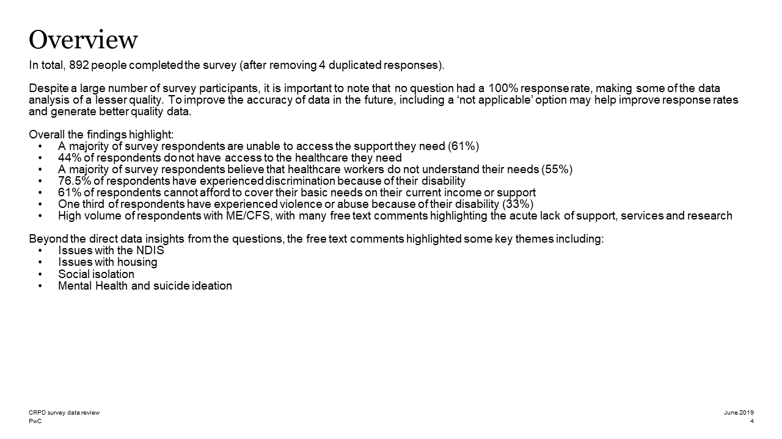

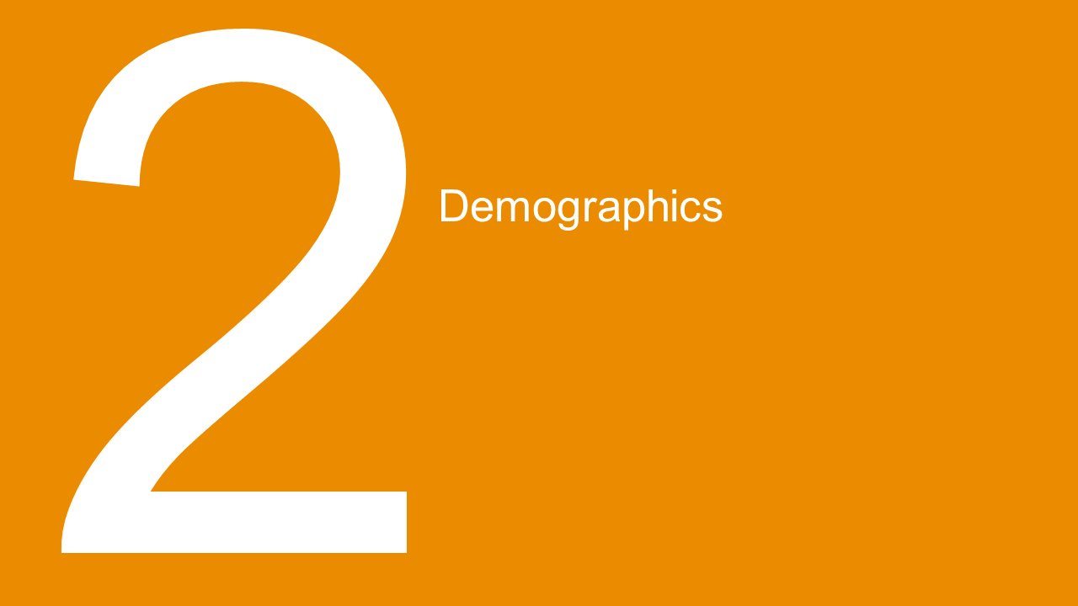

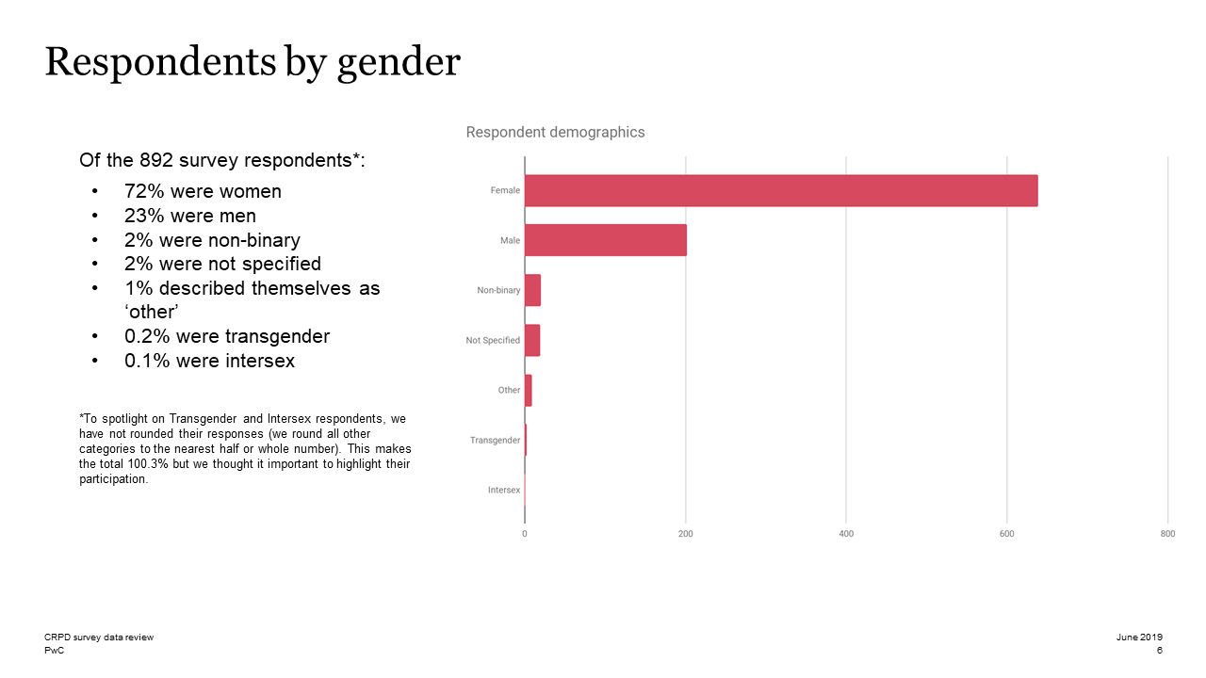

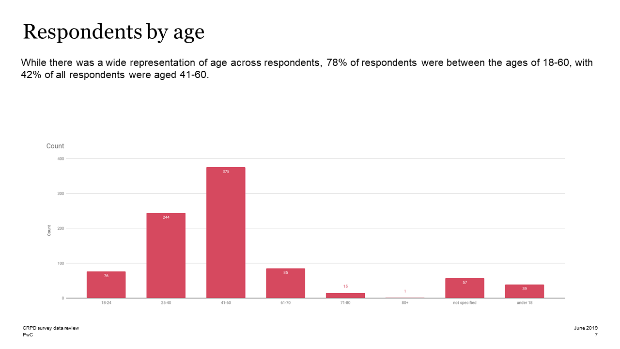

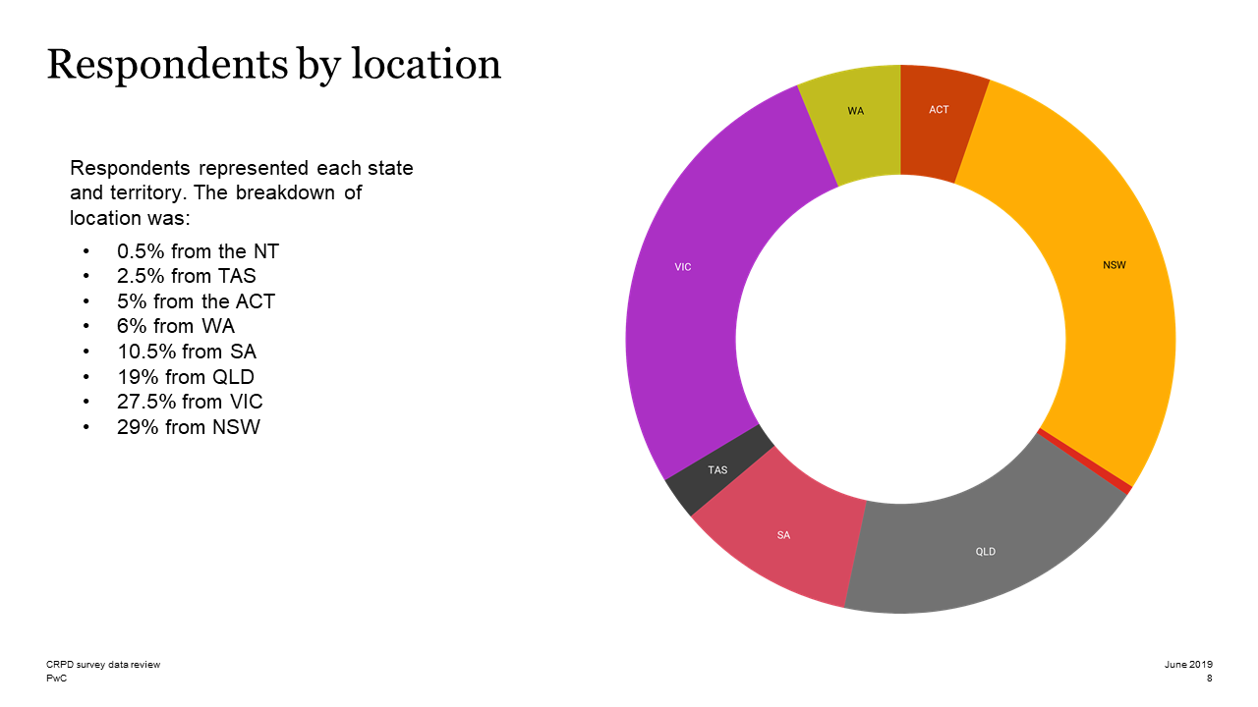

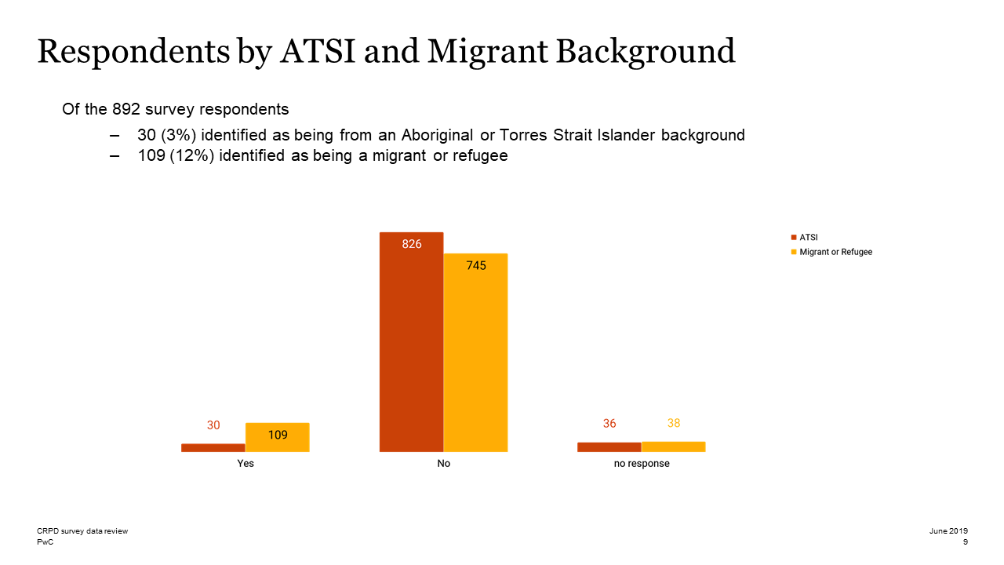

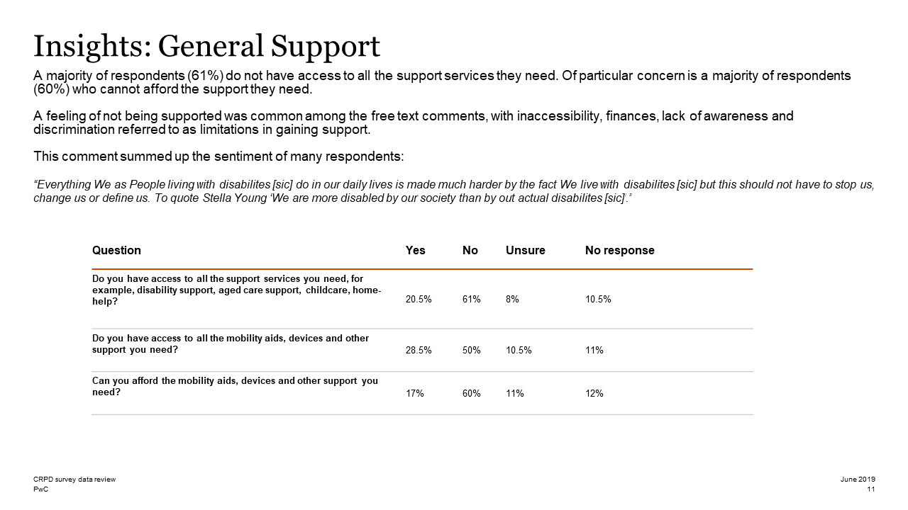

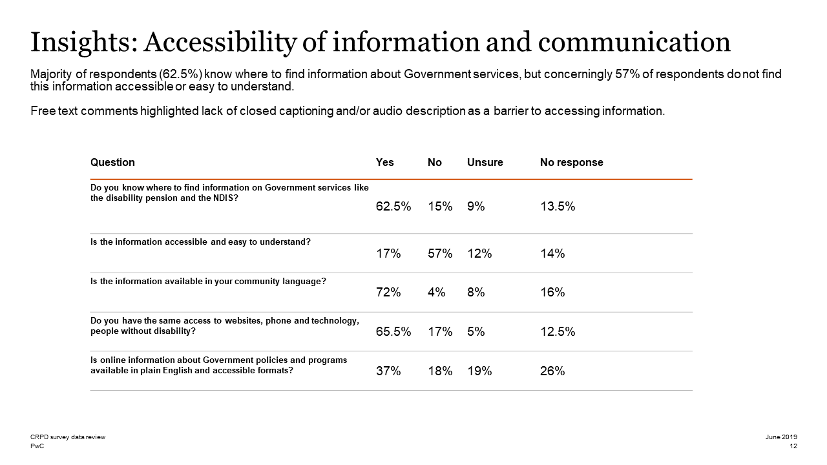

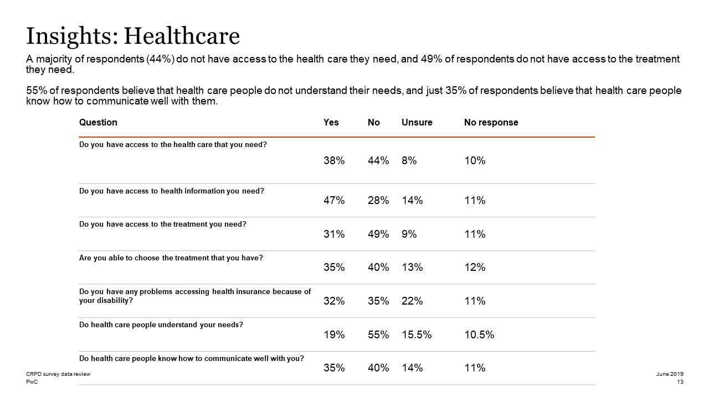

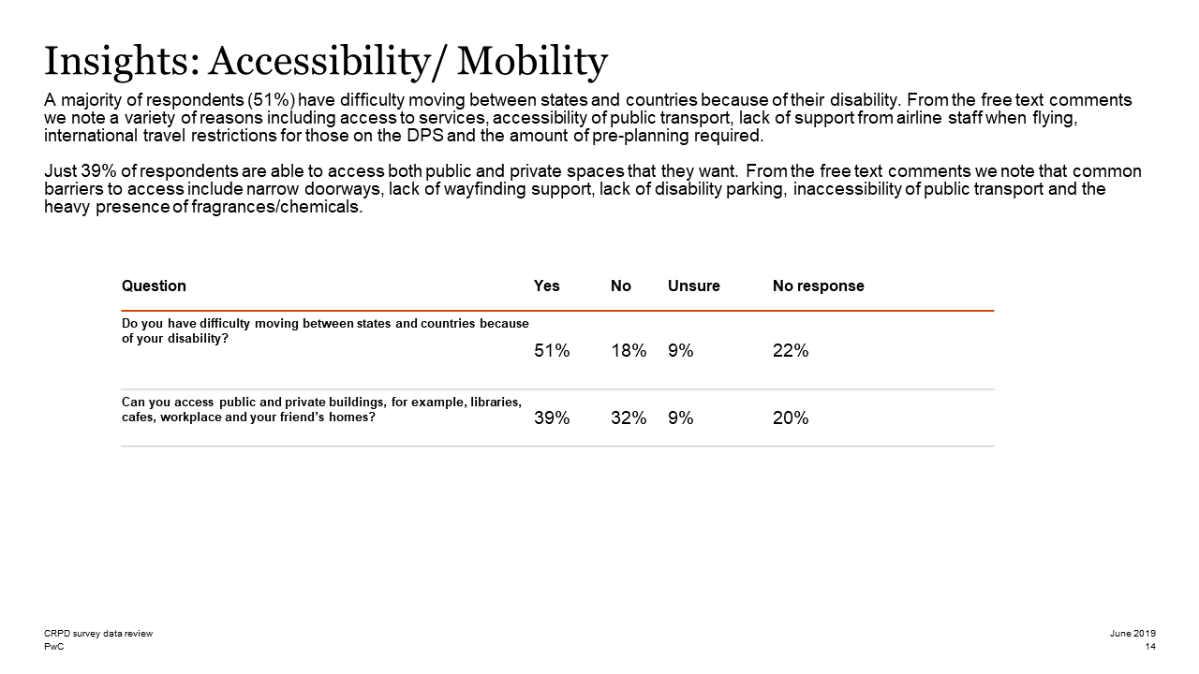

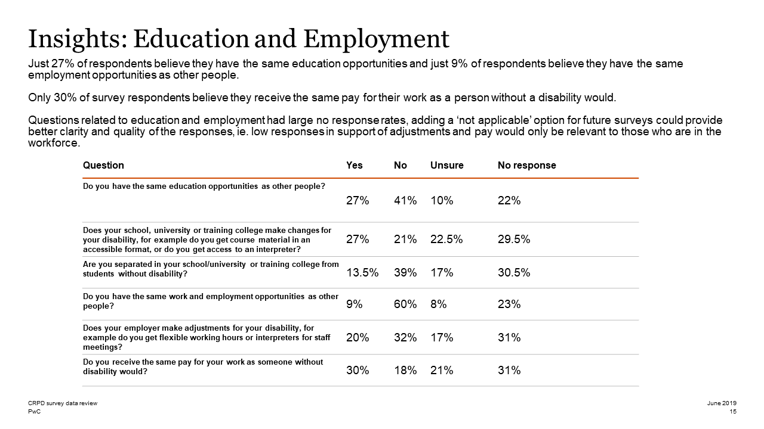

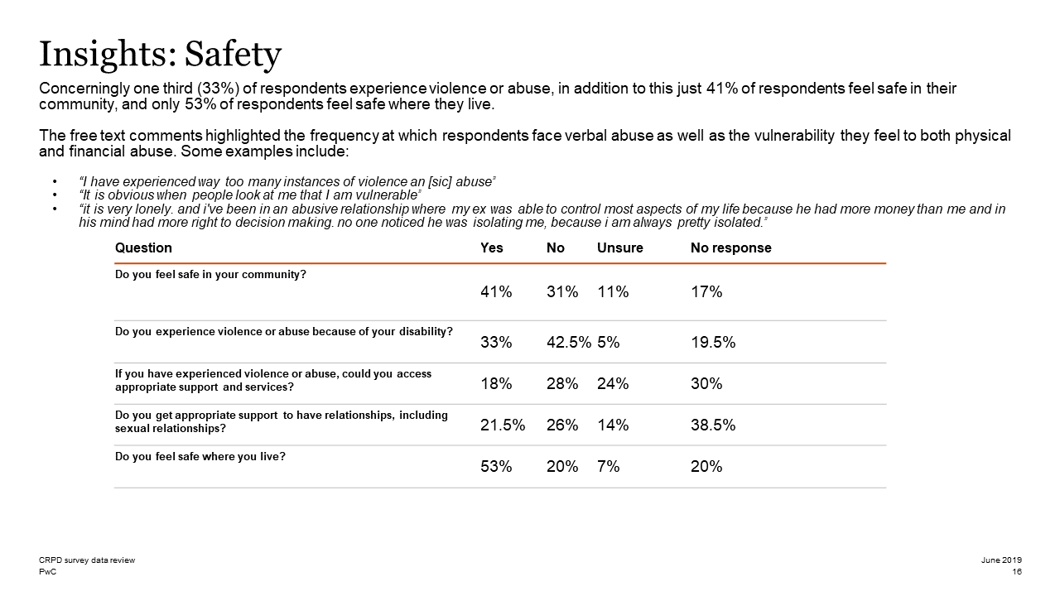

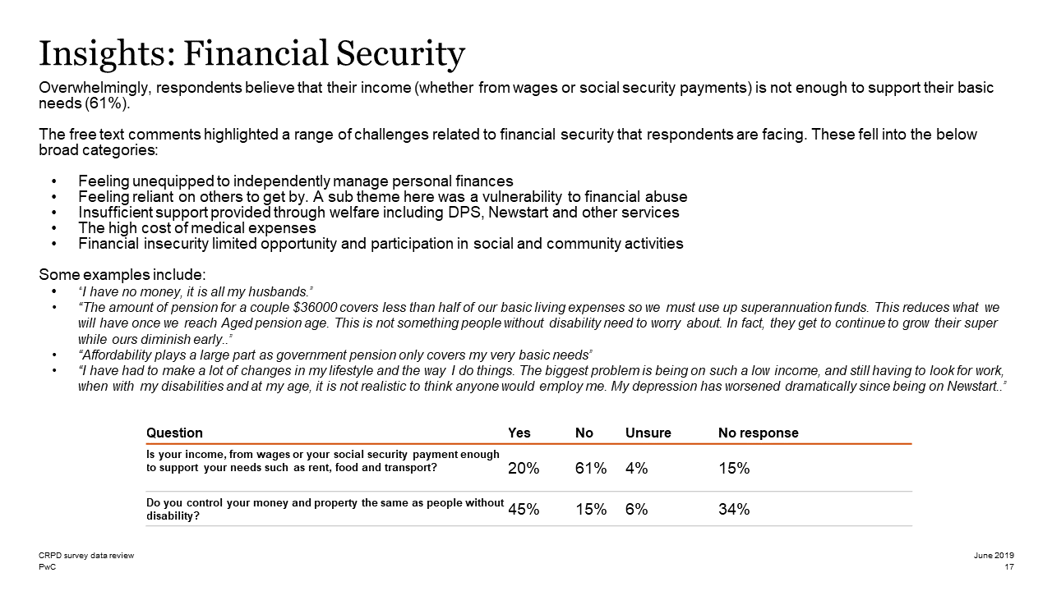

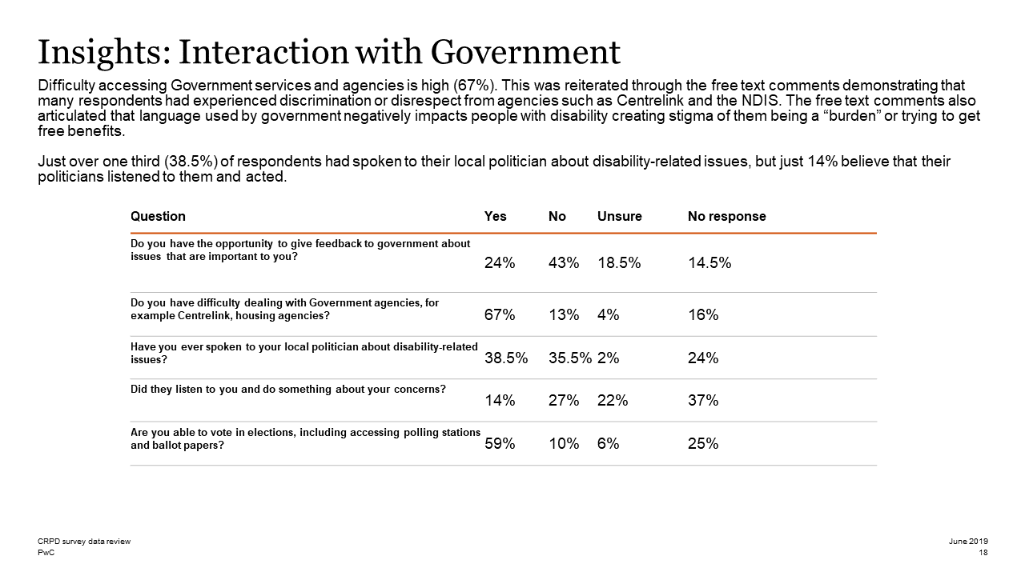

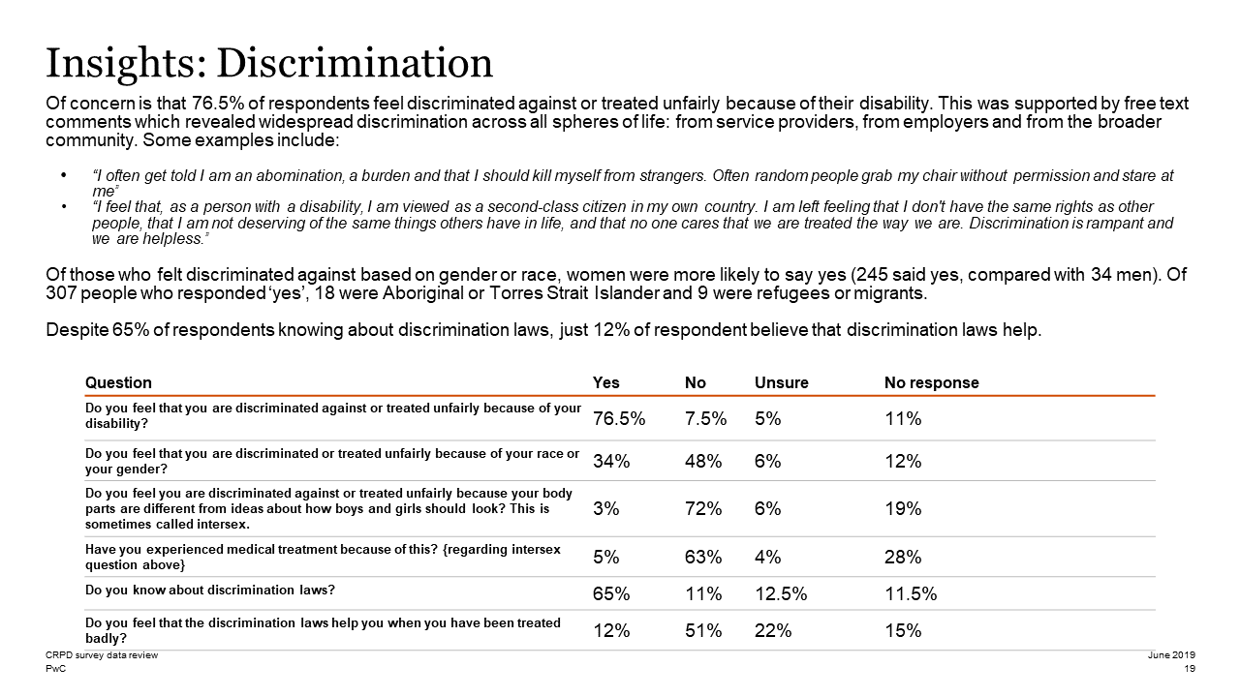

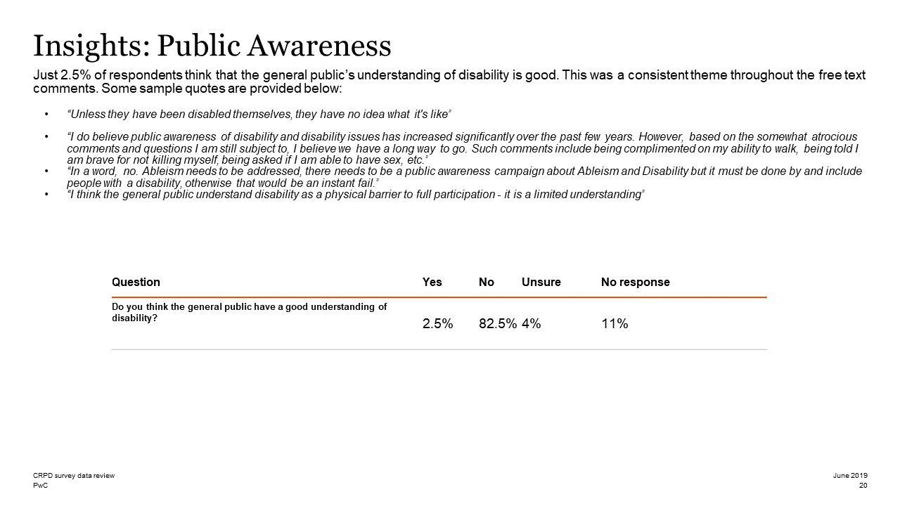

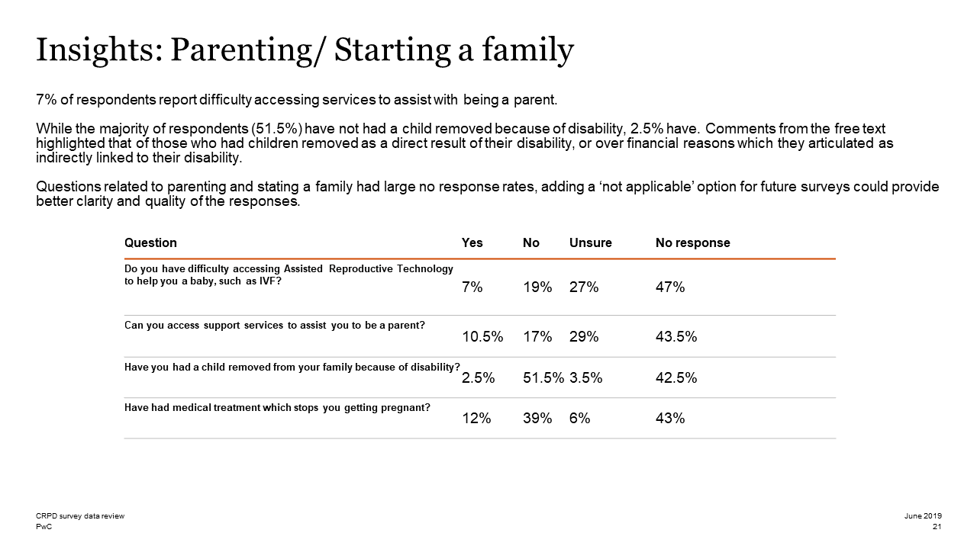

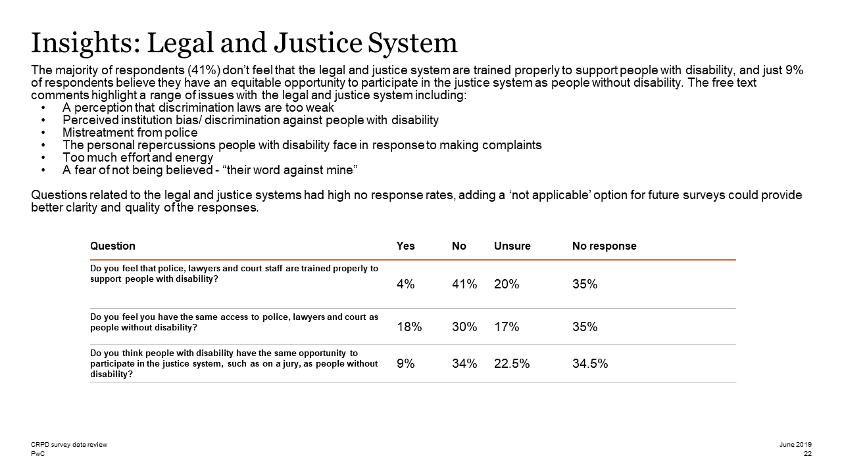

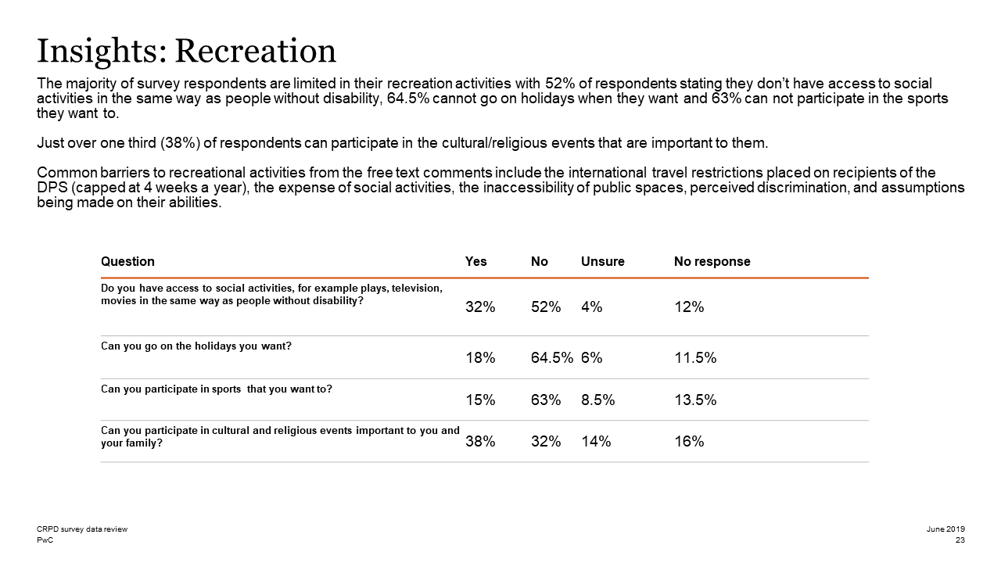

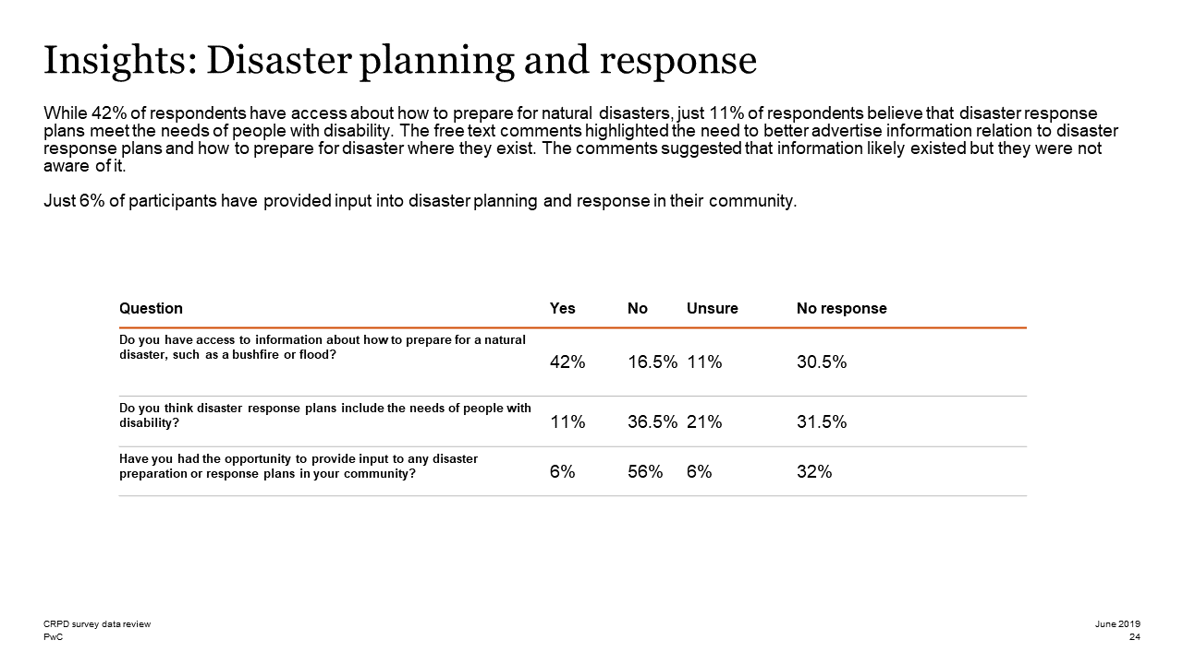

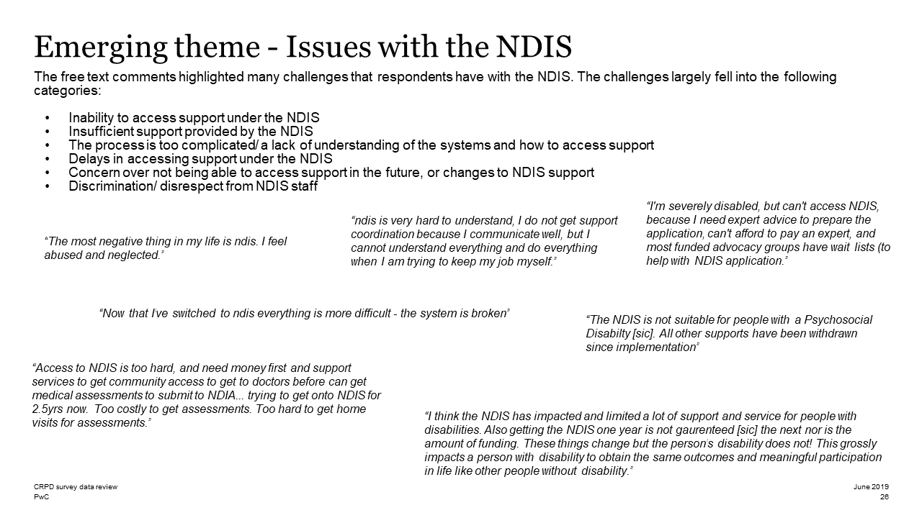

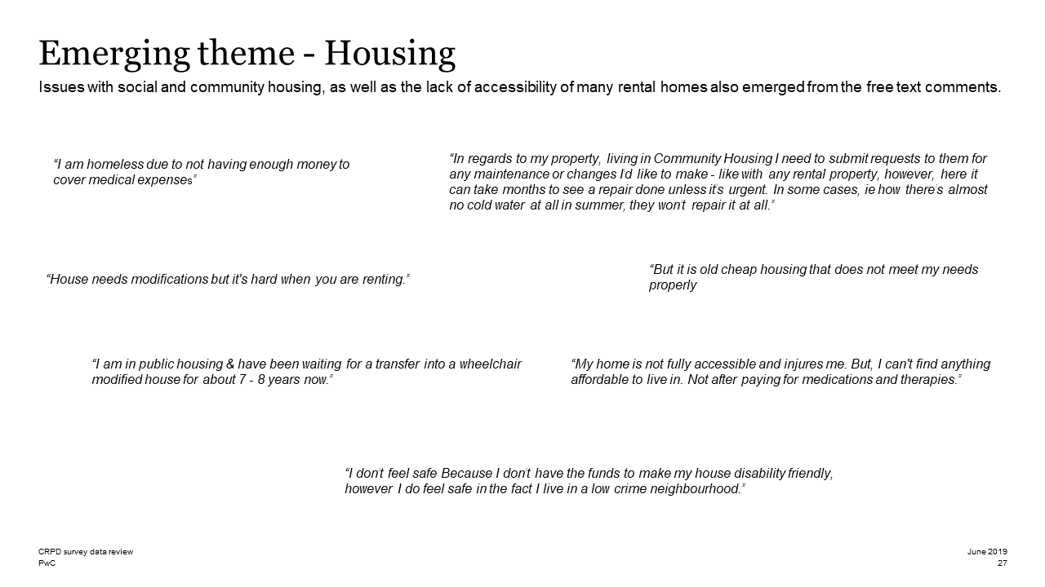

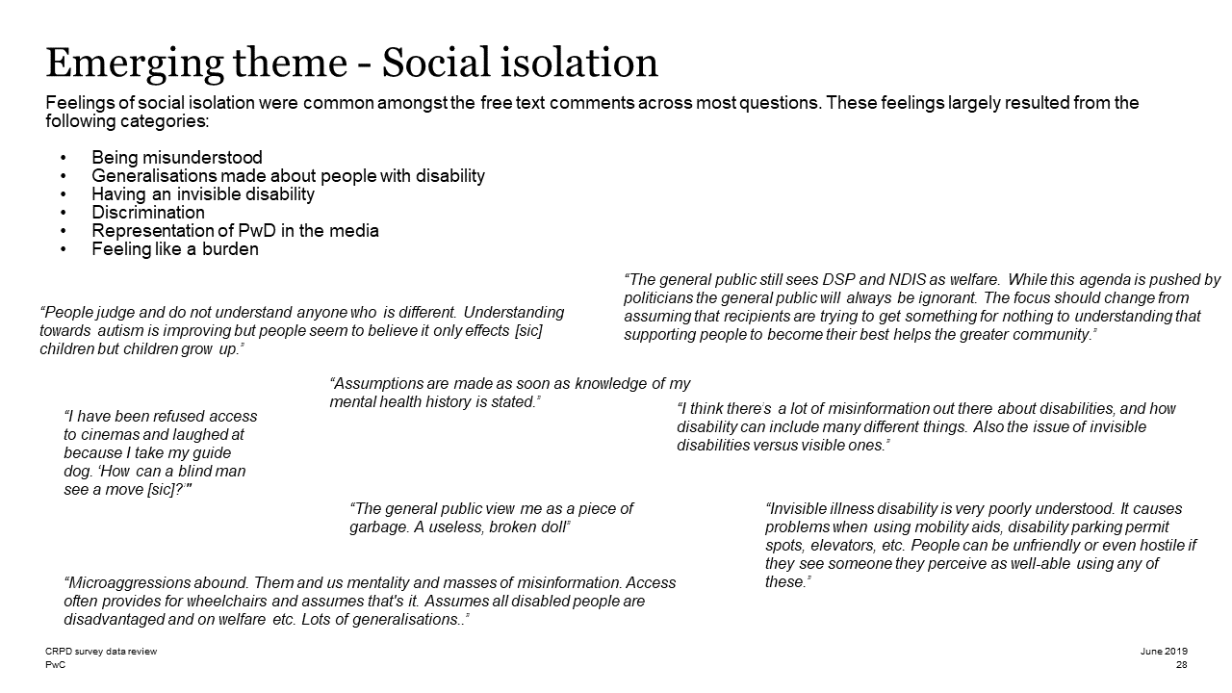

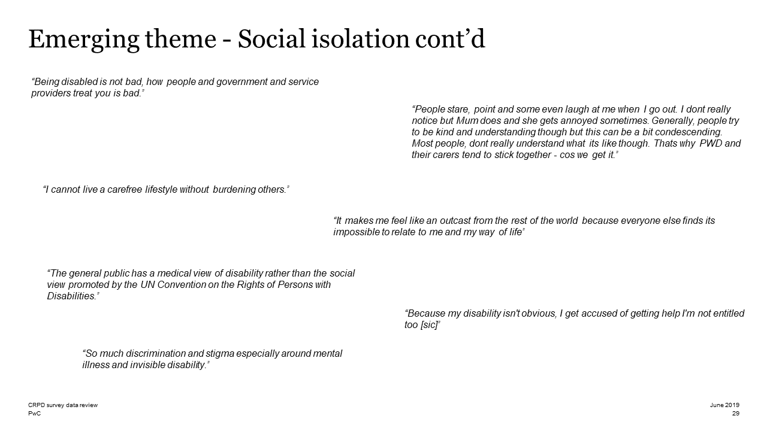

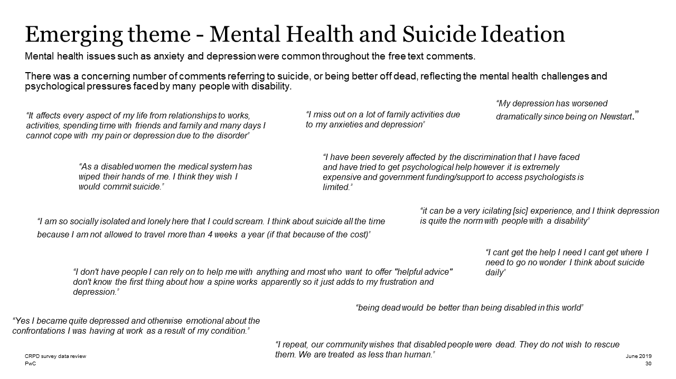

For individual advocacy support contact the Wayfinder Hub between 9:00 am and 5:00 pm (AEST) Monday to Friday via phone (toll free) on 1800 843 929 or via email at info@wayfinderhub.com.au.

Submission Contact: Giancarlo de Vera, Senior Policy Officer: giancarlod@pwd.org.au

UN General Assembly, International Covenant on Economic, Social and Cultural Rights, 16 December 1966, United Nations, Treaty Series, vol. 993, Art. 11
UN General Assembly, Convention on the Rights of Persons with Disabilities, 13 December 2006, A/RES/61/106, Art 28
Davidson, P., Saunders, P., Bradbury, B. and Wong, M. (2018), Poverty in Australia, 2018. ACOSS/UNSW Poverty and Inequality Partnership Report No. 2, Sydney: ACOSS: p.15
Organisation for Economic Co-operation and Development (2014), Society at a glance: OECD Social Indicators, OECD Publishing
Australian Civil Society CRPD Shadow Report Working Group (2019). Disability Rights Now 2019: Australian Civil Society Shadow Report to the United Nations Committee on the Rights of Persons with Disabilities in response to the List of issues prior to the submission of the combined second and third periodic reports of Australia [CRPD/C/AUS/QPR/2-3], July 2019: p.39
National CRPD Survey (2019) Findings – See attached Appendix A
Australian Institute of Health and Welfare (2019). People with disability in Australia: In brief. Cat. no. DIS 74, Canberra: p.19.
Australian Institute of Health and Welfare (2019). People with disability in Australia Web Report – Education and Skills. Canberra <https://www.aihw.gov.au/reports/disability/people-with-disability-in-australia/education-and-skills>
Australian Institute of Health and Welfare (2019). People with disability in Australia Web Report – Health. Canberra <https://www.aihw.gov.au/reports/disability/people-with-disability-in-australia/health>
Australian Institute of Health and Welfare (2019). People with disability in Australia Web Report – Housing. Canberra <https://www.aihw.gov.au/reports/disability/people-with-disability-in-australia/housing>
Australian Institute of Health and Welfare (2019). People with disability in Australia Web Report – Employment. Canberra <https://www.aihw.gov.au/reports/dis/73-1/people-with-disability-in-australia/employment/employment-rate-and-type>
National Disability Insurance Agency (2018). COAG Disability Reform Council Quarterly Report, 31 December 2018 (2018 Q2 Report). Canberra: p.18
Australian Public Service Commission (2016), As One: Making it Happen – APS Disability Employment Strategy 2016-2019, <https://www.apsc.gov.au/sites/g/files/net4441/f/As-One-Strategy_web.pdf>
People with Disability Australia (2019), Increasing access to mainstream employment, <https://pwd.org.au/federal-election-2019/employment/>
Commonwealth of Australia, Department of the Prime Minister and Cabinet (2019). Independent Review of the APS Review: Priorities for change, Canberra: p. 45.
National Disability Insurance Agency (2018). COAG Disability Reform Council Quarterly Report, 31 December 2018 (2018 Q2 Report). Canberra: p.20
Collie, A., Sheehan, L., Mcallister, A. (2019). The Health of Disability Support Pension and Newstart Allowance Recipients: Analysis of National Health Survey Data. Insurance Work and Health Group, School of Public Health and Preventative Medicine, Monash University: p. 11
ibid
ibid
Li, J., Brown, L, La, H.N., Miranti, R. and Vidyattama, Y. (2019). Inequalities in the Standards of Living: Evidence for Improved Income Support for People with Disability. National Centre for Social and Economic Modelling, Institute for Governance and Policy Analysis, University of Canberra, p. 19.
Australian Institute of Health and Welfare (2019). People with disability in Australia: In brief. Cat. no. DIS 74, Canberra: p.19.
Li, J., Brown, L, La, H.N., Miranti, R. and Vidyattama, Y. (2019). Inequalities in the Standards of Living: Evidence for Improved Income Support for People with Disability. National Centre for Social and Economic Modelling, Institute for Governance and Policy Analysis, University of Canberra, p. 21.
Australian Institute of Health and Welfare 2017. Australia’s welfare 2017. Australia’s welfare series no. 13. AUS 214. Canberra: AIHW
Bennett, O., Lewis, A., O’Halloran, D., Smith, W. (2018). Working It Out: Employment Services in Australia, Per Capita, Melbourne: p.44
Bennett, O., Lewis, A., O’Halloran, D., Smith, W. (2018). Working It Out: Employment Services in Australia, Per Capita, Melbourne: p.18
Productivity Commission 2019, Vulnerable Private Renters: Evidence and Options, Commission Research Paper, Canberra: p. 117.
ibid.

