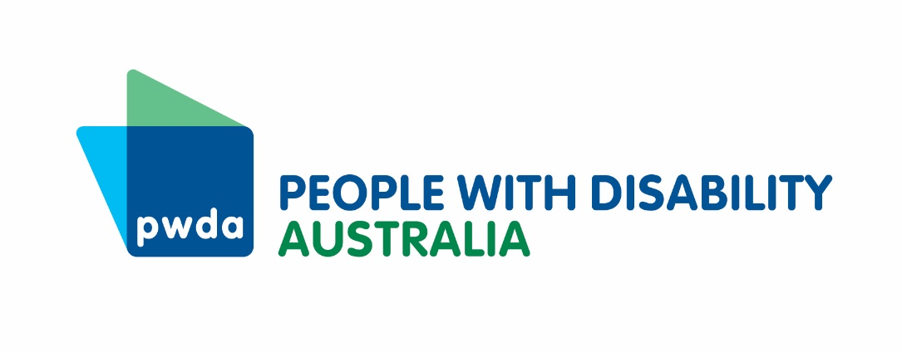

People with disability and COVID-19

“ We fight for diagnosis, we fight for assistance, we fight for ourselves, we fight for our families and we constantly have to fight for our lives. Please don’t make us keep fighting for equal rights especially during a pandemic. ”

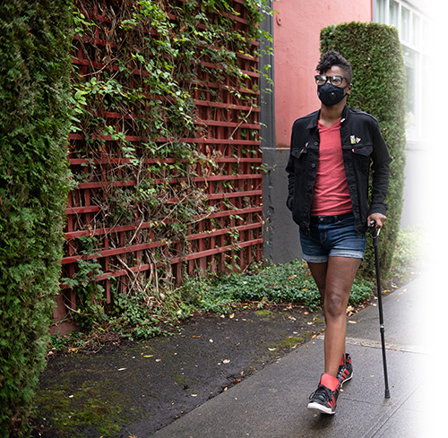

2

This photo was taken by Chona Kasinger. https://affecttheverb.com/disabledandhere

“I had severe difficulty accessing food and groceries initially as I am unable to walk around a shop, and so I rely on home delivery. When home delivery from supermarkets stopped, they stopped for everyone, and I had just moved to a new town, had no support and no way to access these goods.”

“PPE equipment is not just for COVID-19... it protects me from bugs and germs from other people. NDIA says we don’t need PPE equipment or masks, yet due to this virus, my health has deteriorated as I’m struggling to do things myself.”

“I feel that the message I’m getting is that if I   
get the virus, I will die! (I’m on the risk list) ... so stay indoors...FOR months if not YEARS. !!! until   
we get a vaccine. STAY away from everyone...   
but I need support?”

“Both myself and my disabled son have suffered extreme mental health challenges through this situation. My son is now online at TAFE and struggling without disability services, and teachers who don’t understand his needs. I have begun to develop agoraphobia.”

**The COVID-19 pandemic has brought a great deal of changes to everyone in Australia, and particularly to people with disability.**

Australians with disability represent some of the most excluded of all Australians in relation to the impacts of coronavirus. At the same time, many people with disability are particularly at risk from COVID-19, because of barriers that exist to our inclusion, and our need for ongoing support.

Many people with disability have seen changes in our lives from the current COVID-19 public health emergency. These have included:

* increased expenses
* changes to supports, including NDIS supports
* changes to healthcare

Some of these changes have been good, with increased access to services online or on the phone, but many of the changes have had a negative impact on people with disability.

For many of us, the lockdown will continue for many months, and so will these impacts.

People with Disability Australia asked people with disability to tell us about their experiences over the last two months, and this report sets out those findings.

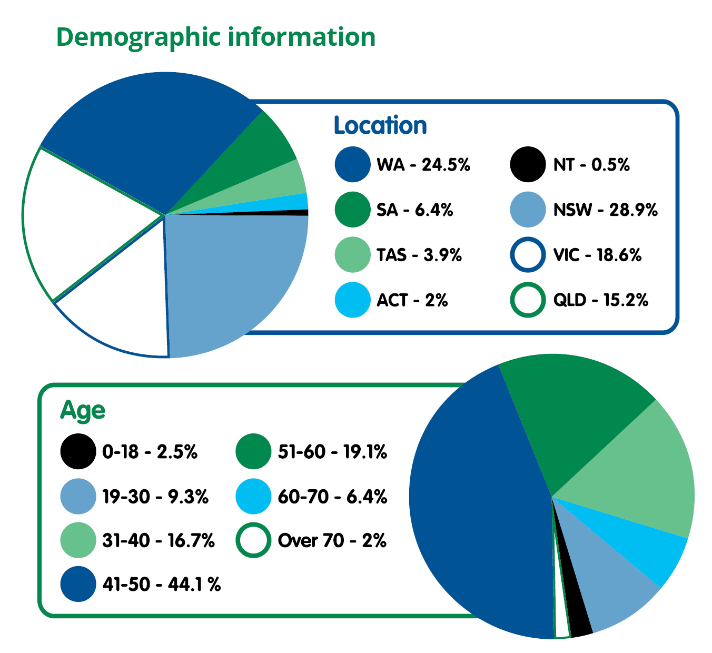

**Key findings:**

* **204 survey respondents,** 88% people with disability, 12% carers/family
* **91% reported increased expenses,** mostly groceries and food, healthcare, internet and phone and hygiene/sanitising equipment
* **41% had less NDIS support**
* **47% had less non-NDIS disability support**

REPORT FINDINGS

3

“Rise in groceries plus having to travel for medical appointments is putting me in financial hardship.”

“I have to go with no food some days so I can pay for my medications and transport is expensive.”

COSTS AND EXPENSES

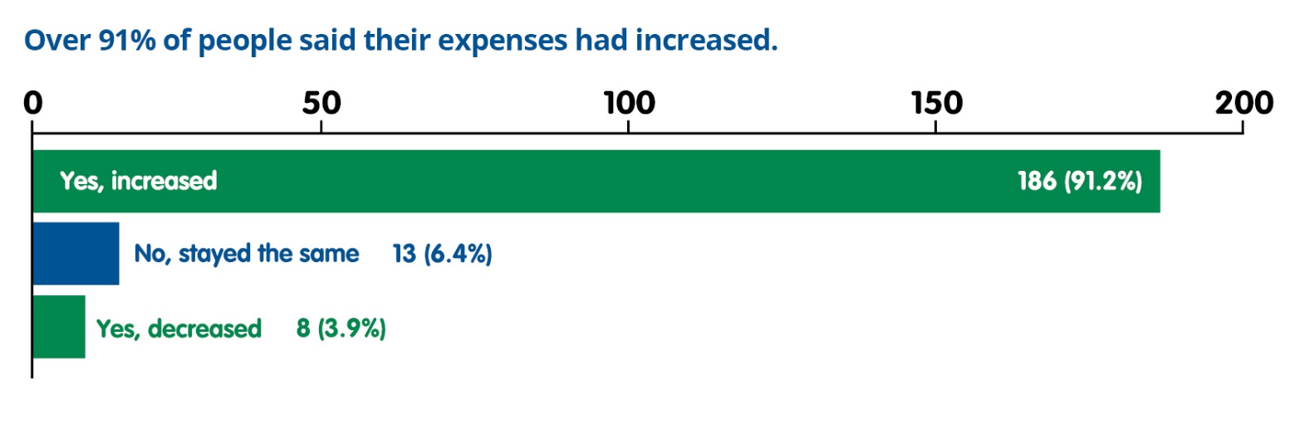

“All my costs have expanded, from having to make multiple trips to the shops to get the basics or having to pay 100% inflated prices online as people are hoarding the medical supplies I need, but I need them, so I must   
pay for it.”

“The way the supermarkets managed the priority grocery delivery service was a disaster. They cancelled normal delivery with having nothing in place. Coles took several weeks to arrange their service, but in the meantime, Woolies were very unresponsive and kept losing peoples forms. I was genuinely scared I would starve, in an affluent country like ours!”

“I have increased costs for groceries, utilities and disability related items. Some of my medications have been unavailable for over a month. Some of the disability related items have increase in price or have been unavailable. I have also had to purchase extra disability related items for my son.”

“The rush on groceries left me unable to get items at their regular prices. The lack of home brand groceries and the dramatically increased prices on essential items increased my grocery bill by at least 1/3rd and left me without ANY spare money each fortnight. It has made a significant impact on my budget, which is low at the best of times.”

We know that many people with disability faced higher expenses. Delivery costs, shortages of goods and increased spending on personal protective equipment were some of the key areas of increase expenses.

People with disability who are in receipt of Disability Support Pension (DSP) are experiencing and facing additional, unforeseen costs in this time of crisis, which is causing significant levels of distress and anxiety, and   
only serving to further entrench DSP recipients into poverty.

It is well recognised that 50% of people with disability already live in poverty so additional costs at this time are tipping people with disability over the edge. Over 40% of people in receipt of the JobSeeker payment are also people with disability and/or chronic illness.

“The additional stress and financial costs were one thing but the lack of proactive support was really the thing that angered me most. We live below the poverty line and are so vulnerable with immunity issues - I felt abandoned and invisible.”

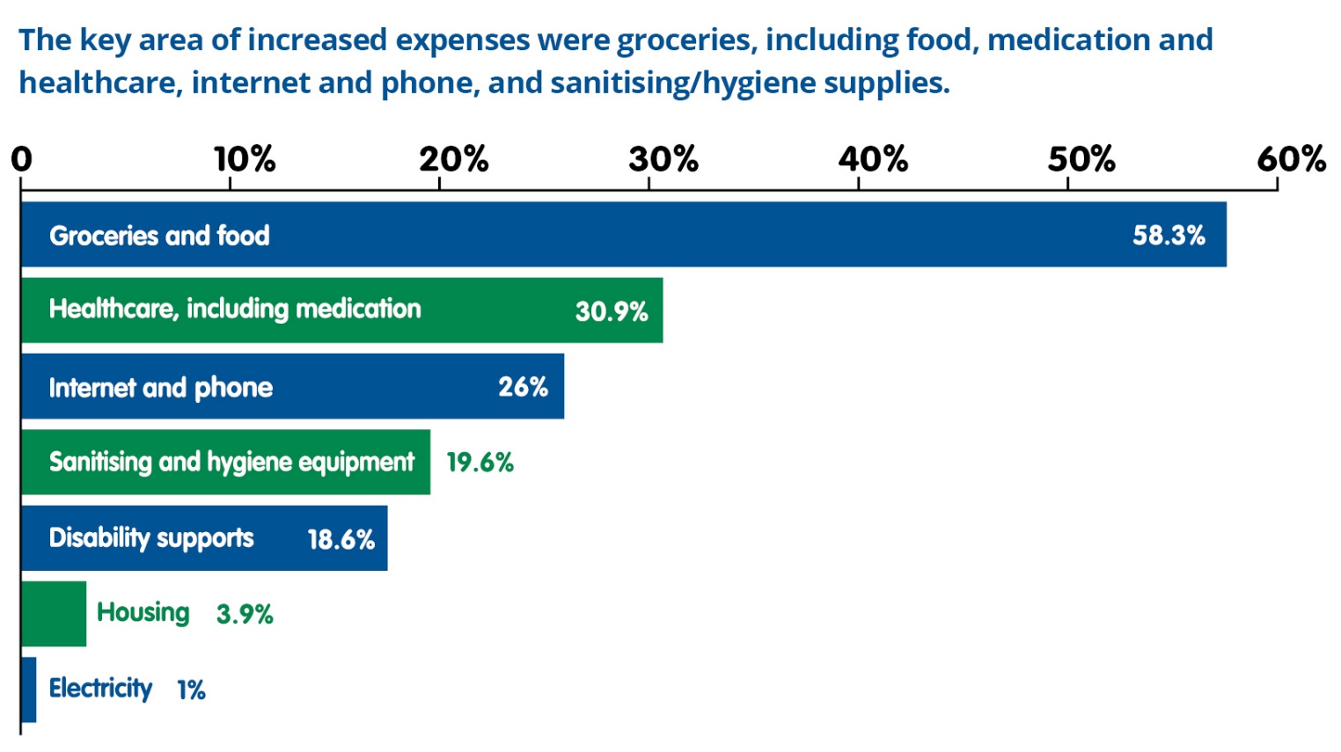

Currently, less than 10% of the population of people with disability in Australia are supported by the NDIS and are therefore unable to access and pay for the additional supports and services they may require during this unprecedented crisis.

The survey found that 66% of people had seen changes to their income during the pandemic, with the majority saying that they had not received the coronavirus supplement to the Disability Support Pension. People also reported losing their jobs, and working fewer hours. 22% of people had no changes to their income.

“I have noticed the cost of living has increased. Groceries in particular.”

“I pray that the rate of Newstart stays the   
same as it is now, as it is deplorable to try and survive on $530 a fortnight. And trying to find a job at my age and being deaf is absolutely horrendous, because of the discrimination I have endured, but still I try, it is not a good life to be living, no fault of my own.”

“It is unfair and discrimination to exclude DSP, carers and seniors out of such a big stimulus package, considering these people have higher living expenses already, they say our situation hasn’t changed, but if that’s the case, why am I heading out for a fourth time this week to get some simple grocery items, or I’m forced to pay 100% more just to get simple medical supplies as everyone has nothing.”

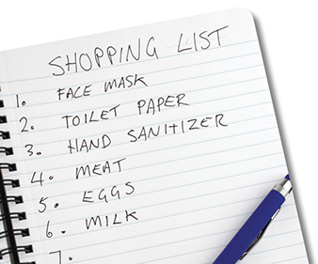

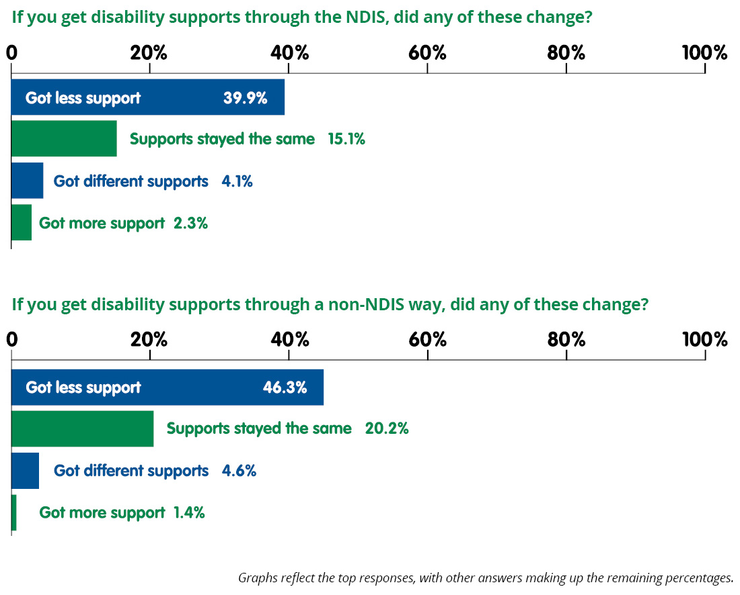

DISABILITY SUPPORTS

People with disability often rely on disability supports to live a good life, fully included in the community. Over 360,000 people with disability have access to supports through the NDIS, but other people with disability use supports via different sources.

“I’m completely isolated...no one has rang to see how I’m going. I have no outside family.”

“No supports provided by support workers during Victoria’s state of emergency as regular supports were redeployed elsewhere. This was not a choice! Service provider suggested we look elsewhere for supports.”

“I lost all NDIS supports, and am now barely alive, I do believe I could die from this. I have had huge issues trying to get any food, food delivery from supermarkets, very patchy. I have no family or friends or informal supports and rely on paid supports to keep me alive, how much longer I live is beyond me. I do not have the technology I need or require or assistance to access it.”

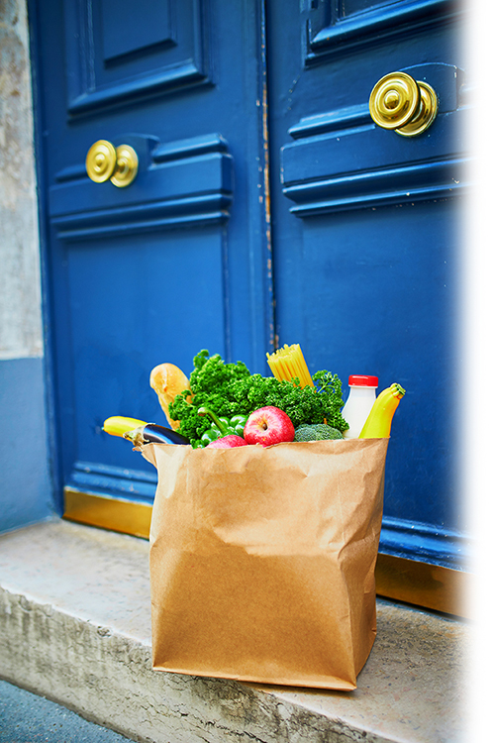

“I was left to die alone at home and denied lifesaving medical care and medications during this time and yet I am disabled and high risk.”

“I was getting out with my support worker, doing food shopping with her but due to Covid-19 I’ve basically been stuck at home due to no support and having to pay friends to drop over food.”

“You put up the costs of my supports by letting providers charge up to 10% more. You did not increase my support budget. I had to do without a couple of supports like cleaning because I could not afford the additional costs.”

During the COVID-19 pandemic, there were many changes to disability support. At PWDA, we heard from many people with disability that they had been left without enough support to go about their days.

One of the key issues we raised with the NDIS, and with state and territory, and the Federal Government, were these gaps in essential support.

Many people with disability and their carers and families said that they had received less support during the pandemic, or that they had different kinds of supports. This applied to people who have NDIS plans, and people who receive supports through other ways.

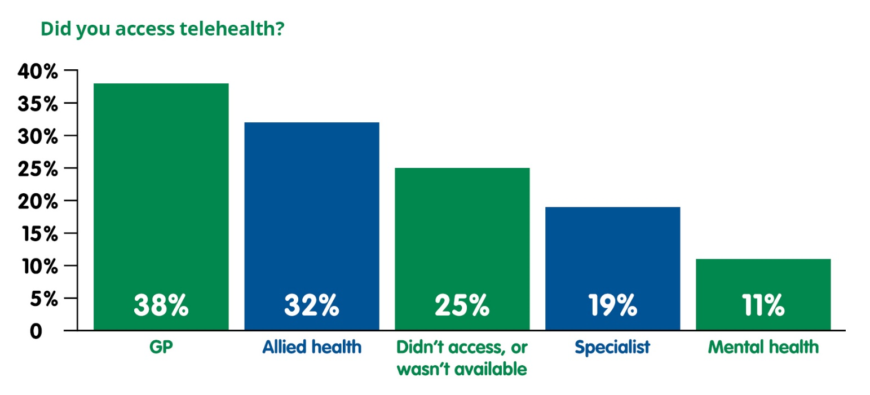

“I am finding phone and video visits with GPS and specialists useful and having my medication brought to my home beneficial.”

Many people with disability have found healthcare difficult to access before the pandemic. There were existing barriers before the pandemic to accessing telehealth, which is a more accessible way to get healthcare for people with disability.

The grassroots report [‘Just Invisible – medical issues for homebound/bedridden persons’](https://notdoneliving.net/justinvisible/) found that “people who are homebound and/or bedridden have extensive and systemic problems with accessing the medical healthcare system, including access to GPs, medical professionals, hospital systems and allied health.”

Access to telehealth during the pandemic has been well received by many people with disability, and the survey respondents reported taking up this program. The survey reflects the different services that people with disability used via telehealth, including allied and mental health.

“Much easier for me to access telehealth services from GPs, specialists and allied health workers, some I didn’t have access to at all before COVID.”

HEALTHCARE

“I am deaf but don’t sign and the move to Zoom and telehealth has been extremely difficult for me. I used my NDIS money for captioning in Zoom meetings as the sound quality was so terrible. It was also hard communicating with the doctor for telehealth sessions.”

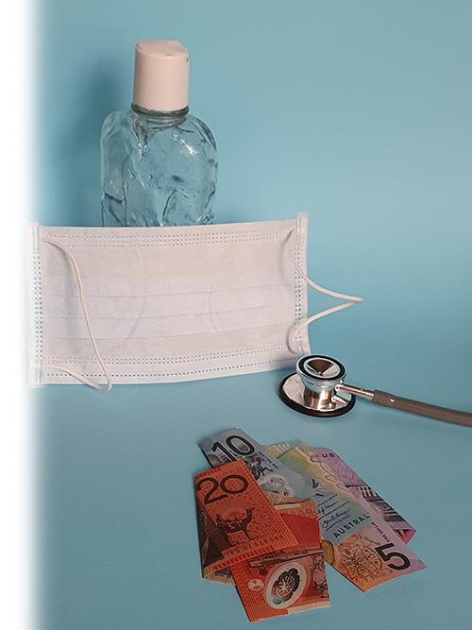

**COVID-19, and the public health measures essential to manage this pandemic, have had a significant impact on people with disability.**

Since March 2020, PWDA, along with dozens of other disability advocacy organisations, have been calling for a seat at the table to ensure that the needs of people with disability are adequately addressed.

We have released several statements, and have heard from many, many people with disability about how difficult this time has been.

* [Immediate Proactive Response to Coronavirus (COVID-19) for Australians with Disability](https://pwd.org.au/covid-19-plan/)
* [Joint Statement on Disability Support Pension](https://pwd.org.au/joint-statement-increase-disability-support-pension-now-to-deal-with-coronavirus/)
* [Media Release: Now is the time to act on pandemic measures for people with disability](https://pwd.org.au/media-release-now-is-the-time-to-act-on-pandemic-measures-for-people-with-disability/)
* [Statement of Concern – COVID-19: Human rights, disability and ethical decision-making](https://dpoa.org.au/statement-of-concern-covid-19-human-rights-disability-and-ethical-decision-making/)

As we move to a different stage of the lockdown, we want policy makers, politicians and the wider public to know what we have experienced. For many of us, the lockdown will not end until a vaccine has been found. We will be facing increased expenses, changes to support, and need telehealth in the months ahead.

“Deaf people need more Auslan interpreters at emergency announcements and broadcasting with newsreaders.”

“Very lonely without anyone checking on me, Food is hard to get because we have no delivery and no supports means I have to pay someone to shop for me. I have to go without my medications to pay for these extra things.”

“There has been a lack of information and guidelines for people at the highest risk from the virus. Government restrictions have been for healthy people. However, high riskers need to be in more restricted isolation and take greater infection control measures than the general public to stay safe. High riskers have been given no information or support in how to do this. Many of us have been forced to devise our own restrictions and measures, while others have given up because it’s been too hard to take extra precautions.”

“I am going backwards financially as my grocery costs have increased. I am on a restricted diet and everything on it has gone up due to the virus. I am not eating properly and it is causing health issues I have fought long and hard to get through and cope with.”

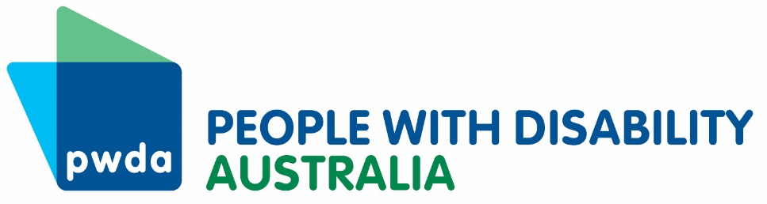

Our phone numbers:

**Phone:** 02 9370 3100

**Toll Free:** 1800 422 015

**Fax:** 02 9318 1372

**TTY:** 02 9318 2138

**TTY Toll Free:** 1800 422 016

Office hours:

**Mon – Fri**

9am – 5pm

Our email:

pwd@pwd.org.au