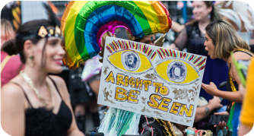
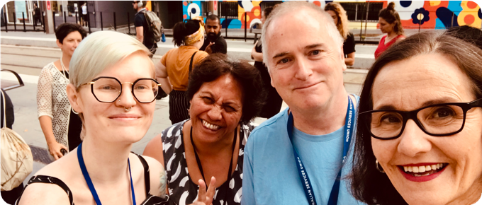
ANNUAL REPORT
19/20

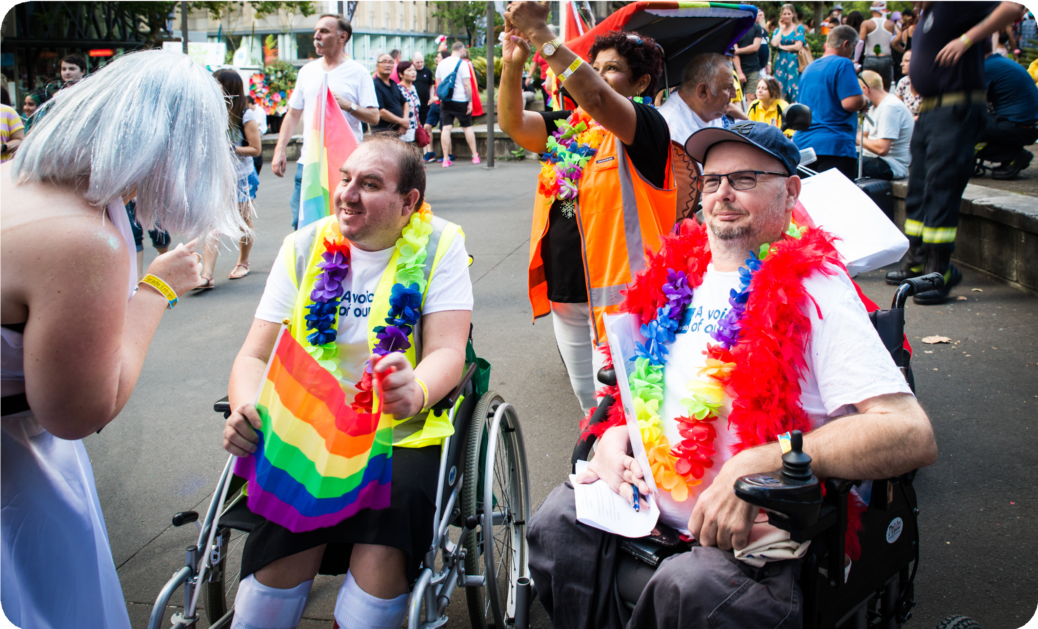
PWDA acknowledges and thanks all of the members, supporters and staff featured in the photos in this report.
PWDA acknowledges the traditional owners on whose land our offices are located.
Copies of this document are available in alternative formats from:
These include the Gadigal people, the Dharug people, the Tharawal people, the Ngunawal people, the Kalkadoon people, the Gureng Gureng people, the Badtjala people, the Gubbi Gubbi people and the Yuggera people.
People with Disability Australia (PWDA)
Postal Address:
PO Box 666 Strawberry Hills NSW 2012
We also acknowledge Elders past, present and emerging.
Street Address: Level 8, 418A Elizabeth Street, Surry Hills NSW 2010
Phone: Toll Free: Fax: Email: TIS:
NRS:
(02) 9370 3100
1800 422 015
(02) 9318 1372
pwd@pwd.org.au 13 14 50
1800 555 677
ACFID Code of Conduct Complaints
PWDA is a signatory to the Australian Council for International Development (ACFID) Code of Conduct.
If you believe PWDA has breached
the ACFID Code of Conduct,
you may lodge a complaint with the ACFID Code of Conduct Committee on complaints@acfid.asn.au, telephone
(02) 6285 1816 or contact PWDA.
To lodge a complaint about PWDA you may contact us on pwd@pwd.org.au or free call 1800 422 015.

Contents
About us
2
President’s report
4
CEO report
6
The year 2019–20
8
Staff, interns, volunteers
14
Individual advocacy – NSW and QLD
20
Individual advocacy – projects and development
26
Representation and systemic advocacy
32
Systemic advocacy projects
40
Training and research
46
Communications, media, membership
50
Financial report

52
1

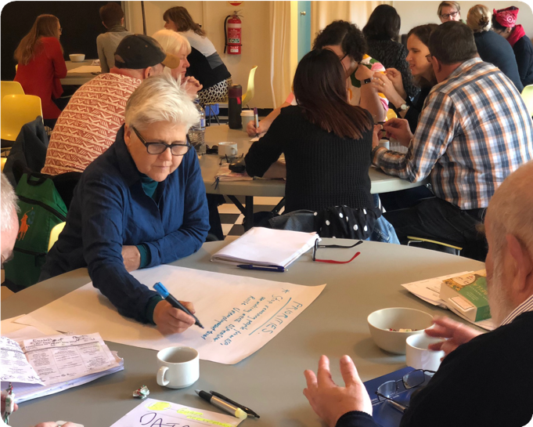
About People with Disability Australia

A voice of our own
People with Disability Australia (PWDA) is a grassroots, mutual support, representative and advocacy organisation of and for people with all types of disability. We were founded in 1980, in the lead-up to the International Year of Disabled Persons (1981), to provide people with disability with a voice of our own. We have a fundamental commitment to self- help and self-representation of people with disability, by people with disability.
We work within the framework of, and seek to bring into reality, the rights recognised in the United Nations Convention on the Rights of Persons with Disabilities – a treaty we played a key role in bringing into force, both internationally and in Australia. We provide: advice and information; individual, group and systemic advocacy; training, research and education; and a representative voice
of people with disability nationally and internationally, and in New South Wales.
Our members
We have a cross-disability focus – our membership is open to people with all types of disability. Individuals with disability and organisations of people with disability are our voting membership. We also have a supporter base of people and organisations committed to the disability rights movement. Our services are not limited to members; they are available to people with all types of disability and their associates.
We are governed by a board of directors, drawn from our members across Australia, all of whom are people with disability.
We employ professional staff to manage the organisation and operate our various
projects. Many of our staff members are also people with disability.
Our vision and purpose
We have a vision of a socially just, accessible and inclusive community, in which the human rights, belonging, contribution, potential and diversity of all people with disability are recognised, respected and celebrated with pride.
Our purpose is to be a leading disability rights, advocacy and representative organisation of and for all people with disability, which strives for the realisation of our vision of a socially just, accessible, and inclusive community.
3

President’s report
4

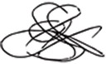
I am pleased to present to you our Annual Report 19/20, detailing the enormous variety and depth of work conducted by People with Disability Australia (PWDA) over the past year.
PWDA is a Disabled Person’s Organisation, run by and for people with disability. Our members, all people with disability and DPOs, come together to elect a board, and myself, as our President.
PWDA had many achievements in 2019–20 and I am pleased to present these to you in this annual report. With the Disability Royal Commission continuing and the coronavirus crisis ongoing, we will continue to experience a key period of change in our country.
Now is the time for us to move forward and gain traction with our advocacy efforts.
I encourage you to stick with us as we work hard in 2020–21 to improve the lives of people with disability.
Those Board members have a huge responsibility – to represent our members and to drive our organisation forward. This year, we’ve been working on our Strategic Plan that will guide our work over the next three years. Members, staff and our Board have been involved in what this plan will look like, and the Board has approved the work our organisation will do.
In addition, we worked to fill the huge shoes left by Matthew Bowden and Therese Sands, our long standing Co-CEOs, and welcomed Jeff Smith to take on the challenge of leading PWDA into the future.
Yours faithfully,
David Abello
Jeff worked tirelessly this year, in very tough circumstances, to deal with both the impact of the bushfires and the global pandemic, but also to work with the PWDA Board through some difficult times. I’m immensely grateful for his work with us all.
This year, PWDA has continued to grow, and attract additional projects and programs. At the same time, we have continued to work across a wide range of policy issues.
I want to thank all PWDA staff for stepping up to meet the enormous change and challenge that the COVID-19 pandemic brought to our organisation. I also want to thank those who served on the Board this year, thanks for your energy and commitment to PWDA.
5

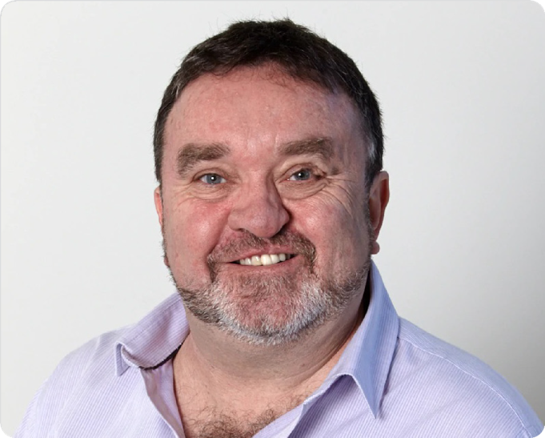
CEO report
6

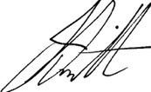
This year will be long remembered as one where our communities faced significant challenges and change, particularly for people with disability.
From fires and floods, to the arrival of COVID-19, people with disability across Australia have experienced profound disruption to our lives.
People with disability told us how difficult the response to the pandemic had been, and how for many, they had felt forgotten and alone, facing changes in supports and hugely increased expenses. We brought these voices to the media and to Ministers, and advocated for more help specifically for people with disability.
While all this was happening, we got on with our work, with two major projects, the Wayfinder Hub and Enable In, finishing their work to ensure that people with disability can get information, including about how to access the NDIS. Other projects included work to make sure domestic and family violence services and youth services were more accessible to people with disability.
We know, however, that this kind of disruption will be an increasing feature of the years
to come, as we experience more impacts from climate change. I was very glad to lead PWDA to attend the climate strike, as people with disability must be at the heart of how we manage any climate adaptation, mitigation and emissions reduction.
The two disasters, bushfires and COVID-19, changed much of what we had planned for this year, but as always, our focus remains on the rights of people with disability across Australia.
Our individual advocacy work expanded to include assisting people to make submissions to the Disability Royal Commission, and reached further north in Queensland, as well as through NSW.
We did comprehensive outreach and a national marketing program to help people with disability to access the National Redress Scheme, and our training team quickly adapted to the lockdown changes, producing high-quality video for the Redress project.
I am immensely proud of our entire PWDA staff who have risen to these unexpected and dramatic events with considerable commitment to the rights and wellbeing of people with disability.
From our advocates working to find a home for families who lost everything in the fires, to our corporate services team relocating the entire office and getting everyone online, to
our policy and communications teams making sure people with disability had the right information quickly.
I want to thank our staff and volunteers for working so tirelessly this year, as well as the PWDA Board, particularly the Executive members, who all volunteered to serve our community.
During the pandemic, we worked closely with other disability advocacy organisations to raise the issues that people with disability were facing with all levels of government, often as the situation was changing very quickly. I was pleased to be invited to join the Advisory Committee – Management and Operational Plan for COVID-19 for People
with Disability, which met regularly to develop the Management and Operational Plan for People with Disability.
Jeff Smith
7

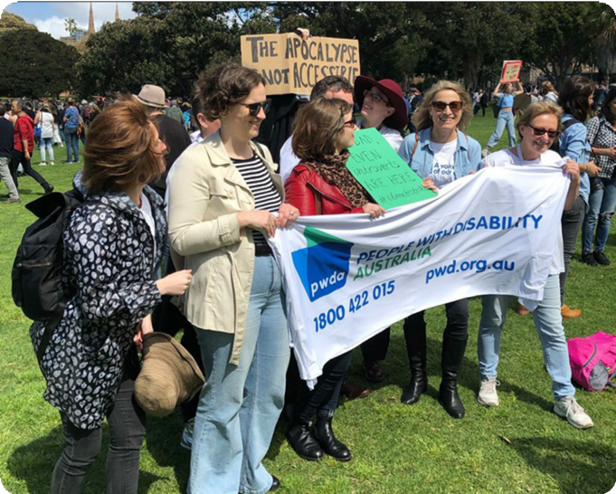
The year 2019–20
8

Auslan interpreters were used for emergency press conferences and announcements, but were frequently cropped out of the frame, despite direct advocacy from a variety of disability and Deaf organisations. Captions were not always provided for video and audio formats. Emergency information was generally not made available in Easy Read formats. At a local level, most information was not made available in accessible formats and did not take into account the needs of a diversity of people with disability.
We know that climate change will increase the frequency and severity of bushfires, and other disasters, and it will be vital that
people with disability are included in how we plan for them.
Bushfires and COVID-19
This year was dominated by two major disasters – the bushfires and the COVID-19 pandemic, both impacting people with disability severely. They have dominated much of PWDA’s work this year, particularly since December 2019, and will for some time to come.
During the bushfire crisis, PWDA, alongside Disability Advocacy Network Australia (DANA), Inclusion Australia and IDEAS, called for urgent funding for disability advocacy and information services, as we were playing a vital role in assisting people with disability on the ground in evacuation centres, and to connect with the supports they needed.
We also called for all disaster-related communications to be accessible for all people with disability, including people with intellectual disability, through Easy Read, Auslan, plain English and other accessible formats.
PWDA, alongside other disability advocacy and information services, quickly collated information from a variety of sources, prioritising accessible formats such as Easy Read and Auslan. Disability advocacy and information services were relied on heavily during this time as trusted organisations
by our communities. PWDA advocates also directly supported people with disability to navigate through the different levels of government, and the sometimes contradictory and often inaccessible information that was present at the time.
PWDA collated information into a bushfire hub on our website, and shared that with our community through social media (Facebook,
Twitter, Instagram), email (newsletters and member emails), as well as posted
information by mail as needed, and provided hard copy information to our advocates to use in local communities.
COVID-19
The COVID-19 pandemic has had a profound impact on people with disability across Australia and the world, and on PWDA.
We transitioned everyone in the Sydney office to working from home in March 2020, which has been a huge challenge. Staff have used online video and chat to stay in touch, as well as for informal catch-ups.
During this time, PWDA worked with other disability advocacy organisations to coordinate urgent responses to the
measures being implemented to deal with the pandemic. We wrote to Ministers, put out media releases, advocated on social media and heard from many people with disability about what they were experiencing.
We worked, with other organisations, on an Open Letter to National Cabinet, endorsed by over 70 disability organisations and individuals. This letter distils many of the concerns that people with disability have about the way the pandemic has been handled, and the disproportionate impact many of the measures have had on people with disability.
9

The key concerns highlighted in the Open Letter covered areas such as:
disability to ensure they had access to food and medication, as well as regular time outside their homes.
We also conducted a survey during May 2020 on COVID-19, receiving more than 200 responses from people with disability and their families, detailing their experiences during the COVID-19 crisis. The survey report became a part of our submissions
to the Parliamentary Inquiry into COVID-19 and the Disability Royal Commission’s investigations into emergency planning and response.
•
guaranteeing continuity of supports for all people with disability
•
expanding the case definition for COVID-19 testing to include people with disability and their support persons
urgently improving communications so they were inclusive for all people with disability
•
•
removing barriers to healthcare for people with disability
ensuring effective measures were in place to recognise and respond to violence, abuse, exploitation and neglect of people with disability
People with disability said they had faced increased expenses (91%) and reduced disability supports (40%), and had also used telehealth to access healthcare and allied health appointments.
The experiences in this report show clearly the extreme anxiety and dread that people with disability felt as the COVID-19
pandemic began to unfold and how we were not included in the narratives and initiatives for the emergency response planning.
•
•
extending the Coronavirus Supplement to the Disability Support Pension
preventing discrimination against students with disability in educational provision
•
•
ensuring the rights of people with disability living in congregate settings
adequately resourcing disabled people’s organisations (DPOs) and disability representative organisations (DROs), to enable support of, and advocacy for, people with disability
Our CEO Jeff Smith was invited to be part of the Advisory Committee for the COVID-19 Response for People with Disability, which met regularly to develop the Management and Operational Plan for People with Disability. Through the regular meetings
of the committee and direct feedback from advocates, the perspectives of PWDA members were incorporated into this work.
•
Continuity of support was a key issue for many people with disability, who reported to trusted organisations, such as PWDA, that service providers were withdrawing essential supports, and not providing alternatives, in contravention of their code of conduct.
Our direct practice, intake and communications staff all reported hearing directly from a wide variety of people with disability that disability support providers had changed their supports without consultation, or had stopped them entirely. Our direct practice staff worked with people with
10

Voices from the pandemic
Some of the direct experiences of people with disability during this time included the following:
“All my costs have expanded, from having to make multiple trips to the shops to get the basics or having to pay 100% inflated prices online as people are hoarding the medical supplies I need, but I need them,
so I must pay for it.”
“I am deaf but don’t sign and the move to Zoom and telehealth has been extremely difficult for me. I used my NDIS money for captioning in Zoom meetings as the sound quality was so terrible. It was also hard communicating with the doctor for telehealth
sessions.”
“The way the supermarkets managed the priority grocery delivery service was a disaster. They cancelled normal delivery with having nothing in place.
Coles took several weeks to arrange their service, but in the meantime, Woolies were very unresponsive and kept losing people’s forms. I was genuinely scared I would starve, in an
affluent country like ours!”
“I lost all NDIS supports, and am now barely alive, I do believe
I could die from this. I have had huge issues trying to get any food, food delivery from supermarkets, very patchy.
I have no family or friends or informal supports and rely on paid supports to keep me alive, how much longer I live is beyond me. I do not have the technology I need or require or assistance to
access it.”
“I’m completely isolated … no one has rung to see how I’m
going. I have no outside family.”
“Much easier for me to access telehealth services from GPs, specialists and allied health workers, some I didn’t have
access to at all before COVID.”
11

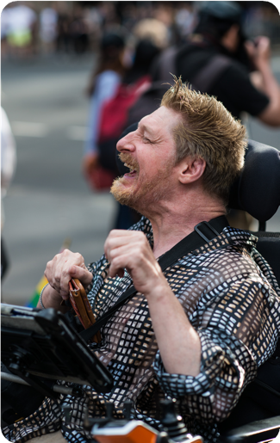
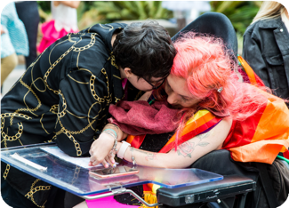
Sydney Mardi Gras
On Saturday 29 February PWDA, in partnership with Northcott, marched with 114 proud and supportive participants in the 2020 Sydney Gay and Lesbian Mardi Gras parade. Our message of human rights and sexuality was received well by all, and there was a real sense of solidarity among our float. In addition, PWDA received significant coverage in the SBS live television broadcast on the night.
12

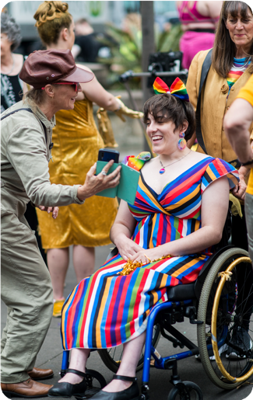
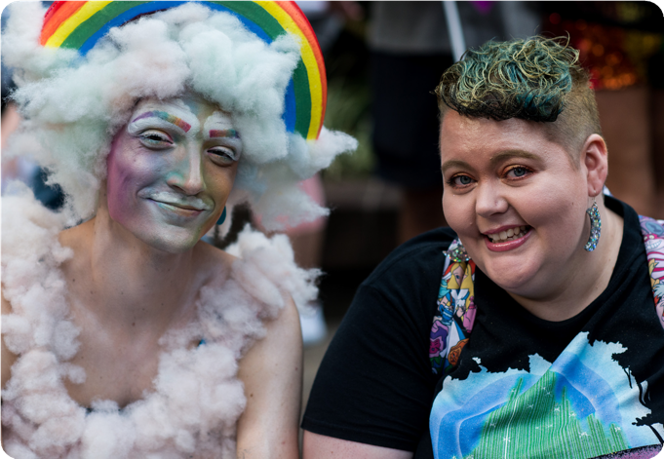
13

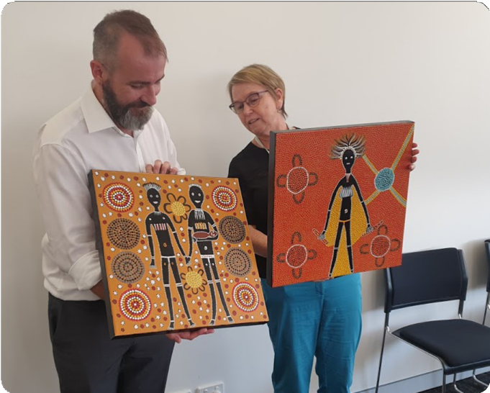
Staff, interns, volunteers
14

PWDA staff, interns and volunteers work from our offices throughout NSW and QLD, with the central office based in Sydney, NSW, and from a variety of remote locations.
Sydney staff moved into our new office in Surry Hills at the start of 2019–20. The office acts as a satellite office for a number of remote workers who make up about 25 per cent of our workforce.
On 23 March 2020 as the COVID-19 pandemic took hold in our community, the majority of our staff began working
from home, in line with official health advice. We took advice from our colleagues who work from their home offices and focused on practical ways we could support people to work remotely, including making our Virtual Private Network run quicker.
Our work lives continued to change during the pandemic and as a result we now use collaborative tools more frequently. We jump on Zoom and Facebook Workplace
to meet up or touch base, and also use technologies such as Google Docs to work together easily. Our VPN helps us share files and information.
During the year we were able to introduce a number of process improvements. These
included a more automated accounts payable process, information and communications technology (ICT) upgrades and a streamlining of ICT contracts.
PWDA passed a National Standards for Disability Services (NSDS) Surveillance Audit in 2019–20, passing all six standards without reservation.
PWDA is focused on caring for our workers’ wellbeing during what is going on in the community and their lives. We make counselling and other support services available to each staff member, through our employee assistance program (EAP) service provider Benestar.
Our staff began visiting the Sydney office in the April-June 2020 period to collect mail.
We worked with a number of consultants this year, including lawyers from HWL Ebsworth which supported our efforts with paid and pro bono work.
PWDA also rationalised our spending on regional office advocacy. Given a number of our advocates spend more time on the road than in regional accommodation, we chose to close our Logan and Bundaberg offices in Queensland, and Sutherland office in New South Wales. This freed up budget to spend more on advocacy in the community.
We are now preparing to officially reopen in 2020–21, subject to public health advice.
CEOs
PWDA opened the 2019–20 year with chief executives Matthew Bowden and Therese Sands preparing to step down. We soon waved goodbye to our leaders and welcomed our new CEO Jeff Smith in August 2019.
Our commitment to staff wellbeing continued during 2019–20 as our workers began to
be affected by the bushfire crisis across the country. In response, we cancelled all non- essential travel to affected areas during the height of the crisis. Some workers began to work from home more frequently.
15

Individual advocacy
Our individual advocates are based in our offices in Surry Hills, Bowral and Queanbeyan in New South Wales, and Hervey Bay, Sunshine Coast and Mount Isa in Queensland. Their work includes advocacy support to people with disability
and managing key projects on disability rights and information, community outreach and Redress. Team members included:
Systemic advocacy
Our Systemic Policy and Advocacy staff work on policy and law reform, government relations, community engagement, capacity building, and advocacy and representation. Team members included:
Fleur Beaupert Linda Forbes
Dr Meg Clement-Couzner
Romola Hollywood
Giancarlo de Vera Lisa Ira
Robyn Edwards
Samantha French
Adrienne McGhee Alison Champion Annie Piper Danielle Santos Dorothy Catts Gareth Elliot Grace Stevenson Jen Ruse
Karen Kobier Kym Bowen Leonie Hazelton Lizzie Blue Margot McKnight
Matthew Langman Mina Hunt
Natalie Ross Polly Seymour Robin Turnham Stephen Kilkeary Sunil Fernando Ted Jensen
Tracey Moffatt
Alicia Bairle Andrew Stensel Charlotte Wilde David Skidmore Fran Krix
Garry Oates Ilona Wildauer Jessica Bell Kien Tang
Lee-Anne Pringle Linda Wiseham Luke Gale
Martin A’Bell Michelle Arapovic Natalie McMullen
Oliver Moore
Corporate services
The Corporate Services team is the engine room of PWDA and has traditionally operated out of the Sydney office. The team covers everything to do with governance and compliance, finance, people and culture, and operations. Team members included:
Andrew Emmerson Hollee James Karin Waldmann Maja Bulut
Puneet Chaudhary Sue Strasser
Zara Pamboukhtchian
Carolyn Talbot Jana Dolezalova Leanne Wrightson Pete Darby Stanja Buvac
Uma Ramaprasad
Rebecca Rongotaua Shaana Dekker Stephin Hargreave Tamanna Rahman
Tessa Newman
16

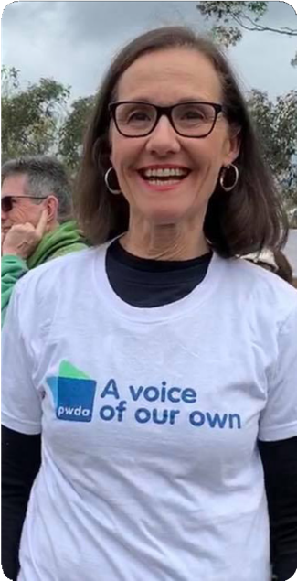
Strategic projects and research
The Strategic Projects and Research team is based in the Sydney office, and work remotely in regional New South Wales and Queensland. Their work is to develop and work on Information, Linkages and Capacity Building (ILC) grants, state-based grant projects (for example, on domestic violence services), provide Disability Awareness training, and ensure the voices of PWDA and people with disability are heard across research fields including in academic projects with universities. Team members included:
Volunteers
PWDA is fortunate to have many people willing to contribute their time and skills to build the capacity of our organisation.
In 2019–2020 these people included:
Ce Liu
Josh Peachey Max Lee
Nadarre Harkness
Scott Mercer
Courtney Triplett Katie Lee Simpson Murray Pairama
Niki Sheldon
Ashleigh Rouco
Freya Higgins Mel Harrison
Frances Quan Farrant Kate Finch
Rhea Harding
Media and communications
The Media and Communications team is based in the Sydney office, and work
remotely across NSW and Victoria. They work to get the word out about what PWDA is doing, and about the rights of people with disability through the website, media, social media and newsletters. Team members included:
Adriana Malavisi
Asher Wolf
Ben Crompton
Maggie Korenblium Siv Parker
El Gibbs
Naomi Chainey Phuong Tran
17

Boarding houses as a site
of advocacy
People with disability have the right to live independently and to be supported to live ordinary lives in the community, just like everyone else.
There has been significant progress in realising these rights and the creation of the Boarding Houses Act 2012 was
intended to protect the rights of residents accommodated in Assisted Boarding Houses (ABH). PWDA had a pivotal
role within the boarding house sector, working with residents, the Department of Communities and Justice (DCJ), accommodation providers and other service providers in protecting the rights of residents specified in the Boarding Houses Act 2012.
substandard health care, poor nutrition, and a lack of community access.
Two PWDA individual advocates are assigned to each ABH to have regular contact with management, to explore and resolve matters of concern for residents and to collate information about systemic problems across the ABH sector. Quarterly and as required visits are undertaken in collaboration with ABH management.
Considering the risks that could be faced by ABH residents due to
the prevailing COVID19 pandemic, our individual advocates were requested to have increased contact with residents. PWDA developed
a detailed plan to assist access by residents to additional supports, during these extraordinary times.
PWDA’s individual advocates collaborate with our systemic advocacy colleagues to progress responses to structural concerns that emerge in the ABH sector. These concerns include the violation of fundamental human rights that constitute breaches of the CRPD, for example,
the right to choose where, how and with whom a resident wants to live.
The pivotal role PWDA plays in advocating for individuals and groups of people with disability is acknowledged by the funding support we have received for many years from DCJ, to provide individual and group advocacy to people with disability living in ABHs in metropolitan Sydney and regional NSW.
A recent focus of our work in the ABH space has been to create a systemic oversight, reporting and follow-up process for the boarding houses that we visit, across NSW. This allows our individual advocates to identify and address problems such as financial exploitation,
Through PWDA’s work providing advocacy support for people with disability living in boarding houses,
18

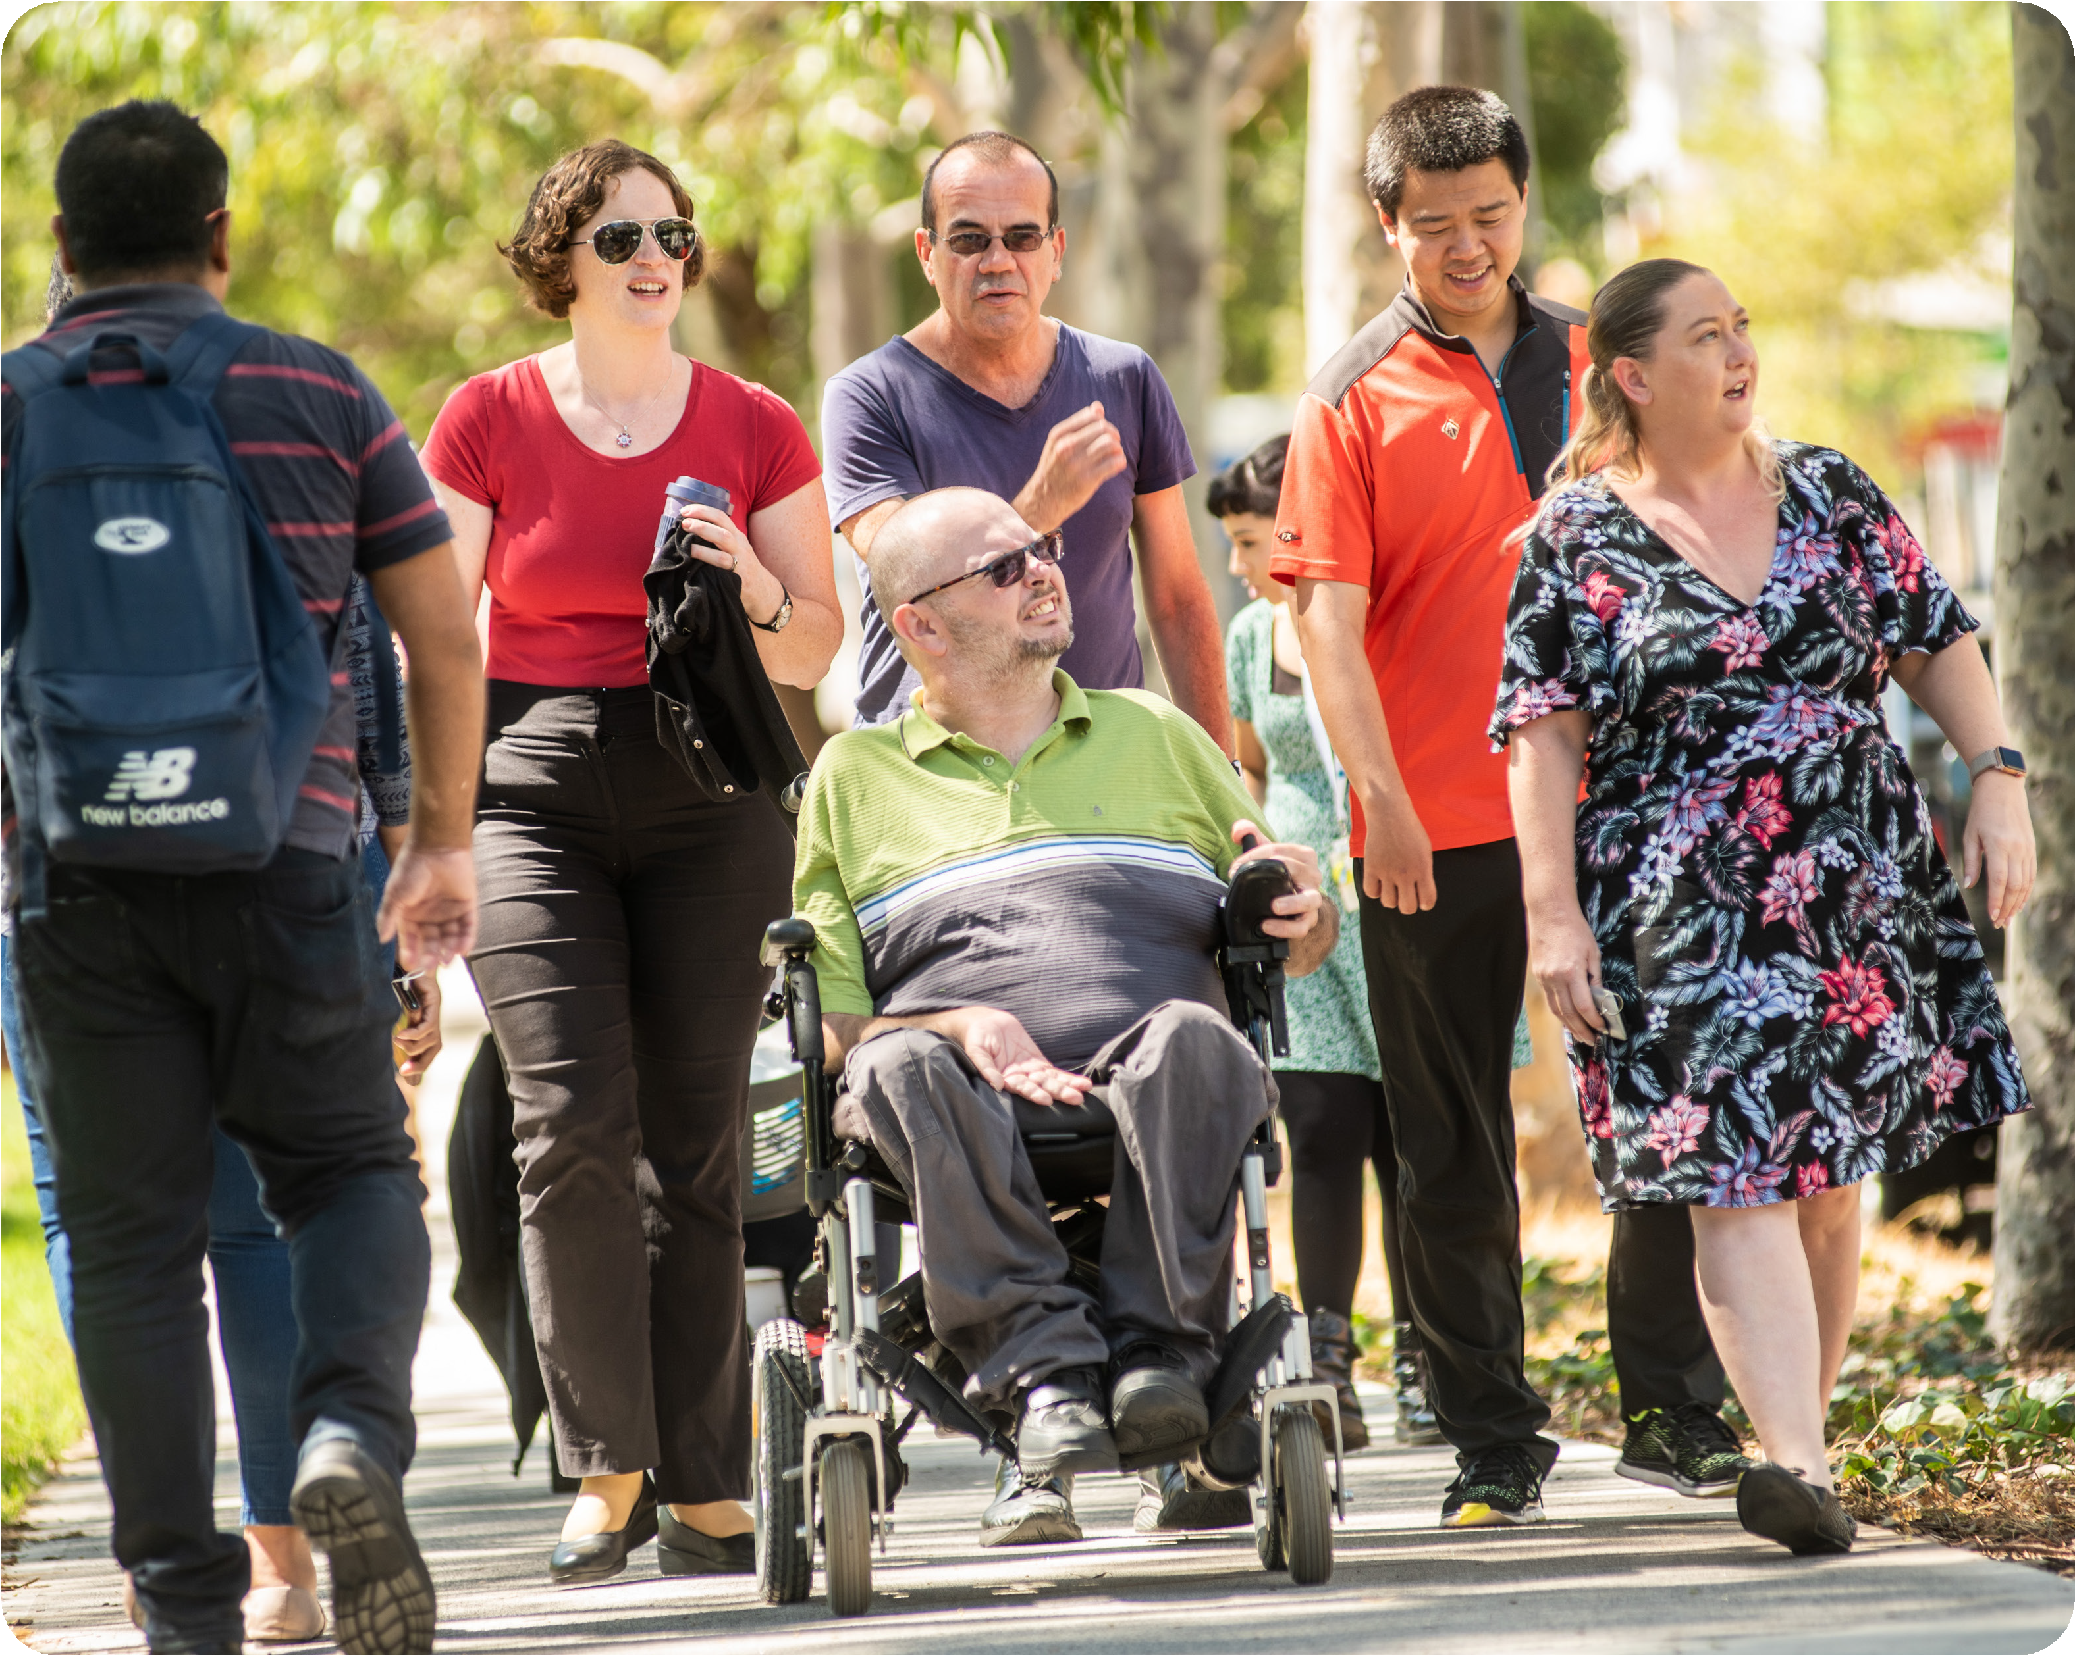
we made a submission to the statutory review and called for the closure of
all assisted boarding houses by 2024. In our submission, we made it clear that the way boarding houses operate presents an irreconcilable conflict between a person’s right to housing and their right to choose who delivers it and what supports they need.
PWDA highlighted how this conflict led to the very real potential for coercion and control, with inadequate oversight and safeguards.
created, to ensure people with disability currently living in boarding houses
are supported to live independently in contemporary, affordable and accessible housing in the community, and be provided with adequate
individual support to live independently.
PWDA is now working with the NSW Government to redevelop the legislation, and will participate in the Industry Taskforce to advocate for
a transition plan that will realise the rights of all people with disability to live independently in the community, just like everyone else.
Our submission was heard by the NSW Government. In our submission, we also called for a transition plan to be
19

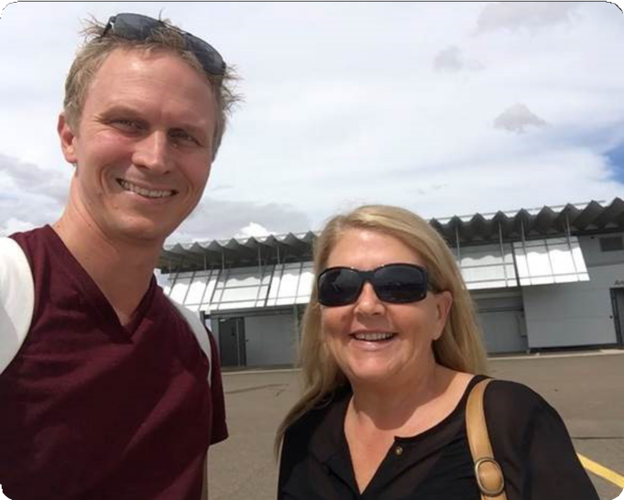
Individual advocacy – NSW and Qld
20

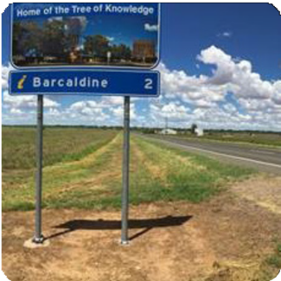
PWDA is funded by the Commonwealth Department of Social Services (DSS) to provide individual advocacy to people with disability in New South Wales and
Queensland. This support promotes the rights of people with disability and maximises our choice and control.
Individual advocates come together to learn about how trauma affects people with disability and how they can improve their skills in responding to survivors.
During the 2019–20 year, advocates provided advocacy and education support to many people with disability; however with the
onset of COVID-19, advocates have had to be creative about the way support has been provided. This includes utilising technology including video conferencing with people with disability. This has been successful and has enabled our advocates to support people with disability while remaining safe.
New South Wales
During the 2019–20 year, the individual advocacy team supported people with disability across a range of issues in NSW. The majority of the work of the advocates involved supporting people through issues involving the National Disability Insurance Scheme (NDIS) and housing. This included liaising with health professionals and other stakeholders to ensure that they were able to uphold their rights to safety and an adequate standard of living. Advocates also educated service providers to ensure people with disability are afforded the dignity and respect they have a right to.
Many people with disability who contact PWDA for support have been or still are affected by violence. To assist individual advocates enhance their understanding of violence and their reactions to it, PWDA has engaged a trauma specialist to facilitate monthly group supervision sessions.
Case study A – Youngster builds support network during COVID-19
Jo is a young man with disability who contacted PWDA seeking advocacy support. After fleeing family violence and experiencing a stint of homelessness, and surviving multiple suicide attempts, he was living in short-term accomodation funded through his NDIS plan. Due to his change in circumstances, he had limited informal supports. Jo and the advocate have used video conferencing during the current COVID-19 crisis to meet regularly and build up an extensive rapport. During the almost weekly sessions, Jo and the advocate have built a clear agenda of tasks for both to complete separately. The tasks that need to be done together have been able to be done in a more efficient manner while including other important supports for his life such as his support coordinator and behavior support practitioner.
21

Case study B – Man leaves nursing home after forced residence
JB is a 59-year-old man with disability. Against his will he was placed in residential aged care by the public guardian. He was not permitted to leave the premises except for occasional supervised outings, and on these he was not allowed to get off the bus. Management of the aged care facility submitted an application to join the NDIS on JB’s behalf but JB was refused access to the scheme. JB’s individual advocate submitted
a second, more thorough, application, with additional supporting evidence. This time JB’s application was successful. With his NDIS plan in place, JB was able to participate in community activities on a regular basis, with the assistance of support workers. The plan also paid for a specialised support coordinator to explore housing options. When a supported accommodation home was identified that JB was agreeable to he was able to transfer from the nursing home. He is reported to be doing well.
Our advocates working on the Disability Royal Commission (DRC) have had great success getting submissions accepted, with many people with disability wanting private hearings. The Commission has been very responsive to achieving private hearings, using a combination of Zoom and face-
to-face counselling. We have had a good uptake of the option in Qld but even more outreach needs to be done as many people in rural and remote communities do not know of the Royal Commission.
Queensland
In spite of fires, floods and COVID-19, PWDA’s individual advocacy has achieved amazing results in Queensland this year. We have had an increase in family and domestic violence (FDV), service provider complaints and complex legal cases. The advocates have adapted well to working from home and engaging with people with disability via phone link-ups and various computer platforms.
Like Sutherland in New South Wales, officers in the Queensland suburbs of Bundaberg and Logan closed their sites after advocates reported the physical locations were rarely used as the majority of work was being
done on the road. Closing these offices freed up thousands of dollars in our budget which allowed for more advocacy time to be spent with people with disability. Reports on the closures have been positive from both advocates and the people they help.
A significant part of our work is NDIS appeals.
Advocates working in this area have a high success rate, with 98% of people with
disability we work with achieving a higher level of care in their NDIS packages. Reviews and appeals that have advocacy help are much more likely to achieve results, sometimes rising by hundred thousands dollars.
Case study C – Tenant faces elder abuse from landlord
An elderly pensioner with disability was so affected by discriminatory abuse from a landlord that she was hospitalised twice. While working with her PWDA advocate over the following months, she was able to not only
prevent herself from becoming homeless but also successfully represented herself in Federal Court under the
Anti-Discrimination Act and received substantial compensation.
All advocates have been taking the opportunity of training which has been offered remotely, particularly around the DRC and human rights legislation.
22

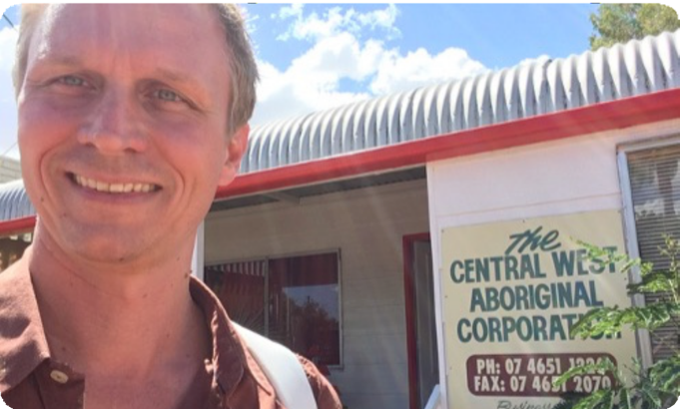
Advocates travel to remote regional Qld for DRC work
When doing outreach work to very remote Queensland for the Disability Royal Commission, our advocates sought out respected individuals and organisations that had an established presence in these communities. Our advocates are well established in their own communities and appreciate that relationships like this add
substantial value to the outcomes we provide to people with disability. All of the connections we made initially expressed dismay, noting that as a community they were neglected
by the metropolitan areas who directed opportunities to suit themselves without considering the unique challenges of living in such remote locations.
However, all of the people in these communities demonstrate a resilience, determination and resourcefulness that is critical to their survival. Our advocates worked hard with them to identify what
information and resources they would need to make sure their voices were heard.
The relationships that we formed sparked hope that they could make a difference.
The community leaders became passionate about putting forward stories that highlighted the unique barriers faced by people with disability that have resulted in violence, abuse and neglect.
Many of the situations that were disclosed to us could never happen in a metropolitan area. For example, the interconnectedness of small towns prevents many of the people who would normally speak up from doing so for fear of repercussions from close community connections. Additionally, the extreme geographical distances involved can isolate individuals from accessing essential medical support.
Consistent engagement with these community leaders would strengthen their relationships with PWDA and grow their capacity to assist their community in providing a response to the DRC.
Additionally, providing a physical presence in these communities would ensure that those who have suffered the most would choose to have their stories told.
23

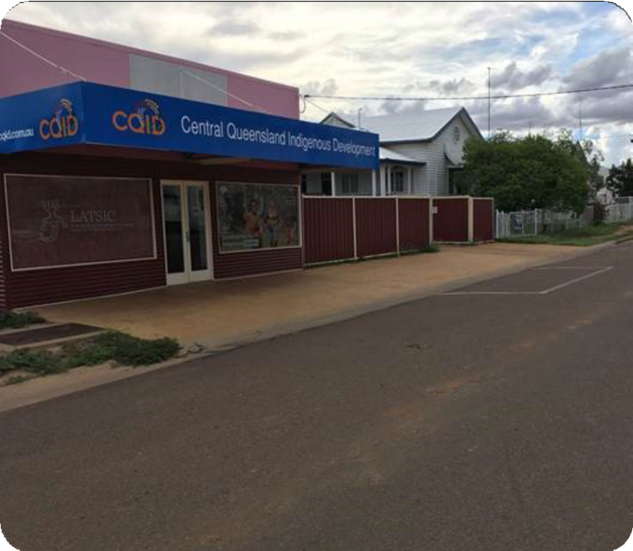
Case study D – Man experiences several COVID-19 crises
One of PWDA’s highlights this year was supporting a person with disability through a lockdown scenario in his supported accommodation during a number of COVID-19 crises. In collaboration with stakeholders involved we were able to get him into
emergency accommodation due to the high level of harm/abuse he was exposed to at his accommodation. We reported and sent incident reports to the Queensland Office of the Public Guardian (OPG) and Department of Housing and Public Works (DHPW), which escalated an investigation through OPG’s investigations team and the housing department in regards to the previous accommodation provider of this person with disability. We are still supporting him through these investigation progresses. While he was in lockdown, his siblings also attempted to take financial advantage by putting a house he had inherited on the market, while he was in lockdown and cut off from his supports. We informed OPG and the Public Trustee of Queensland (PT) and ensured
the man was linked in with a solicitor for ongoing legal support. The house could not be sold without his consent and the matter is currently going through court.
24

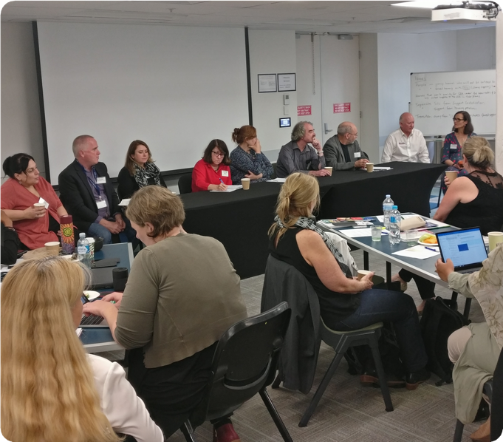
Case study E – Thirty-year- old accesses the NDIS
PWDA advocates worked with a young Indigenous person with disability, who had left school in
year 8 and had never received access to disability services. At age 30, he received help from an advocate
to apply for the National Disability Insurance Scheme (NDIS) and connect him with a culturally safe support coordinator. Among other things, the support coordinator was able to connect him with LinkUp facilitating his return to country.
Case study F – Finally enough support
Despite having significant support needs, a young person with disability had only received enough NDIS funding for one-on- one support for eight hours a day, while his support needs were much greater than this.
The advocate assisted the family to obtain assessments addressing his significant functional impact and time in his plan subsequently doubled and included two-on-one care 24 hours a day.
25

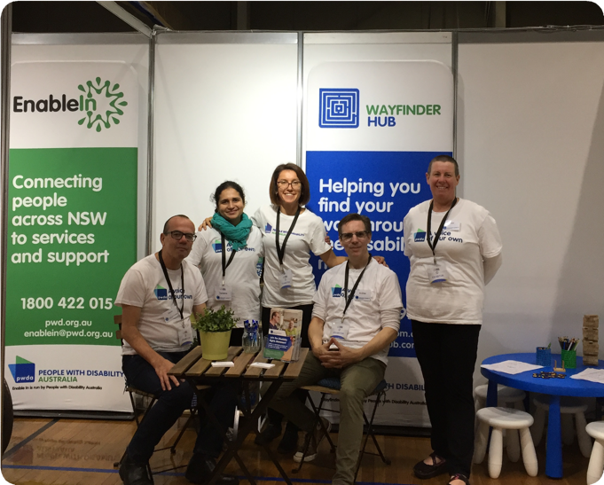
Individual advocacy
– projects and development
26

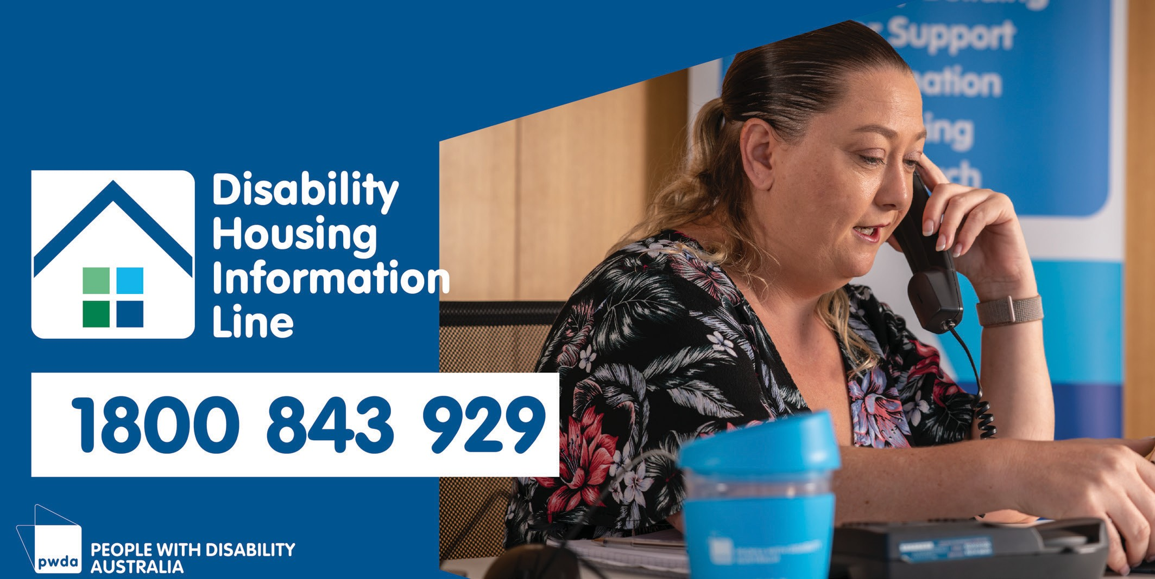
PWDA supports people with disability who advocate for their own interests or seek our support as advocates who can back their efforts to live life with autonomy. We have been involved with a number of individual advocacy projects over the past year, including housing advocacy efforts, the National Redress Scheme, the Enable In effort, Wayfinder and the NDIS appeals process.
Our advocates are committed to talking with people with disability, their housing providers and people’s family members to assist with issues of accommodation, the quality of services provided and the rights of residents. Our project area covers SDAs in the suburbs of Sydney and regional, rural and remote areas of NSW.
Since the DHAS and DHIL projects began outreach in September 2019, strong connections have been built with a wide range of accommodation providers, service providers and other relevant stakeholders. Through these connections, DHAS and DHIL have been able to promote referral pathways and build a network of people to help. During the last year, a total of 40 issues have been referred to DHAS to assist residents of SDA, SIL or short or medium-term transitional NDIS-funded accommodation. Of these files, 15 have been closed, and 25 remain open as of 30 June 2020.
Disability Housing Advocacy Service and Information Line NSW
The NSW Disability Housing Information Line (DHIL) and Disability Housing Advocacy Service (DHAS) projects aim to assist people with disability living in Specialist Disability Accommodations (SDAs), who have tenancy problems or concerns. The Information Line provides information and advice to people living in SDAs, their supporters and housing providers. The Advocacy Service is designed to facilitate resolving people’s disputes with housing providers.
27

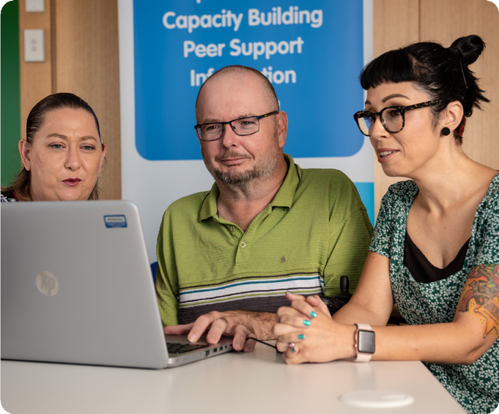
DHIL has contacted and/or assisted more than 450 residents, accommodation providers, service providers and others in a range of accommodation settings. We have given advice and information, promoted self-advocacy, provided education on how
to understand and navigate government and other systems/processes and, when required, facilitated referral to PWDA or alternative individual advocates. The DHAS and DHIL projects have identified a raft of systemic issues, some of which have been taken up
by the PWDA Systemic Advocacy team.
DHIL has undertaken key activities through the projects. These activities included supporting people with disability in their NDIS planning meetings and reviews.
We promoted self-advocacy with our work by holding frequent meetings with
people to build their confidence and provide background support to help them focus on resolving issues. DHIL attended
multidisciplinary meetings with stakeholders from the NDIA and various providers, and NSW Health and the Office of the Public Guardian. We also supported people to engage and connect with legal support, and participated in regular case conferences to hold people’s support networks accountable. These meetings helped us ensure actions were being pursued. Holding regular meetings with the people we are helping helps us build trust and rapport, and support people to communicate and make decisions. We have also had an ongoing discussion with the National Disability Insurance Agency’s (NDIA) early resolution team.
28

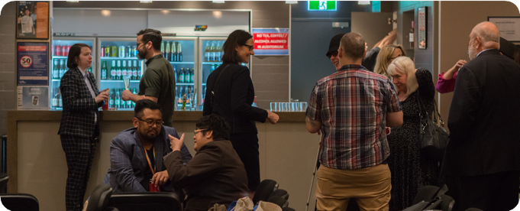
The project provided one-day service training for workers from 17 services in remote NSW.
The training also attracted registrations from people located in several other regions across NSW (however due to COVID-19, these were unable to be completed). The training covered a broad range of topics, including understanding NDIS eligibility, supporting people in hard-to-reach settings, NDIS terminology and provided practical examples and letters of support.
The Enable In team partnered with the University of NSW (UNSW Sydney) to develop an action research paper in consultation with people with disability, the peer support groups, services in metro, regional and remote communities, and the Project Advisory Group (PAG).
Throughout the project, the barriers and challenges to navigating the NDIS processes were identified during consultations with people with disability. These included: a lack of knowledge about the NDIS; the daunting and complicated nature of the NDIS process; and people’s confusion about processes such as eligibility, access, pre-planning and planning.
The Enable In team provided outreach and information sessions across NSW and
worked in collaboration with a large number of services and organisations including the NDIA and local area coordinators.
\=
Enable In NSW
The Enable In project was a two-year project funded through a National Disability Insurance Agency’s Information, Linkages and Capacity (ILC) Building grant. Enable In assisted in making the NDIS process more accessible for people with disability who were homeless or at risk of homelessness, and people with psychosocial disability.
The project focused on building capacity for individuals so they could achieve their goals and advocate for themselves and for others.
Enable In formed three peer support groups and trained a number of peer navigators in metropolitan and regional NSW. This was very successful and a positive experience for the people who attended. The peer support groups were held in informal settings where people were able to meet others, share experiences with peers and get help them connect with services. Enable In project
staff shared general information about NDIS and mainstream support, as well as offering individualised support to those who required it.
29

At the end of March 2020, in the midst of the COVID-19 pandemic, PWDA gave evidence to the hearing of the Joint Select Committee on Implementation of the National Redress Scheme. We highlighted the multiple barriers that must be addressed to enable people with disability to seek redress. PWDA is
continuing to develop our systemic responses to strengthen access to Redress for people with disability in the lead-up to the second anniversary review of the scheme.
The organisation continues to work to promote awareness of the National Redress Scheme within the wider disability community, to create safe referral pathways, and advocate for safer ways for people with disability to access information and support to participate in the Redress process.
National Redress Scheme
The National Redress Scheme was set up to acknowledge and recognise the sexual abuse many people, including people with disability, experienced as children in institutions. It
was set up by the Australian Government in response to the Royal Commission into Institutional Responses to Child Sexual Abuse. The National Redress Scheme is
one way for people to get recognition for the harms they experienced.
PWDA provides confidential and free support to survivors of institutional child sexual abuse with disability, who are considering applying for Redress across Australia. In 2019–20 individual advocates provided direct information and support to people with disability interested in seeking Redress located in NSW, Queensland, and Western Australia.
The organisation researched and developed accessible information for people with disability about the National Redress Scheme, including easy-read brochures about the scheme and the support that PWDA can provide. PWDA continues to give advice to the Australian Government about making information about the scheme accessible.
PWDA also works with other Redress Support Services to build capacity in working with people with disability. We produced a short video to raise awareness about some of the additional barriers people with disability face in accessing the scheme, and this was approved and distributed by DSS to these services Australia-wide.
PWDA continues to give feedback to the Australian Government about systemic issues in accessing the scheme and structural changes to improve experiences and outcomes for people with disability engaging with the scheme.
Wayfinder
The Wayfinder Hub (Wayfinder) was funded through a National Disability Insurance Agency Information, Linkage and Capacity Building grant. The project funding period was completed on 30 June 2020.
The Wayfinder project was established to provide people with disability, their families and supporters easy access to information, advice and referrals to assist choice, link to appropriate supports and make informed decisions. The Wayfinder information service has promoted the values of equality and respect with an understanding of disability and human rights.
People can access Wayfinder online to link with information and services, to assist choices and decisions that affect individuals directly.
30

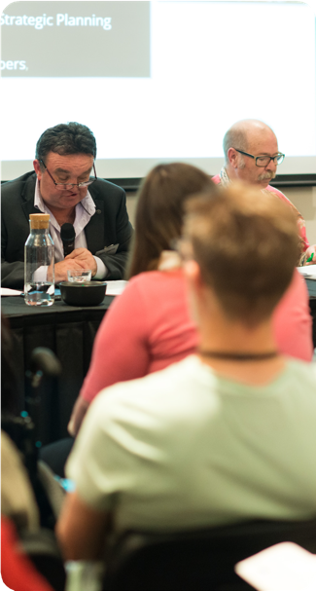
The Wayfinder project final ILC report was well received by the NDIA with acknowledgment of the success of the project. The Wayfinder project received 123 contact requests in the month of July 2019 and 351 in June 2020. The total contacts for the period from July 2019
to June 2020 was 3148. Most of these contacts resulted in the provision of information or linkages with local services or other supports. A number of requests moved to the PWDA individual advocacy teams across NSW and Queensland.
Wayfinder continues to receive contacts via phone, email or website based contact requests for assistance on any aspect of disability information. The service operated
through the 2019–20 financial year with four intake staff and a manager.
Knocks child protection training provided by the Intellectual Disability Rights Service.
Our individual advocacy work often involves engaging with people with disability who have been or who currently are being affected
by violence. Individual advocates receive ongoing support through access to monthly external group supervision which is facilitated by a trauma specialist engaged by PWDA. This forum provides an invaluable, safe space for individual advocates to critically reflect on their practice, to respectfully challenge each other and to foster an ever-stronger sense
of team. Individual advocates specialising in Disability Royal Commission work additionally have access to monthly, external one-to-one clinical supervision.
The Wayfinder project created an opportunity for PWDA to build on its advocacy intake service and promote capacity building, self- advocacy and links within the community.
More generally it provided people with disability access to information and services to assist and inform decisions.
The Wayfinder service and information-based website will continue to provide disability- related information with website search functionality. Project staff saw the service contacts increase over the year and the website continues to be refined and updated beyond the project end date.
Professional development
Individual advocates participated in numerous professional development activities throughout the year, including: the NDIS Code of Conduct training provided by the ASU; Tenancy Law training provided by the Tenants Union of NSW; Emotional CPR training provided by the Victorian Mental Illness Awareness Council; and When DoCS
31

Representation and systemic advocacy
32

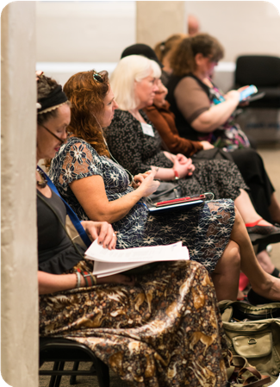
Our representation and systemic advocacy work aims to ensure that people with disability have a voice in key decision-making mechanisms, and in legislative reform and policy development and implementation.
We strive to achieve fundamental positive change to social structures and processes in order to realise the rights of all people with disability by eliminating marginalisation and disadvantage, discrimination, exclusion, and all forms of violence, neglect and exploitation.
We work within a human rights framework to advocate for the full implementation of the UN Convention on the Rights of Persons with Disabilities (UN CRPD). Our work is strongly informed by the concerns of our members and the wider disability community, issues and trends drawn from our individual advocacy program, and the policy and law reform opportunities of the day.
National
With the 46th Australian Parliament formally commencing on 2 July 2019, the beginning of the financial year began with a strong focus on providing briefings to the new Federal Minister for the Families and Social Services Senator Anne Ruston and the new Federal Minister for the National Disability Insurance Scheme (NDIS) Stuart Robert MP. This was the first time that a Minister had been appointed to focus specifically on one government program area and it was clear that the NDIS would be a critical policy area for the Australian Government.
PWDA continued our advocacy to make the National Disability Insurance Scheme (NDIS) work effectively and equitably for people with disability. We consistently raised issues that people with disability experience every day in getting the essential supports we need.
Making the NDIS work for us
In August 2019, the Minister for the NDIS announced a wide-ranging review of the NDIS to be led by David Tune AO PSM. This review of the National Disability Insurance Scheme Act 2013 included plans to introduce a legislated Participant
Service Guarantee to address the extensive waiting times for access to the scheme as well as the delays in plan reviews. PWDA provided an extensive submission to the Tune Review highlighting the fundamental strengths of the objects of the NDIS but how the implementation of the scheme could be improved by reducing the complexity of the NDIS and creating greater equity of access to the scheme. Our submission drew on the experiences of our advocates and members and demonstrated why access to advocacy supports would make access and navigation of the scheme fairer. We also reiterated the importance of collaboration with people with
disability and their representative organisations.
33

PWDA also worked to stave off two attempts by the Australian Government to encroach and limit what reasonable and necessary supports could be funded under the NDIS. The first attempt involved PWDA challenging the NDIS (Streamlined Governance) Bill 2019. The
Bill threatened the long-standing convention that all state/territory disability ministers in the Disability Reform Council had to agree unanimously with any changes to the NDIS. The Bill also had the potential to increase the power of the NDIS Minister to appoint and remove members of the NDIA Board and
the Independent Advisory Council. PWDA spearheaded the disability sector’s opposition to the Bill. PWDA’s Director Policy and Advocacy gave evidence to the Parliamentary Inquiry into the Bill. Unfortunately, despite
our strong advocacy, the Bill passed through Parliament and PWDA continues to closely monitor the situation.
PWDA was meanwhile successful in supporting the applicant, known for legal reasons as WRMF, in a series of highly publicised legal cases argued before the Administrative Appeals Tribunal (AAT) and the Full Bench of the Federal Court of Australia. WRMF sought reasonable and
necessary sexual supports through the NDIS, but the Government viewed the funding of these supports as not meeting community expectations. If sexual supports were not funded, this would have set a dangerous precedent of government deciding what reasonable and necessary supports should be funded, and create an instance of the NDIS being worse than previous state-funded supports. To ensure this wouldn’t happen, PWDA, along with our partner Touching Base, developed a joint statement and government relationships strategy to keep sexual supports funded in the NDIS. Ultimately, PWDA was successful in our advocacy, with both the AAT
and Federal Court agreeing sexual supports should be funded, and more than 50 sector organisations and key individuals signing up to our joint statement.
PWDA was also a highly active member of the NDIA’s Specialist Disability Accommodation (SDA) Reference Group
ensuring that the voice and rights of people with disability were represented in providing advice on the development of the Rules and Standards for SDA and highlighting the rights of people with disability to live independently in the community like our non-disabled peers.
We also worked with the NDIA to develop the LGBTIQA+ Strategy and Participant Pathway including a full review of all training materials, and method of delivery.
PWDA provided ongoing active commentary on a range of issues related to the NDIS including an interview on ABCNews
24, in response to the Minister for the NDIS National Press Club Speech on 14 November. We also provided commentary when the Tune Report was released on 20
January 2020. While we supported many of the recommendations, we highlighted that implementation of any measures needed
to take place in consultation with people with disability and their representative organisations.
The success of the NDIS, and its promise to deliver ‘choice and control’ to people with
disability continues to be a priority for PWDA.
PWDA continued to represent people with disability, including on behalf of the Disabled People’s Organisations Australia, on a range of consultative forums and groups including:
•
•
Ministerial Roundtables
DSS Steering Group for the National Disability Strategy (NDS)
34

•
•
NDIA Independent Advisory Council
NDIA CEO Forum
•
continuing government relations work opposing the national roll-out of
compulsory income management tools
•
NDIS Specialist Disability Accommodation Reference Group
National Quality and Safeguards Commission Consultative Committee
The systemic advocates in the Policy and Advocacy team have continued to work to progress policy work across a range of fronts during 2019–20, including:
•
•
•
NDIS implementation
Disability Royal Commission
•
DSS Disability Employment Services Working Groups
Australian Electoral Commission’s Disability and Democracy Advisory Group
•
•
•
COVID-19 (including health planning)
National Redress Scheme
•
Department of Infrastructure and Regional Development (DIRD) National Accessible Public Transport Advisory Committee (NAPTAC)
1800RESPECT Disability Pathways Project Expert Advisory Group
•
NSW Disability Advocacy Funding Review
housing (including boarding houses)
•
•
•
•
disaster resilience and response
income support
Addressing income inequality and alleviating poverty
We contined our focus on reducing income inequality and alleviating people’s poverty, advocating for people with disability while:
•
employment support including pathways into open employment and wage justice
accessibility including transport and access to premises
•
•
access to justice including responding to adverse changes to the NSW Victims Support Scheme
domestic and family violence, and preventing and responding to violence, abuse, neglect and exploitation
•
making a submission to the Senate Standing Committee on Community Affairs Inquiry into the adequacy of Newstart and alternative mechanisms to determine the level of income support payments in Australia
making a submission to the Senate Standing Committee on Legal and Constitutional Affairs Inquiry into the impact of change to service delivery models on the administration and running of government programs
Providing evidence to a public hearing, and answered questions on notice
for the Senate Standing Committee on Community Affairs Inquiry into Centrelink compliance
•
•
•
education
contributing to the work of DPO Australia as well as PWDA’s strategic planning processes
•
•
infrastructure and communications accessibility
access to justice
•
•
•
human rights implementation and monitoring
35

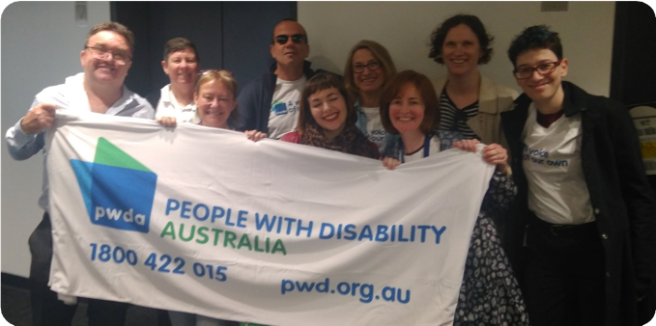
Raising issues of concern
We worked with a wide range of disability sector colleagues, government departments, community sector partners, and private sector stakeholders to raise issues of concern and ensure that the voice of people with disability was represented in reform processes and new project designs.
Our work involved joint campaigns as well as making submissions, appearing at
inquiry hearings, providing expert disability advice and information, participating
on Government advisory and reference committees, and lobbying politicians.
Our work included the following activities:
•
lobbying federal, state and territory disability ministers to not change NDIS legislative instruments in response to the Federal Court’s decision to uphold people’s right to sex work services as part of their NDIS plans
continuing to participate in the Australian Network for Universal Housing Design (ANUHD) and monitor the Release
of the ABCB’s Accessible Housing Consultation RIS
participating in the Strategic Planning process with DPO Australia to determine priorities and refine the Activity Work Plan for 2020–21
working on draft submissions to the Joint Standing Committee of the NDIS on the NDIS Workforce, the Disability Royal Commission on emergency planning and response, and group homes, the Select Committee on Autism, the Joint Select Committee on Implementation of the National Redress Scheme, the Inquiry into Family,
Domestic and Sexual Violence, and the Joint Standing Committee on the NDIS on their inquiry on the National Quality and Safeguards Commission,
•
•
•
•
giving recommendations to the Select Committee on COVID-19 and passing on a copy of the People with Disability and COVID-19 report which was based on our submission to the inquiry and an Open Letter to National Cabinet
sharing those recommendations with the Minister for Family and Social Services and the Minister for the NDIS with a copy of PWDA’s report
•
36

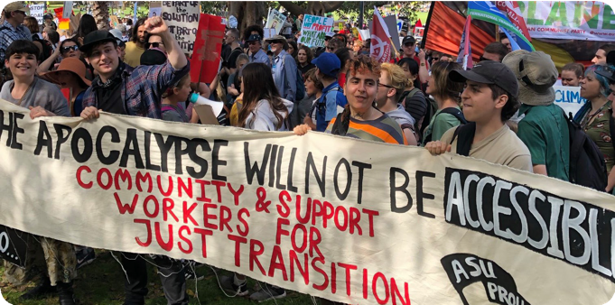
and the Australian Building Codes Board Accessible Housing Project Consultation-RIS
moving to write a letter to the NDIS Quality and Safeguards Commission Independent Inquiry into the death of Ann Marie Smith on behalf of DPOA
drafting or committing to contributions to consultation processes for the Disability Royal Commission on a variety of issues, including healthcare and emergency planning and response, employment, restrictive practices
drafting or committing to proactive DRC submissions on confidentiality, Redress, poverty and income support,
oversight mechanisms and safeguarding accountability and segregation
providing advice to the consultancy reviewing the DSP assessment on behalf of DSS
successfully provided nine recommendations that were picked up for the Newstart report to ensure reviews of DSP impairment tables, mutual obligations for people with disability, and and understanding of how the income support system traps people into poverty
•
engaging and providing policy expertise on the DSS Disability Employment Services (DES) Reference Group
providing input to the University of Melbourne research into NDIS/DES intersection
continual participation in the Advisory Committee of the National LGBTI Health Alliance’s Economic and Cultural Participation ILC project, seeking to understand the employment barriers LGBTIQ+ people with disability face
participation in the Disability Standards for Accessible Public Transport (DSAPT) review and the development of draft Guidelines on DSAPT Equivalent Access
participating in the National Inclusive Transport Advocacy Network (NITAN), the CBA Customer Advocate Community Council, and the National Accessible Transport Taskforce which is progressing the Review of Disability Standards for Accessible Public Transport (DSAPT)
•
•
•
•
•
•
•
•
•
37

funding from the NSW Government including participating in a consultation with NSW Disability Peak Organisations with the NSW Disability Council
contributing to the NSW review of single use plastics and the proposal to ban plastic straws
NSW
In 2019–20, PWDA continued our role as the New South Wales peak cross-disability organisation providing information, advice and representation of and for people with disability across the state.
We are active members of a number of NSW Government committees and advisory groups where we advocate for disability rights, inclusion and accessibility. We made a number of submissions to inquiries and consultation processes across a broad range of policy areas including inclusive education, NSW disability support and the NDIS, juvenile and criminal justice, child protection, guardianship law and policy, mental health law and policy, accessible transport, accessible housing, tenancy rights, deinstitutionalisation, human rights, and violence prevention and response.
PWDA works collaboratively with a range of NSW disability representative and advocacy organisations to coordinate campaigns and projects to progress the rights of people with disability in NSW.
Our work included the following activities and achievements in 2019–20:
•
•
continual participation in the NSW Accessible Transport Advisory Committee (ATAC) including consultation on the roll-out of NSW Trainlink services and a review of NSW ride-share services
responding to proposed changes to the NSW Victims Support Scheme
•
•
commenting on plans for an inclusive education strategy, to support the NSW Disability Strategy Reference Group
supporting the Campaign for a Human Rights Act for NSW
•
NSW Disability Advocacy Funding Review
With the establishment of the NSW Ageing and Disability Commission in July 2019, the new Commissioner Robert Fitzgerald AM commenced a legislated review of disability advocacy funding in NSW.
As the NSW cross-disability peak organisation, PWDA was actively involved in this significant review of the disability advocacy funding in NSW in the second half of 2019. As a key member of the Stand By
Me campaign, we have been calling for long- term sustainable funding for independent advocacy in NSW so that people with disability in NSW can realise our rights to participate fully in all aspects of economic, social and community life in the state.
•
advising the NSW Minister Disability Services on COVID-19 and NDIS, to help inform the Minister’s work on the Disability Reform Council (DRC)
meeting with the minister regarding our submission to the review of the Boarding Houses Act 2012 where we called for the progressive closure of boarding houses
building a relationship with the Western Sydney University Law School
working with the NSW Disability Advocacy Alliance on the next phases of the campaign to secure advocacy
•
•
•
38

We provided a comprehensive submission to the advocacy funding review, highlighting the importance of independent advocacy
to enable people with disability to access services and supports in NSW for education, training, employment, transport and housing. We also highlighted that, in spite
of the introduction of the National Disability Insurance Scheme, the NSW Government has an ongoing responsibility to ensure the voices of people with disability are heard
in all of aspects of NSW government policy development and decision-making. We noted the NSW Government has a responsibility to the almost 1.4 million people with disability living in NSW and that only 10% of people with disability are eligible for the NDIS.
In responding to the review, we also worked closely with partner disability advocacy organisations through the NSW Disability Advocacy Alliance (NSWDDA) and the Stand By Me campaign, contributing to the joint submission representing the collective voice of disability advocacy organisations across NSW. We also participated in numerous consultation meetings with the funding review consultants and directly with the Ageing and Disability Commissioner.
Implementation was coordinated by PWDA, with our volunteers moderating social media channels three days a week.
Ageing and Disability Commissioner Fitzgerald’s Review into Disability Advocacy in NSW report to the NSW Government was released in December 2019, with the
Commissioner calling for disability advocacy funding to be maintained and for funding to be better and longer term.
Commissioner Fitzgerald’s praise for the work of disability advocacy organisations was
good to note, as was his support for individual and systemic advocacy and proposal for
the establishment of a Disability Advocacy Futures program for the state.
It was a disappointing outcome that Minister for Families, Communities and Disability, Gareth Ward chose to only guarantee disability advocacy funding to the end of 2020.
We continue to seek funding support from Government and back the Commissioner’s call for the Government to commit to up to two years of additional transitional funding through to June 2022.
PWDA also supports the Commissioner’s call for the establishment of a Centre for Disability Advocacy Development which would run much needed special projects and support quality improvements in advocacy.
As a member of the NSWDAA, we welcomed the findings and recommendations of the Ageing and Disability Commissioner’s
report: NSW Disability Advocacy Futures Program: Your voice matters: Improving the disability advocacy system for people with disability in NSW, which was released on 19 December 2019. We participated in the press conference at NSW Parliament House.
PWDA also continued to take a leadership role in the communications function of the NSW Disability Alliance and Stand by Me campaign social channels during the period.
39

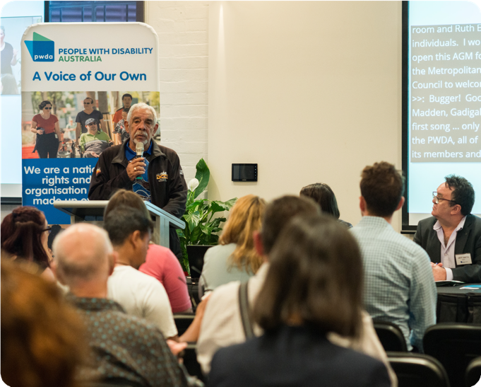
Systemic advocacy projects
40

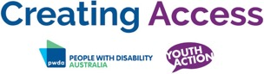
youth services to review and increase the accessibility of their service.
Building Access NSW
In July 2019 we finalised the interim evaluation report for the Building Access project which was focused on New South Wales. We made key findings and recommendations about barriers in the
domestic and family violence (DFV) sector for women with disability. DFV continues to be a big issue for many women with disability, who we know experience high rates of violence.
We partnered with Domestic Violence NSW (DVNSW) and many of the participating services and wrote a letter to Minister Mark Speakman and Minister Gareth Ward asking that access and inclusion to domestic and family violence services be funded so that all women who experience violence can get the services they need.
We did access reviews for four domestic and family violence services from across NSW. During these reviews we assessed a service’s attitudinal, informational, physical and procedural accessibility. There are many barriers in all these areas so during the
review we also help to identify short, medium- and long-term goals for services.
We provided these services with a report designed to help create disability inclusion action plans. We also provided these services with resources and templates to create disability inclusion action plans.
Following this work, we provided training to the participating services in disability awareness and the NDIS. We host an ongoing community of practice where participating services join us for quarterly meetings to talk about their successes and challenges. Last September we had an in-person meeting with speakers from
different services presenting on issues that affect women with disability who are victim- survivors of domestic and family violence.
Creating Access NSW
The Creating Access project was a joint project between PWDA and Youth Action, the peak body for young people and youth services in NSW. It was a one-year NDIS Information, Linkages and Capacity Building program project that aimed to build the capacity of the youth sector in NSW to be
responsive, inclusive and accessible to young people with disability.
The project finished in late 2019, with the launch of a toolkit of resources to be shared across NSW for both young people and youth services.
The Creating Access project is a joint project between PWDA, the peak body for people with disability, and Youth Action, the peak body for young people and youth services in NSW. It is a one-year project which aims to build the capacity of the youth sector in NSW to be responsive, inclusive and accessible to young people with disability.
Over the last year we have consulted with both young people with disability on the barriers they have experienced when accessing youth services, and youth workers on how confident they are working with young people with disability. We have also been working with seven diverse youth services across NSW to review their own organisations accessibility, and implement changes to work towards
best practice. The youth services have also participated in Disability Awareness training facilitated by PWDA.
A toolkit of resources was shared across NSW for both young people and youth services. Resources were made available for young people with disability to learn more about self-advocacy, alongside resources for
41

The pandemic meant that the second event we had planned for our community of practice had to be shortened and brought online. We also had to cancel our final
access review and instead find new ways of supporting services to work on their access and inclusion. Towards the end of the last financial year we began researching what information and resources existed that were accessible and helped women who were experiencing violence.
We also asked participating services what resources they felt they needed to best help women who experience violence. We then began planning resources to share with service providers that will help to make the DFV sector more accessible and inclusive.
We also made plans for a website to share accessible and inclusive information and resources for services, and women with disability.
These public statements included a media release on the routine ignoring of the rights of people with disability in Australia, a call for a comprehensive sexuality policy for the NDIS, and an acknowledgement of DPO Australia’s role in the UN Committee on the Rights of Persons with Disabilities (CRPD Committee) review of Australia, with PWDA.
The UN review of Australia’s compliance with the human rights of people with disability was a highlight for DPO Australia which sent a seven-person delegation to Geneva to participate. This delegation included PWDA, as a member organisation of DPO Australia.
Another highlight for DPO Australia and PWDA in 2019–20 was the start to the Royal Commission into Violence, Abuse, Neglect and Exploitation of People with Disability, which DPO Australia had been campaigning for many years.
PWDA continued to represent people with disability on behalf of DPO Australia, taking part in the following Government reference and advisory groups:
•
the Commonwealth Department
of Social Services (DSS) Disability Employment Services (DES) DES Reference Group
National Disability Strategy (NDS) Reform Steering Group
•
DPO Australia
Disabled People’s Organisations Australia (DPO Australia, DPOA) is an alliance of four national cross disability and population
specific organisations – PWDA, First People’s Disability Network (FPDN), National Ethnic Disability Alliance (NEDA) and Women With Disabilities Australia (WWDA).
As an organisation, DPO Australia promoted better treatment for people with disability in 2019–20, making a number of public statements and promoting better understanding of disability issues on social networks.
•
Independent Advisory Council (IAC) to the National Disability Insurance Agency (NDIA) Department of Infrastructure, Transport, Regional Development and Communications’ (DITRDC) National Accessible Public Transport Advisory Committee (NAPTAC) and Disability Standards for Accessible Public Transport (DSAPT) Modernisation Committee (DCM) and associated sub-committee
the Commonwealth Department
of Industry, Science, Energy and Resources’ Premises Standards Expert Advisory Group (National)
•
42

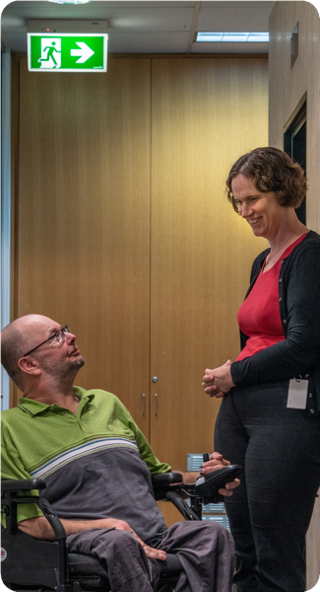
•
the Australian Human Rights Commission Advocacy Network on Inclusive Transport
the Commonwealth Bank Australia (CBA) Customer Advocate Consumer Council
PWDA sent a delegation to the DRC’s first public hearing in Queensland, on
16 September 2019, and has live-tweeted the public events as they have unfolded throughout the 2019–20 year.
We have also promoted understanding of the Commission’s work, developing and regularly updating a section of our website on the Royal Commission, and publishing a jargon buster to convert its language to plain
English. With each DRC public hearing we’ve updated the jargon buster, striving to keep people up to date with what the Commission is doing.
•
•
the Comcare Collaborative Partnership to Improve Workplace Participation
Disability Royal Commission
After many years of campaigning, the Royal Commission into Violence, Abuse, Neglect and Exploitation of People with Disability got underway in 2019–20. The Disability Royal Commission’s (DRC’s) budget of
$527 million dollars over five years is the largest amount ever allocated to a royal commission. The commissioners are required to provide an interim report no later than 30 October 2020, with a final report by no later than 29 April 2022.
PWDA, as part of DPO Australia, called for a royal commission during the 2015 Senate Inquiry into Violence, Abuse and Neglect against People with Disability in
Institutional and Residential Settings which first recommended the Royal Commission, and which gave weight to our campaign for a commission of inquiry.
PWDA continued to advocate for a strong royal commission in 2019–20, one that aimed to provide justice and redress for all people with disability and adequate resources for people with disability to be supported to engage with the Royal Commission.
We engaged with the work of the DRC over the year and helped people with disability provide their submissions. We are funded to undertake individual advocacy with people about the Royal Commission in New South Wales and Queensland, and undertake national systemic advocacy. We also put in funding applications to further support our work on the DRC.
PWDA has coordinated and liaised with other disability advocacy organisations during the Royal Commission process.
43

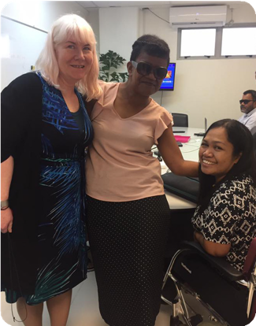
CRPD Geneva
In September 2019 members of the Australian civil society delegation, including delegates from PWDA, travelled to Geneva to present their concerns to the Committee on the Rights of Persons with Disabilities regarding Australia’s implementation of the Convention on the Rights of Persons with Disabilities. The delegation consisted of people with disability, their supporters and representative organisations.
The Shadow Report, Disability Rights Now 2019, was co-written by Australian disabled people’s organisations (DOs), disability representative organisations, and disability advocacy organisations (DAOs). The Shadow Report was tabled to the committee prior to the September review, and was well received by all members of the committee.
The civil society delegation met extensively with all members of the committee prior
to the formal hearings. The delegation was especially well received by fellow
Antipodean, Sir Robert Martin, New Zealand’s representative on the committee. Sir Robert was impressed by the number of delegates with intellectual disability, with Australia having the largest delegation with intellectual disability at the time of the proceedings.
It had been six years since the last review of Australia’s performance, and
the nation’s lack of progress in the meantime was strongly noted with considerable concern from the committee.
The committee raised many concerns about Australia’s implementation of the UN CRPD and requested the Australian Government delegation to respond to several serious questions.
Some of the key concerns about Australia’s implementation of the UN CRPD that
were highlighted by the Committee on the Convention on the Rights of People with Disability, in Geneva, September 2019:
International work
PWDA continues to represent people with disability at regional and international levels through our engagement with the United Nations and networks with our sister Disabled People’s Organisations (DPOs).
Our international work aims to deliver against all of PWDA’s Strategic Directions:
•
advocacy on the rights of people with disability
capacity-building and empowerment
effective representation, capacity- building and sector development
•
•
We do this work by participating in consultations and at conferences, hosting public events and speaking at seminars, making submissions on topics of key concern, and supporting people with disability to have our voices heard and to build leadership and representational skills.
Our international advocacy and representation role is undertaken in our own right or through DPO Australia.
44

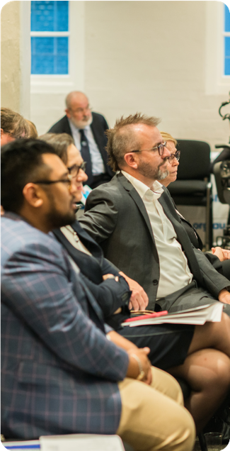
•
that Australia must make progress to remove its interpretative declaration on articles, 12, 17 and 18 – this is essential to ensure justice for people with disability in Australia
that Australia must address the current limitations in the Disability
Discrimination Act 1992, to ensure anti- discrimination laws are strengthened, enable representative claims, enable complaints about disability hate crimes and ensure people with disability
can make complaints about denial of reasonable accommodation
•
that a formal mechanism be developed, including a monitoring and evaluation framework, for the implementation of the CRPD which involves the meaningful engagement of people with disability and their representative organisations
•
PWDA has had a long history of supporting and contributing to the United Nations, especially regarding the UN CRPD. Our delegation last September was well received, and it was noted that the delegation was well prepared, well organised and provided expert knowledge across a range of issues affecting people with disability in Australia.
•
the serious delays in the third implementation plan of the National Disability Strategy (NDS) must be addressed, including the development of a monitoring and evaluation framework
that the NDIS assessment criteria relies heavily on the medical model of disability, in contravention of the UN CRPD, and does not adequately cover older persons with disability,
people from culturally and linguistically diverse (CALD) backgrounds or Aboriginal and Torres Islander people with disability
•
•
that national advocacy programs are not adequately or sustainably funded for people with disability
that Australia should enact national uniform and enforceable legislation prohibiting forced sterilisation and medically unnecessary interventions on people with disability
•
•
that a national action plan for inclusive education be developed that fully complies with article 24
that a national disability jobs strategy be developed to increase workforce participation of people with disability
•
45

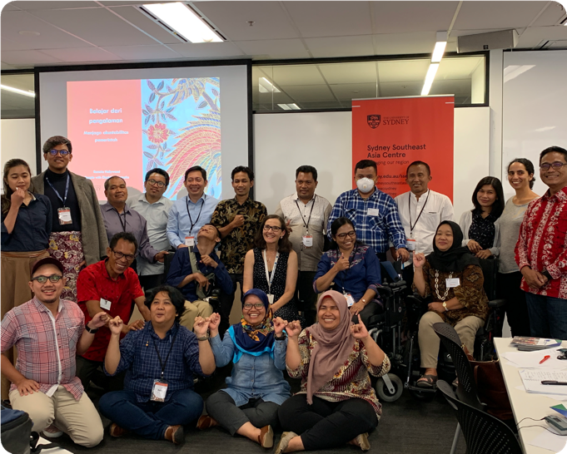
Training and research
46

Facilitating Access for Clients with Disability – This training course is an advanced course from the Disability Awareness training. It looks at putting practical skills around disability going forward. PWDA partners with Guide Dogs NSW/ACT and Deaf Society to provide three-hour interactive training sessions, covering all disability types but focusing more on people who are deaf, blind, have a mobility impairment and/or intellectual disability.
NDIS and Advocacy – This training course aims to prepare people to understand the process of applying for the NDIS, and to be able to advocate for people with disability throughout the process, or to teach people with disability the skills and tools needed for them to be able to self-advocate through the process. This is important as it can help
people with disability to go through the NDIS process without having to adjust their plans or appeal decisions that have been made about their eligibility or the result of their plan.
Training
PWDA continued to deliver high-quality training to people with disability, service providers, family members and members of the community. PWDA provided training to 355 people with four different training packages across New South Wales, in metropolitan and regional areas.
PWDA’s training is provided on a fee-for- service basis, or free for many organisations involved in the work of the Royal Commission into Institutional Responses to Child Sexual Assault, Youth Action, NDIS appeals or through the NSW Domestic and Family Violence Innovation Fund.
A description of the training delivered is below:
Disability Awareness – This training looks at how people can work with people with disability. The training gives tools and strategies on how to communicate with people with disability, facts and statistics around disability including disability discrimination law and the United Nations Convention of the Rights of Persons with Disability, how the disability movement has evolved over the years, appropriate and respectful language, as well as all the different barriers that people with disability may face when accessing services or accessing life in general. This one-day course is appropriate for anyone working with people with disability, is interactive,
and involves group discussions to help with accessibility and inclusion. This course is also offered in a half-day session.
NDIS Reviews, Appeals and Self- Advocacy – This is a free information and education session provided to people with disability. It outlines what a person with disability can do if their eligibility hasn’t been met, or they have not received an adequate plan to meet the needs and requirements of their disability. The session helps a person with a disability or their support person to understand how they can review a decision, and/or appeal a decision. The course aims at providing skills to people with disability
to be able to self-advocate through the process.
47

Highlights of the training are that PWDA:
•
contracted a further seven contract trainers across NSW and QLD
was contracted by Education Centre Against Violence (ECAV) to assist with ensuring its training was accessible for people with disability, providing Disability Awareness training for all its
staff and doing a physical review of the organisation’s workplace and providing recommendations on short-, medium- and long-term improvements it
could make
continued a successful working partnership with the Australian Centre for Disability Law (ACDL) when delivering Disability Awareness Training, with ACDL presenting an information session around disability discrimination law and other general disability law
partnered with ACDL and First Peoples Disability Network (FPDN) in creating legal resources and education to hard- to-reach indigenous communities across NSW over the next three years
is working at putting all training packages online due to the COVID-19 pandemic, so in future PWDA training can be accessed online and face-to-face
worked through the training department to facilitate the production of the Redress video
Disability Awareness
250 were trained
•
Facilitating Access for Clients
with Disability
20 were trained
NDIS, Advocacy, Reviews and
Appeals Information Sessions
50 were trained
•
NDIS and Advocacy
35 were trained
•
•
•
Research
PWDA has been actively involved in a range of research activities that align with our inclusive research protocols over the past year. We support inclusive research that is led by and driven by people with disability.
We ensure that the voice of people with disability is heard in research and that our voice helps drive research that benefits our daily lives.
48
In total: 355 people were trained

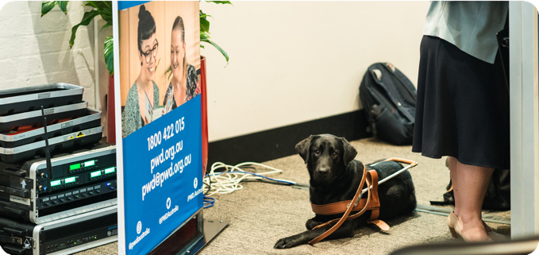
PWDA provides expert advice to universities and other agencies on the experiences of people with disability. We make sure that the social model of disability is part of any research project that we support. We also make sure that researchers understand and
include the United Nations Convention on the Rights of Persons with Disabilities, and that the human rights of people with disability are respected in research.
We have been involved in the following projects over the past 12 months:
This project is being led by Griffith University and UNSW Social Policy Research Centre but is on hold due to the pandemic.
In 2020 we welcomed the start of a new course on disability at the University of Sydney which we had provided expert consultation on when it was being created by the School of Public Health in 2018–19.
PWDA also supports the work of the University of Melbourne Social Equity Institute and its co-research model.
We provide expert consultation to the Institute on a fee-for-service basis for projects related to people with disability. Our support continues but has not been required since lockdown.
We have been involved with a co- designed small research project with the UNSW Social Policy Research Centre on the experiences of NDIS participants and self-management, a project nearing completion.
PWDA is part of the expert advisory panel for a new University of Sydney research project on disability- specific, person-centred disaster risk management.
•
•
•
As an expert advisor, PWDA sits on the Centre for Excellence in Disability Health Advisory Panel. We meet
four times a year to discuss ongoing research projects related to the health of people with disability.
In active research, PWDA has worked with the University of New South Wales (UNSW) Social Policy Research Centre on an upcoming article about the
digital economy and work for people with disability. It is awaiting publication approval in international journals.
PWDA became an advisory group member for a Queensland-based research project on the complex interfaces of the National Disability Insurance Scheme.
•
•
•
•
49

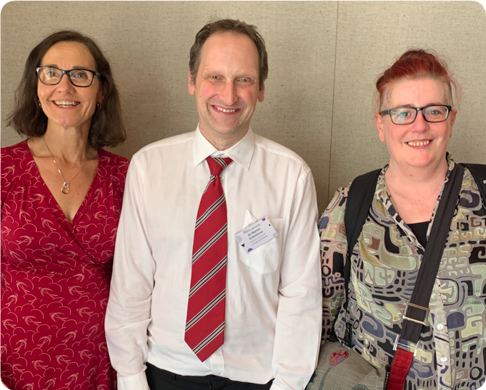
Communications, media, membership
50

This year we continued to benefit from our transition to a new more accessible website that provides accessible content, such as Auslan and Easy English.
The PWDA homepage dynamically links to timely and useful content, driven by our
member engagement and current activities and events. This year we increased our number of web users by 57,333 or 63% to 148,309 last year, while increasing our new users by 52,921 or 58% to 143,874. We often had 500 web users a day at our website, with visitors reaching a record 1250 a day during the height of the pandemic. During the year, we also increased our page views by 112,475 or 46% to 356,484. A majority of 85% of these visitors were new users, while 15% were returning visitors.
to members and supporters. An audio edition is available on our website.
We also send out a Daily Media Round- Up newsletter with a summary of the day’s disability-related news on weekdays.
PWDA has a strong media presence, as the national peak cross disability rights organisation. We have been in the media
over 150 times talking about the importance of disability advocacy, the Royal Commission, housing, the NDIS and transport accessibility.
PWDA has also produced a range of publications for our programs and projects that highlight the wide range of work that we do, including the UN CRPD Shadow Report, Diability Rights Now 2019, the COVID-19 Impact Survey report, and a variety of brochures.
PWDA posts daily on Facebook a selection of news, our work in the media, scheduled program posts (such as highlighting web content or PWDA services) as well as informing people with disability of key developments in disability policy. Our posts have a consistent and strong engagement level, widely shared and commented on by people with disability. This year, we increased our Facebook likes by more than 2337 users, with consistent, strong engagement with our posts, including comments and shares.
PWDA posts daily on Twitter, including live- Tweeting events such as Parliamentary inquiries or other disability-related activities. We participate in hashtag campaigns related to people with disability and post information of interest to people with disability. We built our followers by 1381 this year.
This year, our member survey highlighted members were clearly interested and engaged in disability rights issues.
Their concerns included:
•
NDIS
•
•
income support/welfare
housing
•
•
accessibility
health
•
•
employment
violence/abuse
PWDA has had a steady increase in members this year, with individual memberships available for free for people with disability.
We also continued to use our Instagram account to particularly engage with younger people with disability, adding 901 followers.
PWDA News is published each fortnight to showcase what is happening across our organisation, as well as information of interest
51

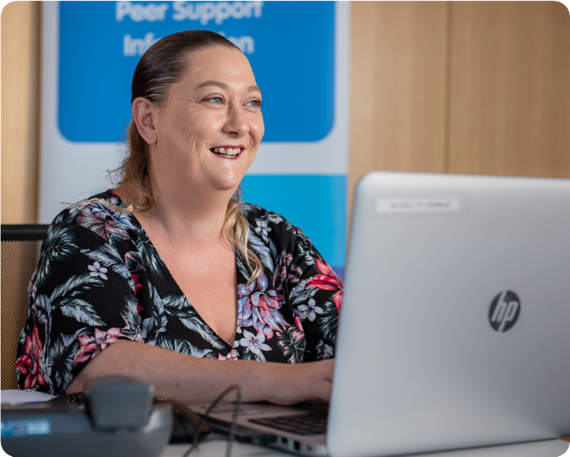
Financial report
52

53

BN 98 879 981 198

STATEMENT OF FINANCIAL POSITION AS AT 30 JUNE 2020

2020 2019
Note $ $
ASSETS
Current assets
Cash and cash equivalents 6 1,972,153 2,536,355
Trade and other receivables 7 468,778 276,619

Total current assets 2,440,931 2,812,974

Non‐current assets

Property, plant and equipment | 8 | 515,584 |  | 466,478
Right‐of‐use assets | 9 | 1,918,383 |  | —
Total non‐current assets |  | 2,433,967 |  | 466,478
TOTAL ASSETS |  | 4,874,898 |  | 3,279,452
LIABILITIES  Current liabilities  Trade and other payables | 10 | 1,169,422 |  | 2,161,151
Provisions | 11 | 785,368 |  | 732,775
Lease liabilities | 12 | 518,920 |  | —
Total current liabilities |  | 2,473,710 |  | 2,893,926
Non‐current liabilities
Provisions | 11 | 125,000 |  | —
Lease liabilities | 12 | 1,506,120 |  | —
Total non‐current liabilities |  | 1,631,120 |  | —
TOTAL LIABILITIES |  | 4,104,830 |  | 2,893,926
NET ASSETS |  | 770,068 |  | 385,526
FUNDS  Accumulated funds |  | 770,068 |  | 385,526
TOTAL FUNDS |  | 770,068 |  | 385,526

The accompanying notes form part of these financial statements

STATEMENT OF PROFIT OR LOSS AND OTHER COMPREHENSIVE INCOME FOR THE YEAR ENDED 30 JUNE 2020

Note |  | 2020  $ | 2019  $
Revenue | 4 | 7,963,178 |  | 5,874,993
Other income | 4 | 21,144 |  | 40,315
 |  | 7,984,322 |  | 5,915,308
Expenses  Computer/website costs |  | (152,784) |  | (119,401)
Consulting and professional charges |  | (546,914) |  | (374,523)
Depreciation expense | 5 | (651,380) |  | (25,309)
Electricity |  | (24,355) |  | (16,918)
Employee benefits expense |  | (5,430,670) |  | (4,114,827)
Meeting expenses |  | (54,732) |  | (107,729)
Motor vehicle expense |  | (45,814) |  | (60,525)
Program costs |  | (46,331) |  | (62,078)
Rental and operating lease expenses |  | (79,516) |  | (357,470)
Repairs and maintenance costs |  | (29,272) |  | (25,519)
Telephone and internet |  | (129,709) |  | (147,177)
Travel and accommodation |  | (242,104) |  | (372,035)
Other expenses |  | (166,199) |  | (193,267)
 |  | (7,599,780) |  | (5,976,778)

Surplus (deficit) before income tax 384,542 (61,470) Income tax expense ‐ ‐
Surplus (deficit) for the year 384,542 (61,470)

Other comprehensive income — —

Total comprehensive income (loss) for the year 384,542 (61,470)

The accompanying notes form part of these financial statements

STATEMENT OF CHANGES IN FUNDS FOR THE YEAR ENDED 30 JUNE 2020

Accumulated Funds

Total

 | $ |  | $
Balance at 1 July 2018 | 446,996 |  | 446,996
Comprehensive income  Surplus (deficit) for the year | (61,470) |  | (61,470)
Other comprehensive income | — |  | —
Total comprehensive income (loss) for the year | (61,470) |  | (61,470)
Balance at 30 June 2019 | 385,526 |  | 385,526
Balance at 1 July 2019 | 385,526 |  | 385,526
Comprehensive income  Surplus (deficit) for the year | 384,542 |  | 384,542
Other comprehensive income | — |  | —
Total comprehensive income (loss) for the year | 384,542 |  | 384,542
Balance at 30 June 2020 | 770,068 |  | 770,068

The accompanying notes form part of these financial statements

Cash flows from operating activities  Receipts from grants and customers | Note | 2020  $  7,359,476 |  | 2019  $  6,367,424
Payments to suppliers and employees |  | (7,350,993) |  | (6,587,639)
Interest received |  | 21,144 |  | 40,315
Net cash flows from operating activities |  | 29,627 |  | (179,900)
Cash flows from investing activities
Purchase of property, plant and equipment |  | (192,523) |  | (397,628)
Net cash flows from investing activities |  | (192,523) |  | (397,628)
Cash flows from financing activities  Repayment of lease liabilities |  | (401,306) |  | —
Net cash flows from financing activities |  | (401,306) |  | —
Net increase (decrease) in cash and cash equivalents |  | (564,202) |  | (577,528)
Cash and cash equivalents at the beginning of the financial year |  | 2,536,355 |  | 3,113,883
Cash and cash equivalents at the end of the financial year | 6 | 1,972,153 |  | 2,536,355

The accompanying notes form part of these financial statements

The financial report is for People With Disability Australia Ltd. as an individual entity. People With Disability Australia Ltd. is registered as a company limited by guarantee and not having a share capital under the provisions of the Australian Charities and Not‐for‐profits Commission Act 2012.

The financial statements were approved by the Board of Directors on 10 October 2020.

Note 2 – Basis of preparation

Statement of compliance
People With Disability Australia Ltd has adopted Australian Accounting Standards ‐ Reduced Disclosure Requirements as set out in AASB 1053 Application of Tiers of Australian Accounting Standards and AASB 2010– 2: Amendments to Australian Accounting Standards arising from Reduced Disclosure Requirements.

These financial statements are general purpose financial statements that have been prepared in accordance with Australian Accounting Standards – Reduced Disclosure Requirements and the Australian Charities and Not‐ for‐profits Commission Act 2012. The company is a not‐for‐profit entity for financial reporting purposes under Australian Accounting Standards.

Australian Accounting Standards set out accounting policies that the AASB has concluded would result in financial statements containing relevant and reliable information about transactions, events and conditions.

Basis of measurement
The financial statements, except for the cash flow information, have been prepared on an accruals basis and are based on historical costs, modified, where applicable, by the measurement at fair value of selected non‐current assets, financial assets and financial liabilities.

Comparatives
Where required by Accounting Standards comparative figures have been adjusted to conform to changes in presentation for the current financial year. Where the company has retrospectively applied an accounting policy, made a retrospective restatement or reclassified items in its financial statements, an additional statement of financial position as at the beginning of the earliest comparative period will be disclosed

Critical accounting estimates and judgements
The Directors evaluate estimates and judgements incorporated into the financial statements based on historical knowledge and best available current information. Estimates assume a reasonable expectation of future events and are based on current trends and economic data, obtained both externally and within the company.
Key estimates
Impairment
The Directors assess impairment at the end of each reporting period by evaluation of conditions and events specific to the company that may be indicative of impairment triggers. Recoverable amounts of relevant assets are reassessed using value‐in‐use calculations which incorporate various key assumptions.

Long service leave provision
The liability for long service leave is recognised and measured at the present value of the estimated future cash flows to be made in respect of all employees at the reporting date. In determining the present value of the liability, estimates of rates and pay increases through promotion and inflation have been taken into account.

New and revised standards that are effective for these financial statements
AASB 15 Revenue from Contracts with Customers
AASB 15 establishes a comprehensive five‐step framework for recognising revenue. AASB 15 applies to all revenue arising from contracts with customers, unless those contracts are in the scope of other standards. Under AASB 15, revenue is recognised when a performance obligation has been satisfied at an amount that reflects the consideration to which an entity expects to be entitled in exchange for transferring goods or services to a customer.

The standard requires entities to exercise judgment, taking into consideration all the relevant facts and circumstances when applying each step of the model to contracts with their customers. The company applied the five‐step model to its various revenue streams to assess the impacts of AASB 15.

The adoption of AASB 15 has not resulted in any changes to the company’s recognition of revenue and accordingly has not materially impacted the company’s financial statements.

AASB 16 Leases
AASB 16 removes the current operating and finance lease distinction for lessees and requires entities to recognise all material leases on the Statement of Financial Position. AASB 16 requires the recognition of a right‐ of‐use asset and a corresponding lease liability at the commencement of all leases, except for short‐term leases and leases of low value assets. The company has elected to apply the modified retrospective method of adoption.

At the date of initial application, 1 July 2019, the company elected to measure the right‐of‐use asset as an amount equal to the lease liability, adjusted by the amount of any prior accrued lease payments relating to that lease recognised in the Statement of Financial Position immediately before the date of initial application.

The adoption of AASB 16 has resulted in:
- The recognition of right‐of‐use assets of $2,426,346
- The recognition of lease liabilities of $2,426,346

The difference between the operating lease commitments as at 30 June 2019 and the lease liability as at 1 July 2019 is due to the lease liability being discounted by the incremental borrowing rate, the effect of timing differences on entering into the lease agreements and the effect of short‐term leases being excluded from the calculation of lease liabilities as at 1 July 2019.

New standards and interpretations not yet adopted
There are no other new accounting standards and interpretations expected to have any significant impact on the company’s financial report that are issued and not yet applicable.

Going concern
The financial report has been prepared on a going concern basis which assumes the company will have sufficient cash to pay its debts as and when they become payable for a period of at least 12 months from the date of the financial report.

The company has incurred a surplus for the year of $384,542 (2019: $61,470 deficit) and incurred a decrease in cash and cash equivalents of $564,202 (2019: $577,528 decrease). The company has a net current asset deficiency of $32,779 (2019: $80,952 deficiency) and net assets of $770,068 as at 30 June 2020 (2019: $385,526).

The Directors believe that the assets and liabilities will be realised at the values presented in the financial statements and the financial statements have been prepared on a going concern basis.

The principal accounting policies adopted in the preparation of the financial report are set out below. These policies have been consistently applied to all the years presented, unless otherwise stated.

Income Tax
People With Disability Australia Ltd is a not‐for‐profit Charity and is exempt from income tax under Division 50 of the Income Tax Assessment Act 1997.

Goods and Services Tax (GST)
Revenues, expenses and assets are recognised net of the amount of GST, except where the amount of GST incurred is not recoverable from the Australian Taxation Office (ATO). Receivables and payables are stated inclusive of the amount of GST receivable or payable. The net amount of GST recoverable from, or payable to, the ATO is included with other receivables or payables in the statement of financial position. Cash flows are presented on a gross basis. The GST components of cash flows arising from investing or financing activities which are recoverable from, or payable to, the ATO are presented as operating cash flows included in receipts from customers or payments to suppliers.

Revenue recognition
Amounts disclosed as revenue are net of returns, trade allowances and duties and taxes including goods and services tax (GST). Revenue is recognised for the major business activities as follows:

Interest
Interest revenue is recognised as it accrues using the effective interest method.

Grants, donations and bequests
Income arising from the contribution of an asset (including cash) is recognised when the following conditions have been satisfied:
- the company obtains control of the contribution or the right to receive the contribution;
- it is probable that the economic benefits comprising the contribution will flow to the company; and
- the amount of the contribution can be measured reliably at the fair value of the consideration received.

Cash and cash equivalents
Cash and cash equivalents include cash on hand, deposits held at call with financial institutions, other short‐ term, highly liquid investments with original maturities of twelve months or less that are readily convertible to known amounts of cash and which are subject to insignificant risk of changes in value.

Trade receivables
Trade receivables are recognised initially at fair value and subsequently measured at amortised cost, less a provision for impairment. Collectability of trade receivables is reviewed on an ongoing basis. Debts which are known to be uncollectible are written off. A provision for impairment is established when there is objective evidence that the entity will not be able to collect all amounts due according to the original terms of receivables.

Property, plant and equipment
Recognition and measurement
Each class of property, plant and equipment is carried at cost less, where applicable, any accumulated depreciation and impairment losses. Cost includes expenditure that is directly attributable to the acquisition of the items.

Gains and losses on disposals are determined by comparing proceeds with carrying amount. These are included in the statement of profit or loss and other comprehensive income.

Property, plant and equipment (continued)
Depreciation
The depreciable amount of all property, plant and equipment is depreciated on a straight‐line basis over the asset’s useful life to the company commencing from the time the asset is held ready for use.

The depreciation rates used for each class of depreciable assets are:
Office equipment 20%
Motor Vehicles 20%
Leasehold improvements Period of lease

The assets’ residual values and useful lives are reviewed, and adjusted if appropriate, at the end of each reporting period. An asset’s carrying amount is written down immediately to its recoverable amount if the asset’s carrying amount is greater than its estimated recoverable amount.

Right‐of‐use assets
At inception, a right‐of‐use assets and a lease liability is recognised. Right‐of‐use assets are included in the
Statement of Financial Position within a classification relevant to the underlying asset.

Right‐of‐use assets are initially measured at cost, comprising of the following:
- the amount of the initial measurement of the lease liability
- Any lease payments made at or before the commencement date, less any lease incentives received
- Any initial direct costs incurred
- An estimate of costs to be incurred in dismantling and removing the underlying asset, restoring the site on which it is located or restoring the underlying asset to the condition required by the terms and conditions of the lease, unless those costs are incurred either at the commencement date or as a consequence of having used the underlying asset during a particular period

Subsequently, right‐of‐use assets are measured using a cost model. The right‐of‐use asset is depreciated to the earlier of the useful life of the asset or the lease term using the straight‐line method and is recognised in the statement of profit or loss and other comprehensive income in “Depreciation and amortisation”.

The company tests for impairment where there is an indication that a right‐of‐use asset may be impaired. An assessment of whether there is an indication of possible impairment is done at each reporting date. Where the carrying amount of a right of use asset is greater than the estimated recoverable amount, it is written down immediately to its recoverable amount. The resulting impairment loss is recognised immediately in surplus or deficit, except where the decrease reverses a previously recognised revaluation increase for the same asset.

The resulting decrease is recognised in other comprehensive income to that extent and reduces the amount accumulated in equity under revaluation surplus, and future depreciation charges are adjusted in future periods to allocate the revised carrying amount, less its residual value, on a systematic basis over its remaining useful life.

Leases
The company leases its premises on an arm’s length basis from a third‐party lessor. A lease is a contract, or part of a contract, that conveys the right to use an asset for a period of time in exchange for consideration.

At inception of a contract, it is assessed to determine whether the contract is, or contains, a lease. A contract is, or contains, a lease if the contract conveys the right to control the use of an identified asset for a period of time in exchange for consideration. If the terms and conditions of a contract are changed, it is reassessed to once again determine if the contract is still, or now contains, a lease.

Leases (continued)
The term of a lease is determined as the non‐cancellable period of the lease, together with the periods covered by an option to extend the lease where there is reasonable certainty that the option will be exercised, and periods covered by an option to terminate the lease if there is reasonable certainty that the option will not be exercised.

The assessment of the reasonable certainty of the exercising of options to extend the lease, or not exercising of options to terminate the lease, is reassessed upon the occurrence of either a significant event or a significant change in circumstances that is within the company’s control and it affects the reasonable certainty assumptions. The assessment of the lease term is revised if there is a change in the non‐cancellable lease period.

The company does not recognise leases that have a lease term of 12 months or less or are of low value as a right‐ of‐use asset or lease liability. The lease payments associated with these leases are recognised as an expense in the statement of profit or loss and other comprehensive income on a straight‐line basis over the lease term.

Lease liability
At the commencement date of the lease, the lease liability is initially recognised for the present value of non‐ cancellable lease payments discounted using the interest rate implicit in the lease or, if that rate cannot be readily determined, the company’s incremental borrowing rate.

The tenor of a lease includes any renewal period where the lessee is reasonably certain that they will exercise the option to renew. The company has reviewed all its leases and included any extensions where the company assessed it is reasonably certain the lease agreement will be renewed.

The lease payment used in the calculation of the lease liabilities should include variable payments when they relate to an index or rate. Where leases contain variable lease payments based on an index or rate at a future point in time, the company has used the incremental uplift contained in the lease or the respective Reserve Bank forward‐looking CPI target for CPI‐related increases.

In the absence of any floor or cap clauses in the lease agreements, the company measures the rent for the year under market review at an amount equal to the rent of the year preceding the market review increased by a fixed rate.

The lease liability is initially measured at the present value of the lease payments that are not yet paid at the commencement date. Lease payments are discounted using the relevant company’s incremental borrowing rate. The incremental borrowing rate used for this calculation is dictated by the tenor of the lease and the location of the asset. The incremental borrowing rate is the rate the company would be charged on borrowings, provided by our banking partners. The weighted average incremental borrowing rate is 0%. The following lease payments being fixed payments, less any lease incentives receivable are included where they are not paid at the commencement date.

Impairment of assets
Assets that have an indefinite useful life are not subject to amortisation and are tested annually for impairment. Assets that are subject to amortisation are reviewed for impairment whenever events or changes in circumstances indicate that the carrying amount may not be recoverable. An impairment loss is recognised for the amount by which the asset’s carrying amount exceeds its recoverable amount. The recoverable amount is the higher of an asset’s fair value less costs to sell and value in use. For the purposes of assessing impairment, assets are compared at the lowest levels for which there are separately identifiable cash flows (cash generating units).

Trade and other payables
Trade and other payables represent the liability outstanding at the end of the reporting period for goods and services received by the company during the reporting period, which remain unpaid. The balance is recognised as a current liability with the amounts normally paid within 30 days of recognition of the liability. The carrying amount of trade and other payables is deemed to reflect fair value.

Income and grants received in advance
Income, including government funding income, that is received before the service to which the payment relates has been provided is recorded as a liability until such time as the service has been provided, at which time it is recognised in the statement of profit or loss and other comprehensive income.

Employee benefits
Provision is made for the company’s liability for employee benefits arising from services rendered by employees to the end of the reporting period. Employee benefits that are expected to be settled within one year have been measured at the amounts expected to be paid when the liability is settled.

 | 2020  $ | 2019  $
Note 4 – Revenue
Revenue
Operating grants | 7,014,985 | 5,471,024
Rental income | 51,905 | 44,904
Training income | 65,303 | 32,641
Travel reimbursement | 27,165 | 24,975
Donations | 10,726 | 6,983
Other income | 793,094 | 294,466
 | 7,963,178 | 5,874,993
Other revenue  Interest income | 21,144 | 40,315
 | 21,144 | 40,315
Total revenue | 7,984,322 | 5,915,308

Note 5 – Expenses

Depreciation and amortisation
Leasehold improvements | 105,627 |  | ‐
Office equipment | 25,910 |  | 13,429
Motor vehicles | 11,880 |  | 11,880
Right‐of‐use assets | 507,963 |  | —
Total depreciation expense | 651,380 |  | 25,309
Note 6 – Cash and cash equivalents
Cash at bank and on hand | 1,325,439 |  | 1,572,675
Term deposits | 646,714 |  | 963,680
Total cash and cash equivalents | 1,972,153 |  | 2,536,355
Note 7 – Trade and other receivables
Current
Trade receivables | 21,963 |  | 51,948
Other receivables | 393,496 |  | 93,421
Prepayments | 53,319 |  | 131,250
Total current trade and other receivables | 468,778 |  | 276,619

Note 8 – Property, plant and equipment

Leasehold Improvements

Office Equipment

Motor Vehicles Total

 | $ |  | $ |  | $ | $
At 30 June 2019
Cost | 370,218 |  | 211,329 |  | 143,330 | 724,877
Accumulated depreciation | ‐ |  | (174,900) |  | (83,499) | (258,399)
Net carrying amount | 370,218 |  | 36,429 |  | 59,831 | 466,478
Movements in carrying amounts
Opening net carrying amount | 370,218 |  | 36,429 | 59,831 |  |  | 466,478
Additions | 149,994 |  | 42,529 | ‐ |  |  | 192,523
Depreciation charge for the year | (105,627) |  | (25,910) | (11,880) |  |  | (143,417)
Closing net carrying amount | 414,585 |  | 53,048 | 47,951 |  |  | 515,584
At 30 June 2020
Cost | 520,212 |  | 253,858 | 143,330 |  |  | 917,400
Accumulated depreciation |  | (105,627) | (200,810) | (95,379) |  |  | (401,816)
Net carrying amount |  | 414,585 | 53,048 | 47,951 |  |  | 515,584
 |  |  |  | 2020 |  |  | 2019
 |  |  |  | $ |  |  | $
Note 9 – Right‐of‐use assets
Leases ‐ at cost |  |  |  | 2,426,346 |  |  | –
Accumulated depreciation |  |  |  | (507,963) |  |  | –
Total right‐of‐use assets |  |  |  | 1,918,383 |  |  | –
Movements in carrying amounts
Balance at the beginning of the year (adoption of AASB 16) |  |  |  | 2,426,346 |  |  | –
Depreciation charge for the year |  |  |  | (507,963) |  |  | –
Closing net carrying amount |  |  |  | 1,918,383 |  |  | –
Note 10 – Trade and other payables
Current
Trade payables |  |  |  | 144,260 |  |  | 239,615
Grants in advance |  |  |  | 741,347 |  |  | 1,711,434
Other payables |  |  |  | 283,815 |  |  | 210,102
Total current provisions |  |  |  | 1,169,422 |  |  | 2,161,151
Note 11 – Provisions
Current
Annual leave |  |  |  | 374,337 |  |  | 377,533
Long service leave |  |  |  | 220,454 |  |  | 216,895
Time in lieu |  |  |  | 53,850 |  |  | 46,454
Redundancy |  |  |  | 136,727 |  |  | 91,893
Total current provisions |  |  |  | 785,368 |  |  | 732,775
Non‐current
Make good provision |  |  |  | 125,000 |  |  | –
Total non‐current provisions |  |  |  | 125,000 |  |  | –

 | 2020  $ |  | 2019  $
Note 12 – Lease liabilities
Current
Lease liabilities | 518,920 |  | –
Total current lease liabilities | 518,920 |  | —
Non‐current
Lease liabilities | 1,506,120 |  | –
Total non‐current lease liabilities | 1,506,120 |  | –
Movements in carrying amounts
Balance at the beginning of the year (adoption of AASB 16) | 2,426,346 |  | –
Repayments | (401,306) |  | –
Closing net carrying amount | 2,025,040 |  | –
Note 13 – Key management personnel
Remuneration of key management personnel  The aggregate amount of compensation paid to key personnel during the year: | 1,205,354 |  | 870,417

Key management personnel is defined as the Senior Leadership Team. The number of Senior Leadership Team members increased during FY20. The FY20 expenditure also includes the one‐off payout of historical entitlements owing to two long‐ standing Co‐CEOs who resigned during the financial year.

Note 14 – Lease commitments

Operating lease commitments
Commitments for minimum lease payments in relation to non‐cancellable operating leases are payable as follows:

Within one year | 6,756 |  | 486,720
Later than one year but not later than five years | 20,268 |  | 1,877,535
 | 27,024 |  | 2,364,255

The company is committed to short‐term and low‐value leases in relation to office equipment which expires in July 2023.

Note 15 – Limitations of members' liability

The company is incorporated as a company limited by guarantee, and in accordance with the Constitution the liability of members in the event of the company being wound up would not exceed $1 per member. At 30 June 2020 the number of members of this company was 1,801 (2019: 1,685).

Note 16 – Events occurring after balance date

Subsequent to the end of the financial year there have been considerable economic impacts in Australia and globally arising from the outbreak of the COVID‐19 virus, and Government actions to reduce the spread of the virus.
At the date of signing the financial statements the Directors are unable to determine what financial effects the outbreak of the virus could have on PWDA in the coming financial period.
The Directors acknowledge their responsibility to continuously monitor the situation and evaluate this impact including the ability to pay its debts as and when they become due and payable.
There were no significant events occurring after balance date.

Note 17 – Economic dependency

The company considers that it is economically dependent on revenue received from the Commonwealth and New South Wales Governments for its various programs. The Directors believe that this revenue will continue to be made available to the company for the remainder of the terms of the grant agreements.
The total amount of recurrent government funding recognised during the financial year was $7,014,985 (2019: $5,471,024) and this represented 87.9% of total revenue (2019: 92.5%).

Note 18 – Related party transactions

There were no related party transactions during the financial year.

Note 19 – Company Details

The registered office and principal place of the company is: People with Disability Australia Limited
Level 8, 418A Elizabeth Street, Surry Hills NSW 2010

The Directors of People With Disability Australia Ltd. declare that:

- The financial statements, which comprises the statement of financial position as at 30 June 2020, and the statement of profit or loss and other comprehensive income, statement of changes in funds and statement of cash flows for the year ended on that date, a summary of significant accounting policies and other explanatory notes are in accordance with the Australian Charities and Not‐for‐profits Commission Act 2012 and:

  - comply with Australian Accounting Standards – Reduced Disclosure Requirements (including the Australian Accounting Interpretations) and the Australian Charities and Not‐for‐profits Commission Regulation 2013; and

  - give a true and fair view of the financial position as at 30 June 2020 and of the performance for the year ended on that date of the company.

- In the opinion of the Directors there are reasonable grounds to believe that the company will be able to pay its debts as and when they become due and payable.

This statement is made in accordance with a resolution of the Board of Directors:

David Abello President

10 October 2020

UNDER THE CHARITABLE FUNDRAISING ACT

In the opinion of the Directors of People With Disability Australia Ltd:

- The financial statements and notes thereto give a true and fair view of all income and expenditure with respect to fundraising appeals conducted by the company for the year ended 30 June 2020; and

- The statement of financial position as at 30 June 2020 gives a true and fair view of the state of affairs of the company with respect to fundraising appeals conducted by the organisation; and

- The provisions of the Charitable Fundraising Act 1991, the regulations under that Act, and the conditions attached to the authority to fundraise have been complied with by the organisation; and

- The internal controls exercised by the company are appropriate and effective in accounting for all income received and applied by the organisation from any of its fundraising appeals.

This declaration is made in accordance with a resolution of the Board of Directors.

David Abello President

10 October 2020

17
PEOPLE WITH DISABILITY AUSTRALIA LTD. ABN 98 879 981 198

FINANCIAL REPORT – 30 JUNE 2020

INDEPENDENT AUDITOR’S REPORT TO THE MEMBERS OF PEOPLE WITH DISABILITY AUSTRALIA LTD.

Opinion
We have audited the financial report of People With Disability Australia Ltd. which comprises the statement of financial position as at 30 June 2020, the statement of profit or loss and other comprehensive income, the statement of changes in funds and statement of cash flows for the year then ended, notes comprising a summary of significant accounting policies and other explanatory information, and the Directors’ Declarations.

In our opinion, the accompanying financial report of People With Disability Australia Ltd. is in accordance with the Australian Charities and Not‐for‐profits Commission Act 2012, including:
- giving a true and fair view of the company’s financial position as at 30 June 2020 and of its financial performance for the year then ended, and

- complying with Australian Accounting Standards ‐ Reduced Disclosure Requirements and the Australian Charities and Not‐for‐profits Commission Regulation 2013.

Basis for Opinion
We conducted our audit in accordance with Australian Auditing Standards. Our responsibilities under those standards are further described in the Auditor’s Responsibility for the Audit of the Financial Report section of our report. We are independent of the company in accordance with the auditor independence requirements of the Australian Charities and Not‐for‐profits Commission Act 2012 and the ethical requirements of the Accounting Professional and Ethical Standards Board’s APES 110 Code of Ethics for Professional Accountants (the Code) that are relevant to our audit of the financial report in Australia. We have also fulfilled our other ethical responsibilities in accordance with the Code.

We confirm that the independence declaration required by the Australian Charities and Not‐for‐profits Commission Act 2012, which has been given to the Directors of the company, would be in the same terms if given to the Directors as at the time of this auditor’s report. We believe that the audit evidence we have obtained is sufficient and appropriate to provide a basis for our opinion.

Material Uncertainty Related to Going Concern
Without modifying our opinion, we draw attention to Note 2 to the financial statements headed “Going concern”, The company has incurred a surplus for the year of $384,542 (2019: $61,470 deficit) and incurred a decrease in cash and cash equivalents of $564,202 (2019: $577,528 decrease). The company has a net current asset deficiency of $32,779 (2019: $80,952 deficiency) and net assets of $770,068 as at 30 June 2020 (2019:
$385,526).

The company’s ability to continue as a going concern is dependent upon the continued funding from the Commonwealth and New South Wales Governments to support the various programs and the ability of the company to successfully generate sufficient operating cash flows. We also draw attention to Note 16 of the financial statements headed “Events occurring after balance date” and the Directors inability to determine what financial effects the outbreak of the COVID‐19 virus could have on the company in the coming financial period.

These conditions indicate that a material uncertainty exists that may cast significant doubt on the company’s ability to continue as a going concern. Our opinion is not modified in respect of this matter.

Directors’ Responsibility for the Financial Report
The Directors of the company are responsible for the preparation of the financial report that gives a true and fair view in accordance with Australian Accounting Standards – Reduced Disclosure Requirements and the Australian Charities and Not‐for‐profits Commission Act 2012 and for such internal control as the Directors determine is necessary to enable the preparation of a financial report that gives a true and fair view and is free from material misstatement, whether due to fraud or error.

In preparing the financial report, the Directors are responsible for assessing the company’s ability to continue as a going concern, disclosing, as applicable, matters related to going concern and using the going concern basis of accounting unless the Directors either intend to liquidate the company or to cease operations, or have no realistic alternative but to do so.

The Directors are responsible for overseeing the company’s financial reporting process.

Auditor’s Responsibilities for the Audit of the Financial Report
Our objectives are to obtain reasonable assurance about whether the financial report as a whole is free from material misstatement, whether due to fraud or error, and to issue an auditor’s report that includes our opinion. Reasonable assurance is a high level of assurance but is not a guarantee that an audit conducted in accordance with the Australian Auditing Standards will always detect a material misstatement when it exists. Misstatements can arise from fraud or error and are considered material if, individually or in the aggregate, they could reasonably be expected to influence the economic decisions of users taken on the basis of this financial report.

A further description of our responsibilities for the audit of the financial report is located at The Auditing and Assurance Standards Board and the website address is http://www.auasb.gov.au/Home.aspx

We communicate with the Directors regarding, among other matters, the planned scope and timing of the audit and significant audit findings, including any significant deficiencies in internal control that we identify during our audit.

Report on Other Legal and Regulatory Requirements
In addition, our audit report has also been prepared for the members of the company in accordance with section 24(2) of the Charitable Fundraising Act 1991. Accordingly, we have performed additional work beyond that which is performed in our capacity as auditors pursuant to the Australian Charities and Not‐for‐profits Commission Act 2012. These additional procedures included obtaining an understanding of the internal control structure for fundraising appeal activities and examination, on a test basis, of evidence supporting compliance with the accounting and associated record keeping requirements for fundraising appeal activities pursuant to the Charitable Fundraising Act 1991 and Regulations.

It should be noted that the accounting records and data relied upon for reporting on fundraising appeal activities are not continuously audited and do not necessarily reflect after the event accounting adjustments and the normal year‐end financial adjustments for such matters as accruals, prepayments, provisioning and valuations necessary for year‐end financial report preparation.

The performance of our statutory audit included a review of internal controls for the purpose of determining the appropriate audit procedures to enable an opinion to be expressed on the financial report. This review is not a comprehensive review of all those systems or of the system taken as a whole and is not designed to uncover all weaknesses in those systems.

The audit opinion expressed in this report pursuant to the Charitable Fundraising Act 1991 has been formed on the above basis.

Auditor’s opinion
Pursuant to the requirements of Section 24(2) of the Charitable Fundraising Act 1991 we report that, in our opinion:

- the financial report gives a true and fair view of the financial result of fundraising appeal activities for the financial year ended 30 June 2020; and

- the financial report has been properly drawn up, and the associated records have been properly kept for the period 1 July 2019 to 30 June 2020, in accordance with the Charitable Fundraising Act 1991 and Regulations; and

- money received as a result of fundraising appeal activities conducted during the period 1 July 2019 to 30 June 2020 has been properly accounted for and applied in accordance with the Charitable Fundraising Act 1991 and Regulations; and

- at the date of this report there are reasonable grounds to believe that the company will be able to pay its debts as and when they become due and payable.

StewartBrown
Chartered Accountants

S.J. Hutcheon
Partner

10 October 2020
54
55
56
57
58

59
60
61

62
63
64
65
66
67

68

69

70
71

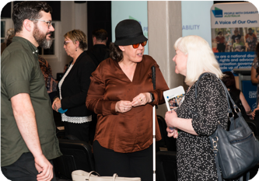
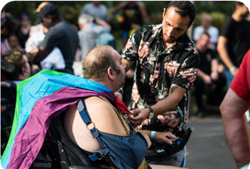
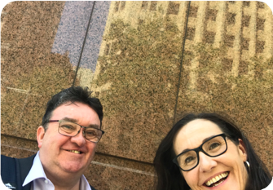
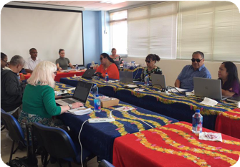
pwd.org.au
pwd@pwd.org.au
(02) 9370 3100
PWDAustralia
PWD.Australia

