A Rights Framework:

Delivering on Australia’s obligations under the CRPD through the National Disability Strategy 2020–2030

PWDA’s submission in response to the Improving outcomes for people with disability under the National Disability Strategy and the National Disability Insurance Scheme Paper (October 2020)
DECEMBER
2020

About PWDA
People with Disability Australia (PWDA) is a leading disability rights, advocacy and representative organisation of and for all people with disability. We are the only national, cross-disability organisation – and we represent the interests of people with all kinds of disability. We are a non-profit, non-government organisation. We help individuals by advocating for their interests, and groups through our systemic advocacy efforts. We also encourage people to engage in self-advocacy.
PWDA’s primary membership is made up of people with disability and organisations primarily constituted by people with disability. PWDA also has a large associate membership of other individuals and organisations committed to the disability rights movement. We employ many people with disability.
We have a vision of a socially just, accessible, and inclusive community, in which the human rights, citizenship, contribution, potential and diversity of all people with disability are recognised, respected and celebrated. PWDA was founded in 1981, the International Year of Disabled Persons, to provide people with disability with a voice of our own.
PWDA is also a founding member of Disabled People’s Organisations Australia (DPO Australia) along with Women with Disabilities Australia, First Peoples Disability Network Australia, and National Ethnic Disability Alliance. DPOs are organisations that are led by, and constituted of, people with disability.

Postal address:
PO Box 666
Strawberry Hills NSW 2012
Street address:
Level 8
418a Elizabeth Street
Surry Hills NSW 2010
Phone: 02 9370 3100
Fax: 02 9318 1372
Toll Free: 1800 422 015
NRS: 1800 555 677
TIS: 13 14 50
Email: pwd@pwd.org.au
ACN: 621 720 143

Contents
About PWDA ii
Contents iii
Introduction 1
Background 6
The importance of outcome areas or domains 13
Question 1 — Inclusive and accessible communities 16
Question 2 – Economic security and accessible employment 22
Question 3 – Health and wellbeing 28
Question 4 – Rights protection, justice and legislation 33
Question 5 – Learning and skills 41
Question 6 – Personal and community support 46
Question 7 – Frequency of reporting on progress 51
Question 8 – Additional information 55
Consent to publish submission 56

Introduction

People with Disability Australia (PWDA) welcomes the opportunity to provide this submission to the Australian Government’s Stage 2 Consultations for the National Disability Strategy.

As a Disabled People’s Organisation (DPO) and a member of Disabled People’s Organisation Australia (DPOA), PWDA has been an active participant in the development and review of the National Disability Strategy 2010–2020. We have also been involved in the planning and Stage 1 consultation processes for the next phase of our National Disability Strategy 2020–2030. Our policy and representation work on behalf of people with disability has included being a member of the National Disability Strategy Reform Steering Group. We have also contributed to numerous consultation processes that have reviewed the efficacy of the National Disability Strategy 2010–2020.

Our submission outlines key opportunities and issues to be addressed through the second stage of review of the National Disability Strategy.

Our submission is structured to follow the department’s questionnaire produced to go alongside the National Disability Strategy Position Paper published in July 2020.

It answers the structured questions but also offers a wider array of recommendations based upon Australia’s obligations under the United Nations Convention on the Rights of Persons with Disabilities, which Australia ratified in 2008.

In making this submission, PWDA notes that there is no comprehensive legislative, administrative, judicial or other protection of human rights in Australian domestic law, such as a Bill or Charter of Rights. This means that the NDS is the principal national strategic plan, agreed by all Australian governments, to implement the UN CRPD. The NDS is therefore critical to the realisation of the human rights of people with disability in Australia.

Our views on Australia’s NDS and implementation of the UN CRPD are based on our experiences as people with disability and our goals for living equal lives, where our human rights are fully realised.

We want to see transformation for people with disability in this country, as intended in the original strategy.

That means that all Governments need to recommit to our National Disability Strategy, and it needs to be fully funded with meaningful accountability mechanisms for delivery on goals and actions. We need a National Disability Strategy for the next decade that has teeth, so Australia can end the segregation, exclusion and disadvantage that we, as people with disability, face every day.

PWDA continues to support the original six outcomes of the National Disability Strategy 2010–2020 and is pleased to see the original strategy’s outcomes reappear in this position paper. However, we note like many other disability organisations that some of the outcomes are too big as topics on their own and should be broken down into more targeted outcomes in consultation with disability peak organisations, following this Stage 2 consultation process.

While we support the National Disability Strategy and its broad outcome areas, we believe Australia has a significant way to go to meet the goals of the NDS, including inclusive and accessible communities, rights protection, justice and legislation and health and wellbeing. There are problems with the strategy’s implementation and efficacy. These problems include a lack of deep buy-in across governments at all levels and across portfolio areas. This is demonstrated by initiatives and goals which are not underpinned by incentives to drive real transformation change. Success for delivery on the next iteration of the NDS must include clear funding and resourcing for the strategy’s implementation, monitoring and evaluation.

As people with disability our human rights are regularly breached in this country and it would be disappointing to see another decade of incomplete protections for us and outcomes that fail to be anything besides aspirational.

The Australian Government has established a Royal Commission into Violence, Abuse, Neglect and Exploitation of people with disability to investigate and recommend change to address the scandalous rates of violence against us. It is critical that plans for the next NDS make provision for implementing the recommendations from the Disability Royal Commission when they are delivered to Government.

We want to see governments successfully turn around the disadvantages we regularly face.

There are many areas of our daily lives that we want to see change in this country. They cut across all government portfolio areas, showing why the NDS is a whole-of-government strategy. In our annual survey late last year, PWDA highlighted the following priorities.

These included:
- making decisions about our lives (64%)
- access to justice (45)
- poverty (44%)
- helping us know our rights (41%)
- how people think and talk about us (30%)
- where we live (28%)
- segregation (27%)
- financial abuse (27%)
- forced medical treatment (23%)
- family violence (21%).

Because the NDS is a whole-of-government strategic plan, we have long recommended that responsibility for the strategy should rest with the Prime Minister and Department of Prime Minister and Cabinet, and comparable First Ministers and the departments of premier and cabinet in states and territories.

We also propose that reporting on the progress of implementing the NDS and improving the lives of people with disability should be undertaken annually. The report should be presented by the Prime Minister to Federal Parliament in a similar way to the progress reports to Closing the Gap. We would suggest that the report should be presented on a set day each year within the parliamentary sitting calendar to enable members of parliament and people with disability to participate the proceedings.

The NDS should also include comparable annual reporting requirements to state and territory parliaments as well as at the local government level. These might take the form of a report on how each state and territory and local government area is progressing with meeting goals on their disability inclusion plans.

It is not enough to report to the National Cabinet on a biannual “target”. Ownership of the strategy should and must be engrained at levels of government, and be part of the guiding principles that every minister adopts with their portfolios.

As we have noted previously, there needs to be more effective accountability, monitoring and evaluation mechanisms. The two progress reports produced previously for a ten-year strategy were simply not frequent enough. The documents unfortunately lacked real accountability for driving improvements in our life outcomes, and our inclusion and participation in all aspects of Australian life.

As the Government knows, the United Nations reviewed Australia’s human rights record for people with disability last year and found the country fell short of meeting its obligations. A prioritised, adequately supported National Disability Strategy for the next decade could help us turn this around, particularly if we address legislative gaps in our implementation of the strategy.

We believe the NDS agenda laid out in the position paper may enable the Government to produce positive progress reports without additional legislative change, a culture of accountability and clear funding arrangements. However, we will continue to face discrimination and fail to have our human rights met under the UN CRPD if this approach is taken. Without a strong focus and relationship to the articles under the UN CRPD in the NDS, Australia is at real risk of continuing its current situation, where our nation does not meet its obligations as a signatory to the UN convention.

The original strategy had, and continues to have, strong buy-in from us – Australia’s people with disability – and the disability sector in this country. It is time to finally leverage that support by properly resourcing the strategy and setting real, deliverable targets so the strategy can have teeth to bite into the real disadvantages we face every day.

Australia’s progress reports on implementing the National Disability Strategy going forward must therefore be meaningful and significant, and efforts must be made to properly resource the strategy to fully deliver properly targeted implementation plans.

The National Disability Strategy is the main way Australia can implement the UN CRPD. These rights include the right to not be discriminated against, and the rights to individual autonomy and independence. That independence includes the freedom to make choices and be given an opportunity to be actively involved in decision-making processes about policies – like this strategy – and programs, including those that directly concern us.

We cannot abandon our vision to ensure the rights of people with disability are promoted, protected and upheld. As a peak advocacy body for people with disability, People with Disability Australia encourages the Australian Government to fight for our rights by maintaining a strong vision for the National Disability Strategy.

Some 4.4 million people, or 19.8 per cent of Australia’s population has disability. The first National Disability Strategy set an ambitious vision for a landmark National Disability Insurance Scheme (NDIS) to support people with disability. While life-changing for many, the NDIS only covers about 10 per cent of people with disability. That means 90 per cent of people with disability, or 4 million Australians still need a resourced National Disability Strategy to counter the disadvantage they face every day.

Australia cannot neglect the rights of such a large group with its latest National Disability Strategy. People with disability not covered by the NDIS make up a significant 18 per cent of the Australian population.

Our nation does not need a weaker NDS to ensure it can claim a bigger chunk of successes in its progress reports to the Australian parliament, to people with disability and the wider Australian public. Instead it needs a stronger commitment to the NDS goals it already has in place.

People with Disability Australia encourages the Federal Government to make better efforts to meet its international obligations to implement the UN CRPD by implementing a rigorous new national strategy, not a simplified document. The new National Disability Strategy should be just as ambitious as the previous strategy and set a committed reform agenda to change the lives of the majority of Australians with disability.

Background

PWDA acknowledges the NDS was developed following a public consultation process conducted across Australia that resulted in the 2009 report, Shut Out: The Experience of People with Disabilities and their Families in Australia. This report exposed the daily experiences of stigma, discrimination, disadvantage and human rights violations that we face as people with disability, and it underscored the critical need for the NDS as a human rights–focused national strategy.

Our goals for a transformation are described in the Shut Out report, which states:

“People with disabilities want to bring about a transformation of their lives. They want their human rights recognised and realised. They want the things that everyone else in the community takes for granted. They want somewhere to live, a job, better health care, a good education, a chance to enjoy the company of friends and family, to go to the footy and to go to the movies. They want the chance to participate meaningfully in the life of the community. And they are hopeful. They desire change and they want others in the community to share their vision. They recognise that governments cannot work in isolation and they want others to see the benefits of building more inclusive communities.”

In 2012, PWDA, other disabled people’s organisations and other disability representative and advocacy organisations joined together as the NGO CRPD Shadow Report Project Group and prepared the Disability Rights Now: Civil Society Report to the United Nations Committee on the Rights of Persons with Disabilities report for a United Nations (UN) review of Australia’s compliance with the CRPD. This Disability Rights Now 2012 report was based on consultations across Australia with people with disability and their representative organisations and outlined the stigma, discrimination, disadvantage and human rights violations experienced by people with disability in relation to the CRPD.

In Disability Rights Now, we noted the progress Australia had made advancing the civil, political, economic and cultural rights of people with disability in the previous 30 years. But we also acknowledged the shortfalls, highlighting that people with disability remain significantly behind people without disability in Australia and people with disability in other countries.

Australia was the first country to be reviewed with its progress under the CRPD, in 2013, but the nation has still failed to enact a number of key reforms from the UN’s Concluding observations on the Initial Report of Australia, Adopted by the Committee at its Tenth Session (2-13 September 2013), including suggestions on access to justice.

The UN flagged its principal concerns with Australia’s implementation of the UN CRPD back in 2013. Among its areas of concern were: Australia’s interpretative declarations on articles 12, 17 and 18 of the convention; its regret that Australia’s governments did not have sufficient mechanisms to engage with people with disability and disability advocacy organisations on policy and programs; and its concern that organisations of people with disability, including people with psychosocial disability and Aboriginal and Torres Strait Islander people with disability, were insufficiently funded for their operations.

In the 2012–2013 era, the government had the opportunity nationalise laws against a key aspect of disability discrimination – intersectional discrimination – where people face discrimination on more than one front. However, its Human Rights and Anti-Discrimination Bill 2012 failed to pass and we were left without the national-level protections many acknowledged we needed, including the Senate Legal and Constitutional Affairs Legislation Committee.

Australia is well aware of its shortfalls in meeting the human rights of people with disability in this nation.

Over the years we have had a number of Senate inquiries that have highlighted the disadvantage and discrimination we face. Among these are the 2015 Senate Inquiry into Violence, Abuse and Neglect Against People with Disability in Institutional and Residential Settings.

This review examined the experiences of people in priority populations, noting age and gender-related dimensions, and the experiences of Aboriginal and Torres Strait Islander people with disability, and culturally and linguistically diverse people with disability. Despite the passage of time since that inquiry people with disability are still struggling in institutional settings, congregate living such as group homes, and inappropriate home environments, such as aged care facilities.

We have also had the Senate Inquiry into the Delivery of Outcomes Under the National Disability Strategy 2010–2020, in 2017. In our submission, made as a member of DPOA, we made seven recommendations.
These recommendations were:

- Commit to investment in accessibility initiatives that sustain innovative action and measures at the local government level in order to increase accessibility for people with disability in their local communities.

- Resource a series of targeted working groups with people with disability and their representative organisations to identify concrete measures for inclusion in the NDS to address the barriers to achieving NDS policy outcome area 1, including in relation to the built and natural environment, transport and accessible communications, captioning and audio description.

- Commit to investment and support to the ABC to establish a dedicated disability online portal or programming voice within the ABC, to meet the obligations of the ABC Charter in respect of disability, such as a multimedia news, opinion and podcast portal to build on the work of ABC Ramp Up.

- Commit to regulatory intervention for universal housing design in the National Construction Code in line with the proposal developed by the Australian Network for Universal Housing Design and Rights & Inclusion Australia.

- Establish National Expert Advisory groups made up of cross-sector representatives for each of the review processes of Accessible Public Transport and the Access to Premises Standards to facilitate effective negotiation that leads to enhanced transport and premises access for people with disability.

- Establish a coordination mechanism for monitoring implementation of DSAPT and the Access to Premises Standards, and which is informed by rigorous data and compliance measures, and that can publicly report on progress in achieving the DSAPT and the Access to Premises Standards.

- Engage with state and territory, and local government authorities to develop nationally consistent guidelines for disability inclusion action planning.

While we acknowledge some progress has been made to address the actions, we are yet to see this agenda fully realised and continue to endorse these reforms.
In September 2019, PWDA participated in the Australian Civil Society Delegation sent to Geneva to participate in a second UN review of Australia’s compliance with the UN CRPD, presenting our concerns to the Committee on the Rights of Persons with Disabilities.

This presentation followed our presentation of a shadow report, Disability Rights Now 2019: Australian Civil Society Shadow Report to the United Nations Committee on the Rights of Persons with Disability: UN CRPD Review 2019 to the UN committee ahead of the meeting, which was prepared for us as members of the Disabled People’s Organisations Australia group, in partnership with other disability representative organisations (DROs), and disability advocacy organisations (DAOs).

This shadow report, Disability Rights Now 2019, was well received by all members of the UN committee, sets an agenda for reform and makes the following critical recommendations for Australia:

- Withdraw its interpretative declarations to articles 12, 17 and 18, which prevent reform and allow for human rights violations including denial of legal capacity, forced treatments, and discrimination against non-Australian people with disability seeking to enter or remain in Australia.

- Strengthen anti-discrimination laws to address intersectional discrimination; enable representative complaints; enable complaints regarding disability hate crimes; and ensure people with disability can effectively make complaints about denial of reasonable accommodation.

- Develop and enact national legislation on the prevention of all forms of gender-based violence.

- Incorporate CRPD rights into legislation, policies and programs that apply to children and young people; and develop mechanisms to ensure that children and young people with disability can participate in consultations, decision-making processes and policy development that affect their lives.

- Establish a national framework for mandated compliance against Disability Standards for Accessible Public Transport; the Disability (Access to Premises – Buildings) Standards and the National Standards for Disability Services, and amend the National Construction Code to mandate minimum access features for all new and extensively modified housing.

- Urgently address the over-representation of people with disability in the criminal justice system, and end the unwarranted use of prisons for the management of unconvicted people with disability.

- Act to ensure that Auslan is recognised as a national language, and harmonise laws to ensure that people with disability, including deaf people are able to equally serve on juries.

- Establish a nationally consistent framework for the protection of people with disability from behaviour modification and the elimination of restrictive practices across a broad range of settings.

- Enact national uniform and enforceable legislation prohibiting sterilisation and medically unnecessary interventions of people with disability and people with intersex variations in the absence of their prior, fully informed and free consent.

- Develop a national plan for the closure of residential institutional environments, and develop genuine community-based housing and support options for people with disability.

- Take urgent action on discrimination against parents with disability, particularly action to address the high rate of child removal from parents with disability.

- Develop a national Action Plan for Inclusive Education that includes a legislative and policy framework that fully complies with Article 24 and General Comment 4.
- Develop a national disability employment strategy that contains targeted gendered measures for increasing workforce participation of people with disability, and that transitions people from segregated employment towards mainstream employment and provides equitable remuneration for work.

- End ongoing eligibility restrictions for the disability pension (DSP), and increase the rate of income support payments to ensure access to an adequate standard of living.

- Establish a formal mechanism for meaningful engagement of people with disability in decision making, and the implementation and monitoring of the CRPD in line with General Comment 7.
The UN committee subsequently shared concerns and recommendations about Australia’s implementation of the UN CRPD in its Concluding Observations on the Combined Second and Third Periodic Reports of Australia. These recommendations are documented in Appendix A and included that Australia must:

- Remove its interpretative declaration on articles, 12. 17 and 18 – an essential element to ensure justice for people with disability in Australia.

- Tackle the current limitations in the Disability Discrimination Act 1992, to ensure anti-discrimination laws are strengthened, enable representative claims, enable complaints about disability hate crimes and ensure people with disability can make complaints about denial of reasonable accommodation.

- Address the serious delays in the third implementation plan of the National Disability Strategy, and develop a monitoring and evaluation framework.

- Understand and address that the NDIS assessment criteria relies heavily on a medical model of disability, in contravention of the CRPD, and does not adequately cover older persons with disability, people from CALD backgrounds or Aboriginal and Torres Islander people with disability.

- Address the current situation where national advocacy programs are not adequately or sustainably funded for people with disability.

- Enact national uniform and enforceable legislation prohibiting sterilisation and medically unnecessary interventions on people with disability.

- Develop a national action plan for inclusive education that fully complies with Article 24.

- Introduce and develop a national disability jobs strategy to increase the workforce participation of people with disability.

- Develop a formal mechanism, including a monitoring and evaluation framework, for the implementation of the CRPD which involves the meaningful engagement of people with disability and their representative organisations.
PWDA believes Australia should implement the recommendations we made to the Senate Inquiry into the Delivery of Outcomes Under the National Disability Strategy 2010–2020 and the shadow report Disability Rights Now 2019, along with the UN committee’s recommendations in its two Concluding Observations (the latest observations are featured in Appendix A) and the key actions we outline in this submission.

We believe these actions should be incorporated into targeted action plans, resourced and implemented so the National Disability Strategy has teeth to take a bite into the disadvantage we face every day.

The importance of outcome areas or domains

People with Disability Australia agrees that the outcome areas or domains from the original National Disability Strategy should be retained, with some refinement to the wording which we outlined as part of our submission to the National Disability Strategy Position Paper.
We believe these principles are a good foundation or organising principle for the second 10-year National Disability Strategy.

The life stories and experiences of people with disability, shared through countless consultations and research reports, continue to highlight that:

- People with disability need better economic security.
- People with disability need fully inclusive and accessible communities.
- People with disability need better rights protection, access to justice and legislation that promotes our legal and bodily autonomy and ends discrimination against us.
- People with disability need better access to personal and community support regardless of our age and where we live
- People with disability need to be able to participate fully in mainstream education and training.
- People with disability need to be able to have strong health and wellbeing just like everyone else.

PWDA believes there are some outcomes areas missing from the National Disability Strategy Position Paper. These are:

- People with disability need safety and violence prevention, and this should be a separate outcome to rights protection, justice and legislation.
- People with disability need to be supported by positive and improving community attitudes, and this should be considered separate from inclusive and accessible communities, which might just become accessible communities.
- People with disability need robust disaster preparedness and response, as we have seen during the current COVID-19 pandemic and recent bushfire seasons.

These outcome areas also intersect, and one outcome may need to be progressed in tandem with another.

PWDA has assessed the government’s National Disability Strategy Position Paper and its NDS and NDIS outcomes framework introductory paper – Improving Outcomes for People with Disability Under the National Disability Strategy and the National Disability Insurance Scheme – and believe these are missing clearly articulated goals, actions and outcomes that will be measured and reported on by governments about our progress to realise the rights of people with disability across Australia.

We recognise that there are many ways that a plan for each outcome area or domain can be developed. However, regardless of the approach, it is absolutely vital that each outcome area contains clear plans to deliver change for people with disability. Each outcome area must include actual measurable outcomes.

One way to achieve this is to create a clear plan for each outcome area.
In the following section, PWDA outlines examples of what this might look like. In providing these examples, we have drawn from the priorities and goals of:

- Consultations held with people with disability for the 2019 Civil Society Shadow Report, Disability Rights Now, submitted at the 22nd Session of the United Nations (UN) Committee on the Rights of Persons with Disability (between 26 August 2019 and 20 September 2019).
- The Concluding Observations of the 22nd Session of the UN Committee on the Rights of Persons with Disabilities.
- Numerous reports and consultations developed in consultation with people with disability that outline, through recommendations, an agreed way forward to improve the life circumstances and experiences of people with disability.
- What our members and the wider community of people with disability tell us needs to change.

The plan for each outcome area must be developed in consultation with people with disability and their representative organisations. It will need clear targets so that we can know we are achieving the goals we have set out to achieve.

These plans should draw on and strengthen work that is already taking in place across government agencies. However, unlike the previous reporting process for the National Disability Strategy 2010–2020, we do not want to see the reporting simply listing of a set of activities that government agencies have delivered. What we need is high-level galvanising goals and targets that bring all stakeholders together to focus on and deliver change and, indeed, deliver on those aspects of the CRPD that have yet to be fully realised in Australia.

What PWDA thinks this looks like is outlined below.

Question 1 — Inclusive and accessible communities

What matters most to measure and report on as we seek to achieve inclusive and accessible communities for people with disability?
- The inclusive and accessible communities outcome aims for people with disability to live in accessible and well-designed communities with opportunity for full inclusion in social, economic, sporting and cultural life.
- Inclusive and accessible communities may include, ease of access to public buildings, moving freely about the local community using public or private transport and having access to communication and information networks.

People with disability have a right to live in accessible and well-designed communities with opportunities for full inclusion in Australia’s social, cultural, political, economic and sporting life.

The accessibility of our communities significantly affects our ability to live independently in the community and our experiences. All people with disability must be supported to live independently in the community, by ensuring we have access to contemporary, affordable, and accessible housing, as well as accessible access to transport and public premises.

It is vital that we do not live in segregated and congregate settings, particularly when housing is linked to the provision of our disability supports. Separating the provision of housing from disability supports also supports the right of people with disability to live a life free from violence, abuse, neglect and exploitation.

Additionally, we must be supported to communicate with others in the community, by ensuring communication is accessible for all people with disability.

Therefore, PWDA’s suggested wording for the inclusive and accessible communities outcome is:

People with disability live in accessible and well-designed [housing] and communities, with [equal] opportunities for full inclusion in social, economic, sporting, cultural and [political] life. [This must include the equal opportunity to access transport and premises, as well as access to communication technologies and systems. Accessible and well-designed housing can include things like mandating accessibility standards for all new and extensively modified housing, including social housing that reflects the Liveable Housing Design Guidelines gold standard, and ensuring existing buildings can be retrofitted to the same gold standard. To ensure access to accessible housing, there needs to be a firm commitment from Commonwealth, state and territory governments, as well as all housing providers].

Outcomes to be achieved
The outcomes for people with disability include, but are not limited, to the following:

- People with disability are supported to live independently in the community
- People with disability are supported to communicate freely
- People with disability can access public transport and premises
- People with disability can secure accessible social housing in a timely manner
- People with disability can live in contemporary, affordable and accessible homes without requiring significant modifications.

The targeted action plan should recognise and refer directly to Australia’s obligations under the United Nations Convention on the Rights of Persons with Disabilities. In particular:

Article 9 – Accessibility, which articulates the following obligations:

- To enable persons with disabilities to live independently and participate fully in all aspects of life, States Parties shall take appropriate measures to ensure to persons with disabilities access, on an equal basis with others, to the physical environment, to transportation, to information and communications, including information and communications technologies and systems, and to other facilities and services open or provided to the public, both in urban and in rural areas. These measures, which shall include the identification and elimination of obstacles and barriers to accessibility, shall apply to, inter alia
  - Buildings, roads, transportation and other indoor and outdoor facilities, including schools, housing, medical facilities and workplaces;
  - Information, communications and other services, including electronic services and emergency services.

- States Parties shall also take appropriate measures:
  - To develop, promulgate and monitor the implementation of minimum standards and guidelines for the accessibility of facilities and services open or provided to the public;
  - To ensure that private entities that offer facilities and services which are open or provided to the public take into account all aspects of accessibility for persons with disabilities.
  - To provide training for stakeholders on accessibility issues facing persons with disabilities;
  - To provide in buildings and other facilities open to the public signage in Braille and in easy to read and understand forms;
  - To provide forms of live assistance and intermediaries, including guides, readers and professional sign language interpreters, to facilitate accessibility to buildings and other facilities open to the public;
  - To promote other appropriate forms of assistance and support to persons with disabilities to ensure their access to information;
  - To promote access for persons with disabilities to new information and communications technologies and systems, including the Internet;
  - To promote the design, development, production and distribution of accessible information and communications technologies and systems at an early stage, so that these technologies and systems become accessible at minimum cost.

Article 19 – Living independently and being included in the community, which articulates the following obligations:

States Parties to the present Convention recognize the equal right of all persons with disabilities to live in the community, with choices equal to others, and shall take effective and appropriate measures to facilitate full enjoyment by persons with disabilities of this right and their full inclusion and participation in the community, including by ensuring that:

  - Persons with disabilities have the opportunity to choose their place of residence and where and with whom they live on an equal basis with others and are not obliged to live in a particular living arrangement
  - Persons with disabilities have access to a range of in-home, residential and other community support services, including personal assistance necessary to support living and inclusion in the community, and to prevent isolation or segregation from the community;
  - Community services and facilities for the general population are available on an equal basis to persons with disabilities and are responsive to their needs.

Article 21 – Freedom of expression and opinion, and access to information, which articulates the following obligations:

States Parties shall take all appropriate measures to ensure that persons with disabilities can exercise the right to freedom of expression and opinion, including the freedom to seek, receive and impart information and ideas on an equal basis with others and through all forms of communication of their choice, as defined in article 2 of the present Convention, including by:

  - Providing information intended for the general public to persons with disabilities in accessible formats and technologies appropriate to different kinds of disabilities in a timely manner and without additional cost;
  - Accepting and facilitating the use of sign languages, Braille, augmentative and alternative communication, and all other accessible means, modes and formats of communication of their choice by persons with disabilities in official interactions;
  - Urging private entities that provide services to the general public, including through the Internet, to provide information and services in accessible and usable formats for persons with disabilities;
  - Encouraging the mass media, including providers of information through the Internet, to make their services accessible to persons with disabilities;
  - Recognizing and promoting the use of sign languages.

Article 28 – Adequate standard of living and social protection, which articulates the following relevant obligations:

- States Parties recognize the right of persons with disabilities to an adequate standard of living for themselves and their families, including adequate food, clothing and housing, and to the continuous improvement of living conditions, and shall take appropriate steps to safeguard and promote the realization of this right without discrimination on the basis of disability.

- States Parties recognize the right of persons with disabilities to social protection and to the enjoyment of that right without discrimination on the basis of disability, and shall take appropriate steps to safeguard and promote the realization of this right, including measures:

  - To ensure access by persons with disabilities to public housing programmes.

How will we measure our progress in this outcome area?
All people with disability live in inclusive and accessible communities, where they can travel, communicate and participate freely and equally in all aspects of life.

Key actions

- Amend the National Construction Code to mandate that accessibility standards applicable to all new and extensively modified Class 1a and Class 2 buildings, reflect Liveable Housing Design Guidelines gold standard as a minimum.

- Develop and resource a national program to stimulate retrofitting existing buildings to be accessible and reflective of Liveable Housing Design Guidelines gold standard as a minimum.

- Separate the provision of housing and disability supports, by ensuring full choice and control in the delivery of housing and disability supports.

- Develop, implement and resource a National Housing Plan for people with disability as part of the National Housing Strategy, that provides a principled and long-term vision for equitable and individualised housing assistance, social inclusion and full choice and control in all housing options for people with disability.

- Develop and implement mainstream strategies to match accessible housing with people seeking accessible housing.

- Ensure all legislative and policy measures are developed and implemented to realise the full range of accessibility obligations under the UN CRPD, including information and communications technologies and systems.

- Develop and implement a reporting compliance framework to ensure information and communications technologies and systems realise the full range of accessibility obligations under the UN CRPD.

- Provide timely accessible social housing to all people with disability who need it.

- Develop and implement a national framework for the standardisation, quality assurance and data collection of government home modifications programs, to promote national consistency and effectiveness.

- Develop, implement and resource a national framework for reporting compliance with the Disability Standards for Accessible Public Transport 2002, the Disability (Access to Premises – Buildings) Standards 2010 and the National Standards for Disability Services.

Views on the outcomes framework introductory paper’s proposal
PWDA notes the Australian Government has proposed a number of person-centred
sub-outcomes and example indicators in its outcomes framework introductory paper.
We believe these are admirable but could be more specific like our key actions.
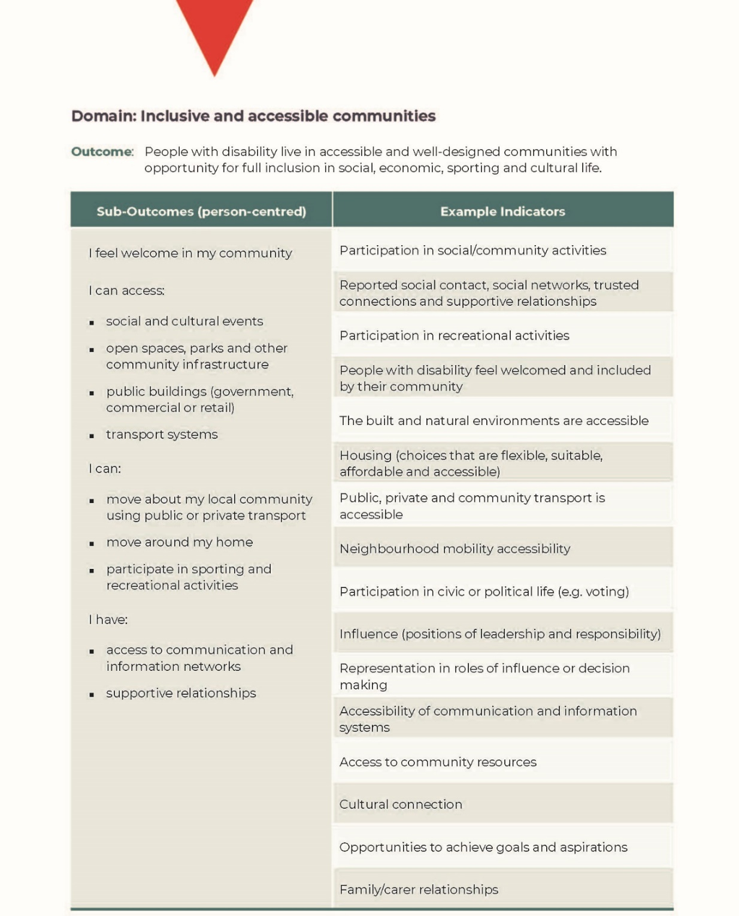

Question 2 – Economic security and accessible employment

What is most important to measure and report on as we seek to achieve economic security for people with disability?
- The economic security outcome aims for people with disability to have economic security and suitable living arrangements, enabling them to plan for the future and exercise choice and control over their lives.
- Economic security may include more people with disability have a job, have enough income for daily living expenses, are not living in poverty, and have somewhere suitable to live.

All of us with disability must be supported to participate in open employment, by improving the participation rates of people with disability in mainstream employment opportunities. People with disability must also enjoy equal employment conditions, and be supported to participate in workplaces that value the full inclusion of people with disability.

The economic security of people with disability must start at the transition from leaving school into open employment, and needs to continue throughout one’s life right through to retirement. Therefore, a life course approach must be considered to realise the economic security of people with disability.

Additionally, a key element of securing the economic security of people with disability will be equal access to adequate income support for when a person with disability has no, or reduced, capacity to work. Providing adequate income support also supports the right of people with disability to have an adequate standard of living and social protection.

Realising the economic security of people with disability will ensure we can participate in society on an equal basis with people without disability. The benefits of realising the economic security of people with disability include dignity, financial security and financial inclusion, a sense of purpose, meaningful social engagement and social connectedness, and the equal opportunity to contribute and participate in the social, political, cultural and economic life of Australia.

While not the only factor, realising the right to economic security also supports the right of people with disability to live our lives free from violence, abuse, neglect and exploitation, by ensuring we can access open employment opportunities that pay the same wages as those available to people without disability.

Therefore, PWDA’s suggested wording for the economic security outcome is:

People with disability have economic security, enabling them to plan for the future and exercise choice and control over their lives. Economic security can include things like having an [equitable] income and having a [job with equal benefits. People with disability should enjoy equal employment conditions and must not be forced into employment or compulsory labour. People with disability should also enjoy equal access and opportunity to employment, and be supported at key transition points to obtain and retain employment. People with disability must also have access to adequate income support, to ensure an adequate standard of living and social protection].

Outcomes to be achieved
The outcomes for people with disability include, but are not limited, to the following:

- People with disability are supported to obtain and retain jobs in open employment on an equal basis with people without disability.
- People with disability access income support in a timely manner when needed.
- People with disability enjoy financial security mainly from employment.
- People with disability enjoy financial security to enable them to plan for the future, and exercise choice and control over their lives.
- People with disability are not segregated from people without disability in employment settings.
- People with disability are able to meaningfully contribute and participate in the social, cultural, political and economic life of Australia.

The targeted action plan should recognise and refer directly to Australia’s obligations under the United Nations Convention on the Rights of Persons with Disabilities. And, in particular:

Article 28 – Adequate standard of living and social protection, which articulates the following obligations:

- States Parties recognize the right of persons with disabilities to an adequate standard of living for themselves and their families, including adequate food, clothing and housing, and to the continuous improvement of living conditions, and shall take appropriate steps to safeguard and promote the realization of this right without discrimination on the basis of disability.

- States Parties recognize the right of persons with disabilities to social protection and to the enjoyment of that right without discrimination on the basis of disability, and shall take appropriate steps to safeguard and promote the realization of this right, including measures:

- To ensure equal access by persons with disabilities to clean water services, and to ensure access to appropriate and affordable services, devices and other assistance for disability-related needs;
- To ensure access by persons with disabilities, in particular women and girls with disabilities and older persons with disabilities, to social protection programmes and poverty reduction programmes;
- To ensure access by persons with disabilities and their families living in situations of poverty to assistance from the State with disability-related expenses, including adequate training, counselling, financial assistance and respite care;
- To ensure access by persons with disabilities to public housing programmes;
- To ensure equal access by persons with disabilities to retirement benefits and programmes.

Article 27 – Work and employment, which articulates the following obligations:

- States Parties recognize the right of persons with disabilities to work, on an equal basis with others; this includes the right to the opportunity to gain a living by work freely chosen or accepted in a labour market and work environment that is open, inclusive and accessible to persons with disabilities. States Parties shall safeguard and promote the realization of the right to work, including for those who acquire a disability during the course of employment, by taking appropriate steps, including through legislation, to, inter alia:

- Prohibit discrimination on the basis of disability with regard to all matters concerning all forms of employment, including conditions of recruitment, hiring and employment, continuance of employment, career advancement and safe and healthy working conditions;
- Protect the rights of persons with disabilities, on an equal basis with others, to just and favourable conditions of work, including equal opportunities and equal remuneration for work of equal value, safe and healthy working conditions, including protection from harassment, and the redress of grievances;
- Ensure that persons with disabilities are able to exercise their labour and trade union rights on an equal basis with others;
- Enable persons with disabilities to have effective access to general technical and vocational guidance programmes, placement services and vocational and continuing training;
- Promote employment opportunities and career advancement for persons with disabilities in the labour market, as well as assistance in finding, obtaining, maintaining and returning to employment;
- Promote opportunities for self-employment, entrepreneurship, the development of cooperatives and starting one’s own business;
- Employ persons with disabilities in the public sector;
- Promote the employment of persons with disabilities in the private sector through appropriate policies and measures, which may include affirmative action programmes, incentives and other measures;
- Ensure that reasonable accommodation is provided to persons with disabilities in the workplace;
- Promote the acquisition by persons with disabilities of work experience in the open labour market;
- Promote vocational and professional rehabilitation, job retention and return-to-work programmes for persons with disabilities.

- States Parties shall ensure that persons with disabilities are not held in slavery or in servitude, and are protected, on an equal basis with others, from forced or compulsory labour.

How will we measure our progress in this outcome area?
All people with disability have economic security, enabling them to plan for their future and exercise choice and control over their lives.

Key actions

- Conduct a complete review of access to, and the adequacy of, the Disability Support Pension.

- End the ongoing eligibility restrictions for the Disability Support Pension, and raise the base rate of JobSeeker and other income support payments such as Parenting Payment Single, to ensure people with disability have an adequate standard of living.

- Implement in full the recommendations from the 2016 Willing to Work Inquiry into Employment Discrimination Against Older Australians and Australians with Disability.
- End segregated employment such as Australian Disability Enterprises (ADEs), by implementing a plan for transitioning away from segregated employment towards genuine work training and skill building opportunities, which lead to open employment and equitable remuneration for work.

- Employ measures to ensure that people with disability can access employment services and supports that meet their individual needs, and which are focused on long-term outcomes.

- Set specific targets, performance indicators and timeframes for increasing the workforce participation of people with disability across all sectors.

- Develop and implement a monitoring and evaluation framework, with key milestones, and specified dates for public reporting on progress.

- Strengthen the support required to transition school leavers with disability from the school education system into further study, including tertiary education, and into open employment.

- Address intersectional discrimination and other barriers that make it harder for many people with disability to obtain and retain a job, such as gender, being from a culturally and linguistically diverse background, being from an LGBTIQA+ background, and living in a rural and remote area.

- Clearly define reasonable accommodation in the Disability Discrimination Act 1992, to ensure people with disability can access the required supports to perform their job.

Views on the outcomes framework introductory paper’s proposal
PWDA notes the Australian Government has proposed a number of person-centred
sub-outcomes and example indicators in its outcomes framework introductory paper.
We believe these are admirable but could be more specific like our key actions.

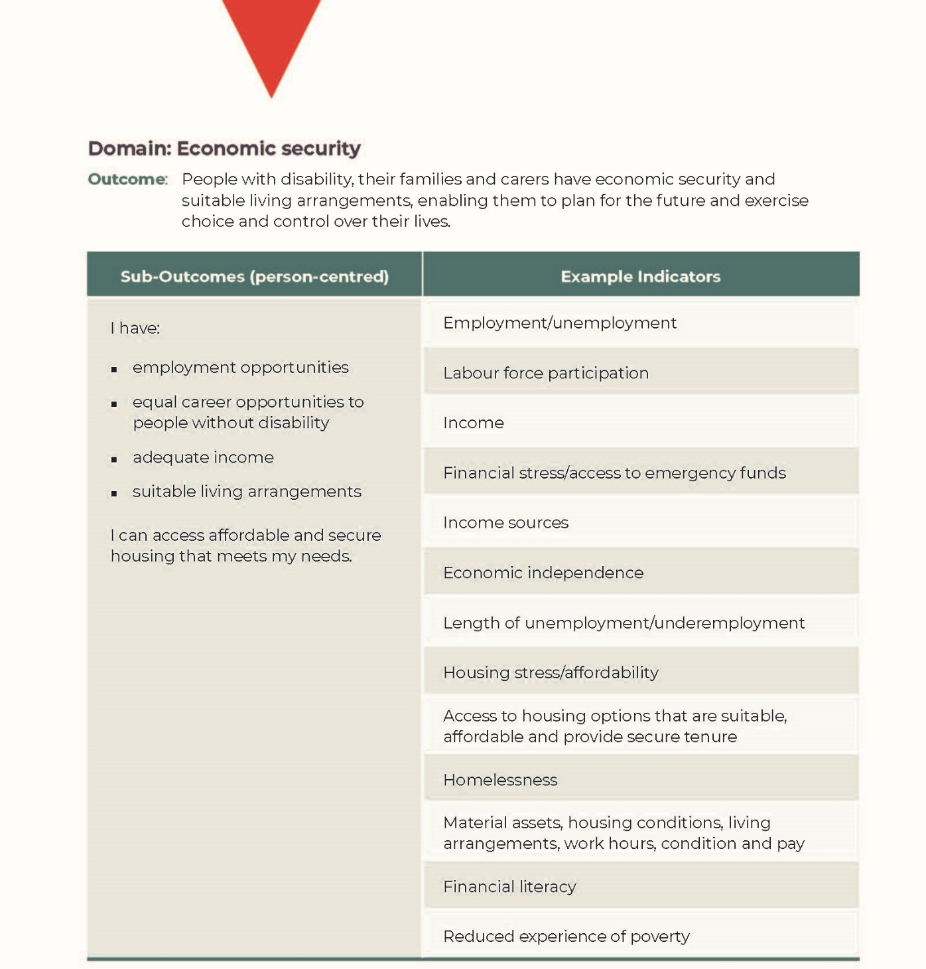

Question 3 – Health and wellbeing

What is most important to measure and report on as we seek to achieve health and wellbeing outcomes for people with disability?
- The health and wellbeing outcome aims for people with disability to attain highest possible health and wellbeing outcomes throughout their lives.
- Health and wellbeing may include, interacting with health professionals who understand needs of people with disability, affordable health services and satisfactory mental health support.

People with disability have a right to attain and maintain the best possible health and wellbeing throughout our lives. Our health and wellbeing is critical to our capacity to participate fully in the social, economic, cultural and political life of Australia.

To attain and maintain the best possible health and wellbeing of people with disability, we must be recognised as experts on what our health and disability support needs are. This means we must be supported to fully exercise our legal capacity to choose and control how we manage our health and wellbeing, with health information we can access.

Together with our chosen supporters, we must also be supported to express and act on our will and preferences for how we manage our health and wellbeing. This must include our right to take risks, as a key way of maintaining our bodily autonomy in all decisions that affect our health and wellbeing.

To support us attaining the best possible health and wellbeing outcomes, our treating professionals must also be supported to provide appropriate care regardless of our disability, by not misattributing medical conditions to our disability, by ensuring the robust collection of data on our health, and trained to address our needs including our will and preference.

Therefore, PWDA’s suggested wording for the Health and Wellbeing outcome is:

People with disability [have the right and help to] attain the [best] possible health and wellbeing outcomes throughout their lives. [People with disability must maintain their bodily autonomy by exercising their legal capacity to choose and control how they manage their health and wellbeing. The will and preferences of people with disability must be respected, by ensuring our treating professionals are supported to provide an adequate standard of health care that reflects our informed choices. All health information must be accessible to us.]

Outcomes to be achieved
The outcomes for people with disability include, but are not limited, to the following:

- People with disability make informed choices and can exercise choice and control over decisions that affect their health and wellbeing.
- People with disability access NDIS services and supports that promote their health and wellbeing at all stages of life, in all locations and at all times.
- All people with disability can access mainstream and community supports that promote their health and wellbeing at all stages of life, in all locations and at all times.
- The bodily autonomy of people with disability is respected.
- The will and preference of people with disability are understood, respected and acted upon.
- People with disability access treating professionals who are trained to understand, provide and meet the needs and standard of care for all medical and disability needs.
- Policies on the health and wellbeing of people with disability are based on robust data and evidence-based approaches.
- People with disability access health information they can understand.

The targeted action plan should recognise and refer directly to Australia’s obligations under the United Nations Convention on the Rights of Persons with Disabilities. And, in particular:

Article 17 – Integrity of the person, which articulates the following obligations:

Every person with disabilities has a right to respect for his or her physical and mental integrity on an equal basis with others.

Article 25 – Health, which articulates the following obligations:

States Parties recognize that persons with disabilities have the right to the enjoyment of the highest attainable standard of health without discrimination on the basis of disability. States Parties shall take all appropriate measures to ensure access for persons with disabilities to health services that are gender-sensitive, including health-related rehabilitation. In particular, States Parties shall:

- Provide persons with disabilities with the same range, quality and standard of free or affordable health care and programmes as provided to other persons, including in the area of sexual and reproductive health and population-based public health programmes;

- Provide those health services needed by persons with disabilities specifically because of their disabilities, including early identification and intervention as appropriate, and services designed to minimize and prevent further disabilities, including among children and older persons;

- Provide these health services as close as possible to people’s own communities, including in rural areas;

- Require health professionals to provide care of the same quality to persons with disabilities as to others, including on the basis of free and informed consent by, inter alia, raising awareness of the human rights, dignity, autonomy and needs of persons with disabilities through training and the promulgation of ethical standards for public and private health care;

- Prohibit discrimination against persons with disabilities in the provision of health insurance, and life insurance where such insurance is permitted by national law, which shall be provided in a fair and reasonable manner;

- Prevent discriminatory denial of health care or health services or food and fluids on the basis of disability.

How we will measure our progress in this outcome area
All people with disability are recognised as experts on how to manage their health and wellbeing, by being supported to exercise their legal capacity to make any decision that affects their health and wellbeing, by having their bodily autonomy and will and preferences respected, and by accessing services and supports that promote and meet all their health and wellbeing at all stages of life, in all locations and at all times.

Key actions

- Ensure all health services and supports are provided to all people with disability with their free and informed consent, and based on the disabling nature of functional or social impairments, irrespective of eligibility for the NDIS.

- Adequately resource all personal and community health services and supports to assist people with disability and the general community, so people with disability can set goals for, and attain the best possible health and wellbeing outcomes themselves.

- Develop and enact national, uniform and legally enforceable legislation prohibiting the sterilisation of children and adults, in the absence of their prior, fully informed and free consent.

- Develop and enact national, uniform and legally enforceable legislation prohibiting unnecessary medical interventions, including but not limited to, surgical and hormonal interventions on intersex children and adults without their prior, fully informed and free personal consent.

- Implement measures to address the poor health outcomes of people with disability, with a particular focus on First Nations people with disability, people with intellectual disability, people with psychosocial disability and women with disability.

- Create and resource a national network of intellectual disability health specialists to enhance the capacity of mainstream services to cater to the specific needs of people with intellectual disability.

- Adequately resource peer-managed mental health services and programs that ensure alternatives to forced confinement and treatment, and that support people with psychosocial disability regardless of NDIS eligibility.

- Enshrine the value of preventative healthcare and early intervention in the delivery of all health services in Australia to limit the development of disability in the community.

- End all discrimination in all service delivery settings, particularly for young people, people aged between 18 and 65 years of age, and older people with disability, by ensuring equal access to all services and supports for all people with disability, particularly by private health insurance companies and assisted reproductive therapy providers.

- Develop a national mechanism that enables the collection of disaggregated data on the health of people with disability.

Views on the outcomes framework introductory paper’s proposal
PWDA notes the Australian Government has proposed a number of person-centred sub-outcomes and example indicators in its outcomes framework introductory paper.
We believe these are admirable but could be more specific like our key actions.
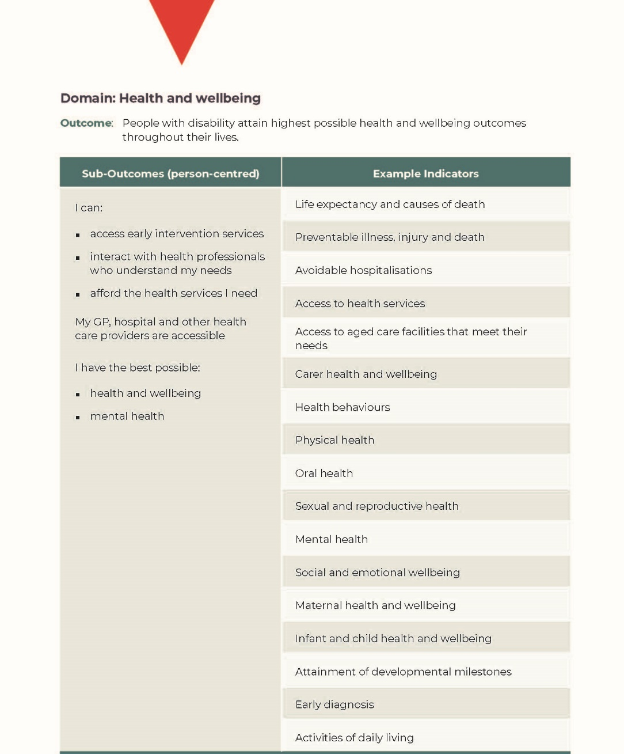

Question 4 – Rights protection, justice and legislation

What is most important to measure and report on as we seek to achieve rights, protection, justice and legislation outcomes for people with disability?
- The rights protection, justice and legislation outcome aims for people with disability to feel safe and have their rights promoted, upheld and protected.
- Rights protection, justice and legislation may include feeling safe, the ability to participate in democratic processes and being free from disability related discrimination.

People with Disability Australia believes rights protection is a primary vehicle through which we as people with disability are enabled to participate fully and equally in society.

We believe the wording of the new NDS rights protection, justice and legislation outcome needs some finessing. We think the words should be refined so the outcome conveys the importance of people feeling safe and also being safe from abuse.

PWDA thinks it is worthwhile to finesse the wording of the outcome to name the types of abuse people may experience, in line with the name of the Disability Royal Commission and the wording of Article 15 of the United Nations Convention on the Rights of Persons with Disabilities.

As a result, we believe this outcome should be refined to read:

People with disability have their rights promoted, upheld and protected [and are safe, and feel safe, from violence, abuse, neglect, exploitation and torture].

Realisation of rights is dependent on a strong legislative and policy framework embedding Australia’s human rights obligations. We stress that independent advocacy is also essential for people with disability to be able to realise our rights as quickly and effectively as possible, and would like to see a greater focus on independent advocacy in this section of the NDS.

As an organisation, PWDA has already spent considerable time thinking about how Australia can improve its rights protection, justice and legislation regime.
We did this as a member of Disabled People’s Organisation Australia (DPOA) when we collectively prepared the Disability Rights Now 2019 shadow report to the UN last year.

In that report we made specific recommendations that had the support of more than 70 non-government organisations involved with people with disability, which we have included below where appropriate.

We have evaluated the original National Disability Strategy and suggest that policy directions 1, 3, 4 and 5 would be improved by the following additions and changes, and recommend the inclusion of an additional policy direction to advance the rights of children and young people with disability.

Policy Direction 1 highlights the importance of increased awareness and acceptance of the rights of people with disability. This not only requires campaigns to raise public awareness generally, but also targeted campaigns focused on particular priorities and sectors to facilitate the translation of awareness of rights into action. The justice and education systems are two key areas that PWDA believes call for dedicated strategic campaigning.

Schools are one place where awareness of our rights could be improved to give children a better start in life. School system employees often lack awareness about the full spectrum of rights we as people with disability have and enjoy, and how to protect them.

The justice system is another key to upholding our rights as people with disability. Yet similarly justice system agents are often not aware of how best to facilitate the delivery of justice to people with disability.

Disability discrimination laws are also crucial within measures to increase awareness and acceptance of our rights of people with disability and require bolstering to ensure effective rights protection.

Policy Direction 3 affirms people with disability should have access to justice. We recommend this policy direction be shifted to encompass our broader right to equal recognition before the law and should read:

People with disability have access to justice [and are recognised as persons before the law].

The right to recognition everywhere as persons before the law and the enjoyment of legal capacity on an equal basis with others are foundational aspects of our access to justice and we also call for this to be mentioned in this section, as enshrined in Article 12 of the UN CRPD. We also call for support for each of us to participate as a person before the law within the justice system, with this right encompassing a recognition of our right to enjoy legal capacity in all contexts.

Respecting our legal capacity would require the Australian governments to implement measures to support us as people with disability so we can exercise our legal capacity in accordance with Article 12 of the CRPD.

Article 12 has been interpreted by the Committee on the Rights of Persons with Disabilities as requiring the repeal of legislation providing for substitute decision-making, such as guardianship and other measures facilitating the making of decisions on behalf of individuals on the basis of mental capacity tests.

Australia has maintained interpretive declarations stating its position that substitute decision-making regimes do not breach the CRPD’s provisions, thereby denying us our rights as full citizens. Despite this, PWDA believes that Australian governments should take action to implement Article 12 to the greatest extent possible.

This means that consideration should always be given, when enacting new legislation and reviewing existing laws, to how to minimise deprivations of legal capacity as well as how to enable and facilitate supported decision-making measures, with a view to progressive dismantling of the substituted decision-making regime.

In addition to the judiciary, legal professionals and court staff, we suggest this section include mention of the staff of administrative agencies in facilitating and delivering access to justice including through complaints processes.

Policy Direction 4 affirms people with disability should be safe from violence, exploitation and neglect.

PWDA believes people with disability should both feel and be safe from violence, abuse, neglect, exploitation, torture and cruel, inhuman or degrading treatment or punishment. We see it as essential that Australia ensures our right to be free and safe from torture, violence and interference with bodily integrity under articles 15, 16 and 17 of the UN CRPD across all settings, both within and outside the home.

We note people with disability have been calling for a royal commission into violence against people with disability for many years and we are following the activities of the resulting Royal Commission into Violence, Abuse, Neglect and Exploitation of People with Disability closely. We are also campaigning through the Disabled People’s Organisations Australia for the Australian Government to #MakeItSafeToSpeak to the Disability Royal Commission to ensure people’s right to give evidence in anonymity be guaranteed in perpetuity, consistent with other rights abuse victims have such as sexual abuse whose anonymity in media reports must be maintained unless they waive that right.

We must allow people full privacy protections so they can potentially protect themselves from retribution from perpetrators who they might still depend upon. We believe this change should be made swiftly and must not be delayed until 2021.

Tragic deaths in recent years of people with disability, including Ann Marie Smith, Willow Dunn and David Harris underscore the need for urgent attention on strengthening safeguarding measures to prevent violence, abuse and exploitation of people with disability at the state and territory and federal levels, within and beyond the NDIS.

These measures should include the establishment of a national disability watchdog to respond to instances of violence against people with disability, full implementation of Australia’s obligations as a state party to the Optional Protocol to the Convention against Torture and Other Cruel, Inhuman or Degrading Treatment or Punishment (OPCAT), and ending forced and non-consensual medical treatments imposed upon people with disability.

People with disability are at heightened risk of violence in institutional environments. The progressive closure of institutions and community-based residential options for people with disability is imperative to prevent violence against people with disability. Specific measures to address gender-based violence are also essential.

In addition to discussion about the significant overrepresentation of people with disability in the criminal justice system as offenders and prisoners, PWDA is of the view that additional recognition of discrimination faced by victims of crime within the criminal justice system would strengthen this policy direction. Prosecutions are far less common when people with disability are victims because of stereotypes and discriminatory attitudes driving decision-making, in addition to lack of adequate support measures to enable people to participate in criminal processes effectively.

This policy direction should also refer to the situation of forensic patients, and in particular people with disability who have not been convicted of an offence who are managed in prisons and forensic facilities. The unwarranted use of prisons and forensic mental health facilities for the management of unconvicted people with disability needs to be urgently addressed, and Australian governments should also urgently consider the compliance of forensic mental health laws and systems with Australia’s human rights obligations.

PWDA would like to see a policy direction focused on the rights of children and young people included in the National Disability Strategy to recognise the importance of children and young people with disability growing up free from discrimination and violence, and enabled to participate in all aspects of life, so they can realise their full potential.

We propose that this policy direction be worded similarly to:

Children and young people with disability fully enjoy their human rights, and the views of children and young people with disability on matters affecting them are given due weight.

Two vital steps in rights protection for children and young people with disability are:

- Reviewing and revising legislation and policies to ensure they effectively incorporate and protect CRPD rights.
- Ensuring children and young people can participate in decision-making processes affecting their lives.

Outcomes to be achieved
The outcomes for people with disability include, but are not limited, to the following:

- People with disability are supported to participate in all aspects of the justice system.
- People with disability enjoy legal capacity in all aspects of life.
- People with disability feel safe and are safe from violence, abuse, neglect, exploitation and torture.
- The proportion of offenders with disability and people with disability in prisons is reduced dramatically.
- People with disability in prisons and forensic mental health facilities can access needed services and are supported to transition into community living.
- The views of children and young people with disability are respected in decision-making processes affecting their lives.

How we will measure our progress in this outcome area
People with disability have our rights promoted, upheld and protected and are safe, and feel safe, from violence, abuse, neglect, exploitation and torture.

Key actions

- Increase campaigning to enhance awareness of the rights of people with disability among the general public in addition to campaigns targeting particular sectors including the justice and education systems.

- Withdraw Australia’s interpretative declarations to articles 12, 17 and 18 of the UN CRPD, which prevent reform and allow for human rights violations including the denial of legal capacity, forced treatments, and discrimination against non-Australian citizens with disability seeking to enter or remain in Australia.

- Further develop measures to support people with disability to exercise our legal capacity in all contexts, accompanied by measures to progressively reduce substitute decision-making arrangements, moving towards elimination of substitute
decision-making.

- Incorporate UN CRPD rights into legislation, policies and programs that apply to children and young people, and develop mechanisms to ensure that children and young people with disability can participate in consultations, decision-making processes and policy development that affect their lives.

- Develop a national plan for the closure of residential institutional environments, and develop genuine community-based housing and support options for people with disability.

- Strengthen anti-discrimination laws to: address intersectional discrimination; enable representative complaints; enable complaints regarding disability hate crimes; and ensure people with disability can effectively make complaints about denial of reasonable accommodation.

- Develop and enact national legislation on the prevention of all forms of
gender-based violence.

- Incorporate a redress mechanism into, or at the conclusion of, the current Royal Commission into Violence, Abuse, Neglect and Exploitation of People with Disability, and implement the recommendations of the Disability Royal Commission.

- Establish a national accessible oversight, complaint and redress mechanism for people with disability who have experienced violence, abuse, exploitation or neglect in all settings, including all those not eligible for the NDIS and, particularly, older women with disability who are especially at risk.
- Incorporate CRPD rights into legislation, policies and programs that apply to children and young people; and develop mechanisms to ensure that children and young people with disability can participate in consultations, decision-making processes and policy development that affect their lives.

- Fully implement Australia’s obligations as a state party to the Optional Protocol to the Convention against Torture and Other Cruel, Inhuman or Degrading Treatment or Punishment, with formal implementation of the National Preventative Mechanism network as soon as possible.

- Implement legislation prohibiting the use of restrictive practices, and medical interventions made on people with disability without their consent, including electroconvulsive therapy, forced administration of psychiatric medications, forced sterilisation of children, young people and adults, the administration of contraception and the imposition of abortion procedures on women and girls with disability.

- Adopt clear legislative provisions to prevent invasive and irreversible medical interventions being imposed on intersex people before they reach the age of consent.

- Urgently address the over-representation of people with disability in the criminal justice system, and end the unwarranted use of prisons and forensic mental health facilities for the management of unconvicted people with disability.

- Comprehensively consider the compliance of forensic mental health laws and systems with Australia’s human rights obligations.

Views on the outcomes framework introductory paper’s proposal
PWDA notes the Australian Government has proposed a number of person-centred
sub-outcomes and example indicators in its outcomes framework introductory paper.
We believe these are admirable but could be more specific like our key actions.

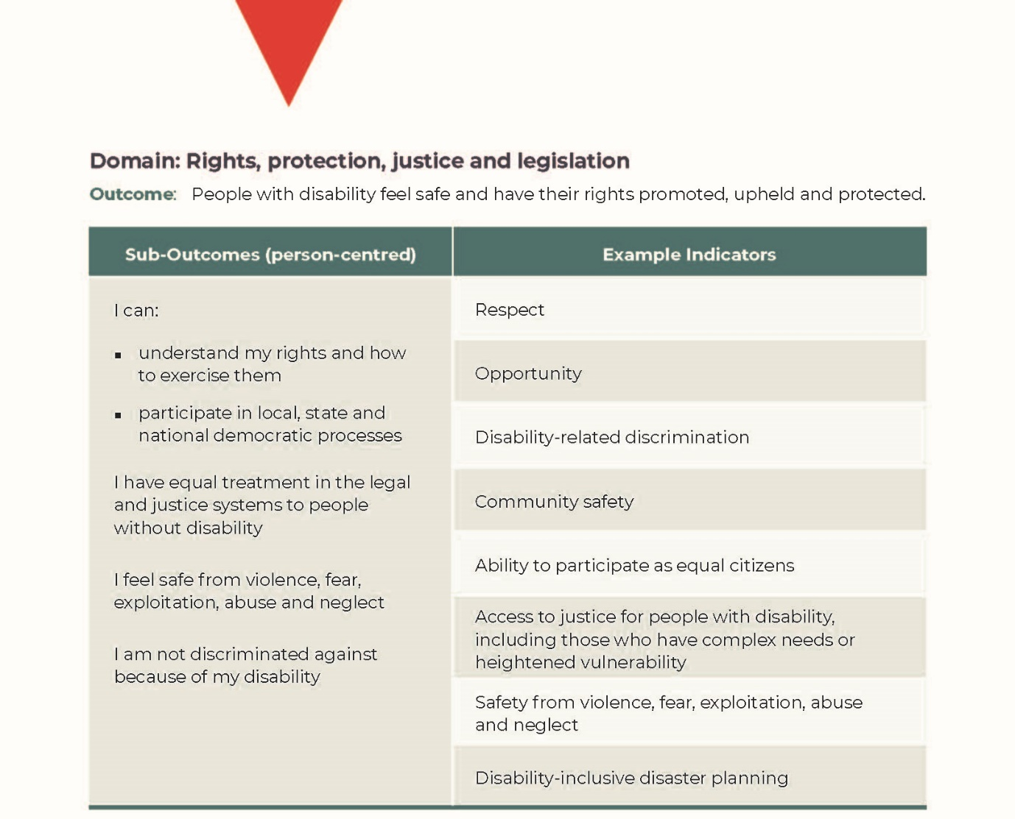

Question 5 – Learning and skills

What is most important to measure and report on as we seek to achieve learning and skills outcomes for people with disability?
- The learning and skills outcome aims for people with disability to achieve their full potential through their participation in an inclusive, high-quality education system that is responsive to their needs. It also aims for people with disability to have opportunities to continue learning throughout their lives in both formal and informal settings.
- Learning and skills may include, teachers who understand needs of people with disability, continued access to formal and informal learning settings, and preparation for transitioning from one level of education to the next, or from education to employment.

People with Disability Australia believe the learning and skills outcome area would be better titled education and learning.

We believe people with disability have a right to a high-quality education. Inclusive education is vital to turning the disadvantages people with disability
face as a result of their impairments.

Inclusive education must be realised without discrimination and on the basis of
equal opportunity. Education is key to supporting our right to the full development
of our potential, and accessing inclusive education recognises our inherent dignity
and self-worth.

Students with disability must be able to participate in an inclusive high-quality education in a mainstream setting, with the right supports at school and in the community to be able to participate fully by ensuring all reasonable accommodations are met and are supported.

An inclusive education must also ensure we are ready to participate in the community after our schooling. This means students with disability must be supported to realise our aspirations and further options after school, so we can access further education and open employment.

PWDA also endorses the Australian Coalition for Inclusive Education’s (ACIE) Driving change: A roadmap for achieving inclusive education in Australia in full.

Therefore, PWDA’s suggested wording for an education and learning outcome is:

People with disability [have the right to participate in a high-quality education that is responsive to our needs. People with disability must have equal opportunity to continue learning throughout our lives in mainstream settings and be supported fully in each education setting. People with disability must also be supported to realise our aspirations and options, so we can be supported to pursue further learning and open employment].

Outcomes to be achieved
The outcomes for people with disability include, but are not limited, to the following:

- People with disability are supported to participate in fully inclusive mainstream education.
- People with disability are supported to realise their aspirations and further options after compulsory schooling.
- People with disability are supported to pursue further education and training.
- People with disability are supported to transition into open employment based on our educational outcomes.
- People with disability have all reasonable accommodations met in all education settings.

The targeted action plan should recognise and refer directly to Australia’s obligations under the United Nations Convention on the Rights of Persons with Disabilities. And, in particular:

Article 24 – Education, which articulates the following obligations:

- States Parties recognize the right of persons with disabilities to education. With a view to realizing this right without discrimination and on the basis of equal opportunity, States Parties shall ensure an inclusive education system at all levels and lifelong learning directed to:

- The full development of human potential and sense of dignity and self-worth, and the strengthening of respect for human rights, fundamental freedoms and human diversity;
- The development by persons with disabilities of their personality, talents and creativity, as well as their mental and physical abilities, to their fullest potential;
- Enabling persons with disabilities to participate effectively in a free society.

- In realizing this right, States Parties shall ensure that:

- Persons with disabilities are not excluded from the general education system on the basis of disability, and that children with disabilities are not excluded from free and compulsory primary education, or from secondary education, on the basis of disability;
- Persons with disabilities can access an inclusive, quality and free primary education and secondary education on an equal basis with others in the communities in which they live;
- Reasonable accommodation of the individual’s requirements is provided;
- Persons with disabilities receive the support required, within the general education system, to facilitate their effective education;
- Effective individualized support measures are provided in environments that maximize academic and social development, consistent with the goal of full inclusion.

- States Parties shall enable persons with disabilities to learn life and social development skills to facilitate their full and equal participation in education and as members of the community. To this end, States Parties shall take appropriate measures, including:

- Facilitating the learning of Braille, alternative script, augmentative and alternative modes, means and formats of communication and orientation and mobility skills, and facilitating peer support and mentoring;
- Facilitating the learning of sign language and the promotion of the linguistic identity of the deaf community;
- Ensuring that the education of persons, and in particular children, who are blind, deaf or deafblind, is delivered in the most appropriate languages and modes and means of communication for the individual, and in environments which maximize academic and social development.

- In order to help ensure the realization of this right, States Parties shall take appropriate measures to employ teachers, including teachers with disabilities, who are qualified in sign language and/or Braille, and to train professionals and staff who work at all levels of education. Such training shall incorporate disability awareness and the use of appropriate augmentative and alternative modes, means and formats of communication, educational techniques and materials to support persons with disabilities.

- States Parties shall ensure that persons with disabilities are able to access general tertiary education, vocational training, adult education and lifelong learning without discrimination and on an equal basis with others. To this end, States Parties shall ensure that reasonable accommodation is provided to persons with disabilities.

How we will measure our progress in this outcome area
All students with disability are welcomed as valued learners, are fully included in mainstream education, are supported to realise their aspirations and options after schooling, and are fully supported to transition into post-school options.

Key actions

- End all segregated education.

- Transition all segregated students with disability into mainstream education, ensuring age-appropriate settings for all students at all levels, in particular Aboriginal and Torres Strait Islander students.

- Develop, implement and resource a National Action Plan for Inclusive Education, that includes a legislative and policy framework consistent with Article 24 and General Comment No. 4

- Review, in consultation with disability representative organisations, the Disability Standards for Education 2005.

- All state and territory governments develop and implement a transparent improvement framework for inclusive education, with an independent national oversight body created and resourced to oversee national improvement.

- Ensure adequate and needs-based funding for best practice improvement methods to be used in all schools.

- Amend the Disability Discrimination Act 1992 to ensure all reasonable accommodations are met, so all students are learning the same curriculum as their peers, reasonably adjusted and differentiated to a student’s needs.

- Embed Universal Design for Learning principles in all aspects of education design
and delivery, so class lessons are accessible to the greatest number of students.

- Increase the retention of students with disability until year 12, and the rate of young people with disability enrolled in higher education and vocational education and training.

- Record and monitor data on students with disability, including the use of restrictive practices and punitive and disciplinary measures.

Views on the outcomes framework introductory paper’s proposal
PWDA notes the Australian Government has proposed a number of person-centred
sub-outcomes and example indicators in its outcomes framework introductory paper.
We believe these are admirable but could be more specific like our key actions.

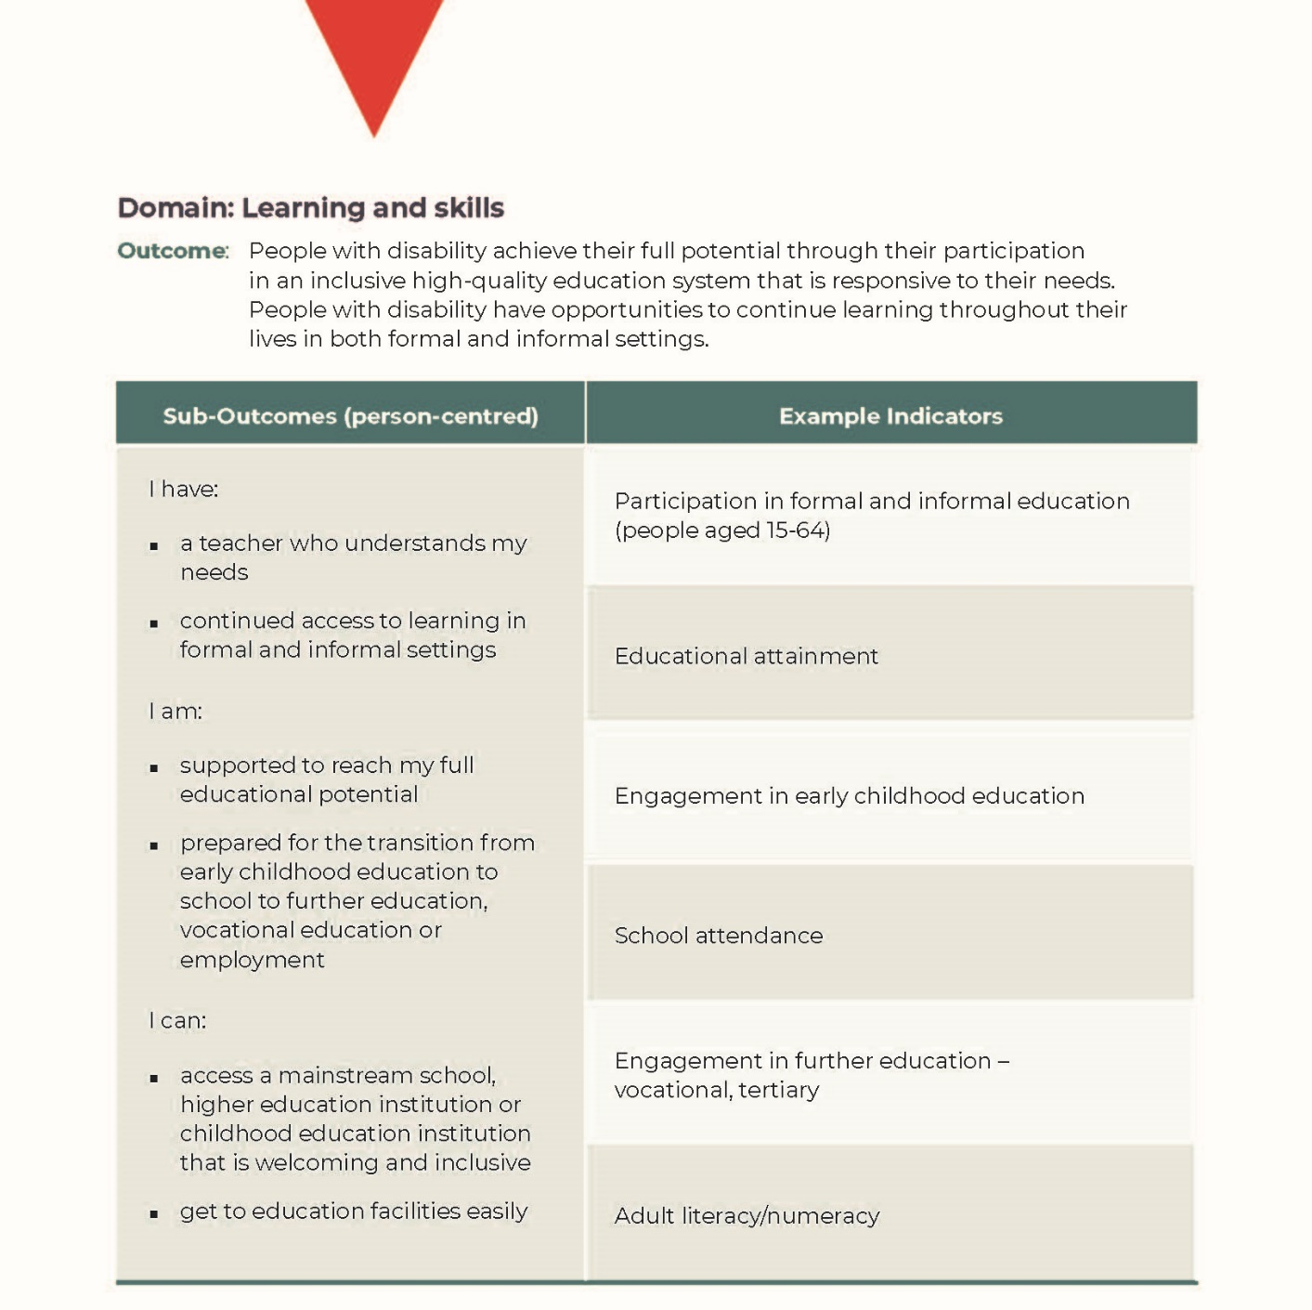

Question 6 – Personal and community support

What is most important to measure and report on as we seek to achieve personal and community support outcomes for people with disability?
- The personal and community support outcome aims for people with disability, their families and their carers to have access to a range of well-coordinated and effective services and supports that are appropriate to their needs.
- Personal and community support may include, access to specialised disability services and supports, including NDIS for eligible participants, community-based services that are available when and where they are needed and services that are well coordinated.

People with Disability Australia believes personal and community support is vital for people with disability.

We as people with disability have a right to access equitably all reasonable and necessary supports that are delivered by providers we choose and who meet all of our needs at all times.

Access to personal and community supports must support our equal and full participation in the social, cultural, economic and political life of Australia, and must include all mental, physical, emotional and sexual needs of people with disability.

It is vital that our right to access personal and community supports can be enjoyed without discrimination, with all steps taken to ensure accessing supports is not based on whether we have access to the National Disability Insurance Scheme. This means, all state and Commonwealth mainstream systems must be equipped to provide services for all people with disability in all locations.

For those of us who have access to the NDIS, access to the scheme must be equitable and timely, with adequate and timely support to assist us to use our NDIS plans fully.
All of us with disability must be provided with information and advocacy supports from sources we trust, both digital and in person, to help us navigate and manage providers that suit our needs.

Therefore, PWDA’s suggested wording for the personal and community support outcome is:

People with disability [have the right to access all] supports that [promote the equal and full participation of people with disability in all aspects of our lives. The delivery of these supports must be well coordinated, and meet all of our disability needs at all times in all locations, to the level of support that is required. Accessing these supports must be timely and continuous, irrespective of whether a person has access to the National Disability Insurance Scheme. To ensure access to supports that meet the needs of people with disability, we must also be provided with information and advocacy supports to navigate providers and to ensure the quality of supports being delivered].

Outcomes to be achieved
The outcomes for people with disability include, but are not limited, to the following:

- People with disability access all reasonable and necessary supports to participate in all aspects of our lives equally and fully.
- People with disability receive quality supports that meet all of our needs, in all locations, at all times.
- People with disability access the NDIS in an equitable and timely manner.
- People with disability are supported to fully use their NDIS plans.
- People with disability successfully navigate and access providers that suit their needs and are of their choosing.
- People with disability equitably access all mainstream service systems.
- People with disability access sources of information they trust.
- People with disability successfully advocate for the full realisation of their rights.

The targeted action plan should recognise and refer directly to Australia’s obligations under the UN Convention on the Rights of Persons with Disabilities. And, in particular:

Article 25 – Health, which articulates the following obligations:

States Parties recognize that persons with disabilities have the right to the enjoyment of the highest attainable standard of health without discrimination on the basis of disability. States Parties shall take all appropriate measures to ensure access for persons with disabilities to health services that are gender-sensitive, including health-related rehabilitation. In particular, States Parties shall:

- Provide persons with disabilities with the same range, quality and standard of free or affordable health care and programmes as provided to other persons, including in the area of sexual and reproductive health and population-based public health programmes;
- Provide those health services needed by persons with disabilities specifically because of their disabilities, including early identification and intervention as appropriate, and services designed to minimize and prevent further disabilities, including among children and older persons;
- Provide these health services as close as possible to people’s own communities, including in rural areas;
- Require health professionals to provide care of the same quality to persons with disabilities as to others, including on the basis of free and informed consent by, inter alia, raising awareness of the human rights, dignity, autonomy and needs of persons with disabilities through training and the promulgation of ethical standards for public and private health care;
- Prohibit discrimination against persons with disabilities in the provision of health insurance, and life insurance where such insurance is permitted by national law, which shall be provided in a fair and reasonable manner;
- Prevent discriminatory denial of health care or health services or food and fluids on the basis of disability.

Article 28 – Adequate standard of living and social protection, which articulates the following obligations:

- States Parties recognize the right of persons with disabilities to an adequate standard of living for themselves and their families, including adequate food, clothing and housing, and to the continuous improvement of living conditions, and shall take appropriate steps to safeguard and promote the realization of this right without discrimination on the basis of disability.

- States Parties recognize the right of persons with disabilities to social protection and to the enjoyment of that right without discrimination on the basis of disability, and shall take appropriate steps to safeguard and promote the realization of this right, including measures:

- To ensure equal access by persons with disabilities to clean water services, and to ensure access to appropriate and affordable services, devices and other assistance for disability-related needs;
- To ensure access by persons with disabilities, in particular women and girls with disabilities and older persons with disabilities, to social protection programmes and poverty reduction programmes;
- To ensure access by persons with disabilities and their families living in situations of poverty to assistance from the State with disability-related expenses, including adequate training, counselling, financial assistance and respite care;
- To ensure access by persons with disabilities to public housing programmes;
- To ensure equal access by persons with disabilities to retirement benefits and programmes.

How we will measure our progress in this outcome area
All people with disability access the reasonable and necessary supports they need to participate equally and fully in all aspects of their lives, and are supported to navigate providers and advocate for the full realisation of their rights.

Key actions

- Invest adequately in independent advocacy and representation that meets all needs.
- Withdraw Australia’s interpretive declaration on Article 12, to promote supported decision-making processes that promote evidence-based best practice approaches that support informed choice and control in provider decisions.
- Regularly collect and publish information on the experiences people with disability have with disability support providers.
- Invest adequately in support coordination according to need.
- Clearly articulate the roles, responsibilities and activities for those responsible for disability supports market stewardship and workforce development.
- Release a Provider of Last Resort policy.
- Clarify the boundaries between the NDIS and mainstream service systems, and where gaps exist, develop, implement and resource a plan to address gaps.
- Ensure equitable and timely access to the NDIS regardless of disability.
- Define what is considered reasonable and necessary under the National Disability Insurance Act 2013, so there is certainty about what supports can be funded under the scheme.

- Create a national independent oversight mechanism with powers to effectively protect, investigate and enforce findings, including but not limited to, the powers to prohibit restrictive practices and involve people with disability in a co-design capacity.

Views on the outcomes framework introductory paper’s proposal
PWDA notes the Australian Government has proposed a number of person-centred
sub-outcomes and example indicators in its outcomes framework introductory paper.
We believe these are admirable but could be more specific like our key actions.
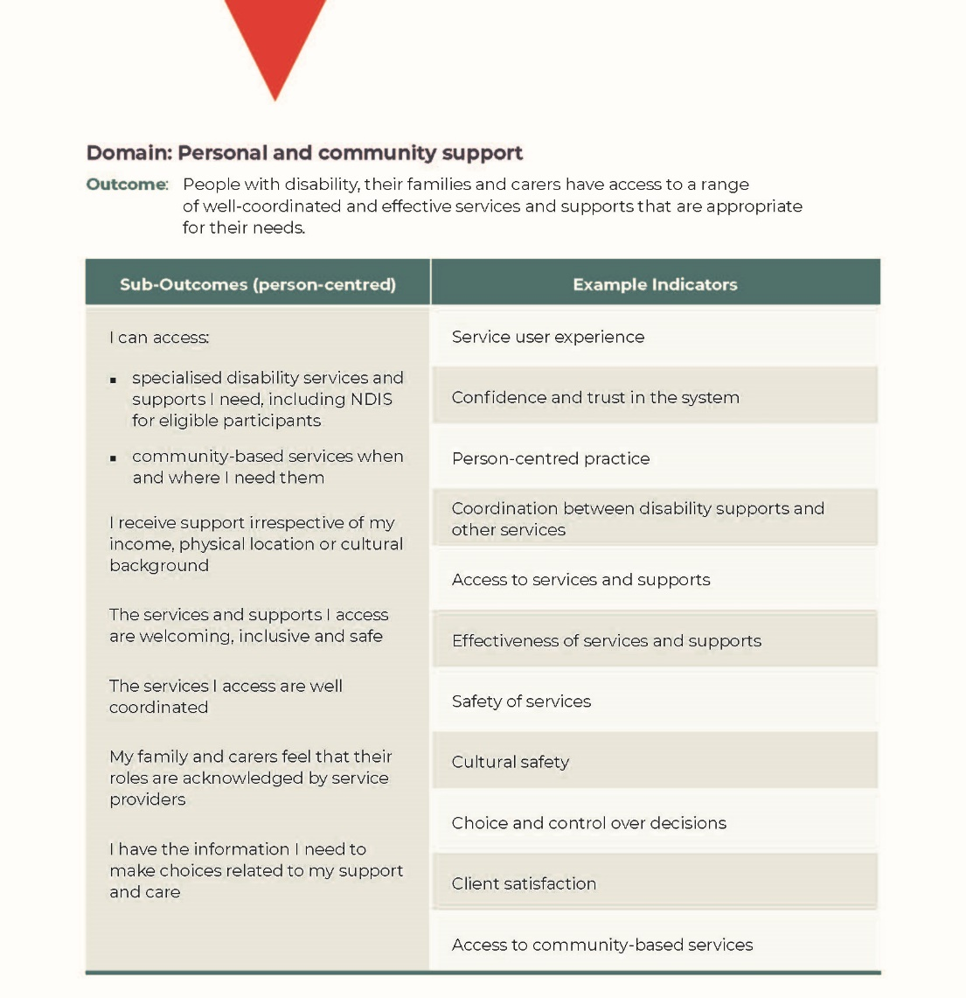

Question 7 – Frequency of reporting on progress

How often would you like to see progress against the outcomes for people with disability in the National Disability Strategy and the National Disability Insurance Scheme reported?

People with Disability Australia has long called for a robust system for monitoring and reporting on outcomes under the National Disability Strategy. We believe the new NDS must include appropriate levels of investment in an outcomes framework which tracks and reports on how the NDS is driving and delivering positive change in the lives of people with disability across Australia.

The framework must include accountability for monitoring and reporting, not only from the Australian Government but also from state, territory and local governments.

The outcomes framework must work from agreed population-based measures. We support the use of the indicators that have been developed and are being used for reporting at an international level through the United Nations.

We note the current development of the National Disability Data Asset (NDDA) will be critical to achieving the level of monitoring and reporting on changes in the lives of people with disability. It is critical that the new NDS moves away from its reliance on piecemeal activity-based reporting, which was a hallmark of the National Disability Strategy 2010–2020.

It is also critical that appropriate funding streams are available for Australian Government agencies, and state and territory governments and their agencies, as well as local governments to be able implement the targeted action plans that will deliver change and realise the rights of people of disability.

The recently released Factsheet on People with Disability, developed to accompany the UPR NGO Coalition Report for Australia’s Universal Periodic Review (UPR), highlights the challenges with the old systems of monitoring and reporting on the NDS and what needs to change for the new strategy.

The factsheet states:

Key stakeholders, including the United Nations’ Committee on the Rights of Persons with Disabilities and the Australian Government’s Senate Standing Committee on Community Affairs, have highlighted issues with [the NDS’s] efficacy, including the lack of:

- sufficient resources and funding for its implementation, monitoring and evaluation
- effective accountability, monitoring and evaluation mechanisms (e.g., there have been only two progress reports on the NDS, which generally provide anecdotal evidence for actions and initiatives taken, rather than evaluate outcomes and the success of the Strategy for people with disability)
- actions and measurable outcomes to address systemic human rights violations in health, employment, education, freedom from violence, and forced medical treatment and
- participation of people with disability and their representative organisations in its design, implementation and evaluation.

As the NDS is also siloed within the Australian Government Department of Social Services as a disability policy responsibility, there is limited authority to coordinate change across other Australian Government departments and state and territory jurisdictions.

Governments across Australia are now working together to design a new NDS to guide disability policy, programs, and legislation over the next 10 years – making this a ripe time to incorporate recommended reforms.

PWDA believes the new NDS must be properly resourced by the federal, state and territory governments. Transparent monitoring and evaluation of outcomes for people with disability must be linked to accountability measures across governments, ensuring targets are met. People with disability, and their representative organisations, must also be positioned at the centre of the NDS’ development, implementation and monitoring.

As a representative on the UPR NGO Coalition – the Universal Periodic Review coalition of non-government organisations – PWDA fully supports and commends these recommendations.

Further, at the time of writing, the Department of Social Services (DSS) has just launched a separate consultation process on the NDS Outcomes Framework. PWDA will be contributing to this consultation process.

PWDA believes reporting on the National Disability Strategy’s progress should be made on annual basis through our parliaments. A report presented to the Australian Parliament, as well as to State and Territory Parliaments, demonstrates to us as people with disability and the wider Australian community that our nation is committed to our obligations to the UN CRPD and to realising the rights of people with disability.

PWDA proposes that responsibility for the strategy must rest with the Prime Minister and First Ministers of states and territories, and their departments – the Department of Prime Minister and Cabinet and the corresponding departments of premier and cabinet.

PWDA sees it as essential that progress with the NDS’s specific, discrete targets are publicly reported upon so the United Nations, Australia and its disability representative organisations can determine how the lives of people with disability are improving, staying the same or worsening in this country.

We note the UN Committee on the Rights of Persons with Disabilities had views on what Australia could do to improve its implementation and reporting framework and outlined these in paragraphs 6(c) and 6(d) of its Concluding Observations.

We support these recommendations and have included them in our key actions, below.
PWDA also supports the reporting framework model similar to the Closing the Gap report.
We recommend the government takes this on board as it develops the latest NDS, a third implementation plan for the strategy and targeted action plans.

Key actions

- Place responsibility for the National Disability Strategy with the Prime Minister and the Department of the Prime Minister and Cabinet, and state-and-territory First Ministers and their departments of premier and cabinet.
- Publicly report at least annually on progress with implementing the National Disability Strategy.

- Develop a third implementation plan for the National Disability Strategy.

- In close consultation with and with the effective participation of diverse organisations of people with disability, ensure the National Disability Strategy receives adequate resources, an implementation plan with measurable goals and a robust monitoring mechanism, a formal performance reporting framework and evaluation, governance and accountability requirements, including through the implementation of the recommendations made by the Productivity Commission.

Question 8 – Additional information

Is there anything else that you think should be considered when we are monitoring and measuring the impact of activities on people with disability?

Throughout this submission we have referred to the critical roles of the Australian Government, State and Territory Governments and Local Government in driving and delivering on goals under the new NDS.

We are concerned, with the recent shift from the arrangements of the Coalition of Australian Governments (COAG) to the formation of the National Cabinet, that local government does not have a seat within the National Cabinet.

We propose that the inclusion of local government in the NDS 2020–2030 must continue. that local government is a key provider and stakeholder in several of the NDS outcome areas. Without the inclusion of local government, it will be particularly difficult to realise change for people with disability under the inclusive and accessible communities outcome area. In addition, funding opportunities for local government to deliver on goals developed under targeted action plans must be included within the new NDS.

Consent to publish submission

PWDA agrees for the government to publish our submission. This agreement applies to the NDS website and any other channels the government may use.

For individual advocacy support contact the Wayfinder Hub between 9:00 am and 5:00 pm (AEST/AEDT) Monday to Friday via phone (toll free) on 1800 843 929 or via email at info@wayfinderhub.com.au.

People with Disability Australia, https://pwd.org.au
National Disability Strategy, https://www.dss.gov.au/our-responsibilities/disability-and-carers/publications-articles/policy-research/national-disability-strategy-2010-2020
National Disability Strategy Position Paper, https://engage.dss.gov.au/nds-stage2-consultation/national-disability-strategy-position-paper
United Nations Convention on the Rights of Persons with Disabilities, https://www.un.org/development/desa/disabilities/convention-on-the-rights-of-persons-with-disabilities/convention-on-the-rights-of-persons-with-disabilities-2.html
Shut Out: The Experience of People with Disabilities and their Families in Australia, https://www.dss.gov.au/our-responsibilities/disability-and-carers/publications-articles/policy-research/shut-out-the-experience-of-people-with-disabilities-and-their-families-in-australia?HTML
Disability Rights Now: Civil Society Report to the United Nations Committee on the Rights of Persons with Disabilities, https://pwd.org.au/our-work/policy-areas/human-rights-campaigns/united-nations-convention-on-the-rights-of-persons-with-disabilities/crpd-civil-society-shadow-report
UN Committee on the Rights of Persons with Disabilities, Concluding observations on the Initial Report of Australia, Adopted by the Committee at its Tenth Session, http://docstore.ohchr.org/SelfServices/FilesHandler.ashx?enc=6QkG1d%2FPPRiCAqhKb7yhsnzSGolKOaUX8SsM2PfxU7tjZ6g%2FxLBVYsYEv6iDyTXyNk%2BsAB%2FHgrVpAKHcEYTB%2B1t%2FH3HX1F%2F%2Bo%2Bk3O4KhxfhPoTQZ3LeS75n8PHidYHE3
The Senate, Legal and Constitutional Affairs Committee (Parliament of Australia), Exposure Draft of the Human Rights and Anti-Discrimination Bill 2012, February 2013.
Committee on the Rights of Persons with Disabilities, https://www.ohchr.org/EN/HRBodies/CRPD/Pages/CRPDIndex.aspx
Disability Rights Now 2019: Australian Civil Society Shadow Report to the United Nations Committee on the Rights of Persons with Disability: UN CRPD Review 2019, https://dpoa.org.au/rights-of-people-with-disability-routinely-ignored-new-report
Disabled People’s Organisations Australia, https://dpoa.org.au
Australia’s interpretative declarations to articles 12, 17 and 18, https://www.alrc.gov.au/publication/equality-capacity-and-disability-in-commonwealth-laws-dp-81/2-conceptual-landscape-the-context-for-reform/international-context-2/#_ftn29
CRPD rights, https://www.un.org/development/desa/disabilities/convention-on-the-rights-of-persons-with-disabilities/convention-on-the-rights-of-persons-with-disabilities-2.html
Disability Standards for Accessible Public Transport; the Disability (Access to Premises – Buildings) Standards, https://www.legislation.gov.au/Series/F2010L00668
National Standards for Disability Services, https://www.dss.gov.au/our-responsibilities/disability-and-carers/standards-and-quality-assurance/national-standards-for-disability-services
National Construction Code, https://ncc.abcb.gov.au/ncc-online/NCC?pageNumber=2&searchTerm=&sort=&results=&generalParam=
Auslan, http://www.auslan.org.au/about/history
UN CRPD Article 24, https://www.un.org/development/desa/disabilities/convention-on-the-rights-of-persons-with-disabilities/article-24-education.html
UN General Comment 4, https://tbinternet.ohchr.org/_layouts/15/treatybodyexternal/Download.aspx?symbolno=CRPD/C/GC/4&Lang=en
UN General Comment 7, http://docstore.ohchr.org
Committee on the Rights of Persons with Disabilities, Concluding Observations on the Combined Second and Third Periodic Reports of Australia, https://tbinternet.ohchr.org/_layouts/15/treatybodyexternal/Download.aspx?symbolno=CRPD/C/AUS/CO/2-3&Lang=En
Australian Government Australian Law Reform Commission, International context – United Nations Convention on the Rights of Persons with Disabilities, Interpretative Declaration on Articles, 12. 17 and 18, https://www.alrc.gov.au/publication/equality-capacity-and-disability-in-commonwealth-laws-dp-81/2-conceptual-landscape-the-context-for-reform/international-context-2/#_ftnref29
Australian Disabled People’s Organisations (DPOs), Disability Representative Organisations (DROs) and Disability Advocacy Organisations, Disability Rights Now 2019 Australian Civil Society Shadow Report to the United Nations Committee on the Rights of Persons with Disabilities: UN CRPD Review 2019, https://dpoa.org.au/wp-content/uploads/2019/08/CRPD-Shadow-Report-2019-English-PDF.pdf
Committee on the Rights of Persons with Disabilities, General Comment No. 1 (2014) (19 May 2014), CRPD/C/GC/1, 6.
For example, Australia, Ratification (with Declarations), registered with the Secretariat of the United Nations 17 July 2008, 2527 UNTS 289 (date of effect 16 August 2008).
See https://humanrights.gov.au/our-work/rights-and-freedoms/projects/opcat-optional-protocol-convention-against-torture
Australian Coalition for Inclusive Education, Driving change: A roadmap for achieving inclusive education in Australia, https://www.cyda.org.au/resources/details/149/acie-driving-change-a-roadmap-for-achieving-inclusive-education-in-australia
See for example, indicators for people with disability used in the following: United Nations 2018, Disability and Development Report Realizing the Sustainable Development Goals by, for and with persons with disabilities, https://www.un.org/development/desa/disabilities/wp-content/uploads/sites/15/2019/07/disability-report-chapter2.pdf
https://www.dss.gov.au/disability-and-carers-research-and-data/the-national-disability-data-asset
Factsheet People with Disability, Australia’s Human Rights Score Card #ausUPR20, https://static1.squarespace.com/static/580025f66b8f5b2dabbe4291/t/5f9b917ee7bfcd36e151af5a/1604030848547/UPR+Coalition+Factsheet+-+Rights+of+People+with+Disability.pdf
ibid.

