Peer Support Groups
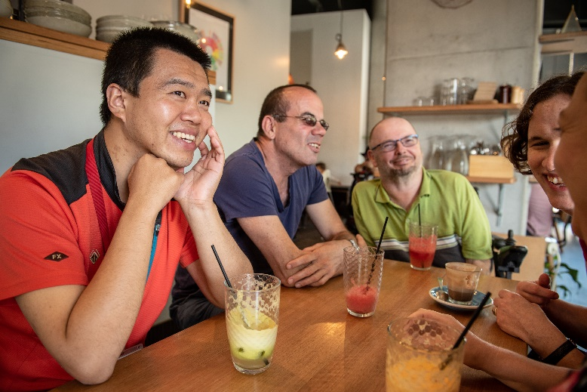
What is a peer support group?
It is a group of people who have something in common.
They meet regularly to share their experiences and support one another.
This group is for people who:
- have disability, and
- would like to share their experiences, and learn about rights or advocacy.
Why participate?
- To make new friends – share stories and have fun.
- To offer support from your own experience – to contribute.
- To get ideas from others for your own life.
- To get help with difficult challenges.
- Information about other places to get help.
What can you offer?
Your experiences and ideas are valuable.
In groups, you can use your experiences to support one another.
We want to build people’s strengths – what are you good at?
What would you like to share?
Details
We are thinking to start with a 1.5 hour meeting, followed by half an hour for lunch together. It will be free to attend, with lunch provided (if we can do it in person).
It will be on zoom, and at People With Disability Australia’s Sydney office (near Central).
It will then be up to the group to choose when, where and how often to meet.
We will talk about your ideas, topics for future meetings, your interests and issues, etc.
Interested?
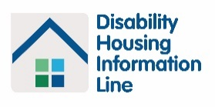
Contact Liesl on 02 9370 3100 or lieslh@pwd.org.au or register here https://bit.ly/3gLNNxs.
PEER SUPPORT GROUPS – PEOPLE WITH DISABILITY AUSTRALIA – LIESL HOMES AND ANDY YIP

