30 WAYS TO MAKE YOUR SERVICE MORE ACCESSIBLE

30 WAYS TO MAKE YOUR SERVICE MORE ACCESSIBLE
People tend to associate disability access with wheelchair ramps and bathrooms that work for everyone. But there are lots of simple, cost-effective changes your service can make while investigating larger, bricks-and-mortar solutions. Consult women with a variety of disabilities, when undertaking an accessibility audit, because they are the experts in their respective fields.

ATTITUDINAL ACCESSIBILITY
Identifying – and challenging – the unconscious bias within your organisation towards people with disability is a great place to start. Stereotypes are deeply entrenched. Just listening to what women with disability have to say about their experiences can make a huge difference.
Steps you can take to improve attitudinal accessibility are:
- Familiarise staff with the social model of disability. (Born out of the civil rights movement of the 1960s and 70s, the social model focuses on the person – and dismantling any barriers to their full participation – not on their impairment.)
- Inform staff of the obligations your organisation has towards people with disability under the UN Convention on the Rights of Persons with Disabilities (CRPD). For more information, go to:
https://www.arts.unsw.edu.au/sprc/our-projects/convention-rights-persons-disabilities.

- Include disability awareness and human rights training as part of the induction process. This training should be provided by disability services or women with disability. People With Disability Australia (PWDA) offers training packages.
- Make staff aware of the ways in which language can reinforce negative stereotypes and exclude people with disability. For more information, see PWDA’s inclusive Language Guide.
- Make asking about a reasonable adjustment plan for individual staff part of supervision agenda items, whether a staff member identifies as having a disability or not.
- Hire people with disability, and/or people who have completed disability-specific training, since they will address discrimination from within.
- Actively recruit women with disability for your working/advisory groups.
- Include women with disability in your governance body. Make inclusiveness part of your organisation’s strategic plan.
- Develop an Inclusion Action Plan (IAP) using the template in this toolkit. Allocate each specific task or responsibility in the IAP to a particular staff member to ensure IAP actions are achieved.

PHYSICAL ACCESSIBILITY
Physical access doesn’t just apply to wheelchair users. Women with vision impairment, sensory sensitivity and/or psychosocial disability, for example, also face significant barriers.
Here are some simple changes you can make to improve physical accessibility:
- Clear corridors of obstacles and clutter.
- Identify potential hazards with contrasting colours or tactile ground surface indicators (TGSI).
- Do an audit of light switches, elevator buttons, doorknobs and power points to ensure they can be easily reached by women of short stature and those who use wheelchairs.
- Make sure smoke alarms, doorbells and alarm clocks convert into flashing lights or vibrations to alert women with hearing impairments.
- Add braille or raised tactile markings to the buttons in your lift and/or install an audio system.
- Provide shower seats for women with mobility issues. Install a handheld shower head at an accessible height.
- If bench tops are too high to accommodate women of short stature and those who use a wheelchair, provide a portable stove and benchtop.
- Identify spaces for people with autism or other sensory sensitivities to retreat to, such as a quiet room, or one in which they can make noise without affecting other service users.

- Identify accessible parking spots, if you don’t already have them. Ensure they provide access to the main entrance of the building and are adequately signposted.
- Scope out a grassed area for toileting service dogs.

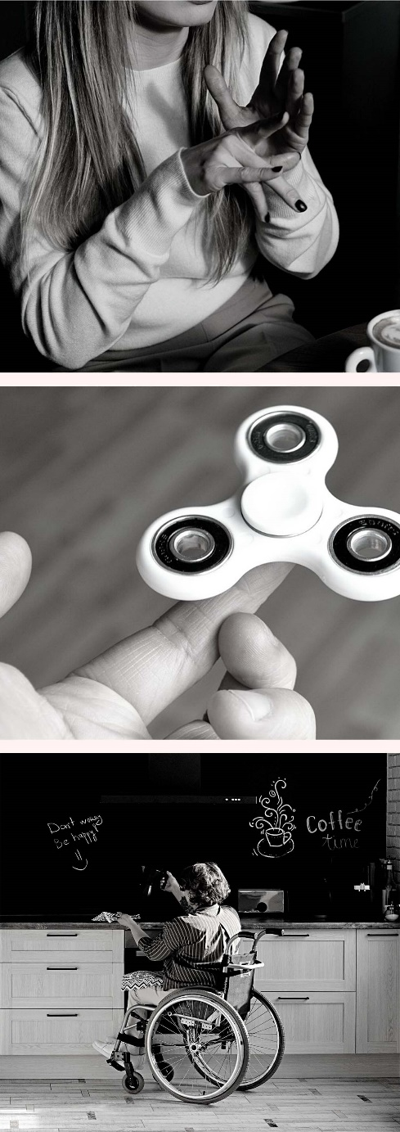
INFORMATIONAL ACCESSIBILITY
Information provided by services is not always accessible, nor communicated effectively, to women with disability. As a result, women with disability may be unaware of the services available to them.
Ways you can improve informational accessibility are:
- Convert promotional materials, such as brochures and business cards, into accessible formats, such as braille and Easy Read. Publish Word versions of documents (which can be read by assistive technologies such as screen readers) as well as PDFs.
- Distribute brochures in places that are frequented by women with disability, such as disability services, disability advocacy organisations, doctors’ offices, supermarkets, community centres, and accessible bathrooms.
- Convert intake, consent, and complaint/feedback forms into accessible formats.
- Provide assistance to women who require help in filling out forms and questionnaires. This includes support for feedback and evaluation surveys.
- Display the form for women with disability to provide feedback on your service prominently on your webpage.
- Break induction down into smaller segments to accommodate women with a learning or intellectual disability.

- Use plain sans-serif fonts (such as Verdana) in at least 12 points for all written text.
- Make sure the images on your website and the organisation’s social media posts have concise, ALT text descriptions.
- Put a link on your website to the National Relay Service and/or Translating and Interpreting Service.
- Train staff in the use of your television’s closed-captioning text.
- Train your staff in the use of assistive communication devices and technology.

