Creating an Inclusion Action Plan

Creating an Inclusion Action Plan

An IAP sets out the ways in which your organisation plans to increase its accessibility to people with disability. Women with disability are the experts in this field, so be sure to involve them closely in the development process.
Invite staff at all levels of the organisation to help you develop your IAP. Give them specific tasks to foster ownership, accountability and commitment to the changes you are making.
This template will help you identify the goals and objectives for your IAP. It also suggests how you might communicate those goals and objectives to staff and provides a framework for an ongoing review process.
The headings and dot points in this template are intended as prompts. The headings reflect areas your service needs to cover and the dot point suggest issues to address in each area.
This template is designed to be used in conjunction with Women with Disability and Domestic and Family Violence: A Guide for Policy and Practice and 30 Ways To Make Your Service More Accessible, which are also part of this toolkit. For more information, visit www.pwd.org.au or call (02) 9370 3100.
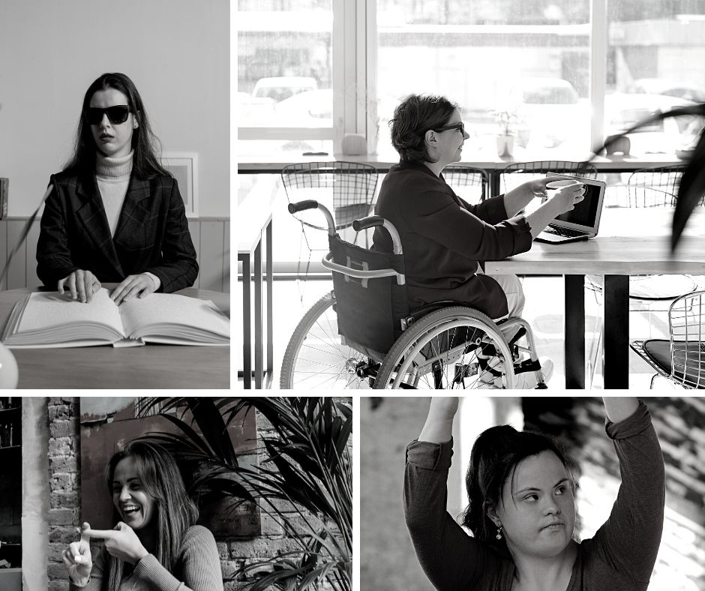

Inclusion Action Plan
[INSERT ORGANISATION’S NAME]
Aims and Objectives
- Why is it important to your organisation to be more accessible to all women, including women with disability?
- How will your service incorporate this IAP into other organisational plans such as your strategic plan?
- What are the overarching short- and long-term goals for your organisation in relation to accessibility?
- What are the priority areas covered by your IAP?
Communication
- How will you communicate your IAP to staff and women with disability? For example:
  - In your regular weekly/monthly meeting.
  - In an internal and/or external newsletter.
  - Include it as part of your disability awareness training for new staff or schedule an all-staff training day on IAP goals and targets.
- Will you publish your IAP on your website?
- Will you chart your performance in some kind of public forum? One example might be to publish monthly targets on your website and update the document when those targets have been achieved.
- How (and how often) will you communicate your progress to your board?
- How (and how often) will the implementation of goals and targets be assessed?
Implementation
- Who will be responsible for ensuring the goals and targets are implemented?
- Who will monitor their progress?
- Will the goals and targets be included in staff members’ work plans?
- How will you ensure your service is held accountable for its performance against the IAP? For example:
  - Publish a report card on your website.
  - Provide updates on your website as key actions are completed.
  - Include goals and targets in employees’ KPIs.
Evaluation
- How will the implementation of goals and targets be monitored? For example:
  - Delegate responsibility to specific staff members.
  - Disseminate a survey to staff.
  - Gather data from service users (For example, how many women with disability are using the service and what is their experience?).
- How often will you review your progress? (For example, will you formally review it annually or bi-annually?)
- How will you involve women with disability in review and evaluation processes?
- How will you ensure the IAP is up-to-date and relevant? What will this review process look like? (NB: There should be both informal and formal review processes.)
- Will you establish a grievance procedure for any complaints of disability discrimination?
- Will you establish opportunities for women with disability to provide feedback on your IAP?

The following section provides a framework to identify practical steps you can take to address physical, informational, procedural and attitudinal accessibility for women with disability.
Physical accessibility relates to the built environment and material obstacles.
Informational accessibility addresses written, visual and audio communications and a service’s promotional material.
Procedural accessibility covers an organisation’s policies and procedures – everything from governance and recruitment to intake and client rights.
Attitudinal accessibility applies to the culture of a service, including staff awareness and knowledge of disability.

1. Physical Accessibility
Objective
In this section, you should state your primary objective(s) in relation to physical accessibility. For example:
- To ensure our service is fully accessible to women who use wheelchairs within five years. To come up with interim solutions, such as shower chairs, portable stoves and benchtops, in consultation with women with disability.
- To modify our service to accommodate women with vision impairment.

Goals
You should list SMART (specific, measurable, attainable, relevant, time-based) goals to help you reach your stated objectives. For example:
- Management to purchase a shower chair, within the next three months, to enable women who use a wheelchair to access the shower.
- At the end of our lease, management will ensure the service relocates to premises that are accessible for people with physical disability.

You can use the following table to help you list your SMART goals.
Issue/ Barrier | Action Required | Who is Responsible | By When

2. Informational Accessibility
Objective
In this section, you should state your primary objective(s) in relation to informational accessibility. For example:
- To increase our ability to communicate effectively across a variety of different platforms.
- A staged upgrade of the service’s website to comply with the Web Content Accessibility Guidelines (WCAG).

Goals
You should list SMART goals to help you reach your stated objectives. For example:
- We will engage the Council for Intellectual Disability to create an Easy Read version of the service’s complaints form by December 20**, to enable women with intellectual disability to use our complaints process.
- All staff will be trained on how to book an Auslan interpreter by June 20**.
- The marketing team will update the website and promotional materials to include the service’s informational accessibility features by July 20**.

You can use the following table to help you list your SMART goals.
Issue/ Barrier | Action Required | Who is Responsible | By When

3. Procedural Accessibility
Direction/Objective
In this section, you should state your primary objective(s) in relation to procedural accessibility. For example:
- To provide women with disability with the tools they need for self-advocacy.
- To actively involve women with disability in all levels of the organisation, including governance bodies.

Goals and/or Targets
You should list SMART goals to help you reach your stated objectives. For example:
- Management will change the intake policy, within the next three months, to include a presumption that women who access our service have capacity to make decisions. Management changes to the intake policy will also specify that women will be provided with information in a format that will allow them to self-advocate.
- The Operations Manager will incorporate clearly stated references to anti-discrimination legislation into all policies within the next three months.

You can use the following table to help you list your SMART goals.
Issue/ Barrier | Action Required | Who is Responsible | By When

4. Attitudinal Accessibility
Objective
In this section, you should state your primary objective(s) in relation to attitudinal accessibility. For example:
- An “approachable” service that has earned the trust of women with disability by treating them with respect.
- Ensure women with disability are represented in all areas of our organisation, including staff, peer advisory groups, and governance bodies.

Goals
You should list SMART goals to help you reach your stated objectives. For example:
- The Training Officer will ensure all staff attend Disability Awareness delivered by PWDA by July 20**.
- Management will provide information about the Disability Discrimination Act 1992 (Cth) to all staff at the upcoming staff meeting in Dec 20**.
You can use the following table to help you list your SMART goals.

Issue/ Barrier | Action Required | Who is Responsible | By When

