13 October 2021

People with Disability Australia Ltd PO Box 666
Strawberry Hills NSW 2012

DECLARATION OF RESULTS – People with Disability Australia Ltd Board Election 2021

I am writing to you in my capacity as the duly appointed Returning Officer for the People with Disability Australia Ltd Board Election 2021.

In accordance with the rules of the People with Disability Australia Ltd, I declare the following results for the FOUR (4) contested positions as Director.

BALLOT COUNT
Postal ballot paper declarations envelopes received | 1
Informal ballot paper declarations envelopes | 0
Total formal ballot paper declaration envelopes | 1
Postal ballot papers | 1
Informal postal ballot papers | 0
Total formal postal ballot papers | 1
Total formal online ballots | 341
Total formal ballots for count | 342

POSITIONS: FOUR (4) POSITIONS AS DIRECTOR
COUNT METHOD APPLIED: MULTIPLE PREFERENTIAL
CANDIDATES | VOTES | STATUS
Samantha Connor | 314 | Elected
Kelly Cox | 336 | Elected
Clare Gibellini | 331 | Elected
Dan Graham | 320 | Elected
Richard Ouvrier | 146

I therefore declare the following persons have been elected to the FOUR (4) positions as Director:

- Samantha Connor
- Kelly Cox
- Clare Gibellini
- Dan Graham

Ref: 883-2021PWDADirector-Declaration-FINAL.docx | Page 1 of 2

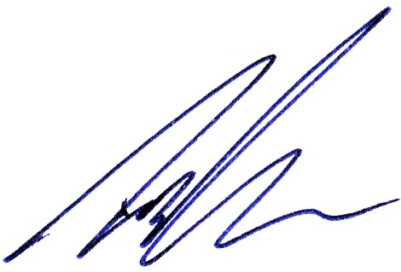
The count method and result has been audited by CorpVote Pty Ltd. Yours sincerely,

Signed: ……………………………….
Date: 13/10/2021
Timothy Jones as Returning Officer.
Signed: ……………………………….
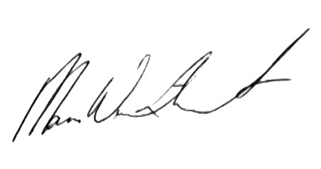
Date: 13/10/2021
Mara Winthorst as Election Administrator.

Commercial in Confidence

Ref: 883-2021PWDADirector-Declaration-FINAL.docx | Page 2 of 2

