The 2021 PWDA AGM
This year, like last year, the People with Disability Australia AGM will be conducted completely online via Zoom. This document will guide you through the process to access the AGM.
Zoom has a range of in-built accessibility features and in addition we will have both captioning and a real-time Auslan captions.
We look forward to seeing you at our virtual 2021 AGM!
Regards,
PWDA

Table of Contents
The 2021 PWDA AGM 1
Part 1 – Joining the Meeting 4
Part 2 – Inside the Meeting 6
Voting on the Motions 6
Proxy Votes 6
Raising Your Virtual Hand 7
Accessibility Guide 10
Auslan Interpreter 10
Closed Captions 10
Audio Description 11
Keyboard Navigation 11
Screen Reader Support 11
Additional Accessibility Information 11
Accessing the Meeting – FAQs 12
Can I share my audio or video during the meeting? 12
I am having issues with Zoom or I can’t access the meeting. 12

Part 1 – Joining the Meeting

Step 1
Download Zoom if you have not already done so. You can download it here.

Step 2
You can join the meeting via the methods listed below.
IMPORTANT: Please ensure you use your full name as your Zoom display name. This will allow staff to confirm you are a member:
Direct Link: https://us06web.zoom.us/j/83921963441
Click here to Join Zoom Meeting
Zoom Meeting Details: Meeting ID: 839 2196 3441
Join Via Telephone: Dial by your location
+61 8 7150 1149 Australia
+61 2 8015 6011 Australia
+61 3 7018 2005 Australia
+61 7 3185 3730 Australia
+61 8 6119 3900 Australia
Enter the meeting code: 839 2196 3441

Step 3
You will then be taken to a new page. The Zoom application should then open and take you to the meeting waiting room.
Important: You may be given a warning box that asks you to ‘Open Zoom.us?’. Select ‘Open’ or ‘Allow’. If you do not allow access the meeting will not open for you.

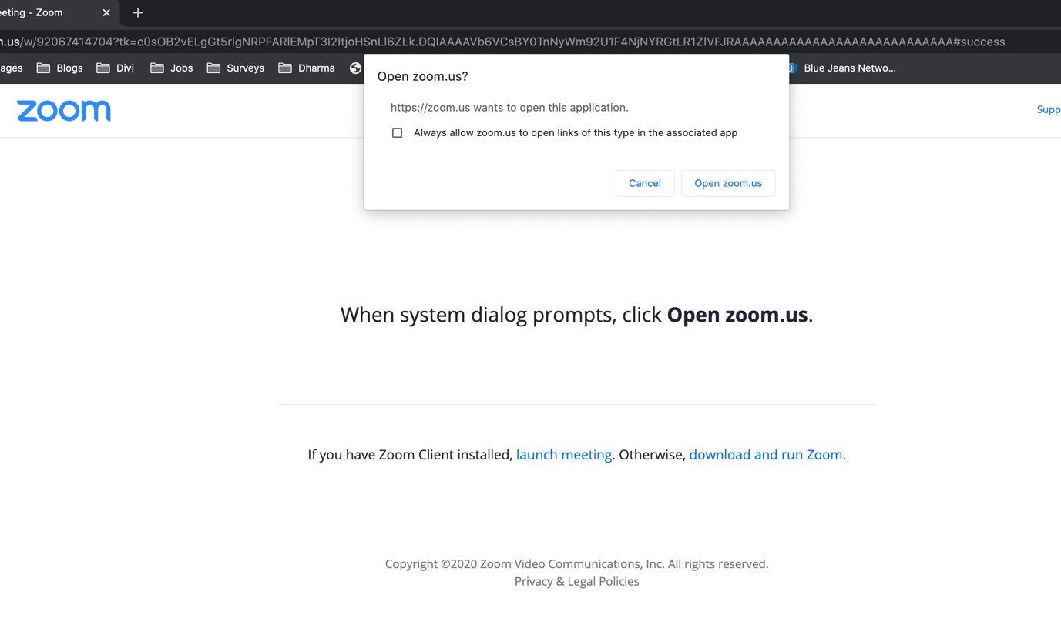
Caption: New page opened showing the ‘Open zoom.us’ box

Step 4
You will then see a message saying “Please Wait, the meeting host will let you in soon” – this is the meeting’s waiting room. Please remain there. We will then check-in each member.
If we need any further information from you, you may be taken to a breakout room for us to confirm any details.

Step 5
Once you are checked in to the meeting, Zoom will then open asking you to select an audio option.
Select “Join with Computer Audio”.
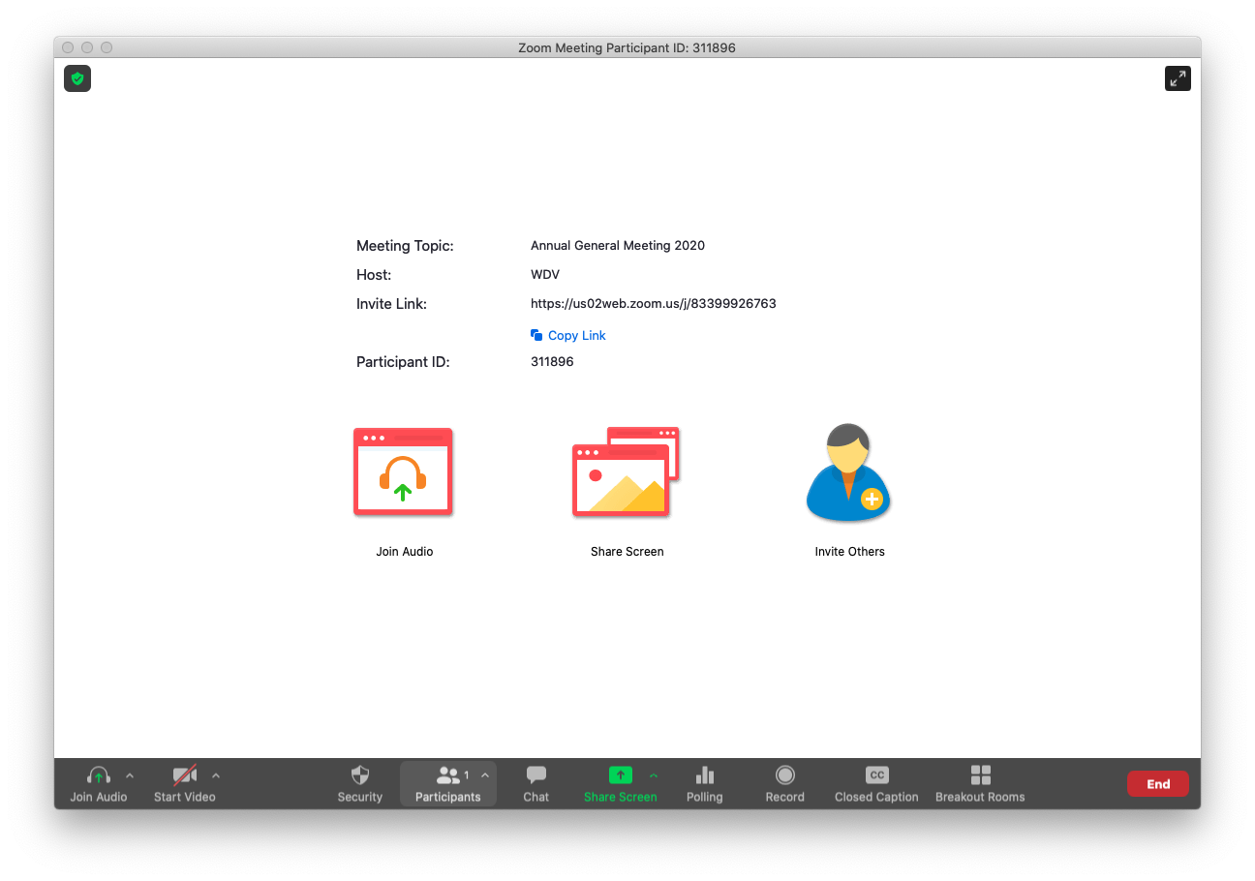
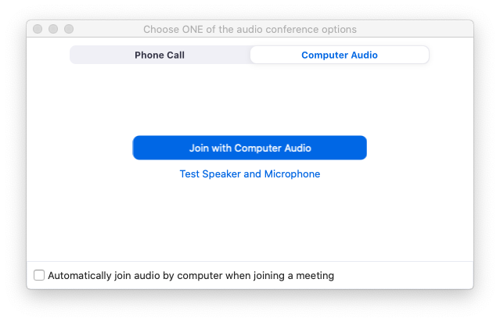
Caption: Zoom Meeting showing the audio selection options.

Step 8
You have now joined the meeting – Welcome!

Part 2 – Inside the Meeting
Once you are in the meeting you will see a series of slides with information on how the meeting with run and instructions on how to participate in the meeting. As a default, everyone’s microphone will be muted. If you are due to speak, you will be asked to unmute your video or microphone.
When the meeting starts, you will see and hear the Chairperson on the screen and any other speakers.

Voting on the Motions
When it comes time to voting on the motions put to the AGM, a window will appear for you to select your option and cast your vote. This voting function replaces the ‘show of hands’ we would ordinarily have at the AGM.
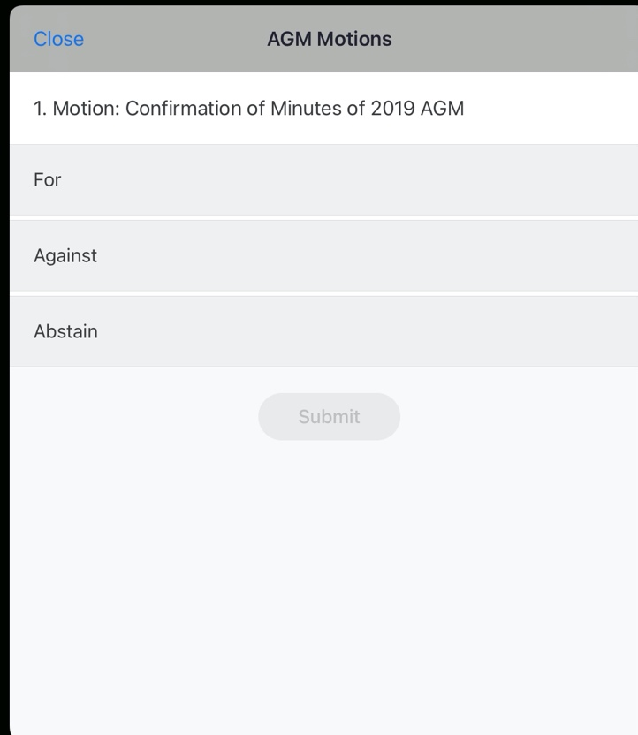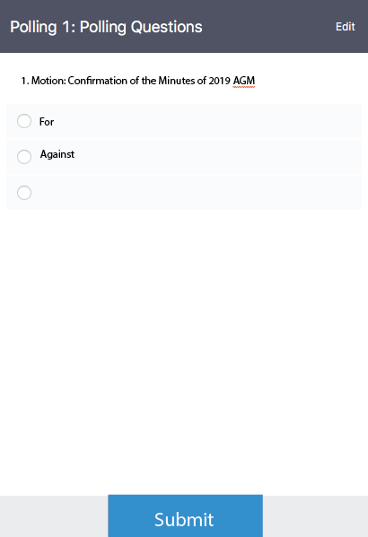
Caption: The voting windows as seen on an iPad (left) and computer (right).
Each member signed into the meeting will be able to vote once. If there are multiple members together, each will need to be signed into the meeting on a separate computer or device.

Proxy Votes
If you have appointed a proxy and indicated the way you wish this proxy to exercise your vote, then this will be automatically tallied. If you have been appointed as a proxy in the meeting for another member for this proxy, you do not have to do anything except vote yourself.
If you have appointed a proxy you can still join the meeting and vote, however your proxy vote will then not be counted.

Raising Your Virtual Hand
At times during the meeting you may be asked to raise your virtual hand to indicate you wish to speak or to support or second a motion. How you raise your hand may differ depending on whether you are using a computer, tablet or other device.

On Computer
During the meeting, click on the icon labelled "Participants" at the bottom centre or top of your screen. At the bottom of the window on the right side of the screen, click the button labelled "Raise Hand." Your digital hand is now raised.
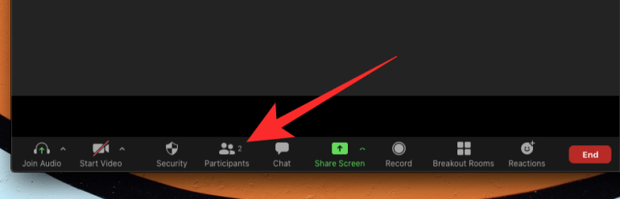
Caption: The Participants button on the bottom or top of your screen

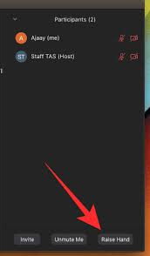
Caption: The Raise Hand button will appear when you select ‘participants’

On Mobile
- In the Zoom toolbar, select Show Participants
- Select ‘More’
- Then select ‘Raise Hand’
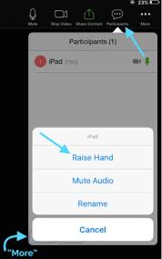

Other Devices
If you are using any other device, you can view the Zoom Help and follow the instructions on how to raise your hand.

Accessibility Guide
We are using the Zoom meeting platform which is compliant with WCAG 2.1, and as such has inbuilt support for keyboard navigation, screen readers and other technology.
We will also have an Auslan Interpreter and Live Captioning provided. We will also be providing audio description for any video or slides on the screen.

Auslan Interpreter
The Auslan interpreter will be on the screen during the entire meeting. If you require the Auslan interpreter, you may also wish to pin their video
For participants who wish to have the Auslan interpreter on their screen, at the top of the screen you should see the video of the interpreter. If you do not, select ‘Gallery View’ to expand the number of videos shown.
Once you have found the interpreter’s video, select the three dots next to the video and select ‘Pin Video’.
The display may look different depending on if you are using a Windows or Mac computer. Please view the Zoom article on pinning a video for more information on how to pin a video based on the computer you are using.

Closed Captions
We also have live captions available. To access the closed captions, select the ‘Closed Caption’ button at the bottom or top of the screen.
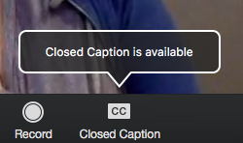
Caption: The Closed Caption button to turn on captions in the meeting

Audio Description
At times there may be multimedia or holding slides providing overview or information. We will be providing audio description to convey the information. The description will be the main audio coming through the meeting, so you will not have to enable it, just ensure your speakers are not muted.
In situations where a visual is required to be shown on the screen by a speaker, the speaker will provide a description at the start.

Keyboard Navigation
Zoom supports Keyboard Shortcuts for easy navigation of Zoom and its platform.
You can view the Zoom article on Hot Keys and Keyboard Shortcuts, for a full list.

Screen Reader Support
Zoom follow the latest accessibility standards to ensure that the product is fully accessible to the latest screen readers.

Additional Accessibility Information
Zoom has created a set of FAQs about accessibility features including:
- Important accessibility keyboard commands for keyboard users
- High contrast support
- Larger font settings
If you have any accessibility requirements that are not covered in the guide below, please contact us prior to the meeting.

Accessing the Meeting – FAQs

Can I share my audio or video during the meeting?
Everyone but the host of the meeting and the active speakers will have their audio muted. Your video may also be turned off.
If you are scheduled to speak in the meeting or are called on in the meeting then you will have your audio and video unmuted. If this happens you will receive a request inside Zoom.

I am having issues with Zoom or I can’t access the meeting.
We have PWDA staff who are available to provide some basic guidance and assist you if you are having trouble connecting to the meeting.
You can contact: AGM Tech Support
Email: pwd@pwd.org.au
If you are in Zoom and have a question about using Zoom, you can select ‘Chat’ and in the drop down box, select ‘PWDA Support and Chat’ and send a message.

