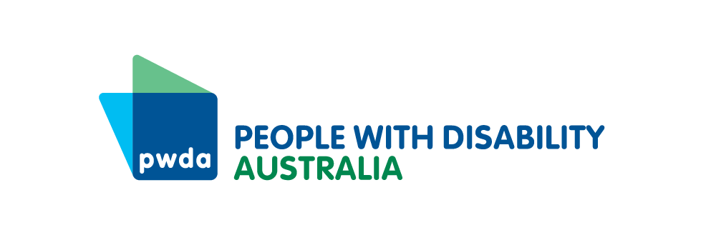
Date updated: February 2022
Contact Person: Giancarlo de Vera
Phone: +61 2 9370 3100

Design disability employment service programs that focus on us
People with Disability Australia's position on a disability employment services and new models for DES programs like NDESM
People with disability need meaningful support into employment with employment services programs they can opt into. Any new model for disability employment services, like the New Disability Employment Support Model (NDESM) proposed in 2021 and 2022, must be optional and available to all people with disability.
People with Disability Australia (PWDA) does not support in conditionality for social security payments, such as compulsory Disability Employment Services (DES), jobactive or the ParentsNext participation requirements for people with disability.
The existing failures of the DES model must not be repeated in NDESM. We believe any new program should understand and respond to our real needs by centring and heavily weighting the expertise, views and experiences of people using employment services when designing programs and monitoring program quality and outcomes.
We believe in moving to a desegregated employment services model that incorporates a range of specialist providers that tailor supports based on specific disabilities and gives people with disability full choice and control over their provider.

About PWDA
PWDA is a national disability rights and advocacy organisation made up of, and led by, people with disability. We are a peak, not-for-profit non-government organisation that represents the interests of people with all kinds of disability. We have a vision of a socially just, accessible and inclusive community in which the human rights and freedoms of all people with disability are recognised, respected and celebrated.

Contact person
Giancarlo de Vera
Senior Manager Policy
+61 413 135 731
policy@pwd.org.au

