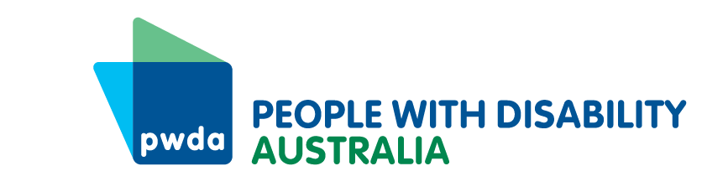
PO Box 666
Strawberry Hills
NSW 2012
+61 2 9370 3100
pwd@pwd.org.au
www.pwd.org.au

28 February 2022

The Hon. Kevin Andrews MP
Chair
Joint Standing Committee on the National Disability Insurance Scheme
PO Box 610
Parliament House
Canberra ACT 2600

Via email at ndis.sen@aph.gov.au
Dear Mr Andrews

Joint Standing Committee on the NDIS inquiry into current scheme implementation and forecasting
People with Disability Australia (PWDA) welcomes the opportunity to provide this submission to the Joint Standing Committee on the NDIS inquiry into current scheme implementation and forecasting.
This submission represents the interests and views of PWDA's members and supporters and has been written by our systemic policy and advocacy team in consultation with our individual advocates.
If you wish to discuss the content of our submission further, please contact my Senior Manager of Policy, Giancarlo de Vera, at giancarlod@pwd.org.au or on 0413 135 731.
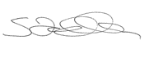
Yours sincerely

Sebastian Zagarella
Chief Executive Officer
People with Disability Australia

