People with disability in NSW have a right to live in the community and participate fully in economic, social and cultural life. Currently, people with disability are excluded from access to secure, accessible, affordable housing, transport, and employment opportunities. The NSW Government can change this.

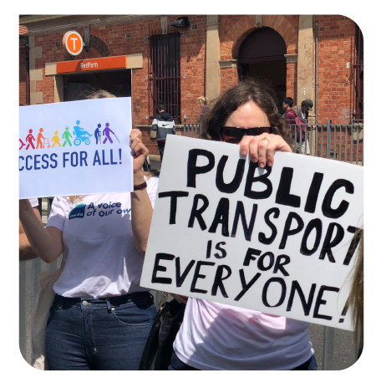What people with disability are facing now
People with disability are in need of more accessible and affordable housing in NSW. 17% of us live in poverty, and because demand for social housing outstrips supply, we are compelled to rent privately or become homeless. We then face discrimination and a shortage of accessible properties. Affordable private housing is poorly located outside metropolitan areas, with limited accessible public transport, local services and employment opportunities.
Institutional housing options, such as group homes, cluster housing and large residential centres, remain and do not provide genuine community living for people with disability. Some of us with psychosocial disability face homelessness or are forced to remain in acute hospital settings rather than in the community. Our choice and control is limited when disability support services are tied to accommodation service providers.
The built environment is often inaccessible, and prevents people with disability from being part of the community. Footpaths are poorly designed and in outer-metropolitan areas are often non-existent. Essential services such as doctors and dentists are located within inaccessible premises. Accessible toilets are not available in many public venues, meaning we simply cannot use them.
Accessible and affordable public and community transport remains a barrier for people with disability in NSW. Many buses are inaccessible, the majority of train stations do not have lifts, and mobility parking spaces are unavailable. Those of us living in remote, rural and regional NSW are often isolated and cannot access essential services due to the lack of public and community transport.
People with disability make up only 2.5% of the NSW public sector workforce, even though we are 20% of the population. This decrease from 6% in 2000 reflects poorly on policy commitments and strategies to improve employment outcomes for people with disability. As the largest employer in the state, the NSW Government should be increasing and retaining employment of people with disability, to reflect and draw on the skills of our diverse community.

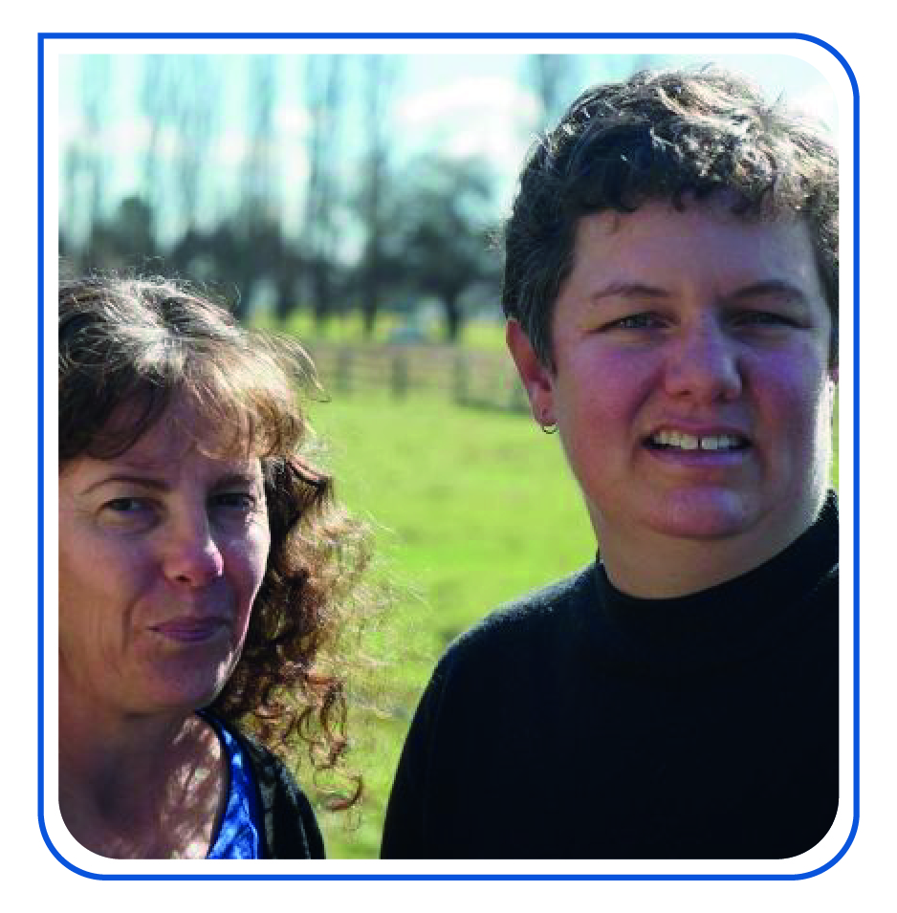What the NSW Government can do to make a difference
Implement a comprehensive Social and Affordable Housing Strategy. This strategy needs to be developed to reduce homelessness, improve access to social, public and affordable housing for groups at risk of housing stress and homelessness, including people with disability. The strategy must be resourced to deliver at least 5,000 new social housing dwellings and 9,000 affordable rental dwellings per year.
Deliver the universal housing design targets agreed to in the National Disability Strategy (NDS) by 2020. The NDS sets a goal of achieving universal design in all new housing stock as a priority action across all levels of government. Minimum access requirements, in line with Livable Housing Australia’s Design Guidelines Gold Level, should be introduced immediately in NSW for all new and extensively modified housing.
Deliver individualised community housing arrangements, with legislated rights, for people with disability. Remaining large residential centres, group homes and other congregate accommodation must be closed, and people who currently live in these institutions, supported to transition to living in the community. Those of us in supported accommodation, including Specialist Disability Accommodation, must be able to access our tenancy rights. These rights must be legislated and ensure that we have the choice to live where and with whom we want.
Invest in an accelerated program to make transport in NSW accessible for all people with disability, with full resourcing and cross-government coordination. This should include a plan to comply with NSW’s obligations to the National Access to Public Transport Standards, and be in line with the Government’s commitment to the whole of journey guide.
Implement a whole-of-government disability employment strategy that increases the number people with disability employed at all levels of the public service. The strategy must contain accountability measures, such as building outcomes into performance measures for public sector executives and introducing innovative training and internship programs. The strategy should also include procurement practices that preference suppliers who meet targets for diversity in the workplace and who demonstrate best practice in the employment of people with disability in the open market.

For more information please contact:
Dean Price, Senior Policy Officer
0413 135 731 deanp@pwd.org.au @DeanPWDA

Davidson, P., Saunders, P., Bradbury, B. and Wong, M. (2018), Poverty in Australia, 2018. ACOSS/UNSW Poverty and Inequality Partnership Report No. 2, Sydney: ACOSS.
Distrupted: The consumer experience of renting in Australia, CHOICE, National Shelter and NATO, 2018 http://www.choice.com.au/disrupted
State of the NSW Public Sector Report 2018, NSW Public Service Commission http://www.psc.nsw.gov.au/sopsr/2018
Office of the Director of Equal Opportunity in Public Employment (2001), Advancing Equity: Report to the Premier by the Director of Equal Opportunity in Public Employment for 2001, NSW Government, Sydney, 2001

