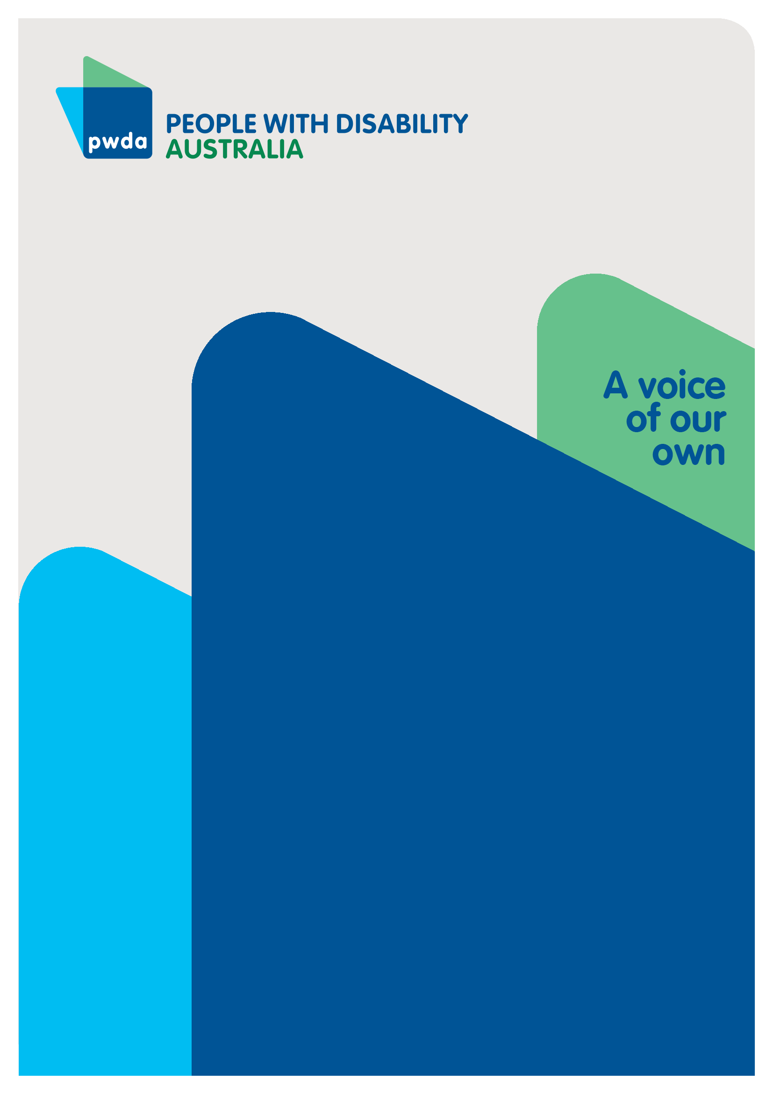
Our lives, our decisions
Submission to the Disability Royal Commission’s Public Hearing 30 on guardianship, substituted and supported decision-making

NOV
2022

Copyright information
Our lives, our decisions: Submission to the Disability Royal Commission’s Public Hearing 30 on guardianship, substituted and supported decision-making.

First published in 2022 by People with Disability Australia Ltd.
Level 8, 418a Elizabeth Street, Surry Hills, New South Wales, Australia 2010
Head office also in Sydney
Email: pwda@pwd.org.au
Phone: +61 2 9370 3100 Fax: +61 2 9318 1372
URL: www.pwd.org.au

Typeset in Arial 12 and 14 pt and VAG Rounded 18 and 26 pt

© People with Disability Australia Ltd. 2021

The moral rights of the authors have been asserted

National Library of Australia Cataloguing-in-Publication data:

Creator(s): | Lisa Ira and Michelle Keogh
Title: | Our lives, our decisions: Submission to the Disability Royal Commission’s Public Hearing 30 on guardianship, substituted and supported decision-making

All rights reserved. Except as permitted with the Australian Copyright Act 1968 (for example, a fair dealing for the purposes of study, research, criticism or review), no part of this book may be reproduced, stored in a retrieval system, communication or transmitted in any form or by any means without prior written permission. All inquiries should be made to the publisher at the address above.

Ira, L. and Keogh, M., Our Lives, our decisions: Submission to the Disability Royal Commission’s Public Hearing 30 on guardianship, substituted and supported decision making, 17 November 2022, People with Disability Australia, Sydney

ISBN 978-0-6454251-2-3

About PWDA
People with Disability Australia (PWDA) is a leading disability rights, advocacy, and representative organisation of and for all people with disability. We are the only national, cross-disability organisation - we represent the interests of people with all kinds of disability.

We are a non-profit, non-Government organisation. We help individuals by advocating for their interests, and groups through our systemic advocacy efforts. We also encourage people to engage in self-advocacy.

PWDA’s primary membership is made up of people with disability and organisations primarily constituted by people with disability. PWDA also has a large associate membership of other individuals and organisations committed to the disability rights movement. We employ many people with disability.

We have a vision of a socially just, accessible, and inclusive community, in which the human rights, citizenship, contribution, potential and diversity of all people with disability are recognised, respected and celebrated.

PWDA is committed to human rights and believes human rights are for everyone, regardless of race, religion, ethnicity, indigeneity, disability, age, displacement, caste, gender, gender identity, sexuality, sexual orientation, poverty, class or socio-economic status.

Our organisation was founded in 1981, the International Year of Disabled Persons, to provide people with disability with a voice of our own.

PWDA is a New South Wales and national peak organisation and founding member of Disabled People’s Organisations Australia (DPO Australia) along with Women With Disabilities Australia, First Peoples Disability Network Australia, and National Ethnic Disability Alliance. DPOs are organisations that are led by, and constituted of, people with disability.

We are a DPO and work as a disabled people’s representative organisation, representing the interests of our members.

Table of Contents
About PWDA iii
Introduction v
Submission overview vi
Summary of Recommendations 7
Short-term recommendations to address issues in the current guardianship regimes 7
Recommendations to support the replacement of Australia’s current substitute decision-making regimes with a national supported decision-making framework 10
Part 1: The current guardianship regimes 11
Lack of opportunities to use supported decision-making 11
Guardianship applications 13
The conduct of Public Guardians 18
Dignity of risk 21
Capacity building 22
Part 2 – A national supported decision-making framework 25
A CRPD compliant supported decision-making regime 26
Conclusion 29

Introduction
People with Disability Australia (PWDA) welcomes the opportunity to provide this submission to the Royal Commission into Violence, Abuse, Neglect and Exploitation of People with Disability (the Disability Royal Commission) in respect to Public Hearing No. 30: Guardianship, Substituted and Supported Decision-Making.
Our submission is based on the experiences of PWDA’s individual advocacy clients, as well as systemic issues identified by PWDA’s individual advocates. Our individual advocates have extensive experience working with people subject to guardianship, administration and financial management orders in New South Wales and Queensland.
PWDA advocates have supported clients through issues arising while under guardianship, administrative and financial management orders and, in some instances, assisted clients in having these orders removed.
This submission also reflects the experiences and views of PWDA’s Board members who are people with disability with extensive involvement and experience in the disability rights sector.
In this submission, the term ‘guardianship’ will be used to describe guardianship, administration and financial management arrangements for ease of reference.

Submission overview
This submission is divided into two parts. Part 1 examines current issues with Australia’s existing guardianship regimes. This includes:
- The lack of supported decision-making options
- Urgent guardianship applications being decided without the presence of the person with disability
- Guardianship orders being sought as a tool of convenience and control
- People with disability not being able to choose their guardian
- Guardians not following the person with disability’s will and preference
- Guardians not allowing people with disability to have dignity of risk; and
- The lack of focus on building people with disability’s decision-making capacity.
We believe these issues can only be fully addressed by replacing Australia’s current guardianship regimes with a national supported decision-making framework, which will be explained in Part 2.
However, developing and implementing such a scheme will be a lengthy process and urgent changes to the current regimes are needed to prevent harm. As such, Part 1 of this submission provides shorter term recommendations to improve the current guardianship regimes.
As noted above, Part 2 of this submission contains our key recommendation for the replacement of Australia’s current substitute decision-making regime with a national supported decision-making framework, outlining key features of a framework compliant with the Convention on the Rights of Persons with Disabilities (CRPD). Part 2 also identifies the need for a co-designed inquiry to determine how such a scheme could be developed and operate effectively in an Australian context.

Summary of Recommendations

Short-term recommendations to address issues in the current guardianship regimes

Recommendation 1: The Australian Government prioritises funding for further supported decision-making projects across a range of public and private settings. This should include funding for education and awareness campaigns for people with disability, their families, friends, supporters, and professionals, such as allied health staff, to raise awareness of the right to access decision making support, the benefits of such support, and where and how supported decision-making services can be accessed.

Recommendation 2: The Government establishes a specific program of funding to enable independent individual advocates to provide supported decision-making services to people with disability, while further investigation of a national supported decision-making framework takes place. The program should also include training of independent individual advocates to equip them with the skills needed to act as supported decision-makers.
The new funding should sit alongside the existing National Disability Advocacy Program model as a separate funding stream to allow for flexibility and responsiveness.

Recommendation 3: That particular priority is placed on embedding supported decision-making in hospital settings, through independent advocacy or otherwise, to assist people with disability to understand and make fully informed medical decisions. This role must not be undertaken by the person applying for guardianship.

Recommendation 4: State and territory guardianship tribunals amend their practice directions and/or other relevant policy documents to require that all hearings, including urgent hearings, be held with the presence of the person with disability and their support persons, either in-person or through an agreed accessible format such as via telephone or videoconference. The practice directions and/or other policy documents should require that people with disability are given every opportunity to understand the decisions being made at the hearing and to communicate their will and preferences, with all necessary communication supports provided, such as captioning and/or Auslan interpreters.

Recommendation 5: State and territory guardianship tribunals work with local hospitals to ensure that accessible on-site guardianship hearings can occur. Where this is not possible, accessible teleconference and videoconference facilities must be available to enable people with disabilities to attend guardianship hearings.

Recommendation 6: Examine why some guardianship orders are being made prematurely in hospital settings before the person has been given ample time to recover. This should involve examining any pressures that are coming from hospital staff to expedite guardianship orders to make more hospital beds available.

Recommendation 7: The Government commences an education awareness campaign targeting hospital staff, support coordinators, tribunal members and other professional who may be in positions of applying for, supporting, or approving orders, to address the issue of premature guardianship orders and to highlight that this practice constitutes a breach of the person with disability’s human rights.

Recommendation 8: State and territory governments reform guardianship legislation and/or policy documents to give primacy to the person with disability’s choice of guardian, subject to safeguards. Safeguards should include identifying undue influence and conflict of interest and assessing whether the chosen person is capable and willing to follow the person with disability’s will and preferences when making decisions.

Recommendation 9: States and territories should amend their guardianship legislation to require guardians to follow the person with disability’s will and preferences, unless this would result in significant harm to the person with disability, taking into account dignity of risk.

Recommendation 10: Public guardianship bodies be staffed by people with disability and people with contemporary knowledge of disability rights. All staff members should receive training on the human rights model of disability, supported decision-making, dignity of risk, and how to ascertain and follow the will and preferences of people with disability.

Recommendation 11: Guardianship bodies should ensure staff have time and are encouraged to establish a relationship with people under guardianship and administration orders to understand their will and preferences.

Recommendation 12: Make enquiries into the extent to which Offices of the Public Guardian, Public Trustees and any other public guardianship bodies are experiencing a high turnover of staff and what could be done to address this issue so people with disability work with someone who they have built rapport with and who understands their will and preference.

Recommendation 13: All people with disability under guardianship, administration or financial management orders should automatically be connected to decision-making capacity building services provided independently of service providers to avoid any potential conflict of interest.

Recommendation 14: Staff of public guardianship bodies should receive training and develop skills to assist their clients to build and practice decision-making capacity even after orders have been made.

Recommendation 15: Guidance be developed to ensure that NDIA planners, Local Area Coordinators and Early Childhood Early Intervention Partners consider upon entry, and at each plan review meeting, whether participants require supports to develop their decision-making capacity, regardless of whether they are subject to guardianship orders. This should include a discussion with participants to help them to identify the skills they need to build.

Recommendation 16: The Government should assist to develop and fund supports for decision-making capacity building, child and young person-specific supported decision-making services, and independent advocacy services specifically designed for children and young people with disability.

Recommendation 17: State and Territory governments ensure that aftercare planning should commence well in advance of the end of child protection care orders and to include decision-making skill development and capacity building from a young age, as an alternative to the ‘polished pathway’ of children and young people with disability being subject to guardianship orders when exiting the child protection system.

Recommendation 18: Consider how the Information, Linkages and Capacity Building program could be used to fund programs and services that build children, adolescents and adult people with disability’s decision-making skills.

Recommendations to support the replacement of Australia’s current substitute decision-making regimes with a national supported decision-making framework

Recommendation 19: Australia adopts a national supported decision-making model that is fully compliant with the CRPD and other international human rights treaties and follows the Australian Law Reform Commission’s proposed National Decision-Making Principles outlined in its 2014 Equality, Capacity and Disability in Commonwealth Laws report.

Recommendation 20: The Attorney-General of Australia refers an inquiry to the Australian Law Reform Commission regarding the establishment of a supported decision-making framework in Commonwealth, state and territory jurisdictions. The inquiry should be co-designed by and co-delivered with people with disability and should examine how best to develop and implement a supported decision-making framework that complies with the CRPD.

Part 1: The current guardianship regimes
This section will outline the key issues with Australia’s current guardianship regimes and provide short-term recommendations for how these could be addressed while working towards a national supported decision-making framework.

Lack of opportunities to use supported decision-making
Article 12(3) of the United Nations Convention of the Rights of Persons with Disabilities (CRPD) requires that States Parties provide people with disability access to the support that they may require to exercise their legal capacity.
The CRPD Committee’s General Comment No.1 explains that ‘support’ includes both informal and formal support arrangements. Examples include a formal support people to assist people with disability to make decisions, peer support and communication assistance.
Unfortunately, supported decision-making is not widely available, publicised or funded in Australia. As a result, many people with disability, their support network and health professionals are often unaware that it exists as an alternative to guardianship. PWDA’s individual advocates report that in some cases people with disability seek guardianship without any consideration of less restrictive supported decision-making options.
Case Study 1 – Sandra*
Sandra has an acquired brain injury and learning disability. She relies on a relative to read her letters and help her to communicate her needs. Her independent advocate and her support coordinator are concerned that the relative is financially exploiting her. Sandra has been financially exploited by other people, including a ‘friendly stranger’ who asked her to sign a contract for a financial product that resulted in her accruing a significant debt.
Sandra has no recollection of signing the contract or an understanding of what it was about. Another person in Sandra’s life has also been advising her to make certain financial and lifestyle decisions and she finds it hard to stand up to them.
Concerned about financial exploitation, Sandra spoke to a financial advisor, but did not understand their information or advice. Sandra’s support coordinator suggested that Sandra applies for a financial management order to prevent other people from accessing her finances. Sandra has decided to proceed with the financial management order application, and her support coordinator is supporting Sandra with the application.
*Name has been changed to protect confidentiality
We commend the Government for funding several supported decision-making pilot programs, such as the New South Wales Council for Intellectual Disability’s My Right to Decide training for people with disability, their families and support workers. The Government should prioritise further funding and evaluation of these programs.
In the short term, these programs will provide people with disability more opportunity to enjoy and exercise their right to legal capacity. At the same time, conducting and evaluating these programs will grow the local evidence base for designing a national supported decision-making framework.
Accordingly, we urge the Disability Royal Commission to recommend that:
Recommendation 1: The Australian Government prioritises funding for further supported decision-making projects across a range of public and private settings. This should include funding for education and awareness campaigns for people with disability, their families, friends, supporters, and professionals, such as allied health staff, to raise awareness of the right to access decision making support, the benefits of such support, and where and how supported decision-making services can be accessed.
While work is being undertaken to determine the most effective structure for the provision of informal and formal decision-making support as part of a new supported decision-making framework, we believe independent individual advocates are well placed to act as independent decision supporters. This would also allow time to develop a workforce strategy and service design model for formal decision support.
Providing additional funding to individual advocacy services for supported decision-making would also have the benefit of using existing service structures and could expand an existing workforce that is experienced in providing independent support to people with disability, respecting will and preference, and free from the types of perceived or real conflicts of interest that may exist if decision-making supports are provided by service providers who stand to benefit from a particular decision.
We urge the Disability Royal Commission to recommend that:
Recommendation 2: The Government establishes a specific program of funding to enable independent individual advocates to provide supported decision-making services to people with disability, while further investigation of a national supported decision-making framework takes place. The program should also include training of independent individual advocates to equip them with the skills needed to act as supported decision-makers.
The new funding should sit alongside the existing National Disability Advocacy Program model as a separate funding stream to allow for flexibility and responsiveness.

Guardianship applications
Due to the lack of a supported decision-making framework in Australia, guardianship is commonly viewed as the only viable option for people who require support to make decisions.
Article 12(4) of the CRPD requires that measures relating to the exercise of legal capacity respect the rights, will and preferences of the person with disability. Unfortunately, guardianship applications, hearings and orders often do not accord with the person with disability’s will and preferences. PWDA advocates report that:
- Urgent guardianship hearings are taking place without the involvement or presence of the person with disability
- Guardianship applications are being used by third parties as a means of coercion and control; and
- People with disability are not automatically given the right to choose their guardian.

Urgent guardianship hearings
Our advocates report that in hospital settings, ‘urgent’ guardianship hearings are often conducted without the presence or involvement of the person with disability. These applications are commonly made by hospital social workers, with little information provided to the person with disability and their families prior to the hearing. As one advocate noted:
“… patients and families feel very judged and isolated not knowing their rights and suddenly dealing with a very overwhelming system.”
People with disability are not given the opportunity to identify supported decision-making options or choose who their guardian should be. Our advocates report that in some cases guardianship orders have been made when there were appropriate support people available. Clients have then had to go through the difficult process of having these orders revoked.
We urge the Disability Royal Commission to recommend:
Recommendation 3: That particular priority is placed on embedding supported decision-making in hospital settings, through independent advocacy or otherwise, to assist people with disability to understand and make fully informed medical decisions. This role must not be undertaken by the person applying for guardianship.
Recommendation 4: State and territory guardianship tribunals amend their practice directions and/or other relevant policy documents to require that all hearings, including urgent hearings, be held with the presence of the person with disability and their support persons, either in-person or through an agreed accessible format such as via telephone or videoconference. The practice directions and/or other policy documents should require that people with disability are given every opportunity to understand the decisions being made at the hearing and to communicate their will and preferences, with all necessary communication supports provided, such as captioning and/or Auslan interpreters.
Recommendation 5: State and territory guardianship tribunals work with local hospitals to ensure that accessible on-site guardianship hearings can occur. Where this is not possible, accessible teleconference and videoconference facilities must be available to enable people with disabilities to attend guardianship hearings.
Our advocates have also reported that hearings conducted for hospitalised people can be problematic when orders are made prematurely. Clients who regain capacity shortly after the order has been made have to go through a taxing process to have orders removed.
Case Study 2 – Amit*
Amit had a stroke and spent three months at a rehabilitation unit. The hospital social worker applied for the Public Trustee to be appointed to manage his financial affairs. Amit signed the paperwork, but it is not clear whether he fully understood the implications of this at the time.

Upon release from hospital, Amit was moved into an aged care facility. His possessions, including the van he used to live and travel in, were sold. While Amit agreed to the sale, he felt it could have been sold for a higher price. Without the campervan, Amit had no alternative accommodation options to the aged care home.

Amit began to recover while staying in the aged care facility and has regained a lot of his decision-making abilities. Amit does not like living in the aged care facility where he feels isolated and spends most of his time in his room. He also only has access to the aged care facilities’ health professionals, and they support the Public Trustee.

Amit asked PWDA to assist him to apply for revocation of the administration order. The tribunal member said he must provide a geriatrician’s cognitive assessment report before considering revoking the order. Amit and his advocate have attempted to obtain the report, but this has been unsuccessful due to the limited number of geriatricians working in his area as well as the cost of obtaining the assessment and report.

As a result, Amit is trapped in his administration order.

The PWDA advocate asked the tribunal if a neuropsychologist report could be used instead, but this was declined due to directions stating that the report must be completed by a geriatrician.

*Name has been changed to protect confidentiality

We encourage the Disability Royal Commission to:
Recommendation 6: Examine why some guardianship orders are being made prematurely in hospital settings before the person has been given ample time to recover. This should involve examining any pressures that are coming from hospital staff to expedite guardianship orders to make more hospital beds available.

Misuse of guardianship applications
We are concerned about the misuse of guardianship applications in several areas. Our advocates report that guardianship applications are sometimes made by hospital social workers to deal with conflicting views from the person with disability and other people in their lives. One of our advocates reported that:
“Some families are scared to even show any discord between themselves, or challenge staff because they fear that their loved one will be placed under guardianship or the Public Trustee.”
This issue also arises in the NDIS, with another advocate reporting that:
“Support coordinators may take a similar tact if the person fails to ‘kowtow’ to their directions. It’s all about control and convenience.”
PWDA’s Individual Advocates also report situations where guardianship is being used to ensure adult children do not have to vote in elections. However, with support to understand their voting options, many of these adults may have voted.
Clearly, these guardianship applications are not being made in accordance with the rights will and preferences of the person with disability.
We urge the Disability Royal Commission to recommend that:
Recommendation 7: The Government commences an education awareness campaign targeting hospital staff, support coordinators, tribunal members and other professional who may be in positions of applying for, supporting, or approving orders, to address the issue of premature guardianship orders and to highlight that this practice constitutes a breach of the person with disability’s human rights.

Choice of guardian
Current guardianship regimes, including those in hospital settings, that do not grant the person with disability the right to choose their guardian leave wide scope for abuse. Some people seek to be appointed as a person’s guardian for financial gain and/or to have control over a person’s life.
The following case study illustrates how not honouring the person with disability’s choice of guardian can lead to relatives and public guardianship bodies unnecessarily interfering in the person’s lives:
Case Study 3 – Lucinda*
Lucinda voluntarily appointed her husband as enduring guardian. However, after a serious accident her relatives successfully applied for guardianship and financial management orders. The orders were used to place the client in aged care, restrict the time the client could see her husband and generally interfere in the couple’s lives. As a result, Lucinda experienced significant emotional distress and mental health issues. Our advocate was appointed to try to revoke the orders and reinstate the enduring guardian appointment. The guardianship and financial management orders were gradually eroded; however, disputes continue to arise as the aged care facility and guardianship/financial management authorities interfere in the couple’s lives.
*Name has been changed to protect confidentiality.
To ensure tribunal members give effect to the person with disability’s will and preferences in selecting a guardian, we urge the Disability Royal Commission to recommend that:
Recommendation 8: State and territory governments reform guardianship legislation and/or policy documents to give primacy to the person with disability’s choice of guardian, subject to safeguards. Safeguards should include identifying undue influence and conflict of interest and assessing whether the chosen person is capable and willing to follow the person with disability’s will and preferences when making decisions.

The conduct of Public Guardians
The lack of focus on the person with disability’s will and preferences also extends to the conduct of Public Guardians once guardianship orders commence.
PWDA’s individual advocates report experiencing many situations where Public Guardians do not use supported decision-making and do not follow a person with disability’s will and preferences.
This is demonstrated in the case studies below and breaches Article 12(4) of the CRPD, which requires that decisions made on behalf of an individual should be based on the person’s will and preferences, rather than their ‘best interests’.
As the following case study demonstrates, failure to follow the person with disability’s will and preferences can lead to harmful decisions and loss of autonomy and control:
Case Study 4 – Margie*
Margie was placed under the Office of the Public Guardian (OPG) and Public Trustee (PT) in a large Australian state. She spent six months in hospital waiting for suitable accommodation to be organised. An OPG guardian visited her in hospital two months after she was admitted. Margie also accumulated a long stay hospital debt.
Margie was not given a choice of accommodation providers when arrangements were made following the hospital stay. Margie said that she did not feel safe where she was living. The OPG did not initially respond to her pleas to move accommodation providers, but eventually found her a new accommodation provider. Margie continues to feel frustrated with the OPG and PT regarding the lack of communication, lack of supported decision making and constant staff changes.
Margie asked for more stakeholder meetings, but these were not forthcoming. Margie said she wanted regular stakeholder meetings to express her goals and concerns in a safe environment. She feels that the OPG listens more to the National Disability Insurance Agency and accommodation providers, rather than listening to her.
Margie feels like her voice is not heard, she feels controlled and wants to remove guardianship from her life.
*Name has been changed to protect confidentiality.
In the following case study, the person with disability’s will and preferences were not only ignored, but directly contravened:
Case Study 5 – Beverley*
Beverley was in the care of her state’s child protection system until eighteen years old and was then under the guardianship of the OPG and Public Trustee (PT) until the Administrative Tribunal removed guardianship orders when she was 30 years old. Beverley states there was no supported decision making with OPG and PT and they made all decisions in her life. Beverley says there was a high turnover of staff in OPG and PT. Staff were not trauma informed. She did not feel heard or respected. State disability services and OPG worked closely together but Beverly felt they ignored what she wanted. Beverley noted:
  - they tried to control who she could see, tried to stop her from seeing her then boyfriend, now husband, who also has a mild intellectual disability, and spoke with her boyfriend’s father without her consent. ·
  - OPG neglected to support her health needs when she had chronic pain and repeat hospital stays.
  - Beverley had to ask PT permission to take a holiday and received a minimum amount for living expenses.
  - When reporting an assault, OPG supported the accommodation provider and not her.
  - When pregnant, OPG said she made up the pregnancy and threatened that child protection services would get involved. This scared her and she made alternative arrangements with someone to look after her children because she was afraid her children would grow up in the child protection system.
A disability organisation made a complaint to the Ombudsman on her behalf. Her general practitioner supported her to have OPG and PT guardianship orders removed by stating she could look after herself and had capacity to make decisions in her own life. She still lives in fear that OPG and PT will somehow get control over her life again.
*Name has been changed to protect confidentiality.
As well as demonstrating the harm caused by current, inflexible guardianship regimes, the case of Beverley demonstrates how intersecting systems support the continuing, unnecessary sense of fear and control over a person with disability’s life, even after orders are removed. In this case, the child protection system had perpetuated paternalistic attitudes, impacting Beverley’s future health, dignity and wellbeing.

Dignity of risk
Giving effect to the will and preferences of a person with disability involves allowing them to make choices that may involve risk. However, PWDA individual advocates report that guardians often do not allow people with disability to have dignity of risk, instead making paternalistic decisions on behalf of people with disability.
All decisions in life come with some degree of risk that cannot necessarily be mitigated with support. For example, people without disability are allowed to choose to smoke, even though it is harmful for their health. People with disability should not be prevented from taking risks that people without disability are able to take.
We encourage the Disability Royal Commission to recommend that:
Recommendation 9: States and territories should amend their guardianship legislation to require guardians to follow the person with disability’s will and preferences, unless this would result in significant harm to the person with disability, taking into account dignity of risk.
Recommendation 10: Public guardianship bodies be staffed by people with disability and people with contemporary knowledge of disability rights. All staff members should receive training on the human rights model of disability, supported decision-making, dignity of risk, and how to ascertain and follow the will and preferences of people with disability.
Recommendation 11: Guardianship bodies should ensure staff have time and are encouraged to establish a relationship with people under guardianship and administration orders to understand their will and preferences.
We also encourage the Disability Royal Commission to:
Recommendation 12: Make enquiries into the extent to which Offices of the Public Guardian, Public Trustees and any other public guardianship bodies are experiencing a high turnover of staff and what could be done to address this issue so people with disability work with someone who they have built rapport with and who understands their will and preferences.

Capacity building
Capacity building plays an extremely important role in reducing the overreliance on guardianship orders.
While applications for guardianship, administration or financial management orders often appear to be made to ‘manage risk’ or ‘protect’ a person from potential consequences of decisions deemed ‘risky’, premature applications for such orders can fail to recognise and uphold a person’s right to dignity of risk.
Instead, a more appropriate way to manage or mitigate risk while upholding a person’s rights is to have effective supports for people with disability to build and practice decision-making skills and capacity to understand and navigate risk.
The deprivation of opportunities to practice decision-making skills can lead to a loss of existing skills and create a greater reliance on administrative bodies to govern the lives of people with disability, while exposing people with disability to further risk.
People with disability must have opportunities to build and practice decision-making capacity even after a guardianship order has been made.
We encourage the Disability Royal Commission to recommend that:
Recommendation 13: All people with disability under guardianship, administration or financial management orders should automatically be connected to decision-making capacity building services provided independently of service providers to avoid any potential conflict of interest.
Recommendation 14: Staff of public guardianship bodies should receive training and develop skills to assist their clients to build and practice decision-making capacity even after orders have been made.
An increased focus on capacity building is crucial for both adults and children with disability. The Social Policy Research Centre (SPRC), in conjunction with Children and Young People with Disability and Inclusion Australia state in a recently released paper Growing Up Making Decisions:
“increasing autonomy, developing skills and experience in decision-making, supported or otherwise, should reduce the need for guardianship arrangements to be put in place”.
Our individual advocates see anecdotal evidence of children with disability in the child protection system being told they should seek a guardian when they turn eighteen. However, consistent with the views expressed in the SPRC report, PWDA believes governments should take a ‘life course approach’ to designing and funding capacity building supports and services.
Capacity building should not commence when the person turns eighteen, but during their childhood and adolescence. We encourage children and teenagers without disability to build their decision-making skills in age-appropriate ways so that when they become adults, they will be independent and confident in their ability to make decisions. Children and teenagers with disability should be given the same opportunities.
We urge the Disability Royal Commission to recommend that:
Recommendation 15: Guidance be developed to ensure that NDIA planners, Local Area Coordinators and Early Childhood Early Intervention Partners consider upon entry, and at each plan review meeting, whether participants require supports to develop their decision-making capacity, regardless of whether they are subject to guardianship orders. This should include a discussion with participants to help them to identify the skills they need to build.
Recommendation 16: The Government should assist to develop and fund supports for decision-making capacity building, child and young person-specific supported decision-making services, and independent advocacy services specifically designed for children and young people with disability.
Recommendation 17: State and Territory governments ensure that aftercare planning should commence well in advance of the end of child protection care orders and to include decision-making skill development and capacity building from a young age, as an alternative to the ‘polished pathway’ of children and young people with disability being subject to guardianship orders when exiting the child protection system.
We also encourage the Disability Royal Commission to:
Recommendation 18: Consider how the Information, Linkages and Capacity Building program could be used to fund programs and services that build children, adolescents and adult people with disability’s decision-making skills.

Part 2 – A national supported decision-making framework
While the recommendations in Part 1 may reduce some of the negative impacts of the current guardianship regimes, they are insufficient to fully uphold the rights of people with disability.
As recommended by the CRPD Committee in its 2019 Concluding Observations, to ensure Australians with disability enjoy their right to legal capacity on an equal basis with others, Australia must implement a ‘nationally consistent supported decision-making framework.’ This would involve replacing existing substituted decision-making regimes with a national supported decision-making model, rather than having both systems operate simultaneously.
This is not an impossible task. Other countries, such as Ireland and Canada have made significant progress in developing supported decision-making regimes. Peru has recently abolished guardianship for people with disability and adopted a CRPD compliant supported decision-making model.
We believe a CRPD model is achievable in Australia, despite its federated system of Government. Victoria has already implemented reforms that bring it significantly closer to being CRPD compliant. This is a promising development that demonstrates that supported decision-making regimes can operate within the Australian context.

A CRPD compliant supported decision-making regime
Australia’s supported decision-making regime should be based on the CRPD. According to the CRPD Committee’s General Comment No.1, key features of a CRPD compliant supported decision-making model are:
- Supported decision-making is available to everyone and should not depend on mental capacity assessments
- A person’s mode of communication, even where non-conventional or understood by very few people, should not be a barrier to obtaining support for decision-making
- All forms of support to exercise legal capacity must be based on the will and preference of the person with disability, rather than their ‘best interests’
- The Government must fund and facilitate the creation of support, particularly for isolated people
- Legal recognition of the support person(s) that the person with disability formally chooses
- There must be a mechanism for the verification of the formally appointed support person’s identity and a mechanism for third parties to challenge the support person’s actions where they do not align with the will and preference of the person with disability
- People with disability must have the right to refuse support, change support or terminate support relationships, and;
- Safeguards must be established to ensure the person’s will and preferences are respected.

Role of a representative decision-maker
In cases where all support options have been exhausted and it is not possible to determine the person’s will and preferences, a representative decision-maker (rather than substitute decision-maker) may be appointed. The representative should make decisions based on the ‘best interpretation’ of the person with disability’s will and preferences, based on all information available.
If it is still not possible to determine the best interpretation of will and preference, the representative should make their decision with reference to the person’s human rights.
PWDA supports the Australian Law Reform Commission’s 2014 Equality, Capacity and Disability in Commonwealth Laws report recommendation that a representative ‘may override the person’s will and preferences only where necessary to prevent harm.’ We also believe that the appointment of representatives should be time and subject-matter limited.
We urge the DRC to recommend that:
Recommendation 19: Australia adopts a national supported decision-making model that is fully compliant with the CRPD and other international human rights treaties and follows the Australian Law Reform Commission’s proposed National Decision-Making Principles outlined in its 2014 Equality, Capacity and Disability in Commonwealth Laws report.

Co-designed inquiry into a national supported decision-making framework
While the CRPD and General Comment No. 1 provides broad principles for developing a CRPD compliant supported decision-making model, developing this model in the Australian context requires extensive research and analysis.
We therefore urge the Disability Royal Commission to recommend that:
Recommendation 20: The Attorney-General of Australia refers an inquiry to the Australian Law Reform Commission regarding the establishment of a supported decision-making framework in Commonwealth, state and territory jurisdictions. The inquiry should be co-designed by and co-delivered with people with disability and should examine how best to develop and implement a supported decision-making framework that complies with the CRPD.
Specifically, the inquiry should include:
- A detailed analysis of current legal and policy frameworks in each Australian jurisdiction and how these should be reformed to align with the supported decision-making model
- A thorough examination of international supported decision-making models and the recent Victorian guardianship reforms
- Identification of the measures needed to operationalise the regime, including a strong focus on capacity building for people with disability, supported decision-making training for parents, peers and health care workers and the embedding of supported decision-making in public and private settings, such as banks and hospitals
- Exploration, including thorough evaluation of existing pilots, of the roles of informal and formal decision supporters and a workforce strategy for developing the formal decision supporter component of the framework
- Examination of how to ensure people in various settings, such as group homes, hospitals and banks adhere to supported decision-making requirements contained in the new regime, and;
- Identification of the complexities and barriers to moving from a long-standing model to a new framework and to identify solutions and enablers to progress the necessary change.

Conclusion
To fully uphold the human rights of people with disability and comply with the CRPD, Australia must urgently address the many systemic failings of current substitute decision-making regimes, while progressing towards replacing existing frameworks with a human right focused national supported decision-making framework.
This should be established through a co-designed and co-delivered inquiry to determine how such a scheme could be developed and operate in an Australian context.
People with disability must receive the support they need and want to make their own decisions instead of having decisions unnecessarily made for them.

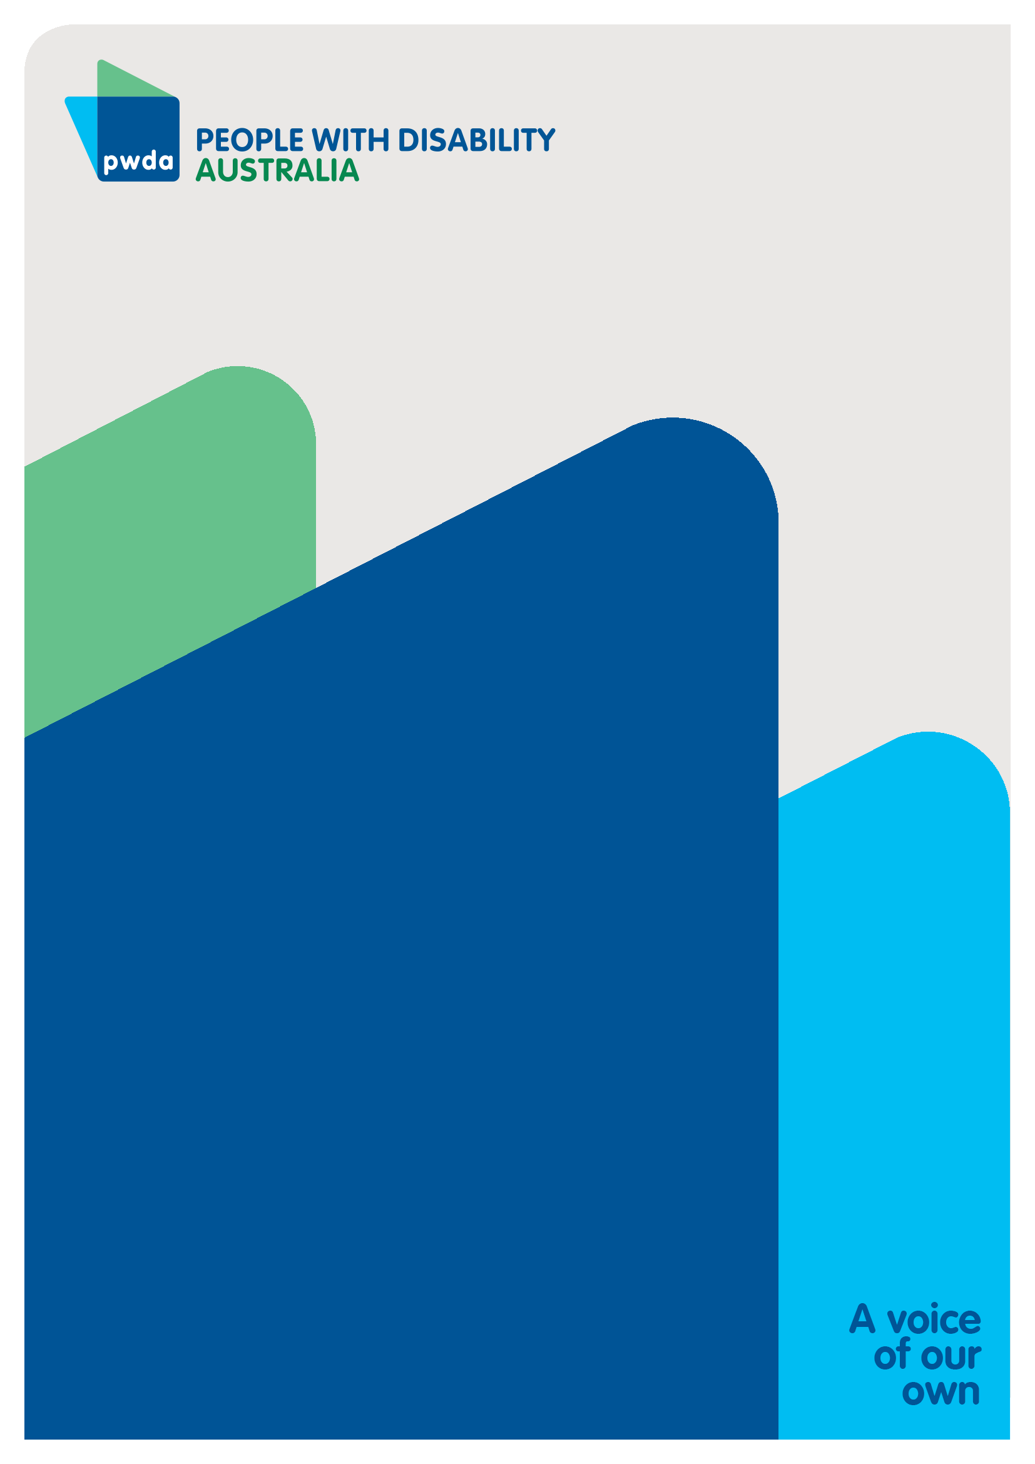
People with Disability Australia (PWDA) is a national disability rights and advocacy organisation made up of, and led by, people with disability.
For individual advocacy support contact PWDA between 9 am and 5 pm (AEST/AEDT) Monday to Friday via phone (toll free) on 1800 843 929 or via email at pwd@pwd.org.au
Submission contact
Giancarlo de Vera
Senior Manager of Policy
E: giancarlod@pwd.org.au

Convention on the Rights of Persons with Disabilities (New York, 13 December 2006) [2008] UNTS 2515 p 3.
Committee on the Rights of Persons with Disabilities (2014) ‘General comment No.1 on article 12: Equal recognition before the law’ [17].
Ibid.
Carney T (2017) Supported decision-making in Australia: Meeting the challenge of moving from capacity to capacity-building?, Disability, Rights and Law Reform in Australia, 35(2), accessed 25 October 2022.
NSW Council for Intellectual Disability, My right to decide [website], accessed 25 October 2022.
Convention on the Rights of Persons with Disabilities (New York, 13 December 2006) [2008] UNTS 2515 p 3.
Committee on the Rights of Persons with Disabilities (2014), above n 2, [21].
Bates, S., Laurens, E., Cross, M., Rowe, B., Wilson, L., Canham, I., Hudson, R., Katz, I., Kayess, R., and Fisher, K.. (2022). ‘Growing Up Making Decisions’. Sydney: Social Policy Research Centre, UNSW, p.45.
Committee on the Rights of Persons with Disabilities (2019) ‘Concluding observations on the combined second and third periodic reports of Australia [24].
Committee on the Rights of Persons with Disabilities (2014), above n 2, [28].
Royal Commission into Violence, Abuse, Neglect and Exploitation of People with Disability (2022) ‘Roundtable Supported Decision-Making and Guardianship: Proposals for Reform ‘ 9, 10.
Martinez-Pujalte A (2019) Legal capacity and supported decision-making: Lessons from some recent legal reforms, Laws, 8(1), accessed 25 October 2022.
McCallum R, The United Nations Convention on the Rights of Persons with Disabilities: An assessment of Australia’s level of compliance, report to the Disability Royal Commission, 2020 p 54, accessed 25 October 2022.
Committee on the Rights of Persons with Disabilities (2014), above n 2, [29].
Australian Law Reform Commission (2014) ‘Equality, Capacity and Disability in Commonwealth Laws’, recommendation 3.3(2)(d).

