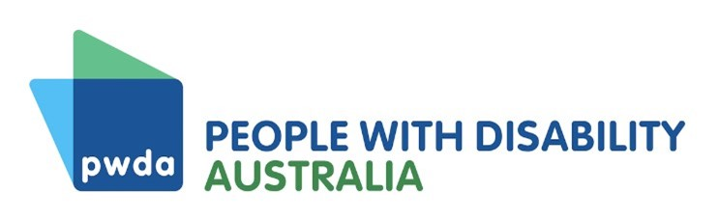
Position Statement
Vision for realising our human rights
This submission, Vision for Realising Our Human Rights, builds on People with Disability Australia’s contributions to the Disability Royal Commission (DRC) to date.
It reflects on the notion of 'inclusion', which is the theme of DRC Public hearing 31, and discusses how widespread segregation, isolation, and systemic exclusion of people with disability not only breach human rights but dangerously create conditions of isolation in which violence, abuse, neglect and exploitation can take place.
The everyday reality for many people with disability continues to be one of separation from the rest of the community by law, policy and practice frameworks that enable segregated arrangements.
The submission takes the position that this should be addressed by adopting a human rights approach, which requires governments to address systemic exclusion and segregation, while also providing individuals with mechanisms to claim their right to be included in the community and live a life free from violence, abuse, neglect and exploitation.
Under the human rights model all people possess human rights by virtue of being human. The human rights model builds on the social model of disability and thus importantly differs from the charity and medical models. In building on the social model of disability, the human rights model recognises that every person with disability has human rights, and every person with disability can claim these rights.
As well as fully implementing Australia’s human rights treaties, including the Convention on the Rights of Persons with Disabilities, the submission calls for a federal charter of human rights to ‘level the playing field’, ensuring that people with disability and other marginalised groups have direct mechanisms for claiming their rights.
The submission asks the DRC to address high level recommendations for legal, policy, structural and practice changes; recommendations to address specific areas of human rights violation identified through PWDA's recent and previous consultation processes; and recommendations on accountability mechanisms to encourage and enable post-DRC continuous disability reform.

United Nations General Assembly, Universal Declaration of Human Rights (10 December 1948) 217 A(III) Articles 1-2.

