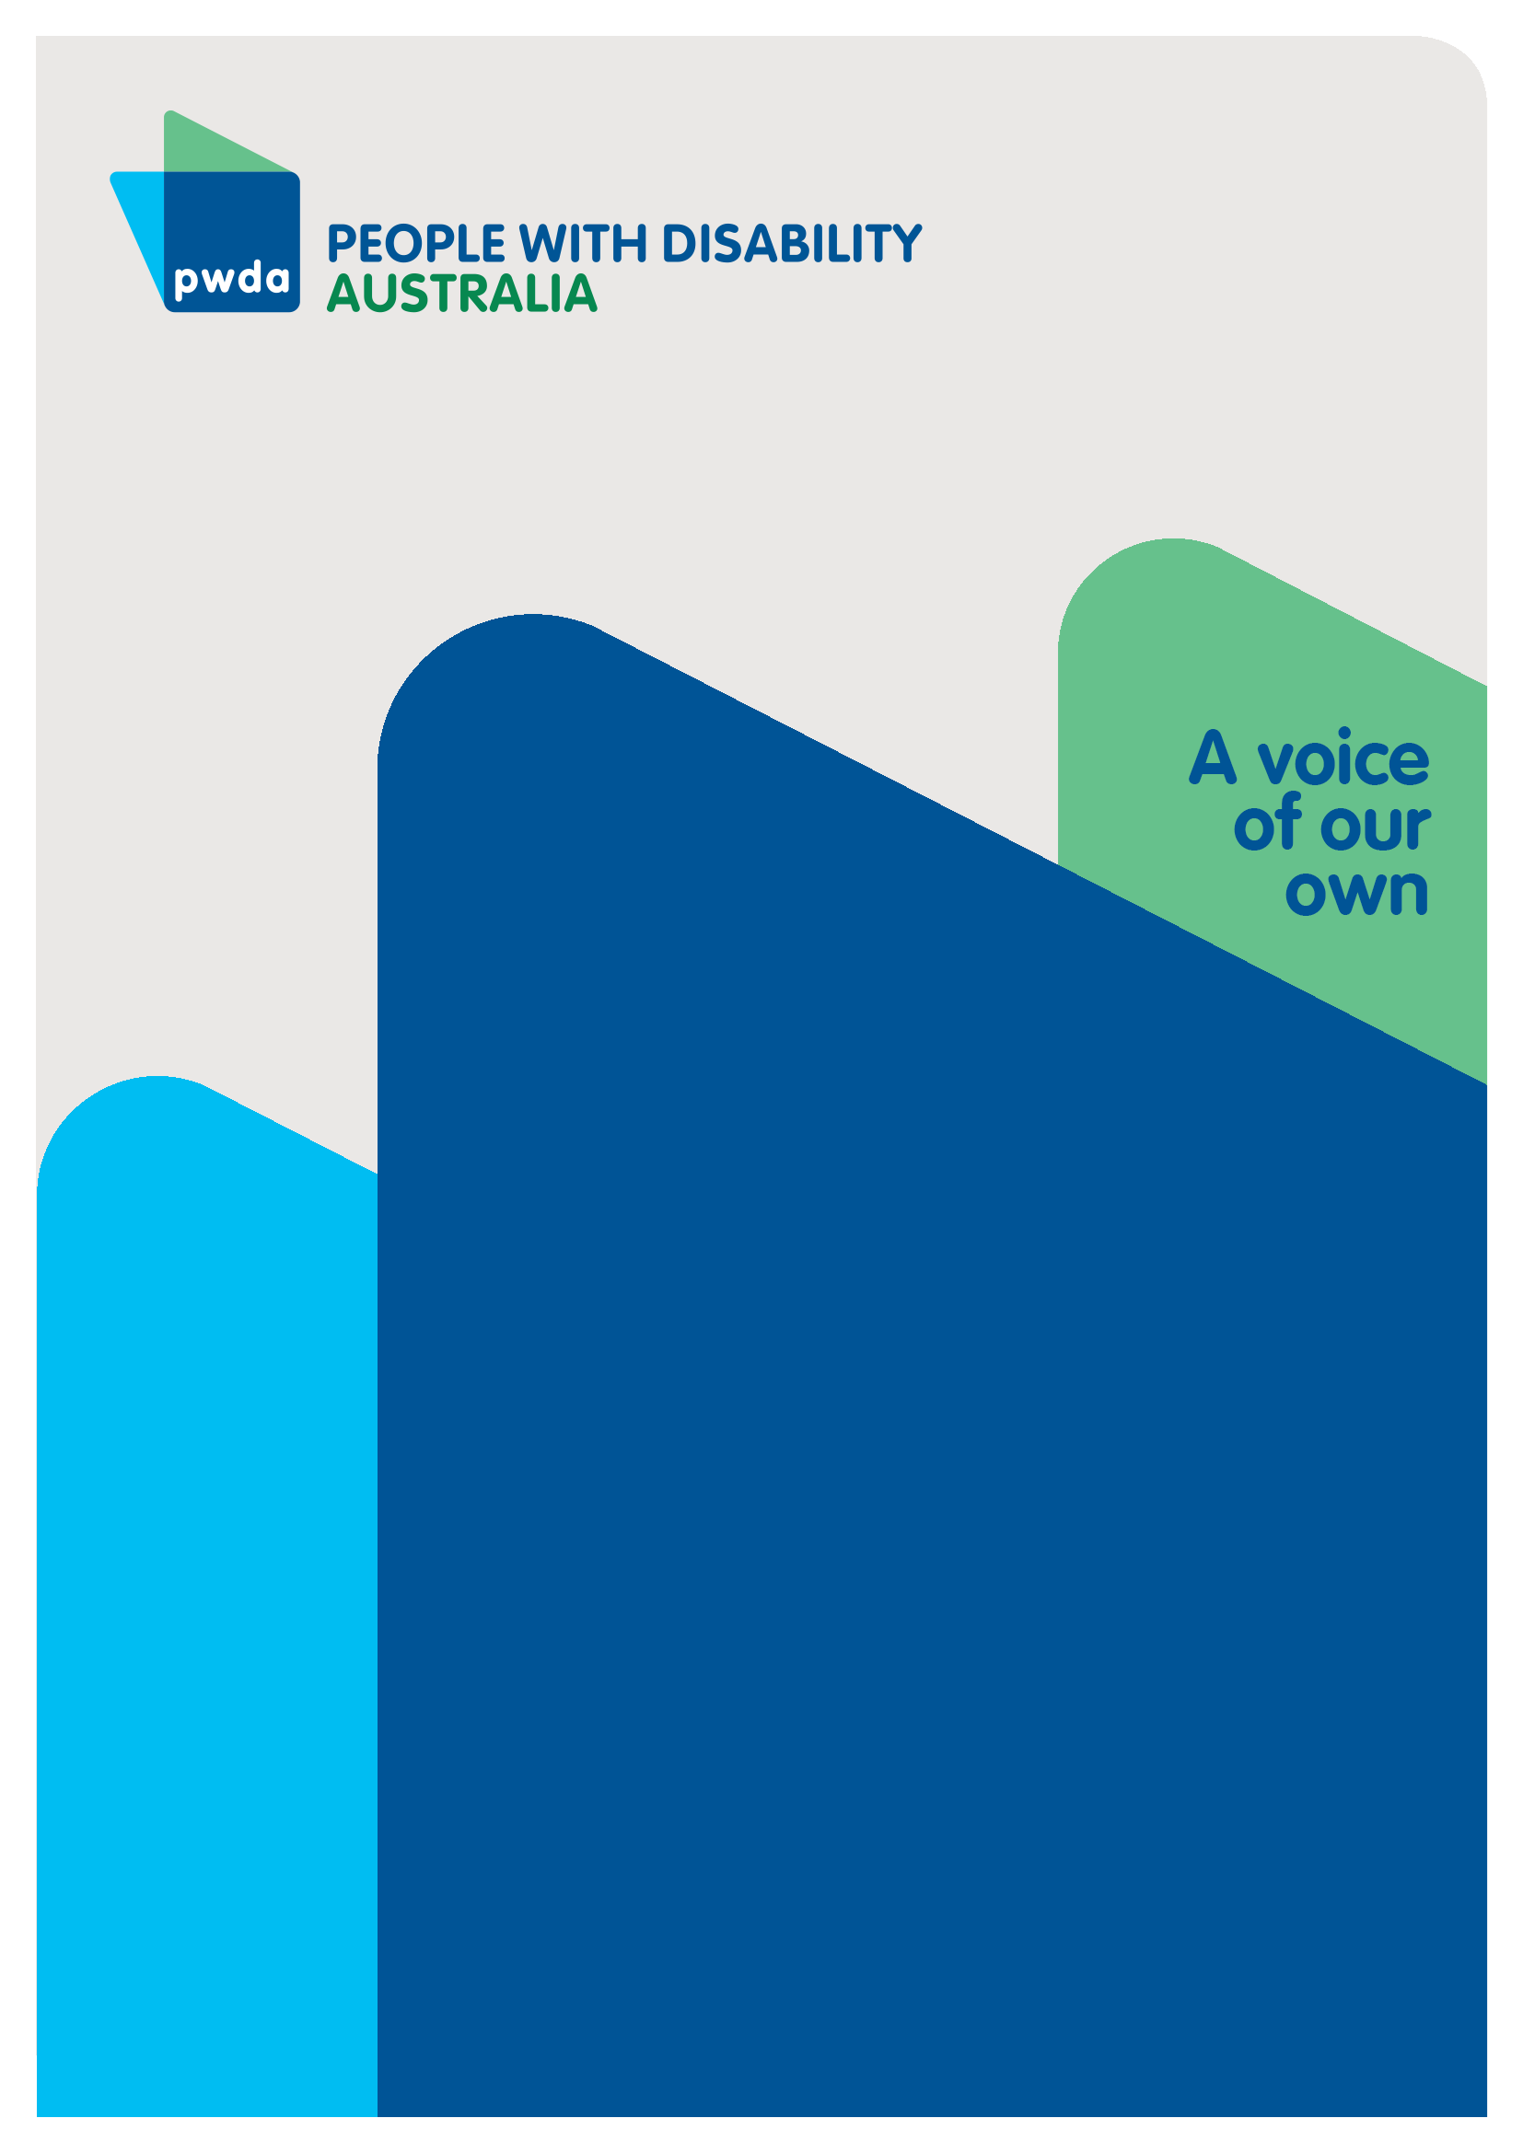
Vision for Realising Our Human Rights
Submission to the Royal Commission into Violence, Abuse, Neglect and Exploitation of People with Disability’s Public Hearing 31 on a vision for an inclusive Australia
DEC
2022

Copyright information
Vision for Realising Our Human Rights: Submission to the Disability Royal Commission’s Public hearing 31 on a vision for an inclusive Australia.

First published in 2022 by People with Disability Australia Ltd.
Level 8, 418a Elizabeth Street, Surry Hills, New South Wales, Australia 2010
Head office also in Sydney
Email: pwda@pwd.org.au
Phone: +61 2 9370 3100 Fax: +61 2 9318 1372
URL: www.pwd.org.au

Typeset in Arial 12 and 14 pt and VAG Rounded 16, 22 and 26 pt

© People with Disability Australia Ltd. 2021

The moral rights of the authors have been asserted

National Library of Australia Cataloguing-in-Publication data:

Creator(s): | Michelle Keogh and Lisa Ira
Title: | Vision for Realising Our Human Rights: Submission to the Disability Royal Commission’s Public hearing 31 on a vision for an inclusive Australia

All rights reserved. Except as permitted with the Australian Copyright Act 1968 (for example, a fair dealing for the purposes of study, research, criticism or review), no part of this book may be reproduced, stored in a retrieval system, communication or transmitted in any form or by any means without prior written permission. All inquiries should be made to the publisher at the address above.

Ira, L. and Keogh, M., Vision for Realising Our Human Rights: Submission to the Disability Royal Commission’s Public hearing 31 on a vision for an inclusive Australia, 9 December 2022, People with Disability Australia, Sydney

ISBN 978-0-6454251-3-0

About PWDA
People with Disability Australia (PWDA) is a national disability rights and advocacy organisation made up of, and led by, people with disability.
We have a vision of a socially just, accessible and inclusive community in which the contribution, potential and diversity of people with disability are not only recognised and respected but also celebrated.
PWDA was established in 1981, during the International Year of Disabled Persons.
We are a peak, non-profit, non-government organisation that represents the interests of people with all kinds of disability.
We also represent people with disability at the United Nations, particularly in relation to the United Nations Convention on the Rights of Persons with Disabilities (CRPD).
Our work is grounded in a human rights framework that recognises the CRPD and related mechanisms as fundamental tools for advancing the rights of people with disability.
PWDA is a member of Disabled People’s Organisations Australia (DPO Australia), along with the First People’s Disability Network, National Ethnic Disability Alliance and Women with Disabilities Australia.
DPOs collectively form a disability rights movement that places people with disability at the centre of decision-making in all aspects of our lives.
‘Nothing About Us, Without Us’ is the motto of Disabled Peoples’ International.

Table of Contents

Summary of recommendations 5
Access to redress and reparation for people with disability who have experienced violence, abuse, neglect and exploitation 8
Background 8
A vision for an inclusive Australia 9
Overcoming barriers to an inclusive Australia – A human rights approach 12
Australia must adopt a human rights approach 12
Addressing violations of human rights 14
Beyond the Disability Royal Commission – Accountability for reform 18
A vision for a human rights focused Australia 19
Appendix: PWDA submissions to the Disability Royal Commission to date 21

Summary of recommendations
PWDA asks the Disability Royal Commission (DRC) to:
- Advocate for an overarching national human rights legislative framework
- Structure its recommendations within a human rights-based approach consistent with Australia’s international obligations under the seven international human rights treaties to which Australia is a party and cross-reference each of the recommendations to the Australian Disability Strategy 2021-2031 to promote implementation of the DRC’s recommendations through existing Australian Disability Strategy mechanisms
- Advocate for implementation of Australia’s outstanding obligations under the CRPD
- Include people with disability and their representative organisations in the development of recommendations to ensure that solutions to entrenched problems are co-designed and result in real change
- Address ableism and community attitudes to influence positive change in how disability is perceived in Australian society; address stigma, unconscious bias and lack of understanding of disability; and to improve inclusion, participation, equity, and justice
- Make concrete recommendations to effect legal, policy, structural and practice changes that are accountable and measurable
- Recommend that the Australian Government establishes a national independent statutory body to oversee the current disability oversight and safeguarding bodies in Australia, including harmonising and facilitating information sharing amongst existing disability oversight and safeguarding mechanisms and addressing systemic issues through data collection and research.
Additionally, PWDA asks the DRC to specifically address the following violations of human rights, drivers of violence, abuse, neglect and exploitation, and barriers to inclusion and justice experienced by people with disability and discussed by PWDA in previous submissions:
- Segregated, inaccessible and unsuitable housing
- Indefinite detention of people with disability in prisons and forensic settings
- Segregated education, training, and employment
- ‘Client capture’ where one organisation provides the full range of services to a client
- Guardianship and substitute decision making regimes
- Over reliance and inappropriate use of restrictive practices
- Underfunding and waiting lists for independent advocacy
- Lack of timely engagement of people with disability in disaster planning and responses, including floods and the Covid-19 pandemic
- Immigration practices that discriminate on the basis of disability
- Inaccessible, inappropriate, and ineffective policing, legal and justice systems
- Structural barriers to accessing and receiving appropriate support from the NDIS
- Inaccessible and ineffective complaints processes for people with disability who want to make or escalate a complaint or report violence, abuse, neglect, or exploitation
- Insufficient understanding of the human rights approach across services and systems.
To encourage and enable continuous reform, PWDA further proposes inclusion of the following accountability mechanisms in the DRC’s recommendations:
- The Australian Government issues a formal response to the DRC’s final report in which they address whether each recommendation is accepted, accepted in principle, rejected or subject to further consideration, and how they intend to respond to and implement each recommendation
- The Australian Government creates a roadmap for the implementation of accepted recommendations following its formal response to the DRC’s final report
- The Australian Government provides its formal response and roadmap within a reasonable timeframe and dedicates sufficient resources to ensure that they are considered and comprehensive
- Federal, state and territory government’s implementation of the DRC’s recommendations is monitored, measured and periodically reported on to ensure public accountability for progress
- Implementation and reporting is linked to Australia’s Disability Strategy 2021-2031 Outcomes Framework
- Creation of a government office with central, whole-of-government responsibility for disability inclusion that would work closely with the proposed national independent statutory body on inclusion matters relating to oversight and safeguarding
- The DRC’s final recommendations are included as a standing agenda item at the Disability Reform Ministers’ Meetings and that progress on action items relating to the DRC recommendations be included in the publicly available meeting communiques
- Dedicated ongoing research funding is made available to further understand patterns of human rights violations against people with disability, identify the institutions, systems, legislation, and policies that enable abuse, and continuously build the evidence base and data to support systemic change

Access to redress and reparation for people with disability who have experienced violence, abuse, neglect and exploitation

Background
PWDA has made several submissions (see Appendix) to the DRC, supported people with disability to make private submissions and request private sessions, supported people to consider being witnesses for public hearings, and provided evidence at public hearings.
We have also made submissions to other inquiries and consultation processes during the lifetime of the DRC that have relevance to the work of the DRC in examining violence, abuse, neglect, and exploitation of people with disability, including to the independent review into the circumstances relating to the death of Ms Ann-Marie Smith.
Through our continuous engagement with the DRC, representing the views and experiences of our members, board, and the people we support, PWDA has highlighted and advocated for the systemic and structural changes needed to bring an end violence, abuse, neglect and exploitation, and uphold and progress the human rights of people with disability in Australia.
PWDA will continue to advocate our vision for an Australia where people with disability not only experience inclusion but also justice, and a society in which we can take our rightful place as equal members of society.
This submission is informed by the experiences of PWDA’s individual advocacy clients, as well as systemic issues identified by our Individual Advocates. It also reflects input from our Board members, who are people with disability with extensive involvement and experience in the disability rights sector.

A vision for an inclusive Australia

Inclusion
Inclusion of people with disability is a human right, affirmed, protected and promoted under the CRPD.
The Centres for Disease Control and Prevention defines disability inclusion as:
‘…more than simply encouraging people; it requires making sure that adequate policies and practices are in effect in a community or organization.
Inclusion should lead to increased participation in socially expected life roles and activities—such as being a student, worker, friend, community member, patient, spouse, partner, or parent.
Socially expected activities may also include engaging in social activities, using public resources such as transportation and libraries, moving about within communities, receiving adequate health care, having relationships, and enjoying other day-to-day activities.’
Historically, people with disability were hidden away, out of view, and not treated as equals in society. Although progress has been made, segregation and large-scale inequality remain. Genuine inclusion and full participation in society for people with disability is dependent on ending segregation and upholding individual autonomy.

Segregation and isolation
As discussed in our joint position paper to the DRC on segregation, the everyday reality for many people with disability continues to be one of separation from the rest of the community by law, policy and practice frameworks that enable segregated arrangements.
In many areas of life people with disability remain invisible and excluded from so-called ‘mainstream’ society, including in ‘special’ schools, institutional living arrangements, and segregated employment.
In addition to breaching human rights under the CRPD (see discussion in the Addressing Violations of Human Rights section below), segregation and exclusion also dangerously create conditions of isolation in which violence, abuse, neglect and exploitation can take place. Segregation and exclusion as enablers and drivers of violence, abuse, neglect and exploitation have been well documented through the courageous sharing of experiences with the DRC.
PWDA’s Individual Advocates also report encountering situations in which isolation contributes to the voices of clients with disability not being heard, including when trying to make complaints, report concerns, or disclose experiences of violence, abuse, neglect or exploitation. Exacerbating factors include:
- Closed and hard to reach settings such as prisons, forensic psychiatric units, and institutional style accommodation
- ‘Client capture’ in which all services are provided by one service provider
- People who may experience additional barriers to speaking up, being heard, listened to, or taken seriously when they reach out, including people with intellectual disability or complex communication needs
- Settings in which independent individual advocacy is not available or denied, and;
- Where complaints processes are ineffective or inaccessible.
Inclusion and ‘visibility’ in society are foundational to preventing violence and providing access to justice where violence has occurred.

Systemic exclusion
Even in settings not typically considered ‘isolated’, people with disability continue to experience systemic exclusion and structural barriers to inclusion.
Barriers remain in government policy, societal attitudes, communications, and the built environment. As discussed in our joint position paper on segregation (p. 7):
‘Many people with disability remain indirectly segregated from community life by pervasive environmental, communication, attitudinal and systemic barriers that law, policy and practice frameworks have failed to remove – such as inaccessible housing, transport, information and communication systems, voting; non-inclusive violence prevention and response services; barriers in accessing justice and legal systems; and employment and health discrimination. Many people with disability remain directly segregated by law, policy and practice frameworks that continue to establish, maintain and fund segregated settings - such as special schools, units and classrooms; institutional accommodation settings; and segregated employment - as well as through substitute decision-making arrangements that limit our autonomy, such as guardianship, financial management and involuntary mental health systems.’

Current examples
The existence of systemic exclusion and structural barriers to inclusion has been particularly evident throughout the Covid-19 pandemic. Comprehensive risk management strategies were not in place to ensure people with disability’s needs were met when the pandemic started. Most notably, people with disability experienced a lack of access to COVID-safe supports, which could have potentially been averted with proper workforce planning. Without adequate supports, people with disability cannot exercise their right to be included and segregation is further entrenched. As responses to Covid now take a less directive approach by governments, people with disability who are at risk must take on greater responsibility to self-isolate as mask-wearing and social distancing becomes less and less common.
Similarly, people with disability experience barriers to accessing safe, secure and accessible housing which is critical to accessing other supports and services. This has been exacerbated by the current housing crisis in Australia. Lack of appropriate housing and fear of becoming homeless keeps many people living in violent, abusive, neglectful and exploitative living environments, or leads to homelessness, itself a driver of violence.

Overcoming barriers to an inclusive Australia – A human rights approach

Australia must adopt a human rights approach
The only way to comprehensively address the persistent segregation, isolation, and exclusion of people with disability is to adopt a human rights approach.
A human rights approach requires governments to address systemic exclusion and segregation, while also providing individuals with mechanisms to claim their right to be included in the community and live a life free from violence, abuse, neglect and exploitation.
Under the human rights model all people possess human rights by virtue of being human. The human rights model builds on the social model of disability and thus importantly differs from the charity and medical models. In building on the social model of disability, the human rights model recognises that every person with disability has human rights, and every person with disability can claim these rights.
Adopting a human rights approach involves fully implementing the international human rights treaties to which Australia is a signatory, including the CRPD.
The CRPD does not create new human rights, but rather provides clarity on how existing rights must be upheld in the context of disability. In this sense, the CRPD should be seen as a holistic guide or ‘roadmap’ to the specific measures required to achieve inclusion for people with disability and reduce violence, abuse, neglect and exploitation.
It is vital that all provisions of the CRPD are implemented because human rights are indivisible, interrelated and interdependent.
For example, to enjoy the right to freedom from violence and abuse conferred under Article 16, the right for people with disability to choose with whom they live, conferred under Article 19, must also be upheld. Similarly, the Article 19 right to be included in the community relies on the Article 9 right to access the physical environment, transport, information and communications.
Critically, the right, under Article 13, for people with disability to access justice when abuse or violence has occurred must be upheld.

Immediate and progressive realisations
Article 4 of the CRPD requires States Parties to take positive steps to implement CRPD rights.
Civil and political rights, such as the right to life, must be implemented immediately, while economic, social and cultural rights, such as housing and inclusive education can be realised progressively.
It is important to note, however, that progressive realisation of rights must occur through taking measures ‘to the maximum of [the State’s] available resources. Although we recognise implementing certain rights, such as the right to housing, is expensive, this does not negate Australia’s legal obligation to direct the maximum amount of funds possible to these efforts.
Particular attention should be given to right to equality and non-discrimination conferred under Article 5, which requires immediate implementation.
Other rights in the convention contain dimensions related to non-discrimination, particularly segregation, and those dimensions are therefore subject to immediate realisation. For example, failing to provide students with disability equal access to mainstream school not only breaches Article 24, but constitutes discrimination and directly contravenes Article 5. Therefore it needs to be remedied immediately, rather than progressively.

Federal charter of rights
Unfortunately, reliance for recognising human rights is placed on a patchwork of mechanisms, such as Victoria, Queensland and the Australian Capital Territory charters of human rights, and various state and federal discrimination laws, rather than properly embedding human rights in Australian law.
The most effective way to embed human rights in Australia is through the establishment of a legislated federal charter of rights. The federal charter of rights should:
- require governments and public servants to consider human rights when creating legislation and policies and delivering services
- provide clear pathways to access justice when rights are violated; and
- include a central list of all rights and freedoms.
A charter of human rights will ‘level the playing field’, ensuring that people with disability and other marginalised groups will have direct mechanisms for claiming their rights.
It will also foster better societal understanding and respect of the rights of people with disability and progress a human-rights focused culture. Only then can genuine inclusion and full participation in society for people with disability be realised and embedded.

Addressing violations of human rights
Critical to progressing a human rights approach is identifying, understanding and addressing the circumstances in which violations of human rights occur.
PWDA’s Individual Advocates have seen time and time again how human rights violations translate into drivers of violence, abuse, neglect and exploitation of people with disability. Examples include segregated housing, segregated employment, substitute decision making, indefinite detention, misuse of restricted practices, and inaccessible justice and policing systems.
As the DRC enters its final stages PWDA takes this opportunity to again urge the DRC to apply a human-rights lens when examining evidence and making its recommendations.
The recommendations of the DRC, combined with the policy framework of Australia’s Disability Strategy 2021-2031, can provide a powerful mechanism to address drivers of violence and progress the human rights of people with disability.
PWDA asks the DRC to:
- Advocate for an overarching national human rights legislative framework
- Structure its recommendations within a human rights-based approach consistent with Australia’s international obligations under the seven international human rights treaties to which Australia is a party and cross-reference each of the recommendations to the Australian Disability Strategy 2021-2031 to promote implementation of the DRC’s recommendations through existing Australian Disability Strategy mechanisms
- Advocate for implementation of Australia’s outstanding obligations under the CRPD
- Include people with disability and their representative organisations in the development of recommendations to ensure that solutions to entrenched problems are co-designed and result in real change
- Address ableism and community attitudes to influence positive change in how disability is perceived in Australian society; address stigma, unconscious bias and lack of understanding of disability; and to improve inclusion, participation, equity, and justice
- Make concrete recommendations to effect legal, policy, structural and practice changes that are accountable and measurable
- Recommend that the Australian Government establishes a national independent statutory body to oversee the current disability oversight and safeguarding bodies in Australia, including harmonising and facilitating information sharing amongst existing disability oversight and safeguarding mechanisms and addressing systemic issues through data collection and research
Additionally, recognising the safeguarding role of inclusion, visibility, and access to justice, and the right to participate in and contribute to society, PWDA urges the DRC in its final recommendations to specifically address the following violations of human rights, drivers of violence, abuse, neglect and exploitation, and barriers to inclusion and justice experienced by people with disability and discussed by PWDA in previous submissions:
- Segregated, inaccessible and unsuitable housing
- Indefinite detention of people with disability in prisons and forensic settings
- Segregated education, training, and employment
- ‘Client capture’ where one organisation provides the full range of services to a client
- Guardianship and substitute decision making regimes
- Over reliance and inappropriate use of restrictive practices
- Underfunding and waiting lists for independent advocacy
- Lack of timely engagement of people with disability in disaster planning and responses, including floods and the Covid-19 pandemic
- Immigration practices that discriminate on the basis of disability
- Inaccessible, inappropriate, and ineffective policing, legal and justice systems
- Structural barriers to accessing and receiving appropriate support from the NDIS
- Inaccessible and ineffective complaints processes for people with disability who want to make or escalate a complaint or report violence, abuse, neglect, or exploitation
- Insufficient understanding of the human rights approach across services and systems.

Beyond the Disability Royal Commission – Accountability for reform
When the DRC has concluded, people with disability, advocates and organisations will continue to advocate for disability reform. To encourage and enable continuous reform, PWDA further proposes inclusion of the following accountability mechanisms in the DRC’s recommendations:
- The Australian Government issues a formal response to the DRC’s final report in which they address whether each recommendation is accepted, accepted in principle, rejected or subject to further consideration, and how they intend to respond to and implement each recommendation
- The Australian Government creates a roadmap for the implementation of accepted recommendations following its formal response to the DRC’s final report
- The Australian Government provides its formal response and roadmap within a reasonable timeframe and dedicates sufficient resources to ensure that they are considered and comprehensive
- Federal, state and territory government implementation of the DRC’s recommendations is monitored, measured and periodically reported on to ensure public accountability for progress
- Implementation and reporting is linked to Australia’s Disability Strategy 2021-2031 outcomes framework
- Creation of a government office with central, whole-of-government responsibility for disability inclusion that would work closely with the proposed national independent statutory body on inclusion matters relating to oversight and safeguarding
- The DRC’s final recommendations are included as a standing agenda item at the Disability Reform Ministers’ Meetings and that progress on action items relating to the DRC recommendations be included in the publicly available meeting communiques
- Dedicated ongoing research funding is made available to further understand patterns of human rights violations against people with disability, identify the institutions, systems, legislation, and policies that enable abuse, and continuously build the evidence base and data to support systemic change
- Access to redress and reparation for people with disability who have experienced violence, abuse, neglect and exploitation.

A vision for a human rights focused Australia
The Disability Royal Commission has provided a critical, once in a lifetime chance to understand the context, impact and extent to which violence, abuse, neglect and exploitation of people with disability occurred, and still occurs, in Australia. A light has begun to be shone on some of the darkest corners of our society through peoples’ courage to share their stories.
It is incumbent on all stakeholders to work together to ensure that the courage to share deeply personal and traumatic experiences leads to concrete and measurable change.
Further, the success or otherwise of this Royal Commission in bringing about change and improving the lives of people with disability must be measured by the post-Royal Commission lived experiences of people with disability, rather than by evaluation measures decided by policy makers and service providers alone.
Evaluation of disability strategies and policies, current and future, should be co-designed with people with disability and include the views and experiences of the people whose lives they affect .
PWDA believes the DRC’s recommendations can substantially contribute to a more inclusive and just Australia where the human rights of people with disability are realised, barriers to accessing human rights are addressed, and, in turn, the drivers of violence, abuse, neglect and exploitation are reduced or eliminated.
Accordingly, we again urge the Disability Royal Commission to use the weight of its recommendations to advocate and progress the human rights and freedoms of people with disability in Australia.
Appendix

PWDA submissions to the Disability Royal Commission to date
Joint DRO submission, Gap analysis
Submission and position statement, Our lives, our decisions: guardianship, substitute and supported decision making
Joint DRO letter, Gaps and priorities
Joint position statement with IA and DANA, Australians with disability need action to remove barriers to secure, safe and accessible housing
Jointly commissioned report with IA, Wage equity and more choices in employment for people with an intellectual disability - research review
Joint submission with NEDA & FECCA, The experiences & perspectives of people with disability from Culturally and Linguistically Diverse Backgrounds
Submission, We Belong Here: our nation must end exclusionary systems that harm people with disability
Position Statement, We Belong Here: our nation must end exclusionary systems that harm people with disability
Submission, We have a right to choose homes without violence (response to DRC Violence and Abuse of People with Disability at Home Issues Paper Dec 2020)
Submission, Safeguards help marginalised people with disability (in response to DRC Safeguards and Quality Issues Paper Nov 2020)
DPOA position paper with PWDA, CYDA, WWDA, AFDO, IA, DANA and FPDN, Segregation of People With Disability Is Discrimination And Must End
Submission, Realising our right to be safe in emergencies (response to DRC Emergency Planning and Response Issues Paper April 2020)
Submission, Realising our right to live independently in the community (in response to DRC Group Homes Issues Paper Nov 2019)
Survey and findings, People with Disability and Covid 19
Submission, Response to DRC Draft Accessibility Strategy released in August 2019
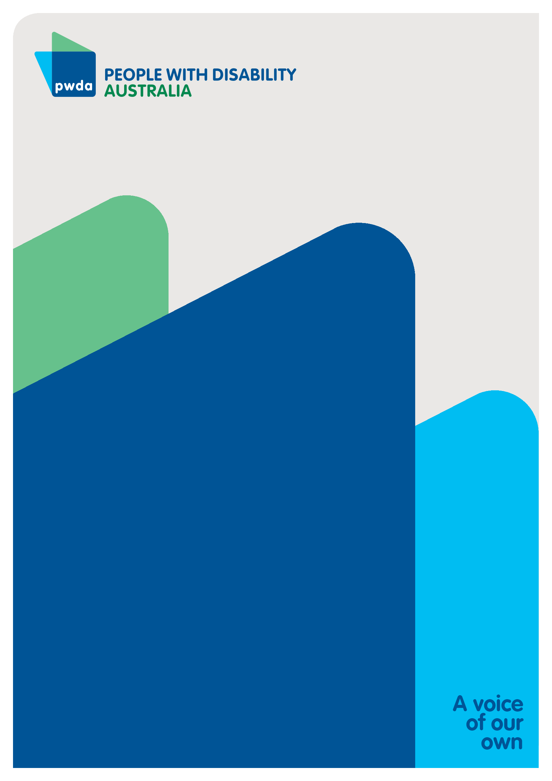
People with Disability Australia (PWDA) is a national disability rights and advocacy organisation made up of, and led by, people with disability.
For individual advocacy support contact PWDA between 9 am and 5 pm (AEST/AEDT) Monday to Friday via phone (toll free) on 1800 843 929 or via email at pwd@pwd.org.au
Submission contact
Giancarlo de Vera
Senior Manager of Policy
E: giancarlod@pwd.org.au

United Nations General Assembly, Universal Declaration of Human Rights (10 December 1948) 217 A(III) Articles 1-2.
Convention on the Rights of Persons with Disabilities (New York, 13 December 2006) [2008] UNTS 2515 Preamble.
Convention on the Rights of Persons with Disabilities (New York, 13 December 2006) [2008] UNTS 2515 Article 4(2).
ibid.
Committee on the Rights of Persons with Disabilities (2018) ‘General comment No.6 (2018) on equality and non-discrimination’ [12].
Emily Cukalevski & Cátia Malaquias (2019) A CRPD analysis of NSW’s policy on the education of students with disabilities – a retrogressive measure that must be halted, Australian Journal of Human Rights, 25:2, 232-247, DOI: 10.1080/1323238X.2019.1609720
Committee on the Rights of Persons with Disabilities (2018) ‘General comment No.6 (2018) on equality and non-discrimination’ [63].

