Modern slavery is a disability Issue

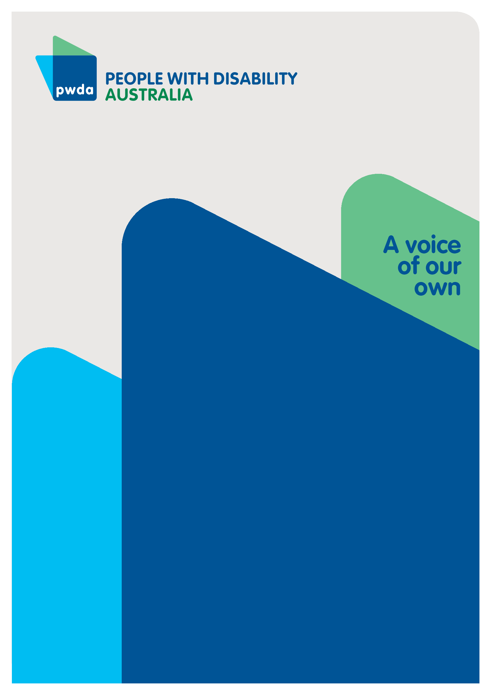
Submission to the NSW Anti-Slavery Commissioner’s discussion paper #002: Developing a strategic plan to combat modern slavery
DEC
2022

Copyright information
Modern slavery is a disability issue – Submission to the NSW Anti-Slavery Commissioner’s discussion paper #002: Developing a strategic plan to combat modern slavery

First published in 2022 by People with Disability Australia Ltd.
Level 8, 418a Elizabeth Street, Surry Hills, New South Wales, Australia 2010
Head office also in Sydney
Email: pwda@pwd.org.au
Phone: +61 2 9370 3100 Fax: +61 2 9318 1372
URL: www.pwd.org.au

Typeset in Arial 12 and 14 pt and VAG Rounded 18 and 26 pt

© People with Disability Australia Ltd. 2022

The moral rights of the authors have been asserted

National Library of Australia Cataloguing-in-Publication data:

Creator(s): | Lisa Ira
Title: | Modern slavery is a disability issue – Submission to the NSW Anti-Slavery Commissioner’s discussion paper #002: Developing a strategic plan to combat modern slavery

All rights reserved. Except as permitted with the Australian Copyright Act 1968 (for example, a fair dealing for the purposes of study, research, criticism or review), no part of this book may be reproduced, stored in a retrieval system, communication or transmitted in any form or by any means without prior written permission. All inquiries should be made to the publisher at the address above.

Ira, L., Modern slavery is a disability issue – Submission to the NSW Anti-Slavery Commissioner’s discussion paper #002: Developing a strategic plan to combat modern slavery, 14 December 2022, People with Disability Australia, Sydney.

ISBN 978-0-6454251-4-7

About PWDA
People with Disability Australia (PWDA) is a national disability rights and advocacy organisation made up of, and led by, people with disability.
We have a vision of a socially just, accessible and inclusive community in which the contribution, potential and diversity of people with disability are not only recognised and respected but also celebrated.
PWDA was established in 1981, during the International Year of Disabled Persons.
We are a peak, non-profit, non-government organisation that represents the interests of people with all kinds of disability.
We also represent people with disability at the United Nations, particularly in relation to the United Nations Convention on the Rights of Persons with Disabilities (CRPD).
Our work is grounded in a human rights framework that recognises the CRPD and related mechanisms as fundamental tools for advancing the rights of people with disability.
PWDA is a member of Disabled People’s Organisations Australia (DPO Australia), along with the First People’s Disability Network, National Ethnic Disability Alliance and Women with Disabilities Australia.
DPOs collectively form a disability rights movement that places people with disability at the centre of decision-making in all aspects of our lives.
‘Nothing About Us, Without Us’ is the motto of Disabled Peoples’ International.

Table of Contents

Summary of recommendations 5
Introduction 7
Why the Strategy needs a disability focus 7
Response to discussion paper questions 9
Q1: How should services to prevent and remedy modern slavery be different? 9
Q2: How should modern slavery risks in supply chains and portfolios be addressed differently? 10
Q3: How should the criminal justice system address modern slavery differently? 11
Q4: How will partnerships strengthen anti-slavery efforts? 12
Q5: How will anti-slavery efforts integrate survivor leadership? 12

Summary of recommendations
Recommendation 1 – The Government commissions research into the intersection between disability and modern slavery, both domestically and internationally. The research should be co-designed by and should involve people with disability and their representative organisations.
Recommendation 2 – The Government collects disaggregated data to identify victim-survivors with disability and their other relevant characteristics, including disability type, supports required, cultural background, setting where the offence occurred and whether the disability was pre-existing or acquired due to their modern slavery experience.
Recommendation 3 – Targeted modern slavery education and awareness raising are provided to people with disability, including education about what modern slavery is and how to access help. People with disability living in ‘closed’ settings, such as group homes and mental health facilities, and people with disability who are isolated from the community should be prioritised in the roll-out of these measures.
Recommendation 4 – The Government conducts an evaluation of the accessibility of NSW modern slavery response mechanisms, including but not limited to the NSW Victims Support Scheme, helplines and crisis accommodation centres. The evaluation should be co-designed and co-implemented by people with disability and their representative organisations.
Recommendation 5 – The NSW Anti-Slavery Commissioner ensures that the proposed modern slavery ‘hotline’ is accessible and that alternative options are provided for people with disability who are unable to use a telephone.
Recommendation 6 – Information about the modern slavery hotline should be made available in Easy Read documents and accessible videos, be written in Plain English, and translated into a variety of community languages.
Recommendation 7 – The Government provides targeted training and education to health professionals and other people who work in the disability sector regarding how to identify and report signs of modern slavery.
Recommendation 8 – The NSW Anti-slavery Commissioner conducts routine inspections into Australian Disability Enterprises, during which private discussions should be held with employees and information disseminated to employees about their human rights.
Recommendation 9 – The Modern Slavery Strategy is used to implement the Convention on the Rights of Persons with Disabilities Committee’s recommendation that ‘training modules on working with people with disabilities and the Convention are incorporated into mandated training programs for police officers, prison officers, lawyers, judicial officers, judges and court staff’ in the context of modern slavery.
Recommendation 10 – Partnerships should be formed to increase information sharing and referral pathways amongst frontline modern slavery response personnel, and disability-specific services, including independent disability advocacy to ensure people with disability’s intersectional needs are met.

Introduction
PWDA appreciates the opportunity to provide comment on Discussion Paper 02: Developing a strategic plan to combat modern slavery (the discussion paper) released by the NSW Anti-slavery Commissioner. This submission will firstly explain why the NSW modern slavery strategy (the Modern Slavery Strategy) requires a disability focus. It will then address the discussion paper questions with a focus on ensuring that the Modern Slavery Strategy is disability inclusive.

Why the Strategy needs a disability focus
People with disability face an increased risk of experiencing modern slavery and must therefore be a focal point of the Modern Slavery Strategy. For example, research has shown that girls under the age of 18 with severe physical disability are almost six times more likely to become victims of sex trafficking compared to their peers without severe physical disability. Similarly, girls with low cognitive ability are almost five times more likely to becomes victims of sex trafficking compared to their peers without low cognitive ability.
According to the United States Office of Justice Programs, people with disability face an increased risk of human trafficking due to the following factors, which we believe apply more broadly to modern slavery offences:
- Reliance on others to meet basic needs, giving caregivers the opportunity to traffic people with disability
- People with disability may become submissive to their caregivers and compliant with their wishes, which may make them believe that abuse is ‘normal’
- People with disability may not be aware of their right to object to unwanted touch or exploitative labour
- People with disability may experience barriers to getting help because they are often segregated and/or isolated
- People with disability may not be believed when reporting abuse.
Not only are people with disability more likely to become victims of modern slavery, but victims without disability may acquire physical or psychosocial disability due to their experience of modern slavery. It is therefore crucial that the Modern Slavery Strategy addresses the situations and needs of people with disability.
To address the intersection between disability and modern slavery, we must understand it. In this regard we recommend that:
Recommendation 1 – The Government commissions research into the intersection between disability and modern slavery, both domestically and internationally. The research should be co-designed by and should involve people with disability and their representative organisations.
Recommendation 2 – The Government collects disaggregated data to identify victim-survivors with disability and their other relevant characteristics, including disability type, supports required, cultural background, setting where the offence occurred and whether the disability was pre-existing or acquired due to their modern slavery experience.

Response to discussion paper questions

Question 1: How should services to prevent and remedy modern slavery be different?
Article 8 of the Convention on the Rights of Persons with Disabilities (CRPD) requires States Parties to immediately adopt measures to raise awareness about the rights of people with disability, including through awareness-training programs. As such, we recommend that:
Recommendation 3 – Targeted modern slavery education and awareness raising are provided to people with disability, including education about what modern slavery is and how to access help. People with disability living in ‘closed’ settings, such as group homes and mental health facilities, and people with disability who are isolated from the community should be prioritised in the roll-out of these measures.
Article 9 of the CRPD requires States Parties to ensure that people with disability have access to services and facilities on an equal basis to others. Unfortunately, modern slavery services and facilities are not always accessible. For example, the Australian Red Cross recently reported that their case workers struggle to find accommodation for modern slavery victims with disability that is accessible and accommodates their specific needs.
To improve modern slavery services for people with disability, we recommend that:
Recommendation 4 – The Government conducts an evaluation of the accessibility of NSW modern slavery response mechanisms, including but not limited to the NSW Victims Support Scheme, helplines and crisis accommodation centres. The evaluation should be co-designed and co-implemented by people with disability and their representative organisations.
Recommendation 5 – The NSW Anti-Slavery Commissioner ensures that the proposed modern slavery ‘hotline’ is accessible and that alternative options are provided for people with disability who are unable to use a telephone.
Recommendation 6 – Information about the modern slavery hotline should be made available in Easy Read documents and accessible videos, be written in Plain English, and translated into a variety of community languages.
Recommendation 7 – The Government provides targeted training and education to health professionals and other people who work in the disability sector regarding how to identify and report signs of modern slavery.

Question 2: How should modern slavery risks in supply chains and portfolios be addressed differently?
Special attention must be given to ‘sheltered workshops’ or Australian Disability Enterprises, as they are known in Australia. We believe these settings pose a risk of modern slavery because:
- They are ‘segregated settings’, that are largely hidden from the wider community, meaning coercion and abuse are more easily concealed
- In some Australian states and territories the decision to work in a sheltered workshop can be made by a guardian, rather than the employee, leading to the possibility of coercion
- Employees can be subject to restrictive practices that limit employees’ freedom of movement in the workplace.
To address modern slavery risk in sheltered workshops, we recommend that:
Recommendation 8 – The NSW Anti-slavery Commissioner conducts routine inspections into Australian Disability Enterprises, during which private discussions should be held with employees and information disseminated to employees about their human rights.

Question 3: How should the criminal justice system address modern slavery differently?
As noted by the CRPD Committee, Australians with disability face barriers to accessing justice, particularly people with intellectual or psychosocial disabilities ‘whose reasonable and procedural accommodations are not adequately met.’
We recommend that:
Recommendation 9 – The Modern Slavery Strategy is used to implement the CRPD Committee’s recommendation that ‘training modules on working with people with disabilities and the Convention are incorporated into mandated training programs for police officers, prison officers, lawyers, judicial officers, judges and court staff’ in the context of modern slavery.

Question 4: How will partnerships strengthen anti-slavery efforts?
Recommendation 10 – Partnerships should be formed to increase information sharing and referral pathways amongst frontline modern slavery response personnel, and disability-specific services, including independent disability advocacy to ensure people with disability’s intersectional needs are met.

Question 5: How will anti-slavery efforts integrate survivor leadership?
To uphold Article 4(3) of the CRPD, we urge the Commissioner to actively engage Disabled People’s Organisations, including PWDA, in developing current and future modern slavery policies. While it may be difficult to find modern slavery survivors with disability to share their experiences, we believe people with disability who have experienced other forms of violence and abuse can provide valuable insight into anti-slavery efforts.

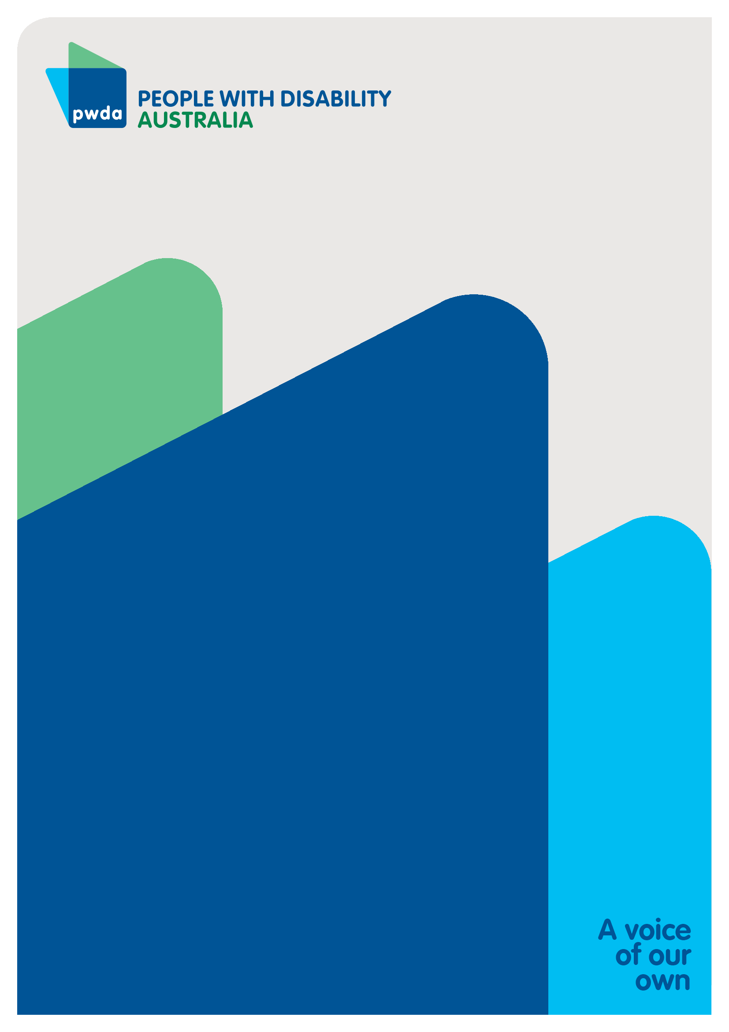
People with Disability Australia (PWDA) is a national disability rights and advocacy organisation made up of, and led by, people with disability.
For individual advocacy support contact PWDA between 9 am and 5 pm (AEST/AEDT) Monday to Friday via phone (toll free) on 1800 843 929 or via email at pwd@pwd.org.au
Submission contact
Giancarlo de Vera
Senior Manager of Policy
E: giancarlod@pwd.org.au

Committee on the Rights of Persons with Disabilities (2019) Concluding Observations on the Combined Second and Third Periodic Reports of Australia (‘Concluding Observations’), United Nations, 26(f).
Committee on the Rights of Persons with Disabilities (2022), General comment No.8 (2022) on the right of persons with disabilities to work and employment, [50].
Franchino-Olsen H et al (2020) ‘Minor sex trafficking of girls with disabilities’, International Journal of Human Rights in Health Care, 13(2):97-108.
Ibid.
US Office for Victims of Crime (OVC) (n.d.) ‘Victims with physical, cognitive, or emotional disabilities’, Human Trafficking Task Force e-guide, OVC website, accessed 13 December 2022.
Polaris (2018) Individuals with disabilities may face increased risk of human trafficking, Polaris website, accessed 13 December 2022.
Convention on the Rights of Persons with Disabilities (New York, 13 December 2006) [2008] UNTS 2515 p 3, arts 8(1) and 8(2)(d).
Ibid art 9.
Australian Red Cross (2021) Barriers in accommodating survivors of modern slavery: Working towards safe, suitable and sustainable housing, accessed 13 December 2022, p 14.
Steele L (forthcoming) 'Law and disability ‘supported’ employment in Australia: The case for ending segregation, discrimination, exploitation and violence against people with disability at work', Monash University Law Review, 49(1), accessed 13 December 2022.
Ibid.
Concluding Observations (n 1) [25].
Ibid [26](f).

