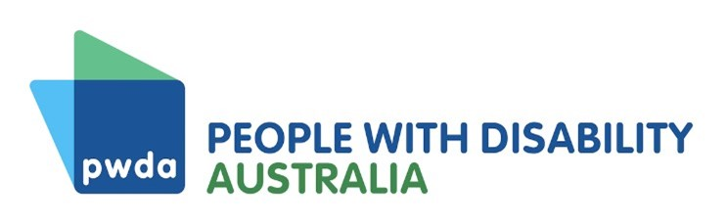
Position Statement
Modern Slavery
People with Disability Australia (PWDA) strongly condemns all forms of modern slavery, including forced labour, human trafficking, slavery, child labour, organ removal and slavery-like practices.
Modern slavery is a disability issue. People with disability face an increased risk of experiencing modern slavery and people can acquire a disability from their modern slavery experience. Dependency on caregivers who can exploit us, barriers to getting help and a lack of awareness of our right to refuse unwanted touch and exploitative labour increase our risk of modern slavery.
The Convention on the Rights of Persons with Disabilities requires Australia to ensure that people with disability are not subject to slavery, servitude or forced labour. However, modern slavery against people with disability is an under-researched and often neglected area in law, policy and practice around the world.
To ensure Australia’s responses to eradicate modern slavery are disability inclusive, we call on all levels of government to consider the below recommendations, as appropriate:
- Collect disaggregated data that identifies victim-survivors with disability
- Commission co-designed research into the intersection between disability and modern slavery
- Address the structural drivers of victimisation, such as segregation and guardianship
- Provide modern slavery education and awareness raising to people with disability
- Train disability sector workers, including health professionals, to identify and report signs of modern slavery
- Conduct routine inspections into Australian Disability Enterprises to ensure people are not being coerced into labour or otherwise exploited
- Ensure that all modern slavery complaint mechanisms and victim services are accessible
- Ensure justice system personnel, including police officers, lawyers, judicial officers and court staff receive training on working with people with disability
People with disability and their representative organisations must also be included in the development of modern slavery policies and laws. Modern slavery issues are disability issues and there should be ‘nothing about us without us’.
Last updated December 2022

Commonwealth Government Joint Standing Committee on Foreign Affairs, Defence and Trade (2017) Hidden in plain sight: An inquiry into establishing a Modern Slavery Act in Australia, accessed 13 December 2022, p 29.
Committee on the Rights of Persons with Disabilities (2022), General comment No.8 (2022) on the right of persons with disabilities to work and employment, [50].
Polaris (2018) Individuals with disabilities may face increased risk of human trafficking, Polaris website, accessed 13 December 2022.
US Office for Victims of Crime (OVC) (n.d.) ‘Victims with physical, cognitive, or emotional disabilities’, Human Trafficking Task Force e-guide, OVC website, accessed 13 December 2022.
Convention on the Rights of Persons with Disabilities (New York, 13 December 2006) [2008] UNTS 2515 p 3, art 27(2).

