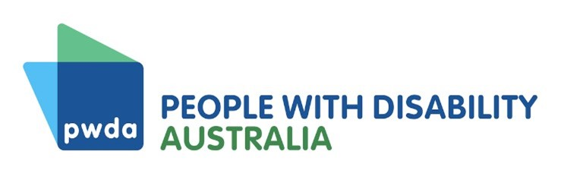
Position Statement

Extent and nature of poverty in Australia
As a leading systemic and individual advocacy and disability representative organisation, our submission to the Community Affairs References Committee inquiry into the extent and nature of poverty in Australia specifically addresses the impacts of poverty on Australians with disability.

Disability and poverty
Australians with disability experience significant economic disadvantage. On average, people with disability have much lower labour force participation rates and lower income than people without disability, leading to high rates of poverty. The Organisation for Economic Cooperation and Development estimated in 2010 that 45 per cent of all people with disability in Australia were living in poverty at that time; and the Australian Council of Social Service and University of New South Wales estimated that 41 percent of people in households with a person accessing the Disability Support Pension in 2017-18 were in poverty. Living in poverty causes a cascade of poor outcomes in other life domains, including housing, health, and education. These are discussed further in our submission.

Drivers and impacts
The connection between drivers and impacts of poverty for people with disability is cyclical in nature: disability can either cause or be a consequence of poverty, often becoming a cycle of disability and poverty that is difficult to escape. Poor outcomes in employment, housing security, health, education, and other life domains, can be both drivers and impacts of poverty, with cascading effects.

Income support payments and poverty
Australians with disability are overly reliant on income support as a source of income and increasingly likely to be on unemployment payments, struggling in deep poverty. While providing some basic income, these payments do not provide an adequate safety net or standard of living for people experiencing complex barriers to education and employment. Inadequate rates of payment mean people trapped on income support fall further and further behind the living standards of the community as a whole, perpetuating the disability-poverty cycle.

Summary of recommendations
Our submission proposes and discusses the following recommendations:
- Breaking the links between poor educational outcomes, access to employment, and limited economic security by addressing barriers to education for people with disability
- Breaking the link between disability and poverty by addressing barriers to employment for people with disability, and;
- Providing for an adequate standard of living, in relation to the rest of the community, for people with disability who cannot access employment.
View our submission on the extent and nature of poverty here https://pwd.org.au/disability-rights/submissions-and-reports/
Contact
Giancarlo de Vera
Senior Manager of Policy
pwd@pwd.org.au

Australian Institute of Health and Welfare (AIHW), The Geography of disability and economic disadvantage in Australian capital cities, AIHW, Australian Government, 2009, accessed 4 January 2023; AIHW, People with disability in Australia (income and finance), AIHW, Australian Government, 2022, accessed 4 January 2023; Organisation for Economic Co-operation and Development (OECD), Sickness, disability and work: breaking the barriers; a synthesis of findings across OECD countries, OECD Publishing, 2010, accessed 4 January 2023; Australian Council of Social Service (ACOSS) and University of New South Wales (UNSW), Rate of poverty by income support payment, ACOSS and UNSW (n.d.), accessed 3 February 2023.

