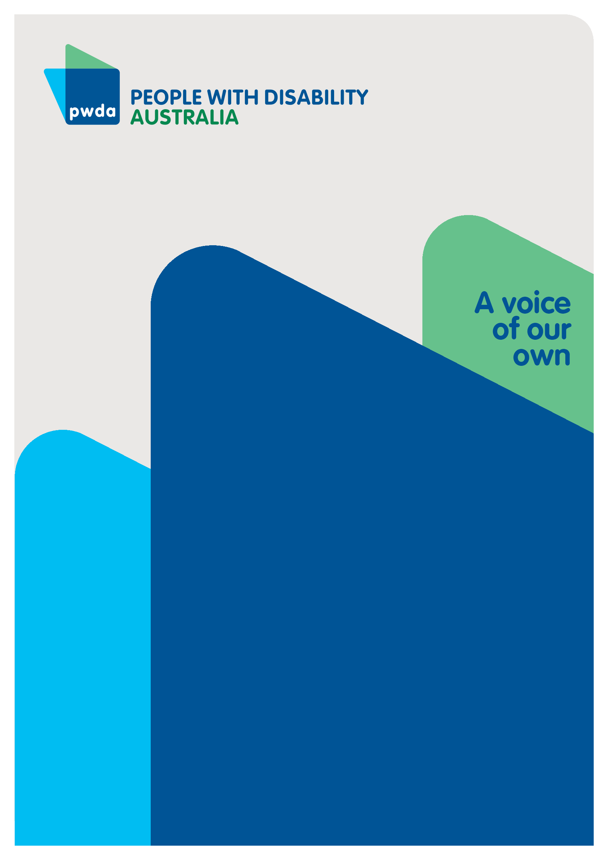
Disability and Poverty
Submission to the Community Affairs References Committee inquiry into the extent and nature of poverty in Australia
FEB
2023

Copyright information
Disability and poverty: Submission to the Community Affairs References Committee inquiry into the extent and nature of poverty in Australia.

First published in 2023 by People with Disability Australia
Level 8, 418a Elizabeth Street, Surry Hills, New South Wales, Australia 2010
Head office also in Sydney
Email: pwda@pwd.org.au
Phone: +61 2 9370 3100 Fax: +61 2 9318 1372
URL: www.pwd.org.au

Typeset in Arial 12 and 14 pt and VAG Rounded 16, 22 and 26 pt

© People with Disability Australia 2023

The moral rights of the authors have been asserted

National Library of Australia Cataloguing-in-Publication data:

Creator(s): | Michelle Keogh
Title: | Disability and Poverty: Submission to the Community Affairs References Committee inquiry into the extent and nature of poverty in Australia

All rights reserved. Except as permitted with the Australian Copyright Act 1968 (for example, a fair dealing for the purposes of study, research, criticism or review), no part of this book may be reproduced, stored in a retrieval system, communication or transmitted in any form or by any means without prior written permission. All inquiries should be made to the publisher at the address above.

Keogh, M., Disability and Poverty: Submission to the Community Affairs References Committee inquiry into the extent and nature of poverty in Australia, 3 February 2023, People with Disability Australia, Sydney
ISBN 978-0-6454251-7-8

About PWDA
People with Disability Australia (PWDA) is a national disability rights and advocacy organisation made up of, and led by, people with disability.
We have a vision of a socially just, accessible and inclusive community in which the contribution, potential and diversity of people with disability are not only recognised and respected but also celebrated.
PWDA was established in 1981, during the International Year of Disabled Persons.
We are a peak, non-profit, non-government organisation that represents the interests of people with all kinds of disability.
We also represent people with disability at the United Nations, particularly in relation to the United Nations Convention on the Rights of Persons with Disabilities (CRPD).
Our work is grounded in a human rights framework that recognises the CRPD and related mechanisms as fundamental tools for advancing the rights of people with disability.
PWDA is a member of Disabled People’s Organisations Australia (DPO Australia), along with the First People’s Disability Network, National Ethnic Disability Alliance and Women with Disabilities Australia.
DPOs collectively form a disability rights movement that places people with disability at the centre of decision-making in all aspects of our lives.
‘Nothing About Us, Without Us’ is the motto of Disabled Peoples’ International.

Contents

Disability and Poverty 1
Copyright information 2
About PWDA 3
The extent and nature of poverty in Australia 5
Disability and poverty 5
Recommendations 9
Appendix A 12
Endnotes 13

The extent and nature of poverty in Australia
People with Disability Australia (PWDA) welcomes the Community Affairs References Committee inquiry into the extent and nature of poverty in Australia. This submission addresses terms of reference items d, a, c, e, and f.

Disability and poverty

Term of reference (d) the impacts of poverty amongst different demographics and communities
PWDA is a leading systemic and individual advocacy and representative organisation that represents the interests of people with all kinds of disability. PWDA’s membership is comprised of people with disability and organisations primarily constituted by people with disability, and our Board is comprised of people with disability with extensive involvement and experience in the disability rights sector. This submission specifically addresses the impacts of poverty on Australians with disability.

Term of reference (a) the rates and drivers of poverty in Australia
Australians with disability experience significant economic disadvantage. On average, people with disability have lower income than people without disability, with the Organisation for Economic Cooperation and Development (OECD) estimating in 2010 that 45 per cent of all people with disability in Australia were living in poverty; and the Australian Council of Social Service and University of New South Wales estimating that 41 percent of people in households with a person accessing the Disability Support Pension in 2017-18 were in poverty. Australia also has the highest risk of relative poverty for people with disability among similar countries in the OECD.
These findings of high rates of poverty are borne out in the lived experiences of PWDA’s individual advocacy clients and reflected in PWDA’s reports and recommendations to previous inquiries (see Appendix A).
The connection between drivers and impacts of poverty for people with disability is cyclical in nature - disability can either cause or be a consequence of poverty, often resulting in a disability-poverty cycle that is difficult to escape. Poorer outcomes in employment, housing security, health, education, and other life domains, can be both drivers and impacts of poverty for people with disability, with cascading effects. This is discussed further below.

Term of reference (c) the impact of poverty on individuals in relation to: (i) employment outcomes, (ii) housing security, (iii) health outcomes, and (iv) education outcomes
- Employment
International data indicate people with disability have a labour force participation rate of just over 50 per cent, compared to more than 80 per cent for people without disability, and people with disability experience almost double the unemployment rate as people without disability. Low labour force participation results in reduced income, reduced economic security, and contributes to disadvantage. According to the OECD, low rates of employment are responsible for high rates of poverty for people with disability.
Consequently, living in poverty causes a cascade of poor outcomes in other life domains.
- Housing security
People with disability are, for example, more likely than people without disability to experience difficulties affording secure housing due to low labour force participation, reliance on the Disability Support Pension as a main income source, and additional housing costs such as home modifications.
An inability to secure affordable, accessible, suitable housing, contributes to:
- over-reliance on social housing (notwithstanding long waitlists)
- lack of appropriate choices and being forced to accept unsuitable housing options such as nursing homes, hospitals, group homes, and boarding houses
- increased exposure to violence, abuse, neglect and exploitation
- increased susceptibility to homelessness.
According to the Australian Institute of Health and Welfare (AIHW), 2 in 5 people accessing social housing have a disability; 1 in 12 people accessing Specialist Homelessness Services (SHS) have a disability, and of those who access SHS, people with disability are twice as likely to experience repeat homelessness, at a rate of 6 per cent compared to 3 per cent for those without disability.
In turn, housing insecurity and homelessness create additional barriers to entering or re-entering the workforce, themselves becoming drivers of poverty, further fueling the disability-poverty cycle.
- Health
Similarly, people with disability generally report poorer health and higher levels of psychological distress than people without disability. The economic (and social) disadvantage experienced by people with disability is likely a significant contributory factor to these poorer health outcomes.
For example, 1 in 5 (19 per cent) of people with disability who delay, or do not see a GP, do so because of the cost; 1 in 4 (27 per cent) who do not see a medical specialist when they need to, do so mainly because of the cost and 1 in 4 (24 per cent) who delay, or do not go to hospital, do so because of the cost.
The often-unaffordable higher health costs for people with disability, including additional disability-related costs such as medications, allied health, and specialist healthcare, coupled with lower employment rates and income, perpetuate poverty and add to psychological distress.
Again, in turn, poor health creates an additional barrier to employment or re-employment and financial security, further perpetuating economic disadvantage.
- Education
According to the OECD, the disability employment gap is aligned with a persistent education and skills gap for people with disability. A higher level of education generally results in better employment outcomes and higher income which are key factors in determining economic security.
However, people with disability face significant barriers to safe, quality, inclusive education and are more likely than people without disability to leave school early and to have a lower level of education. For example, only 32 per cent of people with disability aged 20 and over have completed Year 12, compared with 62 per cent of people without disability, and only 15 percent of people with disability aged 20 and over have a bachelor’s degree or higher, compared with 31 per cent of people without disability.
Yet, as highlighted by the Disability Royal Commission, education is critically important to the inclusion and independence of children and adults with disability and is an important determinant of future outcomes and the full development of an individual’s potential.

Term of Reference (e) the relationship between income support payments and poverty
People with disability in Australia are overly reliant on income support as a source of income and increasingly likely to be on unemployment payments, struggling in deep poverty. Analysis from the AIHW shows most Disability Support Pension recipients aged 16 to 64 years tend to remain on this payment for a long time, with very few moving onto other income support payments or exiting the income support system.
The Australian social security system, through its low payment rates and restrictive eligibility requirements, contributes significantly to the high levels of poverty experienced by people with disability.
While providing some basic income, these payments do not provide for an adequate safety net or standard of living. An adequate safety net through income support is particularly important for people with disability who face significant and complex barriers to education and employment. Inadequate rates of payment mean people trapped on income support fall further and further behind the living standards of the community as a whole.

Recommendations

Term of reference (f) mechanisms to reduce and address poverty
PWDA has long advocated for systemic changes to education, employment, and income support systems to reduce and address poverty for people with disability and create equality of opportunity in all life domains, including housing and health.
We reiterate the following key recommendations to this inquiry. These are discussed in more detail in the PWDA submissions listed in Appendix A.
Recommendation 1 – Break the links between poor educational outcomes, access to employment, and limited economic security by addressing barriers to education for people with disability.
In particular:
- phase out segregated education
- increase resources, supports and training for mainstream schools to provide safe, quality, inclusive education that dismantles barriers to people with disability achieving higher educational outcomes
- remove tuition fees for vocational courses and public universities for people with disability.
Recommendation 2 – Break the link between disability and poverty by addressing barriers to employment for people with disability.
The recommended first steps are:
- phase out the segregated employment created through Australian Disability Enterprises
- establish a Centre of Excellence for Disability Employment and specialist Disability Employment Services providers for specific cohorts
- improve accessibility and inclusive practice in all workplaces
- redesign the Disability Support Pension so people with disability are guaranteed lifelong access to support if they meet other eligibility criteria
  - remove any requirement to re-establish qualification upon reclaiming
  - remove the cap on hours that can be worked
  - permit people who meet requirements across multiple tables to access the Disability Support Pension
- employ a co-design and co-implementation approach to new initiatives to increase labor force participation of people with disability.
Recommendation 3 – Provide for an adequate standard of living, in relation to the rest of the community, for people with disability who cannot access employment.
This must include:
- making income support payments available to all who need them
- making sure the Disability Support Pension is always above the Henderson poverty line and increasing it annually, at least until a better measure is established
- increasing the rate of JobSeeker payments to the same rate as the Disability Support Pension inclusive of pension supplements.
PWDA looks forward to engaging with the Community Affairs References Committee to further examine and address the specific contexts, drivers, and impacts of poverty for people with disability in Australia.
Appendix A
PWDA submissions relevant to this inquiry are available at the following links:

2022
- Joint submission to the Australian Treasury’s employment white paper
- Submission to Department of Social Services Review of Disability Employment Services
- Report on wage equity and more choices in employment for people with an intellectual disability

2021
- Submission to Senate Community Affairs References Committee’s inquiry into the purpose, intent, and adequacy of the Disability Support Pension
- Submission to the Department of Social Services review of the Disability Support Pension impairment tables

2019
- Submission to Standing Committee on Community Affairs Inquiry into the adequacy of Newstart and alternative mechanisms to determine the level of income support payments in Australia

Endnotes
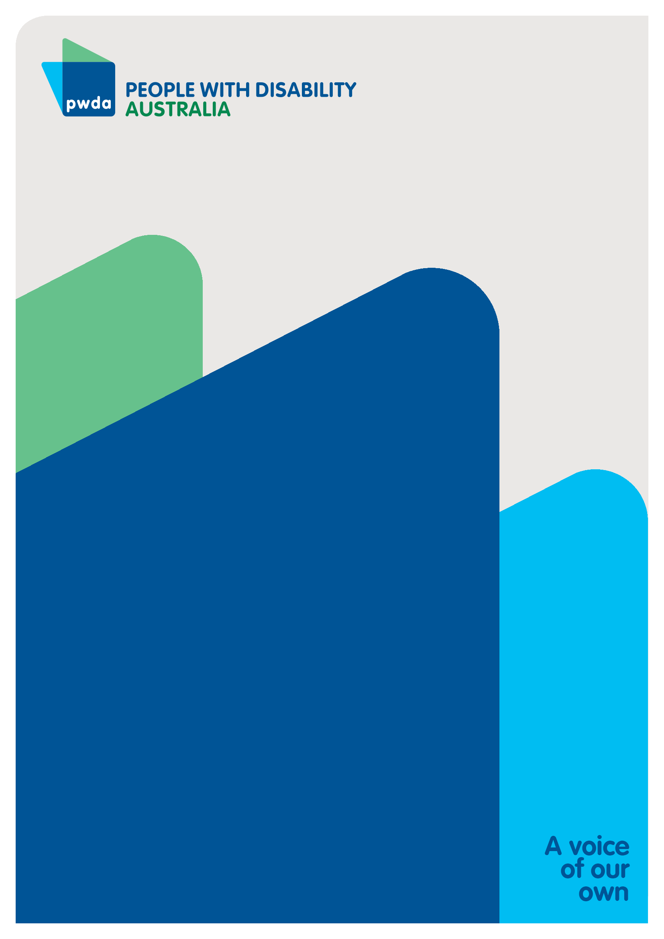
People with Disability Australia (PWDA) is a national disability rights and advocacy organisation made up of, and led by, people with disability.
For individual advocacy support contact PWDA between 9 am and 5 pm (AEST/AEDT) Monday to Friday via phone (toll free) on 1800 843 929 or via email at pwd@pwd.org.au
Submission contact
Giancarlo de Vera
Senior Manager of Policy
E: pwd@pwd.org.au

Australian Institute of Health and Welfare (AIHW), The Geography of disability and economic disadvantage in Australian capital cities, AIHW, Australian Government, 2009, accessed 4 January 2023; AIHW, People with disability in Australia (income and finance), AIHW, Australian Government, 2022, accessed 4 January 2023; Organisation for Economic Co-operation and Development (OECD), Sickness, disability and work: breaking the barriers; a synthesis of findings across OECD countries, OECD Publishing, 2010, accessed 4 January 2023; Australian Council of Social Service (ACOSS) and University of New South Wales (UNSW), Rate of poverty by income support payment, ACOSS and UNSW (n.d.), accessed 3 February 2023.
OECD, Society at a glance 2014: OECD Social indicators, OECD Publishing, 2014, accessed 6 January 2023.
OECD (2010)
Australian Government Productivity Commission, Deep and persistent disadvantage in Australia: productivity commission staff working paper, prepared by Rosalie McLachlan, Geoff Gilfillan and Jenny Gordon, Australian Government, 2013, accessed 4 January 2023.
OECD, Disability, work and inclusion; mainstreaming in all policies and practices, OECD Publishing, 2022, accessed 4 January 2023.
AIHW, People with disability in Australia (housing), AIHW, Australian Government, 2022, accessed 5 January 2023.
Senate Community Affairs Reference Committee, ‘Chapter 3: Lived experience of violence, abuse and neglect’, Violence, abuse and neglect against people with disability in institutional and residential settings, including the gender and age related dimensions, and the particular situation of Aboriginal and Torres Strait Islander people with disability, and culturally and linguistically diverse people with disability, November 2015, accessed 25 January 2023.
AIHW, People with disability in Australia 2019: in brief, AIHW, Australian Government, 2019, accessed 9 January 2023.
AIHW, People with disability in Australia (health), AIHW, Australian Government, 2022, accessed 5 January 2023.
VicHealth, Disability and health inequalities in Australia: research summary, VicHealth, Victorian Government, n.d., accessed 6 January 2023
AIHW (2019)
OECD (2022)
AIHW, People with disability in Australia (education and skills), AIHW, Australian Government, 2022, accessed 5 January 2023.
AIHW (2019)
Royal Commission into Abuse, Neglect and Exploitation of People with Disability (Royal Commission), Students with disability face serious barriers accessing safe, quality and inclusive education, Royal Commission, 2021, accessed 6 January 2023.
OECD (2014)
AIHW, People with disability in Australia (income support), AIHW, Australian Government, 2022, accessed 5 January 23.
Australian Federation of Disability Organisations (AFDO), Poverty and disability: fast facts, AFDO, n.d., accessed 6 January 2023.

