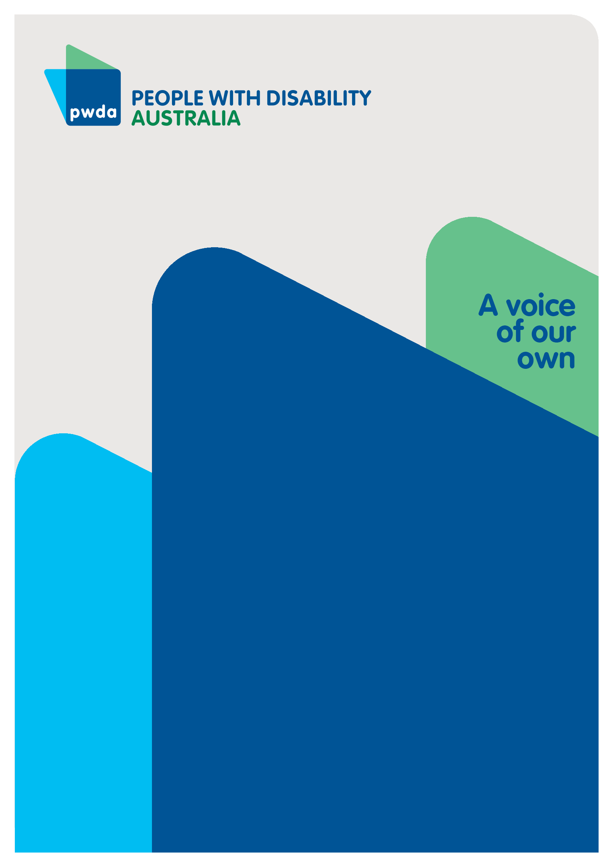
Budget Measures to Help Us Access Everyday Life
A pre-budget submission to the Commonwealth Treasury on employment and housing
JAN
2023

Copyright information
Budget measures to help us access everyday life: A pre-budget submission to the Commonwealth Treasury on employment and housing
Copyright © People with Disability Australia Ltd. 2023
First published 2023
Published by People with Disability Australia
Level 8, 418a Elizabeth Street, Surry Hills, Sydney, New South Wales, Australia 2010
Email: pwda@pwd.org.au
Phone: +61 2 9370 3100 Fax: +61 2 9318 1372
URL: www.pwd.org.au
All rights reserved. Without limiting the rights under copyright reserved above, no part of this publication may be reproduced, stored in or introduced into a database and retrieval system or transmitted in any form or any means (electronic, mechanical, photocopying, recording or otherwise) without the prior written permission of both the owner of copyright and the above publishers.
Printed by People with Disability Australia
Budget measures to help us access everyday life: A pre-budget submission to the Commonwealth Treasury on employment and housing
Ellis, A, Keogh, M, de Vera, G, Ira, L and Britt, J
ISBN 978-0-6454251-9-2
Ellis, A, Keogh, M, de Vera, G, Ira, L and Britt, J, Budget measures to help us access everyday life: A pre-budget submission to the Commonwealth Treasury on employment and housing, People with Disability Australia, 27 January 2023.

Table of contents
About PWDA iv
Summary v
Introduction 7
Employment budget measures 10
Housing budget measures 16

About PWDA
People with Disability Australia (PWDA) is a national disability rights and advocacy organisation made up of, and led by, people with disability.
We have a vision of a socially just, accessible and inclusive community in which the contribution, potential and diversity of people with disability are not only recognised and respected but also celebrated.
PWDA was established in 1981, during the International Year of Disabled Persons.
We are a peak, non-profit, non-government organisation that represents the interests
of people with all kinds of disability.
We also represent people with disability at the United Nations, particularly in relation to the Convention on the Rights of Persons with Disabilities (CRPD).
Our work is grounded in a human rights framework that recognises the CRPD and related mechanisms as fundamental tools for advancing the rights of people with disability.
PWDA is a member of Disabled People’s Organisations Australia (DPO Australia), along with the First People’s Disability Network, National Ethnic Disability Alliance and Women with Disabilities Australia.
DPOs collectively form a disability rights movement that places people with disability at the centre of decision-making in all aspects of our lives.
Nothing About Us, Without Us is the motto of members of the international disability community, and it’s our ethos too. We represent people with any type of disability across the country, to ensure Nothing About Us, Without Us.

Summary
Well-funded government employment and housing measures can create meaningful change for people with disability. The below budget measures will greatly improve the housing and economic security of people with disability, enabling much greater participation in all aspects of Australian life.
We encourage the Commonwealth government to fund the following housing and employment budget measures in the next Commonwealth Budget. These costed measures would involve expenditure of more than $7.5 billion of recurring revenue and at least $7.7 billion in one-off spending to benefit people with disability.

Employment recommendations
- Recommendation 1 – Suspend participation and mutual obligation requirements while the Disability Employment Services program is being reviewed
- Recommendation 2 – Ensure the Disability Support Pension rate is always above the Henderson poverty line (including housing costs)
- Recommendation 3 – Increase JobSeeker payments to the same rate as the Disability Support Pension inclusive of pension supplements
- Recommendation 4 – Introduce a $55 a week disability and illness supplement for people with disability on the JobSeeker payment and the Disability Support Pension to meet additional living costs
- Recommendation 5 – Increase the income free-area for the Disability Support Pension to a level equal with recent changes in the Age Pension and Veteran Payment, and change the taper rate to 25 cents in the dollar for income over the Work Bank total
- Recommendation 6 – Provide lifelong access to the Centrelink Disability Support Pension, and improve access to the Disability Support Pension by permitting people to meet impairment table requirements across multiple tables
- Recommendation 7 – Promote and introduce reforms, including waived tuition fees for vocational courses and public universities.

Housing recommendations
- Recommendation 8 – Create a dedicated national housing plan for people with disability as part of the National Affordable Housing Agreement and appoint a person with disability to join the new interim National Housing Supply and Affordability Council
- Recommendation 9 – Establish a program to fund necessary modifications of existing housing to (a) meet Livable Housing Australia Silver-level design guidelines, and (b) rationalise existing home-modification assistance programs under one Commonwealth program
- Recommendation 10 – Revise targets and begin building at least 25,000 social housing properties each year and set annual targets for housing for people with disability
- Recommendation 11 – Increase Commonwealth Rent Assistance by 50%
- Recommendation 12 – Fund specialist disability homelessness services to meet demand.

Introduction
People with Disability Australia (PWDA) welcomes this opportunity to make recommendations to the Commonwealth Government on the employment and housing priorities of people with disability for the Commonwealth Budget 2023–24.
All funding and policy decisions in relation to people with disability should be underpinned by the principles of the United Nations Convention on the Rights of Persons with Disabilities (CRPD).0F These principles require governments to work collaboratively with people with disability and their representative organisations to co-design and implement disability-related budget measures.
In this submission we outline and cost employment and housing budget measures to improve the housing and economic security of people with disability, enabling much greater participation in all aspects of Australian life. The costed measures would involve expenditure of more than $20 billion of recurring revenue and $4 billion in one-off spending to benefit people with disability.

Employment
Many people with disability face significant barriers to obtaining and keeping a job. This contributes to the high numbers of people with disability who do not have
access to paid work. For example, while unemployment among people with disability has grown from 8% to 10% between 2003 and 2018, it has stayed relatively steady at 5% for people without disability during this period.1F
Employment ensures the independence of people with disability and enables their participation and inclusion in the Australian community. Having jobs helps people with disability realise the human rights and freedoms they have that are actively promoted and protected under the CRPD, including article 272F (right to work) on an equal basis with others.
Additionally, CRPD article 243F affirms the right of people with disability to an education equal to others in the community. Education plays a critical role in ensuring good employment outcomes. It also makes a difference to people realising their rights, just like employment does.
Income support programs delivered by Services Australia affect our success in employment. People with disability need changes to our nation’s income support system to enable us to seek better outcomes in mainstream employment.

Housing
In addition to employment barriers, people with disability continue to face significant barriers to accessing housing that meets their needs. The issues that people with disability experience with housing means they are at increased risk of homelessness.
According to the Australian Institute of Health and Welfare, 2 in 5 people accessing social housing have a disability, 1 in 12 people accessing Specialist Homelessness Services (SHS) have a disability and, of those who access SHS, people with disability are twice as likely to experience repeat homelessness, at a rate of 6% compared to 3% for those without disability.4F
People with disability are more likely to experience difficulties affording secure housing due to low labour force participation, overreliance on the Disability Support Pension (DSP) as a main income source, and additional housing costs such as home modifications.5F
While people with disability have a clear right to live independently in the community (article 19)6F, people with disability must also be able to live in homes free from torture or cruel, inhuman or degrading treatment or punishment (article 15)7F in homes free of exploitation, violence and abuse (article 16)8F. Despite these rights, many people with disability continue to be forced to live in unsuitable accommodation that exposes them violence.9F
Safe, secure and suitable housing is fundamental to the full and equal enjoyment of their other human rights and freedoms, and key to build opportunities for social and economic participation, including education, employment, access health and other services, and to maintain personal safety.
We know well-funded government employment and housing measures can create meaningful change and help people with disability access everyday life. We believe Commonwealth funds can help deliver this change. We encourage the government to fund the budget measures we’re suggesting in the next Commonwealth Budget.

Employment budget measures
Only 53% of working age people with disability of are in paid work, compared to 84% of their peers without disability.10F That gap between their participation rates and the rest of the community continues to be significant.
When compared with other Organisation for Economic Co-operation and Development (OECD) countries, Australia ranks 21 out of 29 for our nation’s employment participation rates for people with disability.11F
In 2020, only 47% of people with disability aged 25 or older with a National Disability Insurance Scheme (NDIS) plan are in open employment with full wages, while another 36% are found in sheltered workshops known as Australian Disability Enterprises (ADEs).12F In ADEs people often work for less than Australia’s $21.38 minimum wage13F – and can be paid hourly rates of $2.37 an hour.14F
The recommendations outlined in this submission will contribute significantly to improving the participation rate of people with disability in the mainstream labour market.

Recommendation 1 – Suspend participation and mutual obligation requirements while the Disability Employment Services program is being reviewed
Current participation and mutual obligation requirements oblige many people with disability to undertake compulsory activities, such as looking for work or working a set number of hours. People with disability often struggle to fulfil these requirements. Support available through Disability Employment Services (DES) and Workforce Australia providers, is often insufficient.15F Many people with disability are placed in jobs that are short term or otherwise not a good fit.
The Commonwealth Government is currently conducting an additional review of the DES program in 2023, after extending its current running time a further two years to 30 June 2025. In the meantime, Services Australia should suspend all participation and mutual obligation requirements. As we saw when obligations were suspended during COVID,16F suspending obligations will give people with disability more capacity to find meaningful jobs in the mainstream labour market.
Cost estimate: No additional cost to the Australian Government

Recommendation 2 – Ensure the Disability Support Pension rate is always above the Henderson poverty line (including housing costs)
Disability and poverty are interrelated. Disability can lead to poverty, and poverty can lead to disability. People with disability are more likely than people without disability to experience poverty.17F While 1 in 8 Australians (13%) live in poverty,18F a greater proportion, or 1 in 6 Australians with disability (17%) live in poverty.19F Concerningly, 45% of people with disability in Australia live near or below the poverty line,20F which is more than double the OECD average of 22%.21F
To address this, we recommend the DSP rate has reference to the Henderson poverty line (inclusive of housing costs) and always remains above it, while also increasing the Commonwealth Rent Assistance payment by 50% in line with ACOSS’ 2023-24 Pre-Budget Submission (please see our recommendation 11 below).

Recommendation 3 – Increase JobSeeker payments to the same rate as the Disability Support Pension inclusive of pension supplements
While recommendation 2 will support people with disability who access the DSP, a significant proportion of people with disability are unable to access the higher DSP payment and subsequently living in poverty on the JobSeeker payment.
For this reason, PWDA supports the ACOSS Pre-Budget Submission recommendation to lift the rate of JobKeeper to align with the current pension rate (including supplements). We do note however, that the increase to JobKeeper should align with any increases to the DSP that arise because of Recommendation 2 above.

Recommendation 4 – Introduce a $55 a week disability and illness supplement for people with disability on the JobSeeker payment and the Disability Support Pension to meet additional living costs
Even with increases to the rates of JobSeeker and the DSP suggested in the above recommendations, these rates do not consider higher disability-related living costs.
We support the ACOSS 2023–24 Pre-Budget Submission to introduce a disability and illness supplement benchmarked to higher living costs faced by people with disability and/or chronic illness. The recommendation reflects work conducted by National Centre for Social and Economic Modelling (NATSEM) in 2019 analysing the costs of disability.22F
NATSEM showed a person with a disability would need an extra $50 a week to achieve the same standard of living as a single person without a disability, and so adjusted for inflation since 2019, we support ACOSS’ call to introduce a Disability and Illness Supplement of $55 a week for those on JobSeeker.
Cost estimate: $3.5 billion in 2023-24

Recommendation 5 – Increase the income-free area of the Disability Support Pension to a level equal with recent changes in the Age Pension and Veterans Pension, and change the taper rate to 25 cents in the dollar for income over the Work Bank total
Presently, people with disability on the DSP who exceed the income free-area (IFA) threshold have their pension reduced by the relevant taper rate.
Following the passing of the Social Services and Other Legislation Amendment (Workforce Incentive) Act 2022 last year, those on the Age and Veterans pension are now able to earn an extra $4000 without having their pension reduced.23F Considering many people with disability live close to the poverty line, the same must apply to people with disability on the DSP.
We recommend parity between the DSP, Age and Veterans Pensions by allowing people with disability in receipt of the DSP to be able to earn an additional $4000 before triggering the relevant taper rate. Additionally, we recommend changing the taper rate to 25 cents in the dollar for income over the Work Bank total.
This will encourage people with disability to participate in the workforce while receiving an income support payment such as the DSP and reduce their risk of living near the poverty line.

Recommendation 6 – Provide lifelong access to the Centrelink Disability Support Pension, and improve access to the Disability Support Pension by permitting people to meet impairment table requirements across multiple tables
People with disability living on the DSP may subsequently become ineligible due to obtaining well-paid or regular work or accessing funds. However, people with disability may need to re-access the DSP when circumstances change, for example if their disability is episodic in nature.
Re-accessing the DSP can be difficult especially with the stricter requirements with the DSP impairment tables, creating unnecessary uncertainty, trauma and stress for people with disability. To address this issue, the government should make DSP access lifelong.
In addition, when assessing eligibility for the DSP, the government should allow people to accumulate points from multiple impairment tables. Many people with disability have multiple co-existing conditions and impairments. While an individual condition might be considered minor, they can collectively add up to significant impairment in our everyday life. Allowing people to accumulate points from multiple impairment tables would acknowledge the pressures of managing multiple conditions and impairments and provide a more inclusive assessment process.
Cost estimate: $1.3 billion a year

Recommendation 7 – Promote and introduce reforms, including waived tuition fees for vocational courses and public universities
Access to free education is fundamental for ensuring equity and opportunity in society. With a good education, people with disability will have more opportunities to gain employment and not have to rely on the DSP.
Research has shown that the more expensive a course, the less likely it will be studied by students with disadvantage24F or intersecting disadvantage, including disability.
Providing free tertiary education would encourage people with disability to enrol in courses that suit their interests and career aspirations, knowing that they can reserve their own funds for the higher costs of living, including disability-related costs, that people with disability have.
Cost estimate: $6.1 billion a year

Housing budget measures
As already discussed, the full and effective participation and inclusion of people with disability is a human right, affirmed, protected and promoted under the CRPD.25F Consequently, Australia is obliged, under the CRPD, to take necessary measures to address systemic exclusion and segregation and to provide individuals with mechanisms to claim their right to be included in the community. Unsuitable housing neither meets people’s immediate needs nor allows for participation, inclusion, or choice and control over their lives and futures.
Low labour-force participation results in reduced income and contributes to disadvantage.26F According to the OECD, low rates of employment are responsible for high rates of poverty for people with disability.27F
At a time when active measures28F are being pursued to increase access to employment for people with disability, housing insecurity and homelessness continue to create additional barriers to entering or re-entering the workforce, becoming drivers of poverty, and fuelling the disability-poverty cycle.
Segregation and exclusion also create conditions of isolation in which violence, abuse, neglect and exploitation can take place, both in congregated housing settings and private homes. Inclusion and ‘visibility’ in society are foundational to preventing violence.
Concerningly, our advocates tell us a lack of available housing alternatives and fear of becoming homeless continue to keep many people with disability living in environments that are considered abusive and exploitative.
PWDA believes a lack of appropriate, accessible, affordable, sustainable housing for people with disability, and an absence of practical solutions, is contributing to:
- over-reliance on social housing (notwithstanding long waitlists)29F
- a lack of appropriate choices and people accepting or being put into unsuitable housing in congregate settings such as nursing homes, hospitals, group homes, and boarding houses
- increased susceptibility to homelessness30F
- additional barriers to independence, community inclusion, participation in education and employment, and accessing health and other services
- increased exposure to violence, abuse, neglect, and exploitation.
The housing crisis for Australians with disability requires immediate and significant action from governments and must be addressed in the Commonwealth Budget 2023–24.
While important and welcome housing measures31F were included in the October 2022 Commonwealth Budget, including a new National Housing Accord,32F and December’s announcement on the introduction of the interim National Housing Supply and Affordability Council,33F more needs to be done to address the even more acute housing crisis being experienced by people with disability.
PWDA advocates for the following urgent, practical housing measures. These measures will make a real difference in the lives of people with disability.

Recommendation 8 – Create a dedicated national housing plan for people with disability as part of the National Affordable Housing Agreement and appoint a person with disability to join the new interim National Housing Supply and Affordability Council
The National Affordable Housing Agreement34F (NAHA) provides a framework for governments to work together to improve housing and homelessness outcomes for all Australians. NAHA aims to improve Australians’ participation in everyday economic and social life by ensuring they have access to safe, affordable and sustainable housing.
PWDA welcomes the Australian Government’s one-year extension of NAHA to 30 June 2024 in the October 2022 Budget35F. However, we believe it remains a concern that the current NAHA does not address the additional barriers to housing experienced by people with disability. To address this, the disability community needs a dedicated national housing plan for people with disability to operate alongside NAHA. The plan must set
co-designed targets and actions, including disability-specific data collection and research, and be informed by targeted performance indicators, evaluation and reporting on the performance of NAHA, specific to people with disability.
The new interim National Housing Supply and Affordability Council36F is also welcomed and will be responsible for delivering advice on options to improve housing supply and affordability, and reporting on key issues in housing policy. It is essential that housing issues specific to people with disability are represented in the council’s advice and reporting.
Cost estimate: No additional cost to the Australian Government

Recommendation 9 – Establish a program to fund necessary modifications of existing housing
It is necessary to fund a program to:
- Meet Livable Housing Australia Silver-level design guidelines37F
Voluntary accessible housing guidelines have not resulted in meaningful change, with approximately less than 5% of new housing having basic accessibility features such as wider doorways, one entry point for wheelchair users, and a toilet on the ground floor.38F This failure has led to the introduction of minimum accessibility requirements in the National Construction Code (NCC) to ensure all new buildings are accessible.39F The resulting lack of accessible housing has meant that people with disability struggle to find accessible homes, increasing people’s reliance on home modifications and retrofitting, and, in many cases, their living in unsafe or unsuitable dwellings.
The government must make funding available to undertake all necessary modifications of existing housing to meet the Livable Housing Australia Silver-level design guidelines, to increase the accessible housing stock across all states and territories.
Cost estimate: $400 million to fund 400,000 dwellings at a cost of $1000 for basic modifications
- Rationalise existing home-modification assistance programs under one Commonwealth program
Home modification schemes can increase the availability of accessible housing stock for people with disability. However, a lack of consistency, coordination, quality control and national standards across the multitude of home modifications schemes, including for older people with disability, reduces the effectiveness of these schemes.
Additionally, we often hear from people for whom home modifications can’t be approved or implemented while living in insecure accommodation. This means people continue to live indefinitely without adequate supports.
At no cost to government, we advocate for a national framework and amalgamate current home modifications supports from the NDIS, aged care and Department of Veterans’ Affairs systems into one system.
Cost estimate: No additional cost to government

Recommendation 10 – Revise targets and begin building at least 25,000 social housing properties and set targets for housing for people with disability
People with disability are often dependent on social housing for the reasons discussed throughout this submission. However, people with disability face extensive social housing waiting times, leaving them without safe housing for years and in some cases decades.40F
The Australian Government has a significant role in funding social and affordable housing, by providing leadership and coordination, and through grants to states and territories. This has been recognised through the welcome establishment of the National Housing Accord and the interim National Housing Supply and Affordability Council. As well as significantly increasing the availability of public housing, these measures, along with the Housing Australia Future Fund, need to set and achieve specific targets for housing for people with disability.
People with Disability Australia supports the Everybody’s Home campaign and agrees that Australia needs to urgently begin building at least 25,000 social housing properties – 5000 more than the existing 20,000 homes target in the National Housing Accord from the October 2022 budget.41F
Cost estimate: An additional $3.8 billion

Recommendation 11 – Increase Commonwealth Rent Assistance by 50%
Australia is experiencing a rental crisis, with very low rental vacancy (less than 1%)42F and increasing rent prices.
The current rent assistance rate is capped at $151.60 for single people without dependents.43F This is insufficient to address the housing insecurity and risk of homelessness faced by the many people with disability who rely on income support.
The rate also does not account for the additional housing burdens experienced by many people with disability, such as limited availability of accessible homes, which can push the market price up, and the need for home modifications, on top of the alarmingly escalating rent prices for all Australian renters.
In line with the ACOSS 2023–24 Pre-Budget submission, the Australian Government must benchmark Commonwealth Rent Assistance to actual rents paid, increasing the current rates’ maximum threshold by 50% and doubling the maximum payment rate.

Recommendation 12 – Fund specialist disability homelessness services to meet demand
People experiencing homelessness are among the most socially and economically disadvantaged in Australian society.44F Only 52% of Specialist Homelessness Services clients with disability are provided with accommodation when they need it.45F
People with disability who are homeless or facing homelessness face additional risk factors, such as limited engagement with the labour market, lack of social support, low income, lack of accessible housing and discrimination in the private rental market. The right wraparound supports are needed, at the right time, to maintain or acquire stable housing and change people’s trajectory of homelessness.46F
The government must adequately fund specialist services that support people with disability who are homeless or at risk of homelessness, including a specialist tenancy support service.
Cost estimate: $100 million a year

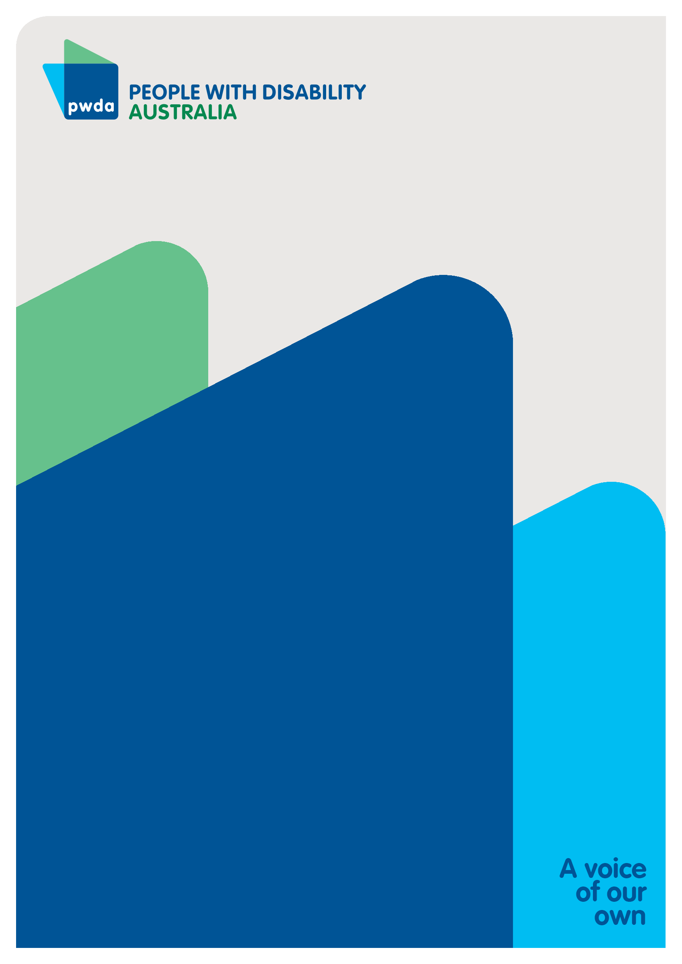
People with Disability Australia (PWDA) is a
national disability rights and advocacy organisation
made up of, and led by, people with disability.
PWDA submission contact:
Amanda Ellis
Senior Policy Officer
pwd@pwd.org.au

United Nations, Convention on the Rights of Persons with Disabilities, UN, 2006, last accessed 12 January 2023. https://www.un.org/development/desa/disabilities/convention-on-the-rights-of-persons-with-disabilities.html
Australian Government Australian Institute of Health and Welfare, ‘Unemployment’, People with disability in Australia 2019: in brief, Australian Government, last accessed 24 January 2023. https://www.aihw.gov.au/reports/disability/people-with-disability-in-australia/contents/employment/unemployment#Unemployment%20rate
United Nations, ‘Article 27 – Work and employment’, Convention on the Rights of Persons with Disabilities, UN, 2006, last accessed 12 January 2023. https://www.un.org/development/desa/disabilities/convention-on-the-rights-of-persons-with-disabilities/article-27-work-and-employment.html
United Nations, ‘Article 24 – Education’, Convention on the Rights of Persons with Disabilities, UN, 2006, last accessed 12 January 2023. https://www.un.org/development/desa/disabilities/convention-on-the-rights-of-persons-with-disabilities/article-24-education.html
Australian Government Australian Institute of Health and Welfare, People with disability in Australia 2019: in brief, Australian Government Australian Institute of Health and Welfare, AIHW, Australian Government, 2019, last accessed 9 January 2023. https://www.aihw.gov.au/reports/disability/people-with-disability-in-australia-in-brief/contents/how-many-people-have-disability
AIHW, People with disability in Australia
United Nations, ‘Article 19 – Living independently and being included in the community’, Convention on the Rights of Persons with Disabilities, UN, 2006, last accessed 12 January 2023. https://www.un.org/development/desa/disabilities/convention-on-the-rights-of-persons-with-disabilities/article-19-living-independently-and-being-included-in-the-community.html
United Nations, ‘Article 15 – Freedom from torture or cruel, inhuman or degrading treatment or punishment’, Convention on the Rights of Persons with Disabilities, UN, 2006, last accessed 12 January 2023. https://www.un.org/development/desa/disabilities/convention-on-the-rights-of-persons-with-disabilities/article-15-freedom-from-torture-or-cruel-inhuman-or-degrading-treatment-or-punishment.html
United Nations, ‘Article 16 – Freedom from exploitation, violence and abuse’, Convention on the Rights of Persons with Disabilities, UN, 2006, last accessed 12 January 2023. https://www.un.org/development/desa/disabilities/convention-on-the-rights-of-persons-with-disabilities/article-16-freedom-from-exploitation-violence-and-abuse.html
Senate Community Affairs Reference Committee, ‘Chapter 3: Lived experience of violence, abuse and neglect’, Violence, abuse and neglect against people with disability in institutional and residential settings, including the gender and age related dimensions, and the particular situation of Aboriginal and Torres Strait Islander people with disability, and culturally and linguistically diverse people with disability, November 2015, last accessed 25 January 2023. https://www.aph.gov.au/Parliamentary_Business/Committees/Senate/Community_Affairs/Violence_abuse_neglect/Report
NDIS, Employment outcomes for NDIS participants: As at 31 December 2020, National Disability Insurance Agency, 2021, last accessed 24 January 2023. https://data.ndis.gov.au/reports-and-analyses/outcomes-and-goals/employment-outcomes-participants-their-families-and-carers#:~:text=Employment%20outcomes%20for%20NDIS%20participants%20as%20at%2031,support%20received%20to%20find%20or%20keep%20a%20job.
OECD, Sickness, Disability and Work: Breaking the barriers – A Synthesis of findings across OECD countries, OECD, 24 November 2010, last accessed 23 January 2023. https://doi.org/10.1787/9789264088856-en
NDIA, NDIS Employment Outcomes 30 June 2018: NDIS participants, their families and carers
Australian Government Fair Work Ombudsman, ‘Minimum wages: Find our fact sheet on maximum weekly hours an employee can work under the National Employment Standards’, Australian Government Fair Work Ombudsman, FWO, undated, last accessed 23 January 2023. https://www.fairwork.gov.au/tools-and-resources/fact-sheets/minimum-workplace-entitlements/minimum-wages
Royal Commission into Violence, Abuse, Neglect and Exploitation of People with Disability, ‘People with disability paid as low as $2.37 per hour in Australian Disability Enterprises’, Royal Commission into Violence, Abuse, Neglect and Exploitation of People with Disability, Disability Royal Commission, 11 April 2022, last accessed 23 January 2023. https://disability.royalcommission.gov.au/news-and-media/media-releases/people-disability-paid-low-237-hour-australian-disability-enterprises
People with Disability Australia and the Antipoverty Centre, Ask What We Want: Ensure employment services encourage meaningful work for people with disability, PWDA, February 2022, last accessed 23 January 2023. https://pwd.org.au/des-review-submission
E Klein, K Cook and S Murray, ‘What happens when you free unemployed Australians from ‘mutual obligations’ and boost their benefits? We just found out’, The Conversation, The Conversation, 25 March 2021, last accessed 23 January 2023, https://theconversation.com/what-happens-when-you-free-unemployed-australians-from-mutual-obligations-and-boost-their-benefits-we-just-found-out-157506
Senate Community Affairs Committee Secretariat, ‘Chapter 4: The impact of income inequality on disadvantaged groups’, Bridging our growing divide: inequality in Australia – The extent of income inequality in Australia, December 2014, last accessed 23 January 2023. https://www.aph.gov.au/Parliamentary_Business/Committees/Senate/Community_Affairs/Income_Inequality/Report/c04
UNSW Sydney and ACOSS, Poverty in Australia 2022: A snapshot – An ACOSS/UNSW Sydney Poverty & Inequality Partnership Project, Australian Council of Social Service in partnership with UNSW Sydney, October 2022, last accessed 23 January 2023. https://povertyandinequality.acoss.org.au/wp-content/uploads/2022/10/Poverty-in-Australia-2020_A-snapshot.pdf
ACOSS and UNSW Sydney, Poverty in Australia 2018, UNSW Sydney and ACOSS, 2018, last accessed 23 January 2023. https://www.acoss.org.au/wp-content/uploads/2018/10/ACOSS_Poverty-in-Australia-Report_Web-Final.pdf
pwc, Disability expectations: Investing in a better life, a stronger Australia – Achieving better outcomes for people with a disability and their families, November 2011, last accessed 23 January 2023. https://www.pwc.com.au/industry/government/assets/disability-in-australia.pdf
OECD, Sickness, disability and work
Li, J. et al, Inequalities in standards of living: Evidence for improved income support for people with disability, National Centre for Social and Economic Modelling, 2019, last accessed 25 January 2023. https://www.afdo.org.au/wp-content/uploads/2019/09/02A-NATSEM-Online-Disability-Report.pdf
Minister for Social Services, ‘Giving older Australians the choice and flexibility to work’, The Hon Amanda Rishworth MP media release, 22 November 202, last accessed 25 January 2023. https://ministers.dss.gov.au/media-releases/9746
M Henry, ‘The good, the bad, and the “TBC”: How the Job-Ready Graduates Package affects student equity‘, NCSEHE | National Centre for Student Equity in Higher Education, Curtin University, 22 July 2020, last accessed 24 January 2023. https://www.ncsehe.edu.au/job-ready-graduates-package-student-equity
UN, Convention on the Rights of Persons with Disabilities
Australian Government Productivity Commission, Deep and persistent disadvantage in Australia: productivity commission staff working paper, prepared by Rosalie McLachlan, Geoff Gilfillan and Jenny Gordon, Australian Government, 2013, last accessed 4 January 2023. https://www.pc.gov.au/research/supporting/deep-persistent-disadvantage
OECD, Disability, work and inclusion: mainstreaming in all policies and practices, OECD Publishing, 2022, last accessed 4 January 2023. https://www.oecd.org/social/disability-work-and-inclusion-1eaa5e9c-en.htm
Ministers for the Department of Social Services, ‘Government inks agreement for innovative disability employment pilot’, The Hon Amanda Rishworth MP media releases, 6 January 2023, last accessed 23 January 2023. https://ministers.dss.gov.au/media-releases/9981
Australian Government Australian Institute of Health and Welfare, ‘How many receive housing assistance?’, People with disability in Australia 2019: in brief, Australian Government, last accessed 24 January 2023. https://www.aihw.gov.au/reports/disability/people-with-disability-in-australia-in-brief/contents/how-many-receive-housing-assistance
Australian Institute of Health and Welfare, How many receive housing assistance?
Australian Government, Budget October 2022–23 Improving Housing Supply and Affordability: The Australian Government’s commitment to deliver more homes for Australians, housing factsheet, October 2022, Australian Government, last accessed 23 January 2023. https://budget.gov.au/2022-23-october/content/factsheets/download/factsheet_housing.pdf
Ministers Treasury portfolio, ‘National Housing Accord: working together to help tackle housing challenges’, Ministers Treasury portfolio, Joint media release with The Hon Julie Collins MP, Minister for Housing, Minister for Homelessness, Minister for Small Business, 25 October 2022, last accessed 23 January 2023. https://ministers.treasury.gov.au/ministers/jim-chalmers-2022/media-releases/national-housing-accord-working-together-help-tackle
Minister for Housing, Minister for Homelessness, Minister for Small Business, ‘Interim National Housing Supply and Affordability Council’, Ministers Treasury portfolio, Australian Government, 20 December 2022, last accessed 23 January 2023. https://ministers.treasury.gov.au/ministers/julie-collins-2022/media-releases/interim-national-housing-supply-and-affordability
Coalition of Australian Governments, National Affordable Housing Agreement, COAG, undated, last accessed 23 January 2023. https://federalfinancialrelations.gov.au/sites/federalfinancialrelations.gov.au/files/2021-07/national-housing-agreement.pdf
PRObono Australia, ‘Housing spending blitz in budget’, PRObono Australia, 26 October 2022, last accessed 23 January 2023. https://probonoaustralia.com.au/news/2022/10/housing-spending-blitz-in-budget
Minister for Housing, Minister for Homelessness, Interim National Housing Supply and Affordability Council
Liveable Housing Australia, Liveable Housing Design Guidelines: LHA Silver, Livable Housing Australia, LHA, undated, last accessed 16 January 2023. https://livablehousingaustralia.org.au/lha-silver
Building Better Homes, ‘Our mission’, Building Better Homes: A National Construction Code for All Australians, Building Better Homes, undated last accessed 23 January 2023. https://www.buildingbetterhomes.org.au/mission.html
Building Better Homes, Building Better Homes: A National Construction Code for All Australians
H Stone, A Batchelor and M Mead, Access denied: The experiences of people with physical disability across the NSW housing sector, PDCN Physical Disability Council of NSW, February 2023 forthcoming publication, last accessed 23 January 2023.
Everybody’s Home, Everybody’s Home Budget Position Paper October 2022, Everybody’s Home, 2022, last accessed 16 January 2023. https://everybodyshome.com.au/resources/everybodys-home-budget-position-paper-october-2022
AHURi, Why does Australia have a rental crisis, and what can be done about it?, AHURi, 16 November 2022, last accessed 23 January 2023. https://www.ahuri.edu.au/research/brief/why-does-australia-have-rental-crisis-and-what-can-be-done-about-it
Australian Government Services Australia, ‘How much you can get’, Australian Government Services Australia, last updated 20 September 2022, last accessed 23 January 2023. https://www.servicesaustralia.gov.au/how-much-rent-assistance-you-can-get?context=22206
Table DIS.2 in Data tables: Specialist homelessness services annual report 2021–22 at Australian Government Australian Institute of Health and Welfare, ‘Homelessness and homelessness services’, Australian Government Australian Institute of Health and Welfare, Australia's welfare 2021 snapshot, 2021, AIHW, last accessed 23 January 2023. https://www.aihw.gov.au/reports/homelessness-services/specialist-homelessness-services-annual-report/data
AIHW, Homelessness and homelessness services
National Council on Intellectual Disability, ‘Accommodation’, The Rights of People with Disabilities: Areas of Need for Increased Protection, chapter 4, AHRC, 1989, last accessed 23 January 2023. https://humanrights.gov.au/our-work/rights-people-disabilities-areas-need-increased-protection-chapter-4-accommodation#recs and S Maalsen, P Wolifson, D Rogers, J Nelson, C Buckle, Understanding Discrimination Effects in Private Rental Housing, AHURI, September 2021. https://doi.org/10.18408/ahuri7324501

