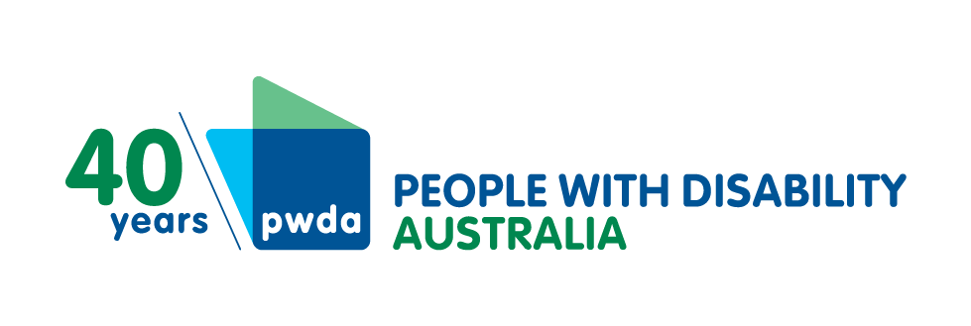
PO Box 666
Strawberry Hills
NSW 2012
+61 2 9370 3100
pwd@pwd.org.au
www.pwd.org.au
20 December 2021
Legal & Constitutional Affairs Legislation Committee
Parliament of Australia
Parliament House
Canberra ACT 2600
Attention: Legcon Chair
CC: Legcon Secretariat (legcon.sen@aph.gov.au)
Delivered electronically at aph.gov.au

Dear senators Henderson, Carr, Ciccone, Scarr and Thorpe

Religious Discrimination Bill 2021 and related bills
People with Disability Australia (PWDA) welcomes this opportunity to make this submission on the following 23 November 2021 religious discrimination Bills to the Legal & Constitutional Affairs Legislation Committee (Legcon) inquiry:
- Religious Discrimination Bill 2021
- Religious Discrimination (Consequential Amendments) Bill 2021
- Human Rights Legislation Amendment Bill 2021
PWDA has already publicly gone on the record along with many other social sector organisations in opposing earlier drafts of the legislation in an open letter to Prime Minister Scott Morrison which you can find online at Equality Australia (enclosed).

About us
PWDA is a leading disability rights advocacy and representative organisation and the only national cross-disability organisation representing the interests of people with all kinds of disability. We are a not-for-profit and non-government organisation, and our membership is comprised of people with disability and organisations primarily constituted by people with disability, including the PWDA Board and many members of our staff.
Our organisation is funded by the Commonwealth Government as a national peak disability organisation representing all people with disability, as well as the New South Wales Government to be a state disability peak body. We are also funded by the Queensland Government to undertake systemic advocacy on behalf of people with disability in regional Queensland.
PWDA has extensive experience in providing individual advocacy and outreach to people with disability, including people living in closed or hard-to-reach settings. We deliver advocacy support through the National Disability Advocacy Program across New South Wales and Queensland.

Our views
PWDA supports fair and equal anti-discrimination laws which equally protect all of us,
including people with disability, people of faith and those who are not religious,
alongside other groups. Equally we note that all states and territories have existing legislation to prohibit religious discrimination.
Given that we understand the draft legislation is now complete we hold some concerns with the second part of the Bill including:

Statement of belief provision
PWDA is concerned the statement of belief provision of the draft legislation will override existing federal, state and territory anti-discrimination laws by making so-called statements of belief immune from legal consequences under said Commonwealth laws such as the Disability Discrimination Act 1992 and the Racial Discrimination Act 1975.
We note that this provision is a stark departure from the considered practice of federal anti-discrimination law. The consequence of overriding state and territory laws could cause the state-based tribunal system to be placed under extreme pressure.
PWDA highlights the draft bills are a very complicated piece of legislation with layers of loopholes.
We also question whether this piece of legislation is constitutional.
PWDA does not believe the external affairs powers that the federal parliament is nominally relying upon to enact this legislation is the platform.
Instead, we believe the proper platform for any reforms of this nature is for the Australian Government to enact treaty obligations, such as the International Covenant on Civil and Political Rights, which otherwise covers the right to freedom of thought, conscience, and belief. PWDA notes that Australia has not fully implemented this multilateral treaty from 1966. We believe fully enacting this 55-year-old treaty would ensure fully sanctioned freedom of thought, belief and conscience, without overriding existing federal, state and territory anti-discrimination laws.
PWDA notes that the state of Victoria has passed legislation (Equal Opportunity (religious exemption) Amendment Bill 22) in response to this proposed Religious Discrimination Bill, seeking to clearly state that in Victoria, dismissing teachers and staff in faith-based schools for being LGBTQI is illegal.
We are seriously concerned that the statement of beliefs provisions of this proposed legislation will allow people to make discriminatory statements about people with disability and thus override existing protections found in the federal Disability Discrimination Act 1992 and state and territory anti-discrimination laws.

Religious exemptions
Religious exemptions as defined in the Religious Discrimination Bill 2021 appear to be broader than in any other piece of anti-discrimination legislation in the country.
Furthermore, the test by which organisations must satisfy in order to discriminate against others is considerably simpler than in other anti-discrimination legislation.
Section 7, Part 2, which covers conduct that will not be considered discrimination, states a religious body may not be considered to discriminate if engaging in 'good faith'. Specifically, Section 9 lays out how this applies to disability services, with note 2 stating:
For the purposes of the paragraph (C), it is not unlawful for a person engaging, in good faith, in conduct in the course of administering etc., religious camps, or conference sites to discriminate in relation to accommodation in some circumstances
Section 9
This means that service providers will be able to refuse to accommodate people with certain disabilities within the providers' settings based entirely upon on a subjective notion of good faith.
PWDA would like to point out that this reflects the religious model of disability and not the social model of disability upon which all pieces of disability policy and legislation current in Australia are based on through Australia's ratification of the United Nations Convention on the Rights of Persons with Disability (UN CRPD).
The moral/religious model of disability is the oldest model of disability and is found in a number of religious traditions, including the Judeo-Christian tradition (Pardeck & Murphy 2012:xvii). The religious model of disability is a pre-modern paradigm that views disability as an act of a god, usually a punishment for some sin committed by the disabled individual or their family. In that sense, disability is punitive and tragic in nature.
This model frames disability as something to be ashamed of and insinuates that disabled people or their families are guilty of some unknown action that caused their impairment. But that mentality only serves to stigmatize disability. and the claim that praying heals disability is based on purely anecdotal evidence.
Disabled World
Additionally, PWDA notes that international human rights law is very clear – religious freedom cannot be used to override or otherwise interfere with other rights.
A Religious Discrimination Bill, such as proposed here, which contains the above components, does not and cannot have PWDA's support.
PWDA urges recognition that this proposed new law covering purported religious discrimination effectively undermines and contravenes key principles of the UN CRPD, including the following rights found in article 3, the eight general principles of the present convention:
- Respect for inherent dignity, individual autonomy including the freedom to make one’s own choices, and independence of persons
- Non-discrimination
- Full and effective participation and inclusion in society
- Respect for difference and acceptance of persons with disabilities as part of human diversity and humanity
- Equality of opportunity
- Accessibility
- Equality between men and women
- Respect for the evolving capacities of children with disabilities and respect for the right of children with disabilities to preserve their identities.

We must all be protected equally
We urge the Australian Government to ensure that any religious discrimination legislation it considers, or passes does not remove existing discrimination protections or undermine Australians’ access to non-judgemental healthcare.
If any religious discrimination legislation passes it must ensure all our workers, students, customers and clients are equally protected from discrimination, no matter who they are, whom they love or what they believe. It must not privilege the rights and beliefs of one group over another. It must be alive to the real harm caused by divisive and discriminatory rhetoric that undermines the inclusive organisations and society that we have attempted to build together. It must not take us backwards.
Unless any religious discrimination Bill protects all of us, equally, or people with disability specifically, PWDA simply cannot support it.
Yours sincerely
Sebastian Zagarella
Chief Executive Officer
People with Disability Australia

