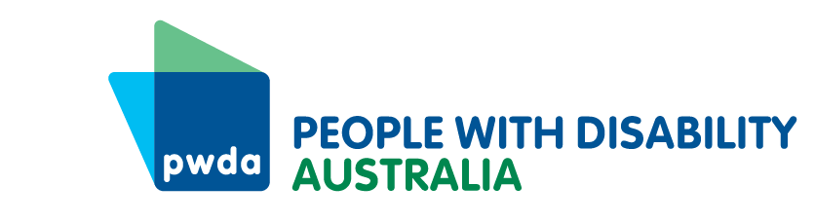
PO Box 666
Strawberry Hills
NSW 2012
+61 2 9370 3100
pwd@pwd.org.au
www.pwd.org.au
15 June 2023

Director, Civil Justice, Vulnerable Communities and Inclusion
Policy, Reform and Legislation
NSW Department of Communities and Justice
Locked Bag 5000
Parramatta
SYDNEY NSW 2124

Delivered by email to policy@justice.nsw.gov.au

Dear Director

Submission to Disability Inclusion Regulation review
Thank you for inviting People with Disability Australia (PWDA) to contribute to the review of the Disability Inclusion Regulation 2014 (Existing Regulation).
PWDA is Australia’s national peak disability organisation, representing the 1 in 6 Australians with disability. PWDA is also the NSW cross-disability peak organisation funded under the NSW Disability Advocacy Futures Program. As such, PWDA provides cross-disability systemic advocacy for people with disability in NSW. PWDA also provides individual advocacy in NSW under the NSW Disability Advocacy Futures Program and the National Disability Advocacy Program (NDAP). We have a vision of a socially just, accessible and inclusive community in which the human rights and freedoms of all people with disability are recognised and respected.
PWDA recognises the Regulation as a valuable instrument to support nimble responses to emerging trends and changing needs of people with disability in NSW under the Disability Inclusion Act 2014 (the Act). We therefore broadly support the proposal of NSW Department of Communities and Justice (DCJ) to remake the Existing Regulation. Please find our recommendation and responses to DCJ’s consultation questions below.

Consultation Response
Question 1: Are the NSW Disability Service Standards now redundant or are they are still required in the remake of the Disability Inclusion Regulation 2014, and if so, why? If the NSW Disability Service Standards are still required, what, if any, changes should be made to them, and why?
Our position is that people with disability must not be expected to accept service standards of a lower quality because of their disability or additional needs. We agree that removing Part 3 and Schedule 1 of the Existing Regulation avoids duplication and confusion, since the NSW and National Disability Service Standards are substantially the same with only some difference in the descriptions. As a provider of individual and systemic advocacy in NSW under both NSW (DAFP) and federal funding (NDAP and Disability Representative Organisations), PWDA also believes that the application of the National Disability Service Standards will reduce compliance complexity and allow for more focus on producing outcomes for and with people with disability.
However, we note that s 20(1) of the Act states that “the Regulations may make provision for or about standards (disability service standards) …” We therefore recommend that the remade 2023 Regulation note that the National Standards for Disability Services applies to the provision of supports and services in NSW.
Question 2: Do you have any other suggestions for change in the remake of the Disability Inclusion Regulation 2014?
We agree with the other provisions outlined in the draft 2023 Regulation concerning:
- Clause 4, entities defined as ‘public authorities’ for the purpose of preparing and making Disability Inclusion Action Plans (DIAPs)
- Clause 5, stipulation of six-month timeframe for new public authorities to prepare and submit DIAPs, and
- Clause 6, simplified wording for the appointment process of the Chairperson and Deputy Chairperson on the Disability Council, noting that the term for holding office is retained under Schedule 1 of the Act.
We also welcome the inclusion of the savings provision that will allow parts of the Existing Regulation to remain in force if they were in effect immediately before the repeal.
PWDA takes this opportunity to highlight that while the Regulation is important, it is the Act that makes a meaningful difference to people with disability in NSW. To this end, we offer two recommendations outside the scope of this consultation that will strengthen NSW disability inclusion outcomes:
- establishing a mechanism—relevant to Part 2 Div 2 of the Act—that annually summarises and publicly reports on the outcomes and achievements (not just the implementation) of public authority Disability Inclusion Action Plans (DIAP) with respect to the Australian Disability Strategy 2021-2031 (ADS) and Targeted Action Plan objectives.
- requiring public authorities to ensure their DIAP annual reports—relevant to s 13 (1) of the Act—focus on highlighting achievements that align with ADS outcome areas, Targeted Action Plan outcomes and the NSW State Disability Inclusion Plan.
Noting that the Act was amended in 2022 following a statutory review, we suggest these recommendations can be included in the remake of the Existing Regulation. As the Regulation will remain in force until 1 September 2028 in accordance with s 10 of the Subordinate Legislation Act 1989, this will provide interim coverage of the issue until the next statutory review of the Disability Inclusion Act 2014 in 2026, as provisioned at s 51(2).

PWDA 2023 NSW Election Platform
We would also like to inform you about our 2023 NSW election platform, which proposes a range of asks that will support the NSW Government’s commitment to the ADS.
If you wish to discuss our submission, please contact PWDA Senior Manager of Policy, Mx Giancarlo de Vera, at giancarlod@pwd.org.au or via telephone on 0413 135 731.
Yours sincerely

Sebastian Zagarella
Chief Executive Officer
People with Disability Australia
Attachment: PWDA 2023 NSW election platform

