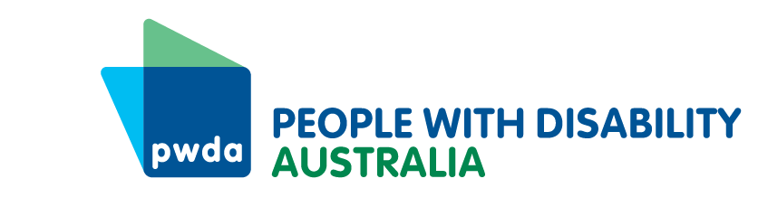
PO Box 666
Strawberry Hills
NSW 2012
+61 2 9370 3100
pwd@pwd.org.au
www.pwd.org.au
19 April 2023
Office for Women
Department of the Prime Minister and Cabinet
1 National Circuit
Barton ACT 2600
Delivered by email to OFWEngagement@pmc.gov.au
Dear Secretariat

Submission to gender equality discussion paper
Thank you for the opportunity to provide this submission to the Australian Government’s National Strategy to Achieve Gender Equality (the National Strategy) discussion paper.
People with Disability Australia (PWDA) is a national disability rights and advocacy organisation made up of, and led by, people with disability. We are a peak, non-profit, non- government organisation that represents the interests of people with all kinds of disability.
We agree with the definition provided by the discussion paper that gender equality means people have equal rights, responsibilities and opportunities regardless of gender. We are also pleased to note that the discussion paper recognises:
Gender inequality can be exacerbated by other forms of exclusion and disadvantage including those related to age, First Nations heritage, cultural and linguistic background, migration status, disability, gender identity and sexuality, as well as socio-economic status (p.3).
However, as the discussion paper also notes, the existing evidence base and data collection methods have many limitations, resulting in a poor understanding of the various ways that sex, gender, age, First Nations heritage, race, ethnicity, migration status, disability and other demographics intersect (p.21).

The invisibility of diverse experiences
Data limitations particularly impact people with disability. As noted in the 2019 Disabled People’s Organisations Australia’s (of which PWDA is one of four members) Position Paper on the status of women and girls with disability in Australia, there is no current disaggregated data and limited research on gender and disability issues.
The invisibility of data on women with disability needs to be addressed in the forthcoming National Strategy, but this must also include the ability to capture disaggregated data on how sex, gender, age, First Nations heritage, race, ethnicity, migration status, disability and other demographics intersect.
While we note that the forthcoming National Disability Data Asset and the Data Improvement Plan associated with the Outcomes Framework for Australia’s Disability Strategy 2021-2031 will improve data disaggregation over time, the visibility of intersectional experiences of women, gender-diverse and non-binary people with disability will be crucial for achieving gender equality for all. Therefore, we also strongly recommend policy coordination of the National Strategy with all other relevant programs, policies and plans to ensure its success.
Recommendation 1 – The Government must ensure policy coordination between the National Strategy and other programs, policies and plans relevant to women with disability, including but not limited to, the National Plan to End Violence against Women and Children, Australia’s Disability Strategy’s Safety Targeted Action Plan and Data Improvement Plan.
Recommendation 2 – When building the evidence base and assessing progress under the National Strategy, the Government must measure the effect of the strategy on women, gender-diverse and non-binary people with disability.
Recommendation 3 – The Government should prioritise its accountability and reporting mechanisms under the National Strategy through annual Federal Government reporting, and three-yearly State and Territory action-and-implementation reporting.

The principle of equity-to-achieve equality
To achieve true gender equality, the National Strategy must also take an equity-to-achieve-equality approach. Equality means that all humans should have the same rights, level of respect and access to opportunities. Equity, on the other hand, focuses on the measures needed to achieve equal outcomes, which may require treating certain groups of people differently. To follow the equity-to-achieve-equality approach, the National Strategy must include targeted measures for various intersectional groups to address their specific needs and barriers to equality. For example, the National Strategy should include targeted measures for women, gender-diverse and non-binary people with disability, LGBTIQA+ people with disability and culturally and linguistically diverse and First Nations women with disability.
Recommendation 4 – The National Strategy follows the principle of equity-to-achieve-equality, which must be reflected in the design, planning, communication, delivery and contracting of all policies, programs and services at every tier of government.
Recommendation 5 - The National Strategy and its associated implementation plans need to commit to a comprehensive series of targeted responses that cover:
- economic inequality
- the burden of care
- high levels of gendered violence
- sex and gender effects on health and access to services
- unequal gender representation in leadership and decision-making
- the effect of gendered factors across people’s lives
- stereotypes and other barriers.
Thank you again for the opportunity to provide this submission. If you would like to discuss our recommendations further, please contact my Senior Manager of Policy, Mx Giancarlo de Vera on giancarlod@pwd.org.au or on 0413 135 731.
Yours sincerely
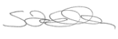
Sebastian Zagarella
Chief Executive Officer
People with Disability Australia

Disabled People’s Organisations Australia (2019), The Status of Women and Girls with Disability in Australia, accessed 6 April 2023.
Australian Human Rights Commission (AHRC) (n.d.) Let’s talk about equality and equity, accessed 5 April 2023
Ibid.

