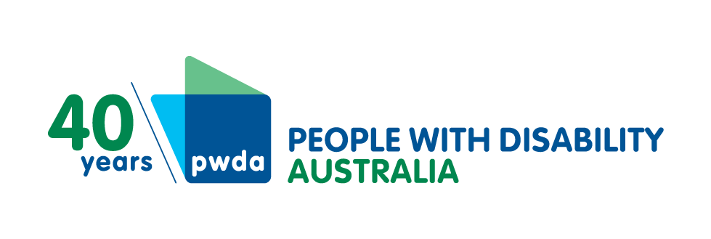
PO Box 666
Strawberry Hills
NSW 2012
+61 2 9370 3100
Toll free 1800 422 015
pwd@pwd.org.au
www.pwd.org.au
26 June 2023
NDIS Review Secretariat
Department of the Prime Minister and Cabinet
PO Box 6500
Canberra ACT 2600
Delivered by email to contactus@ndisreview.gov.au, sarah.renshaw@pmc.gov.au
Dear NDIS Review Secretariat

NDIS Review of Participant Safeguarding
People with Disability Australia (PWDA) is a national disability rights and advocacy organisation made up of, and led by and for, people with disability. We thank you for the opportunity to respond to this important Review.
As a national disability advocacy organisation, PWDA promotes the primacy of the person with disability and accordingly, we frame our work from the perspective of the person. Therefore, we have attached our recent submission to the Review of the Quality and Safeguarding Framework (the Framework) as part of our response to the Participant Safeguarding Review.
In the following, we have provided a summary of the major points under each of the three Proposals. While the Framework submission is directly relevant to Participant Safeguarding, we have also included references to specific Framework recommendations for each Proposal.

The Participant Safeguarding Proposals
PWDA agrees with and supports the three Proposals in the Paper as listed below. Our submission to the Framework offers more details and 19 recommendations on identifying, choosing and managing risk with participants, as well as improving and expanding the range and scope of safeguards across the entire National Disability Insurance Scheme including with other relevant regulatory agencies.

Create an NDIS-wide strategy on participant safeguarding
Formal Safeguards must be seamless within the NDIS as well as with other relevant regulatory systems for participants. Further, the provision of NDIS safeguards must be available to all people with disability who require them, regardless of their status as a NDIS participant.
This includes, for example, a person accessing support through a service funded by the Information, Linkages and Capacity Building (ILC) Program, where the service context comes under the NDIS Code of Conduct, and where someone is applying for NDIS.
This will involve better communication with and decision-supports for the person, efficient and timely information sharing between regulators, regular and accessible information to people with disability, specific responses to people in more vulnerable circumstances, assistance to navigate and use supports and services, clarity in the participant’s funding, consented involvement of the person’s trusted personal networks, widespread access to independent advocacy, and the capacity to tap into supports for decision making on an as-needs basis.
PWDA recognises support for decision making as an important function of empowering people with disability to enact their rights – including the right to be safe. We believe that the NDIS-wide Strategy on participant safeguarding could play a role in monitoring the outcomes arising from the implementation of the recently released NDIS Supported Decision Making Policy.
Monitoring of the implementation of the NDIS-wide Strategy should be independent and will provide evidence on whether people with disability have increased access to support for decision-making, either through supports included in participant NDIS plans or other sources. In addition to individual advocacy, a range of decision supports must be available to participants to assist in the development and implementation of their NDIS plans and use of services.
We also believe that monitoring is needed to ensure that the impact of positive steps like the NDIS Supported Decision Making Policy and the actions that arise from the NDIS Review are not limited over time by other factors such as the annual growth target announced in the 2023 Federal Budget.

See PWDA submission to the Framework recommendations and discussions:
- Recommendation 5 on the provision to people with disability of supports for decision-making
- Recommendation 6 on the provision of intermediaries to support people with disability in the NDIS
- Recommendation 12 on the redesign of the ILC Program.
- Recommendation 19 on coordination and alignment of powers of all relevant regulatory bodies

Work with participants to understand risk and build safeguards
In working with participants on risk and safeguards, NDIS workers must have a good understanding of the importance of equity and equality for people with disability, of the application of dignity of risk, strengths-based approaches, consent and supported decision-making.
PWDA asserts that the actions to mitigate risks for one person with disability should never restrict the choices and activities of others in any ongoing way. We are concerned that substitute decision-makers, e.g. appointed public guardians, may not routinely take into account the choices of the participant or act in their best interests.
See PWDA submission to the Framework recommendations and discussions:
- Recommendation 1 covering national consistency in: processes for restrictive practices, the provision of Community Visitors Schemes, information exchange between regulatory bodies, the availability of individual advocacy.
- Recommendation 2 on strategies for the development of participants to implement their NDIS plans and the fostering of natural safeguards.

Improve the variety of safeguards available to participants
Existing safeguards must be proportionally expanded to address the growth of the disability services sector. Further, these must be nationally coordinated and available.
Safeguards for each person with disability must individually respond to the impact of their disability; to their strengths, capacity and choices; and to their personal circumstances, culture and life history.
Independent monitoring of services to people with disability is essential for the protection and promotion of rights and safety. Community Visitors Schemes provide critical safeguards and information on services to participants and others.
Conflicts of interest can pose real risks to the safety and wellbeing of people with disability, including where there are few choices of provider, with people who may not be able to articulate their issues, and where providers of direct supports are also providers of decision supports.
Equally, PWDA asserts there is a significant conflict of interest and other risks where a person with disability receives both their housing as well as their direct supports from a single provider.
To this end, PWDA reiterates the recommendation it made to the Disability Royal Commission in June 2020 that:

Funding from the NDIA, for people eligible for Specialist Disability Accommodation (SDA) and Supported Independent Living (SIL), separates housing and support services for people with disability, and further, that such separation be a condition of funding.

See also PWDA submission to the Framework recommendations and discussions:
- Recommendation 8 on Community Visitors Schemes
- Recommendation 14 on avoiding conflicts of interest.

Conclusion
If you have any questions about this letter and/or the Framework submission, please contact my Senior Manager of Policy, Mx Giancarlo de Vera, at giancarlod@pwd.org.au or via telephone on 0413 135 731.
We would be pleased to engage directly with the NDIS Review to provide more clarity and information during the development and implementation of the NDIS Participant Safeguarding Proposals.
Yours sincerely

Sebastian Zagarella
Chief Executive Officer
People with Disability Australia
Attachment: Safeguarding the Future: Submission to the NDIS Quality and Safeguarding Framework Issues Paper (5 June 2023)

