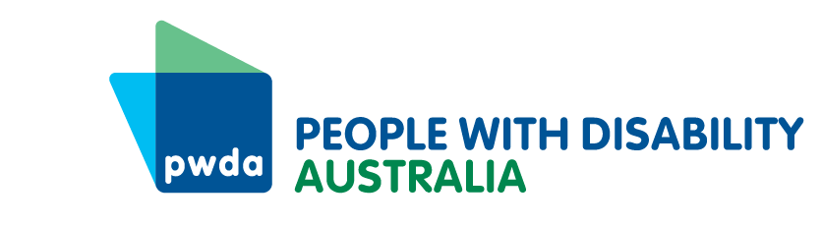
PO Box 666
Strawberry Hills
NSW 2012
+61 2 9370 3100
pwd@pwd.org.au
www.pwd.org.au
31 May 2023

Mr Clayton Barr MP
Chair
Select Committee on the Residential Tenancies Amendment (Rental Fairness) Bill 2023
Legislative Assembly
Parliament House
Macquarie St
SYDNEY NSW 2000

Delivered by email to residentialtenanciesbill@parliament.nsw.gov.au

Dear Mr Barr

Rental fairness for people with disability
Thank you for inviting People with Disability Australia (PWDA) to contribute to the inquiry on the Residential Tenancies Amendment (Rental Fairness) Bill 2023 (the Bill).
PWDA is Australia’s national peak disability organisation, representing the 1 in 6 Australians with disability. PWDA is also the NSW state cross-disability peak disability organisation funded under the NSW Disability Advocacy Futures Program, providing cross-disability systemic advocacy for people with disability in NSW.
We welcome the NSW Government’s intention to provide better protection to renters and improve the functioning of the rental market. However, we are concerned that the proposed reforms could lead to discrimination, exploitation, and insecurity for tenants with disability.
We wish to see an end to the practice of rent bidding. Our concerns with the Bill are outlined in a joint that PWDA has signed on to with the Tenants Union of NSW, Homelessness NSW, the NSW Council of Social Service and others, which has been provided to this inquiry. However, we attach the joint letter to our submission here letter (see Appendix).
Further, we note the inquiry terms of reference are specific to transparency, impact and transactional behaviour related to clause 22B of the Bill, and as well as additional measures to improve transparency and protection for applicants. In addition to proposing a fairer and simpler process, in this submission we also wish to highlight the housing issues that people with disability experience despite it falling out of scope for this inquiry.
Accessible, affordable and secure housing options are crucial for people with disability to live independently – safe from violence, abuse, neglect and exploitation. However, many people on income support payments in NSW would have a hard time finding affordable and appropriate private rental properties.
The housing issues experienced by people with disability are often overlooked yet they are highly relevant to the issue of housing and rental unaffordability. Based on data from our NSW individual advocacy services, housing is the number one issue driving people with disability to seek advocacy support. Additionally, almost 1,300 people using NSW Specialist Homelessness Services in 2021-22 have a disability.
Therefore, we need to see the NSW Government ensure the focus on housing and unaffordability is inclusive of people with disability. To that end, we would also like to take the opportunity to inform you about our 2023 NSW election platform, which proposes a range of asks that will support the NSW Government’s commitment to the Australian Disability Strategy 2021-2031 (ADS).
If you wish to discuss our submission, please contact my Senior Manager of Policy, Mx Giancarlo de Vera, at giancarlod@pwd.org.au or via telephone on 0413 135 731.
Yours sincerely
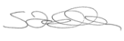

Sebastian Zagarella
Chief Executive Officer
People with Disability Australia

Attachment: PWDA 2023 NSW election platform

Appendix - Joint Letter

To: Legislative Assembly Select Committee on the Residential Tenancies Amendment (Rental Fairness) Bill 2023

Dear Committee Members

We are writing to you as representatives of the below signed organisations. We are concerned about the current draft legislation on rental reform that aims to eliminate secret rent bidding and instead replace it with a regulated rental auction process.

While we welcome the government’s intention to provide better protection to NSW renters and improve the functioning of the rental market, we believe that the proposed reforms have unintended consequences that will have further negative impacts on tenants and the rental market.

Rent bidding is when prospective tenants offer more money than the advertised price for a rental property, either voluntarily or in response to solicitation by agents, owners or third parties. It is a practice that can create unfair competition and increase rental prices in a tight market – especially problematic in a high-inflation environment that we are currently in. It can also lead to discrimination, exploitation, and insecurity for tenants, especially those who are vulnerable or disadvantaged. We note this conduct is not condoned by professional real estate agents and not encouraged.

The current draft legislation requires owners and agents to notify applicants of other offers that are higher than the advertised price but does not prevent them from accepting such offers. This means that rent bidding can still occur, and that tenants can still be pressured or tempted to pay more than they can afford. We have become aware that the recent media on the practice has also led to increased bids from prospective tenants.

We urge you to amend the current draft legislation to remove rent bidding altogether and instead put in place a fair and administratively simple process whereby:

- A fixed rental price must be advertised at the time a property is put up for rent. This advertised rate would act as a ceiling.
- Landlords, real estate agents and potential tenants must not offer, solicit, or accept a higher rental rate than the originally advertised rate.

We believe that this policy would create a fairer and more transparent rental system that would benefit both tenants and landlords. It would reduce stress and uncertainty for tenants, who would know exactly how much rent they need to pay and whether they can afford it. It may also encourage landlords to set realistic and reasonable rents that reflect the market value and condition of their properties and reduce the administrative burden that a regulated rental auction would cause.

We appreciate your attention to this matter and hope that you will consider our proposal. We are happy to meet with you or your staff to discuss this further.

Sincerely,
