NDIS access, eligibility

and planning

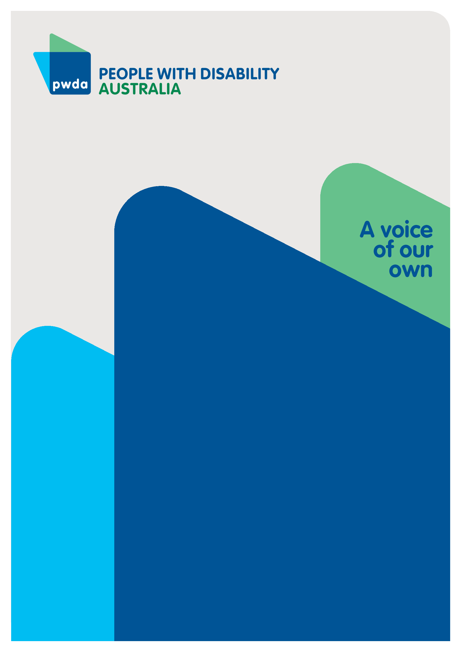
Submission 1 to the Independent Review of the National Disability Insurance Scheme (NDIS)
July
2023

Copyright information
NDIS Access, Eligibility and Planning – Submission 1 to the Independent Review of the National Disability Insurance Scheme (NDIS)

First published in 2023 by People with Disability Australia Ltd.
Level 8, 418a Elizabeth Street, Surry Hills, New South Wales, Australia 2010
Head office also in Sydney
Email: pwda@pwd.org.au
Phone: +61 2 9370 3100 Fax: +61 2 9318 1372
URL: www.pwd.org.au

Typeset in Arial 12 and 14 pt and VAG Rounded 26 pt

© People with Disability Australia Ltd. 2023

The moral rights of the authors have been asserted

National Library of Australia Cataloguing-in-Publication data:

Creator(s): | Jane Britt
Title: | NDIS Access, Eligibility and Planning – Submission 1 to the Independent Review of the National Disability Insurance Scheme (NDIS)

All rights reserved. Except as permitted with the Australian Copyright Act 1968 (for example, a fair dealing for the purposes of study, research, criticism or review), no part of this book may be reproduced, stored in a retrieval system, communication or transmitted in any form or by any means without prior written permission. All inquiries should be made to the publisher at the address above.

Suggested citation:

Britt, J., NDIS Access, Eligibility and Planning – Submission 1 to the Independent Review of the National Disability Insurance Scheme (NDIS), 25 July 2023, People with Disability Australia, Sydney.

ISBN 978-0-6457443-5-4

About PWDA
People with Disability Australia (PWDA) is a national disability rights and advocacy organisation made up of, and led by, people with disability.
We have a vision of a socially just, accessible and inclusive community in which the contribution, potential and diversity of people with disability are not only recognised and respected but also celebrated.
PWDA was established in 1981, during the International Year of Disabled Persons.
We are a peak, non-profit, non-government organisation that represents the interests of people with all kinds of disability.
We also represent people with disability at the United Nations, particularly in relation to the United Nations Convention on the Rights of Persons with Disabilities (CRPD).
Our work is grounded in a human rights framework that recognises the CRPD and related mechanisms as fundamental tools for advancing the rights of people with disability.
PWDA is a member of Disabled People’s Organisations Australia (DPO Australia), along with the First People’s Disability Network, National Ethnic Disability Alliance and Women with Disabilities Australia.
DPOs collectively form a disability rights movement that places people with disability at the centre of decision-making in all aspects of our lives.
‘Nothing About Us, Without Us’ is the motto of Disabled Peoples’ International.

Table of Contents
Copyright information 1
About PWDA 2
Introduction 4
Summary of Recommendations 7
Methodology 9
Discussion 12
NDIS Participants: Experience of accessing the NDIS including eligibility 12
Experience of people with disability unable to access the NDIS 18
NDIS Participants: Experience nce of planning and review processes 22
Conclusion 28
Appendices 29
Appendix A - Combined Easy Read and Non-Easy Read survey demographics 29
Appendix B - focus group demographics 33
Appendix C - NDIS Eligibility, access and planning focus group questions 35

Introduction
The Minister for the National Disability Insurance Scheme (NDIS), The Hon Bill Shorten MP, announced an independent review of the NDIS (the Review) on 18 October 2022. The review examines the design, operations and sustainability of the NDIS, and NDIS workforce capability and capacity.
People with Disability Australia (PWDA) welcomes the Review and this opportunity to comment. This submission will focus on NDIS access, eligibility and planning and forms part of PWDA’s input into the Review.
This submission responds to the following items in the Review’s Terms of Reference:
Part 1 Design, operations and sustainability of the NDIS
a) access to the Scheme, planning and review processes
b) NDIS supports & evidence-based information for access & choice of services
Part 2 Building a more responsive and supportive market and workforce
d) attract, build and retain a capable workforce
f) Improve consumer information and dissemination on supports/ services and the role of intermediaries.
Through our planning recommendations, we will respond to a question posed within the NDIS Review What We Have Heard report (June 2023):
“How can we empower you through the planning process?”
Our recommendations provide a guide to empower people with disability throughout the entire NDIS experience from applying for the NDIS through to the planning process. Further, they provide a guide to rebuild trust; that has been eroded over the course of the Scheme’s delivery.
From March to May 2023, PWDA conducted consultations with people with disability on their experiences of the National Disability Insurance Scheme (NDIS). This involved several focus groups and two online surveys (including one easy read version) which received 441 valid responses. The findings from these consultations, as well as feedback from PWDA Individual Advocacy and Policy functions have provided valuable direction and evidence for the development of this submission to the NDIS Review.
The National Disability Insurance Scheme (NDIS) is a transformative scheme for the provision of supports and services for people with disabilities to live the lives that they choose. PWDA has extensively and consistently advocated for a Scheme that is fully funded and resourced to provide the essential supports and benefits for people with disability.
The benefits for people with disability accessing the NDIS are substantial. Throughout our engagement we heard that people with disability have felt that their wellbeing and overall quality of life has significantly improved with access to the Scheme. People with disability have reported that the Scheme has allowed greater independence, including the ability to live independently, access community, and have social support. It has enabled people with disability to engage in job searching and/or being able to work.
The NDIS has also provided vital access to the needed supports and services that are often out of financial reach. These services and supports include support workers, multidisciplinary therapy and allied health, assistive technology, equipment/aids, and assistance or guide dogs. Participants in the Scheme pointed to the benefits of the NDIS being based on choice and control given to select the supports and services that they need to live the life they choose.
Participants shared the impact that the NDIS has made for them:
“Finally feeling like there is adequate support for managing my disability. The ability to ask for help instead of struggling to be fully independent.”
“I was going downhill fast and was struggling to survive. NDIS supports me in many areas of my life (food prep and deliveries, support workers, multiple therapies, social participation and festive activities are among highlights.”
This submission also reflects the diversity of lived experience in the disability community, with responses reflecting the experiences of a wide range of ages, gender identity, and disability, those from First Nations, culturally and linguistically diverse, and LGBTQIA+ backgrounds, and those who live in metropolitan and rural areas.
In addition, all states and territories are reflected in the people we engaged with for this submission.
For more demographic information, please see Appendix A and B.
For questions asked in the focus group, please see Appendix C.

Summary of Recommendations
Recommendation 1 – The National Disability Insurance Agency (NDIA) stringently adhere to the NDIS Participant Service Guarantee for access request decisions. The time frames being:
- NDIS Access request decisions within 21 days
- NDIS plan provision within 90 days for a participant under 7
- NDIS plan provision within 56 days for participants over 7.

Recommendation 2 – The NDIA, when they are unable to adhere to the Participant Service Guarantee, should review any process which exceeds time frames and provide explanation to the participant within five business days.

Recommendation 3 – The NDIS provides upfront funding for participants requiring assessments if required for an access request, including a Functional Capacity Assessment. This measure should be stipulated in the NDIS Participant Service Guarantee.

Recommendation 4 – The NDIS must provide clearer definition within the s24 access requirements set out in National Disability Insurance Act 2013 (NDIS Act) and consistent application of these requirements. List A classifications for access to the NDIS should be broadened to prevent the exclusion of some people with disability whose support needs are reasonable and necessary.

Recommendation 5 – Listen to the participant during the planning meeting, acknowledging the expertise of a participant in understanding their disability or disabilities, and how their needs can be supported.

Recommendation 6 – To reduce NDIS access wait times;
- where possible, remove the requirement for Functional Capacity Assessments to be completed before access to the Scheme.
- work towards increasing access to practitioners who undertake Functional Capacity Assessments in all areas including rural, regional and remote areas.

Recommendation 7 – The NDIA to provide clearer advice about the information and evidence requirements for an NDIS access request, including what criteria needs to be addressed, so participants understand what is needed before they put in an access request for the Scheme.

Recommendation 8 – The NDIA communicates accessibly by adhering to their own communication criterion set out in the Participant Service Charter whereby the Agency must provide any information in formats that are “accessible and easy to understand” and keep participants “informed and communicate in [the participant’s] preferred format.”

Recommendation 9 – Planning and review meetings are conducted in ways that meet the communication and physical access requirements of the NDIS participant.

Recommendation 10 – NDIA frontline staff and intermediaries working with participants in planning, review, call centre and other participant-facing and decision-making roles, undergo training in understanding disability-specific needs and in providing trauma-informed support through the access, planning and review processes.

Recommendation 11 – Participants are provided with a draft plan to review and provide feedback before the plan is finalised. The draft plan to be accompanied by an explanation of any decisions that are not aligned with the participant’s Access Request.

Methodology

Surveys
PWDA conducted a NDIS Review survey through Survey Monkey which was open to Australians with disability, including those who were NDIS participants and those who were not. PWDA’s survey sought to better understand the impact of the NDIS across geographic areas and across different groups of people. We asked for feedback about what are the current barriers in NDIS access and service support, what is working well, and where improvements could be made. In this report we refer to this survey as the non-easy read survey and responses to this survey are shown in the graphs below as non-easy read.
Staff from Inclusion Australia used the PWDA survey as a base from which to develop an Easy Read version of the survey for people with intellectual disability and other communication needs using RIX software. In this report we refer to this survey as the Easy Read survey. Within the Easy Read survey, people were asked Are you a person with disability? If they answered yes, they are represented in the Graphs below as respondents to the Easy Read survey. If the answer was No but I am supporting a person with disability to fill out the survey, they are represented in the Graphs below as respondents on behalf of.
A total of 441 valid responses were collected from the two surveys. Of these, 381 valid responses were collected from the non-easy read survey. There were 60 valid responses to the Easy Read survey, 41 were provided by people with disability and 19 were provided by people supporting a person with disability to fill in the survey.
Within each of the surveys, people were asked whether they were an NDIS Participant. As shown below, people answered either yes (n-372), no (n-23) or no, but I would like to be (n-46).
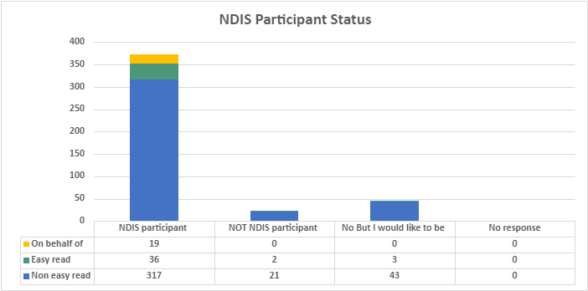
Figure 1. NDIS Participant Status of survey respondents
As respondents were streamed into different sets of questions on the basis of their NDIS participant status, the discussion in the body of this submission has been set out according to these groups.

Focus groups
PWDA also conducted a series of focus groups on the NDIS, including a targeted session on NDIS eligibility, access, and planning.
The targeted focus group on NDIS eligibility, access, and planning was held on 5th May 2023, ran for two hours with seven participants aged 24-64 who were all NDIS participants. The focus group was facilitated by an independent consultant who is a person with disability. (Please see Appendix A for demographic information of survey respondents and focus group participants).
Following the focus group, the transcript of the focus group was deidentified and a summary report was compiled. The transcript was used to identify key themes relating to access, planning and eligibility for the NDIS. The key themes emerging from the focus group were compared with the data input from the surveys, to identify any parallel points or deviations.

Data analysis
Both surveys were initially screened and cleaned to remove invalid responses. Invalid responses constituted:
- any participant who answered no to are you a person with disability unless they nominated that they were supporting a person with disability to fill in the survey.
- no to do you live in Australia
- did not answer any questions beyond the demographic information.
The quantitative data was calculated with the remaining valid responses.
For the qualitative data, a thematic analysis was conducted for both the Easy Read and Non-Easy Read surveys to identify key themes.
The focus group data was analysed using a deidentified transcript and creation of individual summary reports which were submitted to the NDIS Review. The Summary Reports captured the themes emerging from the focus group discussion, based on the pre-determined questions that were asked to participants. A copy of the Focus Group Questions is included in Appendix B.

Discussion

NDIS Participants: Experience of accessing the NDIS including eligibility
Of both surveys, 353 respondents were NDIS participants with 19 people responding on behalf of an NDIS participant – leading to a total of 372 responses related to NDIS participants. Seven NDIS participants took part in the Access and Eligibility Focus Group.
Both survey participants and focus group participants indicated that the access process was challenging.
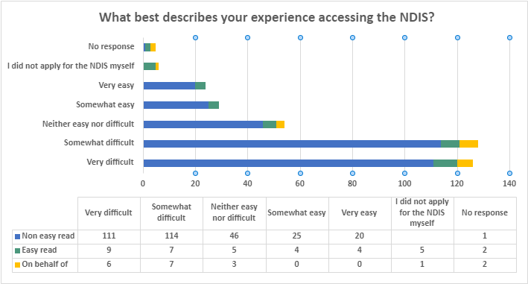
Figure 2: What best describes your experience accessing the NDIS?
When asked to rate their experience accessing the NDIS, out of the 367 survey respondents who answered the question, 69.2% (n-254) rated their experience accessing the NDIS as either Very difficult or Somewhat difficult. 14.7% (n-54) rated the experience Neither easy nor difficult and 14.4% (n-53) listed their experience as Somewhat easy or Very easy. Six people did not apply for the NDIS themselves and five people did not respond.
When asked the reason for their answer, the key themes around initial access difficulties included:
- the length of time it took
- the cost involved with assessments
- accessibility of communications
- no knowledge of specific disability needs from staff handling the processes
- lack of trauma sensitivity in planning and review processes.

Length of time involved in accessing the NDIS
The length of time reported by both survey respondents and focus group participants to access the Scheme ranged from months to years. Survey respondents and focus group participants reported that only after an appeal or appeals did they gained access, with a primary reason being that their disability was not accepted without further evidence being required.
“The initial application was rejected 3 times due to the words permanent, stable and medicated. Epilepsy can be stable until it is not, and most [doctors] do not like stating something that as being stable as per [government] regulations. It took involvement from my local Federal MP’s staff to see common sense.”
In the focus group, participants reported frustration because they were unclear about why an access request was rejected, including seemingly arbitrary reasons such as not using the correct language required by the NDIS.
Participants gaining initial access often referenced the stress involved in initial application.
“Just the huge form took me 6 months… none of the process accounts for executive dysfunction, cognition function, trauma, and many other disability-related things that make this all super hard for us.”

Additional evidence to support access requests
Survey respondents who gained automatic access to the Scheme during the transitional arrangements with states and territories before full implementation of the NDIS reported smooth transitions. However, those who entered the Scheme when the NDIS was fully implemented throughout Australia reported needing to provide further costly and invasive evidence to support their access request.
“I needed to get a hearing test to provide that I am really deaf. Advice that I got was to get my ears checked/tested x 3 at my own expense, have ear washes x 10 to rid my R [right] ear of a tiny bit or ear wax (hearing test results were all the same). It was… painful.”
Survey respondents reported spending thousands to gain access with supporting evidence:
“Required significant personal cost (over $5000) to gain access as my diagnoses were historic and none were list A conditions.”
Another participant shared:
“I had to pay $3000 out of pocket to get my autism diagnosed by a qualified person.”

Eligibility denied due to type of disability
Survey respondents reported issues around access to the NDIS due to the type of disability they have, with certain conditions frequently mentioned throughout responses, including psychosocial, and physical disability, for example, Ehlers-Dandos Syndrome (EDS).
Difficulties related to the permanence criterion were common - with participants taking extreme measures to gain access to the NDIS:
“We had to sell a house, move across the country to access medical treatment and live on savings for 20 months, with my husband as my full-time carer before my condition could be deemed ‘permanent and fully treated’ to apply for assistance with NDIS. I took over 3 years to access NDIS for my neurological condition.”
Similarly, people with intellectual disability expressed frustration that mental health was not supported, leading to a deterioration in their overall wellbeing:
“The restrictions on access to certain fundings. My issues are listed as intellectual, but due to my bad mental health my physical health has suffered, the NDIS will not approve funding for a personal trainer or physical therapy on the basis my disability is purely mental. Because of this my physical health continues to deteriorate, which in turn affects my mental health.”
Focus group participants similarly reported that they experienced challenges getting one or more of their disabilities recognised and included in their NDIS plan.

Access and communication needs
PWDA heard about access issues for entering the Scheme, with participants’ specific and recorded communication needs not being met. For example, sending emails instead of calling.
Both survey respondents and focus group participants reported contacting the NDIS Call Centre to follow up an access request, or ask questions about the Scheme, and experiencing frustration of not having their calls followed up.
“I… got my letter of acceptance by mail and not by email as I specified. I love electronic correspondence. I know where everything is, I can put everything in different spots if I need to. I selected correspondence by email in the beginning, it just came by mail which irritated me because I'm not good with multiple pieces of paper and I have a tendency to hoard sometimes.”
Another person expressed similar frustration:
“Trying to get my plan changed every time I ring NDIS they tell me someone will ring me back and they never do so this week my support worker took me into the NDIS office and I said I am not leaving until I get an appointment so I have an appointment this week.”
Survey respondents also indicated that resources about navigating the complexity of the NDIS would be beneficial if they were made available in participants’ preferred formats:
“[The NDIS could] have some more resources so people can get knowledge like Easy Read and having a good circle [of connections or] network.”
Some respondents extended this to specifically request:
“more easy read information about what you can spend your money on”.

Conclusion
Both survey respondents and focus group participants indicated that there are substantial benefits to being an NDIS participant. However, there are also significant barriers in accessing the NDIS and through the NDIS planning and review processes.
A major barrier to access for people with disabilities is not meeting current access requirements. For NDIS participants, another access barrier is the length of time involved, particularly when access requests are denied. An additional barrier is the prohibitive costs of gaining necessary supporting documentation, including functional capacity assessments, to accompany access requests.
If a person is unable to navigate the access request process, it may be due to the forms of communication being used being inaccessible, including a lack of provision of information in the NDIS participant’s or prospective participant’s preferred format.
Survey respondents and focus group participants also indicated that information provision from the Call Centre is problematic, with calls not being returned despite a request for call back. The lack of accommodation for communication needs extended to all forms of communication between NDIS participants and the Agency.

Recommendations
To ensure that eligibility and access to the NDIS is equitable and accessible for all people with disability, PWDA strongly recommends the following:
Recommendation 1 – The National Disability Insurance Agency (NDIA) stringently adhere to the NDIS Participant Service Guarantee for access request decisions. The time frames being:
- NDIS Access request decisions within 21 days
- NDIS plan provision within 90 days for a participant under 7
- NDIS plan provision within 56 days for participants over 7.

Recommendation 2 – The NDIA, when they are unable to adhere to the Participant Service Guarantee, should review any process which exceeds time frames and provide explanation to the participant within five business days.

Recommendation 3 – The NDIS provides upfront funding for participants requiring assessments if required for an access request, including a Functional Capacity Assessment. This measure should be stipulated in the NDIS Participant Service Guarantee.

Recommendation 4 – The NDIS must provide clearer definition within the s24 access requirements set out in National Disability Insurance Act 2013 (NDIS Act) and consistent application of these requirements. List A classifications for access to the NDIS should be broadened to prevent the exclusion of some people with disability whose support needs are reasonable and necessary.

Recommendation 5 – Listen to the participant during the planning meeting, acknowledging the expertise of a participant in understanding their disability or disabilities, and how their needs can be supported.

Recommendation 6 – To reduce NDIS access wait times;
- where possible, remove the requirement for Functional Capacity Assessments to be completed before access to the Scheme.
- work towards increasing access to practitioners who undertake Functional Capacity Assessments in all areas including rural, regional and remote areas.

Recommendation 7 – The NDIA to provide clearer advice about the information and evidence requirements for an NDIS access request, including what criteria needs to be addressed, so participants understand what is needed before they put in an access request for the Scheme.

Experience of people with disability unable to access the NDIS
As shown above in Figure 1, 15.6% (n-69) of survey respondents were not NDIS participants. When asked if they were an NDIS participant, 23 respondents answered ’No’ and 46 people answered ‘No, but I would like to be’. These groups are referred to below as the No group and the No, but I would like to be group.

Barriers to NDIS – No [I am not an NDIS Participant] group
The No Group was made up of 23 respondents and many of these respondents described the experience of not being able to access the NDIS.
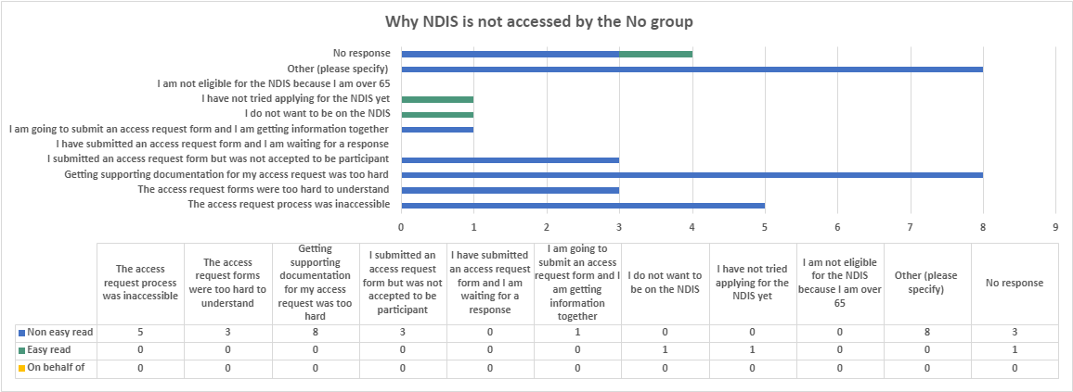
Figure 3: Why NDIS is not accessed by the No Group.
As shown in Figure 3 above, the most common reason for not accessing the NDIS given by the No group was because getting supporting documentation was too hard (n-8) or that the access process was inaccessible (n-5). Three people noted that the access request forms were too hard to understand and three people submitted the documentation but were denied access. For those that noted other, the key responses related to a belief that there is no formal recognition for their disability and/or that the NDIS difficult to access.
For survey respondents who did not have formal recognition of their disability, many referenced “not being disabled enough.” Survey respondents shared the following experiences:
“I was deemed too well after a cerebrovascular accident, even though I was barely functioning. I could wash and shower but struggled with shopping and housework. A local community stepped in to help until I could cope better. I now only have help with lawn mowing.”
“ADHD is not listed as a condition under NDIS and my other neurodivergent diagnosis are low support needs.”
“I have a range of possible causes for my condition and none could be classified adequately to suit NDIS so haven't bothered.”
“My CP is too mild and I can paddle my own boat.”
Some respondents did not have a formal diagnosis; therefore they did not have supporting documentation. While others didn’t attempt to try to access the NDIS due to the belief of not meeting access criteria.
“I don’t believe I would meet the threshold to access NDIS.”
For some respondents, it was a combination of a lack of diagnostic information and supporting evidence and financial barriers preventing their access to the diagnostic services and reports.
“I do not have the capacity or finances to pursue to medical reports required and I'm worried it will just be denied.”

Barriers to NDIS - No, but I would like to be [an NDIS participant] group
The No, but I would like to be [an NDIS Participant] group was made up of 46 respondents and many of these respondents described the experience of not being able to access the NDIS.
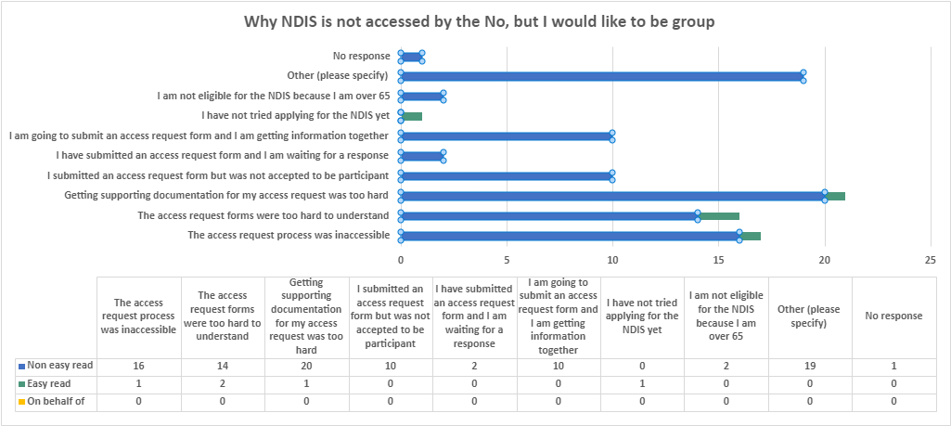
Figure 4: Why NDIS is not accessed by the No, but I would like to be group (more than one choice possible).
For the No, but would like to be group, the primary reason for not gaining access was also that getting supporting documentation for the access request was too challenging (n-21). Commonly respondents found the access request process too inaccessible (n-17) or too hard to understand (n-16). Ten respondents indicated that they submitted an access request but were denied access and ten respondents indicated that they are in the process of getting information together for an access request.
For respondents in this group who answered “other”, the reasons listed for not being able to access the NDIS included their disability not being recognised, not having the capacity to navigate the access process and/or the process being inaccessible, prohibitive costs to getting the necessary documentation for access, and needing assistance with completing the access request. Other reasons included that the condition could be treated, the participant was told to wait for Aged Care access, or the medical professional did not complete the necessary paperwork.
“I’ve applied fully 3 times and with 3 reviews, all denied. I have had help filling in my forms from occupational therapist, specialist rehab doctors (from my 6 rounds of hospital rehab) and my physio I've seen for 7 years. The final reason was that as my hip injury which arose from pregnancy exacerbation from my hip joint and means I can't stand at all without pain but even though no rheumatologist, rehab specialist, physio or occupational therapist can see any further route of treatment, NDIS says there are further treatment options so they assess me as ineligible”
“I was told because I 53, I should wait to aged care. Also told a lot mine was medical but these medical are my disabilities where I need support.”
“Medical professional did not want to complete paperwork.”

Conclusion
Overall, access to supporting documentation was the primary barrier for respondents who did not have access to the NDIS, or who did not have access to the NDIS but wanted to access it. Survey respondents shared that they were unable to get supporting documentation due to cost and that they did not gain access due to not having a formal diagnosis. Inaccessibility of the process in various ways (fatiguing, difficult to understand, or a lack of provision of preferred formats for information) was also a barrier noted by respondents.
NDIS is excluding people who have disabilities which are not part of this access requirement criterion. The access requirements need to be broadened.

A further hinderance to NDIS access is for prospective participants who meet List A conditions prescribed under s24(1)(a), the access criterion of s24(1)(c) requires a prospective participant to have substantially reduced functional capacity. Prospective participants have to make a significant financial outlay to get a Functional Capacity Assessment completed to access the scheme.

Recommendations
Refer to Recommendations 3 and 4 above.

NDIS Participants: Experience of planning and review processes
When asked about their experiences of their NDIS Planning meeting, 340 people responded. Of those responses, 34.7% (n-118) of participants found the experience very difficult and 27% (n-92) found it somewhat difficult with only 12.9% (n-44) indicating it was somewhat easy and 5.2% (n=18) indicating it was very easy. 18.8% (n-64) of respondents noted the planning meeting was neither easy nor difficult and four (1.1%) participants had not attended a NDIS planning meeting.
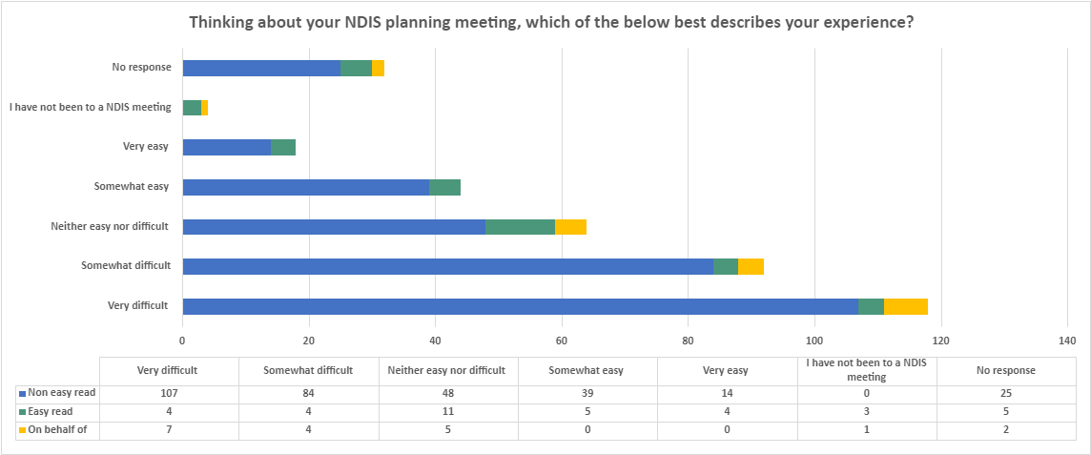
Figure 5. Descriptions of NDIS Participants’ experience of NDIS planning meetings
Survey respondents used terms like stressful, fatiguing, and complicated to describe planning and review meetings - with some participants noting:
“too many reviews”
“masses of paperwork”
and having to “justify very personal things.”
Some respondents noted that having an advocate or other supports made the process much easier, while other respondents felt they weren’t listened to, or the people involved (LAC) didn’t understand their disability which made the process harder.
“The lady spoke to me but I needed help to answer. My parents were there too. I got them to answer for me sometimes. I don’t think the lady understood me or my life.”

Choice and control in the planning process
Both survey respondents and focus group participants indicated a desire for more choice and control around decision-making in their plans.
Many survey respondents and focus group participants indicated dissatisfaction with funding, including misalignment between what was funded and their disability support needs.
Survey respondents and focus group participants reported that the experience of planning and reviews was demoralising, especially explaining disability needs in terms of deficits only, rather than strengths, and considering worse-case scenarios when disability needs are at their greatest.
“Feeling like I need to downplay how independent and capable I am so that I get appropriate funding.”
Focus group participants reported that the planning experience itself did not involve participant choice and control:
“To the planning meeting, not really given much choice. There was good communication between the LAC office but not really given much time or leeway, which was really bad for me because I was in the middle of an episode. I went in there manic and I had my guardian with me… To go into a planning meeting when you're not well is really bad. How they reinforce that you must have a planning meeting… quickly. [They] don't allow participants any time to get better or to be stable before that can happen.”
“LAC was speaking to fast and it was hard to understand. They left out some important words [and] didn’t ask any questions about what you want in the plan and what support and services that are available in the plan [or] the best way to use the funding to help me live independently.”
This lack of choice and control was compounded by a lack of continuity of staff supporting survey respondents when they attend planning meetings:
“Over three years, I have had 5-6 different Support Coordinators (or whatever you call those staff members who help you with your NDIS plan). It's frustrating, because by the time they have familiarised themselves with my circumstances, it is almost time to do the next plan. Then, by the time I have a new plan, I have a new Support Coordinator! Having to do an NDIS plan once a year is too much effort and paperwork. My parent/carer has masses of paperwork to get through. It is not fair on them.”

Lack of reviewing documentation or missing documentation
Other issues reported including documents being lost:
“In my case, when I submitted my assistive technology assessment (AT) report, I did not receive any AT funding. When I contacted the NDIA to understand why, I was told that there was no supporting documentation. Following up around dates it was submitted to the NDIA by my service provider yielded information that it had been sent to an inbox for AT reports, that was not being checked. It took me 13 months to get the AT funded for me to be able to access the funding to buy what I needed. I needed the AT to access the computer to use the rest of my funding for community access!”
While other survey respondents reported documents not being read.
“The plan is not made with the PwD [person with disability] … Either info from meeting doesn’t reach the planner or planner doesn’t read the reports. They fund whatever they want and don’t care about impact of their decisions… It is long and exhausting to get… basic therapies and support workers funded.”

Physical and communication accessibility issues
Similarly, survey respondents and focus group participants further reported both physical and communication accessibility issues for planning and review processes, in addition to access requests.
Survey participants indicated that often the physical location for the NDIS planning and/or review meetings was challenging.
“Having to go to the NDIS office was difficult” and “physically accessing the building was difficult.”
Communication needs can also impact how the planning process needs to take place. Therefore, it is incumbent on the Agency to make accommodations for these needs. Survey respondents reported this isn’t always the case:
“Because of my complex communication needs, participating in planning is a very time-consuming exercise that requires a lot of energy for me to participate fully using my AAC. And because my needs are very significant, there are a lot of areas to cover. The experience has become even more stressful since local planners have lost their capacity to determine the level of need. They were able to meet me in my home, see me using my AAC, talk to my family and support staff about my life and challenges etc. and then make decisions. Things became much more difficult and concerning when the funding decisions were taken away from the local planners and transferred to nameless, faceless people for whom I was simply an NDIS number. Twice my mum (nominee) has appealed. The first time, all of the funding that had been denied was re-instated. The second time, it was only partially restored, with the assessor refusing to fund my AAC.”
When people felt sure of their needs and support was provided, survey respondents noted a positive experience.
“My planning meeting was ok because I understand my disability and how it impacts me. I really valued the support of my coordinator of supports. I would not be able to get what I need to live the life I do without my support coordinator.”
However, the process for reviewing circumstances was deemed to be overly onerous, with one respondent with intellectual disability stating the following as something about the NDIS they do not like is:
“having to complete so many forms when the funding runs out.”

Trauma sensitivity
Finally, survey respondents also referred to a lack of trauma-sensitivity.
“I have ended up having a trauma response after two of these meetings. The planner was verbally abusive.”
Another survey respondent stated:
“I get to repeat my and my family’s life story every year, it heartbreaking… I hate talking to new people, it’s so hard.”’

Conclusion
Survey respondents and focus group participants shared that their experience of planning and review processes could be improved by increasing the NDIS participant’s choice and control during the meeting. Further, meeting physical and communication access requirements for the NDIS participant would enable planning and review processes to operate more efficiently.
In addition, NDIS participants expressed the need for a trauma-informed approach to conducting planning and review meetings.
Finally, NDIS participants expressed frustration when their support documentation was lost or not reviewed prior to planning and review meetings.
Overall, NDIS participants who had unsatisfactory planning or review processes and outcomes indicated the primary issue was a lack of understanding of their disability.
“I have had to beg for incontinence supplies even after I had an incontinence assessment… Only when my situation fell under human rights violations and also criminal negligent territory that I started getting the support I was assessed as needing.”
The issue of disability-specific knowledge and response will be covered further in PWDA’s responses to the NDIS review.

Recommendations
Recommendation 8 – The NDIA communicates accessibly by adhering to their own communication criterion set out in the Participant Service Charter whereby the Agency must provide any information in formats that are “accessible and easy to understand” and keep participants “informed and communicate in [the participant’s] preferred format.”

Recommendation 9 – Planning and review meetings are conducted in ways that meet the communication and physical access requirements of the NDIS participant.

Recommendation 10 – NDIA frontline staff and intermediaries working with participants in planning, review, call centre and other participant-facing and decision-making roles, undergo training in understanding disability-specific needs and in providing trauma-informed support through the access, planning and review processes.

Recommendation 11 – Participants are provided with a draft plan to review and provide feedback before the plan is finalised. The draft plan to be accompanied by an explanation of any decisions that are not aligned with the participant’s Access Request.

Conclusion
The NDIS has positively transformed the lives of hundreds of thousands of Australians with disability. The benefits of the Scheme have been profound for improving the daily lives of people with disability. There have also been issues for the NDIS. The NDIS Review described the NDIS as presently having a shortfall in meeting the needs of all people with disabilities.
“Community supports for all people with disability, as originally proposed, have not been delivered. As a result, the NDIS has become an oasis in the desert.”
Throughout this submission, we have discussed the barriers which have prevented the NDIS operating in line with its full potential to meet the needs of all people with disabilities, from checking eligibility, through to the access and planning processes. We have provided recommendations which could shift the NDIS from being a mirage for disability inclusion - to a more effective contributor to an inclusive community for all people with disability. Our recommendations provide a road map that will help to rebuild trust between NDIS participants (both current and prospective) and the NDIA.
NDIS participants want greater choice and control, not just in the way they access supports but throughout all NDIS processes. This will require the NDIS to communicate inclusively with people - including being clear about why decisions were made at all stages in the access, eligibility and planning phases. We look forward to seeing the future NDIS where the expertise and the ingenuity of people with disability is a guiding force because people with disability have the solutions.

Appendices

Appendix A - Combined Easy Read and Non-Easy Read survey demographics
Age group demographics |  | Number of respondents
10 - 17 years |  | 16
18-24 years |  | 26
25 - 39 years |  | 113
40 - 55 years |  | 170
56+ years |  | 111
Did not answer |  | 5
Total |  | 441
Gender identity demographics | Number of respondents
Female | 277
Male | 120
Non-binary | 23
Genderfluid | 4
Genderqueer | 1
Agender | 4
Prefer not to say | 12
Did not answer | 0
Total | 441
First Nations demographics |  | Number of respondents
Identifies as First Nations |  | 20
Does NOT identify as First Nations |  | 402
Prefer not to say |  | 19
Did not answer |  | 0
Total |  | 441
LGBTQIA+ demographics |  | Number of respondents
Identifies as LGBTQIA+ |  | 106
Does NOT identify as LGBTQIA+ |  | 312
Prefer not to say |  | 23
Did not answer |  | 0
Total |  | 441
CALD demographics |  | Number of respondents
Identifies as CALD |  | 65
Does NOT identify as CALD |  | 360
Prefer not to say |  | 16
Did not answer |  | 0
Total |  | 441
Area of respondent | Number of respondents
Metropolitan | 306
Rural | 115
Remote | 2
Did not answer | 18
Total | 441

State demographics | Number of respondents
NSW & ACT | 144
VIC | 107
QLD | 94
SA | 22
WA | 40
NT | 1
TAS | 16
Did not answer | 17
Total | 441
NDIS Participant demographics | Number of respondents
NDIS participant | 372
NOT NDIS participant | 23
NOT NDIS participant, would like to be | 46
Did not answer | 0
Total | 441

My disability is best described as | Total
Physical | 74
Acquired brain injury | 5
Intellectual | 39
Neurological | 27
Psychosocial | 16
Autism | 30
Cerebral Palsy | 25
Multiple Sclerosis | 17
ADHD/ADD | 3
Sensory - Hearing | 2
Sensory - Vision | 30
Multiple | 138
Other | 29
Not answered | 6
Total | 441

Appendix B - focus group demographics
Age range of participants | Number of participants
18-24 | 1
25-44 | 3
45-65 | 3

Gender of participants | Number of participants
Female | 7

States/territories | Number of participants
NSW | 3
VIC | 2
QLD | 2

Geographic area | Number of participants
Metropolitan | 4
Rural | 3

Intersectional diversity | Number of participants
Culturally and linguistically diverse (CALD) | 2
LGBTIQA+ | 1

Participant | How the participant self-identified their disability
1 | Physical impairment
2 | Psychosocial, neurological
3 | Cerebral palsy
4 | Cerebral palsy, chronic illness, psychosocial disabilities
5 | Multiple sclerosis
6 | Physical and psychosocial
7 | Muscular skeletal/neuro

Appendix C - NDIS Eligibility, access and planning focus group questions
Question 1: What type of preparation did you do before you accessed the NDIS for the first time? What helped you?
Question 2: Thinking about the entire process of access to the scheme, planning meetings, plan reviews, how well do you feel that the NDIS communicates with you, and why?
Question 3: Overall, what do you think would make the entire access and planning process easier and more accessible for you?
Question 4: Considering your experiences, what solutions would you suggest?
Question 5: Is there anything else you want to add?

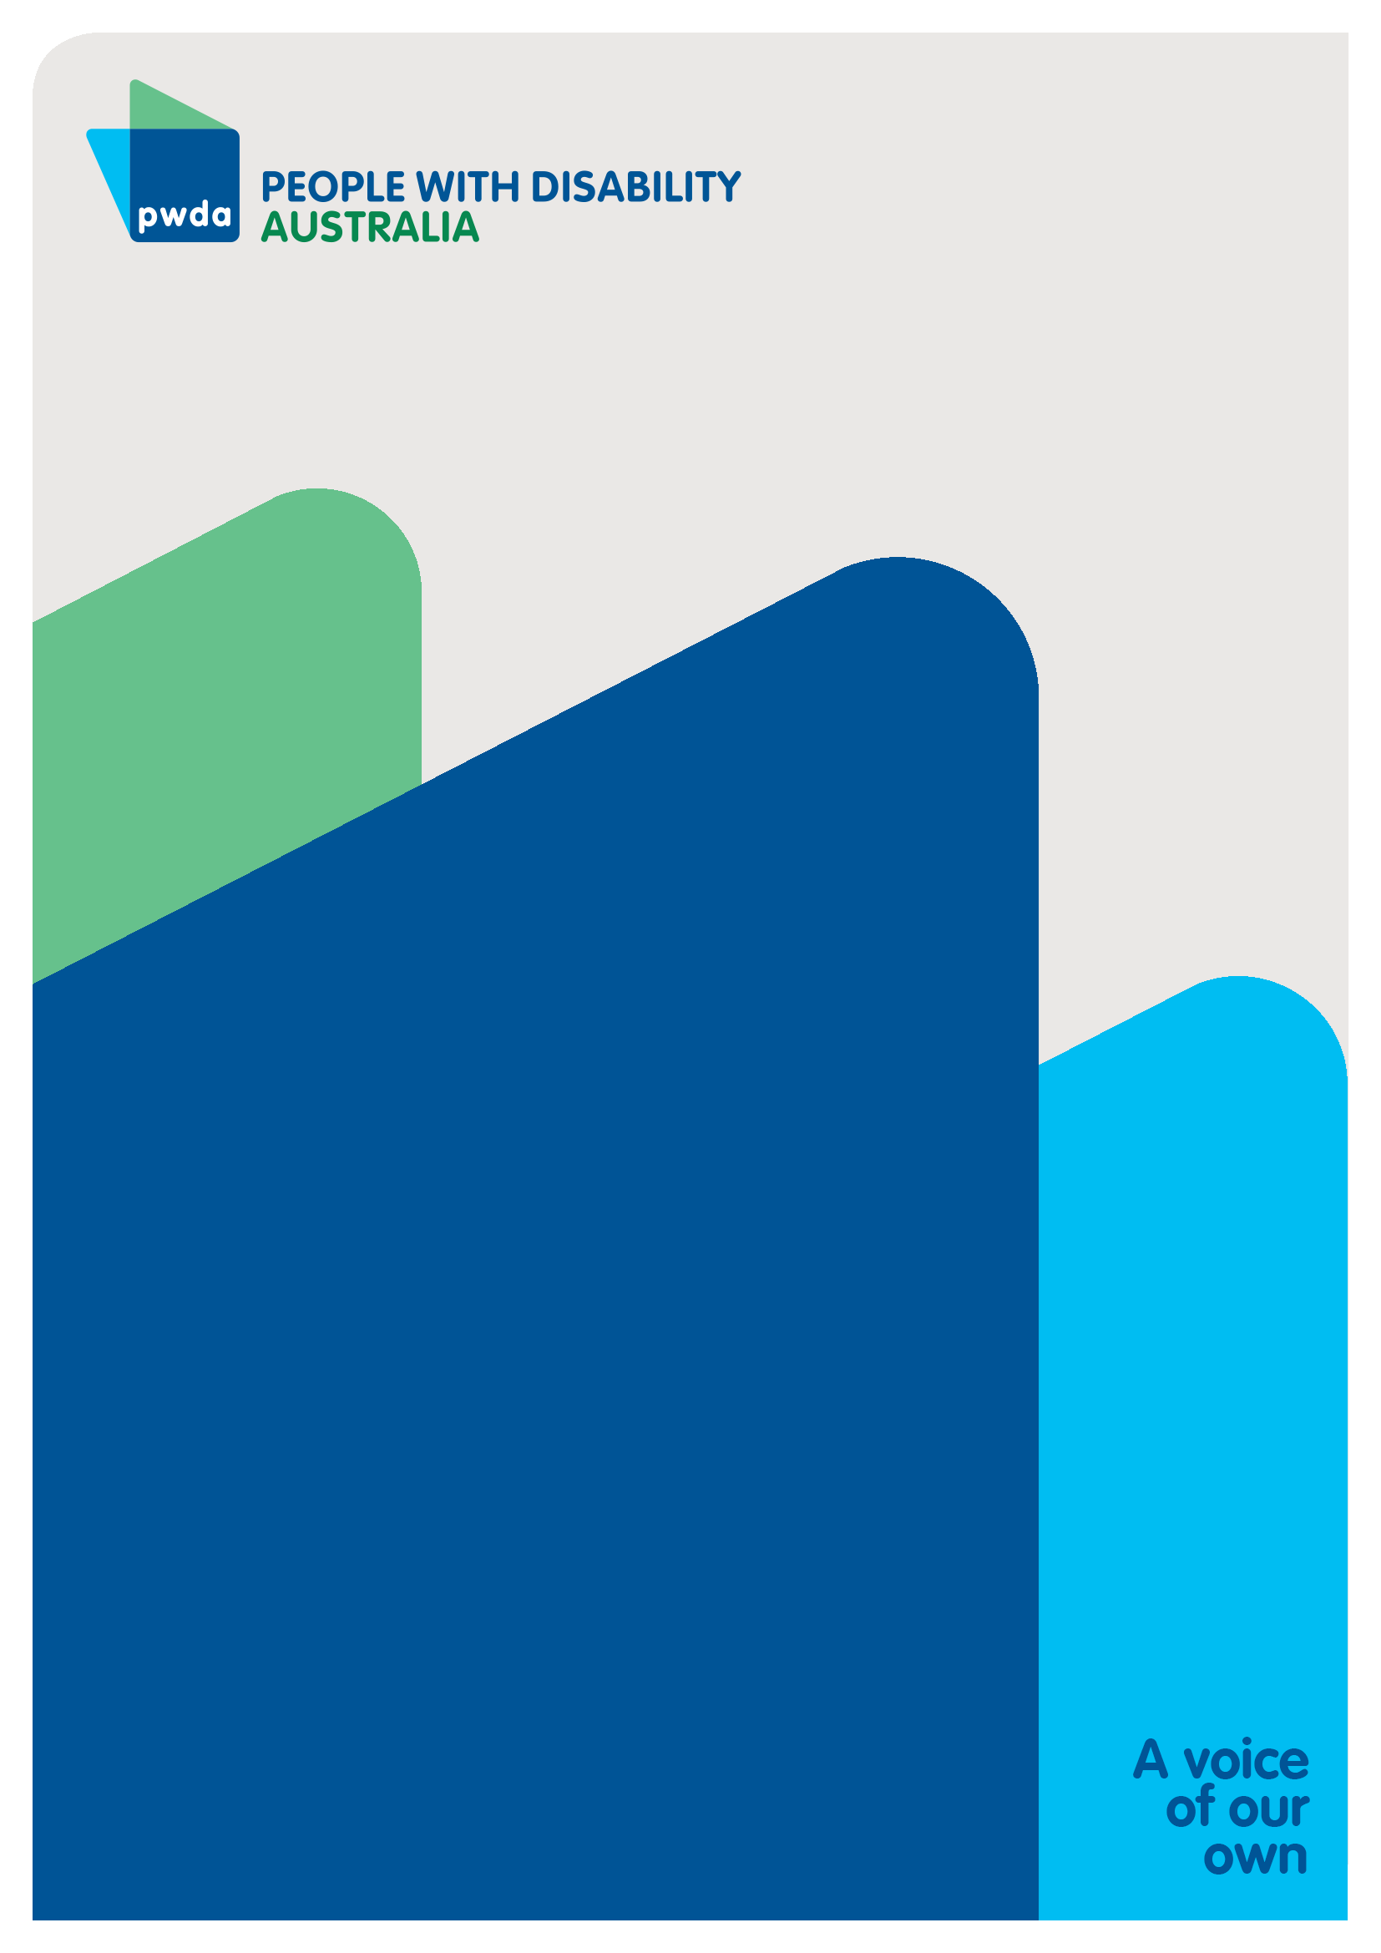
People with Disability Australia (PWDA) is a national disability rights and advocacy organisation made up of, and led by, people with disability.
For individual advocacy support contact PWDA between 9 am and 5 pm (AEST/AEDT) Monday to Friday via phone (toll free) on 1800 843 929 or via email at pwd@pwd.org.au
Submission contact
Giancarlo de Vera
Senior Manager of Policy
E: giancarlod@pwd.org.au

Augmentative and Alternative Communication (ACC) devices are used by people who communicate through forms other than oral communication.
NDIS Review, 2023, What we have heard report (webpage), accessed at < What we have heard report | NDIS Review>.

