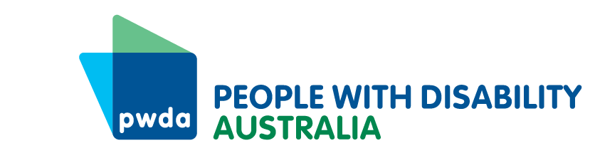
PWDA Director Job Descriptions 2023

The Board of Directors of PWDA is the voice of our members. The Board’s job is to speak with and for people with disability, set strategic direction and govern the organisation.

PWDA is a large organisation with many staff and responsibilities. Our work includes advocacy, representation and implementing projects. We also raise awareness, including through the media, about issues facing people with different kinds of disability across Australia.

The members of PWDA elect Directors to represent them to lead the organisation. The Directors do this by:

- Ensuring we are the voice of and for people with disability.
- Setting strategic goals and a way forward.
- Making sure our money is spent wisely.
- Making sure we obey the law.
- Leading and inspiring staff to do our work.

Duties Of All Directors

All PWDA Directors must:

- Have a commitment and knowledge of our values, aims and objectives.
- Consult with our members and other people with disability on issues.
- Act in the best interests of PWDA.
- Act with reasonable care and use all our skills so that we carry out our work in a way that means we have enough money to cover all our costs.
- Make sure PWDA complies with its legal, constitutional and contractual obligations.
- Make sure our members receive an Annual Report which shows them the work PWDA has done over the year as well as an end of year financial report.
- Provide a written report of any other meetings you have attended on behalf of PWDA.
- Find new Directors for the Board of Directors.
- Use all information correctly in your position you have as a PWDA Director.
- Tell other Directors about and manage all conflicts of interest you think you may have.
- Set the strategic direction for the organisation.
- Recruit, appoint and manage the Chief Executive Officer.
- Make sure the people who have been chosen as the Chief Executive Officer are:
  - working well for PWDA
  - have the support and resources to do their job.

Responsibilities Of All Directors

Directors have a lot of responsibilities, these include:

- Understanding your responsibilities as a Director of PWDA.
- Understanding the shared values of PWDA.
- Attending Board meetings.
- Communicate any access requirements or reasonable adjustments they need to do their job as Board directors.
- Reading all the papers you have been sent before the Board meeting.
- Asking questions during Board meetings to make sure you understand all the papers given to you.
- Respecting all other Directors’ opinions, even if they are different from yours.
- Responding to all telephone calls and emails as soon as you can.
- Attending and participating in all Board Advisory Groups you are a member of.
- Understanding the difference between the work of the Directors and the work of the staff.
- Reviewing and developing relevant policies.
- Developing and reviewing our strategic plan with our members and staff.
- Safeguarding PWDA’s mission and vision – i.e. what it plans to achieve, where it wants to be and how it plans to get there.
- Checking, planning and looking over the management of risks for the organisation.
- The Board must finalise and approve the annual budget and needs to sign off on any items of expenditure outside the approved budget.
- Providing a link between our members and PWDA.
- Developing the job description for the CEO, working closely with them and monitoring their performance.
- Reviewing the audited annual financial report and determining that it gives a true and fair view in accordance with Australian Accounting Standards and the Australian Charities and Not-for-profits Commission Act 2012.

Board Executive Committee
The Board Executive Committee consists of the PWDA President, Vice President, Treasurer and Secretary.
Once the Board Director vacancies are filled after the AGM has concluded, the new Board will appoint a President, Vice President, Treasurer and Secretary so that a Board Executive Committee can be established.
The role of the Board appointed President will be to show leadership to the Board of Directors in all matters; consult with the Board of Directors on all matters and carry out the will of the Board of Directors and the membership.
The role of the Vice-President is to act for the President when the President is unavailable, or the role has been delegated to them by the President.
The role of the Treasurer is to organise and chair the Finance and Risk Advisory Group and to work with relevant PWDA senior managers to ensure that the organisation is trading solvently.
The role of the Secretary is to make sure correct records are kept for the Board of Directors.

