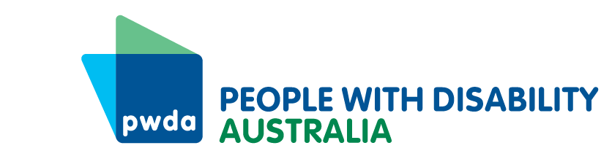
PO Box 666
Strawberry Hills
NSW 2012
+61 2 9370 3100
Toll free 1800 422 015
pwd@pwd.org.au
www.pwd.org.au
Guide For Nominees 2023
The Board of Directors of People with Disability Australia (PWDA) is the voice of our members. The Board’s job is to speak with and for people with disability, set strategic direction and to govern the organisation.
PWDA is a large organisation with many staff and responsibilities. Our work includes advocacy, representation and implementing projects. We also raise awareness, including through the media, about issues facing people with different kinds of disability across Australia.
People with all kinds of disabilities and from diverse backgrounds are encouraged to submit nominations. The PWDA Board especially encourages people with intellectual disability, First Nations people, LGBTIQ+ people, people from culturally and linguistically diverse backgrounds to submit nominations. As a national organisation we encourage nominees from all states and territories.

About Being a Director
The role of a Director of the Board of PWDA includes responsibilities including setting the strategic direction of the organisation, ensuring PWDA is well governed, making sure you are aware of policy issues which affect people with disability, and volunteering your time and expertise for PWDA.
You can read more about this in the PWDA Director Job Description.
There are also policies and procedures that Directors are expected to understand and follow.
Any member of PWDA can apply to be a Director of the Board and needs to know these things:
- If you are a Director of the Board of PWDA you will be volunteering your time and do not get paid to do Board work.
- The costs for support that you may require to do your work as a Director of the Board of PWDA will be paid for by PWDA. This can include an interpreter, an attendant to assist with personal care, a support person to go through your papers with you.
- Board meetings are scheduled approximately every eight (8) weeks.
- Board meetings may be held either face-to-face, or by videoconference or using other technology.
- Board meetings are usually held on a Thursday from 6:00pm to 8.00pm or by arrangement of the Board. Your lunch, travel and accommodation will be provided for face-to-face meetings.
- The Constitutions Act says that if you are an undischarged bankrupt, you cannot be a Director of a company. Please let us know if you have questions about this.
- We will ask you (and pay for) for a Working with Children’s Check and a National Police Clearance, but we recognise that some people with disability have lived experience in the justice system and we value this.
If you think you would have difficulties with a successful National Police Clearance, please contact our CEO for a confidential chat to talk about this.

About The Nomination Process
- The Returning Officer, Thomas Balakas of OGL Group, has been appointed by the Board of PWDA to manage the election process.
- Nominations close at 11.59pm AEST on Monday 4 September 2023.
- Late nominations cannot be accepted. If you are submitting nominations by post, PWDA will not be held responsible for any nominations sent by post that are delayed due to circumstances beyond PWDA’s control. If you wish to ensure PWDA receives your nomination by the closing date please consider using registered and/or express mail.
- You can nominate yourself or someone else for the position of Director. Either way, every nomination must be seconded by one other PWDA member.
- Only Individual Members of PWDA who have voting rights can stand for the position of Director. If you are not sure about this, please contact PWDA.
- Organisational members can nominate an eligible individual for election for Director.
- Individual and Organisational members can sign/second nomination forms.
- Please make sure that all the people who need to fill in, sign and provide contact details to support your nomination have done so before you submit your form.
- A nomination cannot be accepted from a person who is not a voting member of PWDA, nor can a nomination form be accepted which is signed by someone who is not a voting member of PWDA. The Returning Officer will check with PWDA that everyone who nominates for the position of Director, or anyone who signs a nomination form, is a voting member of PWDA.
- Please submit your nomination using the online nomination form OR return your completed nomination form to pwd@pwd.org.au OR post to PWDA, PO Box 666, Strawberry Hills, NSW, 2012.
- If you are unable to complete the nomination form in writing and require an adjustment to be made, PWDA’s Constitution allows us to accept alternative formats. You must contact PWDA about your requirements to arrange this before nominations close.
- If you would like to find out if your membership status is current or wish to nominate and are not sure who else is a member who can propose or second you, then please contact PWDA.
- If you need any other help with nominating yourself or another person, please contact PWDA and request assistance.

About The Election Process
- After the closing date for nominations has passed, all nominations will be collated, and the Board will review the nominations against the selection criteria as outlined in the Director nomination form, our Constitution and policies and procedures.
- The Board of Directors will approve the nominees that meet the selection criteria.
- If the number of successful nominees are more than the number of vacancies available on the Board, then the Board of Directors will put the successful nominees forward for an election process. PWDA members will then be given the opportunity to vote on the nominee that they think is most suitable. Relevant communications about any election will be sent to all PWDA members.
- When the election period has concluded, all votes will be counted and recorded by the Returning Officer. The nominees that have received the most number of votes will be put forward to the AGM for appointment by the members in attendance.
- To ensure the integrity of the election process, PWDA membership will ‘close’ at midnight on Monday 21 August 2023 and will remain closed until the Annual General Meeting has been completed on Wednesday 15 November.
Completing The Nomination Form
All nominees need to complete a nomination form which includes:
- Nominee contact details
- Proposer contact details (this can be yourself if you are a member)
- Seconder contact details
- Questions about the nominee’s background, skill set and interest in being a Director
- Nominee photo
- Nominee declaration
Contact Us
- Thomas Balakas | Returning Officer | 0405 603 853 | pwd@pwd.org.au
- PWDA | 1800 422 015 | pwd@pwd.org.au

