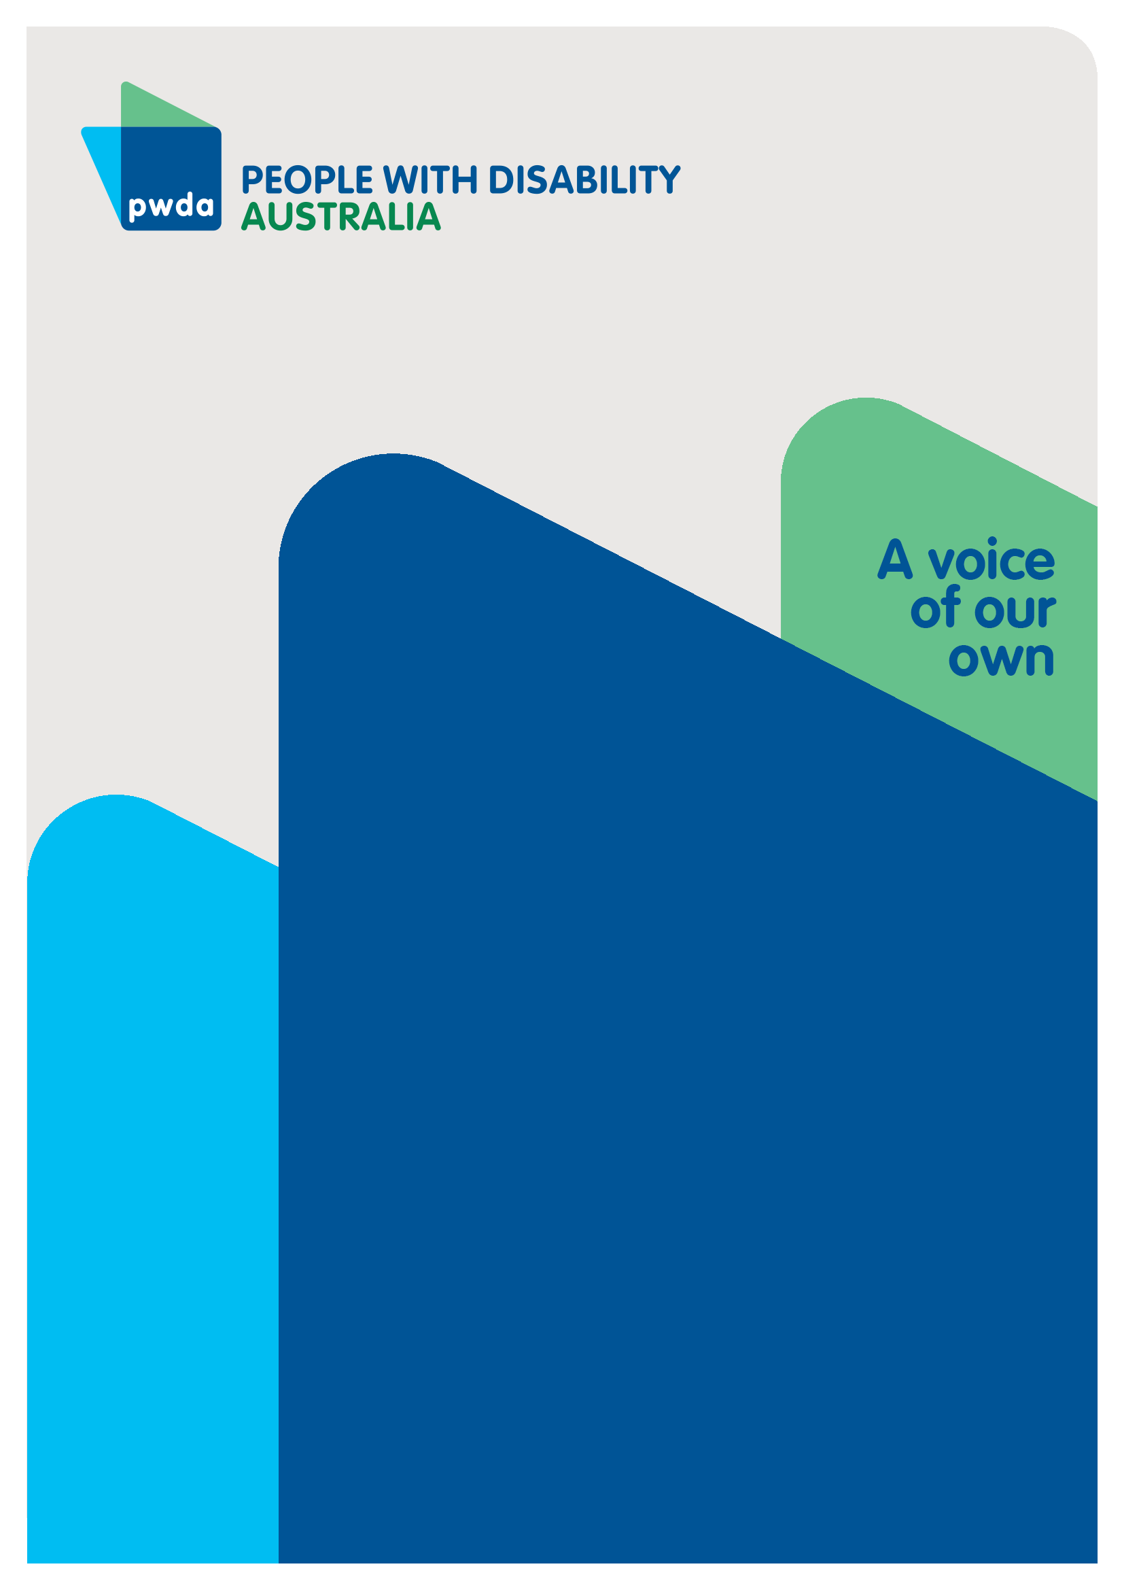
A Human Rights Act for All

Submission to the Parliamentary Joint Committee on Human Rights’ Inquiry into Australia’s Human Rights Framework

June
2023

Copyright information
A Human Rights Act for All: Submission to the Parliamentary Joint Committee on Human Rights' Inquiry into Australia's Human Rights Framework
First published in 2023 by People with Disability Australia Ltd.
Level 8, 418a Elizabeth Street, Surry Hills, Sydney, New South Wales, Australia 2010
Email: pwda@pwd.org.au
Phone: +61 2 9370 3100 Fax: +61 2 9318 1372
URL: www.pwd.org.au
© People with Disability Australia Ltd. 2023
The moral rights of the authors have been asserted
National Library of Australia Cataloguing-in-Publication data:
Creator(s): | People with Disability Australia
Title: | A Human Rights Act For All: Submission to the Parliamentary Joint Committee on Human Rights' Inquiry into Australia's Human Rights Framework
All rights reserved. Except as permitted with the Australian Copyright Act 1968 (for example, a fair dealing for the purposes of study, research, criticism or review), no part of this book may be reproduced, stored in a retrieval system, communication or transmitted in any form or by any means without prior written permission. All inquiries should be made to the publisher at the address above.
Suggested citation: People with Disability Australia, A Human Rights Act for All: Submission to the Parliamentary Joint Committee on Human Rights' Inquiry into Australia's Human Rights Framework, 14 June 2023.
ISBN 978-0-6457443-4-7
Contents

About PWDA 4
Introduction 5
Summary of recommendations 7
Key recommendation 7
Supporting recommendations 7
Inadequacy of current protections 8
The positive impact of human rights legislation in realising human rights 10
Law making and reform 10
Tribunals and court cases 12
Complaints and dispute resolution 14
Scope of the human rights legislation 16
Why should the CRPD be expressly incorporated in national human rights legislation? 16
Australian Human Rights Commission recommendations 18
Further recommendations 19
Conclusion 20
21

About PWDA
People with Disability Australia (PWDA) is a national disability rights and advocacy organisation made up of, and led by, people with disability.
The disability representative organisation has a vision of a socially just, accessible and inclusive community in which the contribution, potential and diversity of people with disability are not only recognised and respected but also celebrated.
PWDA was established in 1981, during the International Year of Disabled Persons.
It is a peak, non-profit, non-government organisation that represents the interests
of people with all kinds of disability.
The organisation of people with disability helps represent the Australian disability community at the United Nations, particularly in relation to the international human rights outlined in the Convention on the Rights of Persons with Disabilities (CRPD).
PWDA’s work is grounded in a human rights framework that recognises the CRPD and related mechanisms as fundamental tools for advancing the rights of people with disability.
The Disabled People’s Organisation (DPO) is a member of Disabled People’s Organisations Australia (DPO Australia), along with the First People’s Disability Network, National Ethnic Disability Alliance and Women with Disabilities Australia.
As a DPO, PWDA collectively forms a disability rights movement that places people with disability at the centre of decision-making about all aspects of their lives. This in keeping with the human rights of people with disability to be involved with legislation, policies and other issues relating to them through representative organisations, and right to equal recognition before the law, under articles 4(3) and 12 of the CRPD.
PWDA’s work also embraces the Nothing About Us, Without Us motto of members of the international disability community, prioritising inclusion and respect for people’s right to legal capacity.

Introduction
PWDA welcomes the opportunity to comment on the Parliamentary Joint Committee on Human Rights’ Inquiry into Australia’s Human Rights Framework.
Our key recommendation to the Inquiry is that Australia enacts a federal human rights act that upholds the rights of all Australians, including people with disability.
As a national peak disability rights and advocacy organisation, our submission will focus on implementing the Convention on the Rights of Persons with Disabilities (CRPD) through a national human rights act.
The CRPD sets a progressive agenda for disability rights. The creation of the CRPD marked a significant moment in history, as it globally recognised people with disability as rights holders, rather than objects of charity and social welfare. It was created by us and for us, with non-government organisations and disability-rights activists heavily involved in the negotiation process, including PWDA who played a significant role in the CRPD’s development.
Despite this international progress, Australia has not adequately implemented the CRPD in Australian law. As with many groups, people with disability in Australia enjoy only a ‘patchwork’ of human rights protections. As a result, people with disability commonly experience human rights violations. For example:
- 47% of adults with disability have experienced violence after age 15
- 16% of people aged 15-64 with disability experienced disability discrimination in 2022
- 30% of people aged 15-64 with mobility or communication challenges have difficulty accessing buildings or facilities, and
- people aged 15-64 with disability are more than twice as likely to be in financial stress as those without disability.
As we bear witness to the countless reports of human rights violations at the Royal Commission into Violence, Abuse, Neglect and Exploitation of People with Disability (the Disability Royal Commission), we can no longer credibly say that Australia’s human rights protections are adequate for people with disability.

Key recommendation
Recommendation 1 – Australia enacts national human rights legislation that upholds the rights of all Australians, including people with disability, and ensures the full protection of the human rights of people with disability.
We need a national human rights act to make sure our rights are protected in all areas of our lives, no matter where we live. This position and this submission are endorsed by:
- Amnesty International Australia
- Australian Centre for Disability Law
- Children and Young People with Disability Australia
- Disability Advocacy Network Australia
- National Ethnic Disability Alliance
- Inclusion Australia, and
- Women with Disabilities Australia

Summary of recommendations

Key recommendation
Recommendation 1 – Australia enacts national human rights legislation that upholds the rights of all Australians, including people with disability, and ensures the full protection of the human rights of people with disability.

Supporting recommendations
Recommendation 2 – That any national human rights legislation expressly incorporates immediate rights in the CRPD, by individually listing each CRPD right or by reference to incorporation of the CRPD into the legislation.
Recommendation 3 – That the Government engages an international human rights law expert to examine and identify which rights and components of rights in the CRPD are subject to immediate realisation. The Government should also engage Disability Representative Organisations to assist in determining which rights should be prioritised for incorporation in the human rights legislation.
Recommendation 4 – That national human rights legislation includes a provision that requires decision-makers to consider international human rights law jurisprudence as persuasive in interpreting the legislation.
Recommendation 5 – That the Government designates an appropriate body to undertake dispute resolution and adjudication functions, for matters arising under the national human rights legislation. This body must be appropriately resourced to carry out all dispute resolution and adjudication functions, and in a manner that is fully accessible to all people with disability.
Recommendation 6 – If a national human rights act is established and an adjudication body designated, the Government must ensure that civil society has a role in assisting the adjudication body to address systemic issues arising from cases, and funding should be provided accordingly.

Inadequacy of current protections
Australia’s ‘patchwork’ of human rights protections in place for people with disability has proved insufficient, so people with disability do not enjoy full human rights protection in Australia.
The UN Committee on the Rights of Persons with Disabilities (CRPD Committee) last raised many deficiencies in its 2019 Concluding Observations on the Combined Second and Third Periodic Reports of Australia, including, but not limited to:
- the ongoing segregated and underpaid employment of people with disability in Australian Disability Enterprises
- the lack of an effective legislative framework to protect people with disability from systemic, intersectional and multiple forms of discrimination
- the ‘significant proportion of the existing built environment that is inaccessible’
- a lack of progress in abolishing the guardianship system and substituted decision-making regime, particularly in decisions concerning forced psychiatric treatment
- the arbitrary and indefinite detention and forced treatment of people with disability
- the use of restrictive practices against people with disability, including physical restraints, seclusion and psychotropic medications
- the ongoing legalised practice of forced sterilisation, abortion and contraception among people with disability, particularly women and girls
- a significant increase in students with disability experiencing a segregated education, seclusion, isolation and lack of age-appropriate settings
- migration legislation’s health requirement that allows for discrimination against people with disability.
One reason for these deficiencies is the heavy reliance on parliaments, judges and public officials to uphold and respect our human rights. This reliance is problematic because ableism, which views disability as a deficit that needs to be fixed, is heavily entrenched in Australia’s legal, policy and practical frameworks, as well as in societal attitudes.
This entrenched ableism causes well-meaning law and policy reforms to often miss the mark, further entrenching the segregation of people with disability from society and denying our autonomy. For example, state and territory governments continue to fund and develop segregated education facilities, which violates the CRPD Article 24 right to inclusive education. Further, governments often celebrate special school funding as a measure that enhances equality for students with disability. For example, in 2022, the Victorian Government announced that:
Students with disability and special needs are entitled to exactly the same opportunities as every other student in Victoria. A $326 million investment will deliver upgrades for 36 special schools – meaning these kids and their school communities will have the first-class facilities they deserve.
Guaranteeing our human rights in a national human rights act will ensure that change is driven by the CRPD, rather than outdated conceptualisations of disability that segregate and dehumanise us.

The positive impact of human rights legislation in realising human rights
A host of measures are needed to address the human rights deficiencies identified by the CPRD Committee. We believe a key mechanism is the establishment of a national human rights act. Human rights legislation in Australian Capital Territory (ACT), Queensland, Victoria and in the United Kingdom (UK) has already improved the lives of people with disability.
The impact is seen at different levels, including in the development of new laws, at tribunals and courts and through complaint mechanisms. Human rights legislation has also proved to be an important tool for disability advocates in negotiating favourable outcomes for people with disability.
This section highlights examples of the positive impact that human rights legislation has had on law reform, cases and dispute resolution outcomes in Australia and the UK.

Law making and reform

Victoria: guardianship and administration reforms
The Charter of Human Rights and Responsibilities Act 2006 (Vic) (the Victorian Charter) has been effective in driving law reform that increases compliance with human rights. For example, the Victorian Attorney-General asked the Victorian Law Reform Commission to review the Guardianship and Administration Act 1986 (Vic) and included in its terms of reference to consider whether the laws are consistent with the Victorian Charter. The Victorian Law Reform Commission noted that the Victorian Charter ‘served as a helpful guide … when designing new guardianship laws’, and that along with the CRPD, the Victorian Charter ‘has informed the development of principles to underpin new guardianship laws.’
The Victorian Law Reform Commission’s Inquiry led to the development and passing of the new Guardianship and Administration Act 2019 (Vic), which represented a ‘landmark change’ in guardianship law, with a focus on ensuring that people with disability are able to make and participate in decisions affecting their lives. This law has translated to more choice and control for people with disability (see Tribunal and Court cases section below).

Queensland: voluntary assisted dying legislation
Queensland’s recent Voluntary Assisted Dying Act 2021 (QLD) (‘Voluntary Assisted Dying Act’) contains specific provisions about the rights of people with disability. Section 13 of the Voluntary Assisted Dying Act states that people with disability are subject to the same eligibility criteria for access to voluntary assisted dying as people without disability. Section 13 also clarifies that having a disability does not make a person eligible for voluntary assisted dying in and of itself.
According to the Queensland Law Reform Commission, these provisions:
‘…[make] it clear that people who have a disability … have the same rights and protections as other members of the community, and should not be discriminated against or denied access to voluntary assisted dying if they meet all the eligibility criteria.’
Section 13 of the Voluntary Assisted Dying Act is based on recommendation 7-2 of the Queensland Law Reform Commission’s 2021 Report, A Legal Framework for Voluntary Assisted Dying, which recommended that the legislation state that people with disability can access Voluntary Assisted Dying if they meet all the criteria, and that having a disability does not in and of itself make a person eligible for voluntary assisted dying.
In making its recommendations, the Queensland Law Reform Commission expressly referred to the Queensland Human Rights Act 2019 (‘QLD Human Rights Act’), noting the right to ‘recognition and equality before the law’ and the ‘right to access health services without discrimination’. As such, the presence of the QLD Human Rights Act that the Queensland Law Reform Commission had regard to the rights of people with disability and this translated through into the legislation.

Tribunals and court cases

Victoria: OUR (Guardianship) [2021] VCAT 176
In this case, the Victorian Civil and Administrative Tribunal (VCAT) conducted a reassessment hearing of an administration order under the new guardianship legislation. Under the new legislation, VCAT was obliged to let OUR’s will and preferences direct the decision ‘as far as practicable.’ OUR was given the opportunity to indicate her will and preferences, stating that she wanted the administration order to be revoked so she could manage her money herself. The new legislation also requires that VCAT presumes OUR had decision-making capacity unless there was evidence to the contrary, which there was not. As a result, OUR’s administration order was revoked and she was able to manage her own money.

Victoria: Ingram v QBE Insurance (Human Rights) [2015] VCAT 1936
This case involved a student, Ms Ingram, who purchased travel insurance in 2011 for a study trip scheduled for 2012. In early 2012, Ms Ingram developed depression and was unable to attend the study trip. The insurance company refused to pay a claim for the cost of the trip relying on an exclusion in its policy for claims arising from mental illness. Ms Ingram argued that the mental illness exclusion policy discriminated on the basis of disability and breached the Victorian equal opportunity legislation. The Tribunal used the Victorian Charter to interpret the meaning of ‘disability’ in the equal opportunity legislation, which meant that that the definition of disability included ‘a disability that may exist in the future.’ As a result, the fact that Ms Ingram did not have depression at the time of purchasing the policy did not preclude her from claiming discrimination. This case is an example of the Victorian Charter encouraging a human rights interpretation of legislation.

UK: RR (Appellant) v Secretary of State for Work and Pensions (Respondent)
This case concerned a Government regulation that deducted a percentage of the housing benefit where the number of rooms in the house exceeded the size of the family or people who lived there.
The regulation did not contain exceptions for adults with disability who cannot not share a bedroom due to disability and those who require an extra bedroom for overnight care from a non-resident carer. The Court held that the regulation contravened the UK Human Rights Act 1998, by breaching Articles 8 (right to respect for private and family life) and 14 (right to non-discrimination) of the European Convention on Human Rights.
The decision prompted the Government to amend its legislation to allow an extra bedroom when a person with disability requires overnight care from a non-resident carer, and to allow adults couples with disability an extra bedroom if they cannot share a bedroom due to disability.

UK: The Queen on the Application of Bernard v. London Borough of Enfield [2002] EWHC 2282 (Admin)
A woman with severe disability and her husband brought a claim alleging that the Housing Department did not provide them with wheelchair accessible accommodation. The woman could not use her wheelchair and had to rely on her husband for all tasks of daily living. The woman was incontinent due to difficulties of getting to a toilet in time because of the property layout and lack of wheelchair use. She was also unable to care for and supervise her six children as she could not move around the home. The local authority accepted that it was under a duty to provide adapted accommodation but failed to comply with this duty for 20 months. The Court found that the Housing Department had violated Article 8 of the European Convention on Human Rights by failing to respect the private and family life of the claimants and awarded damages to the claimants. The Court noted that Article 8 may require governments to take positive steps to ensure respect for private or family life, as opposed to merely abstaining from interference.

Complaints and dispute resolution
People with disability and their advocates have also been able to use human rights legislation to resolve disputes directly with institutions and where necessary, through complaint mechanisms without the need to litigate.

ACT: Abuse and freedom of movement
This case involved a man who had allegedly been frightened and provoked deliberately by his carers. The Commissioner found no reliable evidence that this had happened, but made recommendations about staff training, critical incident reporting and communication and information sharing between agencies involved in the man’s care. The Commissioner also raised concern about the fact the man was unable to leave his accommodation and that the doors of his residence were locked. The Commissioner recommended that a human rights analysis of the man’s care and treatment be conducted, including the restriction of his movement. The recommendations were accepted.

Queensland: Mental health and eviction
Tenants Queensland used the QLD Human Rights Act to help a man with mental health issues avoid eviction. The housing provider sought to evict the man due to his frequent complaints about common areas. Tenants Queensland assisted the tenant in drafting a human rights complaint stating that the housing provider should have taken the man’s disability into account and given him an alternative way of communicating rather than seeking to terminate the tenancy. Negotiations resulted in the provider withdrawing their application to terminate the tenancy.

UK: Woman denied a double bed
A woman with disability was advised by an occupational therapist that she needed a special profile bed. She was unable to leave the bed and the new arrangement would ensure that carers could give her a bed bath. She wanted to continue to sleep next to her husband, so she requested a double bed. The authority declined her request, even though she offered to pay the difference between a single and double bed. No progress was made for 18 months until the Disability Law Centre advised her to invoke her right to respect for private and family life. Within three hours of making this argument to the authority, the authority approved funding of the whole double profile bed. The woman has since stated that, ‘[i]t has made a phenomenal difference to my life. If something similar happened in future, I would have no hesitation in using the [Human Rights Act] again’.

Scope of the human rights legislation
As the previous section demonstrates, human rights legislation has resulted in tangible and fuller human rights protections for people with disability. Establishing national human rights legislation would replicate and extend the success of this legislation to all jurisdictions.
What should a national human rights legislation cover? Human rights legislation in the ACT, Queensland and Victoria is based on the International Covenant on Civil and Political Rights (ICCPR) and certain rights in the International Covenant on Economic, Social and Cultural Rights (ICESCR). However, establishing national human rights legislation provides the opportunity to take a more comprehensive approach and incorporate all provisions of the CRPD that are subject to immediate realisation.
Rights that are ‘immediately realisable’ are rights that governments must create laws and measures to give effect to immediately, while those which are subject to progressive realisation can be realised subject to the availability of resources. The CRPD contains both immediate and progressive rights.

Why should the CRPD be expressly incorporated in national human rights legislation?
The CRPD is a specialist treaty that articulates how existing international human rights laws apply to people with disability. For example, the Universal Declaration of Human Rights and the ICCPR provide the right to equality before the law. Article 12 of the CRPD reaffirms this right and further provides that people with disability have full legal capacity and must be provided with support, where required, to exercise that capacity.
The doctrine of lex specialis means that laws covering specific subject matters override laws governing general matters. As such, the CRPD’s normative standards override other treaties and jurisprudence relating to people with disability. This means that the CRPD, as opposed to the ICCPR and ICESCR is the most authoritative depiction of the human rights of people with disability.
To ensure the full rights of people with disability are captured in national human rights legislation, the Government must expressly incorporate our CRPD rights rather than relying on the ICCPR and ICESCR as some governments have done in other jurisdictions.
Expressly incorporating the CRPD in national human rights legislation will also help parliaments, courts, public servants and the public understand our specific rights, and ensure that old conceptualisations of disability are not applied. It will provide people with disability a clear enunciation of our rights and confirm that they form part of Australian law.
Recommendation 2 – That any national human rights legislation expressly incorporates immediate rights in the CRPD, by individually listing each CRPD right or by reference to incorporation of the CRPD into the legislation.
While it is important that all immediately realisable rights are incorporated into national human rights legislation, we understand that a phased approach will be necessary. Disability Representative Organisations can play an important role in identifying which rights need to be incorporated most urgently. As such, we recommend that:
Recommendation 3 – That the Government engages an international human rights law expert to examine and identify which rights and components of rights in the CRPD are subject to immediate realisation. The Government should also engage Disability Representative Organisations to assist in determining which rights should be prioritised for incorporation in the human rights legislation.
We also want to make sure that the Government draws upon international human rights law jurisprudence, such as the CRPD Committee’s General Comments, when interpreting national human rights legislation. The Government should be viewing this material as ‘persuasive’ but it currently neglecting to do so. As such, we recommend that:
Recommendation 4 – That national human rights legislation includes a provision that requires decision-makers to consider international human rights law jurisprudence as persuasive in interpreting the legislation.

Australian Human Rights Commission recommendations
In addition to PWDA’s above recommendations, we endorse the Australian Human Rights Commission’s recommendations to this Inquiry, which ask that the Government:
- develops a new National Human Rights Framework
- develops a Draft Exposure Bill for a national human rights act (adding that this should incorporate immediately realisable CRPD rights, as discussed above)
- modernises federal discrimination laws to ensure their effectiveness
- strengthens the parliamentary scrutiny of human rights
- enhances parliamentary oversight and awareness of Australia’s international human rights obligations
- introduces a national human rights education program
- commits to a national human rights indicator index
- commits to an annual statement to Parliament on human rights
- ensures the Australian Human Rights Commission is appropriately and sustainably resourced
- supports measures that build community capacity to realise human rights.

Further recommendations
If Australia adopts a human rights act, we recommend that the Government designate a body, such as the Australian Human Rights Commission or the new Administrative Appeals Tribunal, to provide dispute resolution and adjudication for matters arising under the human rights act.
Recommendation 5– That the Government designates an appropriate body to undertake dispute resolution and adjudication functions, for matters arising under the national human rights legislation. This body must be appropriately resourced to carry out all dispute resolution and adjudication functions, and in a manner that is fully accessible to all people with disability.
Expanding on the Australian Human Rights Commission’s recommendation 10(c), it will be important that civil society bodies, including Disabled People’s Organisations such as PWDA, and Disability Representative Organisations are given a formal role in the dispute resolution and adjudication body to address systemic issues arising from human rights cases.
This will further the implementation of Article 4(3) of the CRPD, which requires governments to closely consult with people with disability and their representative organisations when developing and implementing legislation and policies concerning people with disability.
Recommendation 6 – If national human rights act is established and an adjudication body designated, the Government must ensure that civil society has a role in assisting the adjudication body to address systemic issues arising from cases, and funding should be provided accordingly.

Conclusion
In conclusion, Australia’s current patchwork of human rights protections is failing people with disability. This is confirmed by the poorer outcomes people with disability experience across a variety of life domains, by the distressing evidence heard at the Disability Royal Commission and the CRPD Committee’s last Concluding Observations in 2019.
Many measures are needed to ensure our rights are upheld and protected. However, national human rights legislation would provide a basis for law reform, rights enforcement and self-advocacy.
National human rights legislation must expressly incorporate the CRPD, rather than rely on the ICCPR and ICESCR alone. This will ensure that ableist interpretations of our rights do not seep in, however well-intentioned. It will also provide us with a clear enunciation of our rights and give us the confidence that our specific rights are protected in Australian law.
We have seen the success that human rights legislation has had in the ACT, Queensland, Victoria and the UK for people with disability. We must now seize upon the opportunity to ensure our human rights are protected wherever we reside. We cannot afford to rely on Australia’s patchwork of human rights any longer.

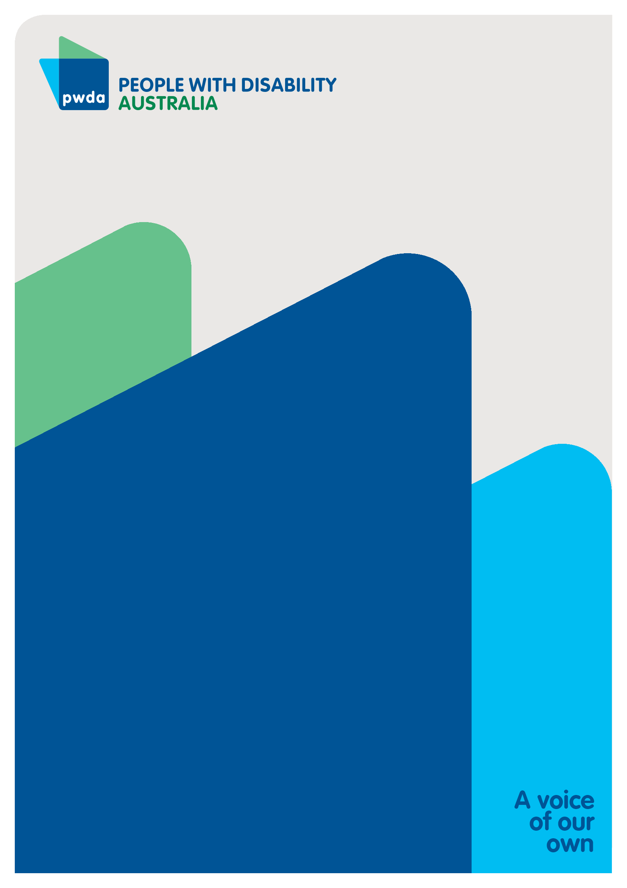
People with Disability Australia (PWDA) is a national disability rights and advocacy organisation made up of, and led by, people with disability.
For individual advocacy support contact PWDA between 9 am and 5 pm (AEST/AEDT) Monday to Friday via phone (toll free) on 1800 843 929 or via email at pwd@pwd.org.au
Submission contact
Giancarlo de Vera
Senior Manager of Policy
E: giancarlod@pwd.org.au

United Nations, High Commissioner for Human Rights (2007) Press conference by High Commissioner for Human Rights on signing of convention, United Nations, accessed 23 June 2023.
United Nations, High Commissioner for Human Rights (2007) Press conference by High Commissioner for Human Rights on signing of convention, United Nations, accessed 23 June 2023.
Committee on the Rights of Persons with Disabilities (2019) Concluding observations on the combined second and third periodic reports of Australia, United Nations.
Australian Human Rights Commission (AHRC) (2022) Free & equal position paper: a human rights act for Australia, AHRC 10.
The Australian Institute of Health and Welfare (AIHW) (2022) People with disability in Australia 2022, AIHW, Australian Government.
Australian Human Rights Commission (AHRC) (2022) Free & equal position paper: a human rights act for Australia, AHRC 10.
Committee on the Rights of Persons with Disabilities (2019) Concluding observations on the combined second and third periodic reports of Australia, United Nations. For a very recent example of discrimination against people with disability in migration law, please see the case of Aaryan: Davis A and Trilling J (2 March 2023) ‘Perth family facing deportation as son’s Down Syndrome diagnosis deemed taxpayer burden’, ABC News, accessed 23 June 2023.
Rosemary Kayess and Therese Sands (2020) Convention on the Rights of Persons with Disabilities: Shining a light on social transformation, report to the Royal Commission into Violence, Abuse, Neglect and Exploitation of People with Disability, 9.
Rosemary Kayess and Therese Sands (2020) Convention on the Rights of Persons with Disabilities: Shining a light on social transformation, report to the Royal Commission into Violence, Abuse, Neglect and Exploitation of People with Disability, 9.
Victorian Government (3 May 2022) Major upgrades delivered for special schools [media release], Victorian Government, accessed 23 June 2023.
Victorian Law Reform Commission (VLRC) (2012) Guardianship Final Report No.24, VLRC, 4, accessed 23 June 2023.
Victorian Law Reform Commission (VLRC) (2012) Guardianship Final Report No.24, VLRC, 45, accessed 23 June 2023.
Victorian Government (1 March 2020) Victorian guardianship reforms now law [media release], Victorian Government, accessed 23 June 2023.
Voluntary Assisted Dying Act 2021 (QLD) 13(1)(a).
Voluntary Assisted Dying Act 2021 (QLD) 13(1)(b).
Queensland Law Reform Commission (QLRC) (2021) A legal framework for voluntary assisted dying, QLRC, 93.
Queensland Law Reform Commission (QLRC) (2021) A legal framework for voluntary assisted dying, QLRC, 119.
Queensland Law Reform Commission (QLRC) (2021) A legal framework for voluntary assisted dying, QLRC, 28.
OUR (Guardianship) [2021] VCAT 176.
UK Department for Work and Pensions (2020) HB Bulletin U1/2020: RR -v- The Secretary of State for Work and Pensions, accessed 28 June 2023.
ACT Human Rights Commission (2015) Annual report 2014-15, 41.
Queensland Human Rights Commission (2020) Annual report on the operation of the Human Rights Act 2019, 2019-2020, 112.
The British Institute of Human Rights (BIHR), The Human Rights Act – changing lives, BIHR, accessed 28 June 2023.
Australian Human Rights Commission (AHRC), Nature of obligations regarding economic, social and cultural rights, accessed 28 June 2023.
Rosemary Kayess and Therese Sands (2020) Convention on the Rights of Persons with Disabilities: Shining a light on social transformation, report to the Royal Commission into Violence, Abuse, Neglect and Exploitation of People with Disability 28.
Rosemary Kayess and Therese Sands (2020) Convention on the Rights of Persons with Disabilities: Shining a light on social transformation, report to the Royal Commission into Violence, Abuse, Neglect and Exploitation of People with Disability 28.
Rosemary Kayess and Therese Sands (2020) Convention on the Rights of Persons with Disabilities: Shining a light on social transformation, report to the Royal Commission into Violence, Abuse, Neglect and Exploitation of People with Disability, 29.

