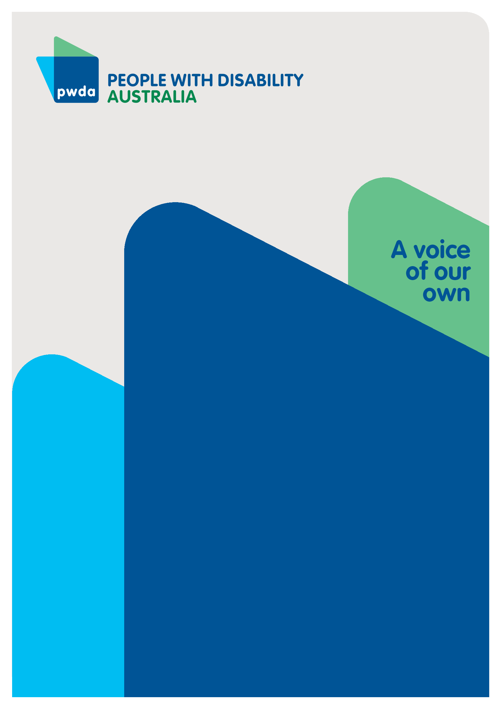
NDIS Review
Housing Survey Summary Report

Summary report of a survey PWDA conducted on National Disability Insurance Scheme (NDIS) housing supports for the Independent Review of the NDIS
Aug
2023

Copyright information
NDIS Review: Housing Survey Summary Report
Copyright © People with Disability Australia Ltd. 2023
First published 2023
Published by People with Disability Australia
Level 8, 418a Elizabeth Street, Surry Hills, Sydney, New South Wales, Australia 2010
Head office also in Sydney
Email: pwda@pwd.org.au
Phone: +61 2 9370 3100 Fax: +61 2 9318 1372
URL: www.pwd.org.au
Typeset in Arial 11 and 12pt and VAG Rounded 16 and 26 pt
© People with Disability Australia Ltd. 2023
The moral rights of the authors have been asserted
National Library of Australia Cataloguing-in-Publication data:
Creator(s): | People with Disability Australia
Title: | NDIS Review: Housing Survey Summary Report
All rights reserved. Without limiting the rights under copyright reserved above, no part of this publication may be reproduced, stored in or introduced into a database and retrieval system or transmitted in any form or any means (electronic, mechanical, photocopying, recording or otherwise) without the prior written permission of both the owner of copyright and the above publisher.
Suggested citation:
People with Disability Australia, NDIS Review - Housing Survey Summary Report [report], 22 August 2023, People with Disability Australia, Sydney

ISBN: 978-0-6457443-9-2

About PWDA
People with Disability Australia (PWDA) is a national disability rights and advocacy organisation made up of, and led by, people with disability.
We have a vision of a socially just, accessible and inclusive community in which the contribution, potential and diversity of people with disability are not only recognised and respected but also celebrated.
PWDA was established in 1981, during the International Year of Disabled Persons.
We are a peak, non-profit, non-government organisation that represents the interests of people with all kinds of disability.
We also represent people with disability at the United Nations, particularly in relation to the United Nations Convention on the Rights of Persons with Disabilities (CRPD).
Our work is grounded in a human rights framework that recognises the CRPD and related mechanisms as fundamental tools for advancing the rights of people with disability.
PWDA is a member of Disabled People’s Organisations Australia (DPO Australia), along with the First People’s Disability Network, National Ethnic Disability Alliance and Women with Disabilities Australia.
DPOs collectively form a disability rights movement that places people with disability at the centre of decision-making in all aspects of our lives.
‘Nothing About Us, Without Us’ is the motto of Disabled Peoples’ International.

Table of Contents

Copyright information 2
About PWDA 3
Executive Summary 5
Support worker issues 5
Housing provider issues 6
NDIS issues 6
Recommendation 6
Introduction 8
Methodology 8
Data analysis 8
Survey demographics 10
Summary of survey question responses 17
NDIS Funding 17
Supports at home 20
Same housing and support provider 28
Separate housing and support providers 33
Conclusion 42
Appendix A - Survey questions 43

Executive Summary
In late 2022, the Government announced an independent review of the National Disability Insurance Scheme (NDIS) (the NDIS Review). As part of People with Disability Australia’s (PWDA) response to the NDIS Review, PWDA conducted an online survey about NDIS participants' choice and control in NDIS-funded housing and supports.
PWDA designed and conducted the survey. Feedback on the survey questions was sought from and provided by the NDIS Review Secretariat. The survey asked qualitative and quantitative questions concerning people’s experiences and satisfaction with their housing and supports. The survey questions focused on whether participants felt they could choose or change housing and support providers and whether they could raise issues with providers.
The survey received 76 responses. The survey's quantitative responses were largely mixed, with respondents reporting both negative and positive experiences. In addition, many questions were not answered by a high number of respondents, which led to difficulty in deducing clear themes. What did emerge strongly is that if given more choice and control, respondents would prefer to live in privately owned accommodation and would prefer to live by themselves or with their partner and/or children.
The qualitative data revealed the following themes:

Support worker issues
- a serious lack of available and appropriately skilled support workers, particularly for people with disability who have complex needs
- the lack of support workers compromises choice and control and results in some participants not receiving any support
- power imbalance between Supported Independent Living (SIL) providers and clients, with SIL providers putting organisational needs ahead of participants' will and preferences, and
- difficulty in raising issues with providers for a range of reasons, including fear of losing the service and receiving adversarial responses.

Housing provider issues
- thin housing markets inhibiting participants' choice and control
- some housing providers not allowing participants to have choice and control in selecting support workers.

NDIS issues
- participants experiencing lengthy delays in responding to home modification requests, which can leave them in inaccessible housing
- difficulty and stress in dealing with the NDIS when home modifications are required
- the inability to access Specialist Disability Accommodation (SDA) funding, leading to fears of homelessness.
A limited number of respondents reported positive experiences, mostly to express satisfaction with being able to choose their own support workers. This included one respondent who reported great satisfaction with their 'concierge model' SDA apartment that allowed participants to have their own support workers.
In summary, respondents shared mixed experiences in housing and support choice and control. However, those who have had negative experiences reported very concerning circumstances, suggesting that the NDIA must undertake significant reform to address deficiencies.

Recommendations
To address the issues raised in this report, we make the following high-level recommendations to the current NDIS Review.
Recommendation 1 – That the NDIS Review recommends urgent action to be taken to address the support worker and accessible housing shortages.
Recommendation 2 – In continuing its examination of NDIS workforce issues, the NDIS Review examines whether NDIS support worker providers and support workers themselves place participants’ will and preferences at the centre of their work.
Recommendation 3 – The NDIS Review recommend that housing providers and support providers should be separate to avoid conflict of interest.
Recommendation 4 – The NDIS Review conduct an in-depth analysis of systemic barriers and delays in accessing home modifications and make recommendations to resolve these barriers and delays in their final report.

Introduction
The Minister for the NDIS The Hon Bill Shorten MP, announced a review of the NDIS (the Review) on 18 October 2022. The review is being led by an Independent Review Panel and will examine the design, operations and sustainability of the NDIS, and NDIS workforce capability and capacity.
PWDA welcomes the Review and this opportunity to comment. This summary report will focus on the results of a survey PWDA conducted with its membership and the broader disability community on NDIS-funded housing and living supports.
The survey was designed and conducted by PWDA, and feedback on the survey was sought from and provided by the NDIS Review Secretariat.
The survey received 76 responses.
Please see Appendix A for a list of survey questions.

Methodology
The survey was conducted through Survey Monkey and was open to all Australians with disability, including people with disability who are NDIS participants and also those who are not NDIS participants.
The survey sought to better understand whether NDIS participants have choice and control in their housing. It also examined whether participants are happy with their current housing and support arrangements and if they feel they can raise issues with their providers where they are not happy.

Data analysis
The survey data was screened and cleaned to remove invalid responses. Invalid responses constituted:
- any participant who answered no to are you a person with disability unless they nominated that they were supporting a person with disability to fill in the survey
- any participant who answered no to do you live in Australia, and;
- any participant who did not answer any questions beyond the demographic information.
The quantitative data was calculated with the remaining valid responses.
A thematic analysis of the qualitative data was conducted to identify key themes, as identified in the Executive Summary above.

Survey demographics
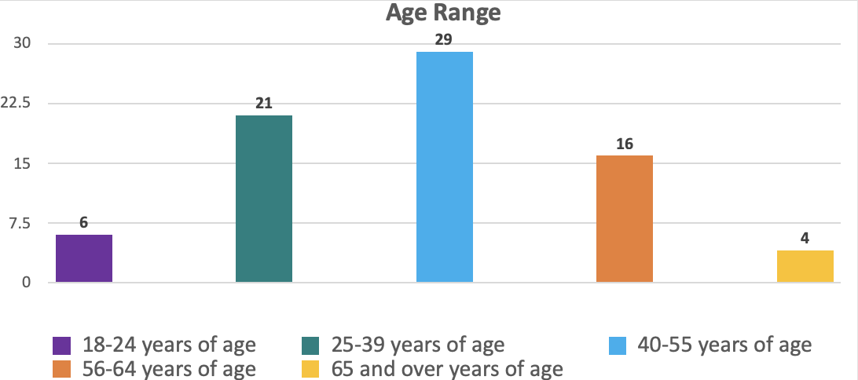
  - Fig. 1 - Age range of respondents

Survey respondent demographics were varied, with diversity recorded in all areas. This section breaks down the demographics of the survey respondents.
There was a variety of ages represented in the respondents. Twenty-nine people were aged between 40-55 years old. This was followed by 21 people aged between 25-39, 16 people aged between 56-64, 6 people aged between 18-24 and 4 respondents aged 65 and above.

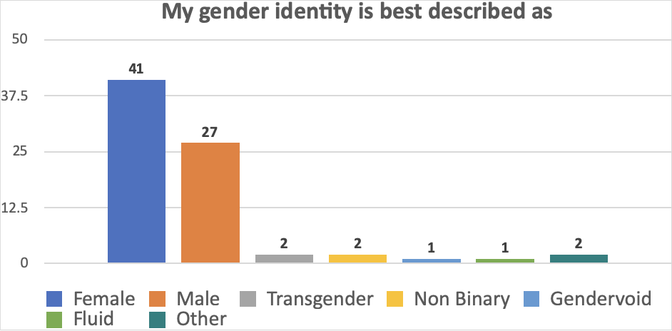
  - Fig. 2 - Gender identity of participants

The majority of the survey respondents identified as female, a total of 41 people. This was followed by 27 respondents identifying as ‘male’, 2 respondents identifying as ‘non-binary’, 2 respondents indicated ‘transgender’ best described their gender, 1 respondent indicated ‘gender fluid’, 1 respondent chose ‘gendervoid’ and 2 respondents indicated 'other'.
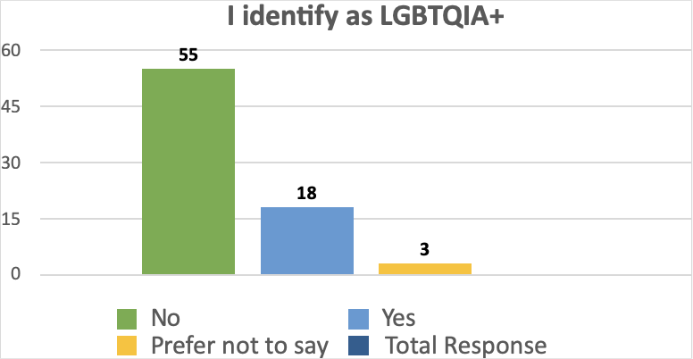
  - Fig. 3 - LGBTQIA+ respondents

Following this, respondents were asked whether they identified as LGBTQIA+. Of the 76 respondents, 18 people identified as LGBTQIA+. There were 55 respondents who did not identify as LGBTQIA+ and 3 respondents chose ‘prefer not to say’.
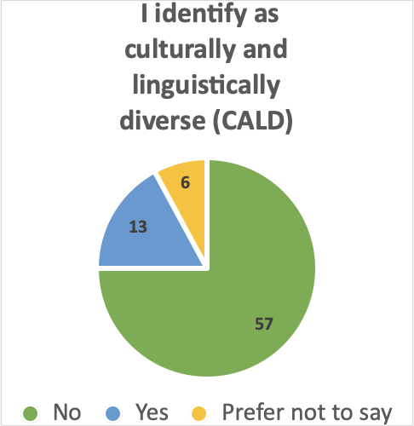
  - Fig. 4 - CALD respondents

Respondents were asked if they are Culturally and Linguistically Diverse (CALD). Of the 76 respondents, 13 identified as CALD. There were 57 respondents who did not identify as CALD and 6 respondents chose ‘prefer not to say’.

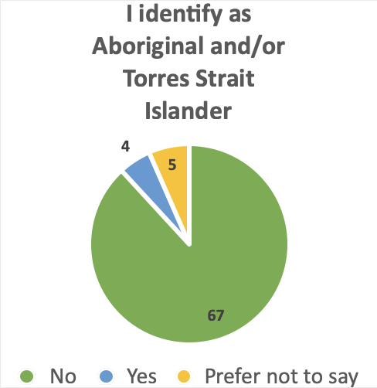
  - Fig. 5 - First Nations respondents

Survey respondents were asked if they identified as First Nations people. A total of 4 respondents identified as First Nations people. There were 67 respondents who did not identify as First Nations people and 5 chose ‘prefer not to say’.
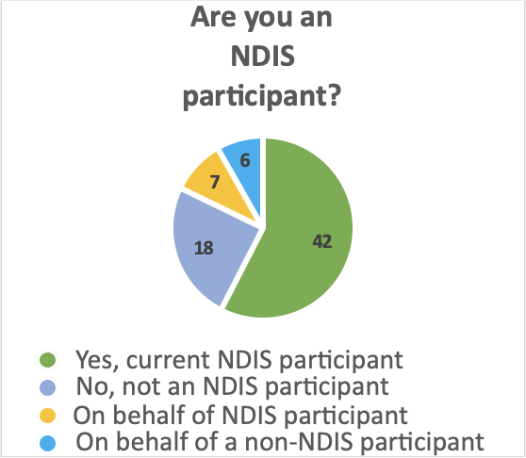
  - Fig. 6 - NDIS participant

Respondents were asked if they were a NDIS participant. There were 42 respondents who indicated they were NDIS participants and 7 people who completed the survey on behalf of an NDIS participant.
There were 18 respondents who indicated they were not NDIS participants and 6 who completed the survey on behalf of a non-NDIS participant. Three respondents did not answer this question.
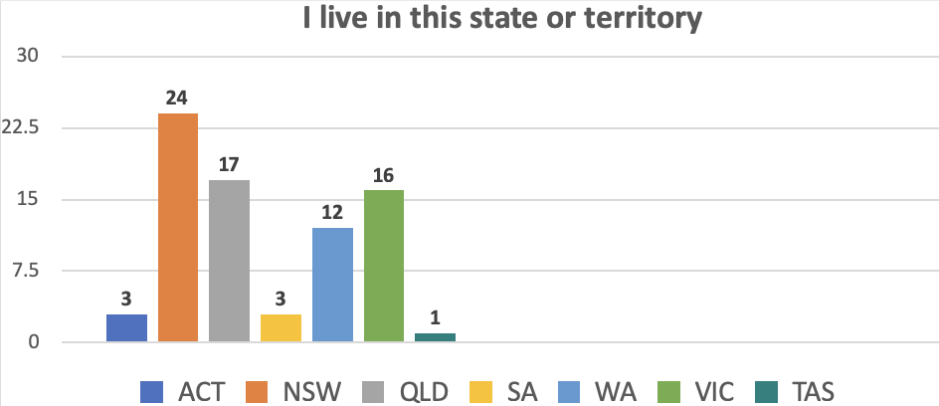
  - Fig. 7 – State/territory of respondents
All survey respondents lived in Australia. The majority (24 people) lived in New South Wales. This was followed by Queensland with 17 people, then Victoria with 16 people. There were 12 people from Western Australia and 3 people from South Australia. Finally, there were 3 people from the Australian Capital Territory and 1 person from Tasmania.
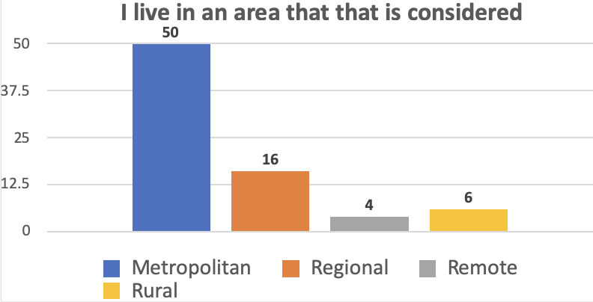
  - Fig. 8 - Residential location of respondents

Respondents were asked if they live in an area that is considered metropolitan, regional, remote or rural. There were 50 people who said they resided in a metropolitan area, followed by 16 people who indicated they lived in a regional area and 6 said they lived in a rural area. Finally, 4 people said they lived in a remote area.
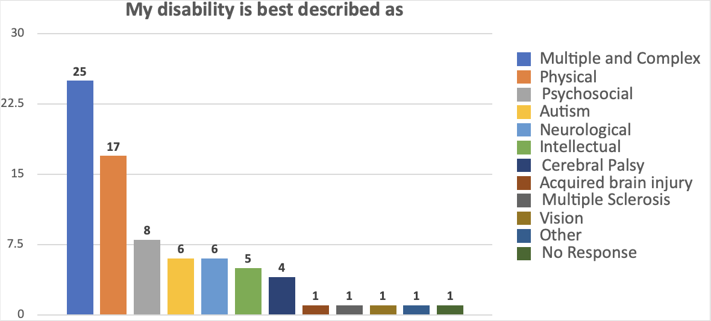
  - Fig. 9 - Type of disability

Participants had various types of disability. These were grouped into categories. There were:
- 25 people with multiple and complex disability
- 17 people with physical disability
- 8 people with psychosocial disability
- 6 people with autism
- 6 people with neurological disability
- 5 people with intellectual disability
- 4 people with Cerebral Palsy
- 1 person with an acquired brain injury
- 1 person with Multiple Sclerosis, and;
- 1 person with a vision disability.
There was one person who categorised their disability as 'other' and one person who did not respond.

Summary of survey question responses
This section summarises the quantitative and qualitative data collected from the survey questions.

NDIS Funding
Question 1: Do you receive Specialist Disability Accommodation (SDA), Supported Independent Living (SIL) or Individualised Living Options (ILO) funding or home modifications or assistive technology (AT)?
  - Fig. 10 - Participants who receive SDA, SIL, ILO, home modifications or AT

67% (n=51) of respondents indicated they receive SDA, SIL or ILO funding or home modifications or AT and 13% (n=25) responded they do not.
Question 2: What funding do you receive
  - Fig. 11 - Funding types
  - Fig. 11 - Funding types

Participants were presented with five options: SDA, SIL, ILO, home modifications and assistive technology. Participants were able to select more than one option.
23 respondents indicated they receive home modifications funding, 20 respondents stated they receive SIL funding, 16 respondents indicated they receive SDA funding,6 respondents responded that they receive ILO funding, and 47 received assistive technology funding.

Question 3: What has your NDIS funding helped you do?
  - Fig. 12 - Benefits of funding

The most common benefits reported included participating in the community (n=50), improved health and wellbeing (n=44) and allowing the person to obtain assistive technology (n=44).
This was followed by living independently (n=38), ability to choose who to live with (n=21), home modification to increase accessibility (n=15) and living in a purpose-built home suitable for the person's disability (n=10).
24 people selected 'other'. The answers in this category were a mix of other benefits and also reports of negative experiences. Examples of other benefits reported include, improved mental health, not having to rely on family for care and not having to live in aged care. On the other hand, many respondents reported negative experiences with the NDIS, including experiencing delays, fighting the NDIA to win the right to live by themselves and not being given choice and control. For example, one responded reported that:
‘I wanted to continue to have my support workers when I lived independently but service provider wanted their staff and NDIS budget won't allow both for daily living so I have had to use my community participation funds to continue my workers to provide consistent support for early morning and late evening alongside of agency staff. Service provider has more influence on NDIA staff to fund their staff and I have had to battle to continue funding for my workers.’

Supports at home
Question 1: What best describes where you live?
  - Fig. 13 - Accommodation type

This question received 51responses.
Of those who responded:
- 31% (n=15) live in a home that is privately owned
- 22% (n=11) live in a private rental
- 14% (n=8) live in an SDA property
- 8% (n=4) live in a SIL home
- 8% (n=5) live in public or social housing
- 2% (n=1) do not have a permanent address, and;
- 15% (n=7) responded 'other' and described where they live.
Those who responded with ‘other’ reported the following living arrangements
- ‘Living in a home with mortgage with family’
- Living in a partially owned home
- Living with ageing parents while an SDA home is being built
- Waiting for an SDA home to be built
- Living in an apartment complex with inaccessible common areas

Question 2: What best describes who you live with?
  - Fig. 14 - Who respondents live with

This question received 56 responses. Of those who responded:
- 34% (n=19) live by themselves
- 27% (n=15) live with their partner and/or children
- 11% (n=6) live with other family (e.g., parents, siblings and cousins)
- 11% (n=6) live with other NDIS participants
- 7% (n=4) live with friends,
- 3% (n=2) live with people without disability who are not NDIS participants, and;
- 7% (n=4) responded with 'other' and described who they live with (this included one person who lives with a carer and 3 people who live with pets).
Question 3a: Were you given enough choices about where you live?
  - Fig. 15 - Choosing where you live

This question received 48 responses. Of those who responded, a majority of 60% (n=29) responded 'no' and 40% (n=19) responded 'yes.'
Question 3b: Were you given enough choices about the type of housing?
  - Fig. 16 - Choosing type of housing

This question received 48 responses. Of those who responded, a majority of 60% (n=29) responded 'no' and 40% (n=19) responded 'yes.'
Question 3c: Were you given enough choices about who you live with?
  - Fig. 17 - Choosing who you live with

This question received 48 responses. Of those who responded, a majority of 65% (n=31) said 'yes' and 35% (n=17) said 'no'.

Question 4: If you had more choice about who you lived with, would you make one or more of the following choices?
  - Fig. 18 - Alternative choices - who you live with

Respondents were able to select more than one answer. If given more choice about who to live with, 26 respondents said they would choose to live by themselves, followed by 14 who would choose to live with their partner and/or children.
This was followed by six respondents who would live with friends, another six who would live with other NDIS participants and four who would live with other people with disability who are not NDIS participants.
Seven respondents recorded 'other' responses. Two of these respondents expressed fear about their current living situation, with one stating:
‘not live with people who trigger and frighten me’’

and the other stating:
‘live in a safe house with [space] so my carers are safe too’.
Other responses included living with fewer NDIS participants who are more compatible, living with a part-time NDIS funded support worker, being able to live with all the person’s animals and foster more animals and having more choice in general. In addition, one person responded:
‘as it is, but I came up with this model and fought for it.’
Question 5: If you had more choice about where you live, where would you prefer to live?

  - Fig. 19 - Alternative choices - where to live

Respondents were able to select more than one answer. If given more choice about where to live, 17 respondents said they would live in a home that is privately owned, 10 respondents said they would live in SDA property, four respondents would live in a SIL home, three would live in public or social housing and two would live in a private rental. A further 10 respondents recorded an ‘other’ response. Two themes that emerged in these responses was the desire to own a home and to ensure that the home had all the necessary modifications.
Question 6: Is the organisation that provides your housing also providing you with other supports?

  - Fig. 20 – Providers who provide housing and supports
  - Fig. 20 – Providers who provide housing and supports
This question received 48 responses. Of those who responded, 10% (n=5) said 'yes' and 90% (n=43) said 'no'. Participants who answered 'no' were directed to proceed to Section 4 of the survey, while those who answered 'yes' were asked to complete Questions 7 - 13 of this section of the survey.

Same housing and support provider
Question 7: What other supports does the organisation that provides you housing provide for you?

  - Fig. 21 – Other supports housing providers provide

Only one of the five respondents whose housing provider also provides other supports answered this question. The participant stated that their housing provider also provides support workers, nursing staff, medical oversight and 24-hour breathing oversight.

Question 8: How much choice and control do you have in selecting these supports?
  - Fig. 22 - Choice and control in selecting supports

Two respondents answered this question. One respondent selected 'I have some choice and control; I can choose some services but not others'. The other respondent selected 'I have no choice and control; I have not chosen any services for myself.'

Question 9: Do you have choice and control over how these supports are provided (timing of them, whether you receive these supports alone or in a group etc.)
  - Fig. 23 - Choice and control in how supports are provided

Two respondents answered this question. One respondent selected 'I have some choice and control; I can choose how and when some of my services are delivered'. The other respondent selected 'I have no choice and control; I have no choice about how and when my services are delivered.'

Question 10: Do you feel you can raise issues about your supports with the provider?
  - Fig. 24 - Raising issues about supports

The two respondents who answered this question stated 'yes'.
Question 11: Are you satisfied with the supports you receive at home?

  - Fig. 25 - Satisfaction with supports
This question received three responses.
One respondent answered 'yes' and two people responded 'no'. One respondent who answered 'no' explained that staff are rotated across houses and most need constant directions to provide support.
The respondent also noted that they are unable to use previous support workers from when they lived independently, apart from on an ad hoc basis.
Question 12: if you have an issue with your supports, do you feel like you can change providers?
This question received two responses. Both respondents answered 'yes'.

  - Fig. 26 - Changing providers

Question 13: If you would like to share information with us about your experiences, please provide information below
No responses received.

Separate housing and support providers
Question 1: How much choice and control do you have selecting services delivered independent of who provides your housing?
  - Fig. 27 - Choice and control selecting services

This question received 43 responses.
The majority 68% (n=29) of respondents indicated they have a lot of choice and control.
This was followed by 23% (n=10) who said 'I have some choice and control; I can choose some services but not others' and 9% (n=4) who said 'I have no choice and control; I have not chosen any services for myself'.

Question 2: How much choice and control do you have over the way in which these supports are provided (timing of them, whether you receive these supports alone or in a group etc.)?

  - Fig. 28 - Choice and control in way supports are provided

This question received 43 responses.
Of those who responded, 49% (n=21) said 'I have a lot of choice and control; I can choose how and when all of my services are delivered'.
This was followed by 37% (n=16) who said 'I have some choice and control; I can choose how and when some of my services are delivered' and 14% (n=6) who said 'I have no choice and control; I have no choice about how and when my services are delivered.'
Question 3: Do you feel you can raise issues about your supports with the provider?

  - Fig. 29 - Raising issues with provider

This question received 59 responses. Of those who responded, 51% (n=30) chose 'no' and 49% (n=29) indicated 'yes'.
Respondents that answered 'no' were asked why they felt this way and 17 people provided answers to this follow up question.
A key theme of the responses was difficulty in communicating with providers. Some respondents reported that providers did not listen to them and in some cases accused the respondent of lying or blamed them for the issue. It was also stated that SIL providers are ‘organisation-centred’ rather than ‘client-centred’. One respondent stated:
‘they call me a liar, don’t want to listen’
Some respondents noted a shortage of support workers as a reason not to raise issues. For example, one respondent noted that:
‘…[i]t's so hard to find support workers that we have to be careful not to upset providers or individual staff by giving feedback.’
Another respondent noted that there are:
‘Not enough support services to be able to be picky’
One respondent noted they had more control once using supports not linked to the housing provider:
‘I use private supports which allows me more control than when I had my supports provided by a provider. The provider was not able to supply flexible supports that I needed.’
Some people responded to this question with their experiences in the private rental market and as a private property owner. In the following responses, the shortage in housing options was cited as a reason to not raise issues:
‘I rent privately and until recently was homeless, moving from caravan park to caravan park until I found a rental last week. I’m on the list for … housing and they estimate 2 - 5 years and that's being priority. I had to accept this unit I’m currently in as it is the ONLY one available in my town. It is unsafe. Trip hazard ledge in the shower, no front railing and there's a big drop off my front porch. Uneven grounds outside and a steep hike upstairs to use the communal laundry. I am unsteady on my feet and am a fall risk as I quite regularly lose my balance. But living in this unsafe house, is better than being homeless so what choice do I have?’
Of key concern was one response that highlighted that inadequate funding and a lack of respect and exclusion more broadly was the issue and that this put them at serious risk:
‘The NDIS does not fund appropriate support to help me with the issues I am experiencing with the body corporate, caretaker and body corporate manager. This means that I cannot progress critical home modifications and I do not have personal emergency and evacuation plans to keep me safe. I own my home. I am a member of the body corporate. But because I live with disabilities, I am not treated respectfully nor included and I am left highly vulnerable to multiple risks and ongoing trauma in this environment. I cannot open my front door safely and independently to escape in circumstances of a fire. My safety and well-being does not seem to be a priority.’
Question 4: Are you satisfied with the supports you receive? If no, why not? (please describe)

  - Fig. 30 - Satisfaction with supports

This question received 68 responses. Of those who responded, 29% (n=20) responded with 'yes' and 71% (n=48) responded with 'no'.
Respondents that answered 'no' were asked why they felt this way. The lack of available and skilled staff emerged as a very strong theme. Respondents reported that this led to difficulty in finding the right or in some cases, any, support.
Respondents also noted difficulty in finding reliable and appropriately skilled support workers, with a lack of coverage when a support worker is sick. One respondent noted that:
‘I can't stick to schedules or decide in advance what I want/need to do. I haven't found anyone competent to take over from my parents, things like doctor/dental appointments and my health needs are neglected due to my disability related impairments.’
Another respondent stated:
‘Can’t find workers, my belongings are broken, food thrown away, refuse to do what they’re paid to do.’
Some respondents noted that service providers remove their choice and are inconsiderate of client requests.
In addition, some respondents said they were not satisfied with their supports due to inadequate NDIS funding. For example, one respondent said that:
‘When the NDIS works it’s great, when it doesn’t ... I need someone to wash the car (which I don’t drive far now) but the NDIS will only provide support to help me do it. I can’t access the community that takes money and mobility.’

Question 5: If you have an issue with your supports, do you feel like you can change providers?

  - Fig. 31 - Changing providers

This question received 61 responses. Of those who responded, 39% (n=24) indicated 'yes' and 61% (n=37) chose 'no'.
Among respondents who answered 'no', the strongest theme that emerged was an inability to change providers due to a lack of choice in service providers.
As one respondent explained:
‘[t]here's very few providers where I live to begin with, combined with very specific needs, and my choices are incredibly limited.’
Other respondents reported that all providers are facing the same issues, so there is no benefit in changing providers.
One respondent wanted to change providers after experiencing abuse, exploitation and neglect. The respondent's support coordinator was removed, but the respondent was left without any support and was felt like they were being “punished” by the NDIA for the service provider's wrongs.
Question 6: If you would like to share information with us about your experiences, please provide information below
Participants raised a number of concerns and details of their experiences with the NDIS. Some respondents were concerned about unscrupulous and fraudulent providers exploiting the NDIS. For example, one respondent stated that:
’I have had service providers steal my funding and personal property, damage my property, do nothing yet charge for services not actually delivered while I have been left neglected and forced to live in solitary confinement in the dark.’
Respondents reported experiencing considerable delay in the NDIS system, including delays and difficulties accessing home modifications and the impact this has on their independence.
‘IT TAKES TOO LONG TO GET HOME MODS APPROVED’
‘My OT was very experienced in home modifications and she couldn’t understand why my home modifications weren’t being approved.’
‘My housing is very unsuitable and not disability friendly at all, but I have not been able to get LACs/planners to include enough funding for an OT assessment for home mods and/or an SDA assessment. After more than 3 years on the NDIS I am still trying to get that basic access to funding to even start the process of getting suitable disability accessible housing. Not having suitable housing also limits what other AT I am able to access and use (e.g. wheelchair) meaning I am much more functionally disabled (mostly bedbound) than is necessary. If I had suitable housing and was able to use the needed AT I could be much more independent and not housebound and most bedbound.’
Other respondents reported that they were unable to get SDA funding, causing them to fear homelessness. In one case, the fear of being homeless led to suicidal ideation and several presentations to the emergency department.
One respondent noted that the NDIA has not provided enough funding to get an occupational therapist assessment for home modifications and/or an SDA assessment. As a result, the respondent reported that they are living in unsuitable housing and cannot properly operate their wheelchair, leaving them mostly bedbound.
The issue of separation in housing and support providers also arose. One respondent reported that SDAs are not providing support worker choice and control:
‘I have been denied access to SDAs because I have my own team of independent support workers and the SIL provider will not allow me to bring my own team, I have to sign up with them to receive support … this is not choice and control.’
Conversely, two respondents reported great satisfaction living in accommodation where they have choice and control in choosing their support workers:
’I live in a concierge model, where a number of SDA apartments are in a large apartment building. A 24/7 backup service is onsite, for emergencies and assistance where two support staff are needed. I also have my own support workers. I love this model, it suits my needs extremely well.”
“I am provided complete choice and control with the support of my SDA provider. They focus heavily on promoting independence, choice and control for the participant. This is much better than some of the older NFP's that offer both housing and care, a complete conflict of interest of their roles.’

Conclusion
The housing survey’s quantitative data revealed mixed results, with some respondents reporting positive experiences and some reporting negative experiences. We did, however, learn that many respondents, if given more choice and control, would prefer to live in privately owned accommodation and to live by themselves or with their partner and/or children.
The qualitative data revealed a number of themes, most of which were negative. Respondents also shared their stories, many of which were very concerning. Many issues that respondents raised related to the lack of available and skilled support workers, as well as difficulties in raising issues with providers. It was also noted that thin housing markets prohibited participants’ choice and control and some housing providers are not letting participants chose their own support workers. In addition, the NDIS itself is causing participants difficulty and stress when home modifications are needed, with delays leaving people in inaccessible housing.
To address the issues raised in this summary report, we make the following high-level recommendations to the NDIS Review:
Recommendation 1 – That the NDIS Review recommends urgent action to be taken to address the support worker and accessible housing shortages.
Recommendation 2 – In continuing its examination of NDIS workforce issues, the NDIS Review examine whether NDIS support worker providers and support workers themselves place participants’ will and preferences at the centre of their work.
Recommendation 3 – The NDIS Review recommend that housing providers and support providers should be separate to avoid conflict of interest.
Recommendation 4 – The NDIS Review conduct an in-depth analysis of systemic barriers and delays in accessing home modifications and make recommendations to resolve these barriers and delays in their final report.

Appendix A - Survey questions
Section 1 (demographic questions)
Q1. I am a current NDIS participant.
Q2. I am supporting someone with disability who is a current NDIS participant and receives funding for housing and/or housing -related supports to complete this survey.
Q3. I live in Australia.
Q4. My disability is best described as:
Q5. My gender identity is best described as:
Q6. My age is:
Q7. I live in this state or territory:
Q8. I live in an area that that is considered:
Q9. I identify as Aboriginal and/or Torres Strait Islander:
Q10. I identify as culturally and linguistically diverse (CALD):
Q11. I identify as LGBTQIA+:
Section 2
Q1. Do you receive Specialist Disability Accommodation (SDA), Supported Independent Living (SIL) or Individualised Living Options (ILO) funding or home modifications or assistive technology?
Q2. What funding do you receive? Tick all boxes that apply to you.
Q3. What has your NDIS funding helped you to do? Tick all boxes that apply to you.

Section 3
Question 1. What best describes where you live?
Question 2. What best describes who you live with? Tick all that applies.
Question 3A. Were you given enough choices about where you live?
Question 3B. Were you given enough choices about the type of housing?
Question 3C. Were you given enough choices about who you live with?
Question 4. If you had more choice about who you lived with, would you make one or more of the following choices? Tick all that applies.
Question 5. If you had more choice about where you live, where would you prefer to live? Please pick one.
Question 6. Is the organisation that provides your housing also providing you with other supports? **If no, go to Section 4, if yes answer questions 7-13**
Question 7. What other supports does the organisation that provides you housing provide for you?
Question 8. How much choice and control do you have in selecting these supports?
Question 9. How much choice and control do you have over how these supports are provided (timing of them, whether you receive these supports alone or in a group etc.)?
Question 10. Do you feel you can raise issues about your supports with the provider? If no, why not? (please describe).
Question 11. Are you satisfied with the supports you receive at home? If no, why not? (please describe).
Question 12. If you have an issue with your supports, do you feel like you can change providers? If no, why not? (please describe)
Question 13. If you would like to share information with us about your experiences, please provide information below.
Section 4
Question 1: How much choice and control do you have selecting services delivered independent of who provides you housing?
Question 2. How much choice and control do you have over the way in which these supports are provided (timing of them, whether you receive these supports alone or in a group etc.)?
Question 3. Do you feel you can raise issues about your supports with the provider?
Question 3A. If no, why not? (please describe)
Question 4. Are you satisfied with the supports you receive?
Question 4A. If no, why not? (please describe)
Question 5. If you have an issue with your supports, do you feel like you can change providers?
Question 5A: If no, why not? (please describe)
Question 6. If you would like to share information with us about your experiences, please provide information below:
Question 7. Would you be interested in participating in a follow-up focus group discussing home and living supports in the NDIS? Participation will be paid for.
Question 8. If yes, what is your mobile and email?
Question 9: Please confirm if you are happy for your de-identified responses to be included in the submission to the NDIS Review.

People with Disability Australia (PWDA) is a national disability rights and advocacy organisation made up of, and led by, people with disability.
For individual advocacy support contact PWDA between 9 am and 5 pm (AEST/AEDT) Monday to Friday via phone (toll free) on 1800 843 929 or via email at pwd@pwd.org.au
Submission contact
Giancarlo de Vera
Senior Manager of Policy
E: pwd@pwd.org.au

