National Housing and Homelessness Plan Response

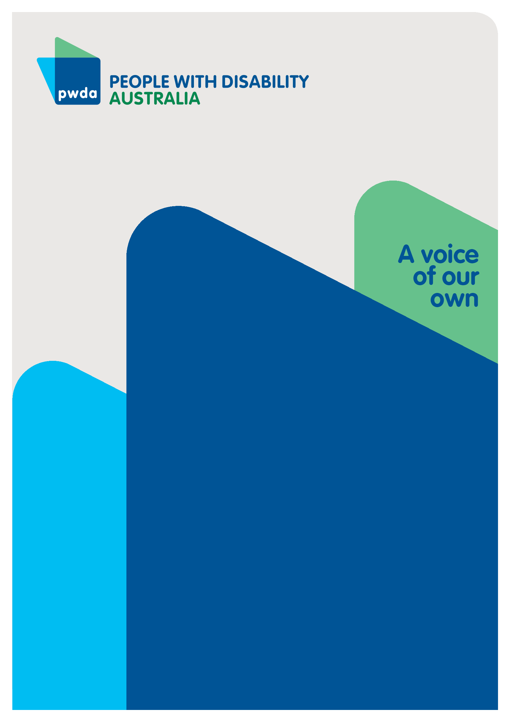
Submission to the National Housing and Homelessness Plan Issues Paper
Oct
2023

Copyright information
National Housing and Homelessness Plan Response – Submission to the National Housing and Homelessness Plan Issues Paper
First published in 2023 by People with Disability Australia Ltd.
Level 8, 418a Elizabeth Street, Surry Hills, New South Wales, Australia 2010
Head office also in Sydney
Email: pwd@pwd.org.au
Phone: +61 2 9370 3100 Fax: +61 2 9318 1372
URL: www.pwd.org.au/
Typeset in Arial 12 and 14 pt and VAG Rounded 26 pt.
© People with Disability Australia Ltd. 2023
The moral rights of the authors have been asserted.
National Library of Australia Cataloguing-in-Publication data:
Creator(s): | Jane Britt
Title: | National Housing and Homelessness Plan Response – Submission to the National Housing and Homelessness Plan Issues Paper
All rights reserved. Except as permitted with the Australian Copyright Act 1968 (for example, a fair dealing for the purposes of study, research, criticism or review), no part of this book may be reproduced, stored in a retrieval system, communication or transmitted in any form or by any means without prior written permission. All inquiries should be made to the publisher at the address above.
Suggested citation:
Britt, J., National Housing and Homelessness Plan Response – Submission to the National Housing and Homelessness Plan Issues Paper, 20 October 2023, People with Disability Australia, Sydney.

ISBN 978-0-6459325-2-2

Table of Contents

Copyright information 2
About PWDA 4
Introduction 5
Rationale for targeted action 6
The impact of the Royal Commission into Violence, Abuse, Neglect and Exploitation of People with Disability 8
Congregate Housing Transition Plan 10
Priority areas for the Congregate Housing Transition Plan 11
Targeted Housing Action Plan for People with Disability 14
Priority areas for the Targeted Housing Action Plan for People with Disability 15
Outcome areas for the Targeted Housing Action Plan for People with Disability 20
Conclusion 23

About PWDA
People with Disability Australia (PWDA) is a national disability rights and advocacy organisation made up of, and led by, people with disability.
We have a vision of a socially just, accessible and inclusive community in which the contribution, potential and diversity of people with disability are not only recognised and respected but also celebrated.
PWDA was established in 1981, during the International Year of Disabled Persons.
We are a peak, non-profit, non-Government organisation that represents the interests of people with all kinds of disability.
We also represent people with disability at the United Nations, particularly in relation to the United Nations Convention on the Rights of Persons with Disabilities (CRPD).
Our work is grounded in a human rights framework that recognises the CRPD and related mechanisms as fundamental tools for advancing the rights of people with disability.
PWDA is a member of Disabled People’s Organisations Australia (DPO Australia), along with the First People’s Disability Network, National Ethnic Disability Alliance, and Women with Disabilities Australia.
DPOs collectively form a disability rights movement that places people with disability at the centre of decision-making in all aspects of our lives.
The work of PWDA embraces the ‘Nothing About Us, Without Us’ motto of the international disability community and Disabled Peoples’ International, the international organisation representing national organisations of people with disability in over 130 countries.

Introduction
People with Disability Australia (PWDA) welcomes the development of a National Plan for Housing and Homelessness. We support the development of a plan which provides guidance on a national approach to housing and homelessness, providing direction for intergovernmental approaches and responsibility to address the current housing crisis, both in the short and long-term.
This submission has been developed based on feedback regarding housing and homelessness provided by PWDA’s individual advocates and our members who are people with disability.
Since 2022, PWDA’s individual advocacy team has supported 1,120 people with housing as either a primary or secondary issue. We have also supported 210 people with homelessness, either as a primary or secondary issue. The numbers of people seeking advocacy support through PWDA for both issues are increasing.
PWDA has further experience and insights about housing from our Building Access project, funded by Women NSW under the Domestic and Family Violence (DFV) Innovation Fund. The Building Access project aims to better meet the needs of women and children with disability accessing crisis accommodation in NSW and works towards improving the accessibility of these services.
PWDA also welcomes the National Housing and Homelessness Plan Issues Paper articulating that the purpose of the National Housing and Homelessness Plan (NHHP) is to:
‘set out a shared national vision across the responsibilities of different levels of Government to improve housing outcomes and help address homelessness in Australia’ (p.9).
Considering this purpose, PWDA supports the position of the Community Housing Industry Association (CHIA) that:
‘while housing outcomes are primarily a state/territory responsibility under the Australian constitution, only with the active participation of both the Commonwealth state/territory Governments can any effort to significantly expand social and affordable rental housing provision succeed. Adequate and affordable housing is an aspect of social security which is a formal Commonwealth responsibility, and it is only the Commonwealth that possesses the scale of tax-raising and borrowing powers required to underpin the scale of investment needed’.
Therefore, the NHHP must be ambitious and clearly set out the necessary investments and responsibilities of governments needed to make the plan work for people with disability. Noting this, and based on PWDA’s experience and expertise outlined earlier, for the NHHP to deliver improved housing outcomes for people with disability, the NHHP needs to take a dual targeted approach that:
- implements a targeted housing action plan for people with disability to address the supply, affordability and accessibility barriers that people with disability face in achieving improved housing outcomes and within that action plan (details from page 10)
- embeds a transition plan to phase out congregate living for people with disability (details from page 14).

Rationale for targeted action
As noted in the National Housing and Homelessness Plan Issues Paper, Australia’s Disability Strategy 2021-2031 (ADS) includes a focus area on inclusive homes and communities. This focus area includes a measure for state and territory governments to partner with the Commonwealth Government, which the Australian Institute of Health and Welfare explains is to ‘increase the accessibility and availability of affordable housing for people with disability.’
However, the ADS does not include any targeted action plans for housing, despite a 2022 Productivity Commission recommendation for Commonwealth, state and territory governments commit to ‘commissioning a housing Targeted Action Plan under Australia’s Disability Strategy.’
In addition, Recommendations 5.2 (‘Review and update of Australia’s Disability Strategy’), 5.3 (‘Review and update of disability strategies and plans’) and 5.4 (‘Review of national agreements, strategies and plans’) from last month’s Final Report and recommendations for the Royal Commission into Violence, Abuse, Neglect and Exploitation of People with Disability (Disability Royal Commission) all recommend updating and review of national plans and agreements in alignment with the ADS. This must include a targeted action plan for housing under the ADS.
The need for a Targeted Housing Action Plan for people with disability stems from Australia’s international human rights obligations and principles, specifically through the United Nations Convention on the Rights of Persons with Disabilities (CRPD) (2008) relating to safe, affordable, secure and accessible housing for people with disability, especially through:
- Article 9 – Accessibility
- Article 19 – Living Independently and Being Supported in the Community
- Article 28 – Adequate Standard of Living and Social Protection.
The right to housing is a cascading right, which means that without access to housing, all other human rights are impinged. Therefore, it is imperative that safe, affordable, secure and accessible housing options for people with disability are achieved through the NHHP.
There are numerous benefits of safe, secure, affordable and accessible housing for people with disability. The Australian Institute of Health and Welfare explains the negative consequences of not delivering housing for people with disability as:
‘A person who does not have access to affordable, secure and appropriate housing may experience several negative consequences, including homelessness, poor health, and lower rates of employment and education’.
People with disability are far more likely to experience the barriers accessing housing described in this submission, and more likely to experience homelessness, than people without disability, leading to poor overall life outcomes.
According to Australian researchers, empirical evidence shows that homelessness correlates with poor life outcomes including poor health, lower levels of employment, a greater likelihood of experiencing violence and lowered life expectancy.
It is opportune timing for action in the NHHP to address barriers to housing access, and to address homelessness affecting people with disability in Australia. Recently, the Housing Australia Future Fund was supported through the passing of the Housing Australia Future Fund Bill 2023, and an independent advisory body to Parliament (the National Housing Supply and Affordability Council) was established through the National Housing Supply and Affordability Council Bill 2023.
Therefore, in this submission, PWDA proposes that mechanisms be embedded within the NHHP to drive necessary changes to address housing and homelessness for people with disability. The issues of undersupply, lack of affordability, and accessibility can be addressed through a Targeted Housing Action Plan for People with Disability under the NHHP. Within this Action Plan, a Congregate Housing Transition Plan must also exist, to support phasing out group homes and supporting people with disability to access individualised living options in the community.
This submission explores how both plans can be successfully implemented with governance and oversight mechanisms delivered through the NHHP, to improve housing and homelessness outcomes for people with disability.

The impact of the Royal Commission into Violence, Abuse, Neglect and Exploitation of People with Disability
Last month’s release of the Final Report and recommendations from the Disability Royal Commission provided very clear evidence that targeted action on housing for people with disability is needed.
The Royal Commission heard disturbing evidence on the correlation between living in congregate settings including group homes, and the increased incidences of violence, abuse, neglect and exploitation towards people with disability:
‘Many of the responses we received detailed incidents of violence, abuse, neglect and exploitation of people with disability in group home settings. These included physical assault, sexual assault and verbal abuse allegedly perpetrated by a range of people including staff, volunteers, community members and other residents in group homes’
In this submission, PWDA calls for the implementation of a Targeted Housing Action Plan for People with Disability to address the supply, affordability and accessibility barriers that people with disability face in achieving housing outcomes. Additionally, a Congregate Housing Transition Plan will sit under the Targeted Housing Action Plan. This is consistent with the recommendations emerging from the Final Report of the Disability Royal Commission.
Notably, the following recommendations be addressed through these housing plans:
- Recommendation 7.41 ‘Group home reform’
- Recommendation 7.42 ‘Improve access to alternative housing options’
- Recommendation 7.43 ‘A roadmap to phase out group homes within 15 years’, particularly addressing housing undersupply through ‘assessing projected supply of alternative housing to inform planning for the transition of people out of group homes, including conducting a stock take of existing disability housing assets that may be repurposed or used to increase the supply of inclusive housing.’
These recommendations are consistent with PWDA’s long-standing positions, including our position that enabling segregation in housing is a breach of fundamental human rights. Along with other Disabled People’s Organisations (DPOs), PWDA asserts that there is no justification for breaches of human rights through being forced into congregate living arrangements:
‘Segregation and segregated facilities cannot be justified as a specific measure to meet higher support, complex, ‘challenging behaviour’ needs or any other needs of people with disability.’
Therefore, through the Congregate Housing Transition Plan, PWDA supports immediate action on transitioning away from group homes. It is important that no new group homes be developed as this would push back the transition by several generations.
A transition away from congregate housing is dependent upon the availability of alternative housing, therefore the increase of housing supply is an urgent priority to ensure the outcome of phasing out group homes can be met. The phasing out of group homes will also require other milestones to be met, such as the milestone outlined by Commissioners Bennett, Galbally, Mason and McEwin to have no new residents placed in group homes within the next five years, as specified under Recommendation 7.43. To be clear, PWDA sees these timeframes as worst-case scenarios and all efforts should be made to meet them earlier (please see further comments on the milestones on page 11).
Additionally, PWDA strongly recommends that oversight and safeguarding during the transition phase away from group housing are strengthened to prevent ongoing violence and abuse in group homes. This aligns with DRC Recommendation 7.43 (‘A roadmap to phase out group homes within 15 years’) part C, ‘transition support for people currently living in group homes, including - interim improvements in group home oversight and practices to ensure that people with disability living in group homes are safe and have greater choice and control during this transition period.’
Further, as an additional and necessary safeguard, PWDA strongly advocates for the separation of housing provision and provision of other services as a key safeguard, meaning that the same provider cannot provide both housing and other supports. There must be a clear separation, with no conflicts of interest between providers and the capacity for people with disability to raise issues without fear or concern of losing their housing and/or supports. This relates to the DRC’s Recommendation 7.41 (‘Group home reform’), that the NDIS Quality and Safeguards Commission conducts ‘a specific review of mechanisms to transition away from allowing the same provider to provide Supported Independent Living and Specialist Disability Accommodation services, with interim arrangements to strengthen oversight to address and monitor conflicts of interest.’

Congregate Housing Transition Plan
As highlighted earlier, the Disability Royal Commission has established a clear correlation between living in congregate settings including group homes, and the increased incidences of violence, abuse, neglect and exploitation towards people with disability.
The prevention of violence, abuse, neglect and exploitation of people with disability in their living environment can be supported by enabling choice and control to live independently in the community and enabling accessibility in a person’s living environment.
The separation of disability supports from the provision of housing is the key mechanism that can support this shift, alongside effective support for home modifications so there is meaningful choice of where, and with whom people with disability live. This needs to be driven through a Congregate Housing Transition Plan.
The effectiveness of a Congregate Housing Transition Plan is contingent on meeting key priority areas, which address the current issues of housing undersupply and the lack of accessibility in legacy and future housing stock for people with disability.
Across all key priority areas, improved housing outcomes for people with disability is best supported through strong, clear direction and leadership, through governance and leadership roles being held by people with disability, and people with expertise in accessible housing that works for people with disability.

Priority areas for the Congregate Housing Transition Plan
The following section will outline the six priority areas PWDA views as key for the Congregate Housing Transition Plan to be successful.

Priority Area 1: Transitioning out of congregate housing settings
This priority area is addressed by the Commonwealth Government mandating and reporting against targets for closing all congregate housing and supporting the immediate transition of people with disability away from congregate living into alternate housing options, with choice and control for alternate options provided to people with disability.
Achieving this priority is consistent with the following recommendations of the Disability Royal Commission: Recommendation 7.41 (‘Group home reform’); Recommendation 7.42 (‘Improve access to alternative housing options’); and Recommendation 7.43 (‘A roadmap to phase out group homes within 15 years’).
Additionally, the milestones within these DRC recommendations that must be met are:
- ceasing construction of any new group homes (within the next two years)
- ceasing placement of new residents in group homes (within five years)
- completing transition of those residents who wish to move from group homes to alternative housing options (within 15 years, ideally beginning immediately).
PWDA firmly asserts that the timelines above should be viewed as worst case scenarios that must not be exceeded, that work to meet these milestones should begin immediately and year on year deliverables are required up to the point of completion.

Priority Area 2: Ensuring minimum accessibility standards
In addition to meeting Outcome 1 under the below Targeted Housing Action Plan for People with Disability, Priority Area 2 is addressed by the Commonwealth Government mandating that any investment provided to states and territories outlined in the NHHP, must be contingent on states and territories meeting Livable Housing Design Guidelines minimum accessibility standards in the National Construction Code (NCC). This measure must be met while ensuring that a quota of accessible housing stock is adaptable for complex needs.

This is consistent with Recommendation 7.35 (‘Increase the availability and supply of accessible and adaptive housing for people with disability through the National Construction Code’) in the Disability Royal Commission Final Report.

Priority Area 3: Mandating the separation of housing from disability supports in the NDIS
Priority Area 3 is addressed by the NDIA, through the soon-to-be released Home and Living policy, committing to mandate the separation of housing from supports, whereby a NDIS participant has choice and control over the choice of provider for housing and their providers for other supports and services.
This is consistent with the Disability Royal Commission Final Report Recommendation 7.41 (‘Group home reform’) stipulates the NDIS Quality and Safeguards Commission should instigate a review of mechanisms to transition away from allowing the same provider to provide Supported Independent Living and Specialist Disability Accommodation services).
This recommendation is extended in PWDA’s proposed Congregate Housing Transition Plan, through a stronger approach. This must be achieved by ensuring complete separation of supports, through mandating that it must be provided by two distinct, unlinked entities, so there is no conflict of interest or vested interest between businesses providing housing, and another business providing other supports or services, to the same participant.

Priority Area 4: Providing navigation and advocacy supports
As people with disability transition out of congregate settings, they must be supported to connect with critical disability advocacy and other services, to reduce the risk of homelessness and locate more suitable housing options.
This is consistent with Disability Royal Commission Final Report Recommendation 7.40
(Address homelessness for people with disability in the National Housing and Homelessness Plan) calling for the Commonwealth Government to work with state and territory governments to establish free, independent advocacy and legal advice services to address homelessness for people with disability.
At present, state and territory governments have inconsistently invested in navigation and advocacy supports, with some jurisdictions not adequately investing in these vital supports. Therefore, addressing this priority ensures adequate investment nationally.

Priority Area 5: Enabling a nationally consistent home modifications approach
Priority Area 5 is addressed through the Commonwealth Government working with the states and territories to ensure adequate funding for all people with disability to access home modifications to meet their accessibility needs. This includes both home modifications for physical (e.g., physical access like ramps), sensory (e.g., glare sensitivity) and any other disability-related needs.
This can be achieved through a nationally consistent approach, as per the Disability Royal Commission Final Report Recommendation 7.35 (‘Increase the availability and supply of accessible and adaptive housing for people with disability through the National Construction Code’) and Recommendation 7.36 (‘Improve social housing operational policy and processes’).

Priority Area 6: Embedding governance arrangements
Priority Area 6 is addressed through people with disability who have experience and expertise of the housing issues people with disability face being included in governance and executive leadership through the following:
- membership on the boards of institutions with responsibilities for overseeing the production and implementation of the NHHP, including the National Housing Supply and Affordability Council and incoming statutory body Housing Australia
- the NHHP must include disability as an ongoing priority area with a Targeted Housing Action Plan for People with Disability
- the publication of data that allows assessment of progress towards better housing
- outcomes for people with disability.
This supports, and is consistent with, both Recommendation 5.6 (‘New governance arrangements for disability’) and Recommendation 5.7 (‘Focal points across jurisdictions to implement the CRPD’, specifically relating to oversight of implementation of CRPD housing articles') in the Disability Royal Commission Final Report.

Targeted Housing Action Plan for People with Disability
Naturally progressing from the work to phase out congregate living, it is critical that a Targeted Housing Action Plan for People with Disability is developed to set out actions that address the issues of supply, affordability, accessibility and safety for people with disability. The Congregate Housing Transition Plan would be embedded within this Action Plan, which would form part of the NHHP.

Fig. 1 Proposed linkages between the NHHP and recommended plans.
At present, there are not adequate mechanisms to address housing and homelessness for people with disability. People with disability must be a priority group in both the National Housing and Homelessness Agreement (NHHA) and the National Housing and Homelessness Plan (NHHP) as per Recommendation 7.33 (‘Prioritise people with disability in key national housing and homelessness approaches’) and Recommendation 7.40 (‘Address homelessness for people with disability in the National Housing and Homelessness Plan’) in the Disability Royal Commission’s Final Report.
A Targeted Housing Action Plan for People with Disability must be developed to sit within the NHHP with four priority areas, and six key outcome areas.
The following section will firstly outline the need for the four priority areas of the Action Plan, followed by outlining the outcomes the plan must achieve.

Priority areas for the Targeted Housing Action Plan for People with Disability

Priority area 1: Housing undersupply
At present, there is a lack of supply across all types of housing, with the likelihood of any available housing being unaffordable for people with disability. Further, PWDA has heard from people with disability who have been supported with individual advocacy that there is a high likelihood of housing being inaccessible for their disability needs. Consequently, people with disability do not have access to safe, affordable or accessible housing, exposing them to housing insecurity in the short and long-term.
In terms of access, the primary barrier to housing access for people with disability is undersupply. The Grattan Institute’s submission to the parliamentary inquiry into housing affordability and supply in Australia in 2021 stated that:
‘Australian cities have not built enough housing to meet the needs of Australia’s growing population. Australia has just over 400 dwellings per 1,000 people, which is among the least housing stock per adult in the developed world.’
Shortages in housing supply are occurring across Australia, from crisis support and transitional accommodation to affordable, public and social housing options. PWDA’s individual advocates have heard that people with disability are currently experiencing waitlists of more than six years for social housing across Queensland and NSW.
Nationally, 174,600 households were waiting for allocation to social housing as at June 2022, increasing from 154,600 in 2014. The Australian Institute of Health and Welfare reports that:
‘The overall growth of social housing households has not kept up with the overall growth in the total number of households in Australia. The amount of social housing households as a proportion of Australian households has seen a steady decline since 2011, from 4.8% to 4.1% in 2022.’
PWDA supports proposals by peak organisations calling for increasing the supply of social and affordable housing stock. For example, the establishment of the Rapid Response Housing Fund for increasing supply of social and affordable housing stock through mechanisms other than new development, has been supported by the Community Housing Industry Association (CHIA) and National Shelter. PWDA would recommend adding a requirement for this stock to be fitted for accessibility (addressed in Priority area 3).
Consequently, this Priority Area for housing undersupply is primarily addressed through Outcome 1 (below), by ensuring legacy and future housing stock meets accessibility measures, in addition to investment for broad expansion of housing stock. Outcome 2 (below) provides transparency and clarity for current net levels of housing stock provision by state and territory governments, and the NDIA.
However, undersupply in the housing market is not the only deficiency. Even if supply is available, then there are two other barriers that emerge for people with disability, namely affordability and accessibility.

Priority area 2: Housing unaffordability
The current housing and cost of living crises disproportionately impact people with disability.
According to the New South Wales Council of Social Service (NCOSS), out of the 1134 people surveyed regarding the costs of living in NSW for the past 12 months, 77% of the respondents with disability reported that they had gone without, or not been able to afford, essentials, including housing and utilities in the past 12 months, and 75% required financial assistance.
The national picture paints a similarly grim portrait of housing stress for people with disability. People with disability are more likely than people without disability to have their primary income coming from Government income support payments, such as the Disability Support Pension. The primary source of income for 56% (2 million) of people with disability, compared to 13% without disability, is Government income support payments.
In stark comparison to these figures, 24% (840,000) of people with disability have their main income from salary or wages compared to 71% (10.2 million) people without disability. Notably, the unemployment rate of people with disability (currently around 10%) compared to people without disability (currently 4.6%) has not changed in 31 years.
Therefore, many people with disability who are currently unemployed are living in poverty. Poverty and disability have a strong correlation. Statistics show that 45% of people with disability in Australia live near or below the poverty line, which is more than double the OECD average of 22%. This has a devasting impact on homelessness and housing stress for Australians with disability.
Earlier in the year, PWDA welcomed the announcement by the Australian Government of a 15% increase in the Commonwealth Rent Assistance (CRA) payment, which is an income support payment received by many people with disability. While this measure will assist in meeting housing costs, with rents rising quickly and incomes (from employment and social payments) not keeping step, it does not address unaffordability prohibiting access to and retention of housing. Consequently, PWDA calls for the CRA to be increased by 50%. This priority area is addressed through Outcome 3.

Priority area 3: Housing inaccessibility
Independent of affordability, another major prohibitive factor faced by people with disability is housing accessibility. Even if a person with disability does manage to find housing, there is currently a lack of accessible housing options and transparency over where they exist.
This is an established issue across the National Disability Insurance Scheme (NDIS), government and private housing. It may mean that someone with disability who is leaving a physically, psychologically and/or emotionally unsafe living environment may be forced into another unsafe living environment, or to return to their previously unsafe living environment, if housing options that are available are not accessible for their disability needs. A report by Monash University found that there are several accessibility issues in existing private dwellings:
‘Problems with existing housing include poor access; unsuitable internal layouts; inadequately designed bathrooms, kitchens and laundries; and a lack of other qualities such as good light and connections to outdoor views and spaces. As well, dwellings may be poorly located in relation to transport, services and amenities, further limiting life choices, particularly around employment. It is up to individual households to make changes to their dwellings – owned or rented – whether through limited Government funding pathways if they qualify, or by privately funding them.’
PWDA’s individual advocates have also experienced a tension between securing home modifications and determining who will bear financial responsibility for the modifications. Prior to the establishment of the NDIS, state and territory governments bore primary responsibility through funding state and territory disability home modification programs. Currently, it is often left to people with disability not living in social housing and/or who have no relevant funding through the NDIS to finance their own home modifications.
An additional discrepancy at the national level is that the Livable Housing Design Guidelines minimum accessibility standards in the National Construction Code are not being implemented across all states and territories, with NSW and WA at the time of writing not agreeing to implement minimum accessibility standards in their respective jurisdictions. Consequently, there needs to be provisions for home modifications to enable people with disability to continue to live in private dwellings which are fully accessible to them.
Accessibility of housing is addressed through Outcome 4.

Priority area 4: Safety and prevention of violence as a driver of homelessness
Violence as a primary driver of homelessness must be addressed through an alignment of the NHHP with the aims of the National Plan to End Violence Against Women. Further, the Commonwealth Government must work with states and territories on investment for a transition pathway from homelessness for people with disability, including by ensuring people with disability are supported when leaving closed settings to not become homeless.
Homelessness Australia identified the primary drivers to homelessness to be ‘family violence and child abuse and neglect’ and therefore, it is important that there is investment in domestic family violence (DFV) as a key action in preventing homelessness.
The NHHP needs to compliment the National Plan to End Violence Against Women. For many people with disability facing unsafe living conditions, the dual issues of undersupply and unaffordability means that many will remain in a physically, psychologically and/or emotionally unsafe environment.
In addition, PWDA individual advocates have shared that people with disability who are in a transient housing situation (and therefore do not having a fixed address) are unable to access services. Homelessness Australia has also recommended investment ‘for people to receive the health, disability, education and other community supports that they need to thrive’.
Therefore, it is critical that investment in crisis and transitional accommodation occurs to support a pathway from homelessness to secure housing for people with disability. This is in line with the Disability Royal Commission Final Report Recommendation 7.43 (‘A roadmap to phase out group homes’), part c) ‘[to] transition support for people currently living in group homes, including through [a] transition pathway.’
Further, Recommendation 7.43, part A) ‘[supports the] delivery of inclusive housing supply to meet demand.’ This must explicitly include transitional and crisis accommodation for people with disability going through the pathway from homelessness to secure housing.
Finally, this transition pathway must support people with disability leaving closed settings, including mental health settings or incarceration, to ensure they do not exit into homelessness. This is supported by the Disability Royal Commission Final Report Recommendation 7.39 (‘Preventing homelessness when people with disability transition from service or institutional settings’). Under this recommendation, lead agencies are responsible for:
- developing and implementing individual plans for people with disability leaving service or institutional settings to identify housing, services and supports for a successful transition into secure housing;
- ensuring supports can be put in place before a person with disability leaves the service or institutional setting; and
- coordinating the implementation of the plan until the person with disability has successfully transitioned to safe and appropriate housing.
Additionally, access to safe housing can be through private rentals, however meeting tenancy obligations can be challenging for many people with disability. PWDA advocates shared that they are often involved in assisting people with disability when they have not met, or are risk of not meeting tenancy obligations, and therefore face eviction. It is important the legislative measures and support for gaining and maintaining tenancy is addressed.
Addressing violence as a primary driver for homelessness is addressed through Outcome 4, while Outcome 5 addresses the need for more accessible transitional and crisis accommodation. Outcome 6 addresses tenancy obligations and strengthening legislative measures around tenancy.

Outcome areas for the Targeted Housing Action Plan for People with Disability

Outcome 1: Increase accessible social and affordable housing
Investments to states and territories through the National Housing and Homelessness Agreement (NHHA) must be contingent on meeting the Livable Housing Design Guidelines minimum accessibility standards in the National Construction Code to ensure new social and affordable housing stock is accessible.
This is consistent with Recommendation 7.35 (‘Increase the availability and supply of accessible and adaptive housing for people with disability through the National Construction Code’) in the Disability Royal Commission Final Report. This includes updating crisis accommodation and Domestic Family Violence Housing services, after conducting an audit as per Recommendation 7.35 Part C in the Disability Royal Commission’s Final Report.

Outcome 2: Create transparency
State and territory governments (for government-funded housing), and the NDIA (for NDIS-funded housing), must regularly report and update net amounts of current and projected housing stock. This process provides transparency and clarity against waitlists for housing support, as well as support the tracking of progress against housing stock/supply expansion targets.
These targets need to be mapped against waitlist times. It is vital that this data shows net stock availability, including the exact number of accessible properties by bedroom number, not merely gross amounts. It must also be transparent that any redevelopment or sale of properties does not lead to a net reduction in the overall number of accessible properties.
This is consistent with Recommendation 5.5 (‘Establishment of a National Disability Commission’) in the Final Report for the Disability Royal Commission, which called for ‘developing an Outcomes for People with Disability report every two years and tabling it in the Australian Parliament.’ The report would ‘analyse data, including outcomes data from National Disability Insurance Scheme reporting and other relevant reporting from the Australian Government and state and territory governments.’
Under this outcome, PWDA recommends the inclusion of housing supply data within the Outcomes for People with Disability report must include the number of accessible properties available by bedroom number, the loss of any accessible properties due to redevelopment, projected targets for addressing undersupply, and reporting on whether targets are being met.

Outcome 3: Improve affordability of housing
PWDA recommends that unaffordability of housing is addressed by increasing investment to Commonwealth income support payments and rental affordability measures, including the National Rental Affordability Scheme (NRAS), and increasing Commonwealth Rent Assistance (CRA) by 50%, to support affordability and access to housing for people with disability living near, or under the poverty line.
While the Disability Royal Commission included a single recommendation relating to improving information availability and transparency on the Disability Support Pension in its Final Report, it did not provide recommendations to address affordability and cost of living pressures. It is proposed that meeting Outcome 3 would provide critical support to enable people with disability to have greater financial access to secure and safe housing options.

Outcome 4: Reduce violence as a driver for homelessness
Reducing homelessness driven by violence could be achieved through the measures outlined under Priority Area 4 in the Targeted Housing Action Plan for People with Disability. This outcome is consistent with Recommendation 8.23 (‘Action plan to end violence against women and children with disability’) in the Final Report of the Disability Royal Commission, and Recommendation 4.7 (‘The right to live free from exploitation, violence and abuse’) in the Disability Royal Commission Final Report.

Outcome 5: Improve the accessibility of transitional and crisis accommodation
People with disability who are homeless need to be able to access disability and general services through changes to service access criteria, to overcome the denial of access based on a person with disability not having a fixed address.
Further, specialist services through a transition pathway need to be available to support people with disability experiencing (or at risk of) homelessness to access housing. However, it should be ensured that the infrastructure supporting people with disability through a transition from homelessness to secure housing is completely accessible.
Therefore, all Commonwealth, state, territory-funded services, and NDIS providers providing relevant support need an integrated approach established through the NHHA to ensure people with disability who are homeless or at risk of homelessness can access accessible services that can support them in moving from homelessness to secure housing without having to meet any stipulation for a fixed address.
Further, this requires additional investment in disability advocacy support services to assist people with disability to navigate and access services.

Outcome 6: Strengthen tenancy and occupancy protections
Tenancy and occupancy protections must be strengthened in the Targeted Housing Action Plan for People with Disability, through reviewing and updating legislation governing the tenancy and occupancy rights of people with disability and increasing the regulation of privately operated and government-funded supported accommodation services.
This is consistent with Recommendation 7.37 (‘Increase tenancy and occupancy protections for people with disability’) and Recommendation 7.38 (‘Minimum service standards and monitoring and oversight of supported residential services and their equivalents’) in the Disability Royal Commission Final Report

Conclusion
People with disability must be able to access safe, secure, affordable and accessible housing.
The right to housing is a cascading right, meaning that without the ability to access housing, the violation of other human rights usually ensues. At present, the strained economic environment for Australians facing rising cost of living and associated financial stress related to housing is creating a housing crisis disproportionately impacting people with disability.
Throughout this submission, PWDA have outlined the barriers to housing facing many people with disability across Australia, namely, undersupply, unaffordability, and inaccessibility across all types of housing, including social, affordable, private rental and privately-owned dwellings.
PWDA has proposed two primary mechanisms through this submission to address barriers to housing, to address both homelessness and to drive action to address housing inequity. These two plans are the Congregate Housing Transition Plan and the Targeted Housing Action Plan for People with Disability.
PWDA’s proposed plans incorporate final recommendations from the recently released Final Report of the Royal Commission into Violence, Abuse, Neglect and Exploitation of People with Disability, especially the key recommendation to phase out group homes. Additionally, both plans provide recommendations that can address violence as a primary driver of homelessness for women and children with disability, through investment in a transition pathway for people with disability from homelessness, or to prevent homelessness for people with disability leaving closed settings.
The National Housing and Homelessness Plan (NHHP) and the National Housing and Homelessness Agreement (NHHA) needs to prioritise people with disability, and the opportunity to do so must be seized to improve housing outcomes and equity for people with disability.
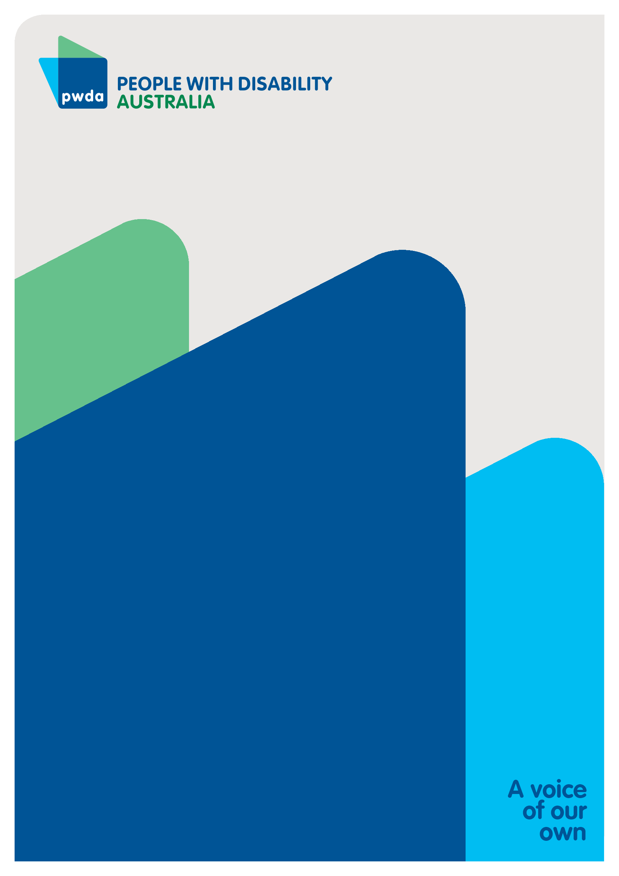
People with Disability Australia (PWDA) is a national disability rights and advocacy organisation made up of, and led by, people with disability.
For individual advocacy support contact PWDA between 9:00 am and 5:00 pm (AEST/AEDT) Monday to Friday via phone (toll free) on 1800 843 929 or via email at pwd@pwd.org.au

Submission contact
Giancarlo de Vera
Senior Manager of Policy
E: giancarlod@pwd.org.au

Community Housing Industry Association (2023). CHIA 2023-24 Commonwealth Pre-Budget Submission. https://www.communityhousing.com.au/our-advocacy/submissions/
Australian institute of Health and Welfare (2022). People with disability in Australia, housing. https://www.aihw.gov.au/reports/disability/people-with-disability-in-australia/contents/housing
Productivity Commission (2022). In need of repair: The National Housing and Homelessness Agreement Review. https://www.pc.gov.au/inquiries/completed/housing-homelessness/report
Australian Institute of Health and Welfare (2022). People with disability in Australia, Housing. https://www.aihw.gov.au/reports/disability/people-with-disability-in-australia/contents/housing
Beer, A., Daniel, L., Baker, E. & Lester, L. (2020). The Shifting Risk of Homelessness among Persons with a Disability: Insights from a National Policy Intervention. International Journal of Environmental Research and Public Health, 17(18). https://doi.org/10.3390/ijerph17186512
Royal Commission into Violence, Abuse, Neglect and Exploitation of People with Disability. (October 2020). Overview of the responses to the Group homes Issues paper. https://disability.royalcommission.gov.au/publications/group-homes
Disabled People’s Organisations Australia (2020). Segregation of people with disability is discrimination and must end. https://dpoa.org.au/endsegregation/
Australian Human Rights Commission. The Rights of People with Disabilities: Areas of Need for Increased Protection: Chapter 4: Accommodation. https://humanrights.gov.au/our-work
Grattan Institute (2021). How to make housing more affordable: Submission to the parliamentary inquiry into housing affordability and supply in Australia. https://grattan.edu.au/news/how-to-make-housing-more-affordable/
Australian Institute of Health and Welfare (2023). Housing assistance in Australia. https://www.aihw.gov.au/reports/housing-assistance/housing-assistance-in-australia/contents/households-and-waiting-lists
Ibid
Community Housing Industry Association (2023). CHIA 2023-24 Commonwealth Pre-Budget Submission. https://www.communityhousing.com.au/our-advocacy/submissions/; National Shelter (2023). Pre-Budget Submission 2023-24. https://shelter.org.au/category/publications/submissions/
NCOSS (2023). Barely hanging on: The cost of living crisis in NSW. https://www.ncoss.org.au/policy-advocacy/policy-research-publications/barely-hanging-on-the-cost-of-living-crisis-in-nsw/, p.35
Ibid, p.50
Australian Institute of Health and Welfare (2022). People with disability in Australia, Income. https:/i/www.aihw.gov.au/reports/disability/people-with-disability-in-australia/contents/income-and-finance/income
Australian Institute of Health and Welfare (2022). People with disability in Australia, Income. https://www.aihw.gov.au/reports/disability/people-with-disability-in-australia/contents/income-and-finance/income
Australian Institute of Health and Welfare (2022). People with disability in Australia, Unemployment. https://www.aihw.gov.au/reports/disability/people-with-disability-in-australia/contents/employment/unemployment
PWC, Disability expectations: Investing in a better life, a stronger Australia – Achieving better outcomes for people with a disability and their families, November 2011, last accessed 23 January 2023. https://www.pwc.com.au/industry/Government/assets/disability-in-australia.pdf
OECD, Sickness, disability and work
Monash University (2021). Adaptable housing for people with disability: A scoping study. https://bridges.monash.edu/articles/report/Adaptable_housing_for_people_with_disability_in_Australia_a_scoping_study/14458563
Homelessness Australia (2023). Overstretched and overwhelmed: The strain on homelessness services. https://homelessnessaustralia.org.au/housing-crisis-is-driving-surging-demand-for-homelessness-services/
ibid

