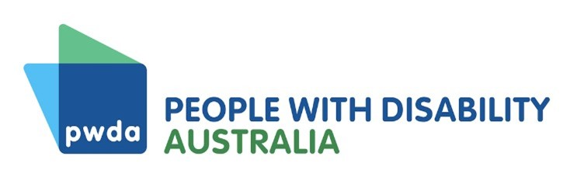

COVID-19 Position Statement
  - September 2023

Background
In late 2021, the Government started to reduce many COVID-19 measures and embrace a 'living with COVID-19' approach. People with Disability Australia (PWDA) wanted to know how this current approach is affecting our members and what, if any, action they would like to see the governments take.
PWDA distributed a survey to its members in March 2023, which received 104 responses. This was followed by an online member forum held on 4 July 2023, which had thirty-one participants. The common themes from the survey and forum were:
- most members have felt worried or scared about the Government's relaxing of COVID-19 measures.
- that the Government and public is ‘pretending’ that the pandemic is over
- feeling forgotten, ignored, and undervalued by the Government and the public.
- concern about contracting long COVID.
- very strong support for telehealth
- feeling unsafe about going out into the community.
This position statement and the below recommendations is based on what we heard from our members through the survey and the online member forum. We have summarised the findings of our consultations in a report. Please see the COVID-19 survey summary report for more information.

Recommendations

PWDA recommends that:
Recommendation 1 – The relevant level of government mandate up-to-date vaccinations for all workers in high-risk settings including but not limited to hospitals, medical services, disability services and aged care homes, and other settings where workers support people with disability.
Recommendation 2 – The Commonwealth Government develops national indoor air quality standards, with consideration given to high-risk settings, including hospitals, medical services, disability group homes, aged care homes, schools and workplaces.
Recommendation 3 – The relevant level of government mandates that people who have tested positive for COVID-19 should not be allowed to visit disability group homes and aged-care homes until they are no longer infectious.
Recommendation 4 – The relevant level of government mandates that masks must are worn in all health and hospital settings.
Recommendation 5 – Each state and territory government implements a traffic light advice mechanism to signal the current level of COVID-19 risk in the community.
Recommendation 6 – The Commonwealth Government creates an exemption to the Medicare ‘Existing Relationship Requirement’ so that people who have disability and/or are immunocompromised can access telehealth appointments regardless of whether they have attended the medical practice in person in the past 12 months.
Recommendation 7 – The Commonwealth Government mandates that general practitioners must bulk-bill telehealth appointments for people with disability.
Recommendation 8 – The Commonwealth, state and territory governments regulates the tertiary education sector to ensure that people who have disability and/or are immunocompromised can choose to attend their course online, in-person or by a combination of both delivery modes.

Feeling unsafe going out into community with less restrictions
Most respondents have felt worried or scared about the Government’s relaxing of COVID-19 measures. A PWDA member who attended the PWDA online forum noted:
'Communication is really important. Messaging around the fact that there's still vulnerable people and plenty of them.'
Relaxing COVID-19 measures has caused many people to go out less into the community, only leaving the house when it is essential. Thirty-nine percent of respondents are restricting themselves to the house and only leaving when it is necessary and avoiding going out in social settings and only going out for medical, work, and study reasons. One respondent stated that they felt they were being asked to sacrifice their life for a community that does not care about them. See Recommendations 1-5.

Less access to supports.
Most members were worried about getting long COVID. Others expressed concern about living with long COVID, due to it having little recognition or support. Thirty percent of respondents say they now have less access to supports, such as support workers who refuse to wear masks, finding it extremely difficult to find supports and therapists, inability to safely go to medical appointments needed for chronic conditions, including attending general practitioner and therapy appointments. At PWDA’s July online member forum, members explained:
'I keep having to do without supports, because I can’t force people to wear a mask in my home.'
'Not even being able to access healthcare safely is outrageous, you should not have to decide if the risk of attending healthcare/ hospital is worth it - a real risk of infection that will make your health worse vs delayed care which equally can make your health worse. Safe healthcare is a healthcare right but is not happening.'
One respondent stated that almost all services and businesses have stopped any accommodations and assistance they had instituted when the restrictions were in place. Most respondents reported very positive experiences with telehealth and felt very strongly that telehealth should continue. All fifteen respondents who directly answered the sub-question about whether telehealth should be bulk billed answered in the affirmative. See Recommendations 6-7.

Limited work and study
Some respondents have told us that they have stopped or reduced their work due to the lessening of restrictions and being forced to go back into the office. Some have reported that universities have not provided alternative options for students who cannot attend in person. One member who attended PWDA’s online forum noted that:
'[I] have had to provide ongoing medical certificates from my GP and specialist to 'justify' to my managers to keep working from home full time during this ongoing COVID Pandemic... Far too often staff living with disability are viewed as a problem and not a person who requires some modicum of care and consideration.'
This further isolates people with disability and makes participation in work and education even more inaccessible. See Recommendations 2 and 8.

Contact

Giancarlo de Vera
Senior Manager, Policy
Email: pwd@pwd.org.au

