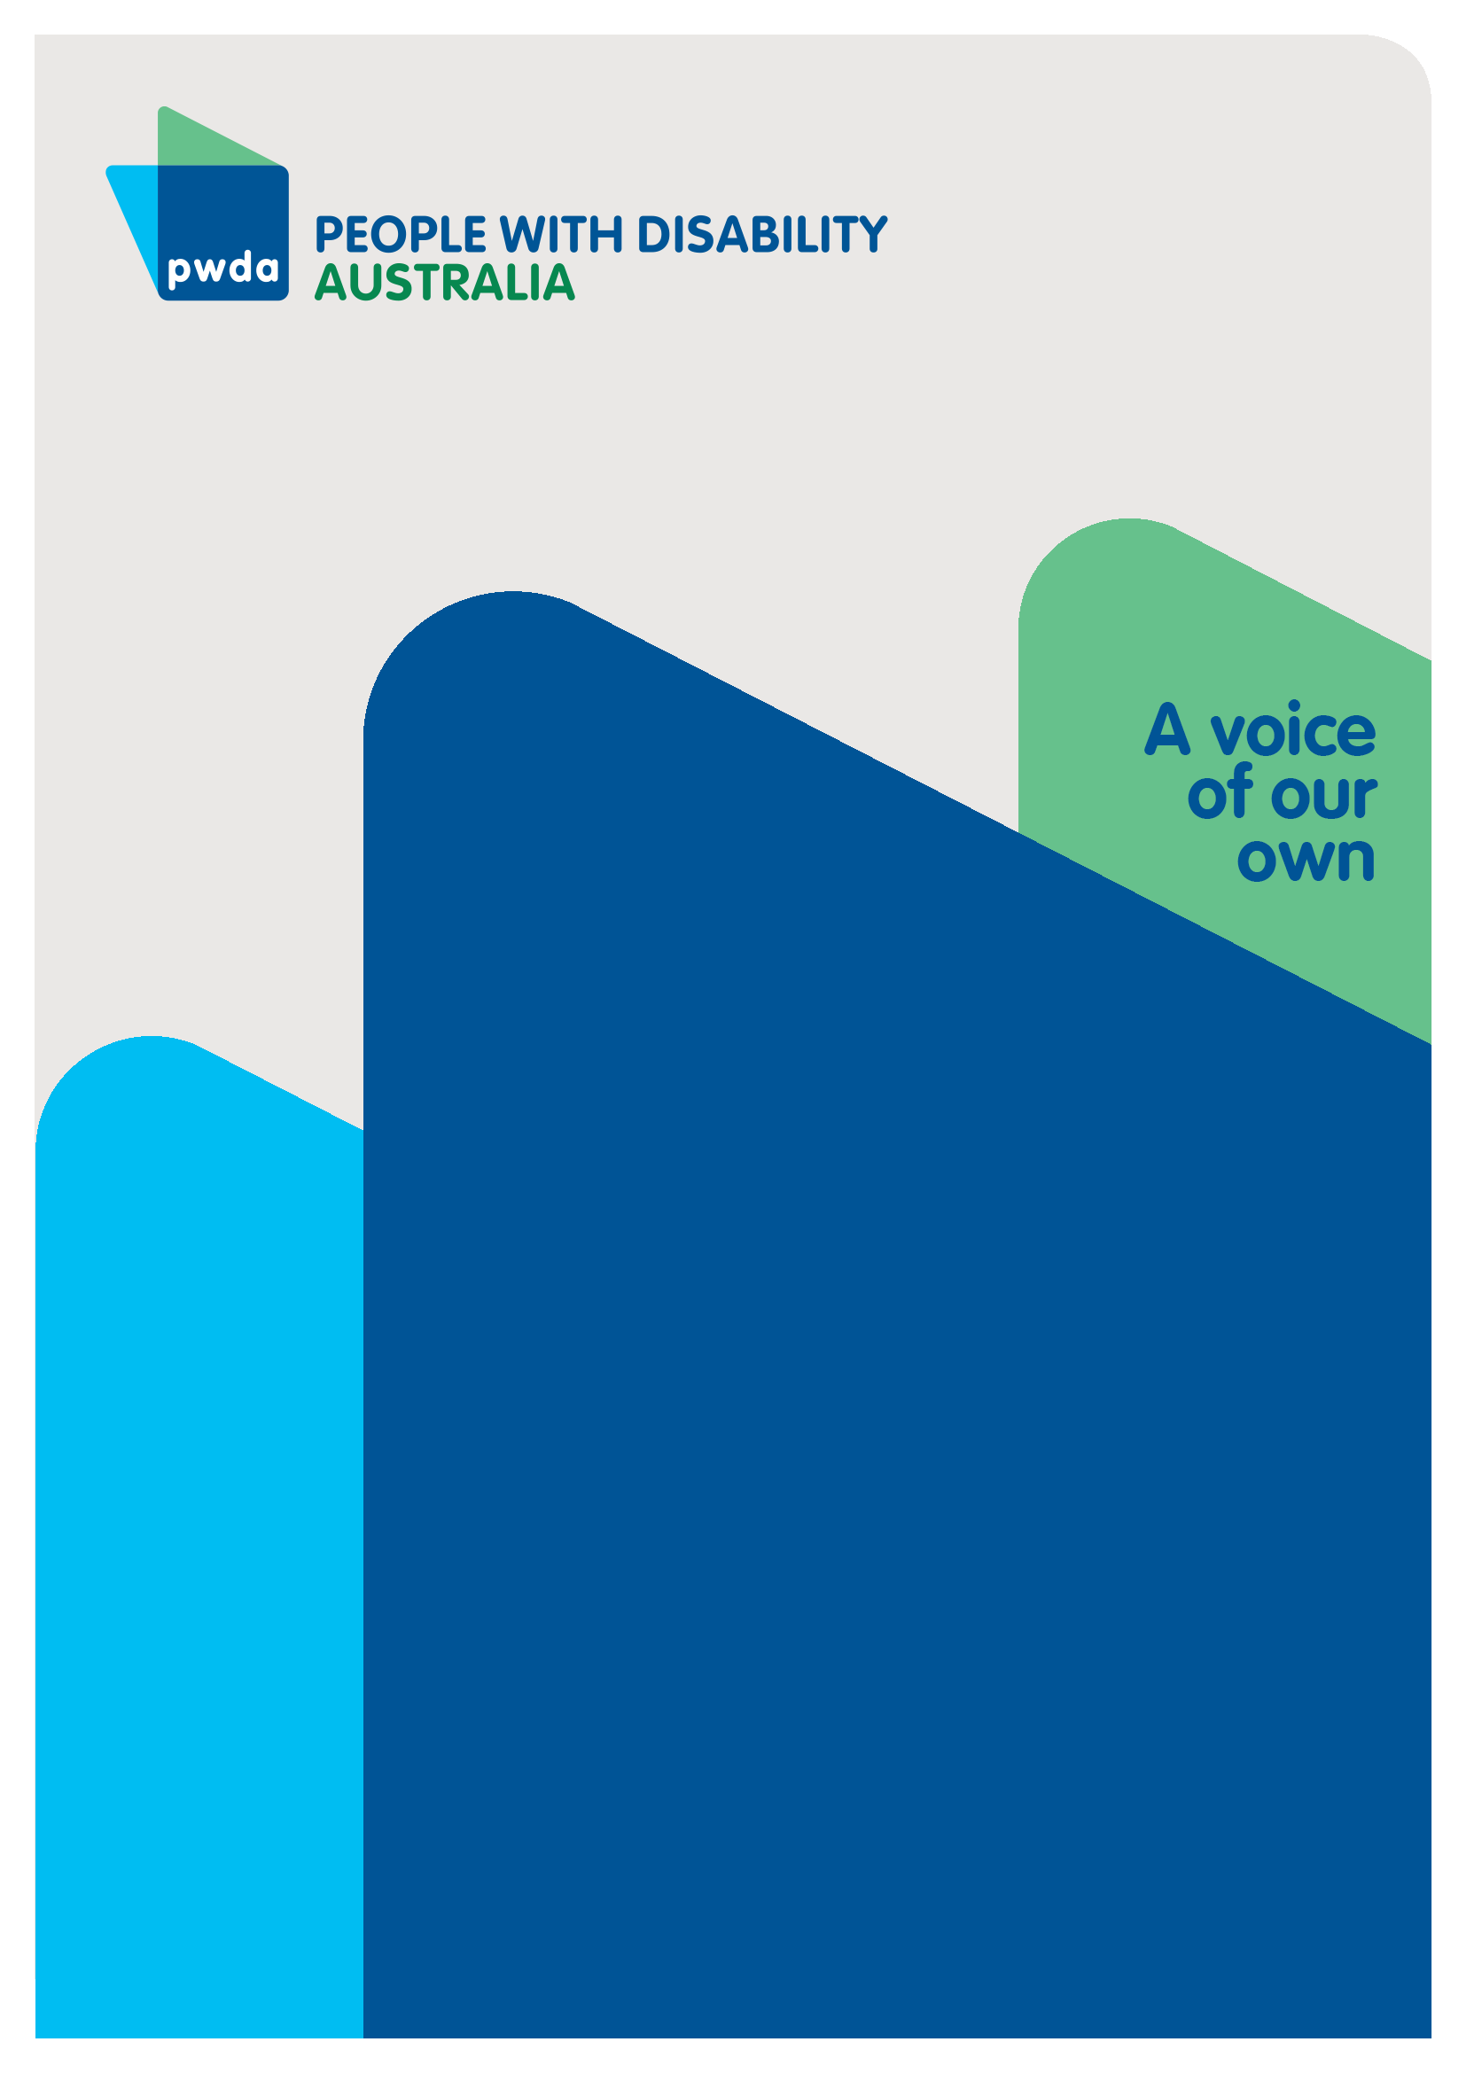
NDIS Review
Why is the NDIS an oasis?

Submission 3 to the Independent Review of the National Disability Insurance Scheme (NDIS)
Aug
2023

Copyright information
NDIS Review – Why is the NDIS an oasis?

First published in 2023 by People with Disability Australia Ltd.
Level 8, 418a Elizabeth Street, Surry Hills, New South Wales, Australia 2010
Head office also in Sydney
Email: pwd@pwd.org.au
Phone: +61 2 9370 3100 Fax: +61 2 9318 1372
URL: www.pwd.org.au

Typeset in Arial 12 and 14 and VAG Rounded 18 and 26 pt

© People with Disability Australia Ltd. 2023

The moral rights of the authors have been asserted

National Library of Australia Cataloguing-in-Publication data:

Creator(s): | Heidi La Paglia Reid
Title: | NDIS Review – Why is the NDIS an oasis?

All rights reserved. Except as permitted with the Australian Copyright Act 1968 (for example, a fair dealing for the purposes of study, research, criticism or review), no part of this book may be reproduced, stored in a retrieval system, communication or transmitted in any form or by any means without prior written permission. All inquiries should be made to the publisher at the address above.

Suggested citation:

La Paglia Reid, H., NDIS Review – Why is the NDIS an oasis?, 29 August 2023, People with Disability Australia, Sydney

ISBN: 978-0-6457443-8-5

About PWDA
People with Disability Australia (PWDA) is a national disability rights and advocacy organisation made up of, and led by, people with disability.
We have a vision of a socially just, accessible, and inclusive community in which the contribution, potential and diversity of people with disability are not only recognised and respected but also celebrated.
PWDA was established in 1981, during the International Year of Disabled Persons.
We are a peak, non-profit, non-government organisation that represents the interests of people with all kinds of disability.
We also represent people with disability at the United Nations, particularly in relation to the United Nations Convention on the Rights of Persons with Disabilities (CRPD).
Our work is grounded in a human rights framework that recognises the CRPD and related mechanisms as fundamental tools for advancing the rights of people with disability.
PWDA is a member of Disabled People’s Organisations Australia (DPO Australia), along with the First People’s Disability Network, National Ethnic Disability Alliance, and Women with Disabilities Australia.
DPOs collectively form a disability rights movement that places people with disability at the centre of decision-making in all aspects of our lives.
‘Nothing About Us, Without Us’ is the motto of Disabled Peoples’ International.

Table of Contents

Copyright information 2
About PWDA 3
Introduction 5
Section 1: NDIS Implementation 6
The beginning of the NDIS 6
Effectiveness of a market driven support system 8
Section 2: A disconnect between the NDIS and the mainstream 11
A Tiered Support System 11
The Failure of Tier 2 11
The National Disability Strategy 13
Section 3: The positive impact of the NDIS 15
Section 4: The NDIS as an Oasis 17
Section 5: The inaccessibility of the NDIS 19
Restrictive eligibility 21
Conclusion and Recommendations 24
Recommendations 25

Introduction

Background
The Minister for the National Disability Insurance Scheme (NDIS), The Hon Bill Shorten MP, announced an independent review of the NDIS (the Review) on 18 October 2022. The Review examines the design, operations and sustainability of the NDIS, and NDIS workforce capability and capacity.
From March to July 2023, PWDA conducted consultations with people with disability on their experiences of the NDIS. This involved several focus groups and surveys on the experiences of people with disability with the NDIS (including one Easy Read version). Participants in these consultations primarily involved people with disability with a broad array of experiences. Some families, carers and support people of also participated in the surveys and focus groups, but represented a small percentage of participants and predominantly participated as representatives of people with disability.
Throughout all these consultations, a cross cutting theme emerged which suggested that, while the NDIS, since its implementation, has drastically changed the lives of many people with disability who have been able to access it, its roll out has left significant gaps for those whose needs are not considered reasonable and necessary.
In the NDIS Review consultation paper titled ‘What We Have Heard: Moving from defining problems to designing solutions to build a better NDIS’. released in June 2023, this phenomenon was referred to as the NDIS as an ‘oasis in the desert.’
Drawing on the experiences of people with disability gained through PWDA’s NDIS Review consultations, this submission discusses why the NDIS has become an ‘oasis’ and how actions can be taken to overcome this.

Section 1: NDIS Implementation

The beginning of the NDIS
The NDIS was first implemented through the National Disability Insurance Scheme Act 2013 (the “NDIS Act”) in 2013 as the first nationally coordinated attempt to address the rights and support needs of people with disability.
The objectives of the NDIS (as outlined in the NDIS Act) include:
a. supporting the independence and social and economic participation of people with disability
b. providing reasonable and necessary supports, including early intervention supports, for participants
c. enabling people with disability to exercise choice and control in the pursuit of their goals and the planning and delivery of their supports
d. facilitating the development of a nationally consistent approach to the access to, and the planning and funding of, supports for people with disability
e. promoting the provision of high quality and innovative supports to people with disability.
Under the NDIS Act, a key principle of the NDIS is that people with disability have a right to participate on an equal basis in all areas of social, economic and cultural life.. To this end, the NDIS, when viewed in conjunction with other legislative and policy frameworks such as the Disability Discrimination Act 1992 and the Australian Disability Strategy (ADS), has been praised both within Australia and internationally as a means to implement the United Convention on the Rights of Persons with Disabilities (UNCRPD) in practice.
However, despite its ambitions, the implementation of the NDIS has not led to the realisation of disability rights in all aspects. Instead, it has created a situation where people with disability need NDIS access to receive the basics, as there is no alternative support available.
State and territory amalgamation
As states and territory governments funnelled their pre-existing disability sector funding into the national NDIS system, the roll out of the NDIS coincided with the dismantling of almost all previously existing local, state and territory government disability support initiatives.
In its NDIS Review consultations, PWDA heard from people with disability, who both were and were not NDIS participants, that the amalgamation of state and territory funding and services had impacted them.
For example, a number of individuals noted that the transition to the NDIS had greatly improved their experience:
"Previously the state system was offering me services that were irrelevant to my needs yet could not fund the services that I can now access through NDIS and which have profoundly improved my mobility, independence and ability to access my community.”
while other individuals who are not NDIS participants explained that the local supports they had access to prior to the NDIS had not been replaced by any initiative.
“I used to get a power wheelchair through a state program called the community aids and equipment program that provided equipment to people with a healthcare card. They cancelled that program when the NDIS came in, but there's nothing to replace it for people who aren't on the NDIS.”

“I was on a waiting list for a great art program ….in Victoria and had been going on for years - but as soon as the NDIS was becoming a thing they had to close.”
“I was working in the space years ago as the NDIS rolled out and what Participant X mentioned is consistent with almost all providers, that the shift from block funding to individual funding meant they didn't have sufficient certainty to continue providing services.”

Effectiveness of a market driven support system
Throughout PWDA’s NDIS Review consultations, it was also highlighted that the introduction of the NDIS had prompted a shift towards a market-based system, dominated by large service providers. One person who was not an NDIS participant noted:
“The problem where everything is privatised someone did mention, and the problem with that is that even when you are getting state-based care, if the company that is contracting to your program decides that they're not going to take that tender in the New Year then all your services are changed, you have to start from scratch and that is currently happening to me.”
These participants’ experiences reflect a NDIS-driven sector shift, from state and territory publicly funded services to private sector service provision. While the benefit of this, it has been argued, is more choice and control for participants, the marketisation of almost the entire service system, has also caused a range of issues for people with disability who both are and are not NDIS participants.

Service Affordability
One major issue that is commonly reported is that the price of disability supports has increased. While for many, having access to the NDIS means that these increased costs are not incurred by them as individuals, those without access to an NDIS plan are faced with a service system that is financially inaccessible. As some focus group participants explained:
“I wasn't diagnosed before the NDIS was a thing, but I have noticed since the NDIS has been implemented that the cost of physiotherapy and other things have sharply increased independently of the cost of living. Service providers can then bill the NDIS at higher rates. Things like OTs in particular, they're either prohibitively expensive to see privately, or if they are public ones in your area the wait list is prohibitively long and then they don't necessarily have the relevant knowledge for specific conditions.”
For those who are NDIS participants, private sector price increases can also impact plan effectiveness and efficiency. In PWDA’s consultations, some NDIS participants explained that their NDIS plan could not cover all of the supports they needed because providers quoted significantly more when they knew they were an NDIS participant.
“I wanted to get a toilet put in my shed because that's my social hub. We got quotes and everything. I know that the NDIS limit is about $15,000 or something, some weird figure. All the quotes I got came in within about $10 of that limit. And then it got knocked back so I didn't get it. So I ended up putting it in myself with the help of a mate took two and a half months instead of two days and cost about $900 that's how much this is getting rorted.”
“I've had to query before, basically, I saw a physiotherapist before I got my NDIS plan and then got funding for physiotherapy in my NDIS plan and I automatically assumed I was charged the same rate but when I looked over my plan, I noticed they were charging more. I was paying $80 they were charging the plan over $100 they didn't tell me I was going to be charged more I called the office and was asked yes NDIS recipients are charged a higher rate than normal client and that really annoyed me so I dropped the amount of reduced the amount of sessions I was having with the physio in order to be able to afford it.”
“Basically, my providers generally charge near or the cost limit that's provided by NDIS.“

Thin Markets
Another major issue with relying on market-driven service provision is the inevitable situation of having limited service options, known as ‘thin markets,’ especially in rural, remote and regional locations. In focus groups, some participants who lived in rural and regional locations further explained:
“And the other thing is on the issue of availability of services in rural and remote areas, more so than anywhere else, I have need for transport, medical problems, I have to go to [Regional Centre] for. I can't get a regular service provider to do it because it's an ad hoc thing it's not a regular every week. Last time I was really crook and I couldn't do it any other way.”
“Now the other thing is support co-ordinators … I have been very lucky, I get mine from [name of service provider] and she has been excellent I've had her for years. She does her best but like anyone in a rural area you're limited by the services on the ground.”
While these participant experiences reflect the difficulties of implementing an NDIS plan in rural and regional areas, where service providers, and in turn, choice and control is extremely limited; other consultation participants described the complete impossibility of accessing services in thin markets outside of the NDIS system.
“I wasn't diagnosed prior to NDIS. I'm only 25 so I was a child when the NDIS came into effect, but I have definitely noticed that the waiting lists for all public services has gotten much longer since the NDIS came in, probably because those state-based and other federally funded services were basically absorbed into NDIS or became NDIS only services and then the public systems that are still in place had to take on the patients that weren't on NDIS from those systems. So it's - yeah, all those wait lists like publicly funded physio, supplies dropped significantly over the past decade with the rise in the NDIS and the wait list for those services that do still remain are just insane. They're six years long in most cases.”
These issues are explored further in our NDIS Cost and Affordability submission, responding to the NDIS Review’s Paper, The role of pricing and payment approaches in improving participant outcomes and scheme sustainability .

Section 2: A disconnect between the NDIS and the mainstream

A Tiered Support System
The NDIS was never meant to support all people with disability through individual funding. Instead, individualised NDIS plans were only meant to support an estimated 10% of people of disability. The other 90%, while mostly not eligible for individualised NDIS funding, were in fact, under the original plan for the NDIS, meant to benefit from community-based supports through the Tier 2 support system.
While it is not well known, the NDIS was originally intended as a three-tier system, with Tier 1 being an insurance against the cost and impact of acquiring significant disability, Tier 2 funding community-based information, referral and inclusion services across the mainstream community, and Tier 3 accounting for the well-known individualised support plans for people with significant and life-long disability – the direct beneficiaries.
However, while this tiered system was a promising means to improve the experiences of all people with disability, ten years of NDIS implementation has seen investment funnelled to individualised Tier 3 funding, while Tier 2 has been diminished to around 1% of Scheme expenditure.

The Failure of Tier 2
In 2020, the NDIA released a policy framework outlining the reframing of Tier 2 supports as being administered via the pre-existing Information, Linkages and Capacity Building (ILC) program. Alongside this reframing, the ILC program transitioned from the NDIA to the Department of Social Services (DSS) and was to be administered as a “vehicle to implement government strategy…to realise the benefits of greater integration and better alignment with the National Disability Strategy and other Commonwealth services and programs”.
Since this time, ILC grants have been spread across a large number of different and time-limited projects. In a 2021 major report on the ILC program delivered by The Swinburne University Centre for Social Impact, it was highlighted that 50% of ILC grant funding distributed between 2019-2021 was allocated to projects categorised as focussed on ‘Individual Capacity Building (ICB)’ - which aim to change individuals, rather than the social, economic and cultural structures which inhibit them – while the other 50% was distributed thinly across four other funding streams including the National Information Program (18%), Mainstream Capacity Building (12%), Community Awareness and Capacity Building (11%) and Social and Community Participation (SCP).
Meanwhile, Partners in Community (Local Area Coordinators and Early Childhood Partners) were funded alongside the ILC program. Despite Partners in Community being required to commit 20% of their time to community capacity building activities by supporting people with disability to connect to mainstream supports, this did not happen. The reality is, over time, Partners in Community, especially Local Area Coordinators (LACs), have become primarily focussed on planning and assisting individuals to access and implement all aspects of individual NDIS plans.
The PWDA NDIS Review survey received a number of negative responses about LACs. In response to questions about problems with the NDIS for example, participants stated:
“Planners and LAC's not understanding persons situation and what they have gone through, not enough voice, choice and control, not being listened to.”
“I don't like the waiting and the stress of finding out what types of money I have in my funding budget. The LAC could interact with us more and help us with understanding our plans.”
“LAC was speaking to fast and it was hard to understand. Didn't ask any question about what you want in the plan and what support and services that are available in the plan.”
“It’s not very clear how to use your funding because there's different categories. LAC doesn't communicate with you too.”
“The local area coordinators who are supposed to shepherd you through the NDIS really assume you have no cognitive issues, no brain fog, no mental exhaustion and if you do it's very, very challenging and in some cases I would say impossible.”
From these responses, the anecdotal evidence suggests a large proportion of what LACs do is focussed on planning and supporting the implementation of funding for individual NDIS participants (rather than promoting community inclusion). This supports the findings of the 2021 Swinbourne Report noted earlier.
The responses also suggests that the quality of LACs can be improved by ensuring LACs are well informed about participants’ needs and circumstances, and are guided by this information.
Additionally, while there have been ILC-funded projects which have, without a doubt, benefited individuals; it must be recognised that the majority of ILC funded initiatives have been too limited in scope to make a difference to the entrenched society-wide disadvantage that is experienced by people with disability.

The National Disability Strategy
Outside of the NDIS, efforts to make mainstream services accessible have also lacked effectiveness. The National Disability Strategy (NDS) 2010-2020 is a key example.
In Australia, Australia’s Disability Strategy (ADS), formally the NDS, was first implemented in 2010 as a ten-year implementation strategy with a “vision is for an inclusive Australian society that enables people with disability to fulfil their potential as equal citizens.”
The NDS had an aim of improving the inclusion of people with disability in mainstream services and community and has been described as a framework for the implementation of disability-related international obligations from UN treaties such as the UNCRPD.
While it is generally agreed that the ambitions and purpose of the NDS was and is admirable, reviews of the Strategy have highlighted large failures in its implementation. In a large-scale review of the NDS conducted in 2019 by the University of New South Wales (UNSW) Social Policy Research Centre a number of areas were identified where change had been limited or unsuccessful; all of which were structural.
Notably, the NDS review identified that the implementation of the NDIS had been the most impactful initiative for individuals since the introduction of the NDS, but that there had been limited change to society-wide issues such as:
- high rates of violence and abuse
- lack of access to accessible housing
- high rates of poverty and unemployment
- inaccessible education
- poor access to community transport
- high rates of institutionalisation and segregation
- inadequate access to public services as such advocacy and legal aid, and;
- a failure to address the intersectional discrimination.

Section 3: The positive impact of the NDIS
While the NDIS has its issues, PWDA’s consultations have highlighted the huge impact that access to the NDIS has on individuals.
When asked about the best things about the NDIS in the PWDA’s NDIS review survey, participants responded with a number of positive affirmations about their individual plans.
Among these responses, a key theme that emerged was appreciation of how the NDIS supported access to mainstream services and community participation, and being able to participate fully in society, on an equal basis as others, by addressing needs that those without disability take for granted like an education or personal care. Survey respondents told PWDA:
“Getting access to things I couldn't before such as OT, Psychology, Speech Therapy, and Physio. But the best support is having disability support workers every day to help me with everyday tasks I used to be too ashamed to ask for family friends to assist me with (personal care, household chores etc).”
“It helps me get out into the community. It provides money to pay for education. It helps provide recreational opportunities e.g. camps.”
“Getting support to do things I am passionate about.”
“Having a support worker helped me thrive in ways of growth for my life in ways of employment, connection, support for me to live independently, and so much more they help me with.”
“Access to social support for the first time in my life. Being able to be funded for consumables directly related to my disability like heat packs and countenance aids.”
“I was going downhill fast and was struggling to survive. NDIS supports me in many areas of my life (food prep and deliveries, support workers, multiple therapies, social participation and festive activities are among highlights.”
In the focus groups, a number of participants cited similar experiences about the NDIS giving them access to mainstream services and community participation, and being able to participate fully in society, on an equal basis as others, that they did not have previously. They told us:
“I like NDIS because we can be taken out to places achieve goals have carers and buy specialist adaptive technology, I like the carer support as well because they can take you out to places especially when your parents get old and that's about it from me at the moment.”
“I used to live in a nursing home. I lived in a nursing home years. And thank God for the NDIS and SDA. I now live in a beautiful apartment in Southbank in inner VIC. And I love every moment of being here. It's sort of given me my life back. It's wonderful.”
“I'm representing my 27-year-old daughter - one good thing about the NDIS is we always thought she would have to live with us until she died. But she is in an SDA at this present time, don't know how long. So that's given her the independence.”
All of these participants reflect the huge difference that the NDIS makes to people with disability who are eligible for individualised supports. However, while this aspect of the NDIS is essential, it must be recognised that significant reform is needed to ensure that those individuals who are not eligible are not, as a result, not able to access to mainstream services and community participation, and not being able to participate fully in society on an equal basis as others.

Section 4: The NDIS as an Oasis
Given the poor implementation of Tier 2 supports under the NDIS and the NDS, it Is unsurprising that accessing an individualised NDIS plan is seen overwhelmingly as the primary option people with disability have to access the support they need.
In PWDA’s NDIS Review consultations, over 60% of people who answered questions about non-NDIS funded supports, indicated they did not receive non-NDIS funded supports. For example, when asked ‘Do you access disability supports or services which are not NDIS funded?’, 62% (n=212) respondents who were NDIS participants and 60.3% (n=41) who were not NDIS participants said ‘no.’
Of the individuals who did access support outside of the NDIS the most common supports accessed included allied health services such as appointments with psychologists and medical specialists, which many noted were prohibitively expensive.
“The NDIS doesn’t always pay for the things that are directly related to my disability like specialist appointments. This means I can’t access these and I am living with more pain than I need to be.”
In a focus group with non-NDIS participants, individuals similarly explained that they had no support to access allied health services. Among a total of 10 participants in this focus group, there was consensus that people with disability who did not have access to the NDIS needed support to access allied health.
In order to manage their conditions, participants said that their care included or ideally would include various and multiple allied health professionals and specialists such as occupational therapists, psychologists, psychiatrists, physiotherapists, hydro-therapists and dieticians. Many of these individuals did not however, access these services because of the associated expenses. Focus group participants who were not NDIS participants noted:
“I'd also like to see a nutritionist because I've got allergies and also poor food absorption. So even when my diet is nutritionally adequate I still end up deficient in things.”
“An OT would be good and a physio because I have got arthritis as well.”
“The things that would help me the most is physiotherapy and hydrotherapy.”
Participants from the focus group for non-NDIS participants also expressed a desire to access other supports, such as assistive technology, mobility equipment, and personal protective equipment (PPE), but being unable to do so due to a lack of financial assistance outside of the NDIS.
“Assistive devices. I really benefit from - if I'm able to listen to text on a screen or like I can't get - I just have had trouble managing to coordinate getting a printer. It's a lot easier for me to read off paper, that kind of thing.”
“I would love to be able to get new mobility aids, like just better ones because these ones are just not quite appropriate for my needs.”
“I need support for COVID safety because of my immune system even though it's not diagnosed, it's - you know, walks like a duck, quacks like a duck, it's obviously there, had it four times and get sicker and sicker. That for me would look like free masks. I have spent thousands on masks over the last three years.”
“I'm trying to access the NDIS currently because what I need is not provided elsewhere. I'm trying to get care, home modifications, assistive technology, adaptive furniture and mobility aids and relevant therapies for my disability, like physiotherapy and acupuncture. I think getting on that will help not only with my independence, especially within my own home. My house is not accessible.”
“Sensory aids I'd really benefit from being able to get sensory aids, but I - that seems to be like exclusive to the NDIS so I can't get them, or they're really expensive or you go on the website and it's like we're registered with the NDIS and I think I can get this from K-Mart which is fun, but it's not like - it's good, but I know that there's ones that I'd benefit from or that are a bit more specific.”
While, as described in the previous section, the NDIS has had a positive impact on those that are able to access it, this section has highlighted how the introduction of the NDIS has left significant support gaps for those whose conditions and support needs are not eligible for NDIS plan funding. In order to bridge this gap, it is important that the Commonwealth works with all levels of government to strengthen and ensure mainstream services, supports and systems are affordable, inclusive and accessible for people with disability.

Section 5: The inaccessibility of the NDIS
While the NDIS is currently the only adequate support system for people with disability, there are significant and numerous barriers to NDIS participation; many of which were highlighted in the PWDA consultations.
In response to a question about why they had not accessed the NDIS in the PWDA NDIS Review survey, a total of 64 respondents gave a range of reasons, most of which were related to eligibility and difficulties with the access processes.

Figure 1: What are your reasons for not accessing the NDIS?
Out of the pre-written responses, the most commonly selected by respondents was ‘Getting supporting documentation for my access request was too hard,’ (45.31%, n=29) followed by ‘The access request process was inaccessible’ (34.36%, n=22) and ‘The access request forms were too hard to understand’ (29.69%, n=19). These reasons were expanded upon by participants in the non-NDIS participant focus group.
In this focus group, a number of participants highlighted that complex access processes had prevented them from accessing, or in some cases, even applying for the NDIS. Focus group participants noted:
“That's where a large portion of NDIS funding is going is to these plan management services that just overwhelm people who are trying to access the NDIS with options. That's been a major barrier for me in actually applying for the NDIS is I can't do this alone, but who the heck do I go with?”
“Every time I've tried to look at even applying for NDIS, if I go to, say like a support service all I get is just an email of here is all the stuff you need to do and get overwhelmed and confused by all of it and then end up just putting it to the side along with everything else.”
In addition to the complexity of the access process being inaccessible, participants in the survey and the non-NDIS focus group described experiences which reinforced the quantitative survey data, which indicated that the NDIS requirement to provide professional reports and evidence alongside an access request was unaffordable.
As discussed earlier, a number of these participants expressed a need for NDIS funding to be able to access specialists and allied health professionals, so needing access to these services for initial NDIS access was extremely difficult. Participants from the Non-NDIS focus group told PWDA:
“I do not have the capacity or finances to pursue to medical reports required and I'm worried it will just be denied.”
“I think with the NDIS application process they really need guidelines that are clearly and very available on the website. Like it's really hard when you're jumping from specialist to specialist that you don't normally see because they have nothing to do with your treatment but they want an NDIS letter from them for your application.
If there's not guidelines for it and they don't know how to write a letter the onus then falls on you as the disabled person to outline what you need in that letter and if that letter is not good enough then you then have to chase them up 10 times and pay more money for appointments.”
In particular, some focus group participants emphasised that the requirements to prove the impact that their disability had on them was too difficult when they were already struggling on a day-to-day basis with disability and / or chronic illness.
“I believe that the burden of proving whether or not you are functionally disabled or like your ability is being impacted should not fall on the person who is currently being impacted by a health issue because it's like you've already got - you're already dealing with enough.”
“I wish that you could just, like - if you need access to a support, you should have access to that support without having to prove anything, without having to, like, do any tests or get a specific doctor to say something for you.”
“The NDIS application process really assumes that either the application is being done by abled parents for their child or by someone who has no cognitive issues, no brain fog, no mental exhaustion. If you're an adult who is applying without your parents shepherding you through the process and you do have cognitive issues or brain fog or mental exhaustion the application process is just overwhelming and inaccessible.”

Restrictive eligibility
Across the community, it is well known that restrictive access criteria, and a narrow understanding of disability is a major barrier NDIS participation. In the survey and the non-NDIS participant focus group, this issue was reflected.
“I suppose not fitting into a neat box, so particularly things like CF ME, PoTS, any kind of neurological disorder or anything rare or specialist you're fighting an uphill battle and often you've got significant complicating or co-morbid conditions, and the NDIS just isn't set up for that, which means that some of the most vulnerable members of our community for whom survival is a daily struggle cannot access the supports designed for them.”
“I have PoTS which is a form of...so my autonomic nervous system doesn't regulate itself properly...I also have muscle spasticity which no neurologist has been able to name other than its muscle spasticity and the NDIS doesn't like that that's not a diagnosis and also that my disordernomia specialist who has the largest cohort of PoTS patients in the country, he is just a GP as far as they're concerned. So my applications keep getting knocked back.”
“I've been diagnosed with chronic fatigue, but none of my doctors can figure out a reason for that, so I've been knocked back by a lot of support services.”
“I bought two wheelchairs which in total has set me back about $4,000 which was about 70% of my savings, because basically the NDIS didn't at that time want anything to do with someone who had a hypermobile...syndrome and undiagnosed orthostatic intolerance.”
“I've applied to the NDIS three different times. I'm trying to apply again currently and every time they reject it because we can't guarantee that I will always be bed bound, or always be wheelchair bound. I've been bed bound for five years and I've been struggling with mobility issues for 10 years, so based on that, it's evident that in let's say two or five years I will probably still be needing a lot of assistance but we can't really guarantee that, and based on that the NDIS has rejected the application.”
For these individuals, NDIS access was denied or was seen as difficult because their disabilities did not easily fit into what the NDIS considered an impactful, life-long disability. For others, no attempts had been made to apply for NDIS access because they were clearly prohibited by the access criteria.
“Not eligible as not disabled enough.”
“ADHD is not listed as a condition under NDIS and my other neurodivergent diagnosis are low support needs.”
“The reason is because of my disability and my age. So I would never be - I could be the most disabled person in Australia, I would never get NDIS because I am now under my aged care, which the services are very minimal.”
Notably, while some of these individuals are denied supports based on an assumption that they can access support through the medical and aged care systems, their experiences suggested that these alternative initiatives are inadequate to meet their needs as people with disability.
“I would never get NDIS because I am now under my aged care, which the services are very minimal. I get one hour cleaning a month and I get discounted food delivery, which is not to be sneezed at, but it's not that great, I must say, and I prefer to cook for myself. But anyway.”
As emphasised in PWDA’s NDIS Review submission on NDIS Access, Eligibility and Planning, experiences like these indicate an urgent need to refine the the s24 access requirements set out in NDIS Act to include a broader range of people with disability, as well as mechanisms to ensure the implementation of this criteria is consistent. This is especially important when considering the evidence that support outside of the NDIS is almost non-existent.

Conclusion and Recommendations
Overall, the PWDA surveys and focus group consultations reinforced the idea that the NDIS is an oasis. While the NDIS has been life-changing for the 10% of people with disability that have been able to access it, there is growing evidence that the other 90% of people who are ineligible for individual NDIS plans are unable to access adequate supports.
While it has been argued that the NDIS was never meant to support all people with disability, this submission has highlighted the ways in which the government and the NDIS has failed to deliver on the Tier 2 community supports that were promised at the beginning of NDIS implementation.
In the first section of the submission, we have outlined how the introduction of the NDIS and the associated privatisation of the disability service system, has seen the diminishment of previously existing local, state and territory support systems and decreased the affordability of disability and allied health services.
In the second section of the submission, we drew back to the planned Tiered approach to NDIS implementation, and how the Tier 2, now known as ILC support stream has struggled to make any real difference to the inclusion of people with disability in the community.
In the third section of the submission, we drew on the PWDA NDIS Review consultations to reinforce that the above development have resulted in the NDIS being an Oasis.
In the fourth section, we outlined the ways in which the NDIS, despite being the only form of adequate support available, is inaccessible to 90% people with disability in Australia.
In order to address the pitfalls of the NDIS being an Oasis, PWDA makes the following recommendations.

Recommendations

Addressing the NDIS as an Oasis
Recommendation 1 – To improve the experiences of people with disability who are not participants in the NDIS and ensure the NDIS does not remain an oasis, the Commonwealth, state and territory governments must work in conjunction with the NDIA to commit to adequate investment in Tier 2 initiatives that make a real difference to the inclusion of people with disability in the mainstream community, and implement mechanisms to monitor and evaluate their effectiveness in line with the Australian Disability Strategy (ADS).

Making the NDIS Accessible
Recommendation 2 – To improve transparency in NDIA decision-making and to ensure people with disability can obtain fit-for-purpose supporting documentation, the NDIA must provide clearer information and advice on evidence requirements including what criteria needs to be addressed, both for access requests and planning processes.
Recommendation 3 – To ensure the cost of preparing reports for assessments are not an access barrier for prospective participants, the NDIS should provide upfront funding for participants requiring assessments if required for an access request, including a Functional Capacity Assessment. This measure should be stipulated in the NDIS Participant Service Guarantee.
Recommendation 4 – To ensure all eligible people with disability can access the NDIS:
- where possible, remove the requirement for Functional Capacity Assessments to be completed before access to the Scheme.
- work towards increasing access to practitioners who undertake Functional Capacity Assessments in all areas including rural, regional and remote areas.
Recommendation 5 – In order to ensure all people with disability whose support needs are reasonable and necessary are eligible for the NDIS, the NDIS must provide clearer definition within the s24 access requirements set out in National Disability Insurance Act 2013 (NDIS Act) and consistent application of these requirements. List A classifications for access to the NDIS should be broadened to prevent the exclusion of particular cohorts of people with disability.
Recommendation 6 –To ensure that people with disability have a positive experience through the NDIS access and planning processes, the NDIA must ensure that frontline staff and intermediaries, including Local Area Coordination (LAC) workers, undergo training in understanding disability-specific needs and in providing trauma- informed support.

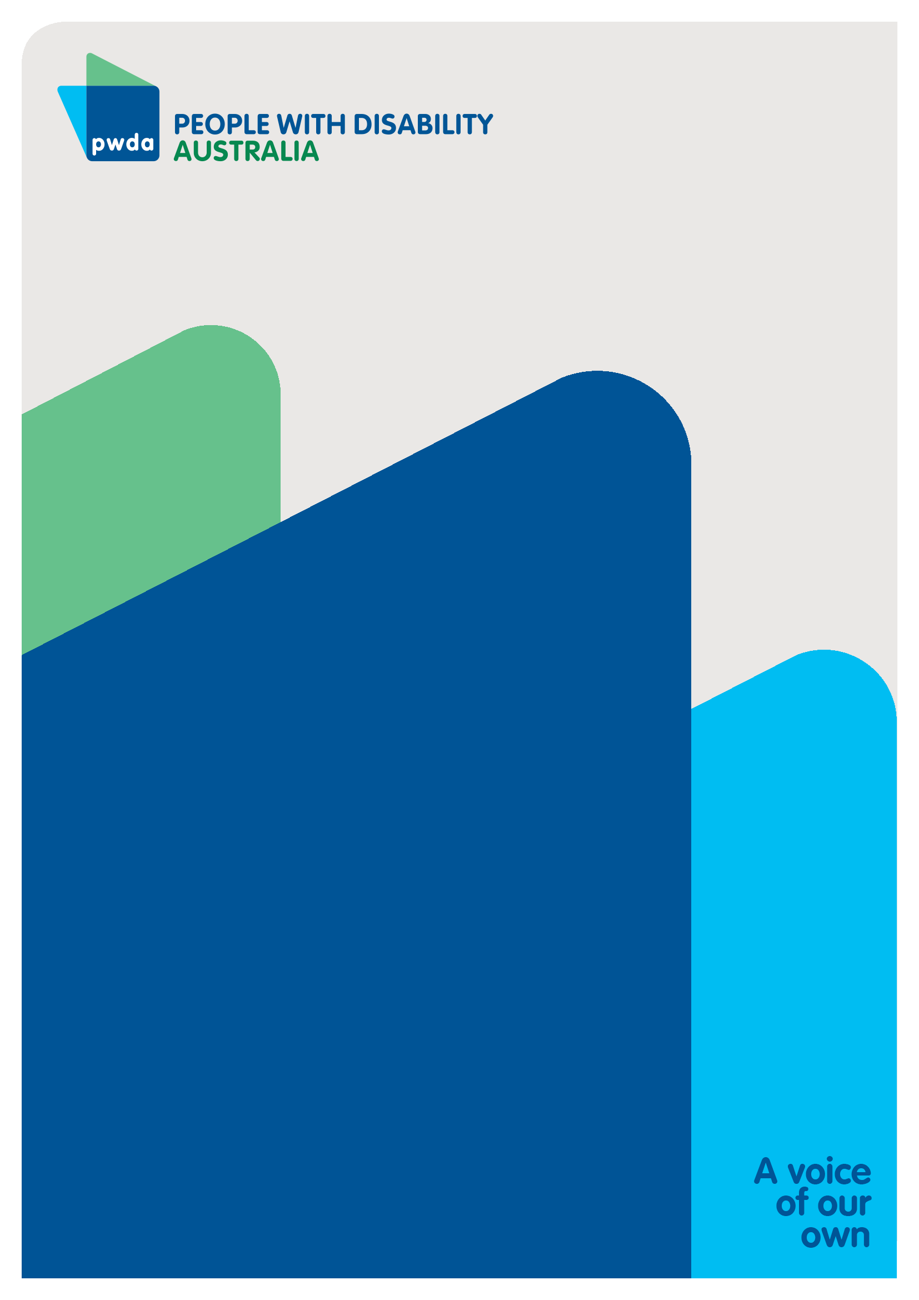
People with Disability Australia (PWDA) is a national disability rights and advocacy organisation made up of, and led by, people with disability.
For individual advocacy support contact PWDA between 9 am and 5 pm (AEST/AEDT) Monday to Friday via phone (toll free) on 1800 843 929 or via email at pwd@pwd.org.au
Submission contact
Giancarlo de Vera
Senior Manager of Policy
E: pwd@pwd.org.au

NDIS Review (2023) What We Have Heard Report, Australian Government, accessed 10 August 2023, p. 3.
See e.g., NDIS Review (2022) Our Approach, Australian Government, accessed 10 August 2023; Tune Review, p. 23
See e.g. Tune, D (2019) Review of the National Disability Insurance Scheme 2013: Removing Red Tape and Implementing the NDIS Participant Service Guarantee, accessed 11 August 2023, p. 25.
See e.g. Tune, D (2019) Review of the National Disability Insurance Scheme 2013: Removing Red Tape and Implementing the NDIS Participant Service Guarantee, accessed 11 August 2023, pp. 25 – 35.
Tune, D (2019) Review of the National Disability Insurance Scheme 2013: Removing Red Tape and Implementing the NDIS Participant Service Guarantee, accessed 11 August 2023, p. 27.
Britt, J and de Vera, G (2023) ‘NDIS Review Cost and Affordability,’ Submission 2 to the NDIS Review responding to The role of pricing and payment approaches in improving participant outcomes and scheme sustainability Paper, People with Disability Australia, Sydney, accessed 17 August 2023.
Per Capita (2023) Not a One Stop Shop: The NDIS in Australia’s Social Infrastructure, Accessed 10 August 2023, p. 5.
Buckmaster, L & Clark, S (2018) The National Disability Insurance Scheme: a chronology, Parliament of Australia, Canberra, Accessed 10 August 2023; Per Capita (2023) Not a One Stop Shop: The NDIS in Australia’s Social Infrastructure, Accessed 10 August 2023.
Ibid.
Per Capita (2023) Not a One Stop Shop: The NDIS in Australia’s Social Infrastructure, Accessed 10 August 2023, p. 5.
Wilson, E. & Brown, C. (2021) ‘The ILC landscape: a snapshot,’ Centre for Social Impact, Swinburne University of Technology, Accessed 11 August 2023, p. 8
Wilson, E. & Brown, C. (2021) ‘Overview of Results: Informing Investment Design: ILC Research Activity,’’ Centre for Social Impact, Swinburne University of Technology, Accessed 11 August 2023. pp. 5-7.
Ibid, p. 7.
Wilson, E. & Brown, C. (2021) ‘The ILC landscape: a snapshot,’ Centre for Social Impact, Swinburne University of Technology, Accessed 11 August 2023, p. 9
Ibid
Commonwealth of Australia (2011) 2010–2020 National Disability Strategy: An initiative of the Council of Australian Governments, Accessed 11 August 2023.
Davy, L., Fisher, K.R., Wehbe, A., Purcal, C., Robinson, S., Kayess, R., Santos, D. (2019) ‘Review of implementation of the National Disability Strategy 2010-2020: Final report.’ Social Policy Research Centre, UNSW Sydney, accessed 11 August 2023, p. 10.
See e.g., Ibid, pp. 22-23.
Ibid, pp. 21-23.
Britt, J. (2023) ‘NDIS Access, Eligibility and Planning,’ Submission 1 to the Independent Review of the National Disability Insurance Scheme (NDIS), People with Disability Australia, Sydney, accessed 11 August 2023.

