Media Statement – Thursday 7 December
NDIS change must be led by people with disability

This page explains a statement about the NDIS Review and what people with disabilities need to make sure it works well.

A statement is a message.

This statement was made by lots of disability groups.

We will share this statement with people that work in TV news, radio and in newspapers.

They might make a news story with items from this statement.

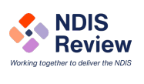 | People from lots of disability groups are working together to share their thoughts, feelings and ideas about the NDIS Review.
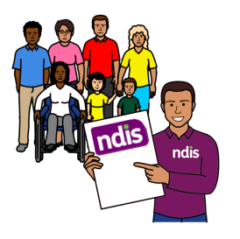 | The NDIS is very important for people with disability to go to school, work and in the community.  The NDIS helps people with disability to build skills and be more independent.
People with disability, families and carers talked with people who wrote the Review.

They shared their stories.

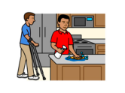 | People with disability said that the NDIS is good but can be hard to use and find supports.
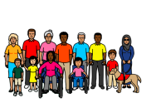 | We want people with disability to be a part of a new group.  This group would work with the government about how to make NDIS better for everyone.
 | We want this group to be called the Disability Reform Implementation Council.
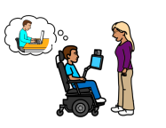 | We want to make sure that no person with a disability is left without support.  We know that the support could be NDIS, schools or other community groups.
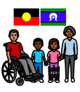 | We ask that First Nations people with disability are included in the plan and given supports they need.
We ask all governments to make sure people with disability are included.

We want people with disability to have the supports they need.

This statement was made by:
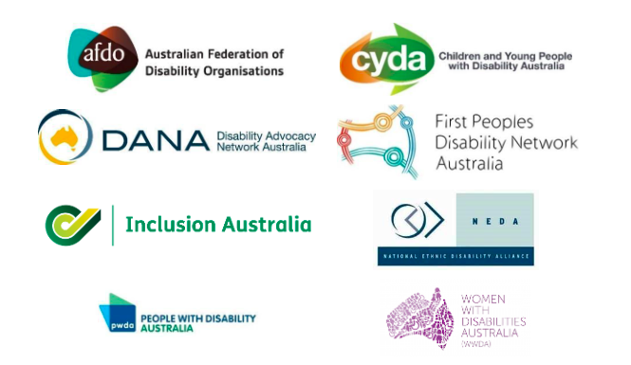

This statement has been supported by lots of groups in Australia.

If you want a list of these groups you can call or email us.

If you have questions about this statement you can call or email Jane or Janelle.

- Jane Metlikovec 0409 539 880 jane@upstride.com.au
- Janelle Del Vecchio 0459 983 096 janelle@upstride.com.au

